SUPPLEMENTARY MATERIALS AND ONLINE METHODS

GWAS Sample collection
Samples were collected through a nation-wide effort, detailed in Suppl. Fig. S1. Each sample’s HTLV-1 seropositivity was confirmed via Western Blot along with nested PCR. HAM/TSP diagnosis was made according to Castro-Costa crtiteria⁶. Genotyping was performed using an Axiom Precision Medicine Research Array. The original genotyping returned 902,527 variants for 1,043 samples. A first round of quality control resulted in 49 samples being removed due to failing dish quality control with a threshold of 0.82. Forty more samples were removed due to having a call rate error greater than 3%. Lastly, 41,374 variants with a call rate error also greater than 3% were removed. Thus, the received data consisted of 954 samples and 861,153 genotyped polymorphisms. Of the 954 samples, three were plate controls. The remaining 951 samples consisted of 416 HAM cases and 535 asymptomatic individuals (Fig. S1). The HAM individuals consisted of 278 females, 136 males, and 2 unknowns while the asymptomatic individuals consisted of 337 females and 198 males.
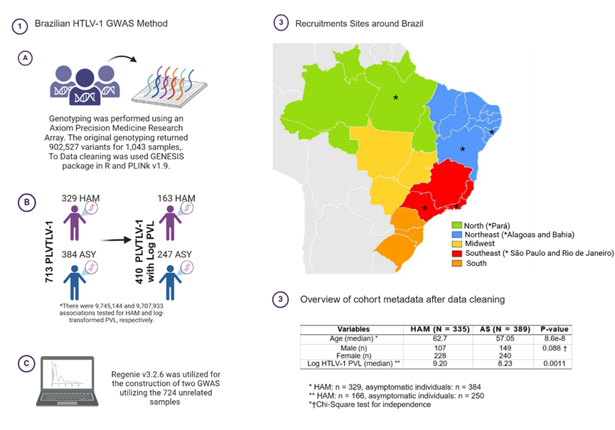

Fig. S1: Nation-wide sample strategy and cohort characteristics

Estimation of relatedness in an admixed population
The GENetic EStimation and Inference in Structured samples (GENESIS v2.32.0) package in R was utilized to estimate relatedness within the admixed cohort [86]. For all pairwise comparisons, this approach calculates the kinship coefficient and the proportion of alleles not in common, k₀. If a pair of samples had a kinship coefficient greater than 0.35 and less than 1% of alleles not in common, k₀ < 0.01, the samples were labeled as replicates. Meanwhile, if a pair of samples had a kinship coefficient greater than 2(-7/2), a standard threshold for identifying first and most second-degree relatives, and less than 60% alleles not in common, k₀ < 0.6, they were labeled as related. This resulted in the removal of 71 samples identified as replicates and 36 samples identified as relatives of another sample. This left 752 samples remaining. When a pair of samples is determined to be replicates or related only one needs to be removed. For the replicates, the sample that had a better genotype rate was retained.

Variant and sample quality control
PLINK v1.9 was utilized for the estimation of the following quality metrics. Variants with a genotype missing rate above 0.05 were removed, resulting in the exclusion of 182 variants and retention of 860,971 variants. Next one sample was removed due to having a genotype missing rate above 0.05, leaving 751 samples. A sex check was then performed. Self-identified females with an F-estimate below 0.4 and self-identified males with an F-estimate above 0.6 were retained. All other samples which had a sex discordance or an unknown self-reported sex, 27 individuals in total, were removed leaving 724 subjects remaining. Then the X chromosome polymorphisms, 33,499 variants, were removed leaving 827,472 variants. A minor allele frequency of 0.01 was applied, removing 284,903 variants and retained 542,569 variants. Variants with a Hardy-Weinberg p-value smaller than 1e-6 when calculated on the controls were removed [249]. Thus 312 variants were removed and left 542,257 variants remaining. Lastly, no individuals were removed when filtering for individuals who had a heterozygosity rate greater than three standard deviations from the mean. After standard quality control, 724 subjects and 542,257 variants remained (Fig. S1).

Imputation and further quality control
Imputation was performed via the Michigan Imputation Server for the 724 retained samples [56]. Phasing with Eagle v2.4 was selected. The reference panel was set to using phase 3 deep sequenced 1000 Genomes samples. Lastly, the population was set to be admixed. This resulted in 48,891,249 variants being returned from the original 542,178. Post-imputation quality control was performed by applying an r-squared threshold of 0.7 and a minor allele frequency of 0.01, thus 12,429,878 variants were retained. Then ambiguous, duplicate, and multiallelic variants were removed. The final number of variants retained for the 724 kept subjects was 9,745,144.

Verifying imputation results

Estimation of population stratification with PCA
The unimputed data, 542,178 variants, and imputed data, 9,745,144 variants, were both merged with the 1000 Genomes reference samples. Only 464,021 and 9,120,733 variants were kept after merging with the 1000 Genomes data for the unimputed and imputed data sets, respectively. Further, only 1000 Genomes reference samples from African (AFR), Amerindian (AMR), East Asian (ASN), and European (EUR) ancestries were utilized. With the sample size for each ancestry being 662, 347, 504, and 502, respectively. Prior to running PCA both the unimputed and imputed data sets had independent variants extracted via pruning with the –indep-pairwise 50 5 0.2 command. PCA was performed using PLINK v1.9 and the first two principal components were plotted to allow for a visual comparison. PCA on the imputed data was also performed without merging with the 1000 Genomes reference samples and the resulting eigenvectors were used as covariates in later analyses (GWAS and PRS analyses).

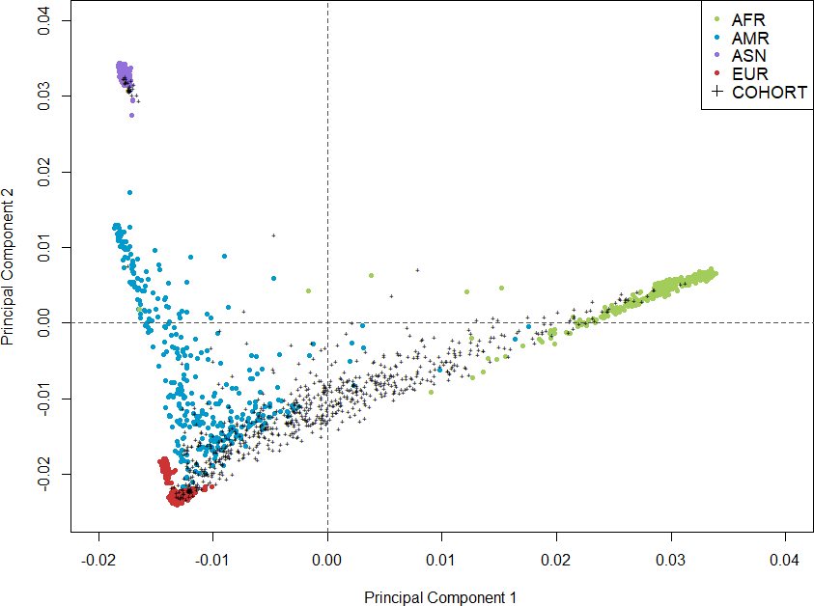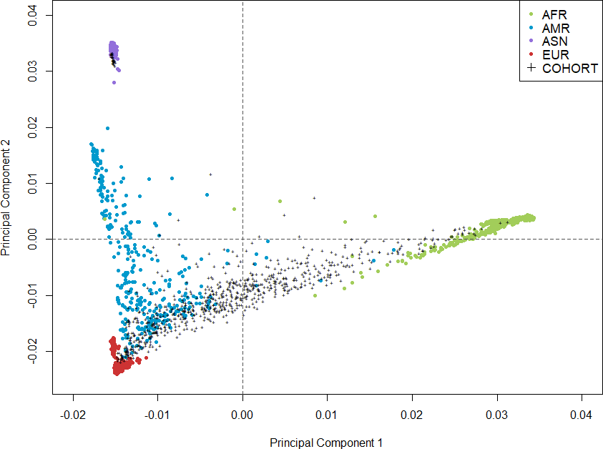
A Unimputed B Imputed

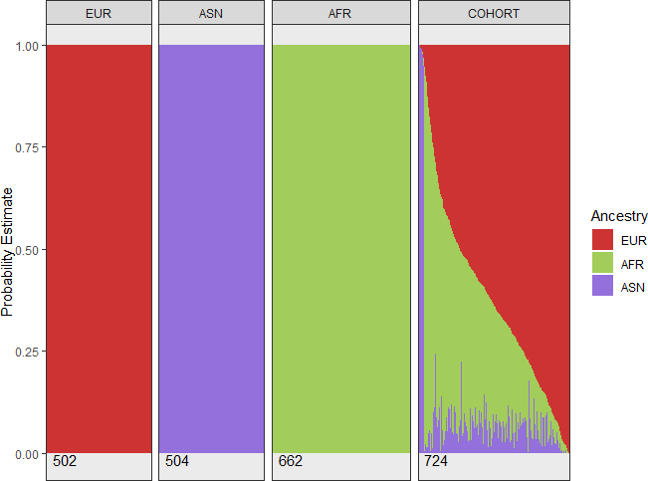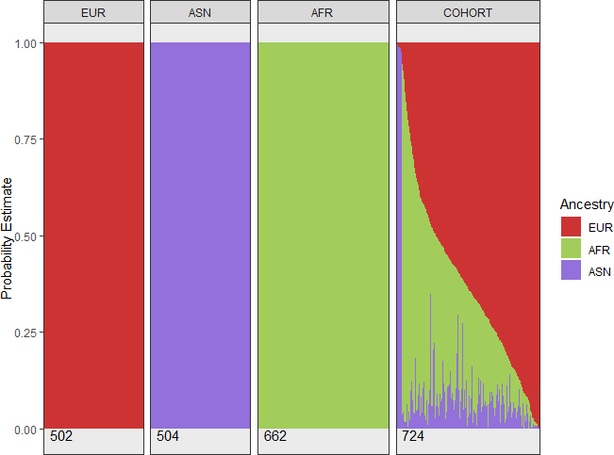

C Unimputed D Imputed

Suppl Figure S2: Comparison of population stratification from PCA and ADMIXTURE for unimputed and imputed data
Shown are the results of plotting the first two principal components after performing PCA on the cohort genotype data when merged with 1000 Genomes AFR, AMR, ASN, and EUR reference populations. A, is utilizing the unimputed cohort data. B, is using the imputed cohort data. Black pluses represent each of the 724 individuals in the Brazilian cohort at hand (COHORT). The colored dots represent individuals from the 1000 Genomes with color being indicative of ancestral background. C-D: Each bar represents an individual’s estimated proportions of global ancestry. The panels titled AFR, ASN, and EUR are the reference populations from the 1000 Genomes, and therefore all individuals are believed to be fully homogeneous for the corresponding ancestry. Each bar in the panel titled COHORT represents a Brazilian individual’s estimated proportions of global ancestry. At the bottom of each panel is the number of samples that were present. C, the results from running ADMIXTURE on the unimputed data. D, the results from running ADMIXTURE on the imputed data.

Global ancestry estimation
ADMIXTURE v1.3 was implemented for calculating global ancestry estimates [3]. Prior to supplying ancestry-specific reference populations unsupervised ADMIXTURE with 10-fold cross-validation was performed. This resulted in the selection of three reference ancestries being most representative (Fig. S3). Thus AFR, ASN, and EUR reference populations from the 1000 Genomes were used as three distinct ancestry populations to calculate three-way admixed ancestry estimates on the cohort. Global ancestry estimates were compared for the unimputed and imputed data using Pearson’s correlation.

ADMIXTURE estimates were used to form homogeneous ancestry groups within the cohort. Therefore, any samples which had an estimate of more than 90% of their genome coming from a single reference ancestry were grouped into that corresponding ancestry. Meanwhile, the remaining individuals were denoted as admixed (MIX).

Genome-Wide Association Studies either using mixed models or accounting for local ancestry

Mixed model GWAS with regenie
Regenie v3.2.6, which accounts for population structure via mixed models, was utilized for the construction of two GWAS utilizing the 724 unrelated samples. One GWAS utilized HAM disease status as a phenotype, while the other utilized log-transformed PVL. Sex, age, and the first five principal components obtained from internal PCA were used as covariates. Not all of the 724 individuals had values for age and or log-transformed PVL. Therefore, the sample size for the HAM GWAS was 713 (329 HAM individuals and 384 asymptomatic individuals) and for the log-transformed PVL was 410 (163 HAM individuals and 247 asymptomatic individuals) (Fig. S1). There were 9,745,144 and 9,707,933 associations tested for HAM and log-transformed PVL, respectively. The resulting summary statistics then had both Manhattan and Q-Q plots constructed for the additive associations using the qqman package v0.1.4 in R [228].

Calculating local ancestry
The phased imputed genotype data returned from the Michigan Imputation Server was used as input for calculating local ancestry with RFMIX v2 [124]. The phased reference samples used for ancestry estimation consisted of AFR, AMR, ASN, and EUR 1000 Genomes samples with 672, 348, 515, and 522 samples respectively. Therefore, phased 1000 Genomes data via SHAPEIT V2 was separately obtained from the UCSC Genome Browser database [58, 150].

Local ancestry based GWAS with TRACTOR
The GWAS had the same sample sizes as before (Table 4). For each of the ancestry-specific summary statistics that resulted from the two phenotypes, both Manhattan and Q-Q plots were constructed [228].

Annotation of GWAS results
After the generation of the 10 different GWAS the resulting associations were annotated with FUMA. All 10 summary statistics had a list of the SNPs with an association having a significance, p-value, less than 0.0001 generated (except for in the local ancestry GWAS for the ASN ancestry where a p-value of 0.001 was used). The two regenie GWAS and the eight TRACTOR GWAS had their filtered summary statistics passed to SNP2GENE. Gene annotations were done considering positional mapping, eQTL mapping, and chromatin interaction mapping for each of the 10 GWAS. The resulting mapped genes for each of the three gene mapping analyses for a single GWAS were combined. Only unique gene entries were retained. The unique list of mapped genes for each of the GWAS was then passed individually to GENE2FUNC. The emerging gene ontology (GO) terms associated with biological processes were obtained. GO terms from each of the distinct GWAS were combined for a single phenotype, either HAM or log PVL. The mean enrichment p-value across the five GWAS results for a single phenotype was calculated, setting p-values to 1 if a GO term that was present in one GWAS’ results was not in another's, and the most significant top 10 GO terms were identified for each phenotype.

Calculation of polygenic risk scores (PRS)
The HAM and MS summary statistics were built on hg19, thus their reported variants needed to be lifted over to hg38 reference build following a similar procedure as discussed above. The MS GWAS consisted of more than 47,000 cases and 68,000 controls. The acetate GWAS consisted of 115,050 individuals and the ApoA-I GWAS consisted of 115,082 individuals. Multiple phenotypes were available for the cohort: HAM, log-transformed PVL, acetate levels, and ApoA-I levels. Therefore, after obtaining all sets of PRS for a single set of summary statistics the best set of PRS was optimized for multiple different phenotypes such that different sets of PRS could be determined as the best depending on the association strength with the phenotypes tested. HAM status and the log-transformed PVL were used as phenotypes to select the best set of PRS for both the Japanese HAM and MS summary statistics. This was done in both PRSice and lassosum. Further, for the PRS calculated with acetate summary statistics, only acetate levels were used as a phenotype for selecting the best p-value threshold. The same was done for ApoA-I summary statistics but instead used ApoA-I levels as a phenotype. Neither of the lipid phenotypes had lassosum based PRS calculated.

For all resulting best sets of PRS, either from PRSice or lassosum, PRS were calculated for both the 724 subjects that remained after quality control and the 1000 Genomes external data set (662 AFRs, 504 ASNs, and 502 EURs). A notation will be used to distinguish the selected set of PRS from a single set of summary statistics, phenotype, and algorithm. PRS coming from PRSice will be denoted with pPRS, it will be prefixed with the summary statistics used and suffixed with the optimized p-value threshold depending on which of the phenotypes were used. For example, the best set of PRS coming from MS summary statistics when testing the association with HAM status is _{MS}pPRS_{0.5}. Meanwhile, PRS coming from lassosum will be denoted with lPRS, prefixed with the summary statistics used, and suffixed with the phenotype tested. It will represent the set of PRS for a specific combination of λ and s from a set of summary statistics that had the strongest association with the denoted phenotype. For example, the best set of PRS when using the Japanese HAM summary statistics when testing the association with the log-transformed PVL is _{HAM}lPRS_{PVL}. To note, acetate summary statistics will be represented with ACE and ApoA-I summary statistics with APO.

PRSice
PRSice v2 relies on the C+T methodology. Clumping was performed using an external data set for LD estimation consisting of the AFR, ASN and EUR populations from the 1000 Genomes using the hg38 reference build. For clumping, kilobase length was set to 250 (–clump-kb), LD threshold to 0.1 (–clump-r2), and the significance value of SNPs to 1 (–clump-p1). Average score-based PRS were calculated for nine p-value thresholds for SNP inclusion: 5e-8, 1e-5, 0.001, 0.005, 0.01, 0.05, 0.1, 0.5, and 1. No covariates were passed to PRSice and the flag –no-regress was used. Further, this process was repeated again but for the same 1000 Genomes samples included for external LD estimation. This procedure was repeated for all summary statistics.

lassosum
Calculating PRS with lassosum v1 was done with values of λ consisting of 40 equally spaced values from 0.001 to 0.2. s values consisted of 0.1 to 1 with a step of 0.1. The set of PRS for the combination of λ and s that resulted in the highest correlation was returned. Further, the values of the parameters that optimized the correlation for the target data set were also used to calculate the PRS for the 1000 Genomes samples.

Statistical analysis of Polygenic Risk Scores
The target data PRS was standardized by subtracting the average PRS of the external data set (1000 Genomes samples) from the corresponding target data set generated PRS and then dividing the difference by the standard deviation of the external PRS (Equation 2). This was done for each p-value threshold individually in the case of PRSice and once for the resulting PRS from lassosun. Additionally, each set of PRS were tested for normality via a Shapiro-Wilks test.

Selecting the best p-value threshold from PRSice
For each of the p-value thresholds tested in PRSice a null model, Equation 2, and a full model, Equation 1, were constructed. The full models were the same models as were used in testing the association of variants in regenie and TRACTOR. Thus, again only 713 and 410 samples were used for constructing these models when using HAM and log-transformed PVL as phenotypes, respectively. When using lipid levels as a phenotype only 75 samples had lipid measurements recorded. The principal components were obtained by running PCA on only the target data, the Brazilian cohort at hand. The R2 when accounting for covariates other than PRS, was taken for each p-value threshold. With logistic regression models, Nagelkerke’s adjusted R2 was used. These metrics were used to assess the performance of the PRS produced from the different p-value thresholds.

PHENOTY PE = PRS + SEX + AGE + PC1 + PC2 + PC3 + PC4 + PC5 (1)
PHENOTY PE = SEX + AGE + PC1 + PC2 + PC3 + PC4 + PC5 (2)

Quantification of HTLV-1 proviral load (PVL)
The amount of HTLV-1 provirus in samples was measured using real-time PCR, which specifically examined the HTLV-1 pol gene using primers and probes. A separate human albumin reference gene was used for normalization. Samples were tested in duplicate to ensure precision, and results were reported as HTLV-1 DNA copies per 10⁶ PBMCs¹⁰.

Digital Transcriptomics and Systems Biology analysis
We performed nCounter (NanoString Technologies, US) digital gene expression analysis using the Human Myeloid/innate Immunity Panel, complemented with a customized Plus panel, targeting a total of 800 human and pathogen transcripts, including HTLV-1 Tax and Hbz (detailed in Suppl. Table XX). The workflow was carried out as established before in critical COVID-19 (1), fatal COVID-19 nursing home outbreaks (2), and respiratory infections at the emergency department (3). In short, transcripts, including 30 housekeeping genes, were quantified by hybridization with specific fluorescent barcodes linked to a 50 bp reporter probe and an adjacent 50 bp capture probe. Data were subsequently normalized for background (negative control probes), internal positive control probes and housekeeping genes using nSolver software version 4.0 (NanoString Technologies, US). Differentially expressed genes and predefined biological pathway scores were determined using nSolver, with correction for multiple testing by the Benjamini-Hochberg method at a 5% false discovery rate for multiple comparisons. STRING version 12.0 protein-protein interacting network analysis (https://string-db.org/) was performed with input from all significantly upregulated genes. GEO2R, Webgestalt, ShinyGO 8.0 and gprofiler were used for systems biology analysis. Statistical analysis was performed with Prism version 10 (GraphPad Software, US) and XL-STAT.

Supplementary References
1. Menezes SM, Braz M, Llorens-Rico V, Wauters J, Van Weyenbergh J. Endogenous IFNβ expression predicts outcome in critical patients with COVID-19. Lancet Microbe. Jun 2021;2(6):e235-e236. doi:10.1016/s2666-5247(21)00063-x
2. Cuypers L, Keyaerts E, Hong SL, et al. Immunovirological and environmental screening reveals actionable risk factors for fatal COVID-19 during post-vaccination nursing home outbreaks. Nat Aging. Jun 2023;3(6):722-733. doi:10.1038/s43587-023-00421-1
3. Fukutani KF, Nascimento-Carvalho CM, Bouzas ML, et al. In situ Immune Signatures and Microbial Load at the Nasopharyngeal Interface in Children With Acute Respiratory Infection. Front Microbiol. 2018;9:2475. doi:10.3389/fmicb.2018.0247

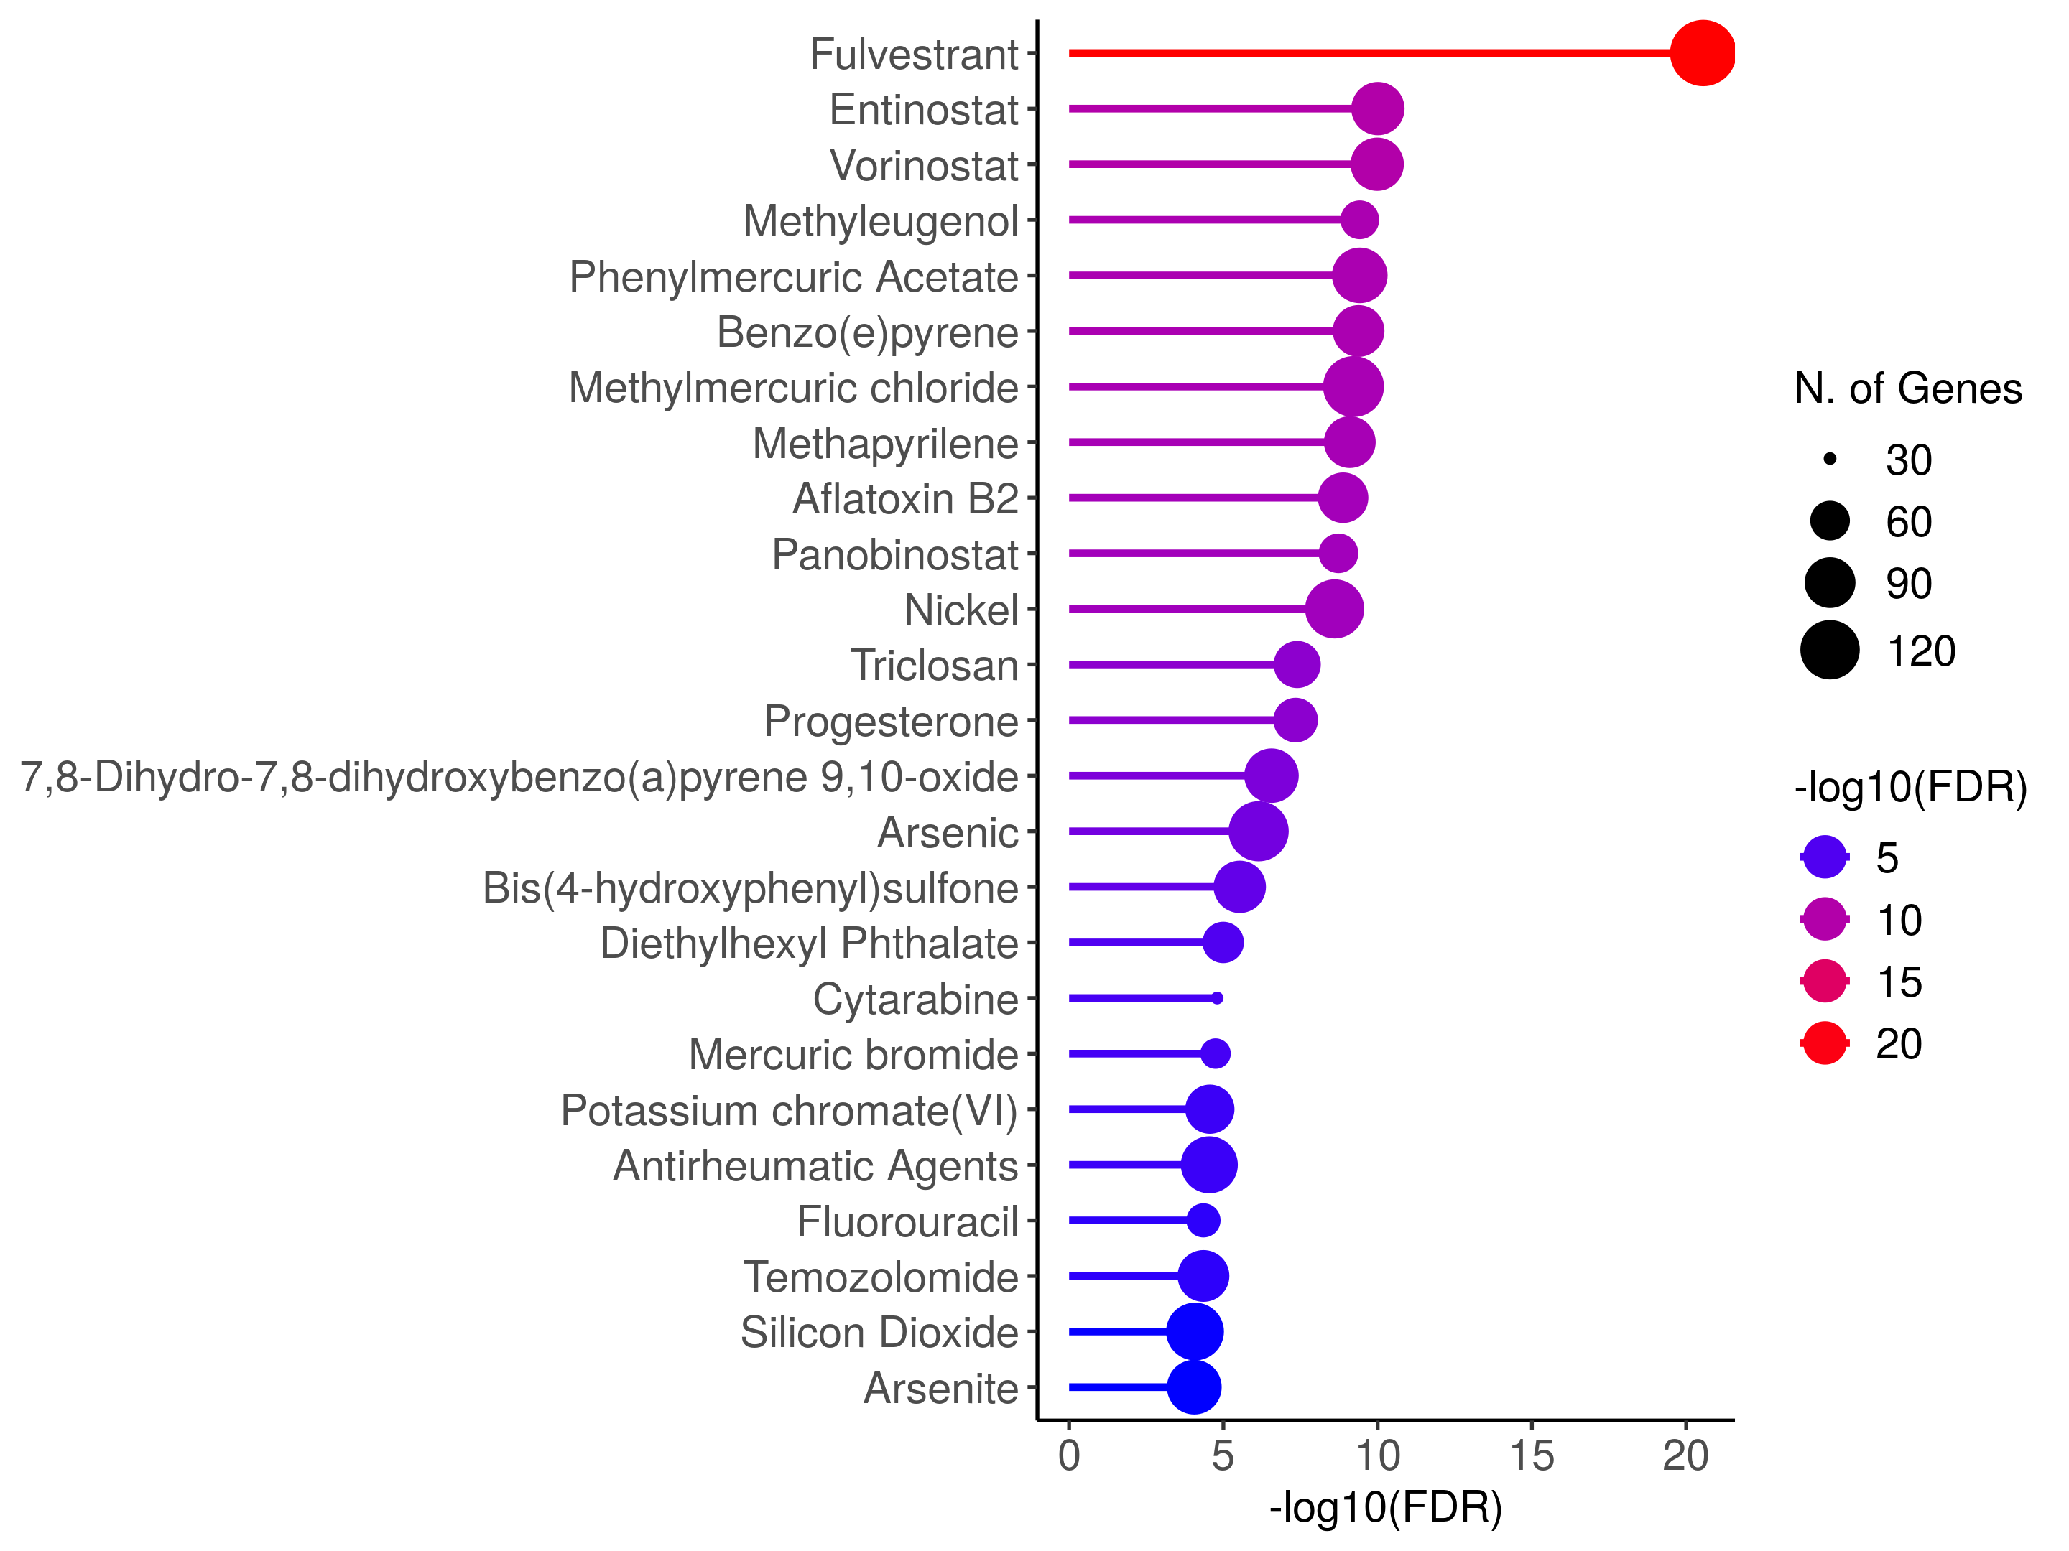
Suppl. Fig. 3: In silico drug screening of validated GWAS genes
Drug screening in silico of 453 validated HAM GWAS genes in publicly available databases was performed using enrichment analysis in shinyGO 8.0.

Metabolomics
Metabolomic analysis of 220 defined metabolites and lipids was performed on the Nightingale ¹H-NMR platform as previously described (Dierckx et al., Assone et al.).

Analysis of metabolomics Data with PRS
For 75 subjects of the 724 that were unrelated there were additional lipid measurements available. The best p-value thresholds from PRSice were selected using acetate and ApoA-I levels as phenotypes when using acetate and ApoA-I summary statistics, respectively.

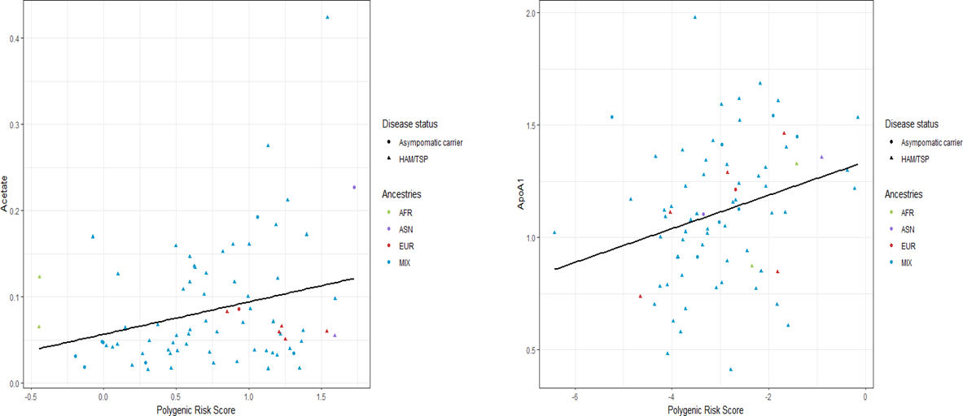

Suppl. Fig. 4: PRS for metabolomic biomarkers as validation of trans-ancestry PRS application with small sample size
The shape of the point corresponds to the disease status and the color corresponds to the assigned ancestry from local ancestry. Left panel, acetate levels and acetate generated PRS. Right panel, ApoA-I levels and ApoA-I generated PRS. Pearson’s correlation R=0.28, p=0.016.

Immune Proteomics
Cytokines, chemokines and immune mediators were measured by Luminex (37-plex inflammatory panel) and Cytometric Bead Array (BD Biosciences) as previously described (Assone et al. 2024).

Ethical approval
The Ethical Board of “Instituto de Infectologia Emilio Ribas”, Sao Paulo-Brazil, approved the protocol (Number 07688818.2.1001.0061). Signed informed consent was obtained from all participants prior to study inclusion.

