Appendix (1)

Table A (1) - Intercorrelations among variables

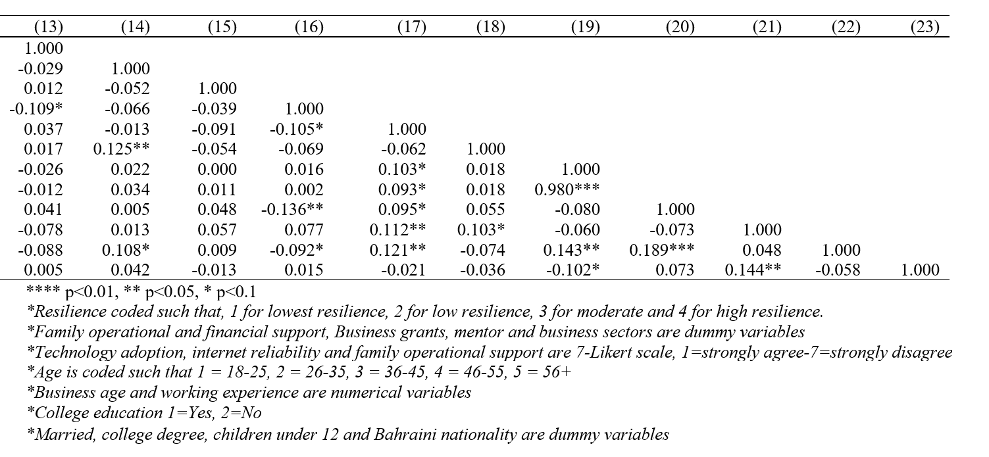
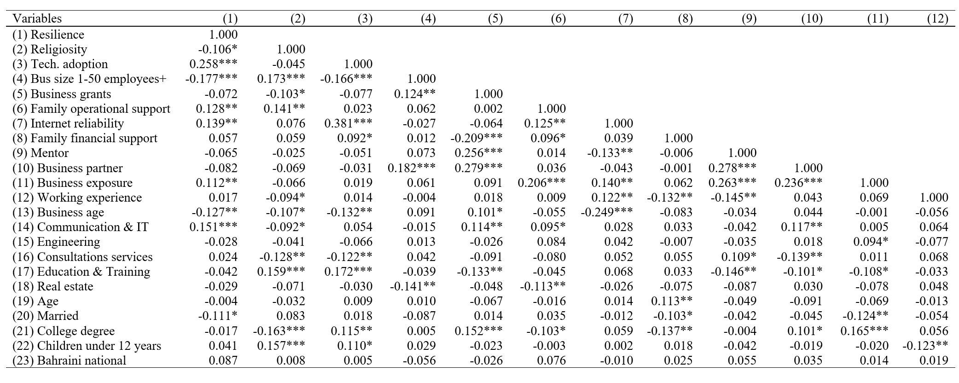

Appendix 1

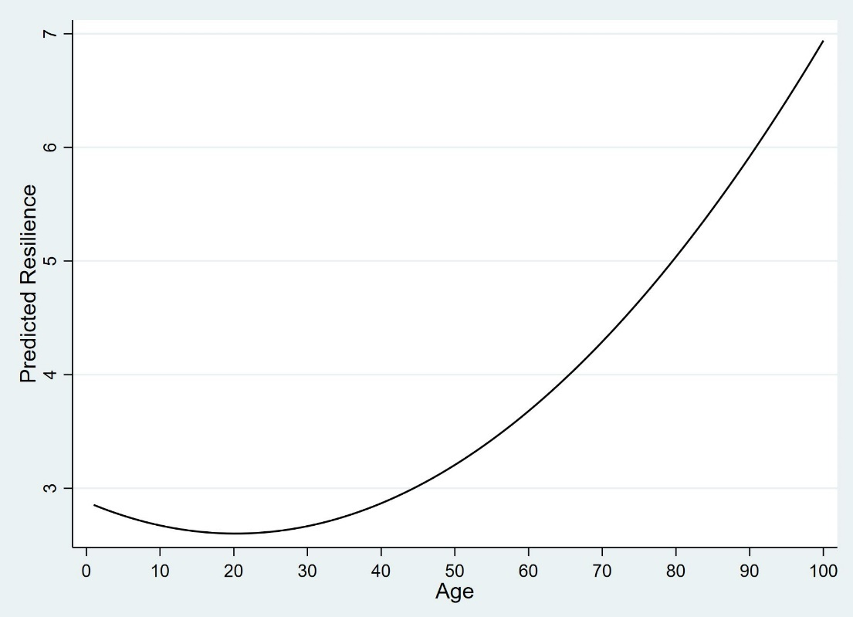

Fig. A1 The graph illustrates the non-linear effects between female entrepreneurs' age and resilience (corresponds to Table 2).

Appendix 2
Table 6 – Religiosity integrated items

Variables | (1) | (2) | (3) | (4) | (5)
RM1: Religion is essential in my life | 1.000
RM2: My religion encourages me to work and become independent | 0.239*** | 1.000
RM3: My religion encourages entrepreneurial activities for women | 0.283*** | 0.835*** | 1.000
RM4: My religion allows me as a woman to attend mixed gender-events for business purposes | -0.032 | 0.368*** | 0.405*** | 1.000
RM5: My business setup must comply with Islamic principles (Sharia) | 0.302*** | 0.223*** | 0.151*** | -0.132** | 1.000
*** p<0.01, ** p<0.05, * p<0.1

The reliability and validaty of the religiosity scale in this study were assessed using exploratory factor analysis (EFA) to examine the common variance among the scale’s as recommended by (DeVellis, 2003). In doing so, the following steps were followed. First, the adequacy of the data for factor analysis was tested; the Kaiser-Meyer-Olkin (KMO) stat exceeded the recommended minimum threshold (KMO= 0.604), and Bartlett’s Test of Sphericity was significant (x² = 504.670, df = 10, p = 0.000), confirming adequate correlations for factor analysis. The unrotated solution revealed a single factor with an eigenvalue of 1.86 explaining 94.27% of the variance. Other factors had eigenvalues below 1, supporting the retention of only one factor (Kaiser, 1960). The scree plot further supports the one-factor solution as the best fit for the data (see Fig. A2).
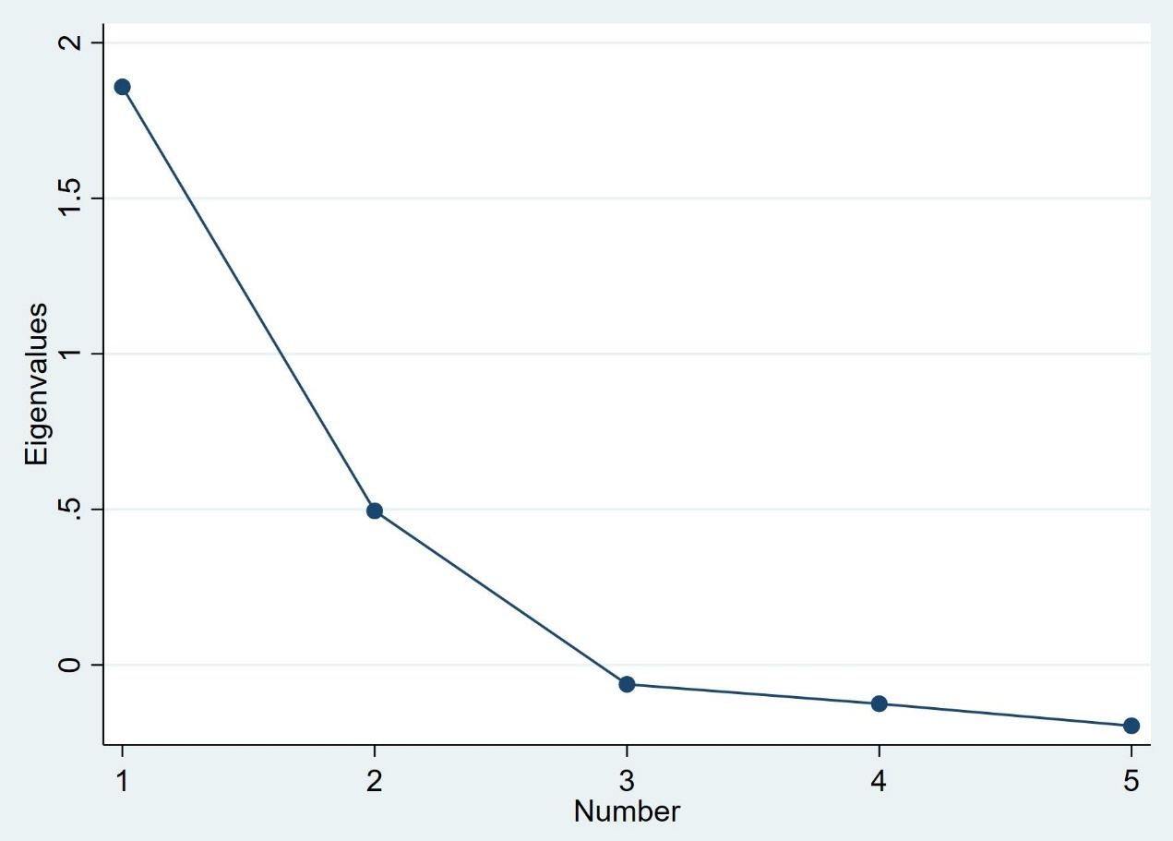

Fig. A2 Scree plot of religiosity scale

This suggests that resilience increases after the age of 21

