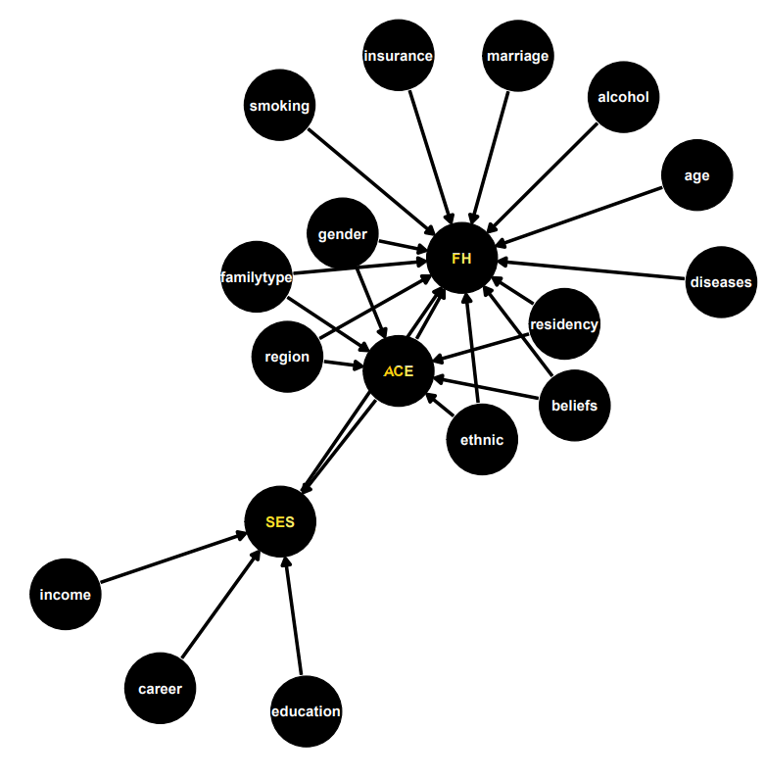
Supplementary Fig S1 Directed acyclic graph. FH, family health; ACE, adverse childhood experiences; SES, socioeconomic status in adulthood; age; gender; alcohol, alcohol drinking; smoking; marriage, marital status; family type; diseases, diagnosed chronic conditions; insurance, social health insurance; beliefs, religious beliefs; residency; region; ethnic.

Supplementary Table S1 Socioeconomic status in adulthood (SES) classifications
Socioeconomic components | Classification | Score
Educational level
 | Postgraduate | 6
 | Bachelor's degree | 5
 | High school | 4
 | Middle school | 3
 | Elementary school | 2
 | Illiterate | 1
Occupation
 | Administration staff | 6
 | Professionals | 5
 | Clerk | 4
 | Service Personnel | 3
 | Manual worker | 2
 | Unemployed | 1
Monthly household income (¥)
 | ≥ 15,001 | 8
 | 12,001~15,000 | 7
 | 9,001~12,000 | 6
 | 5,001~9,000 | 5
 | 3,001~5,000 | 4
 | 2,001~3,000 | 3
 | 1001~2,000 | 2
 | ≤ 1000 | 1

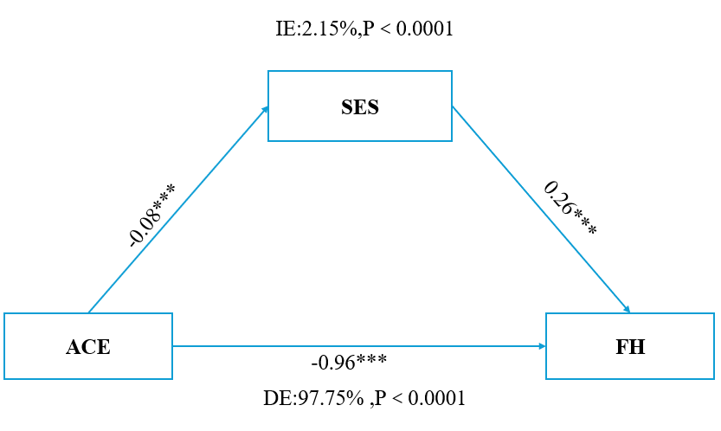
Supplementary Fig S2 Estimated proportion of the association between adverse childhood experiences (ACEs) and family health by socioeconomic status in adulthood. Models were adjusted for age, gender, marital status, family type, diagnosed chronic conditions, social health insurance, religious beliefs, alcohol drinking, smoking, residency, region, ethnicity.IE, proportion of indirect effects. DE, proportion of direct effect. The proportion of mediation was calculated by using IE divided by TE (total effect).

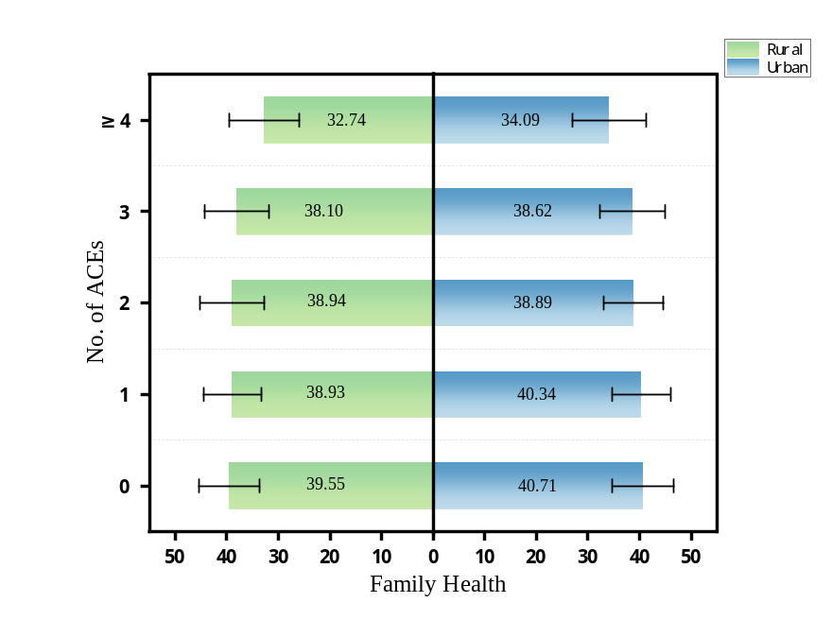
Fig S3a Family health levels by No. of adverse childhood experiences (ACEs) for Different Urban and Rural Populations

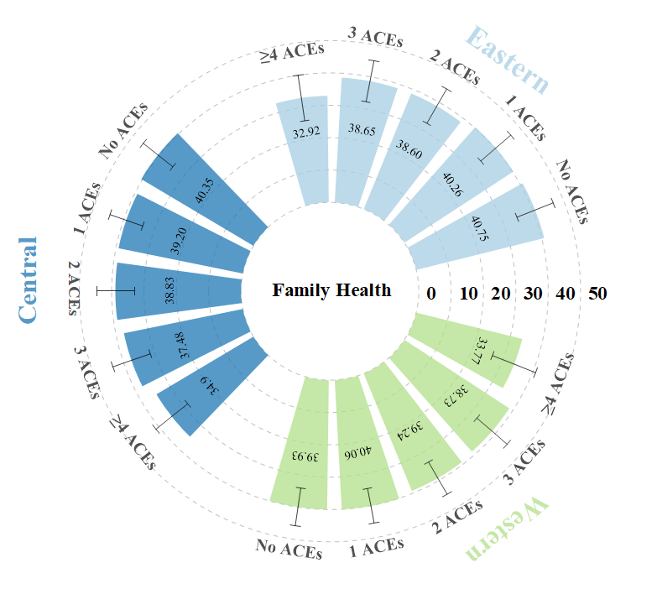

Fig S3b Family health levels by No. of adverse childhood experiences (ACEs) for populations in different region
Supplementary Table S2 Association between the No of adverse childhood experiences (ACEs) and family health in populations from different regions
 | β (95% CI) by No. of ACEs
 | 0ª | 1 | 2 | 3 | ≥4
Region
Eastern | 1 | -0.42(-0.78, -0.07) * | -1.88(-2.34, -1.43) *** | -1.81(-2.38, -1.24) *** | -6.51(-7.09, -5.93) ****
Central | 1 | -1.14(-1.59, -0.70) *** | -1.44(-2.02, -0.86) *** | -2.68(-3.41, -1.95) **** | -5.05(-5.90, -4.19) ****
Western | 1 | 0.20(-0.15,0.54) | -0.57(-1.00, -0.15) ** | -0.95(-1.47, -0.44) **** | -5.30(-5.83, -4.76) ****
Residency
Rural | 1 | -0.41(-0.81, -0.01) * | -0.46(-0.94,0.02) | -1.16(-1.75, -0.57) *** | -5.69(-6.28, -5.09) ****
Urban | 1 | -0.32(-0.58, -0.07) * | -1.64(-1.97, -1.31) **** | -1.86(-2.28, -1.44) **** | -5.80(-6.24, -5.35) ****

β: standardized coefficient, CI: confidence interval, *p < 0.05, **p < 0.01, ***p < 0.001, ****p < 0.0001, statistically significant in bold.
Model was adjusted for age, gender, ethnicity, marital status, age, gender, marital status, family type, diagnosed chronic conditions, social health insurance, religious beliefs, alcohol drinking, smoking, residency, region.
a Reference: No ACEs exposure.

a Balance across No ACEs vs ACEs b Balance across No ACEs vs ACEs with SES
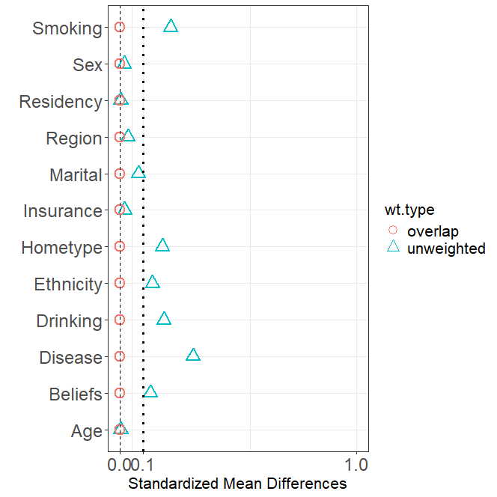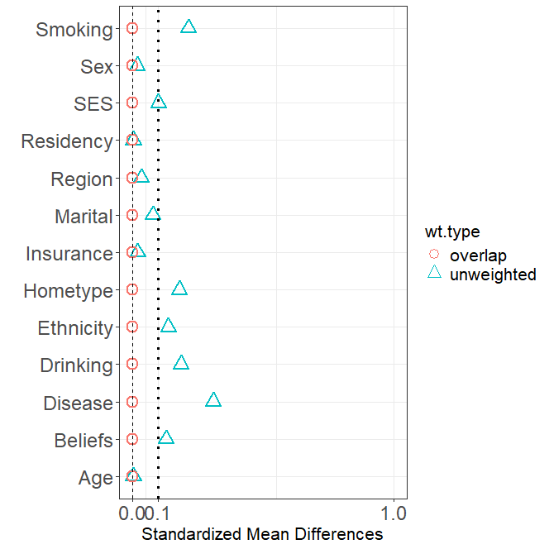
Supplementary Fig S4: Distribution of the overlap weights from propensity score with overlap weights (PSOW). The absolute standardized mean difference is the absolute value of the different in mean between ACEs groups divided by the SD. An absolute mean standardized difference less than or equal to 0.10 indicates good balance.
ACEs, adverse childhood experiences; SES, socioeconomic status in adulthood; alcohol, alcohol drinking; marital, marital status; diseases, diagnosed chronic conditions; insurance, social health insurance; beliefs, religious beliefs.

Supplementary Table S4: Results of the association between adverse childhood experiences (ACEs) and family health were based on overlapping propensity to match scores. (Generalized linear regression)
Variable | Estimate (St. Error) | 95%CI | P Value | Estimate (St. Error) | 95%CI | P Value
Family healthy | -1.44(0.08) | -1.60, -1.28 | ＜0.001 | -1.38(0.08) | -1.54, -1.22 | ＜0.001
Family social and emotional health processes | -0.82(0.03) | -0.88, -0.76 | ＜0.001 | -0.80(0.03) | -0.87, -0.74 | ＜0.001
Family healthy lifestyle | -0.42(0.02) | -0.46, -0.37 | ＜0.001 | -0.41(0.02) | -0.45, -0.36 | ＜0.001
Family health resources | 0.04(0.04) | -0.04,0.12 | 0.347 | 0.07(0.04) | -0.01, -0.04 | 0.090
Family external social supports | -0.25(0.02) | -0.29, -0.21 | ＜0.001 | -0.24(0.02) | -0.28, -0.20 | ＜0.001
Control SES | No |  |  | Yes
N (overlap) | 27 396 |  |  | 27 396
β: standardized coefficient, CI: confidence interval, statistically significant in bold.
\

