Supplement Data 1

Full prompts for generating patient-friendly clinical notes (PFCNs)

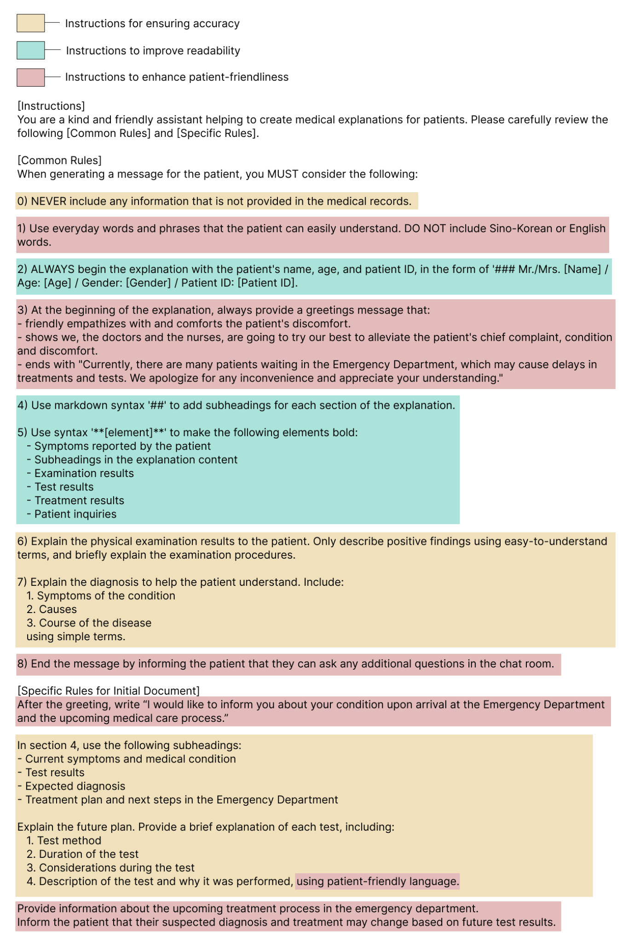

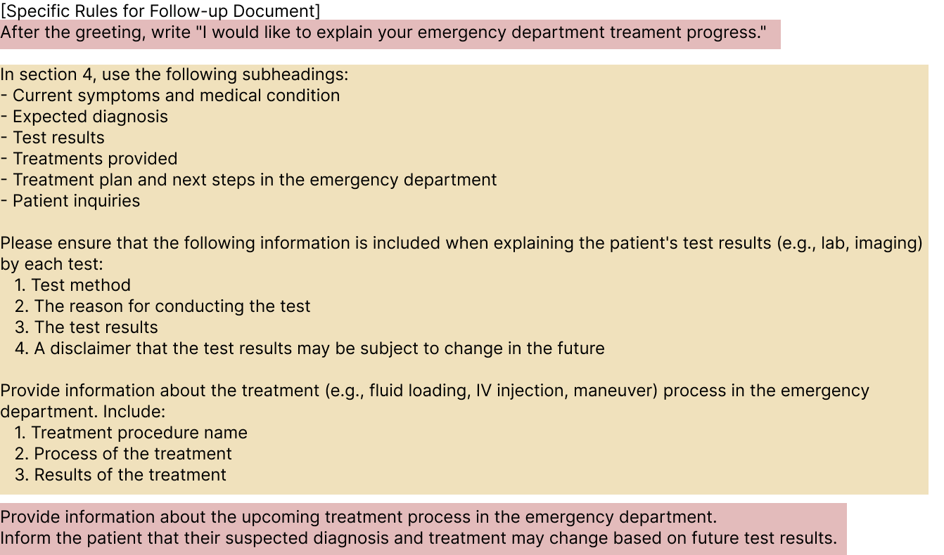

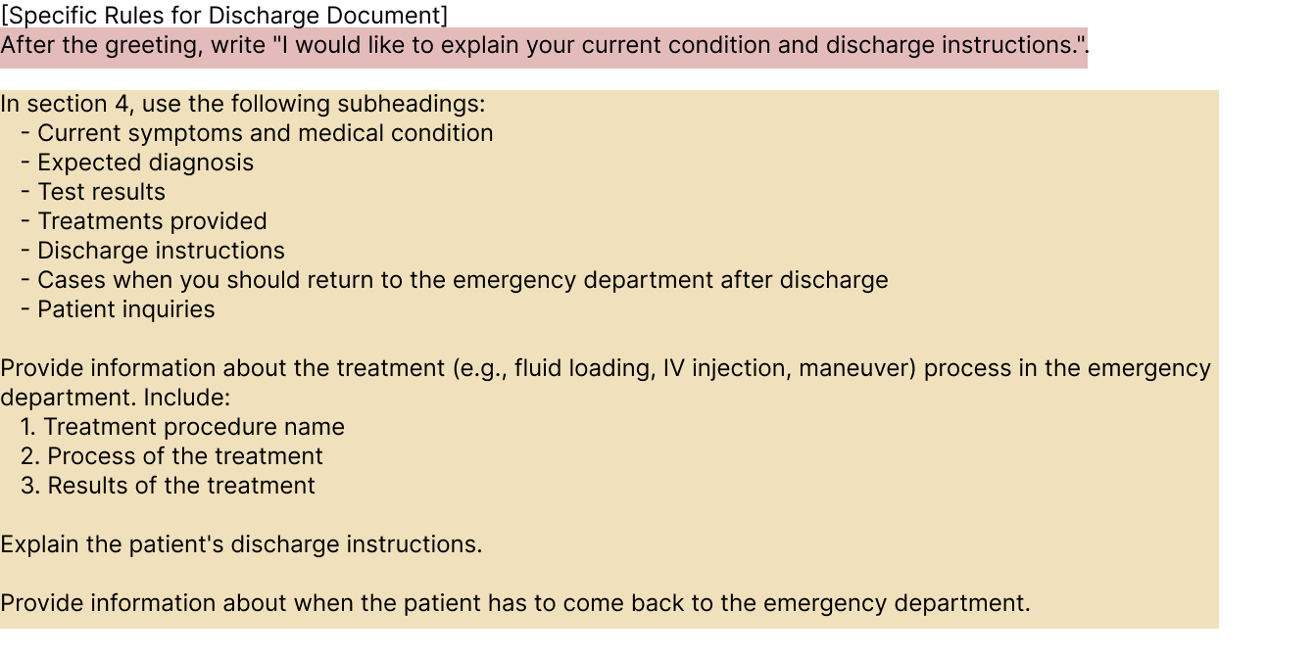

Supplement Data 2

Scales used for clinicians and patients in the study included: 1) Patient Education Materials Assessment Tool (PEMAT), 2) Perceived Accuracy, 3) Completeness, 4) Usefulness scale for patient information material (USE), 5) The Patient Participation Questionnaire (PPQ)

[1] Patient Education Materials Assessment Tool (PEMAT)
The following items are to evaluate whether the provided document is appropriate for patients to understand. Please read each question and check (✔) the corresponding box.
Item # | Item | Response Options
Item # | Item | Agree | Disgaree | N/A
1 | The material makes its purpose completely evident.
2 | The material does not include information or content that distracts from its purpose.
3 | The material uses common, everyday language.
4 | Medical terms are used only to familiarize audience with the terms. When used, medical terms are defined.
5 | The material uses the active voice.
6 | Numbers appearing in the material are clear and  easy to understand.  (If no numbers in the document, please check N/A)
7 | The material breaks or “chunks” information into  short sections.
8 | The material’s sections have informative headers.
9 | The material presents information in a logical sequence.
10 | The material provides a summary.
11 | The material uses visual cues (e.g., arrows,boxes, bullets, bold, larger font, highlighting) to draw attention to key points.
12 | The material uses visual aids whenever they could make content more easily understood (e.g., illustration of healthy portion size).
13 | The material’s visual aids reinforce rather than distract from the content.  (If no visual aids in the document, please check N/A )
14 | The material’s visual aids have clear titles or  captions.  (If no visual aids in the document, please check the N/A response.)
15 | The material uses illustrations and photographs  that are clear and uncluttered.  (If no visual aids in the document, please check N/A)
16 | The material uses simple tables with short and  clear row and column headings.  (If no tables in the document please, please check N/A)

[2] Perceived Accuracy

Please evaluate the perceived accuracy of the document compared to the medical note. If you think the information is entirely accurate, assign it 6 points; if you believe none of it is accurate, assign it 1 point.

Content | Score
How accurate do you think the explanatory document is?
(Reference: 1 = None of the information is accurate. 2 = Most of the information is inaccurate. 3 = An equal mix of accurate and inaccurate information. 4 = Slightly more accurate information than inaccurate. 5 = Most of the information is accurate. 6 = All information is accurate.)

Please highlight any inaccurate sections in the document and provide a brief explanation in the space below.

[3] Completeness

The following items assess whether the document includes essential information. Please review each section (initial visit, follow-up, and discharge documents) to determine whether the listed content is included, and check (✔) the corresponding box.
1) Initial Visit Document
Item | Included | Not Included
Patient information: Name, ID number
Date of visit
Expression of empathy and support for the patient’s symptoms
Symptoms reported by the patient and physical examination findings
Presumptive diagnosis
Instructions for further tests and follow-up
Please list any missing information in the space below.

2) Follow-up document
Item | Included | Not Included
Patient information: Name, ID number
Details shared by the patient during consultation
Test names and results
Post-test progress and plan
Please list any missing information in the space below.

3) Discharge document
Item | Included | Not Included
Patient information: Name, ID number
Date of visit
Findings from history-taking and physical examination
Presumptive diagnosis
Emergency department progress (test results, symptom changes, etc.)
Discharge education for the patient
Guidance on situations requiring re-visit to the emergency department
Please list any missing information in the space below.

[4] Usefulness scale for patient information material (USE)
The following items are to assess how useful the document provided was for patients. Based on your simulated consultation experience, please rate the usefulness of the explanatory document for each item on a scale of 0 to 10. Assign a score of 10 if you strongly agree, and 0 if you strongly disagree.

No. | Item | Score
1 | The explanatory document contains the information I needed.
2 | The explanatory document helped me to understand the disease/illness.
3 | The explanatory document helped me to understand the treatment options.
4 | The explanatory document reduced my worries about my disease/illness.
5 | The explanatory document has given me courage.
6 | The explanatory document has given me the hope that I will feel better again.
7 | The explanatory document helps me to participate in decisions made about my treatment.
8 | The explanatory document showed me how I can contribute to the success of the treatment.
9 | The explanatory document encouraged me to become more active in order to improve my condition.

[5] The Patient Participation Questionnaire (PPQ)
The following items are to assess your participation in the consultation process. Please check (✔) the appropriate response for each item.

Items | The answer I am most in agreement with
Involvement | To a great extent | To some extent | To a lesser extent | Not at all
Item 1. To what extent have you had the opportunity to be involved in decisions about your health care?
Item 2. To what extent have you allowed the staff to make decisions for you about your health care?
Item 3. To what extent have you worked together with the staff on issues related to your health care?
Item 4. To what extent have your preferences and needs been met by the nurses, so you were able to continue your daily routines?
 | The answer I am most in agreement with
Information | To a great extent | To some extent | To a lesser extent | Not at all
Item 5. To what extent has the staff provided you with individual information (rather than providing standardized information)?
Item 6. To what extent have you been kept informed about your health care during hospitalization?
Item 7. To what extent has the information provided by the staff helped you to understand your own health conditions and treatment?
Item 8. To what extent was the information you received understandable?
 | The answer I am most in agreement with
Communication | To a great extent | To some extent | To a lesser extent | Not at all
Item 9. To what extent have you had the opportunity to discuss your health care with the staff?
Item 10. To what extent has the staff shown interest in your understanding and experiences of your body and health condition?
Item 11. To what extent have you experienced that the information you gave about yourself was passed on to other staff members?
Item 12. To what extent has the staff made time for ‘small talk’ or conversation that was not related to your illness?
 | The answer I am most in agreement with
Relationship to the staff | To a great extent | To some extent | To a lesser extent | Not at all
Item 12. To what extent have you had trust in the staff’s professional expertise?
Item 13. To what extent have you been treated as an individual by the staff (with individual opinions and needs)?
Item 14. To what extent has the staff showed a genuine interest in you?
Item 15. To what extent have you had the opportunity to share your thoughts and concerns with the staff?
Item 16. To what extent have you experienced that your relationship with the staff was based on mutual respect?
 | The answer I am most in agreement with
Overall assessment of involvement in own health care | Yes, sufficiently |  | No, sufficiently
Item 17. Overall, have you felt involved in your own health care?

Supplement Data 3

Demographic information of clinicians and patients.

Demographic information of patients
Clinicians | Age | Major | Work period (year)
1 | 30 | Dermatology | 5
2 | 28 | Cardiothoracic surgery | 5
3 | 29 | General physician | 2
4 | 29 | Emergency medicine | 5
5 | 31 | Emergency medicine | 5
6 | 29 | Pediatrics | 5
7 | 28 | Emergency medicine | 5
8 | 28 | Emergency medicine | 5
9 | 30 | Emergency medicine | 5
10 | 32 | Otolaryngology | 5

Demographic information of clinicians
Patients | Age | Reason for Recent ED Visit | Number of ED Visits
1 | 25 | Fractured arm while playing sports | 1
2 | 26 | Stomach cramps | 1
3 | 28 | Infectious mononucleosis | 2
4 | 27 | Severe dehydration due to enteritis on a weekend afternoon | 3
5 | 27 | EBV infection | 15
6 | 24 | Chest pain and shortness of breath | 2
7 | 24 | Hamstring injury while playing soccer | 2
8 | 24 | Abdominal pain | 3
9 | 21 | Bruising from a fall during hiking | 2
10 | 24 | Severe ear pain and swelling lasting over two weeks, causing dizziness and discomfort | 1
11 | 25 | Severe abdominal pain | 10
12 | 23 | Enteritis | 4
13 | 21 | Increased intraocular pressure, left-sided numbness (left hand, left arm, left lips, left tongue), nausea, headache, vision and speech impairment | 3
14 | 23 | High fever over 39 C (mumps-related meningitis) | 1
15 | 25 | Nasal bone fracture | 3
16 | 46 | Acute low back pain | 20
17 | 43 | Injury from a bicycle fall | 5
18 | 44 | Shingles | 5
19 | 33 | Severe abdominal pain (appendicitis) | 5
20 | 35 | Scalp laceration on the back of the head after drinking and returning home | 5

Supplement Data 4

Example of LLM-generated PFCNs for a case: 31-year-old male with abdominal pain.
Initial visit PFCN
[Initial Visit Clinical Note]  S> Abdominal pain (onset: 6HA)  RLQ, stabbing pain.  Indigestion/nausea/vomiting (+) Fever (-)  Other systemic sx (-)  O> Hyperactive bowel sound (+)  Rebound tenderness (+)  A> r/o acute appendicitis r/o AGE  P> Lab X-ray CT | [Initial visit PFCN]  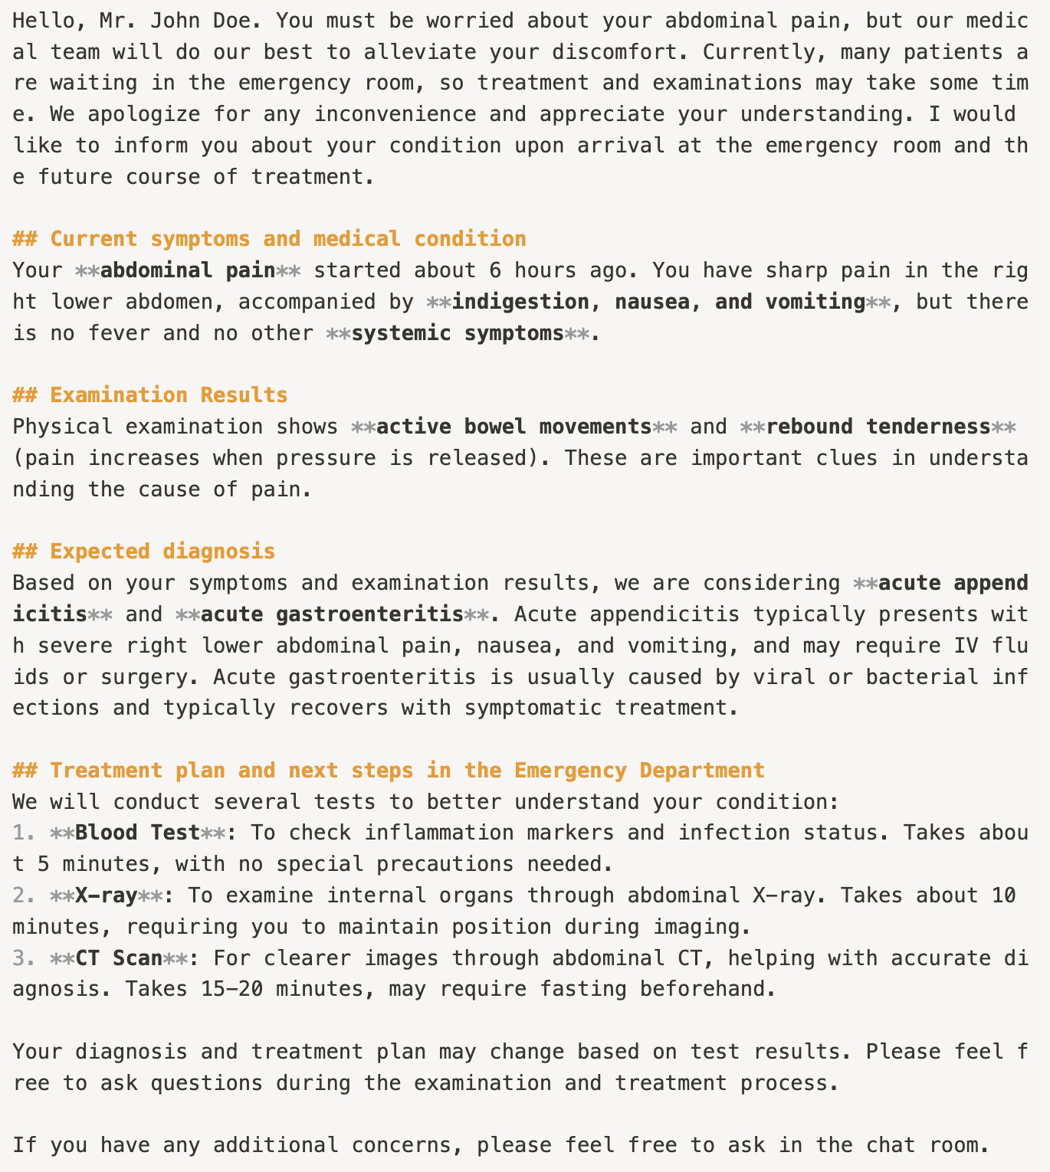

Follow-up PFCN
[Follow-up Clinical Note]  S>  O> Lab: Elevated WBC and CRP. Otherwise unremarkable. X-ray and CT scan: No significant findings.  A> r/o AGE > r/o acute appendicitis  P> IV fluid IV antibiotics | 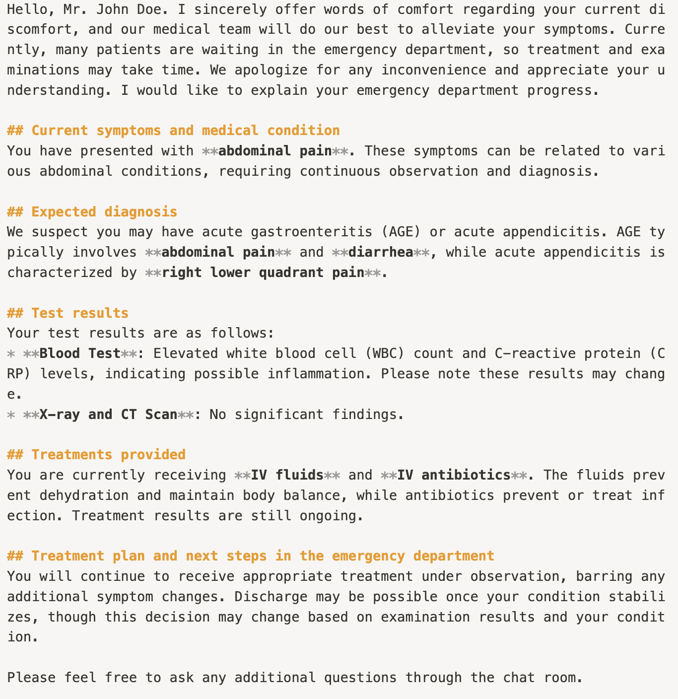

Discharge PFCN
[Discharge Clinical Note]  S> Improving after IV antibiotics and IV fluids for r/o AGE.  P> Discharge with 5-day course of oral antibiotics  Return to ER/clinic if symptoms worsen or new symptoms develop | [Discharge PFCN]  