APPENDICES

Appendix 1: Schematic of cohort study with figures used in the economic evaluation. Numbers in Figure A1 are used in the cohort decision model presented in Figure 1.

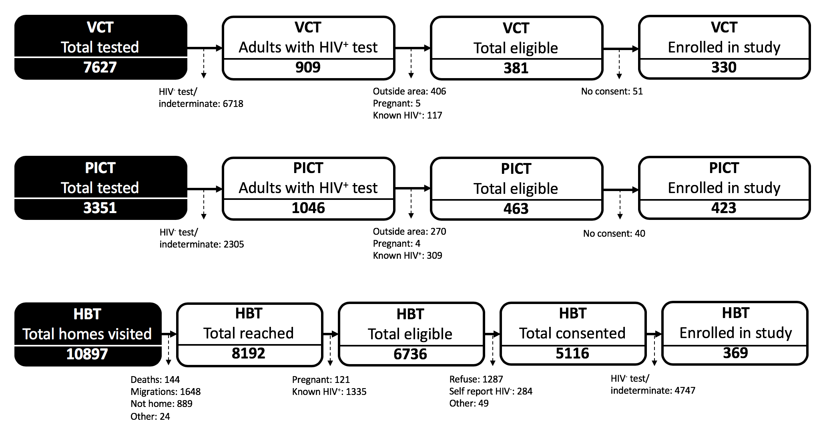
Figure A1: Steps involved in the enrollment of participants into the study across all three HIV counselling and testing strategies.¹⁵ Attrition at each step was quantified.
Abbreviations: VCT, voluntary counselling and testing; PICT, provider-initiated counselling and testing; HBT, home-based testing.

Appendix 2: Copy of the questionnaire administered to study participants to elicit demographic information. Note: Questionnaire was administered in Portuguese.

 |  | Informação do participante
 |  | Daa da visita |__|__| - |__|__|__| - 2014 |  |  | - Sexo Homen Mulher
 |  | Idade em anos |__|__|
 |  | Criterios de Inclusão
Lugar de testagem:  UAT  SAAJ  Triagem  Casa  outro (especificar):|__|__|__|__|__|__|__|__|__|__|__|
Se UATS/SAAJ referencia para testagem: Voluntario Referido (administrar questionário 4 só se voluntário)
Se referido, lugar de referencia consultas PNCT enfermeria consulta prenatal maternidad CCR
Banco sangue  outro (especificar): |__|__|__|__|__|__|__|__|__|__|__|
Tipo de testagem: Individual Familiar
Se familiar, especifique a relação com o participante, o resultado do teste e se for positivo, o num TESFAM
|__|__|__|__|__|__|__|__|__|__|__| Positivo Negativo Indeterminado Num TESFAM |__|__|__|__|
|__|__|__|__|__|__|__|__|__|__|__| Positivo Negativo Indeterminado Num TESFAM |__|__|__|__|
|__|__|__|__|__|__|__|__|__|__|__| Positivo Negativo Indeterminado Num TESFAM |__|__|__|__|
Resultado do teste HIV positivo Negativo Indeterminado
Assinou o consentimento informado? Sim Não
Se não, por qué: |__| (1.Ja conhece status HIV, 2. Recusa, 3. Fora de area de estudo, 4. Recusa do marido ou mulher , 5. Não pode vir as visitas, 6. Outra razão)
Cumpre os criterios de inclusão? Sim Não
(Test positivo, pertencer ao CS Manhiça como centro de referencia TARV, assinar consentimento informado)
Se cumprir criterios, dar numero de estudo é preencher inquerito de identificação e. Se não cumprir, PARAR aqui
Número de estudo TESF (colar etiqueta)

 | Informação do test HIV
 | Sabe o que é o vírus de HIV? |  |  | Sim Não
 | Alguma vez já fez o teste de HIV? |  |  | Sim Não Não sabe responder
 | Se sim, quantas vezes o/a participante já fez o teste de HIV? |  |  | 1 2 Mais de 2
 | Quando foi a última vez que fez o teste? |  |  | < 6 meses Entre 6 meses e 1 ano >1 ano
 | Preferenças para testagem de HIV
 | Onde é que o Sr/Sra. preferiria fazer o teste de HIV? |  |  |  |  | GATV Triagem Casa  Unidade móvil Não tem preferência
 | O Sr/Sra tem intençao de dizer o resultado ao parceiro? |  |  |  |  | Sim Não Não sabe responder  Não tem parceiro.
 | Situaçao laboral
 | Ocupaçao habitual : 1. Campones/pacuaria, 2. Operarios, 3. Comerciantes, 4. Mineiros, 5. Servicios, 6. Vendedor, 7. Domestico, 8. Estudante, 9. Sector de saúde, 10. Outro, |__|__|__|__|__|__|__|__|__|__|__|__|__|__|__|__|__|__|
 | Deixou de fazer a sua ocupaçao no ultimo mes por doença. Sim Não
 | Se sim, quantos dias deixou de fazer? |__|__|
 |  | Identificação a través do DSS (Departamento de demografía)
 |  | Perm_id do participante (copiar do inquerito de identificação) |__|__|__|__|- |__|__|__|-|__|__|
 | Entrevistador: Codigo |__|__|__| Data |__|__|- |__|__|__|-2014 Assinatura _______________
 | Revisor Codigo |__|__|__| Data |__|__|- |__|__|__|-2014
Appendix 3: Copy of the questionnaire administered to study participants to elicit cost-related information for voluntary counselling and testing (VCT) from the patient’s perspective. Note: Questionnaire was administered in Portuguese.
General information
 | Date of the interview (dd / mm / yyyy) | |__|__|- |__|__|__|-|__|__|__|
 | Study number (sticker)
Costs associated with voluntary screening
 | How did you travel here today and how much did it cost? | □ by Walking  □ By bus/”chapa” MZN |__|__|__|__|__|  □ Bicycle MZN |__|__|__|__|__|  □ Your own Car MZN |__|__|__|__|__|  □ Autostop MZN |__|__|__|__|__|  □ Other ______________________ MZN |__|__|__|__|__|
 | How long did it take you to get here from your home? | Hours |__|__| Minutes |__|__| |__|__|
 | How much did you spend today, while here, on? | □ Food MZN |__|__|__|__|__|  □ Drink MZN |__|__|__|__|__|  □ Other _________________________ MZN |__|__|__|__|__|
 | How much time have you spent at this health facility waiting for counseling? | Hours |__|__| Minutes |__|__|
 | How much time did the consultation last? | Hours |__|__| Minutes |__|__|
 | Which activities did you stop due to this consultation? | □ Livestock  □ Agriculture / Harvesting  □ Fishing  □ Making items / Trade  □ Household activities / Children care  □ Building  □ Business  □ Short-term contract, other income-generating activities  □ Other salary-earning job  □ School  □ Other |__|__|__|__|__|__|__|__|
 | Did anyone have to do your activities while you were here today? | □ Yes  □ No  □ Don’t Know
 | Did you have to pay someone else to do your activities? | □ Yes MZN |__|__|__|__|__|  □ No  □ Don’t Know

Appendix 4: Copy of questionnaire used to collect time data, and data on health system resources used for voluntary counselling and testing (VCT), provider-initiated counselling and testing (PICT), or home-based testing (HBT).

 | Study number
Information on HIV test
 | Who is and how many staff are present at this visit? | □ Clinical Officers N |__| Clinical code |__|__|  □ Nurses N |__| Clinical code |__|__|  □ Counsellors N |__| Clinical code |__|__|
 | How long does it take (in minutes) during this visit to carry out the following activities? | □ For home based visits only: how long did it take to reach the participant’s house (start counting from when the team leaves the CISM/health facility/the house of a previous participant)  Start time |__|__|:|__|__| End time |__|__|:|__|__|  □ Explanation of why HIV testing is being recommended, of the voluntary nature of testing and testing procedures, and of the confidentiality of results  Start time |__|__|:|__|__| End time |__|__|:|__|__|  □ Performing the rapid test (include all the steps, also the confirmatory test if needed)  Start time |__|__|:|__|__| End time |__|__|:|__|__|  □ Explanation of the result and of its implications (in case of positive results, include also the explanation of the available treatment and care; in the case of indeterminate result, the explanation of the need to repeat is included)  Start time |__|__|:|__|__| End time |__|__|:|__|__|
 | Which materials and how much/many were used during this visit (please include also materials, such as rapid diagnostic tests, that were thrown away for any reason)? | □ Determine® test N |__|  □ Unigold® test N |__|  □ Lancets N |__|  □ Pairs of gloves N |__|  □ Cotton N |__|  □ Pairs of gloves N |__|  □ Pipette N |__|  □ Other ________________ N |__|
 | Code|__|__|__| signature of interviewer _______________ Date |__|__|- |__|__|__|-|__|__|__|

Appendix 5: Unit costs (US$) of various resource categories employed in the micro-cost estimate approach, along with their low and high estimates as determined from individual sources (Manhiça District, Mozambique)

 | Resource | Unit cost, US$ | Low estimate, US$ | High estimate, US$ | Source
Patient’s perspective | National monthly minimum wage (for agriculture and fisheries)* | 101.35 | 99.04 | 114.56 | (27)
Provider’s perspective | Determine HIV rapid test kit | 1.07 | 0.98 | 1.16 | (29)
Provider’s perspective | Unigold HIV rapid test kit | 3.18 | 2.59 | 4.79 | (29)
Provider’s perspective | Lancets | 0.02 | No data | No data | CISM private communication#
Provider’s perspective | Gloves | 0.01 | No data | No data | (30)
Provider’s perspective | Pipettes | 0.04 | No data | No data | (31)
Provider’s perspective | Nurse monthly wage | 792.00 | No data | No data | CISM private communication#
Provider’s perspective | Nurse assistant monthly wage | 400.00 | No data | No data | CISM private communication#
Provider’s perspective | Counsellor monthly wage | 258.32 | No data | No data | CISM private communication#
Provider’s perspective | Fuel, per litre† | 1.55 | 1.20 | 1.60 | (32)
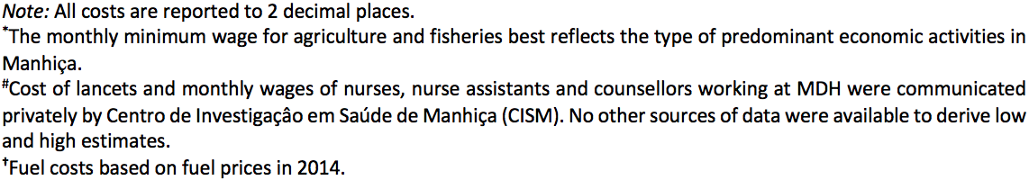

Appendix 6: A cohort decision-analytic model (decision tree) comparing HCT strategies for linking HIV-positive patients to care in Manhiça District, Mozambique.

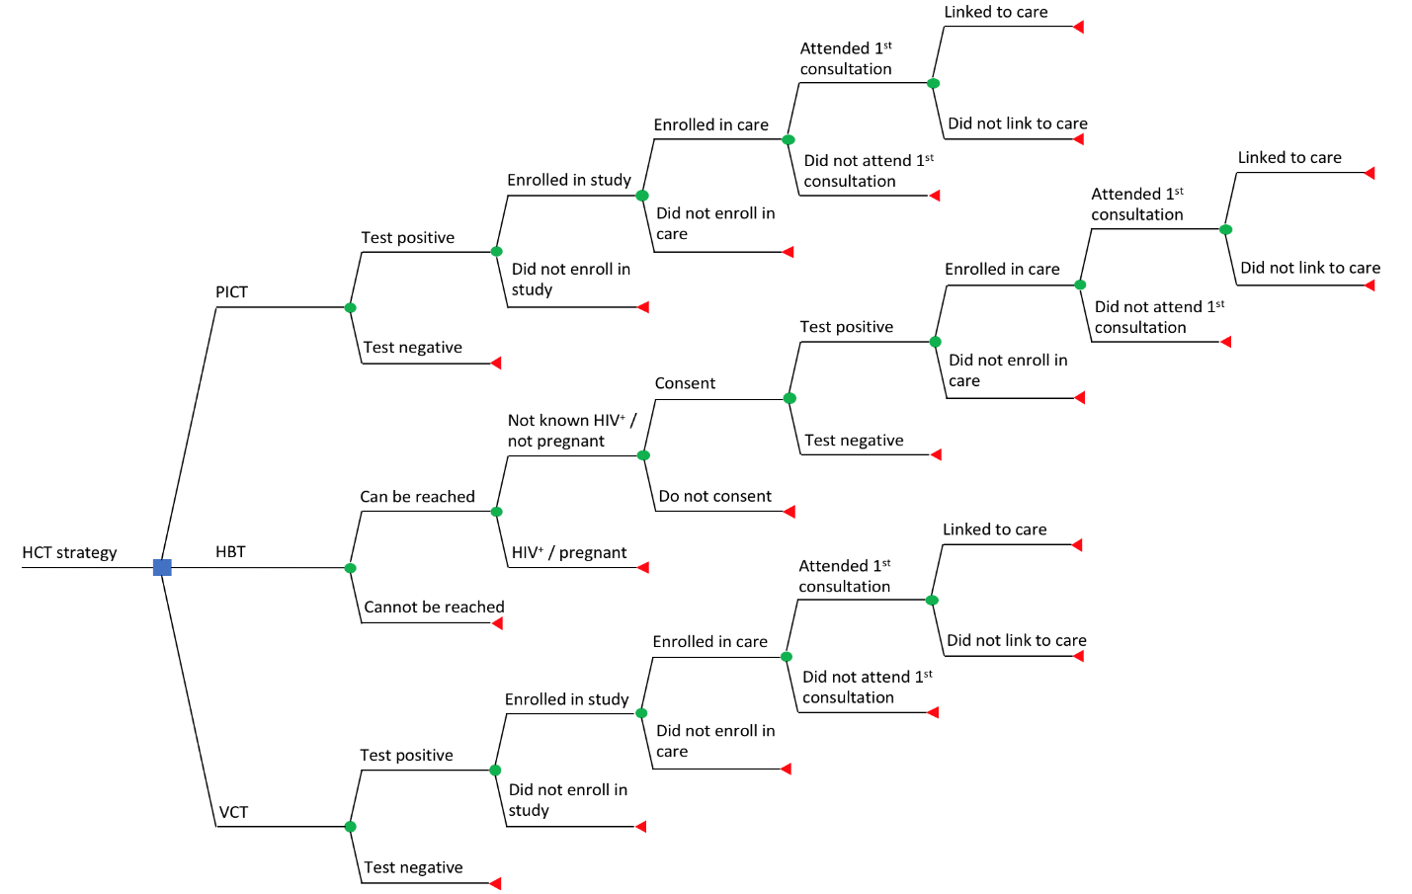

Figure A6. Each branch depicts individual steps of the HIV care cascade as described in the cohort study and is conditional on the previous step. The blue square node represents a decision node, green circular nodes represent chance nodes, and red triangles illustrate terminal nodes.
Abbreviations: HCT, HIV counselling and testing; PICT, provider-initiated counselling and testing; HBT, home-based testing; VCT, voluntary counselling and testing.

Appendix 7: Range of input values explored in the univariate sensitivity analysis for each assumption (input) made in the determination of costs per individual tested

Inputs |  | Input values |  |  | Source of estimates
 |  | Base-case | Low estimate | High estimate | Source of estimates
Patient’s perspective
 | Minimum monthly wage, US$ | 101.35 | 99.04 | 114.56 | From Appendix 5
 | Monthly number of working hours | 176 | 141 (-20%) | 211 (+20%) | Empiric determination#
Provider’s perspective
 | Percentile cut-off for upper limit of variables | 85th | 80th | 90th | Empiric determination#
 | HIV test kit prices, US$ | (Determine = 1.07; Unigold = 3.18) | (Determine = 0.98; Unigold = 2.59) | (Determine = 1.16; Unigold = 4.79) | From Appendix 5
 | Percentage of total costs as capital costs | 3.27 | 3.00 | 14.23* | (12,13,16,23)
 | Percentage of recurrent costs as O & M costs | 1.65 | 0.55 | 28.72* | (12,16,19,23)
 | Nurse monthly wage, US$ | 792.00 | 633.60 (-20%) | 950.40 (+20%) | Empiric determination#
 | Nurse assistant monthly wage, US$ | 400.00 | 320.00 (-20%) | 480.00 (+20%) | Empiric determination#
 | Counsellor monthly wage, US$ | 258.32 | 206.66 (-20%) | 309.98 (+20%) | Empiric determination#
 | 2014 fuel prices, US$ per litre | 1.55 | 1.20 | 1.60 | From Appendix 5
 | Travelling speed, km/hour | 50 | 40 (-20%) | 60 (+20%) | Empiric determination#
 | Fuel consumption, litres/kilometre | 0.143 | 0.114 (-20%) | 0.171 (+20%) | Empiric determination#
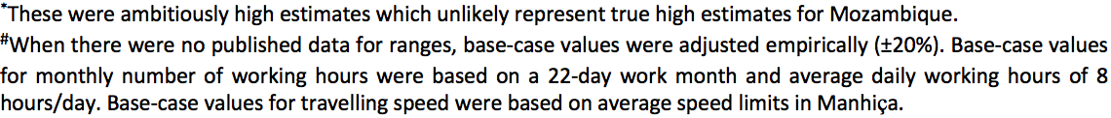
Abbreviations: O & M, operation and management.

Appendix 8: Quantities of resources used in each testing modality.

Quantity by test strategy (cost in the case of transportation, food and drinks, and others)
Mean values and standard deviation are reported
Testing modality |  | VCT | PICT | HBT
Patient’s perspective | Transport (bus, taxi, etc), US$ | 0.19 (0.35) | - | -
Patient’s perspective | Drink + Food, US$ | 0 (0.25) | - | -
Patient’s perspective | Waiting time (hours) | 0.95 (0.94) | - | -
Patient’s perspective | Travelling time (hours) | 0.82 (0.71) | - | -
Patient’s perspective | Any other direct cost , US$ | 0.1 (1.05) | - | -
 | “Determine” HIV rapid test kit (number) | 1 (0) | 1 (0) | 1.03 (0.27)
Provider’s perpective | “Unigold” HIV rapid test kit (number) | 1 (0) | 1 (0) | 1.01 (0.12)
 | Lancets (number) | 1 (0) | 1 (0) | 1.04 (0.21)
 | Gloves (number) | 1 (0) | 1(0) | 1.16 (0.38)
 | Pipettes (number) | 1 (0) | 1 (0) | 1 (0)
 | Personnel time (minutes)* | 46.53 (12.64) | 30.72 (12.60) | 58.45 (15.30)
 | Kilometers to reach the patient | - | - | 13.7 (12.75)
*Personnel time was measured through a time and motion study . Personnel included councellors and/or nurses and clinicians in provider-initiated counselling and testing (PICT). Personnel time includes time to reach patient (home-based testing [HBT] only), explanation, doing the test, waiting for results, and explaining the results and next steps. Abbreviations: VCT, voluntary counselling and testing

Appendix 9: Box and whiskers plot of median explicit and implicit costs of voluntary counselling and testing, in US$, to the patient.

Figure A9. Total cost was driven largely by implicit costs. It can thus be inferred that transport, food and drink costs were insignificant in comparison to opportunity costs of waiting and travelling times. Note: Two anomalous values for explicit cost are not shown: 12.76 and 18.62. Values for implicit costs outside the interquartile range: 3.46, 3.74, 4.03 and 4.65.

Appendix 10: Sensitivity analysis of average and median costs per person tested.
7.79*
7.82*
c
d
b
a
7.14*
7.29*
f
e
Figure A10. Tornado plots of average and median costs per person tested when assumptions were varied between the high and low estimates. A10 a Average costs of VCT, A10 b Median costs of VCT, A10 c Average costs of PICT, A10 d Median costs of PICT, A10 e Average costs of HBT, A10 f Median costs of HBT. Varying nurses’ monthly wage did not affect median cost of VCT and average cost of HBT. *Black vertical lines represent base-case costs.
11.07*
11.81*
Appendix 11: Impact of varying assumptions on base-case average and median costs of VCT from the patient’s perspective among participants who tested HIV-positive.

Parameter |  | Average cost (SD), US$ | Median cost (range), US$
Base-case analysis |  | 1.34 (1.46) | 1.08 (0.00 – 19.58)
Monthly minimum wage*
 | Low estimate = US$99.04 | 1.32 (1.45) | 1.07 (0.00 – 19.56)
 | High estimate = US$114.56 | 1.47 (1.50) | 1.19 (0.00 – 19.70)
Number of working hours per month*
 | Low estimate = 141 hours | 1.59 (1.55) | 1.32 (0.00 – 19.82)
 | High estimate = 211 hours | 1.17 (1.40) | 0.96 (0.00 – 19.42)
Abbreviations: VCT, voluntary counselling and testing; SD, standard deviation.

Appendix 12: Cost-effectiveness plane depicting the four quadrants in which ICERs may reside.

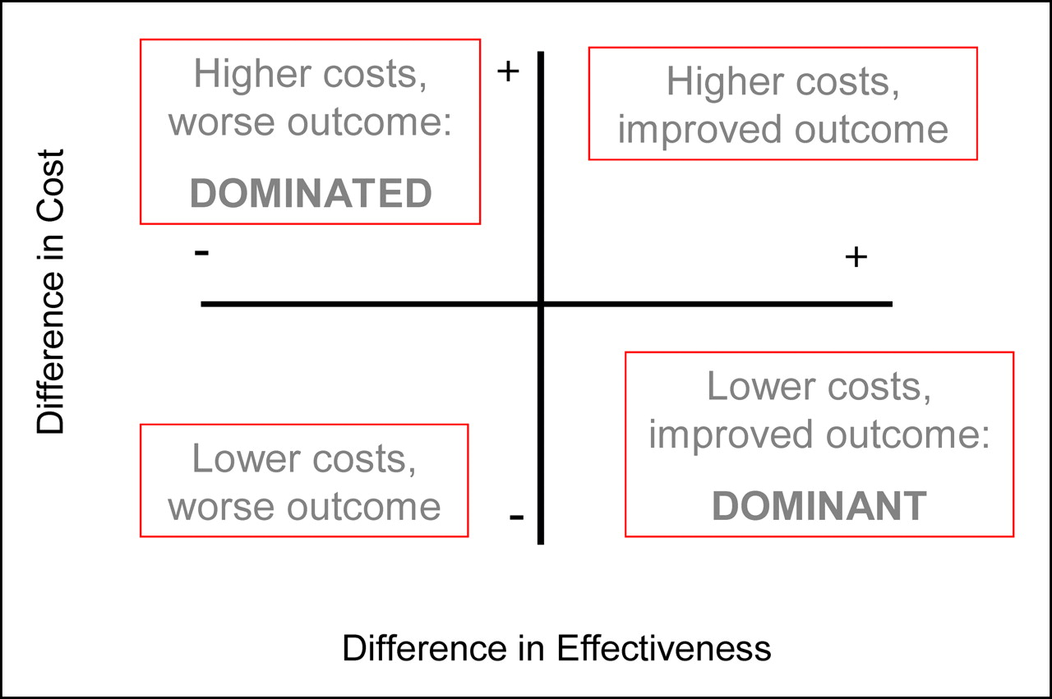
Figure A12. ICERs in quadrants I and III represent scenarios in which the cost-effectiveness of the strategy under comparison is dependent on the cost-effectiveness threshold.
II
I
III
IV

Abbreviations: ICER, incremental cost-effectiveness ratios.

Appendix 13: Tornado plots illustrating fluctuations in linkage-to-care costs between the minimum (low) and maximum (high) values of individual model parameters in the univariate sensitivity analysis.
a
289.67*
+63.78%#
- 49.55%#
b
c
121.46*
+62.86%#
-56.00%#
Figure A13. A13 a Linkage-to-care costs of VCT, A13 b Linkage-to-care costs of PICT, A13 c Linkage-to-care costs of HBT. *Black vertical lines represent base-case results. #Percentage change from base-case costs quantifies the impact of varying cost per test between strategies.
643.37*
+141.61%#
-78.84%#

Abbreviations: VCT, voluntary counselling and testing; PICT, provider-initiated counselling and testing; HBT, home-based testing.

Appendix 14: Impact of varying probabilities and costs used to parameterise the decision tree on linkage-to-care costs of VCT, PICT, and HBT from the provider’s perspective, US$

 |  | VCT |  | PICT |  | HBT
Model parameters |  | Min parameter value* | Max parameter value* | Min parameter value* | Max parameter value* | Min parameter value* | Max parameter value*
Probabilities
 | Positive test result  Enrolled into study  Enrolled into care  Attended first consultation  Linked to care | 322.24 (+11.24%)  344.07 (+18.78%)  298.50 (+3.05%)  312.83 (+8.00%)  335.18 (+15.71%) | 263.38  (-9.08%)  251.99  (-13.01%)  285.88  (-1.31%)  276.09  (-4.69%)  258.26  (-10.84%) | 132.47 (+9.06%)  141.39 (+16.41%)  130.18 (+7.18%)  133.15 (+9.62%)  143.59 (+18.22%) | 111.79  (-7.96%)  107.69  (-11.34%)  116.06  (-4.45%)  112.75  (-7.17%)  107.47  (-11.52%) | 813.86 (+14.40%)  -  835.64 (+20.24%)  736.03 (+26.50%)  773.58 (+29.88%) | 547.15  (-7.53%)  -  535.66  (-15.97%)  594.93  (-14.96%)  540.62  (-16.74%)
Costs
 | VCT  PICT  HBT | 146.14  (-49.55%)  -  - | 474.41 (+63.78%)  -  - | -  53.45  (-56.00%)  - | -  197.81 (+62.86%)  - | -  -  136.11  (-78.84%) | -  -  1554.44 (+141.61%)
Abbreviations: VCT, voluntary counselling and testing; PICT, provider-initiated counselling and testing; HBT, home-based testing.

Appendix 15: Tornado plots illustrating fluctuations in ICERs between the minimum (low) and maximum (high) values of individual model parameters in univariate sensitivity analysis.
a
4.15*
b
Figure A15. A15 a ICERs for the comparison between PICT and VCT, A15 b ICERs for the comparison between HBT and VCT. *Black vertical solid lines represent base-case results. Note: the area shaded red covers all negative ICERs and represents a dominated scenario by VCT for the strategy under comparison. Black dotted lines demarcate the range of ICERs for each comparison that would result from the corresponding ranges of HCT unit costs.
A15 a The shaded area between the lower black dotted line and the origin represents the likelihood that base-case ICER was not robust and a dominated scenario for PICT. A15 b The area enclosed by both dotted lines lie within the shaded region, suggesting base-case findings that HBT was dominated were robust up to this range of unit costs.
-8.57*

Abbreviations: VCT, voluntary counselling and testing; PICT, provider-initiated counselling and testing; HBT, home-based testing; ICER, incremental cost-effectiveness ratios.

4.15*
-8.57*

Appendix 16: Mapping the WTA threshold on the Monte-Carlo plot for the comparison between PICT and VCT.

Figure A16. *ICERs in the south-west quadrant depict when the cost-effectiveness of PICT is dependent on the WTA threshold. #ICERs in the north-west quadrant represent a dominated scenario for PICT. Note: The red ellipse of confidence encircles 95% of the bootstrapped ICERs while black solid lines represent quasi 95% confidence intervals. There is an almost equal chance for ICERs to fall either side of the threshold within the region bounded by the quasi 95% confidence intervals, implying that PICT have equal likelihood of being cost-effective or not relative to VCT.
Comparator dominates#
Cost-effectiveness dependent on WTP threshold*
PICT more cost-effective
VCT more cost-effective

Abbreviations: WTA, willingness-to-accept; VCT, voluntary counselling and testing; PICT, provider-initiated counselling and testing; ICER, incremental cost-effectiveness ratio;

