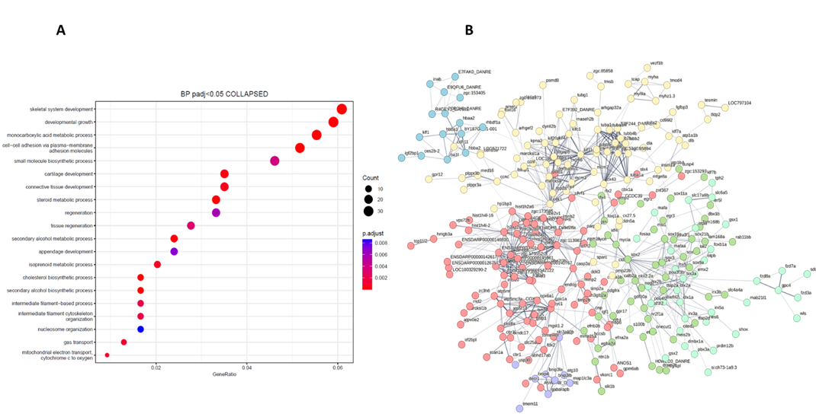
Supplementary Figure 1.(A) RNA-seq analysis sacs^{-/-}-treated vs. WT adult zebrafish; Top20 enriched Biological Processes GO categories were plotted. (B) Protein-protein interaction analysis using the STRING bioinformatic suite (https://string-db.org/). Cell cycle and cytoskeleton organization (highlighted in Yellow), Central nervous system development (highlighted in green), Mitophagy (highlighted in violet), Homeobox (highlighted in light green), Nucleosome and structural constituent of chromatin (highlighted in red) and chromosome condensation (highlighted in blue). Network nodes represent proteins and each node represents all the proteins produced by a single, protein-coding gene locus. The edges represent protein-protein associations, with thickness indicating the strength of data support. PPI enrichment p-value:< 1.0e-16.

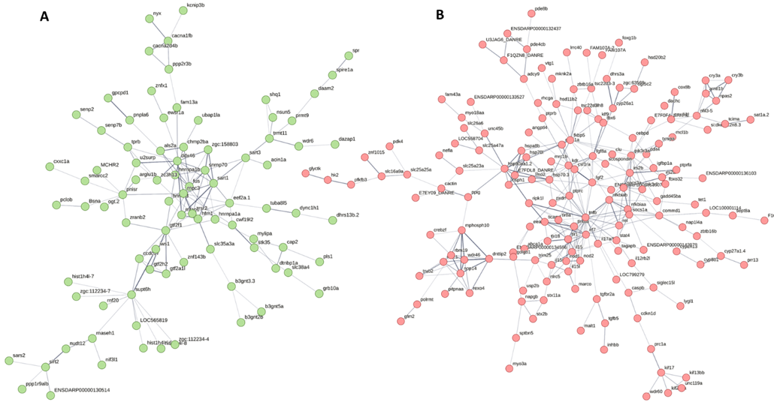
Supplementary Figure 2. Protein-protein interaction analysis using the STRING bioinformatic suite (https://string-db.org/). (A) RNA splicing, RNA processing, mRNA metabolic process (highlighted in green). (B) Regulation of cytokine production, Positive regulation of cytokine production, immune response-regulating signaling pathway (highlighted in red). Network nodes represent proteins and each node represents all the proteins produced by a single, protein-coding gene locus. The edges represent protein-protein associations, with thickness indicating the strength of data support. PPI enrichment p-value:< 1.0e-16.

