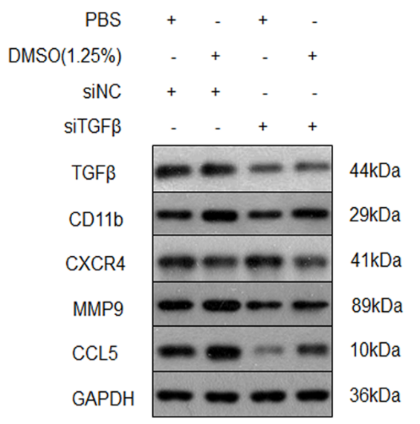

Figure S1. Construction of a tumor-associated N1/N2-neutrophils research model. Detect the key indicators by the WB method to verify N1 and N2 neutrophils：HL60-siNC and HL60-siTGFβ were induced by 1.25% DMSO for 5 days.
WB results suggest that the CD11b expression was increased in both groups. The CXCR4, MMP9, CCL5 were overexpressed in N2-neutrophils groups than N1- neutrophils groups.

