Supplementary Table S2: Preconception health knowledge, attitudes and behavioural intent of survey respondents from five countries stratified by sex.
 |  | Pooled |  | South Africa |  | UK |  | USA |  | Kenya |  | Malaysia
 |  | Men  (n=2590) | Women  (n=2410) | Men  (n=490) | Women  (n=510) | Men  (n=468) | Women  (n=527) | Men  (n=480) | Women  (n=520) | Men  (n=480) | Women  (n=520) | Men  (n=480) | Women  (n=520)
Preconception health knowledge, attitude and behavioural intent
Preconception health knowledge | Poor knowledge score | 1109 (42.8) | 848 (35.2) | 211 (43.1) | 186 (36.5) | 252 (58.9) | 159 (30.2) | 222 (42.3) | 129 (24.8) | 204 (42.5) | 169 (32.5) | 220 (45.8) | 205 (39.4)
Preconception health knowledge | Adequate knowledge score | 1116 (43.1) | 1399 (58.1) | 238 (48.6) | 294 (57.7) | 187 (40.0) | 290 (55.0) | 213 (44.4) | 298 (57.3) | 238 (49.6) | 259 (49.8) | 240 (50.0) | 258 (49.6)
Preconception health knowledge | Good knowledge score | 185 (7.1) | 343 (14.2) | 41 (8.4) | 30 (5.9) | 41 (8.8) | 71 (13.5) | 45 (9.4) | 93 (17.9) | 38 (7.9) | 92 (17.7) | 20 (4.2) | 57 (11.0)
Attitude (% rates as important) | Take folate | 1408 (54.4) | 1753 (72.7) | 297 (60.6) | 399 (78.2) | 226 (48.3) | 302 (57.3) | 238 (49.6) | 293 (56.4) | 353 (73.5) | 421 (81.0) | 294 (61.3) | 338 (65.0)
Attitude (% rates as important) | Avoid alcohol | 2041 (78.8) | 2248 (93.3) | 437 (89.2) | 470 (92.2) | 369 (78.9) | 409 (77.6) | 391 (81.5) | 432 (83.1) | 446 (92.9) | 492 (94.6) | 398 (82.9) | 445 (85.6)
Attitude (% rates as important) | Exercise daily | 2021 (78.0) | 2132 (88.5) | 430 (87.8) | 453 (88.8) | 365 (78.0) | 387 (73.4) | 384 (80.0) | 405 (77.9) | 457 (95.2) | 480 (92.3) | 385 (80.2) | 407 (78.3)
Attitude (% rates as important) | Avoid smoking | 2078 (80.2) | 2365 (98.1) | 445 (90.8) | 482 (94.5) | 383 (81.8) | 457 (86.7) | 389 (81.0) | 455 (87.5) | 455 (94.8) | 505 (97.1) | 406 (84.6) | 466 (89.6)
Attitude (% rates as important) | Maintain good mental health | 2093 (80.8) | 2386 (99.0) | 458 (93.5) | 483 (94.7) | 371 (79.3) | 451 (85.6) | 381 (79.4) | 464 (83.2) | 467 (97.3) | 511 (98.3) | 416 (86.7) | 477 (91.7)
Attitude (% rates as important) | Eat healthily | 2146 (82.9) | 2402 (99.7) | 463 (94.5) | 490 (96.1) | 400 (85.5) | 468 (88.8) | 399 (83.1) | 450 (86.5) | 470 (97.9) | 514 (98.9) | 414 (86.3) | 473 (91.0)
Attitude (% rates as important) | Check blood pressure regularly | 2077 (80.2) | 2346 (97.3) | 454 (92.7) | 487 (95.5) | 378 (80.8) | 430 (81.6) | 373 (77.7) | 439 (84.4) | 459 (95.6) | 514 (98.9) | 413 (86.0) | 476 (91.5)
Behaviour (% rates as likely) | Access preconception care if available and planning a pregnancy | 2048 (79.1) | 2218 (92.0) | 420 (85.7) | 436 (85.5) | 376 (80.3) | 421 (79.9) | 397 (82.7) | 405 (77.9) | 435 (90.6) | 487 (93.7) | 420 (87.5) | 469 (90.2)
Abbreviations: n – number of participants; UK – United Kingdom; USA – United States of America.

Supplementary Table S3. Relative importance of factors before pregnancy.
 | Overall | Kenya |  | Malaysia |  | South Africa |  | UK |  | USA
 | Overall | Women | Men | Women | Men | Women | Men | Women | Men | Women | Men
Seven groups of factors | n = 5000 | n = 520 | n = 480 | n = 520 | n = 480 | n = 510 | n = 490 | n = 527 | n = 468 | n = 520 | n = 480
Relationships and family | 25026 | 2396 | 2369 | 2444 | 2457 | 2503 | 2523 | 2887 | 2451 | 2568 | 2411
Physical health | 27653 | 3066 | 2701 | 2998 | 2653 | 2787 | 2610 | 2850 | 2544 | 2807 | 2595
Money | 21259 | 2021 | 1906 | 2416 | 2042 | 2165 | 2093 | 2201 | 2039 | 2200 | 2154
Mental health | 24460 | 2805 | 2429 | 2590 | 2290 | 2448 | 2232 | 2486 | 2222 | 2626 | 2309
Climate change | 8588 | 930 | 810 | 815 | 1074 | 762 | 754 | 811 | 919 | 776 | 931
Work and education | 14140 | 1319 | 1398 | 1372 | 1397 | 1641 | 1606 | 2113 | 1237 | 1460 | 1353
Living conditions | 18874 | 2023 | 1827 | 1925 | 1527 | 1974 | 1902 | 2178 | 1692 | 2123 | 1676
Values are borda count, with higher scores indicating higher priority (score range: 1 to 7).

Supplementary Table S4. Relative importance of sources of health education/information in the preconception period.
 | Overall | Kenya |  | Malaysia |  | South Africa |  | UK |  | USA
 | Overall | Women | Men | Women | Men | Women | Men | Women | Men | Women | Men
Seven groups of factors | n = 5000 | n = 520 | n = 480 | n = 520 | n = 480 | n = 510 | n = 490 | n = 527 | n = 468 | n = 520 | n = 480
Nurse | 25412 | 2596 | 2471 | 2398 | 2355 | 2597 | 2582 | 2831 | 2482 | 1564 | 2425
Family + friends | 19413 | 1611 | 1638 | 2075 | 2091 | 1877 | 1935 | 2031 | 1896 | 2145 | 2075
Pharmacist | 19456 | 1930 | 1896 | 2034 | 2067 | 1954 | 2034 | 1914 | 1967 | 1790 | 1825
Internet / social media | 13516 | 1255 | 1238 | 1582 | 1564 | 1136 | 1215 | 1346 | 1377 | 1319 | 1460
Clinic doctor | 28395 | 3123 | 2871 | 3059 | 2541 | 2925 | 2867 | 2885 | 2576 | 2889 | 2582
Magazines/newspaper | 9389 | 921 | 878 | 990 | 1005 | 884 | 827 | 973 | 939 | 906 | 1047
Obstetrician/gynaecologist | 24419 | 3124 | 2448 | 2422 | 1817 | 2907 | 2260 | 2580 | 1867 | 2897 | 2026
Values are borda count, with higher scores indicating higher priority (score range: 1 to 7).

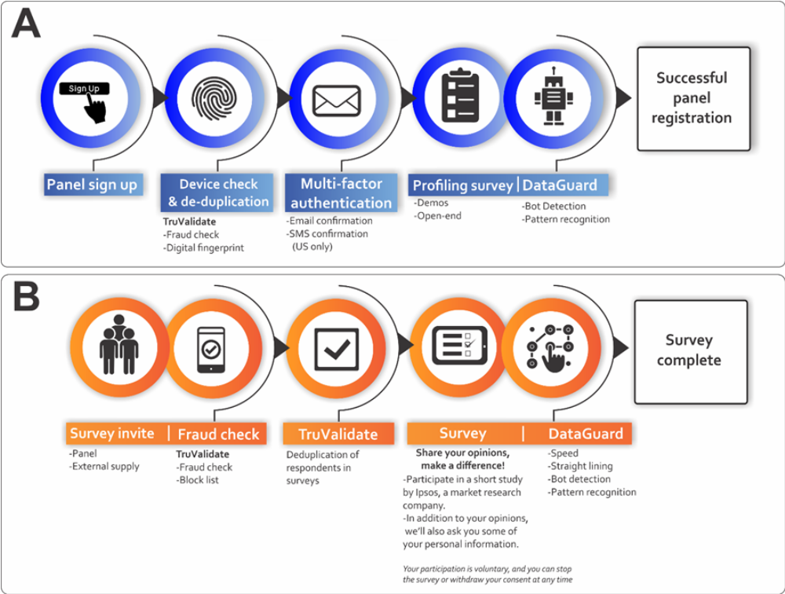Supplementary Figure S1. Ipsos i-Say respondent registration process and survey completion A) panel registration and B) in-survey completion. The survey questionnaire was distributed electronically through Ipsos proprietary i-Say panel as outlined (Supplementary Figure S1), namely in the form of 2 processes A) panel registration and B) in-survey completion. The Ipsos protocol has been published elsewhere [22-24]. In brief, prospective Ipsos panellists interested in partaking in the survey were recruited via a multi-source recruitment process referred by various partner panels known to meet the quality of Ipsos and Global Research Standards. Ipsos additionally partners with TransUnion – an American consumer credit reporting agency – for the use of digital fingerprinting technology known as TruValidate. TruValidate passively collects respondent information associated with the device entering the panel registration and survey link. A unique identifier was issued to the respondents’ device based on its distinctive characteristics. The device was then reviewed against a set of business rules and regulations created by Ipsos to score the likelihood of fraud (fraud check). The device identification is checked to prevent the creation of multiple panel accounts and to ensure that multiple entries into the same survey are ultimately avoided (deduplication). The TruValidate process is deployed at the panel registration and then again in-survey. It is still, however, possible for fraudulent respondents to create multiple digital fingerprints by using different device and account combinations to bypass systems. Digital fingerprinting is one element within a multi-layered suite of tools and systems to mitigate this limitation. Others include the use of Multi-Factor authentication during recruitment (respondent email account and/or cellphone number confirmation), the checking of respondents’ contact details against existing i-Say accounts and checking blocked accounts. Lastly, Ipsos incorporates a newly rebuilt and rebranded tool known as Dataguard, which is a cyber robot designed to detect open ends (copied and pasted text, programmatic text insertion, look-up versus known bad, or suspect responses; exaggerated, and/or unrealistic typing speed; exaggerated, or unrealistic reaction time after question loads), data pattern recognition (algorithms to review new panellists and flag those that match the profile of known fraudsters); speeding (measures the pace of survey completion in answers per minute) and straight lining (identifies respondents who gave the same answer to all statements in a grid question). In the event a respondent is caught by Dataguard, respondents are automatically removed from the survey in real-time.
Men
Women
Supplementary Figure S2. Radar chart showing the relative importance of seven factors before pregnancy across the 5 distinct countries between the sexes (n=5000). Higher scores positioned at the outer edge represent lower importance despite their higher values.
Men
Women
Supplementary Figure S3. Radar chart showing the relative importance of health education/information before pregnancy across the 5 distinct countries between the sexes (n=5000). Higher scores positioned at the outer edge represent lower importance despite their higher values.

