Novel Aryl Substituted sulfonyl piperazine derivatives:
Tandem one-pot multi component synthesis via palladium catalyzed Suzuki-Miyaura cross coupling, structure studies and evaluation of anticancer activity

Jeevan Chakravarthy A S,^{a*} Shriraksha A,^{b} Sreenatha N R,^{c} Sharadamma N,^{d} Nagesh Babu R^{e}

ªDepartment of Chemistry, BMS Institute of Technology & Management, Autonomous under Visvesvaraya Technological University, Bengaluru, Karnataka 560064, India.
^{b} Department of Biochemistry, Bengaluru City University, Bengaluru 560001.
^{c}Department of Physics, Government Engineering College, Chamarajanagara 571313, Karnataka, India.
^{d}Department of Biochemistry, School of Allied Health Sciences, REVA University, Bengaluru 560064, Karnataka, India.
^{e}Department of Biochemistry, Maharani Cluster University, Bengaluru 560001, Karnataka, India.

*Correspondence email: jeechakravarthy@gmail.com.

Experimental Section

General Information:

All the reagents were purchased from commercial suppliers and used without further purification. Solvents were dried according to the standard procedures. All the reactions were monitored by thin layer chromatography (TLC) using standard TLC silica plates and visualized with UV light. Column chromatography was performed using Merck silica gel (100−200 mesh). Nuclear magnetic resonance spectra were recorded on Brucker (400 MHz) ultrashield plus and Jeol (600 MHz) ECZ 600R FT-NMR spectrometer with CDCl3 as solvent. Chemical shifts are reported in δ (ppm) using residual solvent protons as the internal standard (δ 7.26 for CDCl3 in ¹H NMR and δ 77.16 for CDCl₃ in ¹³C NMR spectra). Coupling constants are reported as J values in Hertz (Hz). Splitting patterns are designated as s (singlet), d (doublet), t (triplet), q (quartet), dd (doublet of doublet), dt (doublet of triplet), td (triplet of doublet), m (multiplet), and br (broad). Infrared spectra of neat samples were recorded in ATR (attenuated total reflectance) mode using a FT-IR instrument (Agilent technologies), and HRMS spectra on a 6538 UYHD accurate mass Q-TOF LC/MS spectrometer through electro spray ionization (ESI) mode. Melting points were recorded using an electrothermal capillary melting point apparatus and remains uncorrected. Single crystal X-ray diffraction data were recorded using Bruker AXS GmbH spectrometer.

Spectral data of the novel compounds 5a and 5b.

1-[(1,1'-biphenyl)-4-ylsulfonyl]-4-[(4-chlorophenyl)(phenyl)methyl]piperazine (5a):
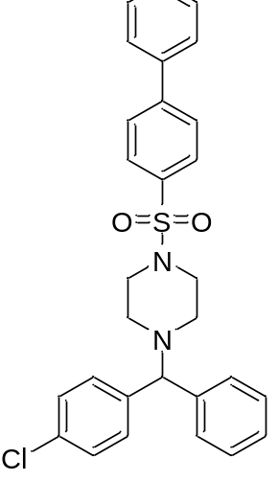
Off White solid; yield 95%; 132-136 °C; R_{f} 0.4 (7:3 EtOAc/hexane); IR (neat, cm^{–1}) 3445, 3327, 1750, 1676, 1297, 1170, 798; 1H NMR (400 MHz, CDCl3) δ 2.47 (s, 4H), 3.07 (s, 4H), 1.03 (s, 1H), 7.17-7.30 (m, 10H), 7.43 – 7.45 (m, 1H), 7.48 - 7.52 (m, 2H), 7.63-7.65 (m, 2H), 7.75 – 7.82 (m, 4H); 13C{1H} NMR (100 MHz, CDCl3) δ 145.5, 141.4, 140.7, 139.2, 134.1, 132.9, 129.1, 129, 128.8, 128.6, 128.4, 127.7, 127.5, 127.3, 50.9, 46.3; HRMS (ESI) m/z: [M]+calcd., for C₂₉H₂₇ClN₂O₂S is 503.0549; found 503.1548. Elemental analysis calcd., C – 69.24%, H – 5.41%, N – 5.57%, S – 6.37%; found C – 69.21%, H – 5.49%, N – 5.61%, S – 6.41%.

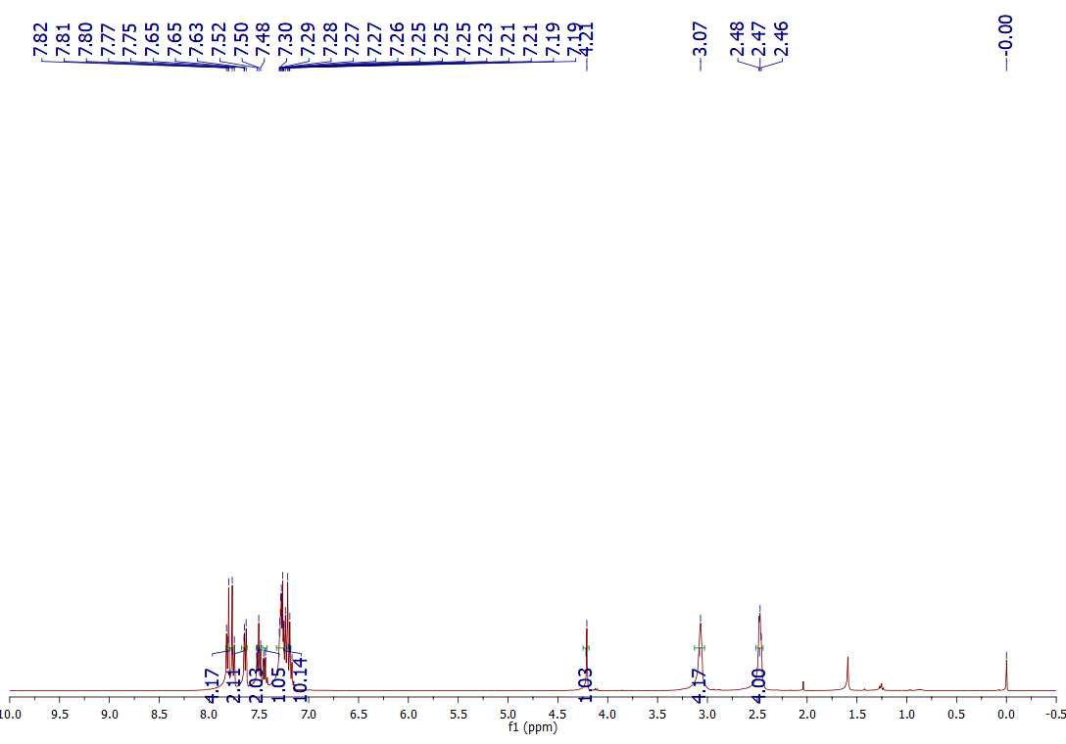
¹H NMR of 5a
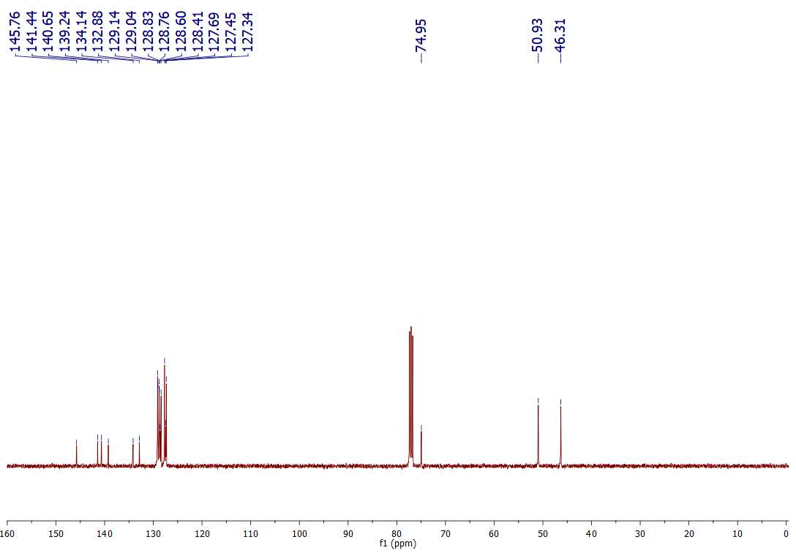
¹³C NMR of 5a

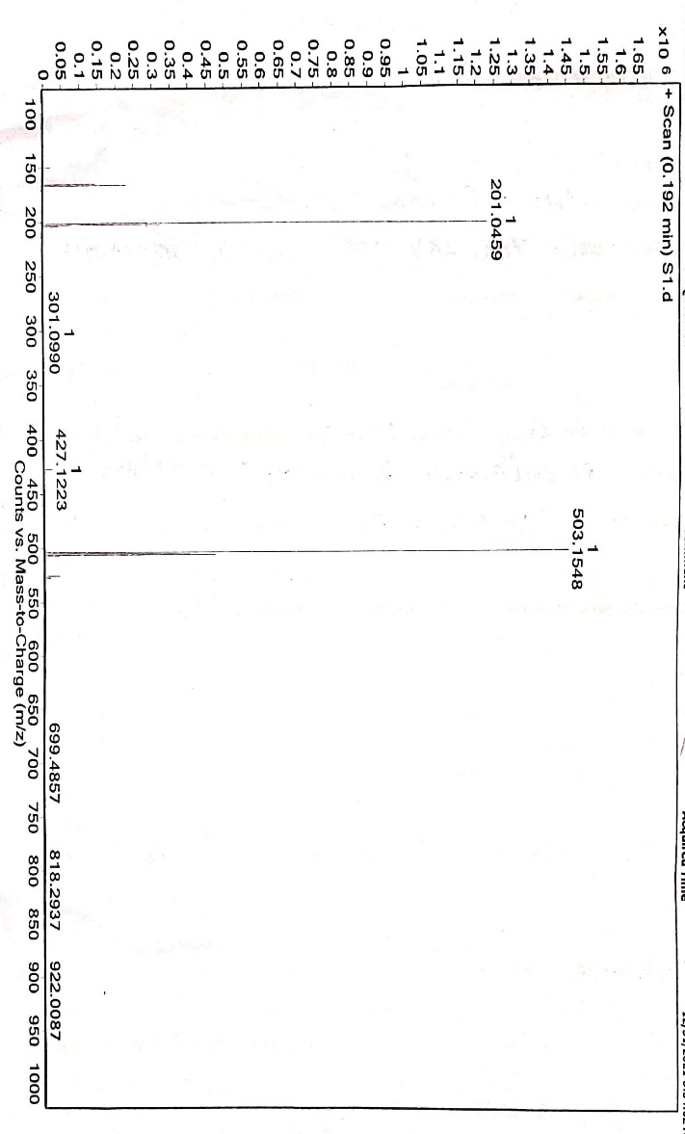
HRMS of 5a

1-[(4-chlorophenyl)(phenyl)methyl]-4-[(2'-ethoxy-(1,1'-biphenyl)-4-yl)sulfonyl]piperazine (5b):
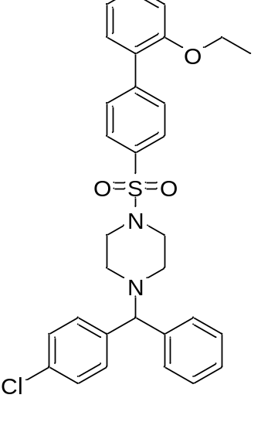Off White solid; yield 97%; 141-144 °C; R_{f} 0.35 (7:3 EtOAc/hexane); IR (neat, cm^{–1}) 3332, 3127, 1785, 1623, 1457, 1211, 982; 1H NMR (400 MHz, CDCl3) δ 1.39 (t, J = 8Hz, 3H), 2.48 (t, J = 4Hz, 4H), 3.08 (s, 4H), 4.1 (q, J = 8Hz, 2H), 4.21 (s, 1H), 7.01 - 7.09 (m, 2H), 7.2 - 7.3 (m, 9H), 7.35 – 7.39 (m, 2H), 7.76 (s, 4H); 13C{1H} NMR (100 MHz, CDCl3) δ 155.9, 143.5, 141.5, 140.7, 133.5, 132.9, 130.8, 130.1, 129.8, 129, 128.7, 127.7, 127.5, 121, 112.7, 64.1, 50, 46.3, 14.8.; HRMS (ESI) m/z: [M]+calcd., for C₃₁H₃₁ClN₂O₃S is 547.1074; found 547.1819. Elemental analysis calcd., C – 68.05%, H – 5.71%, N – 5.12%, S – 5.86%; found C – 68.12%, H – 5.74%, N – 5.17%, S – 5.91%.

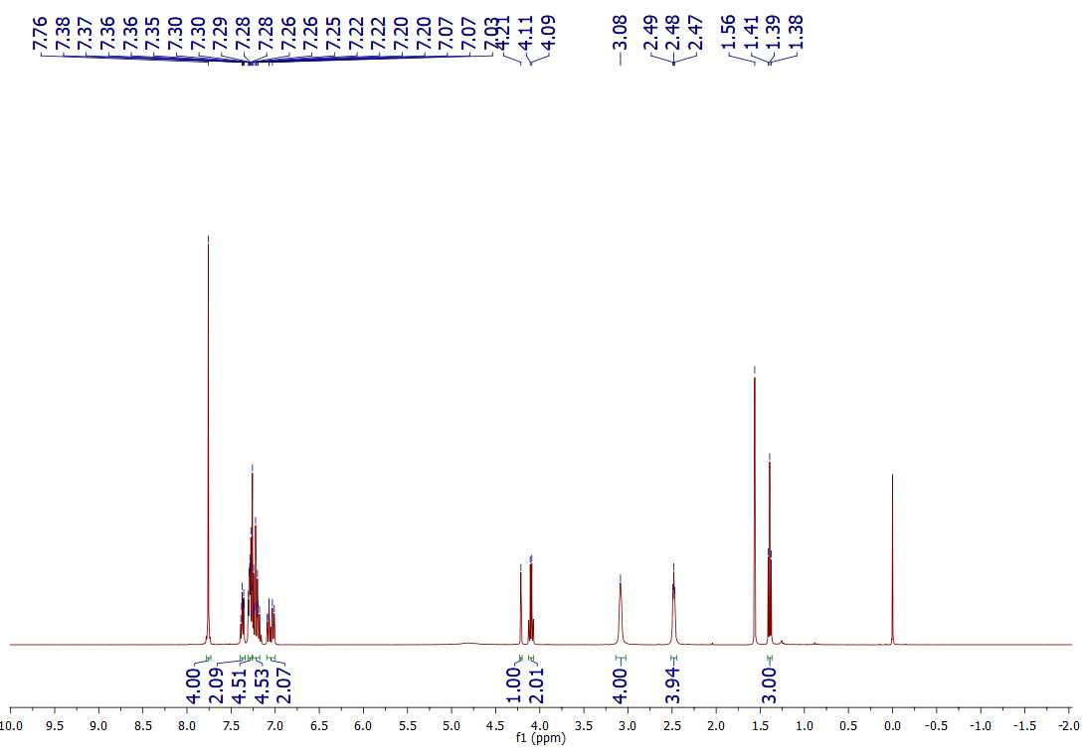
¹H NMR of 5b

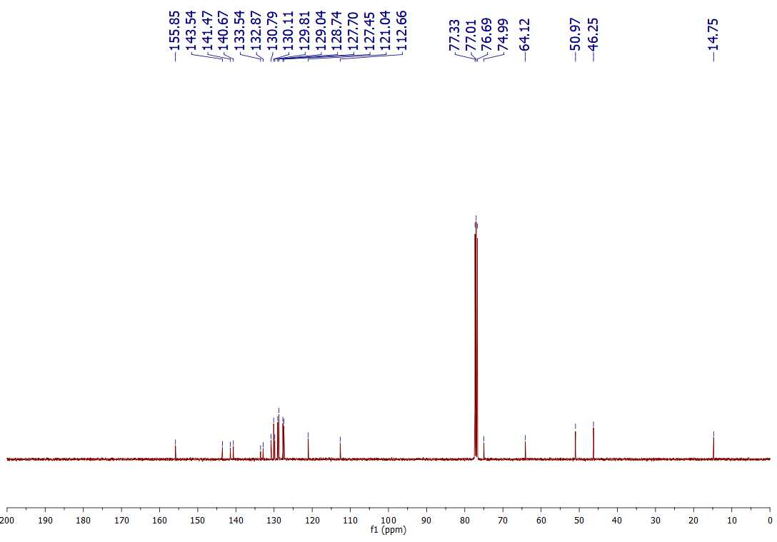
¹³C NMR of 5b

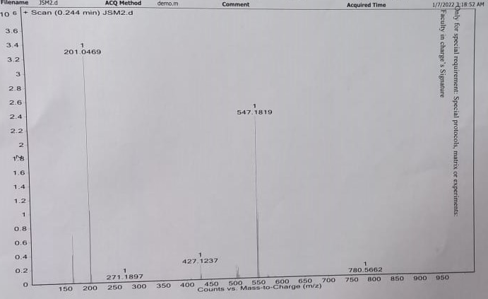

HRMS of 5b

Table S1 Bond lengths of (3) (Angstrom Unit)
Atoms | Bond length | Atoms | Bond length | Atoms | Bond length
C21B-C22B | 1.356 (7) | C14A-C13A | 1.358 (7) | C1B-C2B | 1.496 (7)
C21B-C20B | 1.363 (7) | C14A-H14A | 0.9300 | C1B-H1B1 | 0.9700
C21B-Cl1B | 1.734 (5) | C13A-C12A | 1.389 (7) | C1B-H1B2 | 0.9700
C20B-C19B | 1.376 (7) | C13A-H13A | 0.9300 | C2B-N2B | 1.469 (6)
C20B-H20B | 0.9300 | C12A-C17A | 1.388 (7) | C2B-H2B1 | 0.9700
C19B-C18B | 1.370 (6) | C12A-C11A | 1.520 (7) | C2B-H2B2 | 0.9700
C19B-H19B | 0.9300 | C11A-N1A | 1.473 (6) | C15A-C16A | 1.315 (10)
C18B-C23B | 1.380 (6) | C11A-C18A | 1.525 (7) | C15A-C14A | 1.361 (9)
C18B-C11B | 1.509 (6) | C1A-N1A | 1.449 (6) | C15A-H15A | 0.9300
C11B-N1B | 1.475 (6) | C1A-C2A | 1.491 (7) | C16A-C17A | 1.396 (9)
C11B-C12B | 1.513 (6) | C1A-H1A1 | 0.9700 | C16A-H16A | 0.9300
C4B-N1B | 1.463 (6) | C1A-H1A2 | 0.9700 | C17A-H17A | 0.9300
C4B-C3B | 1.506 (7) | C2A-N2A | 1.457 (6) | N2B-S1B | 1.624 (4)
C4B-H4B1 | 0.9700 | C2A-H2A1 | 0.9700 | N2A-S1A | 1.626 (4)
C4B-H4B2 | 0.9700 | C2A-H2A2 | 0.9700 | O1B-S1B | 1.425 (4)
C3B-N2B | 1.478 (5) | C5A-C10A | 1.384 (6) | O2B-S1B | 1.425 (4)
C3B-H3B1 | 0.9700 | C5A-C6A | 1.392 (6) | O2A-S1A | 1.425 (3)
C3B-H3B2 | 0.9700 | C5A-S1A | 1.758 (5) | O1A-S1A | 1.429 (3)
C5B-C6B | 1.374 (7) | C10A-C9A | 1.367 (7) | C14B-C15B | 1.372 (10)
C5B-C10B | 1.376 (7) | C10A-H10A | 0.9300 | C14B-H14B | 0.9300
C5B-S1B | 1.767 (5) | C9A-C8A | 1.382 (7) | C15B-C16B | 1.363 (10)
C10B-C9B | 1.376 (7) | C9A-H9A | 0.9300 | C15B-H15B | 0.9300
C10B-H10B | 0.9300 | C8A-C7A | 1.371 (7) | C16B-C17B | 1.367 (9)
C9B-C8B | 1.353 (8) | C8A-Br1A | 1.873 (5) | C16B-H16B | 0.9300
C9B-H9B | 0.9300 | C6A-C7A | 1.373 (7) | C17B-H17B | 0.9300
C8B-C7B | 1.375 (8) | C6A-H6A | 0.9300 | C1B-N1B | 1.468 (5)
C8B-Br1B | 1.871 (6) | C7A-H7A | 0.9300 | C19A-H19A | 0.9300
C6B-C7B | 1.369 (9) | C4A-N1A | 1.466 (5) | C20A-C21A | 1.379 (8)
C6B-H6B | 0.9300 | C4A-C3A | 1.489 (6) | C20A-H20A | 0.9300
C7B-H7B | 0.9300 | C4A-H4A1 | 0.9700 | C21A-C22A | 1.356 (9)
C22B-C23B | 1.374 (7) | C4A-H4A2 | 0.9700 | C21A-Cl1A | 1.733 (5)
C22B-H22B | 0.9300 | C3A-N2A | 1.464 (5) | C22A-C23A | 1.364 (8)
C23B-H23B | 0.9300 | C3A-H3A1 | 0.9700 | C22A-H22A | 0.9300
C12B-C13B | 1.379 (6) | C3A-H3A2 | 0.9700 | C23A-H23A | 0.9300
C12B-C17B | 1.394 (6) | C18A-C23A | 1.366 (7) | C19A-C20A | 1.380 (7)
C13B-C14B | 1.360 (7) | C18A-C19A | 1.383 (7) | C13B-H13B | 0.9300

Table S2: Bond angles of 3 (º)
Atoms | Angle | Atoms | Angle | Atoms | Angle
C22B-C21B-C20B | 121.5 (5) | N1A-C11A-C12A | 111.3 (4) | C1A-N1A-C11A | 111.5 (3)
C22B-C21B-Cl1B | 119.5 (4) | N1A-C11A-C18A | 111.1 (4) | C4A-N1A-C11A | 110.1 (3)
C20B-C21B-Cl1B | 119.0 (4) | C12A-C11A-C18A | 108.6 (4) | C2A-N2A-C3A | 111.8 (4)
C21B-C20B-C19B | 118.6 (5) | N1A-C1A-C2A | 111.4 (4) | C2A-N2A-S1A | 118.8 (3)
C21B-C20B-H20B | 120.7 | N1A-C1A-H1A1 | 109.3 | C3A-N2A-S1A | 117.6 (3)
C19B-C20B-H20B | 120.7 | C2A-C1A-H1A1 | 109.3 | O1B-S1B-O2B | 120.2 (3)
C18B-C19B-C20B | 121.9 (5) | N1A-C1A-H1A2 | 109.3 | O1B-S1B-N2B | 106.7 (2)
C18B-C19B-H19B | 119.0 | C2A-C1A-H1A2 | 109.3 | O2B-S1B-N2B | 106.9 (2)
C20B-C19B-H19B | 119.0 | H1A1-C1A-H1A2 | 108.0 | O1B-S1B-C5B | 108.4 (3)
C19B-C18B-C23B | 117.4 (4) | N2A-C2A-C1A | 109.3 (4) | O2B-S1B-C5B | 107.5 (2)
C19B-C18B-C11B | 123.8 (4) | N2A-C2A-H2A1 | 109.8 | N2B-S1B-C5B | 106.3 (2)
C23B-C18B-C11B | 118.8 (4) | C1A-C2A-H2A1 | 109.8 | O2A-S1A-O1A | 120.4 (2)
N1B-C11B-C18B | 111.8 (3) | N2A-C2A-H2A2 | 109.8 | O2A-S1A-N2A | 106.4 (2)
N1B-C11B-C12B | 110.2 (3) | C1A-C2A-H2A2 | 109.8 | O1A-S1A-N2A | 106.4 (2)
C18B-C11B-C12B | 109.8 (4) | H2A1-C2A-H2A2 | 108.3 | O2A-S1A-C5A | 108.3 (2)
N1B-C4B-C3B | 110.7 (4) | C10A-C5A-C6A | 119.9 (5) | O1A-S1A-C5A | 107.7 (2)
N1B-C4B-H4B1 | 109.5 | C10A-C5A-S1A | 120.3 (3) | N2A-S1A-C5A | 107.0 (2)
C3B-C4B-H4B1 | 109.5 | C6A-C5A-S1A | 119.8 (4) | N2B-C2B-H2B1 | 109.6
N1B-C4B-H4B2 | 109.5 | C9A-C10A-C5A | 120.0 (4) | C1B-C2B-H2B1 | 109.6
C3B-C4B-H4B2 | 109.5 | C9A-C10A-H10A | 120.0 | N2B-C2B-H2B2 | 109.6
H4B1-C4B-H4B2 | 108.1 | C5A-C10A-H10A | 120.0 | C1B-C2B-H2B2 | 109.6
N2B-C3B-C4B | 109.8 (4) | C10A-C9A-C8A | 120.0 (5) | H2B1-C2B-H2B2 | 108.1
N2B-C3B-H3B1 | 109.7 | C10A-C9A-H9A | 120.0 | C16A-C15A-C14A | 121.5 (6)
C4B-C3B-H3B1 | 109.7 | C8A-C9A-H9A | 120.0 | C16A-C15A-H15A | 119.3
N2B-C3B-H3B2 | 109.7 | C7A-C8A-C9A | 120.3 (5) | C14A-C15A-H15A | 119.3
C4B-C3B-H3B2 | 109.7 | C7A-C8A-Br1A | 120.9 (4) | C13A-C14A-C15A | 120.4 (6)
H3B1-C3B-H3B2 | 108.2 | C9A-C8A-Br1A | 118.8 (4) | C13A-C14A-H14A | 119.8
C6B-C5B-C10B | 120.3 (5) | C7A-C6A-C5A | 119.5 (5) | C15A-C14A-H14A | 119.8
C6B-C5B-S1B | 120.9 (4) | C7A-C6A-H6A | 120.3 | C14A-C13A-C12A | 120.4 (5)
C10B-C5B-S1B | 118.8 (4) | C5A-C6A-H6A | 120.3 | C14A-C13A-H13A | 119.8
C9B-C10B-C5B | 119.9 (5) | C8A-C7A-C6A | 120.3 (5) | C12A-C13A-H13A | 119.8
C9B-C10B-H10B | 120.0 | C8A-C7A-H7A | 119.8 | C17A-C12A-C13A | 117.6 (5)
C5B-C10B-H10B | 120.0 | C6A-C7A-H7A | 119.8 | C17A-C12A-C11A | 119.2 (5)
C8B-C9B-C10B | 119.7 (5) | N1A-C4A-C3A | 111.2 (4) | C13A-C12A-C11A | 123.1 (4)
C8B-C9B-H9B | 120.1 | N1A-C4A-H4A1 | 109.4 | C15B-C16B-C17B | 120.7 (6)
C10B-C9B-H9B | 120.1 | C3A-C4A-H4A1 | 109.4 | C15B-C16B-H16B | 119.6
C9B-C8B-C7B | 120.5 (5) | N1A-C4A-H4A2 | 109.4 | C17B-C16B-H16B | 119.6
C9B-C8B-Br1B | 119.2 (5) | C3A-C4A-H4A2 | 109.4 | C16B-C17B-C12B | 120.6 (6)
C7B-C8B-Br1B | 120.2 (4) | H4A1-C4A-H4A2 | 108.0 | C16B-C17B-H17B | 119.7
C7B-C6B-C5B | 119.1 (5) | N2A-C3A-C4A | 109.8 (4) | C12B-C17B-H17B | 119.7
C7B-C6B-H6B | 120.5 | N2A-C3A-H3A1 | 109.7 | N1B-C1B-C2B | 110.6 (4)
C5B-C6B-H6B | 120.5 | C4A-C3A-H3A1 | 109.7 | N1B-C1B-H1B1 | 109.5
C6B-C7B-C8B | 120.4 (5) | N2A-C3A-H3A2 | 109.7 | C2B-C1B-H1B1 | 109.5
C6B-C7B-H7B | 119.8 | C4A-C3A-H3A2 | 109.7 | N1B-C1B-H1B2 | 109.5
C8B-C7B-H7B | 119.8 | H3A1-C3A-H3A2 | 108.2 | C2B-C1B-H1B2 | 109.5

Atoms | Angle | Atoms | Angle | Atoms | Angle
C21B-C22B-C23B | 118.9 (4) | C23A-C18A-C19A | 118.3 (5) | H1B1-C1B-H1B2 | 108.1
C21B-C22B-H22B | 120.6 | C23A-C18A-C11A | 119.3 (5) | N2B-C2B-C1B | 110.3 (4)
C23B-C22B-H22B | 120.6 | C19A-C18A-C11A | 122.2 (4) | C15A-C16A-C17A | 119.9 (6)
C22B-C23B-C18B | 121.6 (4) | C20A-C19A-C18A | 120.7 (5) | C15A-C16A-H16A | 120.1
C22B-C23B-H23B | 119.2 | C20A-C19A-H19A | 119.6 | C17A-C16A-H16A | 120.1
C18B-C23B-H23B | 119.2 | C18A-C19A-H19A | 119.6 | C12A-C17A-C16A | 120.2 (6)
C13B-C12B-C17B | 117.4 (5) | C21A-C20A-C19A | 118.8 (5) | C12A-C17A-H17A | 119.9
C13B-C12B-C11B | 122.6 (4) | C21A-C20A-H20A | 120.6 | C16A-C17A-H17A | 119.9
C17B-C12B-C11B | 120.0 (4) | C19A-C20A-H20A | 120.6 | C4B-N1B-C1B | 107.3 (4)
C14B-C13B-C12B | 121.6 (5) | C22A-C21A-C20A | 120.9 (5) | C4B-N1B-C11B | 112.4 (3)
C14B-C13B-H13B | 119.2 | C22A-C21A-Cl1A | 120.1 (5) | C1B-N1B-C11B | 109.8 (3)
C12B-C13B-H13B | 119.2 | C20A-C21A-Cl1A | 118.9 (5) | C2B-N2B-C3B | 111.0 (4)
C13B-C14B-C15B | 120.3 (6) | C21A-C22A-C23A | 119.5 (6) | C2B-N2B-S1B | 118.0 (3)
C13B-C14B-H14B | 119.9 | C21A-C22A-H22A | 120.3 | C3B-N2B-S1B | 117.2 (3)
C15B-C14B-H14B | 119.9 | C23A-C22A-H22A | 120.3 | C1A-N1A-C4A | 108.0 (4)
C16B-C15B-C14B | 119.3 (6) | C22A-C23A-C18A | 121.8 (6) | C18A-C23A-H23A | 119.1
C16B-C15B-H15B | 120.3 | C22A-C23A-H23A | 119.1 | C14B-C15B-H15B | 120.3

Table S3 Torsion angle of (3)
Atoms | Angle | Atoms | Angle | Atoms | Angle
C22B-C21B-C20B-C19B | −0.1 (9) | C23A-C18A-C19A-C20A | 1.4 (8) | C3B-N2B-S1B-C5B | 66.7 (4)
Cl1B-C21B-C20B-C19B | −179.5 (5) | C11A-C18A-C19A-C20A | −173.8 (5) | C6B-C5B-S1B-O1B | −21.3 (5)
C21B-C20B-C19B-C18B | 0.0 (10) | C18A-C19A-C20A-C21A | −0.5 (8) | C10B-C5B-S1B-O1B | 160.1 (4)
C20B-C19B-C18B-C23B | 1.1 (9) | C19A-C20A-C21A-C22A | −2.0 (9) | C6B-C5B-S1B-O2B | −152.6 (4)
C20B-C19B-C18B-C11B | −176.7 (5) | C19A-C20A-C21A-Cl1A | 177.5 (4) | C10B-C5B-S1B-O2B | 28.8 (5)
C19B-C18B-C11B-N1B | −43.6 (6) | C20A-C21A-C22A-C23A | 3.4 (10) | C6B-C5B-S1B-N2B | 93.1 (4)
C23B-C18B-C11B-N1B | 138.6 (4) | Cl1A-C21A-C22A-C23A | −176.1 (5) | C10B-C5B-S1B-N2B | −85.5 (4)
C19B-C18B-C11B-C12B | 79.0 (6) | C21A-C22A-C23A-C18A | −2.5 (11) | C2A-N2A-S1A-O2A | 39.1 (4)
C23B-C18B-C11B-C12B | −98.8 (5) | C19A-C18A-C23A-C22A | 0.1 (9) | C3A-N2A-S1A-O2A | 179.0 (3)
N1B-C4B-C3B-N2B | 58.9 (5) | C11A-C18A-C23A-C22A | 175.4 (6) | C2A-N2A-S1A-O1A | 168.6 (4)
C6B-C5B-C10B-C9B | −0.1 (8) | C14A-C15A-C16A-C17A | −0.6 (12) | C3A-N2A-S1A-O1A | −51.5 (4)
S1B-C5B-C10B-C9B | 178.6 (4) | C13A-C12A-C17A-C16A | 0.0 (8) | C2A-N2A-S1A-C5A | −76.5 (4)
C5B-C10B-C9B-C8B | 0.2 (9) | C11A-C12A-C17A-C16A | −177.1 (5) | C3A-N2A-S1A-C5A | 63.4 (4)
C10B-C9B-C8B-C7B | −0.7 (9) | C15A-C16A-C17A-C12A | 0.0 (10) | C10A-C5A-S1A-O2A | 146.0 (4)
C10B-C9B-C8B-Br1B | 178.4 (4) | C3B-C4B-N1B-C1B | −61.8 (5) | C6A-C5A-S1A-O2A | −34.7 (4)
C10B-C5B-C6B-C7B | 0.5 (8) | C3B-C4B-N1B-C11B | 177.4 (3) | C10A-C5A-S1A-O1A | 14.3 (4)
S1B-C5B-C6B-C7B | −178.1 (4) | C2B-C1B-N1B-C4B | 62.0 (5) | C6A-C5A-S1A-O1A | −166.4 (4)
C5B-C6B-C7B-C8B | −1.0 (9) | C2B-C1B-N1B-C11B | −175.7 (4) | C10A-C5A-S1A-N2A | −99.7 (4)
C9B-C8B-C7B-C6B | 1.1 (9) | C18B-C11B-N1B-C4B | −56.5 (4) | C6A-C5A-S1A-N2A | 79.6 (4)
Br1B-C8B-C7B-C6B | −177.9 (4) | C12B-C11B-N1B-C4B | −178.9 (3) | C13A-C12A-C11A-N1A | 53.5 (6)
C20B-C21B-C22B-C23B | −0.8 (8) | C18B-C11B-N1B-C1B | −175.8 (4) | C17A-C12A-C11A-C18A | 107.7 (5)
Cl1B-C21B-C22B-C23B | 178.6 (4) | C12B-C11B-N1B-C1B | 61.8 (4) | C13A-C12A-C11A-C18A | −69.2 (6)
C21B-C22B-C23B-C18B | 1.9 (7) | C1B-C2B-N2B-C3B | 55.2 (5) | N1A-C1A-C2A-N2A | −59.1 (6)
C19B-C18B-C23B-C22B | −2.1 (7) | C1B-C2B-N2B-S1B | −165.5 (3) | C6A-C5A-C10A-C9A | −1.1 (7)
C11B-C18B-C23B-C22B | 175.8 (4) | C4B-C3B-N2B-C2B | −54.7 (5) | S1A-C5A-C10A-C9A | 178.2 (4)
N1B-C11B-C12B-C13B | 43.2 (5) | C4B-C3B-N2B-S1B | 165.6 (3) | C5A-C10A-C9A-C8A | 0.8 (8)
C18B-C11B-C12B-C13B | −80.3 (5) | C2A-C1A-N1A-C4A | 60.5 (5) | C10A-C9A-C8A-C7A | −0.3 (8)
N1B-C11B-C12B-C17B | −137.7 (4) | C2A-C1A-N1A-C11A | −178.5 (4) | C10A-C9A-C8A-Br1A | 178.7 (4)
C18B-C11B-C12B-C17B | 98.7 (5) | C3A-C4A-N1A-C1A | −59.6 (5) | C10A-C5A-C6A-C7A | 1.0 (7)
C17B-C12B-C13B-C14B | 1.8 (7) | C3A-C4A-N1A-C11A | 178.5 (4) | S1A-C5A-C6A-C7A | −178.3 (4)
C11B-C12B-C13B-C14B | −179.1 (5) | C12A-C11A-N1A-C1A | 54.4 (5) | C9A-C8A-C7A-C6A | 0.2 (8)
C12B-C13B-C14B-C15B | −0.8 (8) | C18A-C11A-N1A-C1A | 175.6 (4) | Br1A-C8A-C7A-C6A | −178.8 (4)
C13B-C14B-C15B-C16B | −1.2 (9) | C12A-C11A-N1A-C4A | 174.2 (4) | C5A-C6A-C7A-C8A | −0.6 (8)
C14B-C15B-C16B-C17B | 2.1 (9) | C18A-C11A-N1A-C4A | −64.5 (5) | N1A-C4A-C3A-N2A | 57.4 (5)
C15B-C16B-C17B-C12B | −1.1 (9) | C1A-C2A-N2A-C3A | 56.0 (5) | N1A-C11A-C18A-C23A | 144.2 (5)
C13B-C12B-C17B-C16B | −0.9 (7) | C1A-C2A-N2A-S1A | −161.9 (3) | C12A-C11A-C18A-C23A | −93.0 (6)
C11B-C12B-C17B-C16B | −180.0 (5) | C4A-C3A-N2A-C2A | −55.6 (5) | N1A-C11A-C18A-C19A | −40.7 (6)
N1B-C1B-C2B-N2B | −59.5 (5) | C4A-C3A-N2A-S1A | 161.7 (3) | C12A-C11A-C18A-C19A | 82.1 (5)
C16A-C15A-C14A-C13A | 1.3 (11) | C2B-N2B-S1B-O1B | 45.4 (4) | C3B-N2B-S1B-O2B | −48.0 (4)
C15A-C14A-C13A-C12A | −1.3 (10) | C3B-N2B-S1B-O1B | −177.8 (4) | C2B-N2B-S1B-C5B | −70.1 (4)
C14A-C13A-C12A-C17A | 0.7 (9) | C2B-N2B-S1B-O2B | 175.2 (3) | C17A-C12A-C11A-N1A | −129.6 (5)
C14A-C13A-C12A-C11A | 177.6 (5)

