Caveolae-Mediated Sensing of Nanopores in Fibroblasts Reprogramming During Wound Healing

Table of Contents for the Supplementary Data:
Supplementary Table 1. Primer sequence of RT-qPCR
Supplementary Table 2. Primer sequence of qPCR for ChIP
Supplementary Table 3. Four truncation probe sequence for Dual-luciferase
Supplementary Table 4. SiRNA and shRNA sequence for gene silence
Supplementary Table 5. List for tyrosine related membrane receptors through LC-MS/MS analysis (Individual excel file)
Supplementary Table 6. List for RNA-seq DDEPs (Individual excel file)
Supplementary Table 7. Whole lists for JASPAR and DNA-pull down (Individual excel file)
Supplementary Table 8. List for four RUNX1 binding sites in the promoter of FGFBP3
Extended Data Figures. Figure 1-29

Supplementary Table 1. Primer sequence of RT-qPCR
Gene name | Towards | Primer sequence (5′–3′)
mFGFBP3 | FORWARD | GGTCGCTTCGTGAGTCCAG
mFGFBP3 | REVERSE | AGCAGCCGTCTCCAGTAGT
mRUNX1 | FORWARD | CACCCAGCGACACCCATTTCAC
mRUNX1 | REVERSE | CGGAGATGGACGGCAGAGTAGG
mGAPDH | FORWARD | AGGTCGGTGTGAACGGATTTG
mGAPDH | REVERSE | TGTAGACCATGTAGTTGAGGTCA

Supplementary Table 2. Biotinylated primer sequence of qPCR for DNA pulldown
Gene name | Towards | Primer sequence (5′–3′)
mFGFBP3-5'bio-F1 | FORWARD | TTCCTCTCTGCCCTCACATG
mFGFBP3-5'bio-R1 | REVERSE | TCCCACCTTGCAAGTCTCAA
mFGFBP3-5'bio-F2 | FORWARD | GCATTTGAGCACACACACCA
mFGFBP3-5'bio-R2 | REVERSE | TCTGTTCTTTGTATGCCTCTGT
mFGFBP3-5'bio-F3 | FORWARD | GCATTTGAGCACACACACCA
mFGFBP3-5'bio-R3 | REVERSE | TCAGATGTGCCAGAAGAGGG
mFGFBP3-5'bio-F4 | FORWARD | CGCTTGCTTTTAATCCCAGC
mFGFBP3-5'bio-R4 | REVERSE | TCTGTTCTTTGTATGCCTCTGT

Supplementary Table 3. Truncation probe sequence for Dual-luciferase
Gene name | Primer sequence (5′–3′)
mFGFBP3 promoter-del 1 | GTATGTGGTCT pGL3-Basic
mFGFBP3 promoter-del 2 | CCATGTGGTTG pGL3-Basic
mFGFBP3 promoter-del 3 | GTTTTTGGTTT pGL3-Basic
mFGFBP3 promoter del 4 | CCATGTGGTTG pGL3-Basic

Supplementary Table 4. ShRNA and siRNA sequence for gene silence
Gene name | Primer sequence (5′–3′)
mCAV1-sh-1 | GCGAAUGAUUGUCAGCAAA
mCAV1-sh-2 | GGUCCUAUGACCAGUCCUA
mCAV1-sh-3 | GGAAGAAUAUUGUAGAAUU
mRUNX1-si-1 | GGUCCUAUGACCAGUCCUA
mCAV1-si-1 | GGUCAAGAUUGACUUUGAA
mCBFβ-si-1 | GCGGUGAUGAUCUCAAACUTT
mPDGFRβ-si-1 | CGACGTGGTCAAGATTGACTT
mFGFBP3-si-1 | GCCCTCCTACCATCTATACTA

Supplementary Table 8. List for four RUNX1 binding sites in the promoter of FGFBP3
Matrix ID | Name | Score | Relative score | Sequence ID | Start | End | Strand | Predicted sequence
MA0002.2 | MA0002.2.RUNX1 | 10.976962 | 0.9121174562768976 | NC_000085.7:C36898999-36896999 | 495 | 505 | + | GTATGTGGTCT
MA0002.2 | MA0002.2.RUNX1 | 9.910577 | 0.8913268106857948 | NC_000085.7:36898999-36896999 | 1205 | 1215 | + | GTTITTGGTTT
MA0002.2 | MA0002.2.RUNX1 | 9.A32303 | 0.8820022139659185 | NC_000085.7:36898999-36896999 | 387 | 397 | + | CCATGTGGTTG
MA0002.2 | MA0002.2.RUNX1 | 9.A32303 | 0.8820022139659185 | NC_000085.7:36898999-36896999 | 929 | 939 | + | CCATGTGGTTG

Extended Data Figures:
Figure 1. Surface characterization of scaffolds with diverse nanopores. Scanning electron microscopy images of the surfaces of scaffolds with different nanopores. The scaffolds with distinct nanopores include round (named as Nanopore #1), 3×-stretched oval (named as Nanopore #2), and 6×-stretched oval (named as Nanopore #3), respectively. Scale bars, 500 nm.

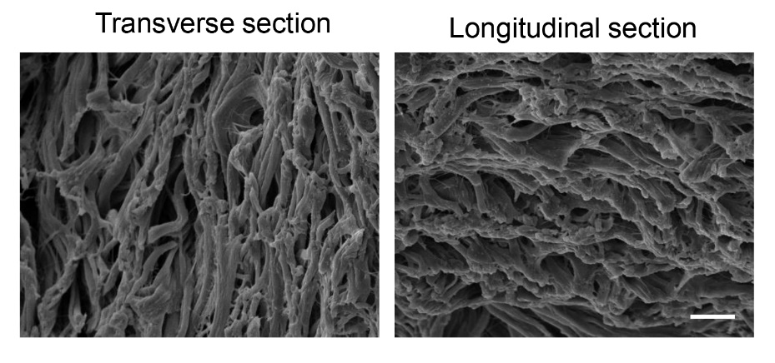
Figure 2. Surface and cross-sectional characterization of artificial dermis scaffolds. a) Scanning electron microscopy images of the surface of artificial dermis scaffolds. b) Scanning electron microscopy images of the cross-section of artificial dermis scaffolds. Scale bars, 10 μm.

Figure 3. Enhanced regeneration of dermal appendages with Nanopore #3 scaffold treatment. a) Oil Red O staining of wounds treated with PBS and Nanopore #3 scaffold after 14 days, with corresponding wound images. Scale bars, 0.5 mm. b) Quantitative analysis of hair follicles. c) Quantitative analysis of Oil Red O positive area at the wound site. n = 6. Data are presented as mean ± SD, ***p < 0.001.
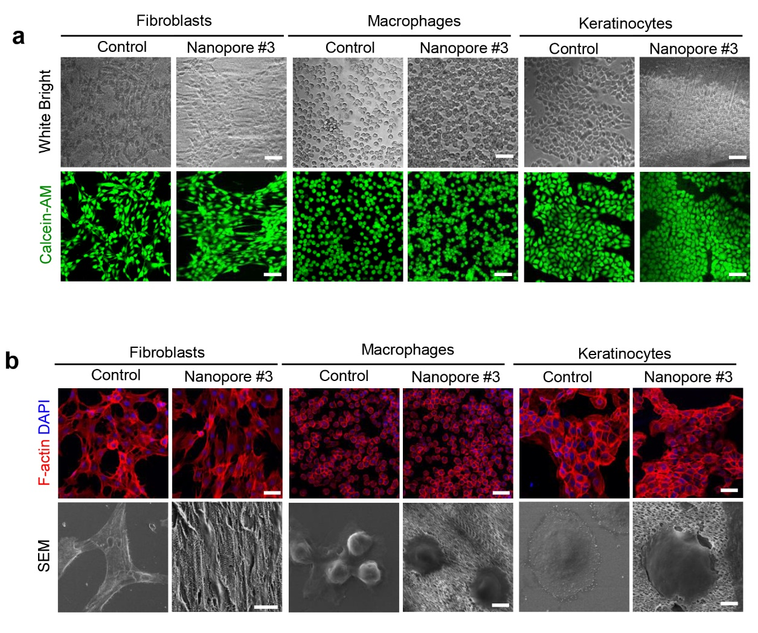
Figure 4. Effect of the Nanopore on the biological behavior of various cells derived from skin. a) Optical and Calcein-AM staining images of primary fibroblasts, macrophages and keratinocytes derived from skin cultured on plates or Nanopore #3 scaffold. Scale bars, 100 μm. b) Cytoskeleton staining (Scale bars, 50 μm) and scanning electron microscopy images of primary fibroblasts (Scale bars, 20 μm), macrophages (Scale bars, 10 μm) and keratinocytes (Scale bars, 5 μm), respectively.

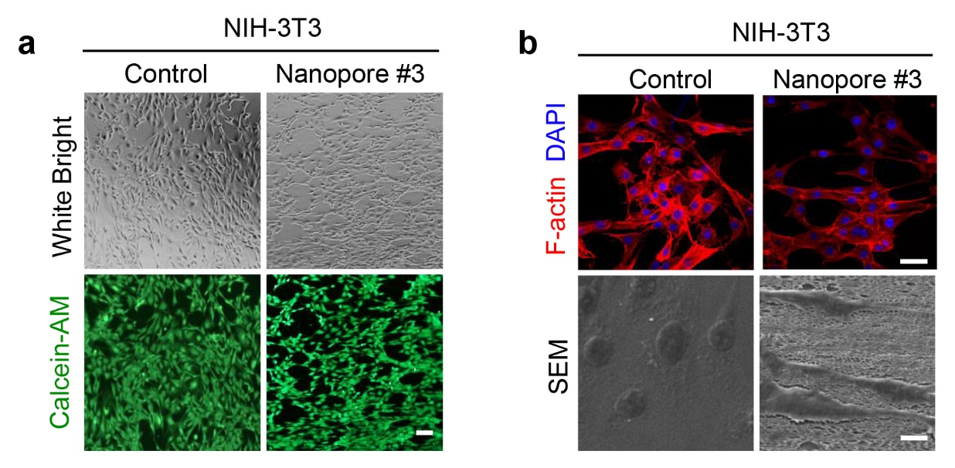
Figure 5. Effect of the Nanopore on the biological behavior of NIH-3T3 cells. a) Optical and Calcein-AM staining images of NIH-3T3 cells planted on plates or Nanopore #3 scaffold. Scale bars, 100 μm. b) Cytoskeleton staining (Scale bars, 50 μm) and SEM images of NIH-3T3 cells (Scale bars, 10 μm).
Figure 6. Nanopores affect the proliferation and migration ability of fibroblasts. a and b) Cell counting kit-8 assay was performed to determine the cell proliferation of primary fibroblasts and NIH-3T3 cells cultured on diverse scaffolds after 24, 48 and 72 hours. c and d) Wound healing assay was used to determine the migration of primary fibroblasts and NIH-3T3 cells planted on different scaffolds. Scale bars, 200 μm. n = 3. Data are presented as mean ± SD, *p < 0.05, **p < 0.01, ***p < 0.001, ****p < 0.0001.

Figure 7. The effect of various of nanopore shape structure scaffolds on ^{Y14}p-CAV1 protein expression. a and b) ^{Y14}p-CAV1 protein levels in primary fibroblasts and NIH-3T3 cells planted on plates or various of nanopore scaffolds were examined by immunoblot analysis. n = 3. Data are presented as mean ± SD, *p < 0.05, **p < 0.01.

Figure 8. Artificial dermis scaffolds promote the expression of phosphorylated Cav1 protein. a) ^{Y14}p-Cav1 protein levels in primary fibroblasts and NIH-3T3 cells planted on plates or artificial dermis scaffold examined by immunoblot. b) Quantitative analysis of ^{Y14}p-Cav1 protein levels. n = 3. Data are presented as mean ± SD, *p < 0.05, **p < 0.01.

Figure 9. The nanopore promotes phosphorylation of Cav1 and endocytosis of caveolae in NIH-3T3 cells. a) Representative immunofluorescence images of ^{Y14}p-Cav1 in NIH-3T3 cells. Scale bars, 20 μm. b) quantification of the fluorescence intensity across the white line in (a). c) Quantitative analysis of the fluorescence of ^{Y14}p-Cav1 protein. d)Transmission electron microscopy images of Cav1 knockdown cells. Red arrows highlight caveolar rosettes and caveolae. Scale bar, 0.5 μm. e) Fluorescence images of endocytosed FM1- 43 dye in NIH-3T3 cells on plate or Nanopore 3# scaffold. Scale bar, 50 μm, n = 3. Data are presented as mean ± SD, **p < 0.01, ***p < 0.001, ***p < 0.0001.

Figure 10. Effect of Cav1 knockdown on the proliferation of fibroblasts cultured on Nanopore 3# scaffold. a and b) Real Time Cellular Analysis (RTCA) was performed to determine the cell proliferation of Cav1 knockdown primary fibroblasts or NIH-3T3 cells cultured on Nanopore 3# scaffold after 72 hours. n = 5. Data are presented as mean ± SD.

Figure 11. Interaction between endogenous PDGFRβ and ^{Y14}p-Cav1 protein in fibroblasts. a) The cell lysates were subjected to immunoprecipitation with PDGFRβ antibody, followed by immunoblotting ^{Y14}p-Cav1 with the antibody. b) The cell lysates were also subjected to immunoprecipitation with ^{Y14}p-Cav1 antibody, followed by immunoblotting with the PDGFRβ antibody. Cell lysates were also subjected to immunoprecipitation with IgG antibody as negative control.

Figure 12. Nanopore promotes the internalization of PDGFRβ binding with Cav1 during caveolae formation. a) Co-localization of endogenous PDGFRβ and Cav1 was examined by double immunofluorescence staining. Scale bars, 20 μm. b) Representative immunofluorescence images of internalized PDGFRβ in NIH-3T3 cells cultured on plates or Nanopore #3 scaffold. Scale bars, 20 μm. c) Quantification of the fluorescence intensity across the white line in (b). d) Intensity of internalized PDGFRβ in NIH-3T3 cells cultured on plates or Nanopore #3 scaffold. Scale bars, 50 μm. n = 20. Data are presented as mean ± SD, **p < 0.01, ***p < 0.001.

Figure 13. Effect of nanopore on ERK and PI3K-AKT signaling pathways in NIH-3T3 cells. a) Immunoblot analysis showed PI3K, p-PI3K, AKT, p-AKT, ERK and p-ERK protein levels from whole cell lysates of NIH-3T3 cells cultured on plates and Nanopore #3 scaffold for 2 days, where GAPDH acts as housekeeping protein. b) Quantification of relative protein levels detected by immunoblot analysis. n = 3. Data are presented as mean ± SD, **p < 0.01, ***p < 0.001.
Figure 14. Effect of Cav1 knockdown on ERK and PI3K-AKT signaling pathways in NIH-3T3 cells. a) Immunoblot analysis showed PI3K, p-PI3K, AKT, p-AKT, ERK and p-ERK protein levels from whole cell lysates of fibroblasts cultured on plates and Nanopore #3 scaffold for 2 days. b) Immunoblot analysis showed PI3K, p-PI3K, AKT, p-AKT, ERK and p-ERK protein levels from whole cell lysates of NIH-3T3 cells cultured on plates and Nanopore 3# scaffold. n = 3. Where protein levels were normalized to GAPDH. Data are presented as mean ± SD, *p < 0.05, **p < 0.01, ***p < 0.001, ***p < 0.0001.

Figure 15. Effect of artificial dermal scaffold on the expression of secretory protein FGFBP3. a) FGFBP3 mRNA levels in cells planted on plates or artificial dermal scaffolds respectively. b) Secretion of FGFBP3 protein levels in the supernatant of cells planted on plates or artificial dermal scaffold was examined by ELISA assays. c) FGFBP3 protein levels in cells planted on plates or artificial dermal scaffold was examined by immunoblot analysis. d) Quantification of FGFBP3 protein levels in (c). n = 3. Data are presented as mean ± SD, *p < 0.05, **p < 0.01.

Figure 16. The angiogenesis ability of HUVECs promoted by Nanopore #3-induced increased secretion of FGFBP3 in the supernatant was inhibited in Cav1 knockdown fibroblasts. a) Secretion of FGFBP3 protein levels in the supernatant of primary fibroblasts and NIH-3T3 cells planted on plates or Nanopore #3 scaffold was examined by ELISA assays. b) Fluorescence images and quantifications of HUVECs forming tubule-like structures with the supernatant of primary fibroblasts cultured on various Nanopore scaffolds. Scale bars, 200 μm. c) Fluorescence images and quantifications of HUVECs forming tubule-like structures with the supernatant of Cav1 knockdown fibroblasts cultured on plates or Nanopore 3# scaffold. Scale bars, 200 μm. n = 3. Data are presented as mean ± SD, *p < 0.05, **p < 0.01, ***p < 0.001, ***p < 0.0001.

Figure 17. Effect of FGFBP3 knockdown NIH-3T3 cells supernatant on the angiogenesis of vascular endothelial cells. a) Fluorescence images of HUVECs forming tubule-like structures with the supernatant of FGFBP3 knockdown NIH-3T3 cells cultured on plates or Nanopore 3# scaffold. Scale bars, 200 μm. b and c) Quantification of total tube length and total tube branches of various of groups. n = 3. Data are presented as mean ± SD, *p < 0.05, **p < 0.01, ***p < 0.001.

Figure 18. Identification of the FGFBP3 promoter site recognized and bound by RUNX1 protein. a) Dual luciferase reporter assays were applied to detect the transcription factor within the FGFBP3 promoter region. b) RUNX1 protein levels pulled down by FGFBP3 promoter was determined by immunoblot analysis.

Figure 19. Expression of p-RUNX1 protein in NIH-3T3 cells planted on plate or Nanopore 3# scaffold. a) Immunofluorescence staining of p-RUNX1 in NIH-3T3 cells planted on plates or Nanopore 3# scaffold. Scale bars, 20 μm. b) Quantification of p-RUNX1 fluorescence intensity in (a). n = 3. Data are presented as mean ± SD, **p < 0.01.

Figure 20. Effect of RUNX1 knockdown primary fibroblasts or NIH-3T3 cells on the expression of FGFBP3 protein. a) Immunofluorescence staining of FGFBP3 in fibroblasts or NIH-3T3 cells planted on plates or Nanopore 3# scaffold. Scale bars, 20 μm. b) Quantification of FGFBP3 fluorescence intensity in (a). n = 20. Data are presented as mean ± SD, ***p < 0.001, ****p < 0.0001.

Figure 21. Effect of adding recombinant FGFBP3 protein to the supernatant of RUNX1 knockdown cells on the angiogenesis of vascular endothelial cells. Fluorescence images of HUVECs forming tubule-like structures with the supernatant of RUNX1 knockdown fibroblasts cultured on plates or Nanopore 3# scaffold. Scale bars, 200 μm. b and c) Quantification of total tube length and branches of various of groups. n = 20. Data are presented as mean ± SD, *p < 0.05, **p < 0.01, ***p < 0.001, ****p < 0.0001.

Figure 22. Knockdown of AAV-Cav1 in skin fibroblasts of mice reduce the expression of p-RUNX1 and FGFBP3. a) Cav1, p-Cav1, RUNX1, p-RUNX1 and FGFBP3 protein levels determined by immunoblot analysis. b) Quantification of relative proteins determined by Immunoblot in (a). c) Skin tissue p-RUNX1 and FGFBP3 contents were examined by immunohistochemical staining. Scale bars, 500 μm. d) Quantification analysis of p-RUNX1 and FGFBP3 positive area in (e). n = 5. Data are presented as mean ± SD, **p < 0.01, ***p < 0.001, ****p < 0.0001.

Figure 23. Effect of Cav1 knockdown on FGFBP3 expression in fibroblasts. a) Immunoblot analysis showed phosphorylated RUNX1 and FGFBP3 protein levels from whole cell lysates of primary fibroblasts and NIH3T3 cells cultured on plates or Nanopore 3# scaffold for 2 days. b) Immunofluorescence staining of FGFBP3 in primary fibroblasts and NIH3T3 cells planted on plates or Nanopore 3# scaffold. Scale bars, 20 μm. n = 3. Data are presented as mean ± SD, *p < 0.05, **p < 0.01, ***p < 0.001, ****p < 0.0001.

Figure 24. Wound healing is disturbed by knockdown of AAV-RUNX1 in fibroblasts. a) Skin tissue FGFBP3 contents examined by immunohistochemical staining. Scale bars, 100 mm. b) Quantification of the FGFBP3-positive area at the wound site. c) Immunofluorescence staining of PDGFRa (red), RUNX1 (green) and FGFBP3 (purple). Scale bars, 100 mm. d) Quantification of RUNX1 and FGFBP3 fluorescence intensity in (c). e) Immunofluorescence staining of α-SMA and CD31 for neovascularization in shNC or shRUNX1 groups, with the vessels indicated by white arrows. Scale bars, 2 mm. f) Quantification of the coverage area of vessels. g) Masson's trichrome staining of various groups after 14 days. Scale bars, 0.5 mm. h) Quantitative analysis of collagen volume fraction. n = 5. Data are presented as mean ± SD, **p < 0.01, ***p < 0.001, ****p < 0.0001.

Figure 25. PDGFRβ knockdown reduces the expression of FGFBP3 in fibroblasts cells. a) FGFBP3 protein levels in primary fibroblasts and NIH3T3 cells examined by immunoblot analysis. b Immunofluorescence staining of FGFBP3 in fibroblasts or NIH3T3 cells planted on plates or Nanopore 3# scaffold. Scale bars, 100 μm. n = 20. c) FGFBP3 mRNA levels in primary fibroblasts and NIH3T3 cells. d) Secretion of FGFBP3 protein levels in the supernatant of PDGFRβ knockdown fibroblasts planted on plates or Nanopore 3# scaffold was examined by ELISA assays. n = 3. Data are presented as mean ± SD, *p < 0.05, **p < 0.01, ***p < 0.001, ****p < 0.0001.

Figure 26. Inhibition of ERK and PI3K-AKT signaling pathways impacts FGFBP3 expression in fibroblasts cultured on Nanopore 3# scaffold. a) ERK, p-ERK, RUNX1, p-RUNX1 and FGFBP3 protein levels in primary fibroblasts with the treatment of ERK signaling inhibitor. b) PI3K, p-PI3K, AKT, p-AKT, RUNX1, p-RUNX1 and FGFBP3 protein levels in primary fibroblasts with the treatment of PI3K signaling inhibitor. n = 3. Data are presented as mean ± SD, **p < 0.01, ***p < 0.001, ****p < 0.0001.

Figure 27. Effect of RUNX1 knockdown in fibroblasts on the ERK and PI3K-AKT signaling pathway. a) RUNX1, p-PI3K, PI3K, p-AKT and AKT protein levels in primary fibroblasts with RUNX1 knockdown. b) RUNX1, p-ERK and ERK protein levels in primary fibroblasts with RUNX1 knockdown. n = 3. n = 3. Data are presented as mean ± SD, *p < 0.05, **p < 0.01, ***p < 0.001, ****p < 0.0001.

Figure 28. Nanopore-mediated Cav1 recruitment of FLNA and CBFβ nuclear translocation enhance RUNX1-dependent FGFBP3 transcription in NIH-3T3 cells. a) Confocal images of Cav1 (red) and FLNA (green) localization in the NIH3T3 cells. Scale bars, 20 μm. b) Confocal images of CBFβ (red) and FLNA (green) localization in the NIH3T3 cells. Scale bars, 20 μm. c) Confocal images of exogenous eGFP-RUNX1 (green) and mCherry-CBFβ (red) in NIH3T3 cells, and positioning analysis of eGFP-RUNX1 and mCherry-CBFβ in NIH3T3 cells. Scale bars, 20 μm. d and e) FGFBP3 mRNA and its protein levels in NIH3T3 cells with CBFβ knockdown. f) Immunofluorescence staining of FGFBP3 in NIH3T3 cells with CBFβ knockdown. Scale bars, 20 μm. n = 3. Data are presented as mean ± SD, **p < 0.01, ***p < 0.001, ****p < 0.0001.

Figure 29. The combination of FLNA and ^{Y14}p-Cav1 in fibroblasts planted on plates or Nanopore 3# scaffold. The cell lysates were subjected to immunoprecipitation with FLNA antibody, followed by immunoblotting with ^{Y14}p-Cav1 antibody. Cell lysates were also subjected to immunoprecipitation with IgG as negative control.

