Extended Figures and Tables

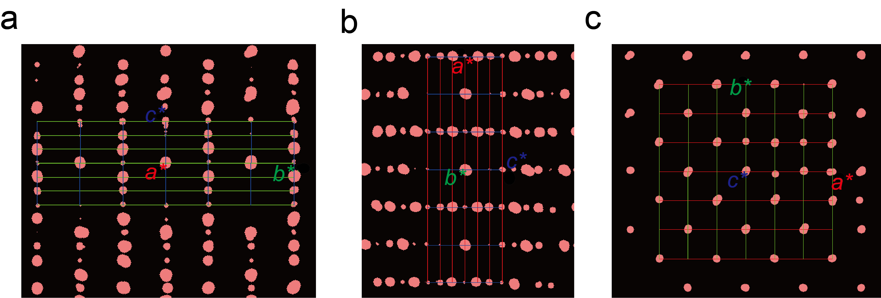

Extended data Figure 1. (a)-(c) Reciprocal lattice data of La₅Ni₃O₁₁ along the a*, b* and c* axes, respectively. The size of the spots represents the intensity of the diffraction peaks.

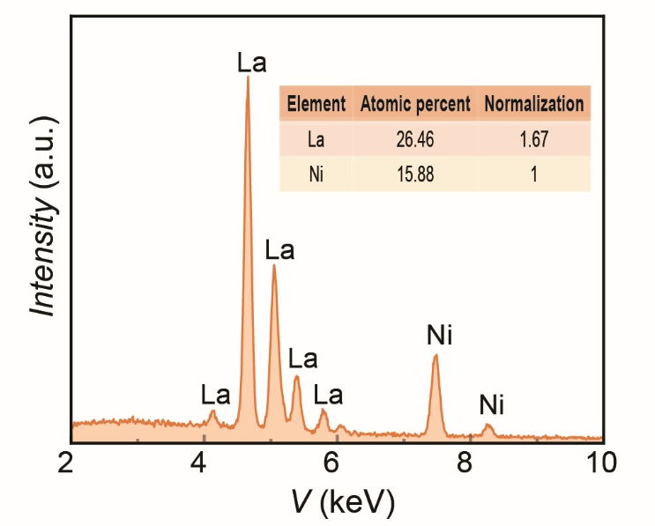
Extended data Figure 2. EDX results of the as-grown microcrystals. The element ratio is La:Ni = 1.67:1, which is consistent with the chemical formula of La₅Ni₃O₁₁.

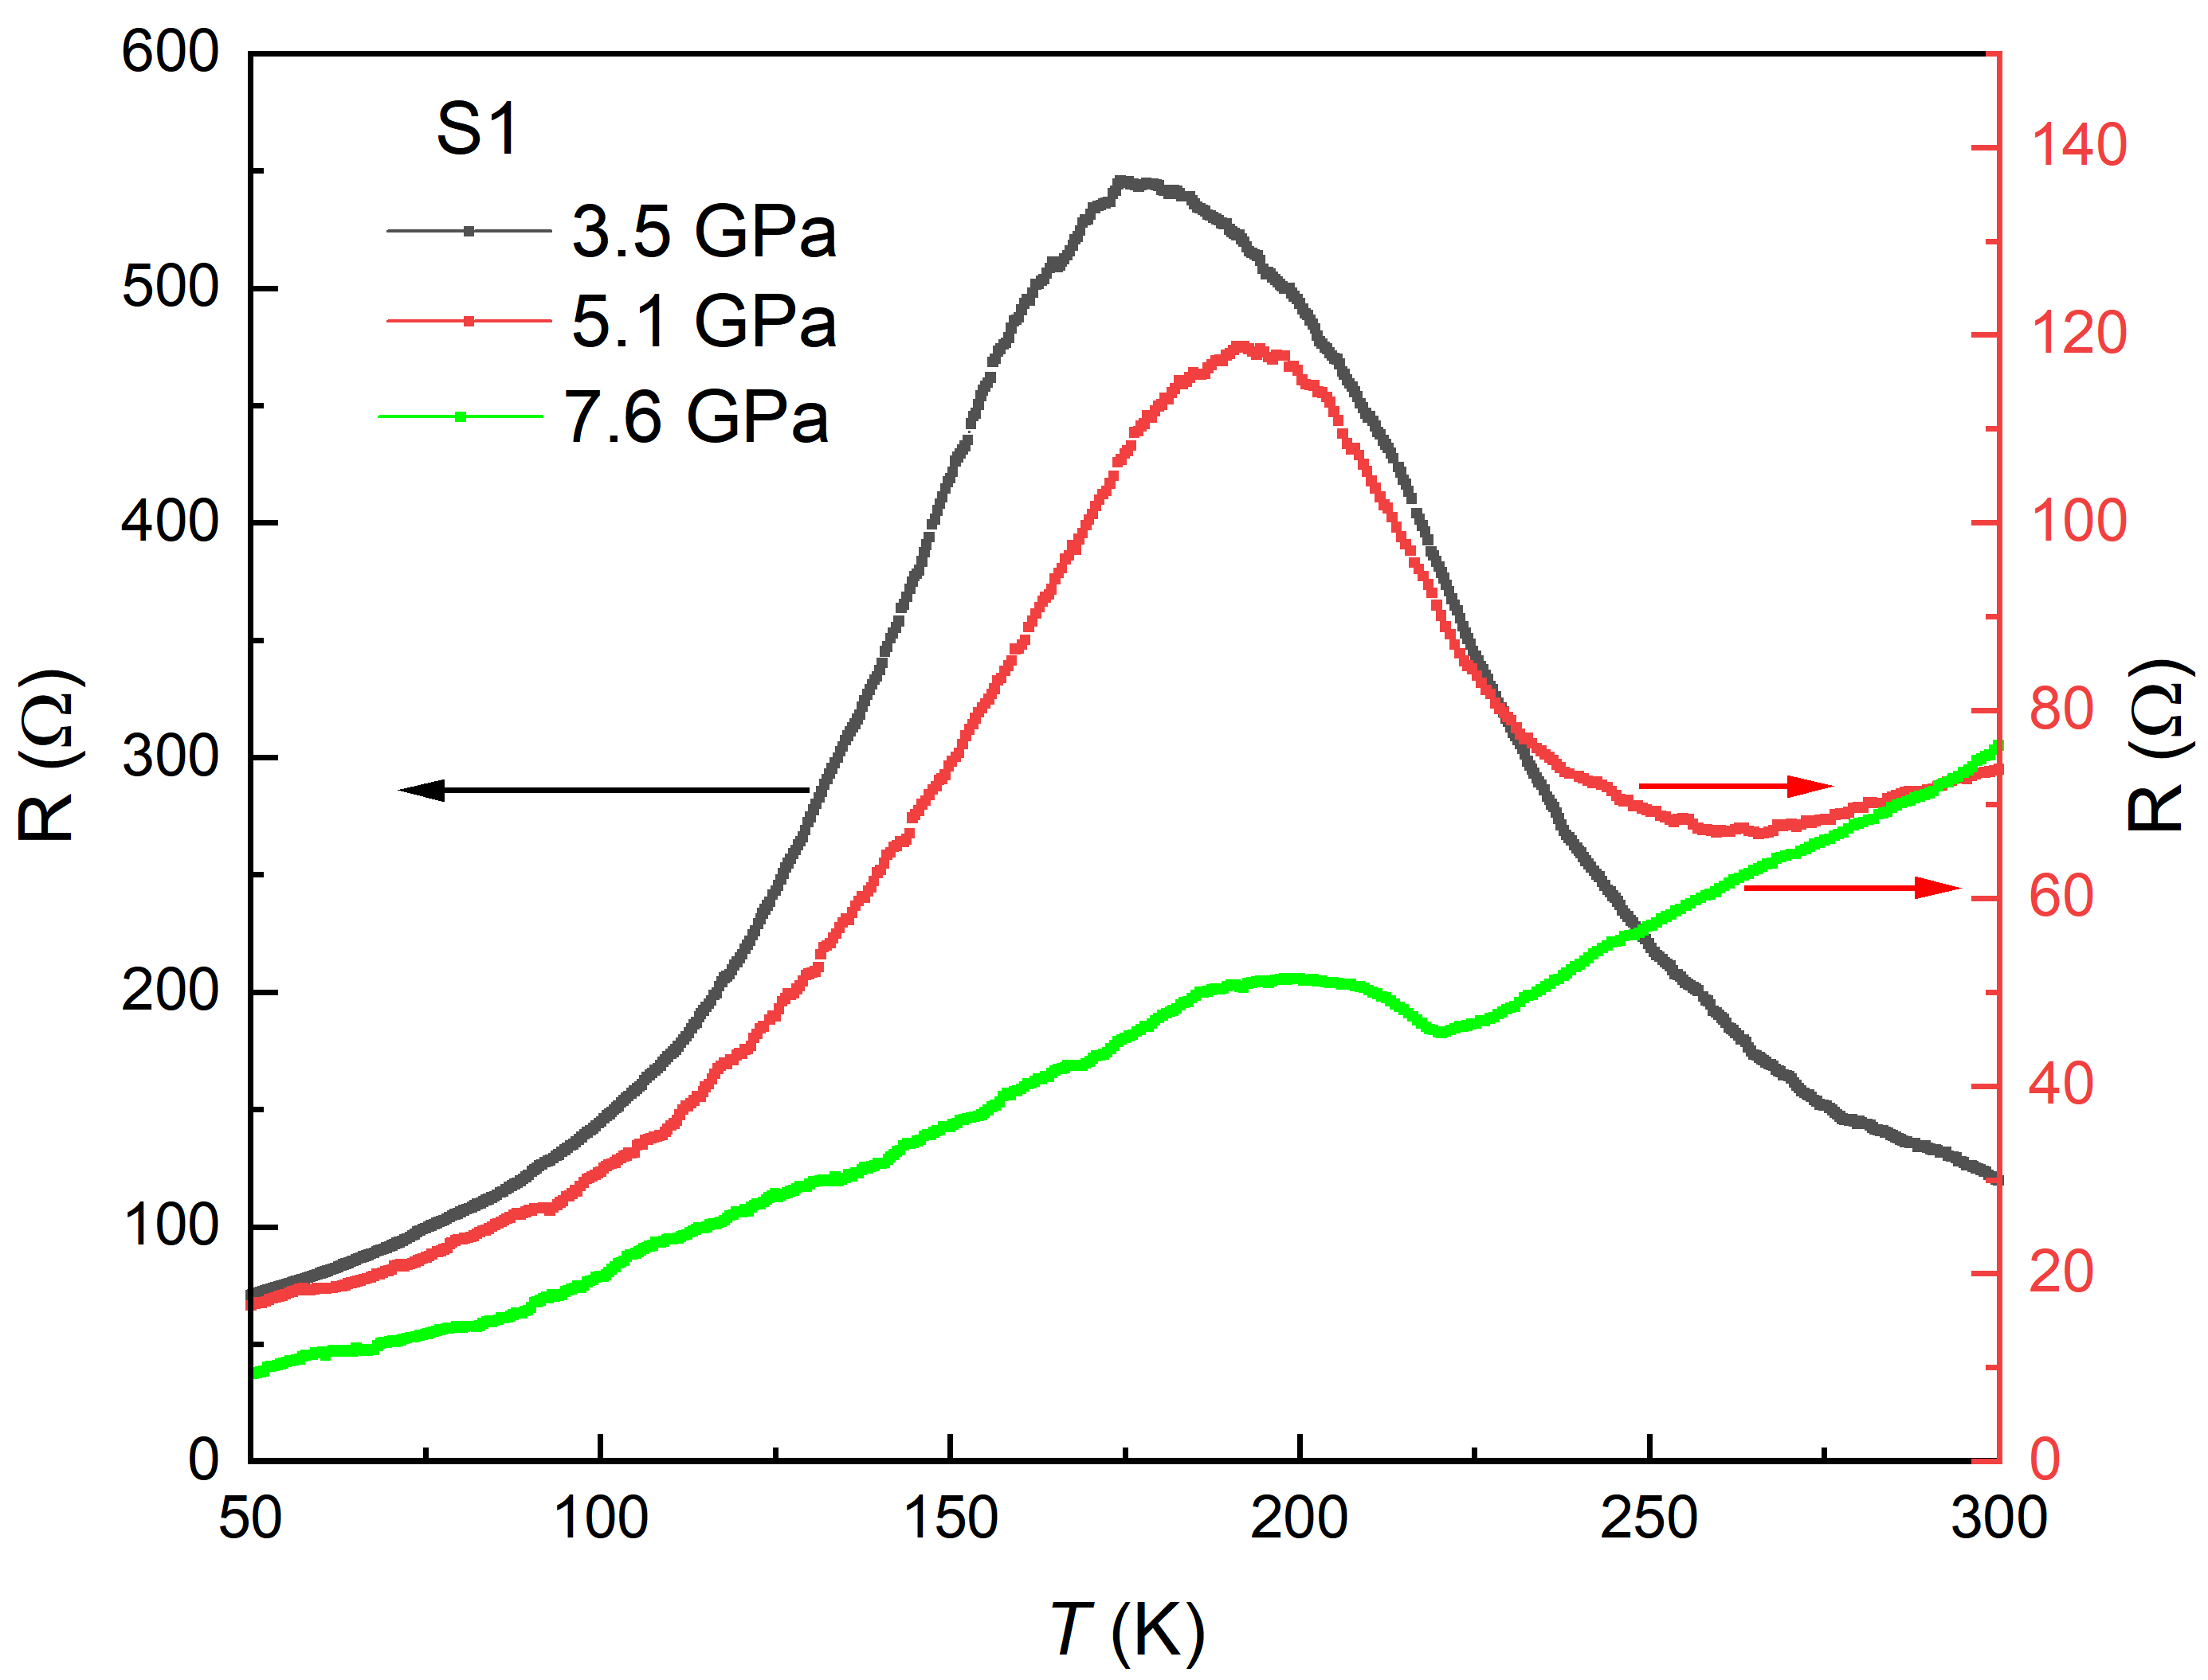

Extended data Figure 3. Temperature-dependent resistance curves for La₅Ni₃O₁₁ (S1) at various pressures.

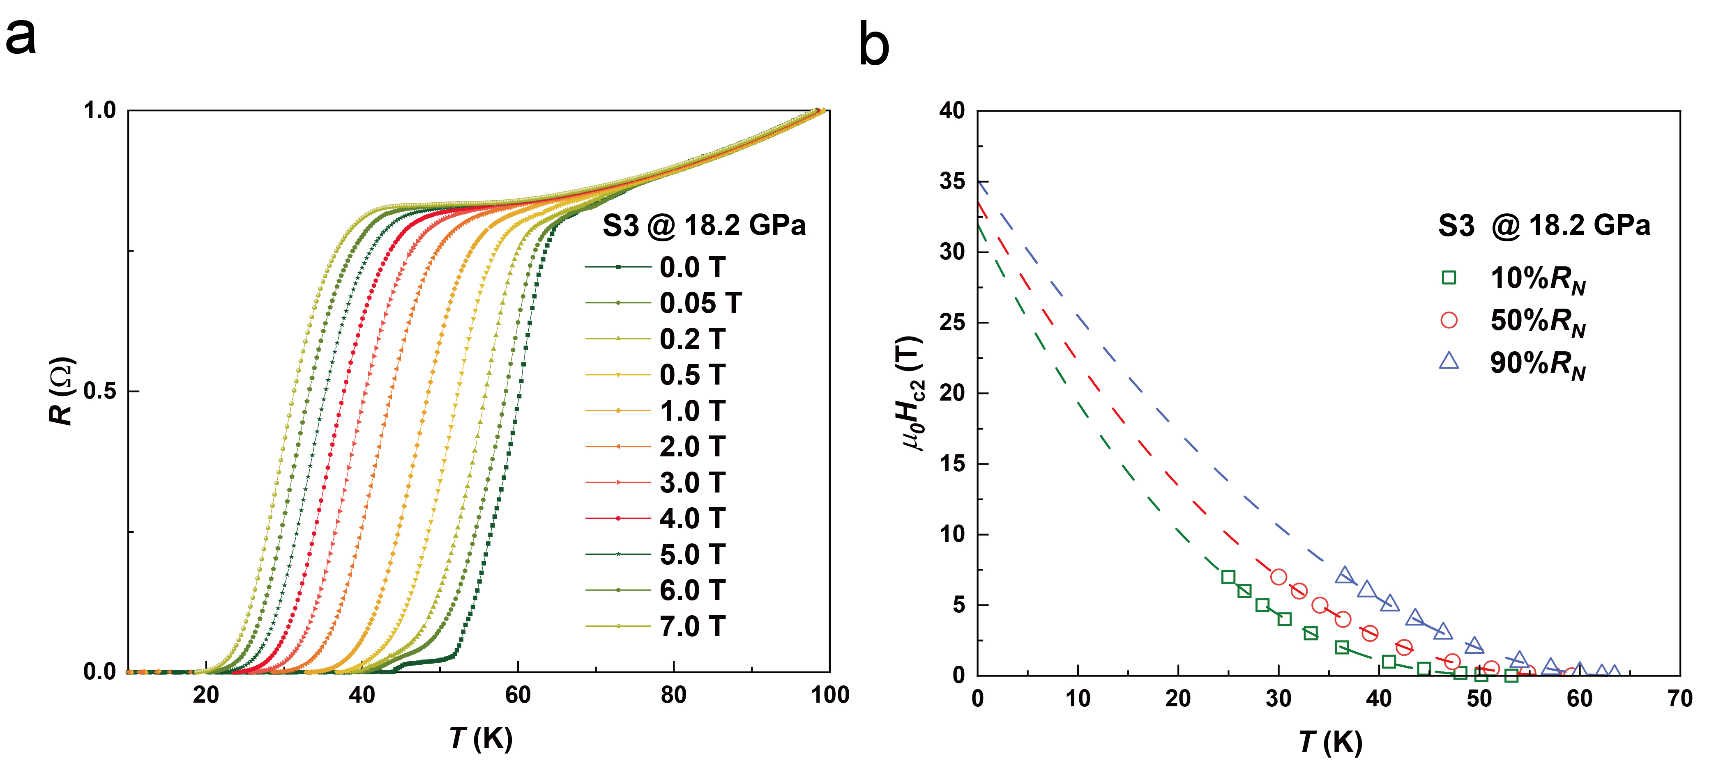
Extended data Figure 4. (a) R(T) curves for La₅Ni₃O₁₁ (S3) at 18.2 GPa under various magnetic fields along the c-axis direction. The onset T_{c} is quickly suppressed to a lower temperature with increasing magnetic field. (b) The upper critical field extracted with different criteria in (a), where the R_{N} is the resistance at the normal state. There is an obvious positive curvature in the H_{c2}-T_{c} curve. The upper critical field at the zero-temperature limit is fitted via the two-band model at the clean limit.

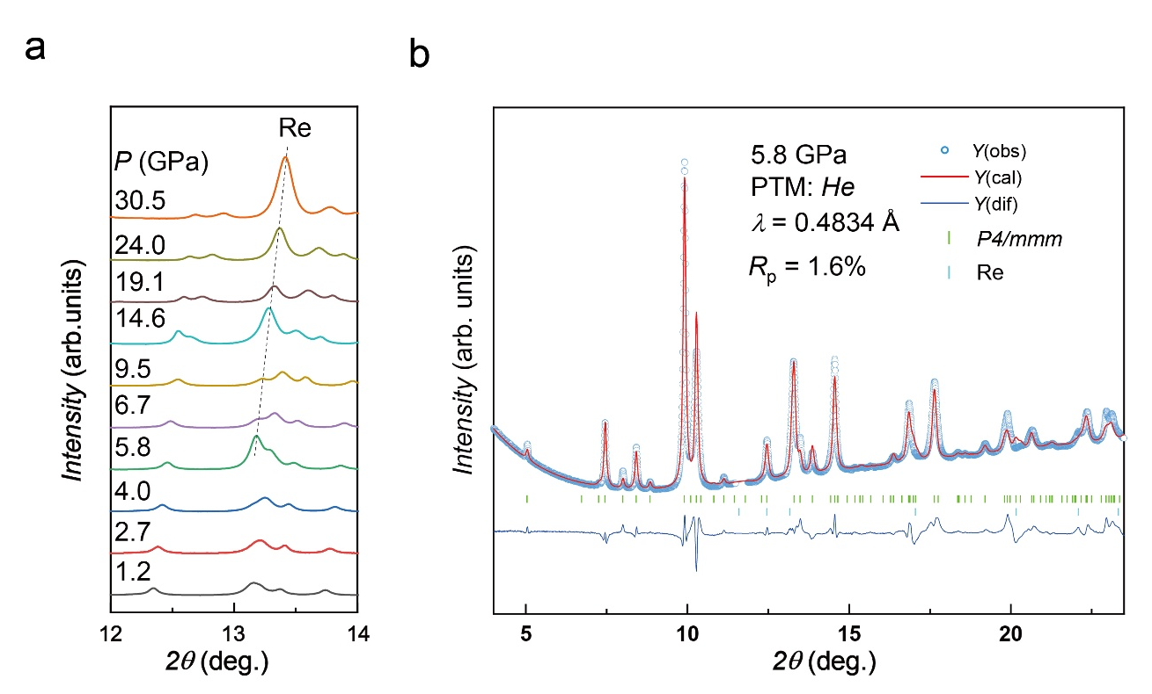
Extended data Figure 5. Powder XRD patterns of the La₅Ni₃O₁₁ crystal under various pressures. (a) Powder XRD patterns of the La₅Ni₃O₁₁ crystal under various pressures in the 2ϴ range of 12–14°, where the dashed line indicates the signal from the gasket (Re). (b) Rietveld refinement of the powder XRD pattern for La₅Ni₃O₁₁ at 5.8 GPa. The collected data can be well fitted via the space group P4/mmm. The blue circles and red lines represent the observed and calculated data, respectively. The blue lines indicate the difference between the observed and calculated data. The short green and cyan vertical lines indicate the calculated diffraction peak positions of La₅Ni₃O₁₁ with P4/mmm space group and Re.

