Additional information
Supplementary Figure 1. Correlations among CD9, CD81 and PDCD6IP levels.
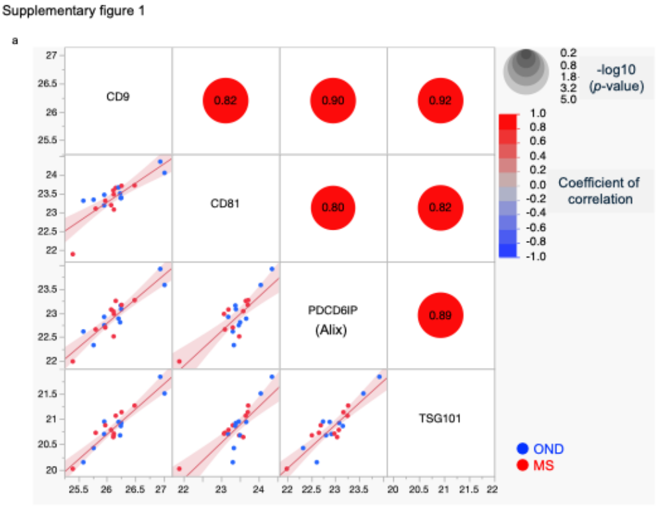
(a) Correlations among CD9, CD81 and PDCD6IP protein levels in CSF-derived EVs. Significant correlations were found between the levels of CD9, CD81 and PDCD6IP, which are marker proteins of EVs.
Supplementary Figure 2. Correlation between ITGAX and P2RX7 levels.
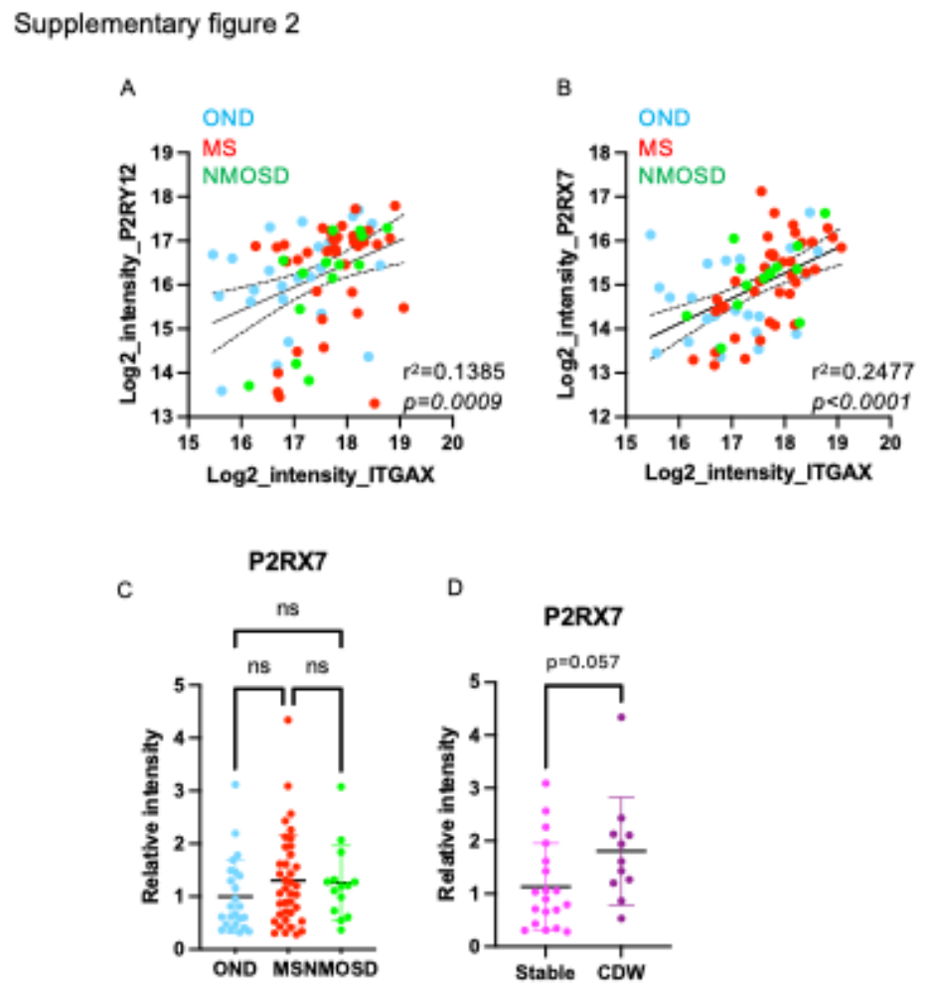
(a) Correlation of ITGAX and P2RY12 protein levels in CSF-derived EVs. ITGAX and P2RY12 levels were significantly but weakly correlated (p = 0.0009, r² = 0.1385). (b) Correlation of ITGAX and P2RX7 protein levels in CSF-derived EVs. ITGAX and P2RX7 levels were significantly and moderately correlated (p < 0.0001, r² = 0.2477). (c) Bar graph of the relative intensity of P2RX7 as measured by mass spectrometry. One-way ANOVA followed by Tukey’s HSD multiple test (ns; not significant). (d) Bar graph of the relative intensity of P2RX7 as measured by mass spectrometry. Student’s t test was used to statistically confirm significance.

