Design, synthesis and biological evaluation of morpholinated isatin-quinoline hybrids as potential anti-breast cancer agents.
Atamjit Singh¹, Komalpreet Kaur¹, Shilpa¹, Jaspreet Kaur¹, Puja Gulati³, Amit Duggal⁴, Preet Mohinder Singh Bedi*^{,1,2}
¹Department of Pharmaceutical Sciences, Guru Nanak Dev University, Amritsar, Punjab 143005, India
² Drug and Pollution testing Lab, Guru Nanak Dev University, Amritsar, Punjab, India143005
³School of Pharmacy, Desh Bhagat University, Mandi Gobindgarh, Punjab 147301, India
⁴Drugs Control Wing, Sector 16, Chandigarh 160015

Corresponding authors: 1) Atamjit Singh
Department of Pharmaceutical Sciences,
Guru Nanak Dev University,
Amritsar, Punjab 143005, India
Email id: atampanesar@gmail.com

2) Dr. Preet Mohinder Singh Bedi
Department of Pharmaceutical Sciences,
Guru Nanak Dev University,
Amritsar, Punjab 143005, India
Email id: bedi_preet@yahoo.com

¹H and ¹³C spectra of synthetics

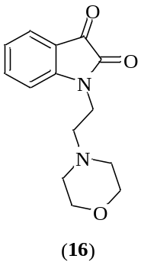
¹H spectrum of 16
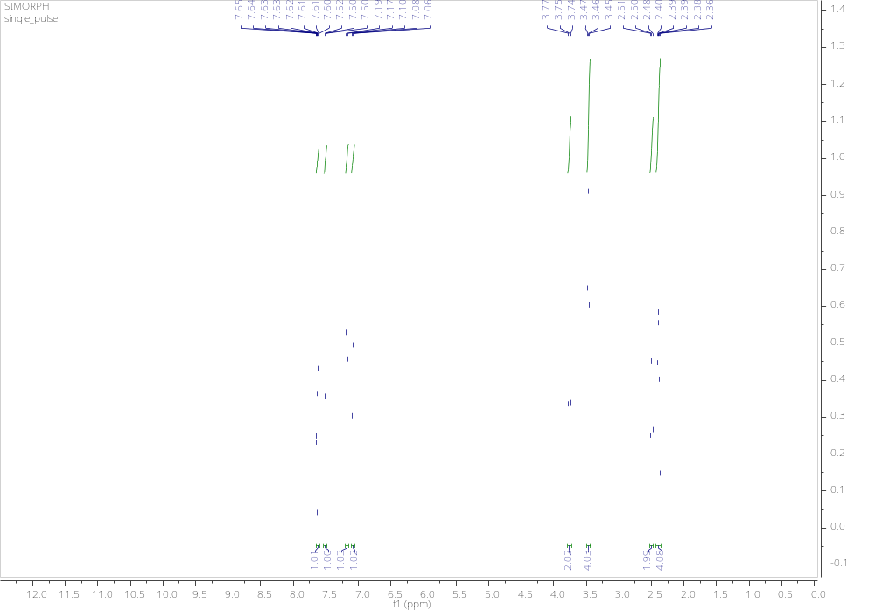

¹³C spectrum of 16
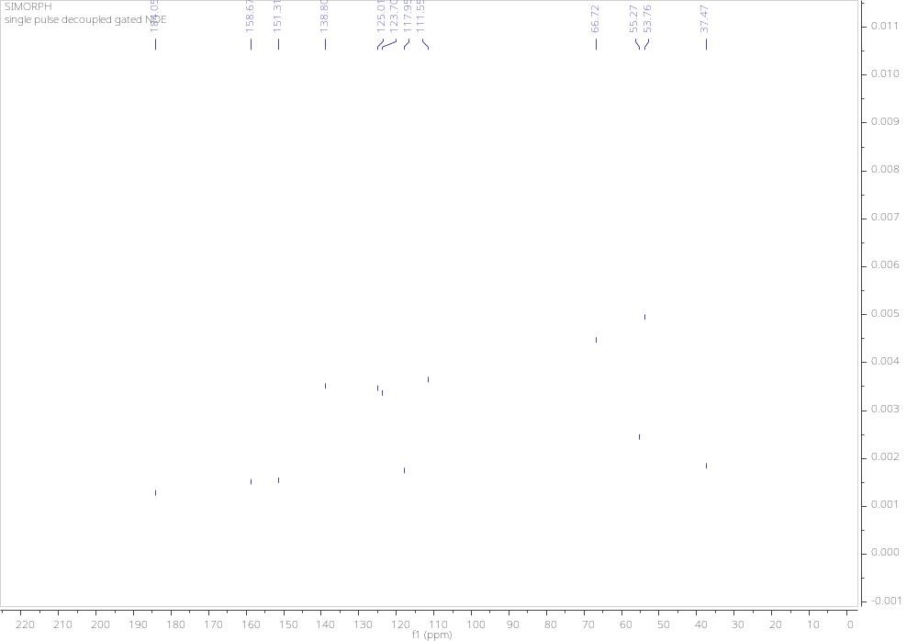

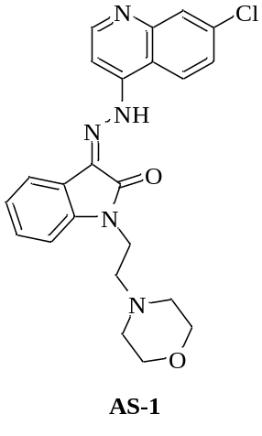
¹H spectrum of AS-1
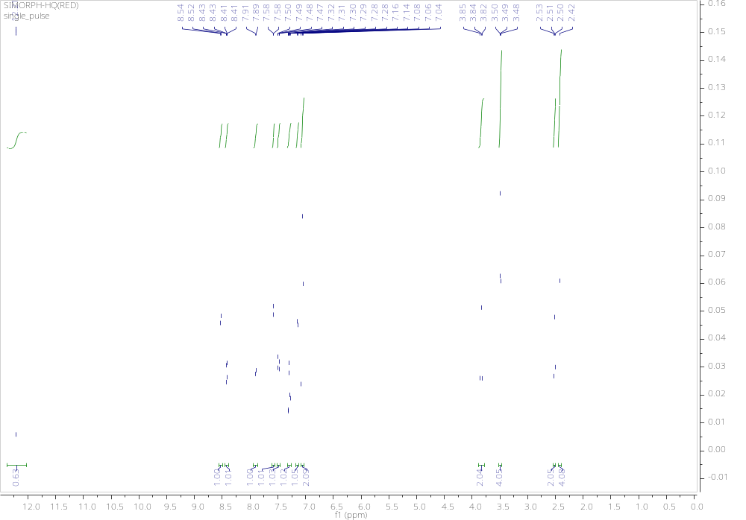

¹³C spectrum of AS-1
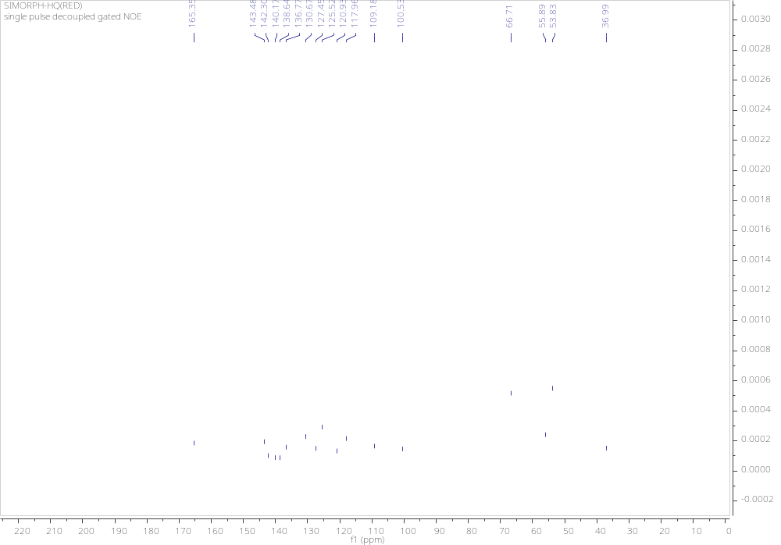

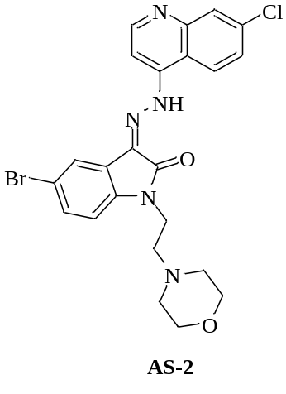
¹H spectrum of AS-2
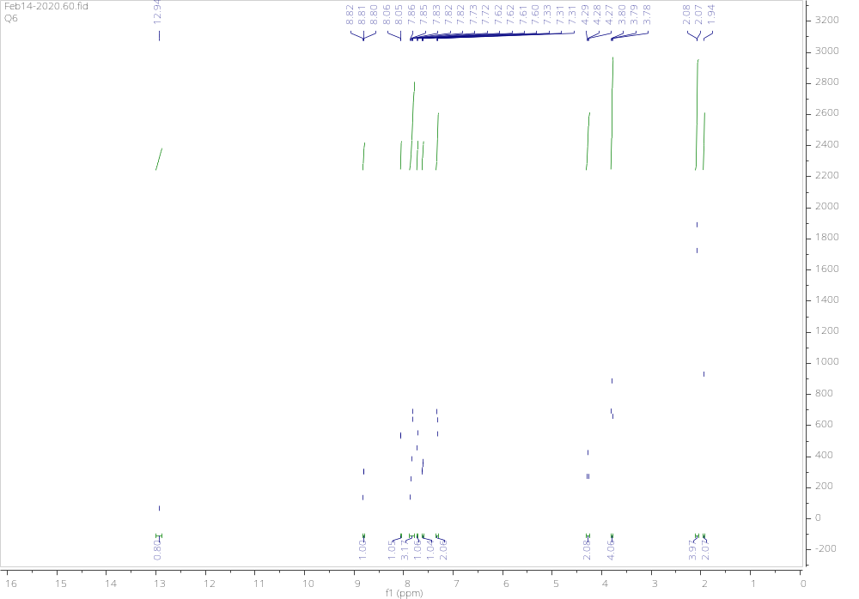

¹³C spectrum of AS-2
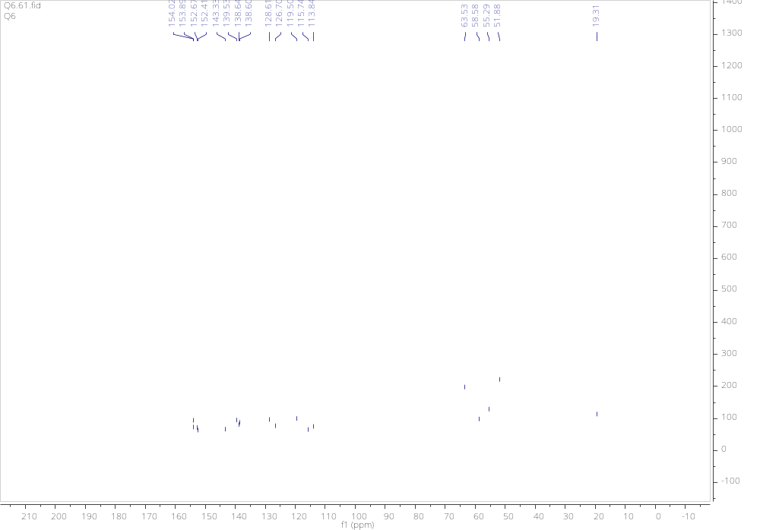

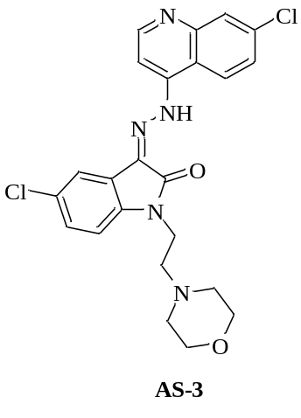
¹H spectrum of AS-3
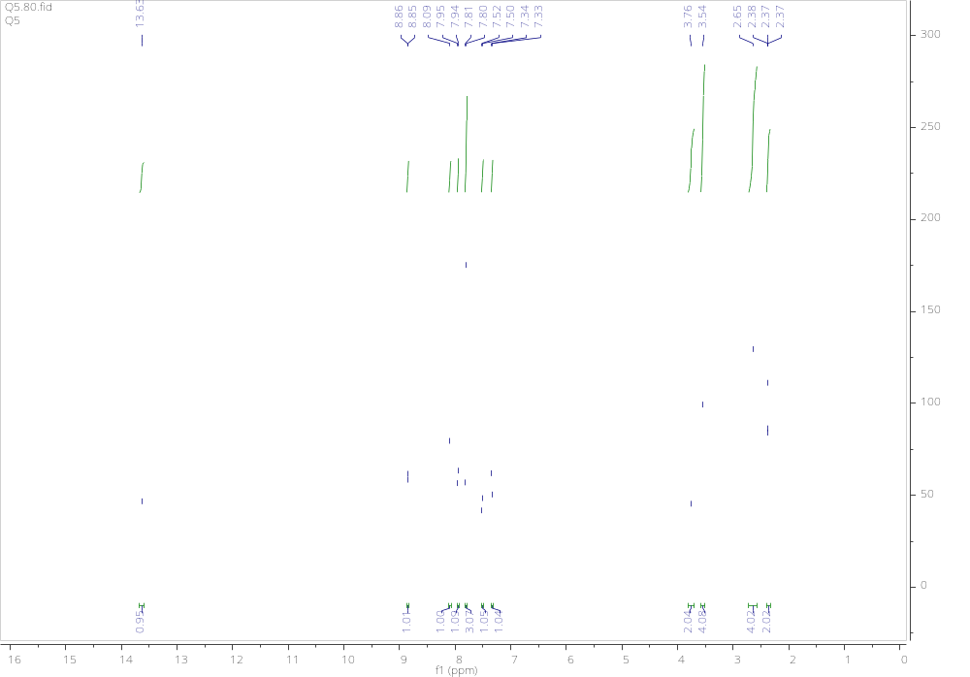

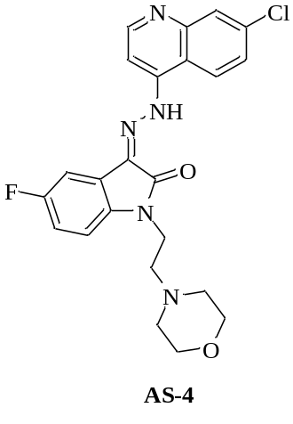
¹H spectrum of AS-4
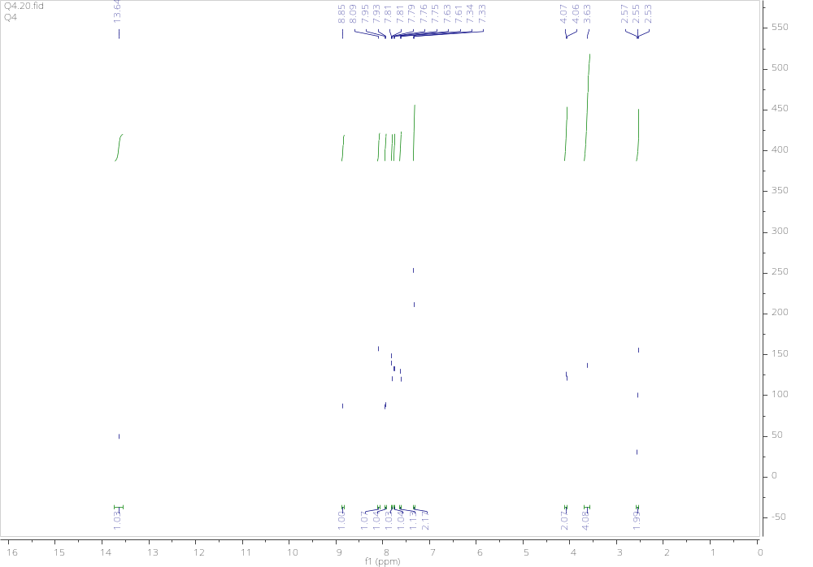

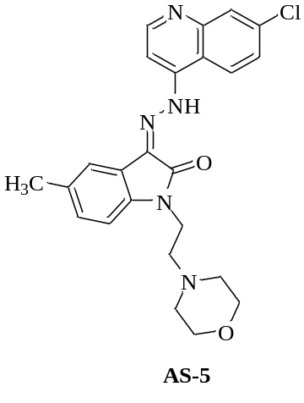
¹H spectrum of AS-5
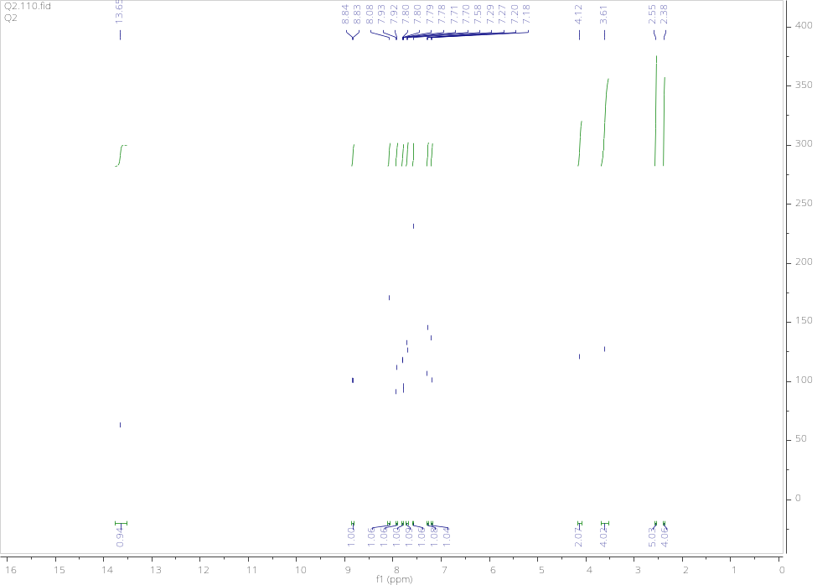

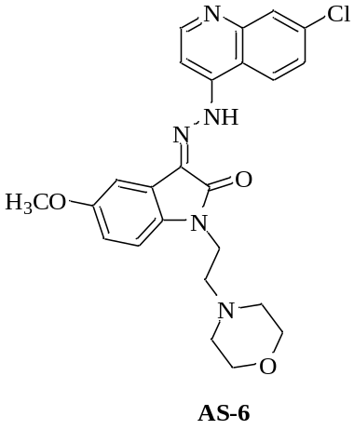
¹H spectrum of AS-6
