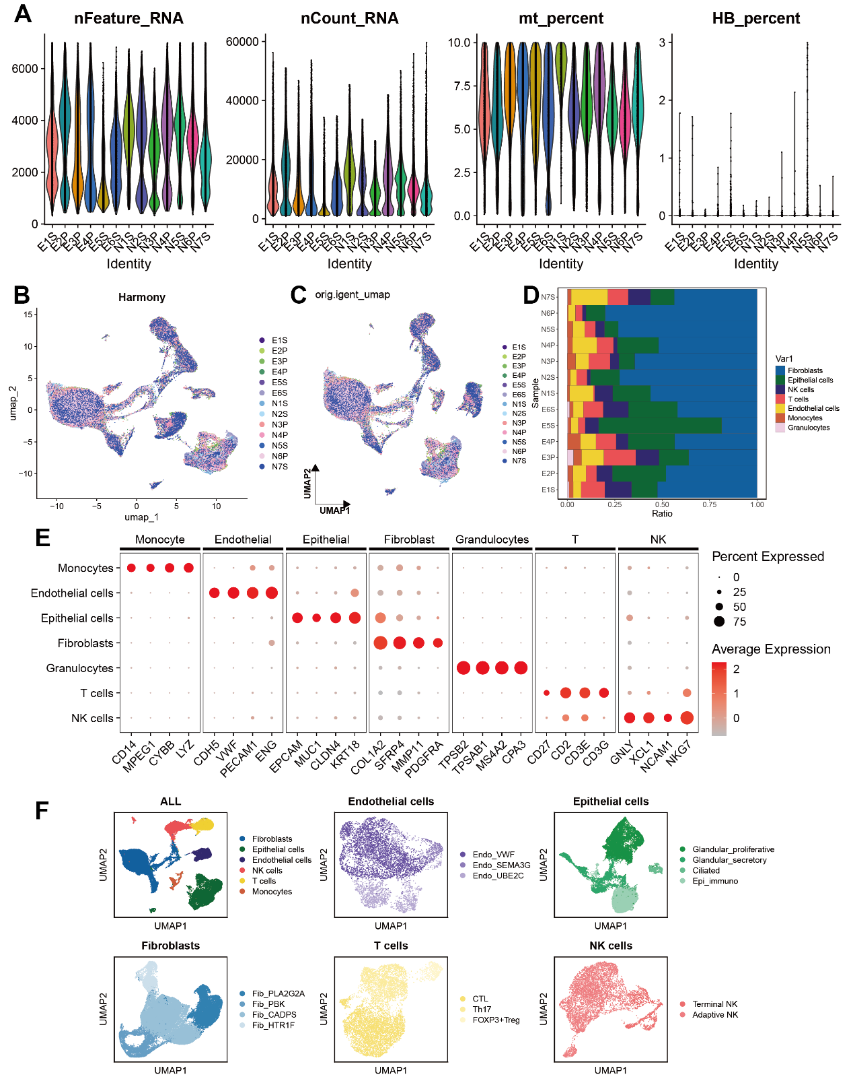
Figure S1 Single-Cell RNA- Seq Analysis of Endometriosis Reveals Cellular Heterogeneity and Immune Landscape. A. Quality control violin plot of scRNA - seq data from all samples. B. UMAP plot of scRNA - seq data from all samples after batch correction using Harmony. C. UMAP plot of scRNA - seq data for each sample. D. Bar chart showing the proportion of each cell type in each sample. E. Bubble chart displaying the expression of marker genes for each cell type. F. UMAP composite figure of each cell subtype in all samples.
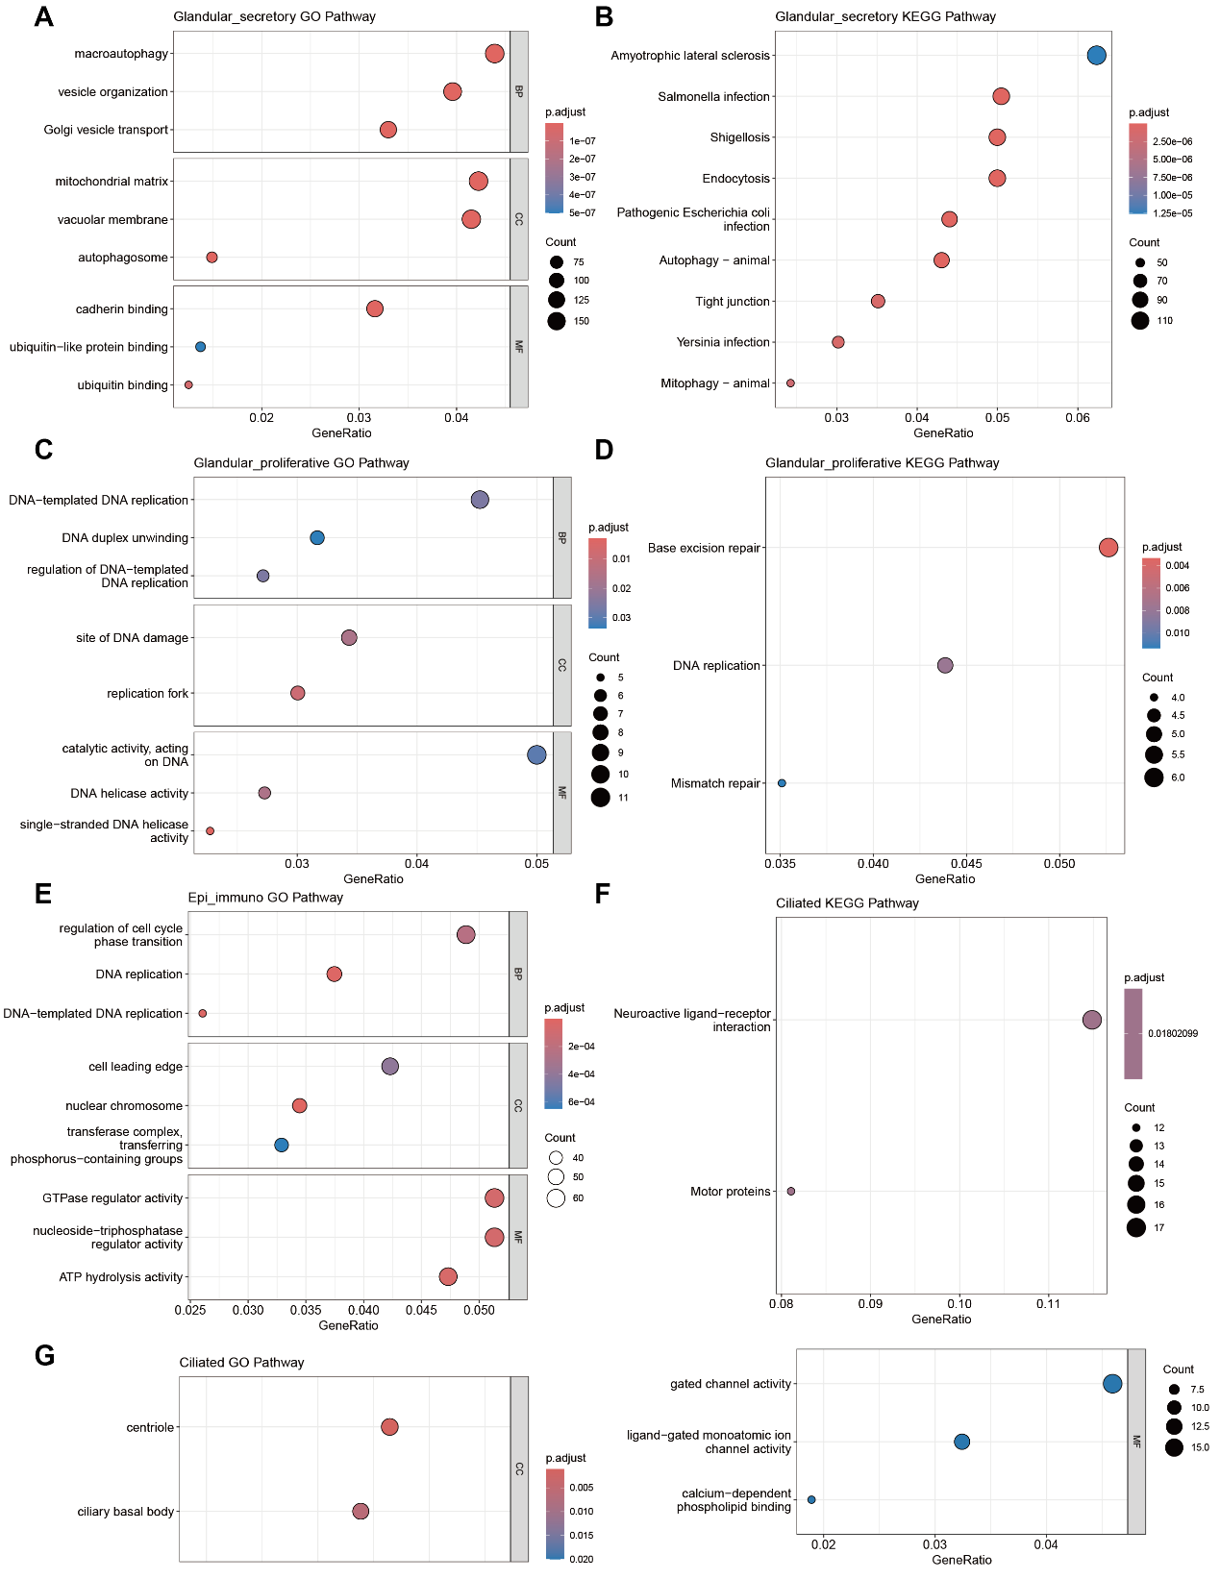
Figure S2 Gene Expression and Pathway Enrichment Analysis in Endometriosis-Associated Cell Types. A. Bar chart displays the GO analysis pathways of the Glandular_secretory gene. B. Bar chart exhibits the KEGG analysis pathways of the Glandular_secretory gene. C.Bar chart presents the GO analysis pathways of the Glandular_proliferative gene. D. Bar chart illustrates the KEGG analysis pathways of the Glandular_proliferative gene. E. Bar chart shows the GO analysis pathways of the Epi_immuno gene. F. Bar chart represents the KEGG analysis pathways of the Epi_immuno gene. G. Bar chart depicts the GO analysis pathways of the Ciliated gene.
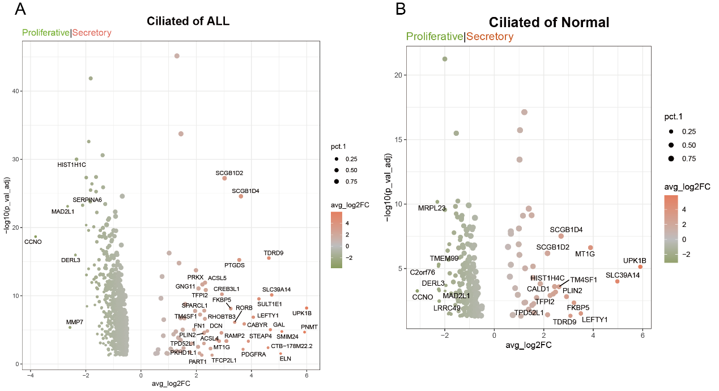
Figure S3 Differential Gene Expression in Ciliated Cells of Endometriosis and Normal Tissues. A. Volcano plot showing the upregulation and downregulation of gene expression in all ciliated cells between the proliferative and secretory phases. B. Volcano plot showing the upregulation and downregulation of gene expression in ciliated cells between the proliferative and secretory phases in normal groups.
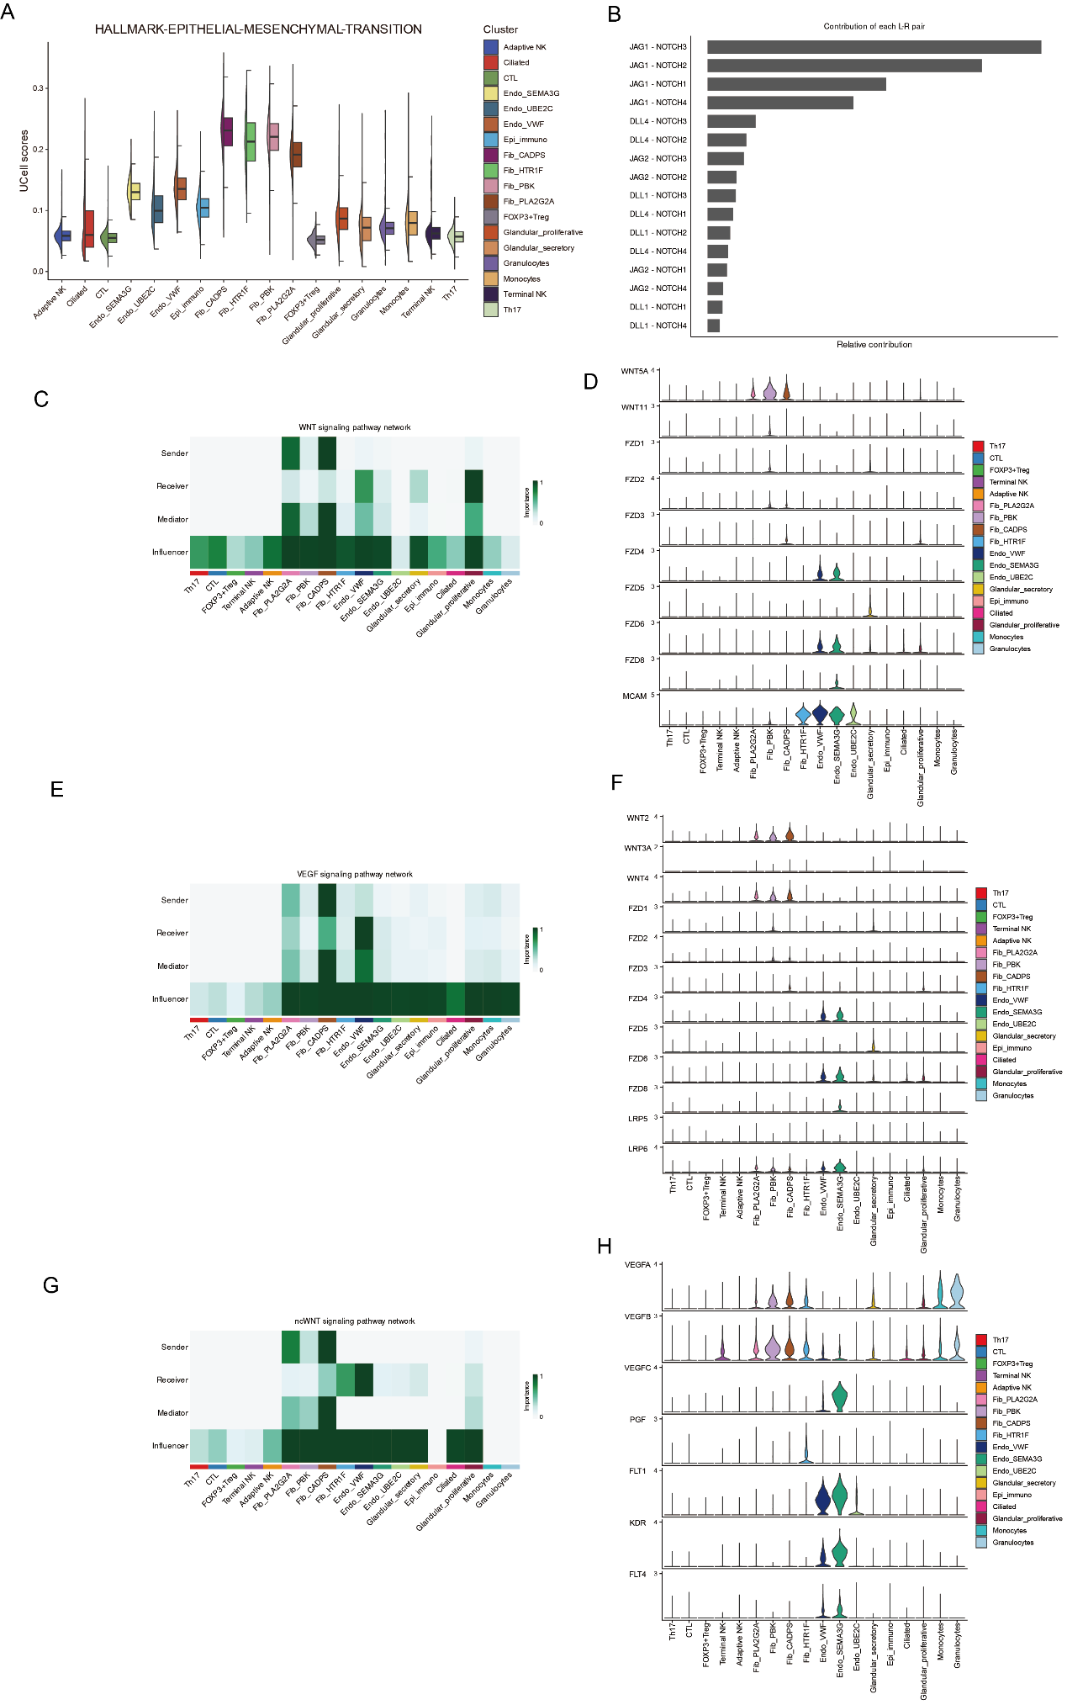
Figure S4 Single-Cell Analysis of Signaling Pathways and Cell-Type Specificity in Endometriosis. A. Semi - violin plot exhibits the contributions of each cell subtype in the endometriosis group to the epithelial - mesenchymal transition (EMT) pathway (Ucell score). B. Bar chart displays the contribution intensities of each ligand - receptor pair in the NOTCH pathway. C. Heatmap illustrates the roles of various cell types in the WNT pathway. D. Violin plot demonstrates the expressions of WNT - related genes across different cell types. E. Heatmap shows the roles of different cell types in the VEGF pathway. F. Violin plot presents the expressions of VEGF - related genes among various cell types. G. Heatmap indicates the roles of different cell types in the ncWNT pathway. H. The violin plot depicts the expressions of ncWNT - related genes in different cell types.

