Supplementary Materials for
Non-equilibrium Plasma Activated Ultradurable Molybdenum Oxycarbide Electrocatalysts for Acidic Hydrogen Evolution up to 10 A cm⁻²
Shiwen Wu^{1, †}, Taesoon Hwang^{2, †}, Amirarsalan Mashhadian^{1, †}, Tianyi Li³, Yuzi Liu⁴, Dewen Hou^{4,*}, Kyeongjae Cho^{2,*}, Guoping Xiong^{1,*}

^{1.} Department of Mechanical Engineering, The University of Texas at Dallas, Richardson, Texas 75080, USA
^{2.} Department of Material Science Engineering, The University of Texas at Dallas, Richardson, Texas 75080, USA
^{3.} X-ray Science Division, Argonne National Laboratory, 9700 South Cass Avenue, Lemont, IL, 60439, USA
^{4.} Center for Nanoscale Materials, Argonne National Laboratory, 9700 South Cass Avenue, Lemont, IL, 60439, USA

† Shiwen Wu, Taesoon Hwang, and Amirarsalan Mashhadian contribute equally
* Corresponding authors: Dewen Hou: houd@anl.gov; Kyeongjae Cho: kjcho@utdallas.edu; Guoping Xiong: guoping.xiong@utdallas.edu
Section S1 Supplementary Figures
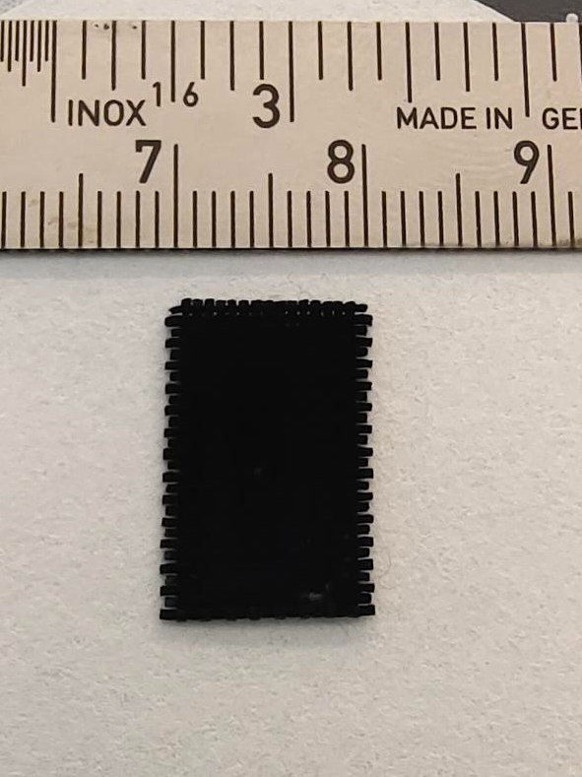
Figure S1. Optical image of HCP-MoOC.

Figure S2. SEM image of HP-MoO₂ grown on Ni foam.

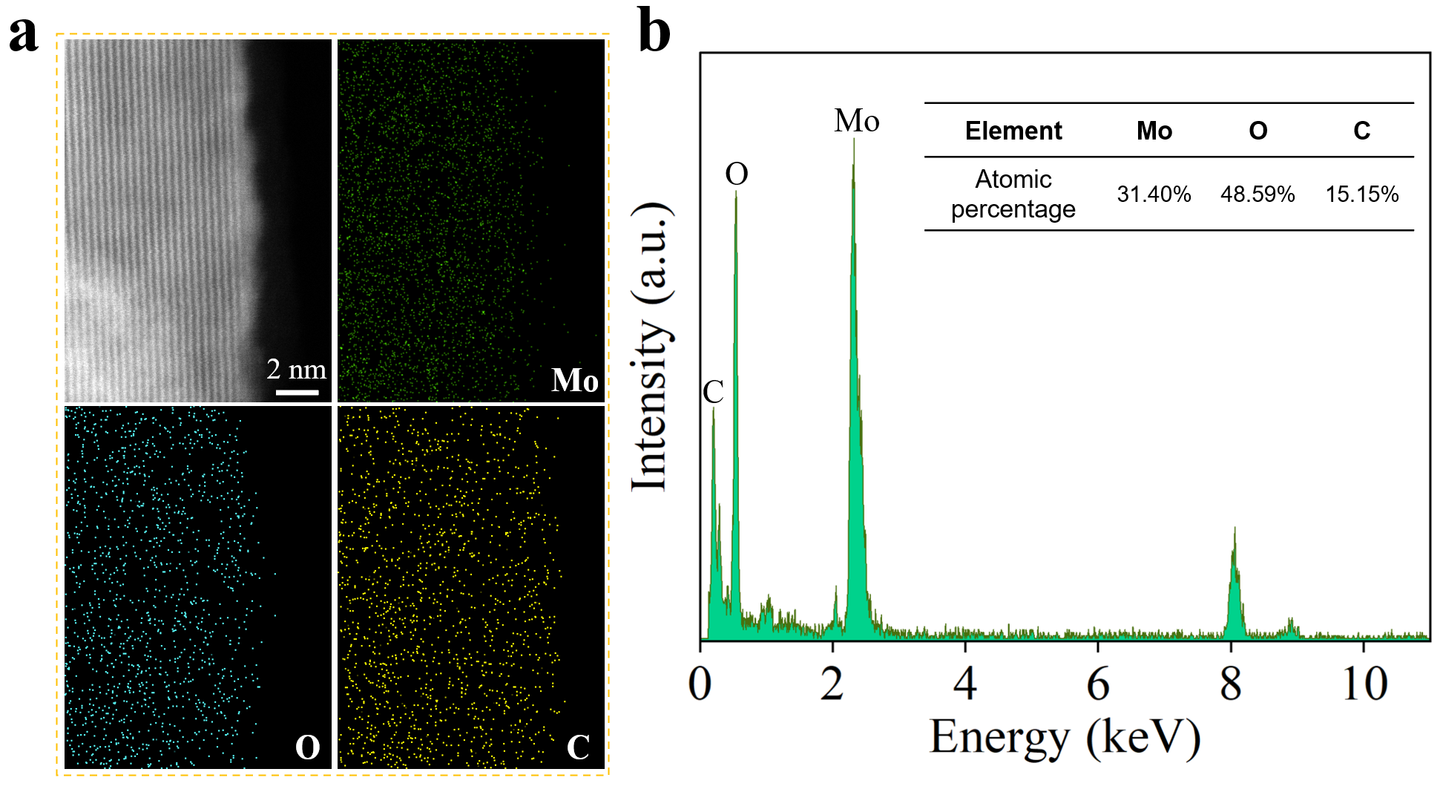
Figure S3. (a) Element mappings of a single MoO_{x}C_{y} sheet in the HP-MoOC. (b) Quantitative EDX analysis showing a Mo:O:C weight ratio of approximately 1:1.5:0.5 in the HP-MoOC nanosheet.

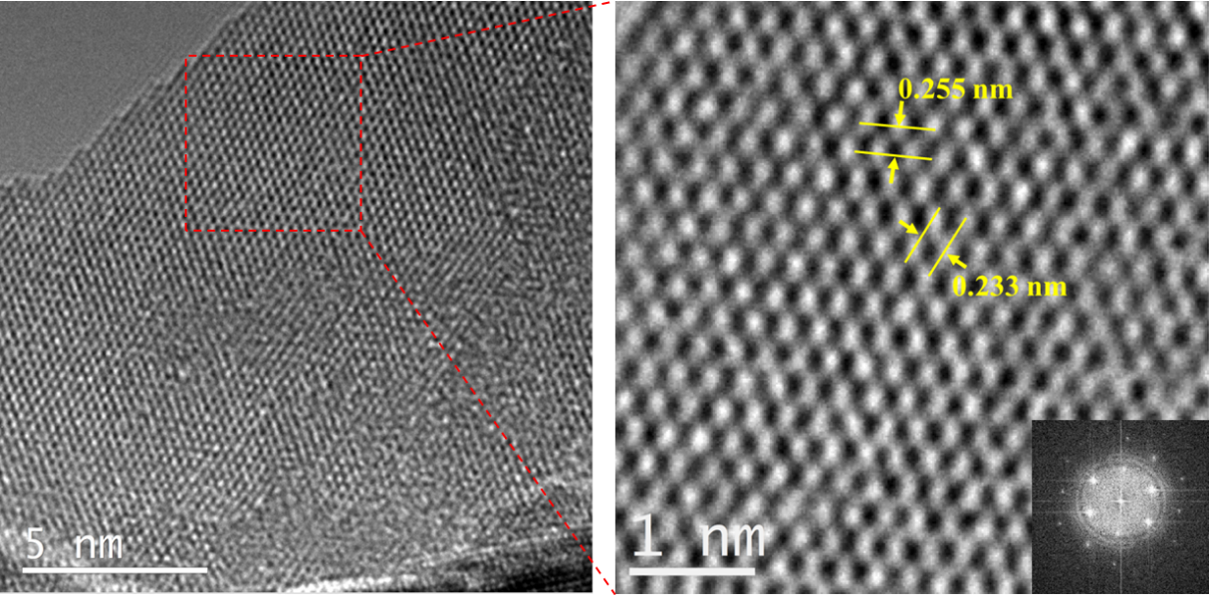
Figure S4. HRTEM images of HP-MoOC with the corresponding FFT pattern in the inset.

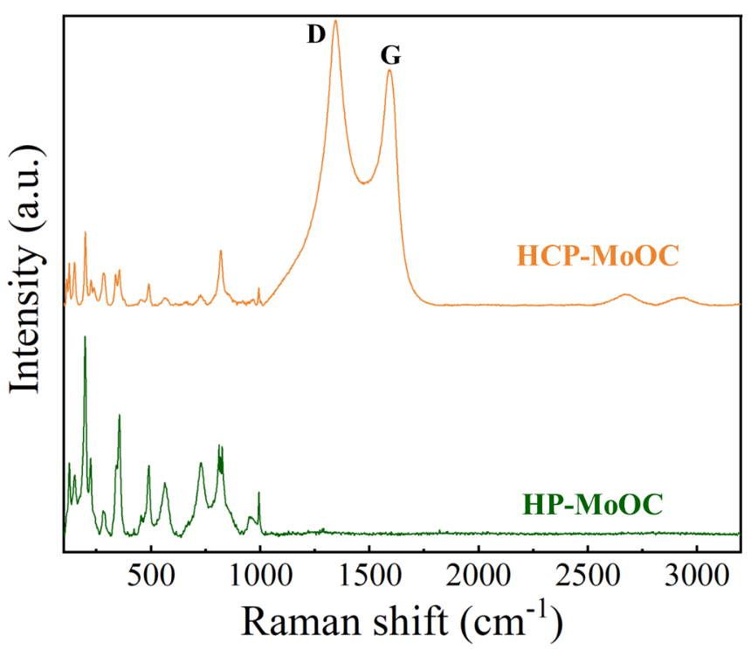
Figure S5. Raman spectra of HCP-MoOC and HP-MoOC.

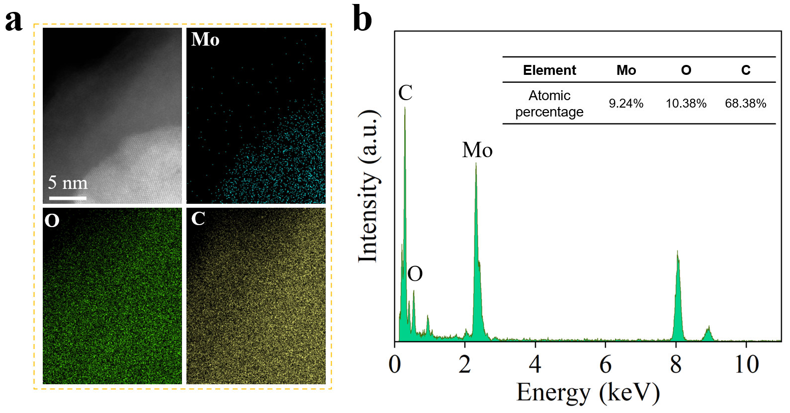
Figure S6. (a) Element mappings of a single MoO_{x}C_{y} sheet in the HCP-MoOC. (b) Quantitative EDX analysis showing a Mo:O:C weight ratio of approximately 1:1:7 in the HP-MoOC nanosheet. Note that the results cannot represent the real atomic ratio inside the crystalline structure of HCP-MoOC because of the existence of the carbon layer coating.

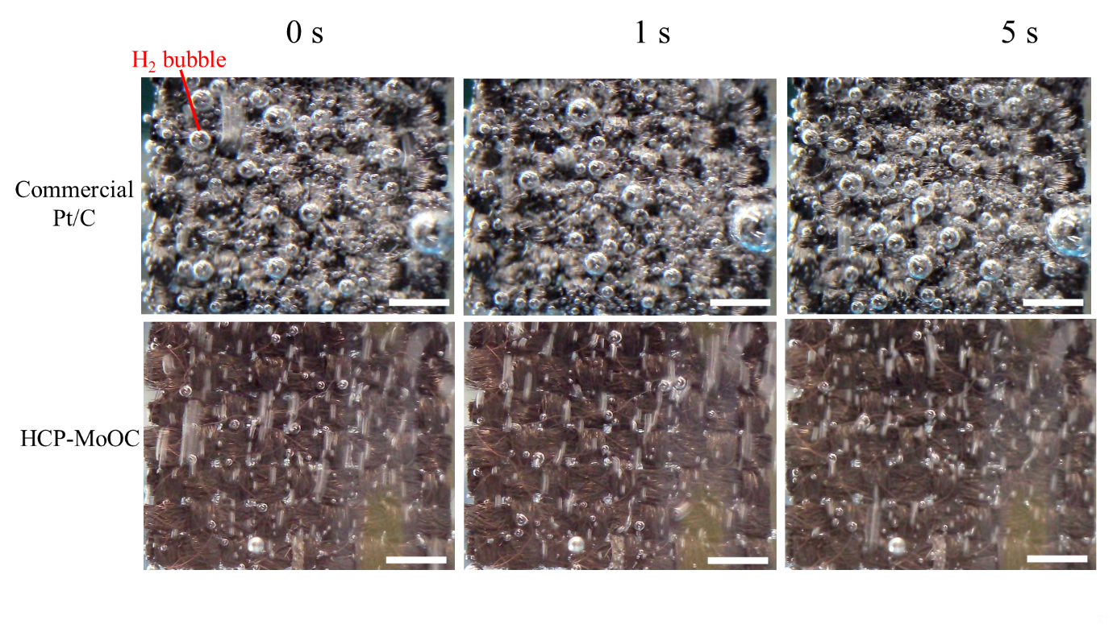
Figure S7. Bubble evolution of Pt/C and HCP-MoOC catalysts at a current density of 100 mA cm⁻². Scale bar: 1 mm.

Section S2 Supplementary Notes
Note S1
To quantitatively determine the atomic ratio within the crystalline structure of HCP-MoOC, hydrogen plasma treatment was performed at room temperature to etch the surface carbon layer. Specifically, the HCP-MoOC samples were cut into 0.5 cm × 1 cm pieces and placed in a crucible boat inside a quartz tube. Next, the tube was evacuated to a pressure of <3 Pa, followed by the introduction of a hydrogen gas flow at 10 mL min^{–1}. The pressure was controlled at 30 Pa, and a 300 W radio frequency source was coupled into the quartz tube to initiate the plasma treatment process.
HCP-MoOC treated by H₂ plasma for 2, 5, 10, and 20 minutes were labeled as HCP-MoOC-HE2, HCP-MoOC-HE5, HCP-MoOC-HE10, and HCP-MoOC-HE20, respectively. Raman spectroscopy was used to characterize all samples. As shown in Figure S8a, the intensities of the peaks corresponding to the surface carbon layer (i.e., D- and G-band peaks) gradually decreased with increasing treatment time, while the peaks representing MoO_{x}C_{y} (100-1000 cm⁻¹) unchanged up to 10 minutes of treatment. This suggests that the surface carbon layer was gradually etched away by the 10-minute plasma treatment, but further exposure (20 minutes) began to damage the MoO_{x}C_{y} crystalline structure. Thus, HCP-MoOC-HE10 can be considered representative of HCP-MoOC without the surface carbon layer. We note that weak D- and G-band peaks can still be observed in the Raman spectrum of HCP-MoOC-HE10, which may arise from the residue carbon located in the valleys of the vertically standing MoO_{x}C_{y} nanosheets. As shown in Figure S8b, while HER activity slightly improved after the removal of the surface carbon layer, the catalyst’s stability significantly deteriorated.
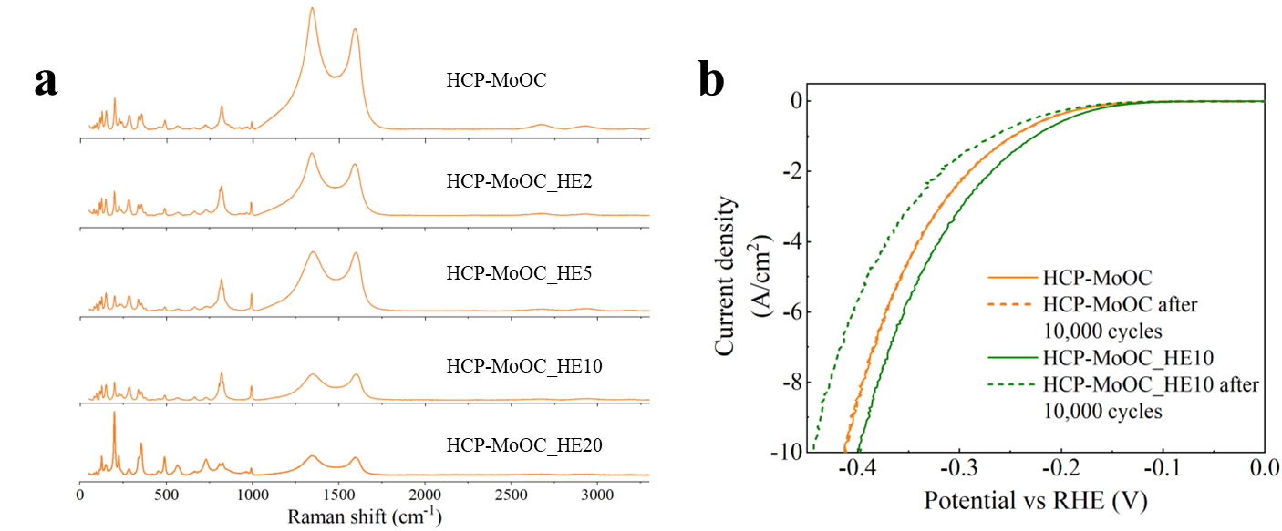
Figure S8. (a) Raman spectra of HCP-MoOC with different H₂ plasma treatment durations. (b) Polarization curves of HCP-MoOC and HCP-MoOC_HE10 before and after 10,000 cycles.

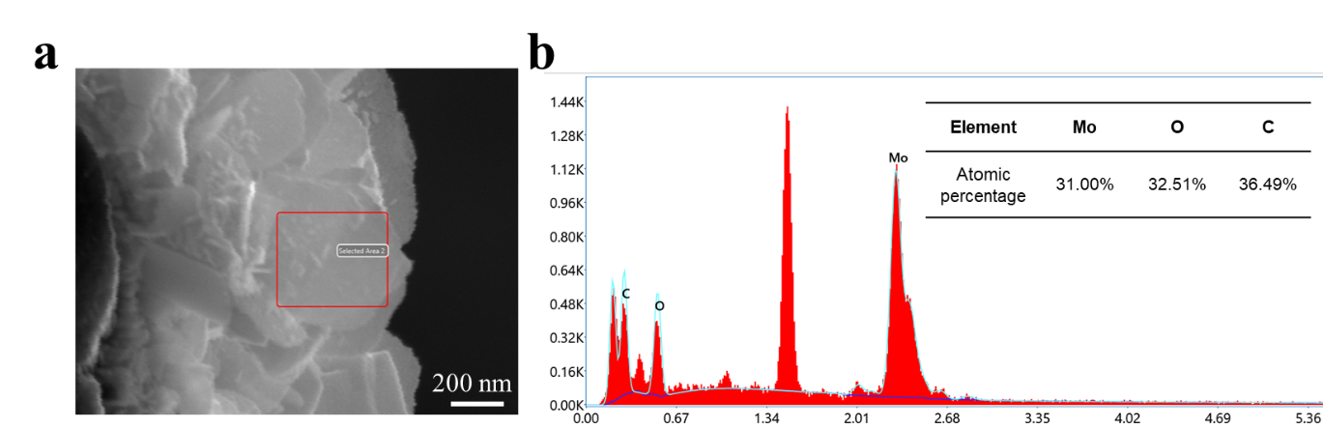
Figure S9. (a) Cross-sectional SEM image and (b) EDX analysis of atomic percentage of the HCP-MoOC-HE10.

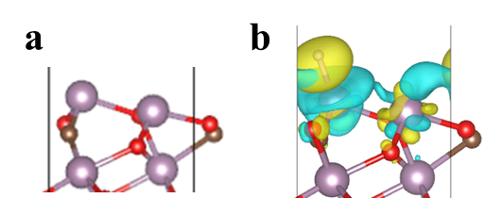
Figure S10. (a) Atomic models and (b) charge distributions of HP-MoOC.

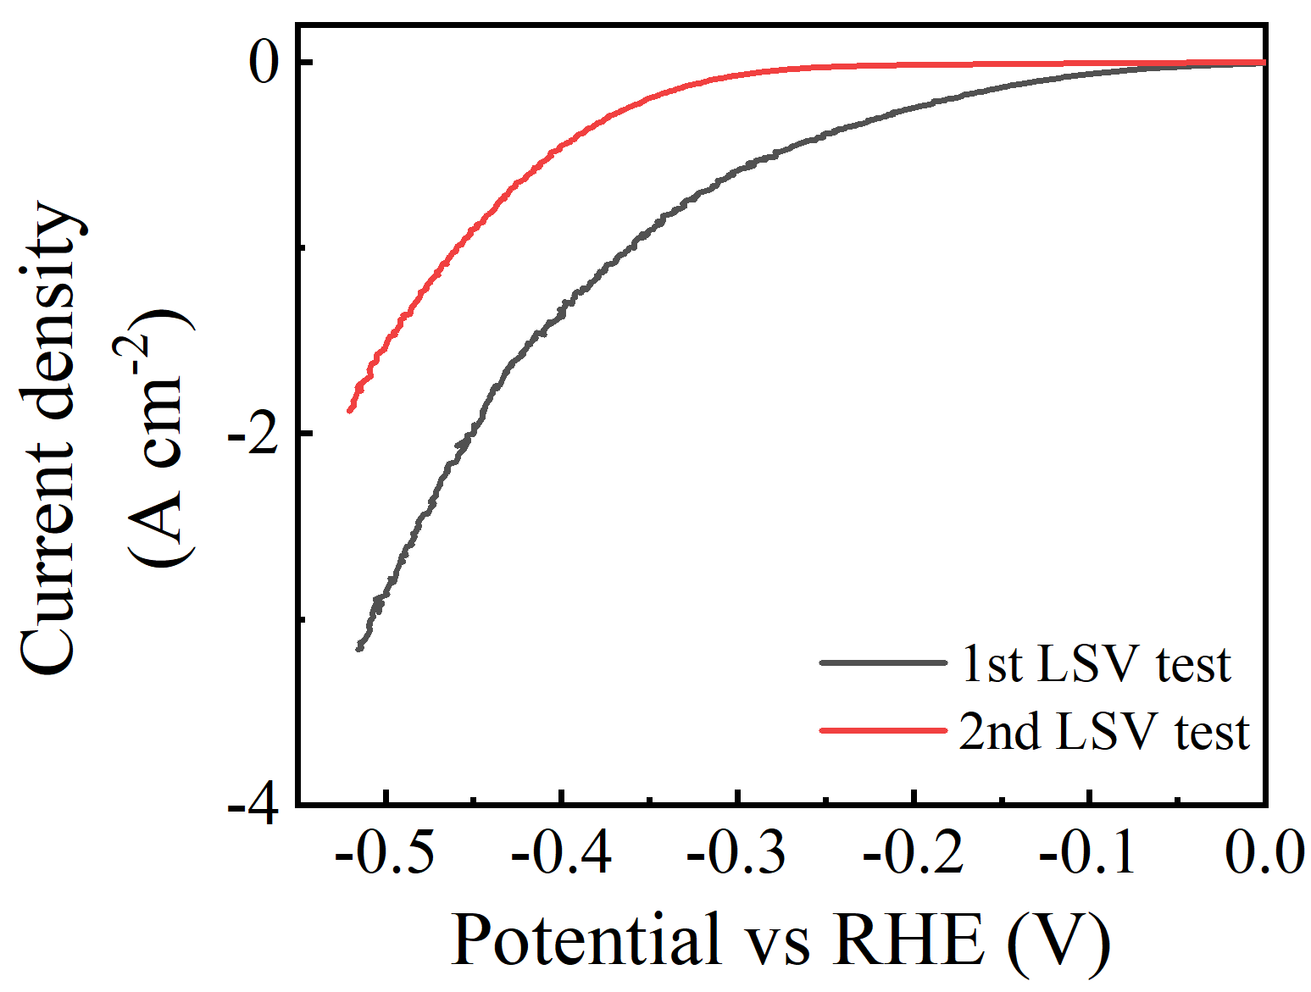
Figure S11. Polarized curves of commercial Pt/C catalysts during repeated LSV tests.

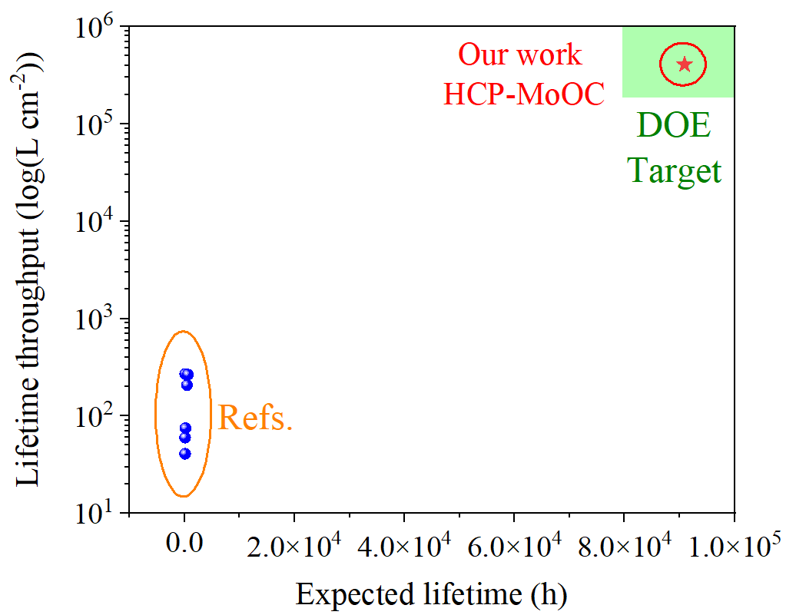

Figure S12. Comparison of hydrogen lifetime throughput and expected lifetime (calculated based on the 10% threshold by U.S. department of energy (DOE)) of HCP-MoOC and state-of-the-art catalysts

Section S3 Supplementary Tables
Table S1. Comparison between the overpotential of acidic HER at large current densities for the HCP-MoOC and the state-of-the-art catalysts
Reference | Paper | Catalyst | Overpotential | Current density | Electrolyte
[1] | Nat. Mater. | 2H-Nb_{1.35}S₂ | 420 mV | 5,000 mA cm⁻² | 0.5 M H₂SO₄
[2] | Adv. Mater. | single-layer Mo₂C | 460 mV | 5,000 mA cm⁻² | 0.5 M H₂SO₄
[3] | Nat. Commun. | Ta-TaS₂ | 398 mV | 2,000 mA cm⁻² | 0.5 M H₂SO₄
[4] | J. Am. Chem. Soc. | α-MoB₂ | 413 mV | 2,000 mA cm⁻² | 0.5 M H₂SO₄
[4] | J. Am. Chem. Soc. | α-MoB₂ | 334 mV | 1,000 mA cm⁻² | 0.5 M H₂SO₄
[5] | Nat. Commun. | Co/Se-MoS₂–NF | 382 mV | 1,000 mA cm⁻² | 0.5 M H₂SO₄
[6] | Nat. Commun. | MoC₂/MoS₂ | 227 mV | 1,000 mA cm⁻² | 0.5 M H₂SO₄
[7] | Nat. Commun. | HC-MoS₂/Mo₂C | 414 mV | 1,000 mA cm⁻² | 0.5 M H₂SO₄
[8] | Adv. Mater. | Co–N–C | 343 mV | 1,000 mA cm⁻² | 0.5 M H₂SO₄
- | Our work | HCP-MoOC | 358 mV | 5,000 mA cm⁻² | 0.5 M H₂SO₄
- | Our work | HCP-MoOC | 415 mV | 10,000 mA cm⁻² | 0.5 M H₂SO₄

Table S2. Summary of the electrocatalytic hydrogen evolution performance of the HCP-MoOC and state-of-the-art catalysts
Ref. | Journal | Catalyst | Current density  (mA cm⁻²) | Stability (h) | H₂ throughput  (L cm⁻²) | Performance degradation (%) | Expected lifetime (h) | Lifetime throughput (L cm⁻²)
[6] | Nat. Commun. | Mo₂S/Mo₂C | 200 | 24 | 2.15 | ̶ | ̶ | ̶
[3] | Nat. Commun. | Ta-TaS₂ | 500 | 175 | 39.18 | ̶ | ̶ | ̶
[3] | Nat. Commun. | Ta-TaS₂ | 1,000 | 25 | 11.19 | ̶ | ̶ | ̶
[2] | Adv. Mater. | Edge-enriched Mo₂C | 2,000 | 8 | 7.16 | ̶ | ̶ | ̶
[1] | Nat. Mater. | NbS₂ | 5,000 | 120 | 268.64 | ~ 10* | ~ 120* | 268.6*
[4] | J. Am. Chem. Soc. | MoB₂ | 1,500 | 60 | 40.3 | ~ 6.74* | ~ 89* | 59.8*
[5] | Nat. Commun. | Co/Se doped MoS₂ | 1,000 | 360 | 161.19 | ~ 6.07* | ~ 593* | 265.5*
[7] | Nat. Commun. | HC-MoS₂/Mo₂C | 450 | 24 | 4.84 | ̶ | ̶ | ̶
[7] | Nat. Commun. | HC-MoS₂/Mo₂C | 200 | 24 | 2.15 | ̶ | ̶ | ̶
[8] | Adv. Mater. | Co–N–C | 1,000 | 32 | 14.33 | ~ 3.52* | ~ 91* | 40.7*
[9] | Adv. Funct. Mater. | Co-Co₂P@NPC/rGO | 1,000 | 20 | 8.95 | 1.2 | ~ 167* | 74.6*
[10] | Chem. Eng. J. | Pt/MoO₂ | 1,000 | 200 | 89.55 | ~ 4.32* | ~ 463* | 207.3*
[11] | Small | CoS|Ni|P | 1,000 | 20 | 8.95 | ~ 11.45* | ~ 18* | 7.8*
[12] | DOE target | ̶ | 3,000 | 1,000 | 1,253.67 | ~ 0.13 | 80,000 | 100,503.1
- | Our work | HCP-MoOC | 10,000 | 1,000 | 4,477.37 | ~ 0.11 | 90,909 | 407,033.6
* The values are estimated from the data in references.

References
[1] Yang J, Mohmad A R, Wang Y, Fullon R, Song X, Zhao F, Bozkurt I, Augustin M, Santos E J G, Shin H S, Zhang W, Voiry D, Jeong H Y and Chhowalla M 2019 Ultrahigh-current-density niobium disulfide catalysts for hydrogen evolution Nat. Mater. 18 1309–14
[2] Wu J, Su J, Wu T, Huang L, Li Q, Luo Y, Jin H, Zhou J, Zhai T, Wang D, Gogotsi Y and Li Y 2023 Scalable Synthesis of 2D Mo2C and Thickness-Dependent Hydrogen Evolution on Its Basal Plane and Edges Advanced Materials 35 2209954
[3] Yu Q, Zhang Z, Qiu S, Luo Y, Liu Z, Yang F, Liu H, Ge S, Zou X, Ding B, Ren W, Cheng H-M, Sun C and Liu B 2021 A Ta-TaS2 monolith catalyst with robust and metallic interface for superior hydrogen evolution Nat Commun 12 6051
[4] Chen Y, Yu G, Chen W, Liu Y, Li G-D, Zhu P, Tao Q, Li Q, Liu J, Shen X, Li H, Huang X, Wang D, Asefa T and Zou X 2017 Highly Active, Nonprecious Electrocatalyst Comprising Borophene Subunits for the Hydrogen Evolution Reaction J. Am. Chem. Soc. 139 12370–3
[5] Zheng Z, Yu L, Gao M, Chen X, Zhou W, Ma C, Wu L, Zhu J, Meng X, Hu J, Tu Y, Wu S, Mao J, Tian Z and Deng D 2020 Boosting hydrogen evolution on MoS2 via co-confining selenium in surface and cobalt in inner layer Nat Commun 11 3315
[6] Luo Y, Tang L, Khan U, Yu Q, Cheng H-M, Zou X and Liu B 2019 Morphology and surface chemistry engineering toward pH-universal catalysts for hydrogen evolution at high current density Nat Commun 10 269
[7] Zhang C, Luo Y, Tan J, Yu Q, Yang F, Zhang Z, Yang L, Cheng H-M and Liu B 2020 High-throughput production of cheap mineral-based two-dimensional electrocatalysts for high-current-density hydrogen evolution Nat Commun 11 3724
[8] Liu R, Gong Z, Liu J, Dong J, Liao J, Liu H, Huang H, Liu J, Yan M, Huang K, Gong H, Zhu J, Cui C, Ye G and Fei H 2021 Design of Aligned Porous Carbon Films with Single-Atom Co–N–C Sites for High-Current-Density Hydrogen Generation Advanced Materials 33 2103533
[9] Li G, Yu J, Jia J, Yang L, Zhao L, Zhou W and Liu H 2018 Cobalt–Cobalt Phosphide Nanoparticles@Nitrogen-Phosphorus Doped Carbon/Graphene Derived from Cobalt Ions Adsorbed Saccharomycete Yeasts as an Efficient, Stable, and Large-Current-Density Electrode for Hydrogen Evolution Reactions Advanced Functional Materials 28 1801332
[10] Qiu Y, Liu S, Wei C, Fan J, Yao H, Dai L, Wang G, Li H, Su B and Guo X 2022 Synergistic effect between platinum single atoms and oxygen vacancy in MoO2 boosting pH-Universal hydrogen evolution reaction at large current density Chemical Engineering Journal 427 131309
[11] Sun J, Ren M, Yu L, Yang Z, Xie L, Tian F, Yu Y, Ren Z, Chen S and Zhou H 2019 Highly Efficient Hydrogen Evolution from a Mesoporous Hybrid of Nickel Phosphide Nanoparticles Anchored on Cobalt Phosphosulfide/Phosphide Nanosheet Arrays Small 15 1804272
[12] Open Energy Data. Energy.Gov. Https://Www.Energy.Gov/Data/Open-Energy-Data (Accessed 2024-05-07).

