Development of diagnostic markers for the disease susceptibility gene Tsn1 in wheat reveals novel resistance alleles and a new locus required for ToxA sensitivity, TAG, Katherine L.D. Running, Krishna Acharya, Tiana M. Roth, Gurminder Singh, Agnes Szabo-Hever, Amanda R. Peters Haugrud, Jason D. Fiedler, Timothy L. Friesen, and Justin D. Faris*
*Corresponding author: justin.faris@usda.gov, USDA-Agricultural Research Service, Cereal Crops Improvement Research Unit, Edward T. Schafer Agricultural Research Center, Fargo, ND, USA

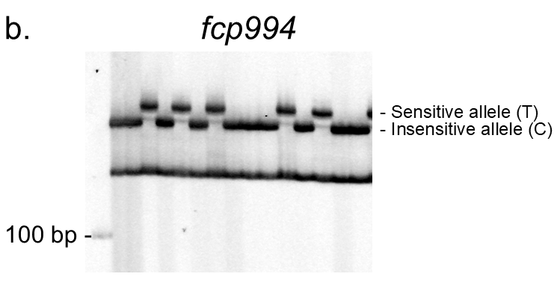
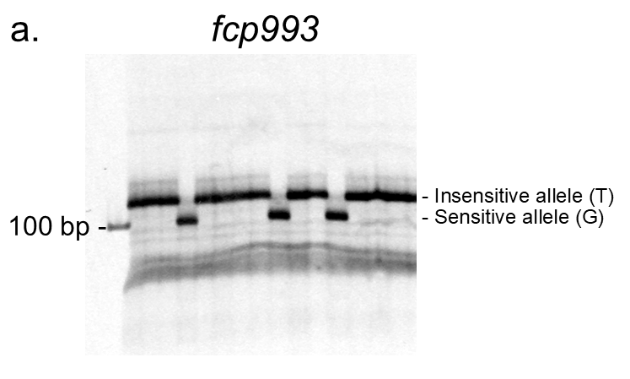

Supplementary Figure 1 Tsn1-B1 STARP markers fcp993 and fcp994.
The polyacrylamide gel images of markers fcp993 (a) and fcp994 (b) run on a subset of the WWP and GDP, respectively. The alleles are labeled to the right of the gel image. The 100 bp ladder is labeled on the left of each gel.

