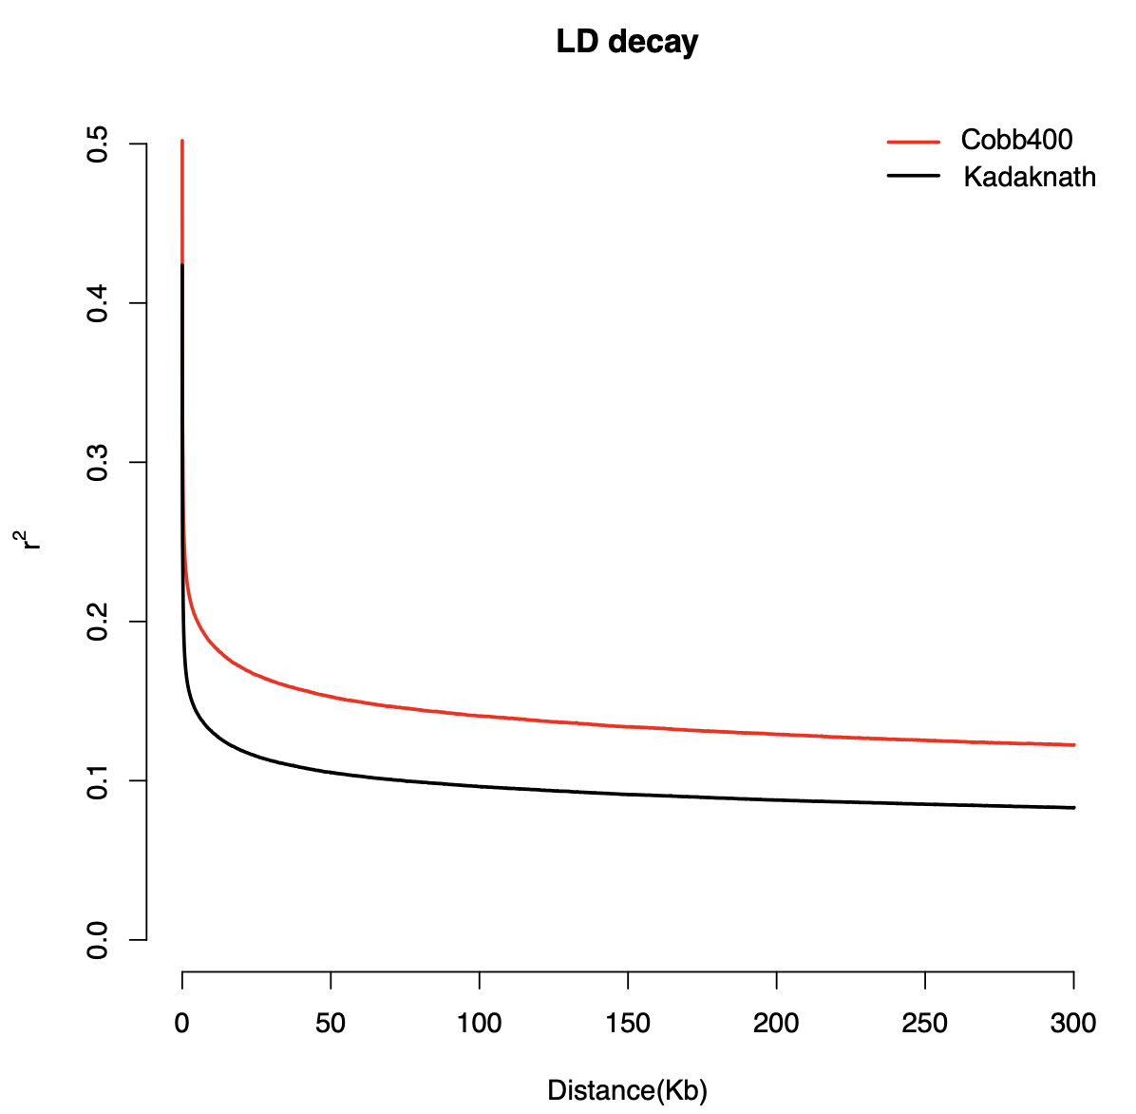
Figure 1 Linkage disequilibrium (LD) decay plots for Cobb400 (A) and Kadaknath (B) chickens from genotype data after quality control. The plots show the decline of LD (r²) with increasing SNP distance (in kilobases, ×100)

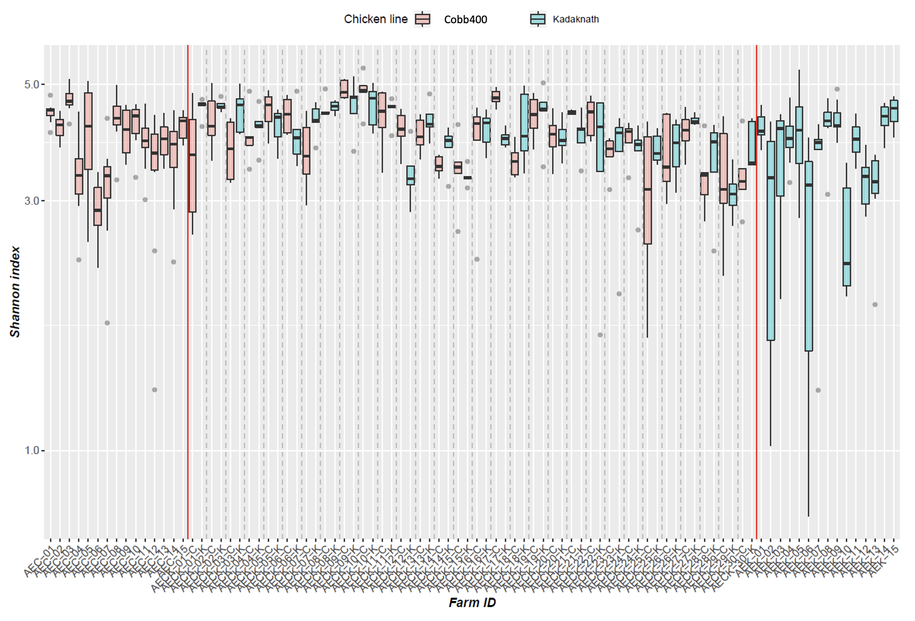

Figure 2 Shannon index alpha diversity distribution plots for Cobb400 and Kadaknath. X-axis shows the farms. AEC farms reared Cobb400 only, AEK farms reared Kadaknath only, AECK farms reared both breeds and the birds are separated in the plot by suffix _K (Kadaknath) and _C (Cobb400)
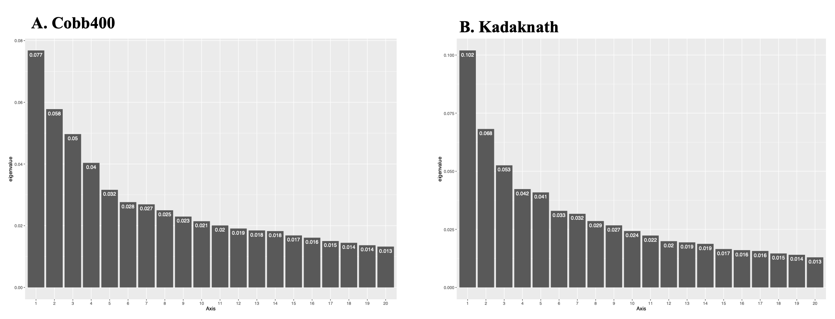
Figure 3. Scree-plot of the first 20 Principal Coordinate Analysis (PCoA) axes for Cobb400 commercial broiler (A) and Kadaknath (B) chickens from all farms.
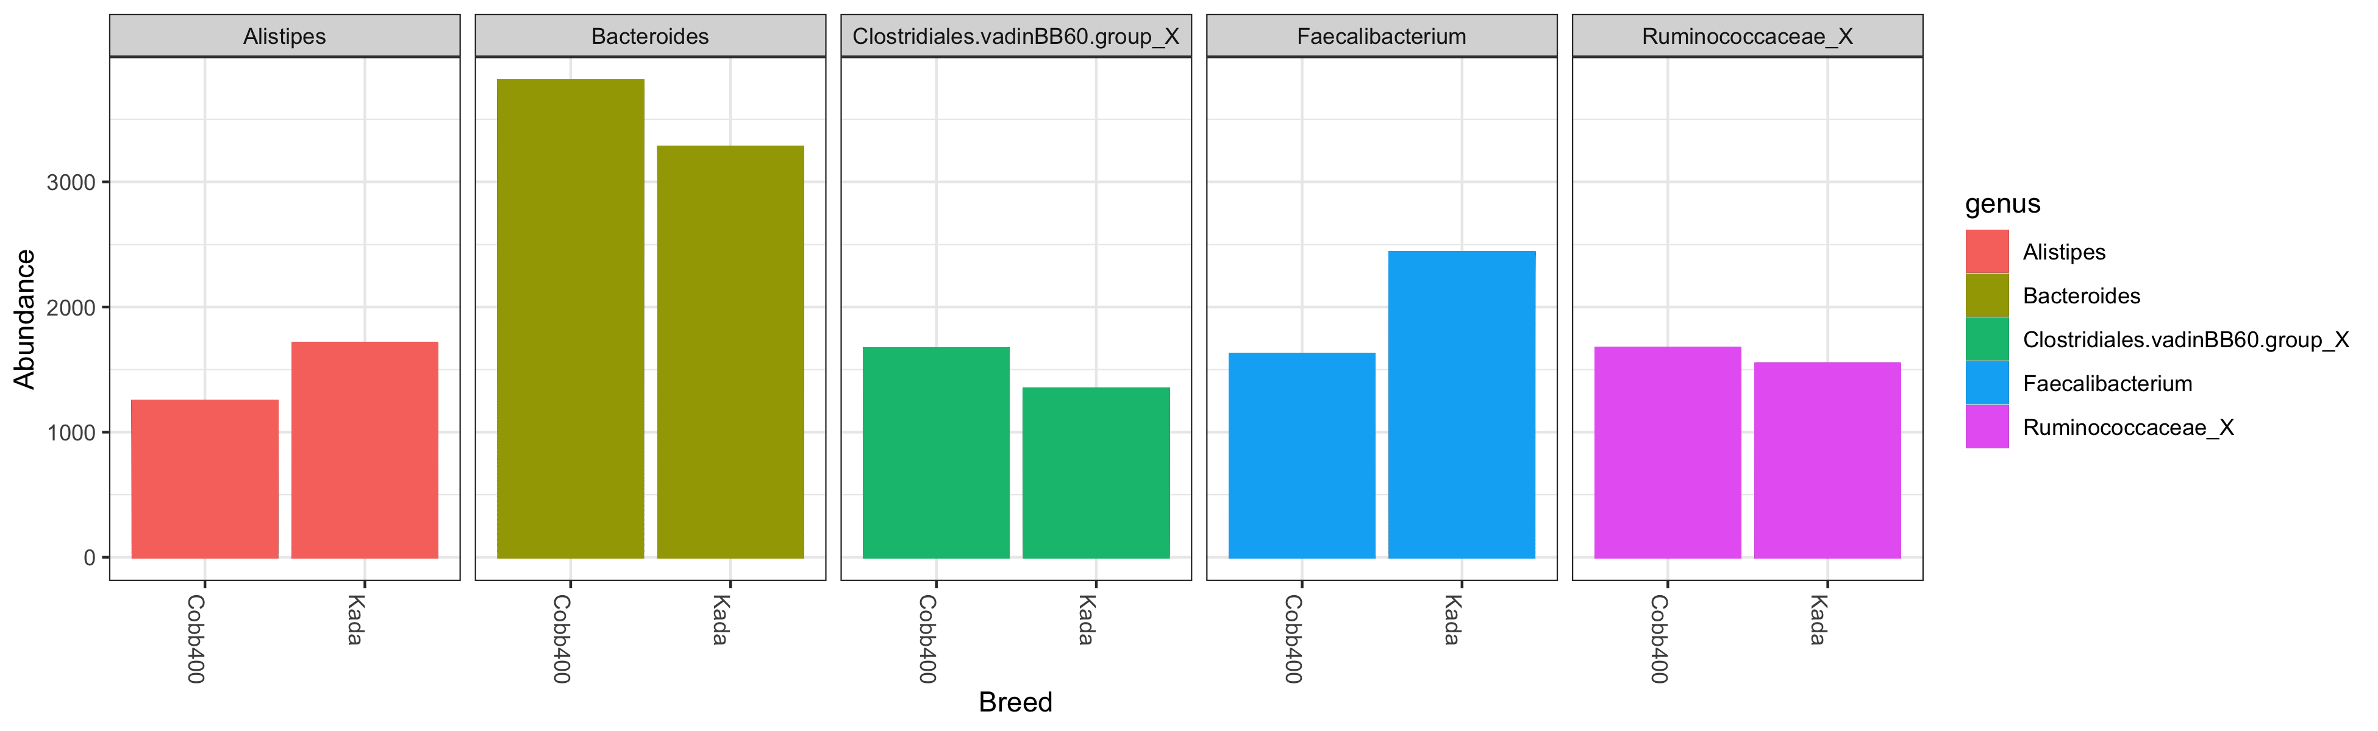
Figure 4 The five most abundant genera detected in caecal contents sampled from Cobb400 and Kadaknath (Kada) chickens.

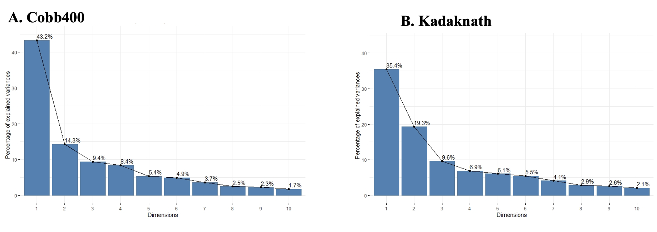
Figure 5 Farm variability for commercial (A) Cobb400 broilers and (B) Kadaknath using Multiple correspondence analyses.
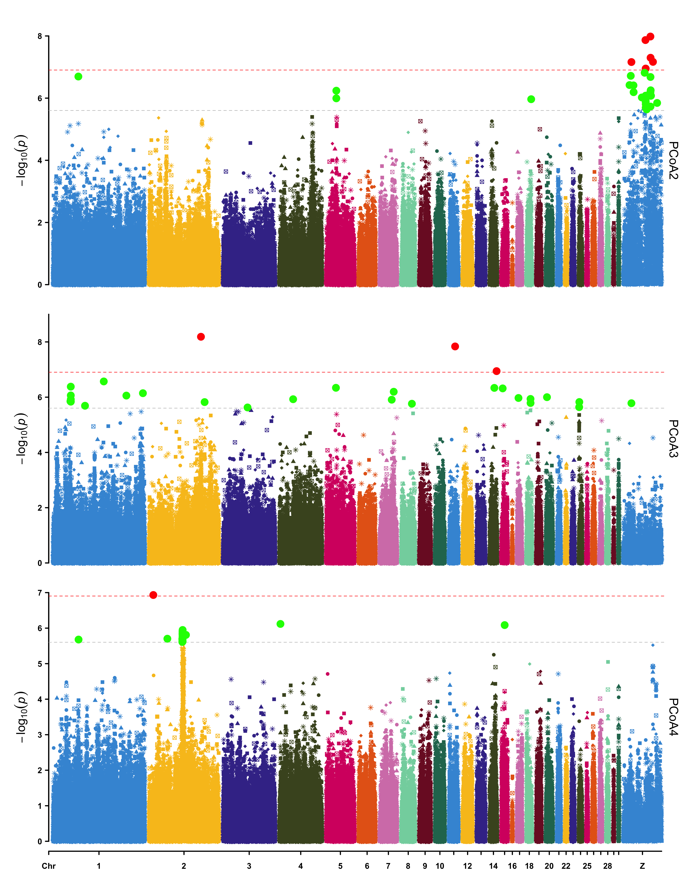
Figure 6 Manhattan plots display the GWAS results for beta-diversity (PCoA axes) in Cobb400 using the imputed 600K HD arrays. Genomic location is plotted against – log10(P) in the Manhattan plot. Genome-wide (P < 0.05) and suggestive genome-wide thresholds are shown as red and grey lines, respectively.

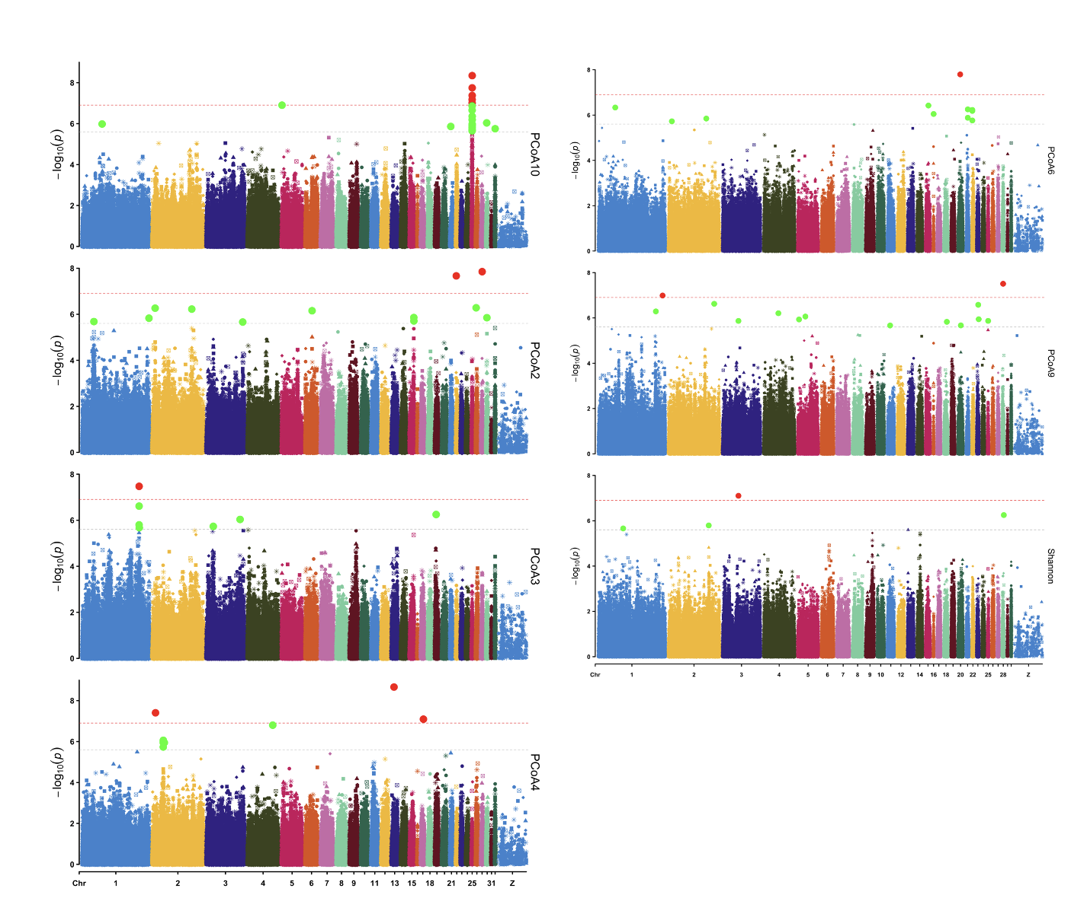
Figure 7 Manhattan plots display the GWAS results for alpha- (Shannon index) and beta-diversity (PCoA axes) in Kadaknath using the imputed 600K HD arrays. Genomic location is plotted against – log10(P) in the Manhattan plot. Genome-wide (P < 0.05) and suggestive genome-wide thresholds are shown as red and grey lines, respectively.

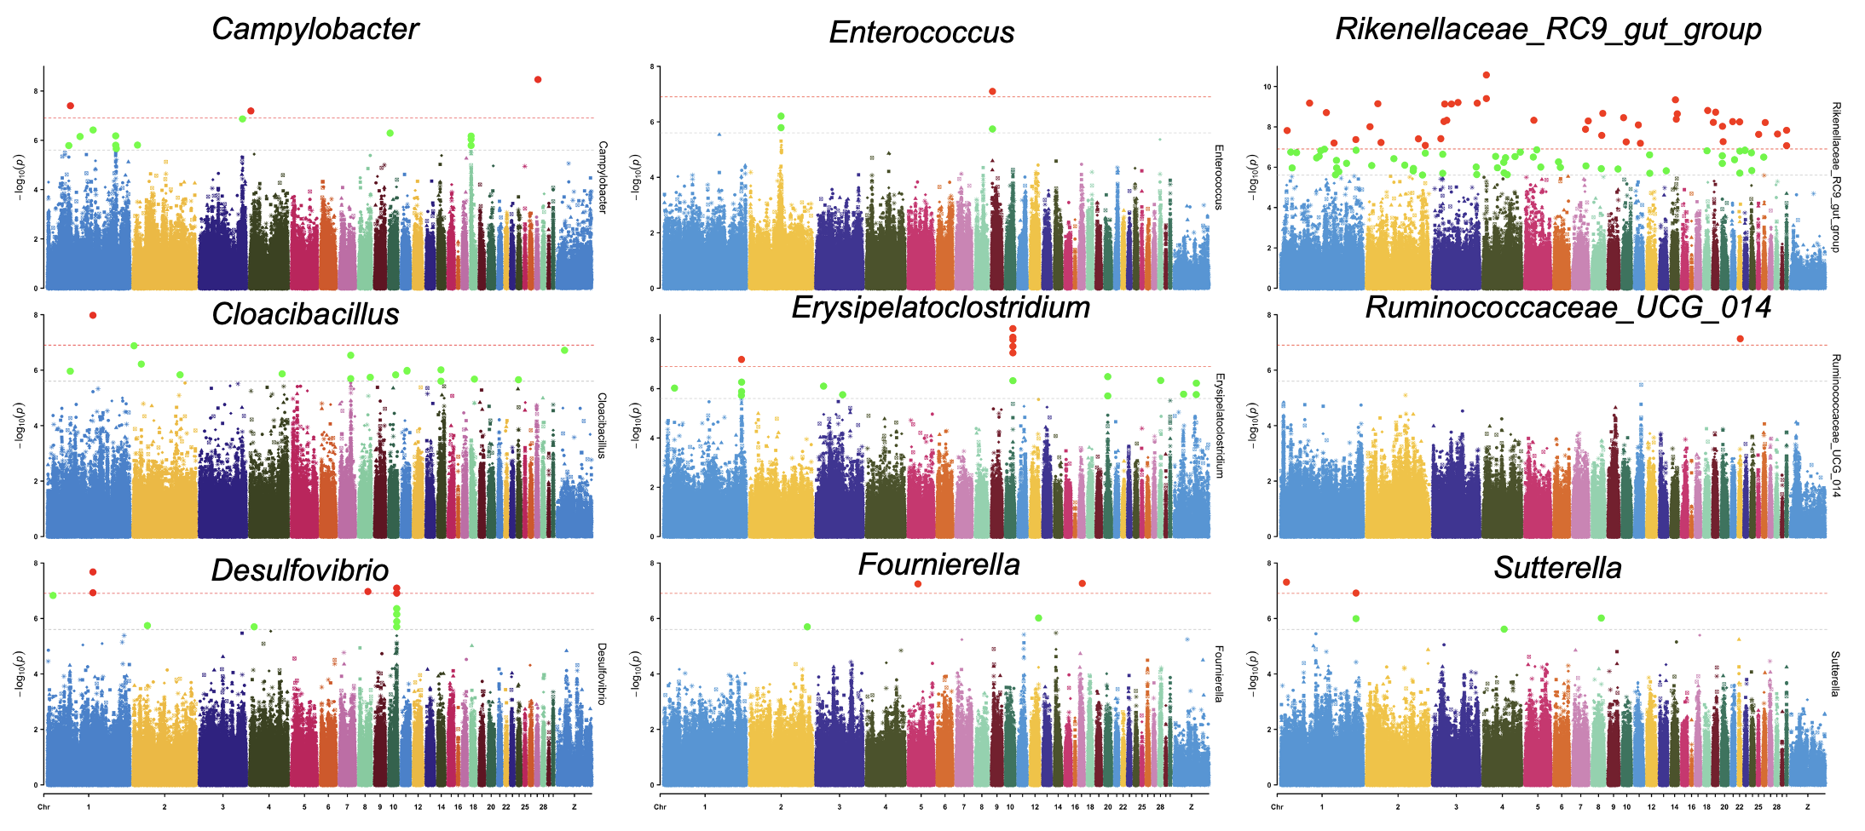
Figure 8 Manhattan plots display the GWAS results for significant SNP-based heritable phenotypes of caecal bacterial genera in Cobb400 using the imputed 600K HD arrays. Genomic location is plotted against – log10(P) in the Manhattan plot. Genome-wide (P < 0.05) and suggestive genome-wide thresholds are shown as red and grey lines, respectively.

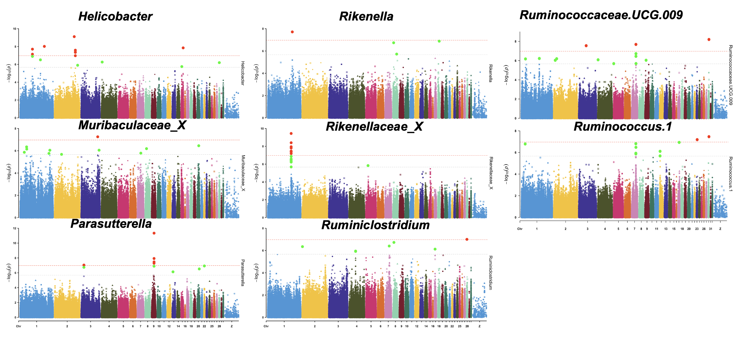
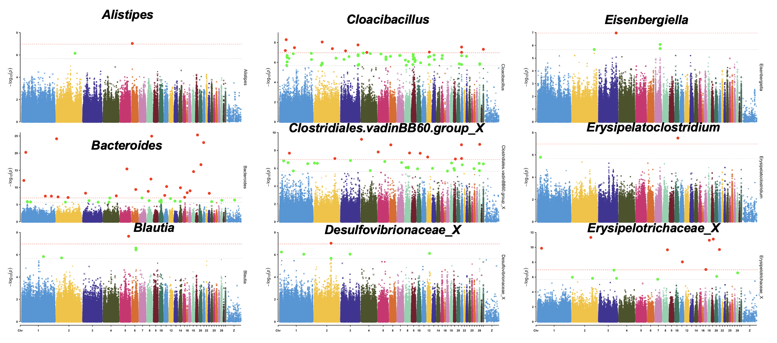
Figure 9 Manhattan plots display the GWAS results for significant SNP-based heritable phenotypes of caecal bacterial genera in Kadaknath using the imputed 600K (B) HD arrays. Genomic location is plotted against – log10(P) in the Manhattan plot. Genome-wide (P < 0.05) and suggestive genome-wide thresholds are shown as red and grey lines, respectively.

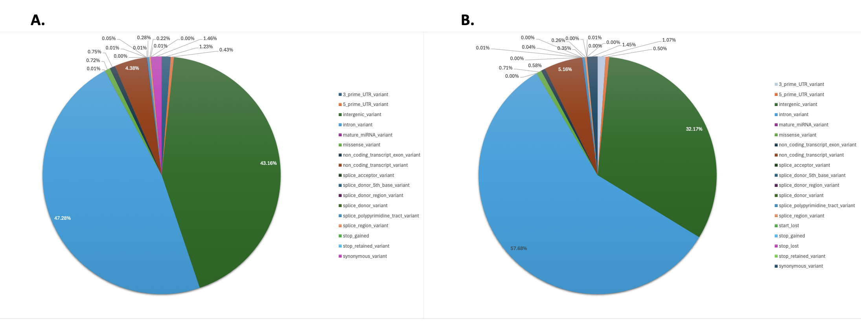
Figure 10 Pie Chart of consequence of VEP analysis of WGS in both Cobb400 (A) and Kadaknath (B).
Figure 11 KEGG enriched pathways of the genes linked to significant SNPs associated with beta-diversity of caecal microbiota in Cobb400 (Cobb) and Kadaknath chickens.

Figure 12 KEGG enriched pathways of the genes linked to significant SNPs associated with caecal genera in Cobb400 (Cobb) chickens.

Figure 13 KEGG enriched pathways of the genes linked to significant SNPs associated with caecal genera in Kadaknath chickens.

Table 2 The overall prevalence and relative abundance (with standard error; se) of the genera selected for GWAS analysis. SNP-based heritability is shown, with se and P-values in Cobb400 and Kadaknath chickens estimated by GCTA (Phenotype types: B = binary; C = continuous).
 |  | Prevalence | Relative abundance, % |  |  |  | SNP-based Heritability
 |  | Prevalence | Cobb400 |  | Kadaknath |  | Cobb400 |  |  | Kadaknath
Type of phenotypes | Traits | Prevalence | Relative abundance, % | s.e | Relative abundance, % | s.e | h² (pve) | se | P-Value | h² (pve) | se | P-Value
B | Akkermansia | 0.97 | 2.10 | 0.35 | 0.82 | 0.27 | 0.57 | 0.14 | <0.01 | 0.09 | 0.10 | 0.07
C | Alistipes | 0.43 | 4.27 | 0.31 | 6.47 | 0.59 | 0.46 | 0.18 | <0.01 | 0.51 | 0.15 | <0.01
B | Anaerostipes | 0.46 | 0.14 | 0.02 | 0.17 | 0.04 | 0.19 | 0.06 | 0.03 | 0.15 | 0.11 | 0.01
B | Bacillus | 0.76 | 0.18 | 0.03 | 0.12 | 0.01 | 0.00 | 0.17 | 0.50 | 0.00 | 0.09 | 0.50
C | Bacteroides | 0.42 | 13.04 | 0.58 | 12.41 | 0.74 | 0.25 | 0.19 | 0.07 | 0.28 | 0.05 | <0.01
B | Barnesiella | 0.97 | 0.92 | 0.19 | 1.42 | 0.39 | 0.36 | 0.16 | 0.01 | 0.22 | 0.17 | 0.12
B | Barnesiellaceae_X | 0.84 | 0.17 | 0.02 | 0.25 | 0.03 | 0.10 | 0.15 | 0.21 | 0.54 | 0.17 | <0.01
B | Bilophila | 0.34 | 0.27 | 0.03 | 0.25 | 0.02 | 0.13 | 0.15 | 0.13 | 0.16 | 0.01 | 0.01
C | Blautia | 0.69 | 0.53 | 0.06 | 0.58 | 0.05 | 0.17 | 0.05 | 0.04 | 0.21 | 0.03 | <0.01
C | Butyricicoccus | 0.49 | 0.93 | 0.08 | 0.57 | 0.06 | 0.17 | 0.03 | 0.02 | 0.05 | 0.10 | 0.28
B | Butyricimonas | 0.94 | 0.29 | 0.04 | 0.20 | 0.02 | 0.23 | 0.07 | 0.06 | 0.53 | 0.15 | <0.01
B | Campylobacter | 0.56 | 0.90 | 0.14 | 0.68 | 0.21 | 0.16 | 0.03 | 0.02 | 0.17 | 0.02 | 0.01
C | Christensenellaceae.R.7.group | 0.92 | 0.87 | 0.07 | 0.57 | 0.05 | 0.00 | 0.08 | 0.50 | 0.41 | 0.16 | <0.01
B | Cloacibacillus | 0.80 | 2.62 | 0.26 | 1.09 | 0.16 | 0.39 | 0.17 | 0.01 | 0.21 | 0.02 | <0.01
C | Clostridiales.vadinBB60.group_X | 0.55 | 5.70 | 0.25 | 5.09 | 0.24 | 0.07 | 0.11 | 0.17 | 0.17 | 0.02 | <0.01
C | Coprobacter | 0.37 | 0.69 | 0.06 | 0.44 | 0.05 | 0.36 | 0.16 | <0.01 | 0.34 | 0.16 | <0.01
B | Defluviitaleaceae.UCG.011 | 0.88 | 0.09 | 0.01 | 0.12 | 0.01 | 0.01 | 0.12 | 0.46 | 0.21 | 0.04 | 0.01
B | Desulfovibrio | 0.49 | 0.58 | 0.06 | 0.33 | 0.04 | 0.28 | 0.05 | <0.01 | 0.21 | 0.04 | <0.01
B | Desulfovibrionaceae_X | 0.59 | 0.12 | 0.02 | 0.08 | 0.01 | 0.21 | 0.06 | 0.04 | 0.49 | 0.18 | <0.01
B | DTU014_X_X | 0.76 | 0.13 | 0.02 | 0.07 | 0.01 | 0.01 | 0.09 | 0.43 | 0.16 | 0.01 | 0.01
B | DTU089 | 0.55 | 0.14 | 0.02 | 0.17 | 0.02 | 0.00 | 0.17 | 0.50 | 0.02 | 0.08 | 0.42
C | Eisenbergiella | 0.39 | 0.80 | 0.11 | 0.73 | 0.05 | 0.01 | 0.13 | 0.48 | 0.17 | 0.03 | 0.01
B | Enterococcus | 0.30 | 0.19 | 0.04 | 0.34 | 0.09 | 0.61 | 0.14 | <0.01 | 0.17 | 0.03 | 0.03
C | Erysipelatoclostridium | 0.33 | 0.29 | 0.03 | 0.49 | 0.04 | 0.19 | 0.03 | <0.01 | 0.36 | 0.15 | <0.01
B | Erysipelotrichaceae_X | 0.91 | 0.07 | 0.01 | 0.15 | 0.02 | 0.00 | 0.12 | 0.50 | 0.27 | 0.05 | <0.01
B | Escherichia.Shigella | 0.46 | 0.92 | 0.15 | 0.78 | 0.18 | 0.00 | 0.19 | 0.50 | 0.08 | 0.09 | 0.08
C | Faecalibacterium | 0.35 | 5.56 | 0.33 | 9.23 | 0.49 | 0.24 | 0.06 | 0.03 | 0.00 | 0.09 | 0.50
B | Flavobacteriales_X_X | 0.47 | 0.33 | 0.03 | 0.14 | 0.02 | 0.67 | 0.13 | <0.01 | 0.42 | 0.18 | <0.01
B | Flavonifractor | 0.39 | 0.06 | 0.01 | 0.06 | 0.01 | 0.10 | 0.14 | 0.15 | 0.00 | 0.08 | 0.50
B | Fournierella | 0.32 | 0.44 | 0.10 | 0.39 | 0.05 | 0.33 | 0.13 | <0.01 | 0.29 | 0.05 | <0.01
C | Gastranaerophilales_X_X | 0.40 | 2.90 | 0.18 | 2.45 | 0.16 | 0.41 | 0.18 | 0.01 | 0.14 | 0.10 | 0.08
C | GCA.900066575 | 0.96 | 0.66 | 0.04 | 0.87 | 0.05 | 0.07 | 0.15 | 0.31 | 0.00 | 0.07 | 0.50
C | Helicobacter | 0.49 | 2.07 | 0.25 | 1.70 | 0.18 | 0.28 | 0.06 | <0.01 | 0.36 | 0.15 | <0.01
C | Lachnoclostridium | 0.96 | 1.97 | 0.10 | 1.78 | 0.07 | 0.10 | 0.01 | 0.05 | 0.00 | 0.15 | 0.50
C | Lachnospiraceae_X | 0.35 | 4.73 | 0.17 | 4.59 | 0.18 | 0.00 | 0.09 | 0.50 | 0.00 | 0.11 | 0.50
C | Lactobacillus | 0.92 | 2.47 | 0.23 | 1.95 | 0.16 | 0.30 | 0.19 | 0.09 | 0.22 | 0.05 | 0.01
B | Megamonas | 0.45 | 1.70 | 0.27 | 3.26 | 0.42 | 0.10 | 0.13 | 0.13 | 0.46 | 0.15 | <0.01
B | Methanocorpusculum | 0.51 | 0.18 | 0.02 | 0.08 | 0.01 | 0.11 | 0.01 | 0.05 | 0.26 | 0.07 | 0.01
B | Mollicutes.RF39_X_X | 0.59 | 0.02 | 0.00 | 0.05 | 0.01 | 0.00 | 0.20 | 0.50 | 0.03 | 0.10 | 0.41
B | Muribaculaceae_X | 0.45 | 0.44 | 0.09 | 0.50 | 0.12 | 0.09 | 0.14 | 0.17 | 0.12 | 0.01 | 0.03
C | Negativibacillus | 0.97 | 0.49 | 0.06 | 0.56 | 0.03 | 0.22 | 0.19 | 0.15 | 0.25 | 0.04 | <0.01
B | Odoribacter | 0.81 | 0.56 | 0.13 | 0.27 | 0.09 | 0.00 | 0.10 | 0.50 | 0.27 | 0.19 | 0.22
C | Oscillibacter | 0.89 | 0.46 | 0.03 | 0.62 | 0.06 | 0.21 | 0.19 | 0.15 | 0.41 | 0.18 | 0.01
C | Parabacteroides | 0.63 | 0.94 | 0.08 | 0.71 | 0.06 | 0.22 | 0.18 | 0.10 | 0.02 | 0.10 | 0.41
C | Parasutterella | 0.34 | 0.88 | 0.09 | 0.67 | 0.07 | 0.06 | 0.14 | 0.31 | 0.30 | 0.13 | <0.01
B | Peptococcaceae_X | 0.41 | 0.10 | 0.01 | 0.06 | 0.01 | 0.04 | 0.13 | 0.35 | 0.18 | 0.03 | 0.01
C | Phascolarctobacterium | 0.79 | 3.65 | 0.18 | 2.84 | 0.19 | 0.11 | 0.15 | 0.18 | 0.43 | 0.18 | <0.01
C | Rhodospirillales_X_X | 0.83 | 0.84 | 0.06 | 0.77 | 0.05 | 0.00 | 0.14 | 0.50 | 0.24 | 0.07 | 0.03
B | Rikenella | 0.32 | 0.19 | 0.03 | 0.22 | 0.03 | 0.08 | 0.10 | 0.10 | 0.36 | 0.14 | <0.01
B | Rikenellaceae_X | 0.73 | 0.14 | 0.02 | 0.58 | 0.10 | 0.26 | 0.08 | 0.03 | 0.45 | 0.18 | <0.01
B | Rikenellaceae.RC9.gut.group | 0.44 | 1.29 | 0.24 | 1.07 | 0.17 | 0.32 | 0.15 | 0.01 | 0.16 | 0.03 | 0.02
C | Ruminiclostridium | 0.83 | 0.83 | 0.06 | 0.91 | 0.06 | 0.03 | 0.14 | 0.42 | 0.35 | 0.17 | <0.01
C | Ruminiclostridium.5 | 0.66 | 0.62 | 0.04 | 0.87 | 0.06 | 0.05 | 0.16 | 0.37 | 0.12 | 0.14 | 0.17
C | Ruminiclostridium.9 | 0.51 | 1.72 | 0.10 | 1.61 | 0.06 | 0.06 | 0.13 | 0.27 | 0.11 | 0.11 | 0.07
C | Ruminococcaceae_X | 0.77 | 5.72 | 0.26 | 5.86 | 0.24 | 0.00 | 0.20 | 0.50 | 0.24 | 0.05 | <0.01
C | Ruminococcaceae.NK4A214.group | 0.86 | 1.07 | 0.09 | 0.57 | 0.04 | 0.07 | 0.10 | 0.15 | 0.27 | 0.05 | <0.01
C | Ruminococcaceae.UCG.005 | 0.81 | 1.76 | 0.13 | 1.61 | 0.11 | 0.24 | 0.06 | 0.05 | 0.41 | 0.18 | <0.01
B | Ruminococcaceae.UCG.009 | 0.31 | 0.14 | 0.02 | 0.10 | 0.01 | 0.00 | 0.16 | 0.50 | 0.26 | 0.12 | <0.01
C | Ruminococcaceae.UCG.010 | 0.61 | 0.37 | 0.04 | 0.27 | 0.02 | 0.00 | 0.19 | 0.50 | 0.29 | 0.06 | <0.01
B | Ruminococcaceae.UCG.013 | 0.74 | 0.17 | 0.02 | 0.15 | 0.01 | 0.33 | 0.07 | 0.03 | 0.13 | 0.02 | 0.05
C | Ruminococcaceae.UCG.014 | 0.69 | 2.63 | 0.14 | 2.32 | 0.11 | 0.26 | 0.08 | 0.04 | 0.00 | 0.13 | 0.50
B | Ruminococcus.1 | 0.32 | 0.28 | 0.04 | 0.27 | 0.02 | 0.02 | 0.10 | 0.42 | 0.24 | 0.04 | <0.01
B | Ruminococcus.2 | 0.62 | 0.16 | 0.03 | 0.14 | 0.02 | 0.11 | 0.05 | 0.16 | 0.21 | 0.16 | 0.06
B | Shuttleworthia | 0.87 | 0.37 | 0.03 | 0.45 | 0.10 | 0.00 | 0.15 | 0.50 | 0.04 | 0.08 | 0.28
C | Subdoligranulum | 0.62 | 0.89 | 0.08 | 0.58 | 0.04 | 0.27 | 0.21 | 0.24 | 0.15 | 0.02 | 0.02
B | Sutterella | 0.65 | 0.34 | 0.04 | 0.33 | 0.04 | 0.29 | 0.04 | <0.01 | 0.11 | 0.13 | 0.12
C | Tyzzerella | 0.81 | 0.66 | 0.06 | 0.52 | 0.04 | 0.15 | 0.05 | 0.09 | 0.13 | 0.02 | 0.04
B | Tyzzerella.3 | 0.42 | 0.05 | 0.01 | 0.07 | 0.01 | 0.00 | 0.18 | 0.50 | 0.01 | 0.07 | 0.41
B | vadinBE97_X | 0.32 | 0.26 | 0.04 | 0.13 | 0.01 | 0.00 | 0.18 | 0.50 | 0.30 | 0.10 | <0.01
B | Victivallaceae_X | 0.51 | 0.28 | 0.03 | 0.19 | 0.02 | 0.16 | 0.15 | 0.11 | 0.25 | 0.07 | 0.05
C | Victivallis | 0.53 | 0.22 | 0.04 | 0.22 | 0.03 | 0.00 | 0.10 | 0.49 | 0.00 | 0.11 | 0.50
C | X.Eubacterium..coprostanoligenes.group | 0.42 | 0.45 | 0.03 | 0.92 | 0.09 | 0.00 | 0.19 | 0.50 | 0.04 | 0.10 | 0.33
B | X.Eubacterium..hallii.group | 0.72 | 0.13 | 0.02 | 0.11 | 0.01 | 0.07 | 0.12 | 0.20 | 0.11 | 0.01 | 0.05
C | X.Ruminococcus..torques.group | 0.31 | 4.70 | 0.21 | 5.51 | 0.23 | 0.08 | 0.16 | 0.32 | 0.00 | 0.11 | 0.50

Table 3. Genera differing significantly between Cobb400 and Kadaknath as per DESeq2 and included in GWAS¹.
kingdom | phylum | class | order | family | genus | baseMean | log2FoldChange | padj
Bacteria | Firmicutes | Negativicutes | Selenomonadales | Veillonellaceae | Megamonas | 2.75 | 0.92 | 0.0137
Bacteria | Firmicutes | Clostridia | Clostridiales | Ruminococcaceae | Faecalibacterium | 7.83 | 0.77 | <0.0001
Bacteria | Epsilonbacteraeota | Campylobacteria | Campylobacterales | Helicobacteraceae | Helicobacter | 1.91 | 0.74 | 0.0071
Bacteria | Firmicutes | Clostridia | Clostridiales | Ruminococcaceae | Oscillibacter | 0.50 | 0.48 | 0.0441
Bacteria | Firmicutes | Erysipelotrichia | Erysipelotrichales | Erysipelotrichaceae | Erysipelatoclostridium | 0.39 | -0.73 | 0.0107
Bacteria | Firmicutes | Negativicutes | Selenomonadales | Acidaminococcaceae | Phascolarctobacterium | 3.39 | -0.37 | 0.0407
Bacteria | Firmicutes | Bacilli | Lactobacillales | Lactobacillaceae | Lactobacillus | 2.26 | -0.56 | 0.0057
Bacteria | Synergistetes | Synergistia | Synergistales | Synergistaceae | Cloacibacillus | 1.95 | -0.84 | 0.0223
Bacteria | Verrucomicrobia | Verrucomicrobiae | Verrucomicrobiales | Akkermansiaceae | Akkermansia | 1.56 | -1.82 | 0.0018

Table 4 Genome-wide significant SNPs associated with the alpha and beta diversity of caecal microbiota in Cobb400.
Trait | dbSNP | Chr | Positionª | P-value | EAF^{b} | Minor/major allele | Effect size (SE)^{c} | Closet_genes^{d}
PCoA2 | rs316331412 | Z | 58109849 | 1.0426E-08 | 0.214 | C/T | -0.496(0.084) | KIAA0825
PCoA2 | rs316960238 | Z | 47340559 | 1.3555E-08 | 0.459 | C/A | -0.365(0.062) | MAN2A1
PCoA2 | rs314736117 | Z | 58456296 | 5.0231E-08 | 0.197 | G/A | -0.497(0.089) | FAM172A
PCoA2 | rs315683746 | Z | 63580769 | 6.8099E-08 | 0.142 | A/T | -0.528(0.095) | ATG10
PCoA2 | rs14752343 | Z | 17221475 | 6.9052E-08 | 0.118 | A/T | -0.634(0.115) | ANKRD55
PCoA2 | rs312519627 | Z | 47874847 | 1.1203E-07 | 0.443 | T/C | -0.353(0.065) | FBXL17
PCoA2 | rs313969155 | Z | 47843213 | 1.1203E-07 | 0.443 | G/A | -0.353(0.065) | FBXL17
PCoA3 | --- | 2 | 110390949 | 6.5103E-09 | 0.375 | G/A | 0.495(0.083) | MRPL15
PCoA3 | --- | 11 | 12449213 | 1.4582E-08 | 0.189 | C/T | -0.607(0.104) | CDH11
PCoA3 | --- | 14 | 14636260 | 1.1404E-07 | 0.331 | G/A | -0.387(0.071) | ENSGALT00000057108
PCoA4 | --- | 2 | 8757131 | 1.168E-07 | 0.124 | A/G | 0.734(0.135) | DNAJB6

ªPosition were derived from remapping to Galgal6 by using LiftOver remapping tool.
^{b}The effect allele frequency calculated using the data from each breed.
^{c}Linear regression beta coefficient and standard error (SE) of the minor allele.
^{d}The closet genes were derived from the Ensemble by using the new position from Galgal6.
PCoA2, 3, and 4 are the first 2, 3, and 4 axis of beta diversity of caecal microbiota.

Table 5 Genome-wide significant SNPs associated with the alpha and beta diversity of caecal microbiota in Kadaknath.
Trait | dbSNP | Chr | Positionª | P-value | EAF^{b} | Minor/major allele | Effect size (SE)^{c} | Closet_genes^{d}
PCoA10 | --- | 25 | 2307838 | 4.49E-09 | 0.186 | T/C | 0.596(0.098) | COPA
PCoA10 | --- | 25 | 2306849 | 1.78E-08 | 0.220 | T/G | 0.539(0.093) | COPA
PCoA10 | --- | 25 | 2306629 | 4.21E-08 | 0.221 | C/A | 0.532(0.094) | COPA
PCoA10 | --- | 25 | 2167691 | 6.68E-08 | 0.190 | A/G | 0.550(0.099) | F-KER
PCoA10 | --- | 25 | 2159506 | 9.74E-08 | 0.197 | C/T | 0.548(0.1) | F-KER
PCoA2 | --- | 27 | 5121354 | 1.41E-08 | 0.192 | G/T | 0.718(0.122) | DCAF7
PCoA2 | --- | 22 | 689363 | 2.14E-08 | 0.100 | C/A | 0.715(0.124) | PPP2R2A
PCoA3 | --- | 1 | 167269928 | 3.36E-08 | 0.173 | G/A | 0.674(0.118) | ENSGALT00000049953
PCoA4 | rs15679485 | 13 | 7493276 | 2.16E-09 | 0.311 | T/A | -0.513(0.083) | CCNG1
PCoA4 | --- | 2 | 8757131 | 3.92E-08 | 0.143 | A/G | -0.634(0.112) | DNAJB6
PCoA4 | --- | 17 | 6829375 | 8.02E-08 | 0.196 | A/G | 0.631(0.114) | CFAP77
PCoA6 | --- | 20 | 5969268 | 1.60E-08 | 0.064 | C/A | 0.982(0.168) | SULF2
PCoA9 | rs317996850 | 28 | 2138482 | 3.11E-08 | 0.095 | G/T | 0.871(0.153) | DOT1L
PCoA9 | --- | 1 | 188886410 | 1.03E-07 | 0.107 | G/T | 0.774(0.141) | CHORDC1
Shannon | --- | 3 | 46086416 | 7.89E-08 | 0.121 | G/A | -0.754(0.136) | UTRN
ªPosition were derived from remapping to Galgal6 by using LiftOver remapping tool.
^{b}The effect allele frequency calculated using the data from each breed.
^{c}Linear regression beta coefficient and standard error (SE) of the minor allele.
^{d}The closet genes were derived from the Ensemble by using the new position from Galgal6.
PCoA 2, 3, 4, 6, 9 and 10 are the first 2, 3, 4, 6, 9 and 10 axis of beta diversity of caecal microbiota. Shannon is the alpha diversity index of caecal microbiota.

Table 6 Genome-wide significant SNPs associated with the heritable caecal genera in Cobb400.
trait | dbSNP | Chr | Positionª | P-value | EAF^{b} | Minor/major allele | Effect size (SE)^{c} | Closest genes^{d}
Campylobacter | rs314783291 | 1 | 53848477 | 3.97E-08 | 0.295 | G/C | 0.221(0.039) | POLR3B
Campylobacter | --- | 27 | 6810316 | 3.42E-09 | 0.09 | C/T | 0.414(0.068) | MLLT6
Campylobacter | rs317261924 | 4 | 1646099 | 6.43E-08 | 0.197 | A/T | 0.238(0.043) | APLN
Cloacibacillus | --- | 1 | 109193389 | 1.05E-08 | 0.243 | A/G | 0.33(0.056) | ETS2
Desulfovibrio | --- | 1 | 109193389 | 2.10E-08 | 0.243 | A/G | 0.251(0.043) | ETS2
Desulfovibrio | --- | 10 | 18347715 | 7.99E-08 | 0.46 | C/T | -0.247(0.045) | IGDCC3
Desulfovibrio | --- | 8 | 21359735 | 1.07E-07 | 0.307 | C/T | 0.273(0.05) | ZSWIM5
Desulfovibrio | --- | 1 | 109197138 | 1.18E-07 | 0.268 | C/T | 0.226(0.042) | ETS2
Desulfovibrio | --- | 10 | 18334889 | 1.23E-07 | 0.46 | T/C | -0.241(0.044) | IGDCC3
Enterococcus | --- | 9 | 1234492 | 7.99E-08 | 0.146 | A/G | 0.265(0.048) | NGEF
Erysipelatoclostridium | --- | 10 | 16787954 | 3.65E-09 | 0.125 | A/G | 0.569(0.093) | ARRDC4
Erysipelatoclostridium | rs317618625 | 10 | 16791476 | 8.17E-09 | 0.124 | G/C | 0.559(0.094) | ARRDC4
Erysipelatoclostridium | --- | 10 | 16826267 | 1.03E-08 | 0.122 | T/C | 0.566(0.096) | ARRDC4
Erysipelatoclostridium | --- | 10 | 16810784 | 1.92E-08 | 0.12 | T/C | 0.566(0.098) | ARRDC4
Erysipelatoclostridium | --- | 10 | 16816916 | 3.54E-08 | 0.126 | C/A | 0.554(0.098) | ARRDC4
Erysipelatoclostridium | --- | 1 | 186023591 | 6.54E-08 | 0.161 | C/T | 0.455(0.082) | CCDC82
Fournierella | --- | 5 | 22338311 | 5.68E-08 | 0.053 | T/C | 0.433(0.078) | TSPAN18
Fournierella | rs312299864 | 17 | 6835139 | 5.44E-08 | 0.076 | T/C | 0.365(0.065) | CFAP77
Rikenellaceae_RC9_gut_group | rs313227007 | 4 | 6663045 | 3.95E-10 | 0.476 | G/A | -0.258(0.04) | PCDH11X
Rikenellaceae_RC9_gut_group | rs314107467 | 14 | 9822602 | 4.55E-10 | 0.17 | A/T | -0.37(0.057) | GRIN2A
Rikenellaceae_RC9_gut_group | rs316361063 | 3 | 59135829 | 6.18E-10 | 0.155 | A/T | -0.404(0.063) | THEMIS
Rikenellaceae_RC9_gut_group | --- | 1 | 67682281 | 6.63E-10 | 0.156 | C/T | -0.395(0.062) | ITPR2
Rikenellaceae_RC9_gut_group | --- | 3 | 104787142 | 6.68E-10 | 0.151 | G/A | -0.411(0.064) | ASXL2
Rikenellaceae_RC9_gut_group | --- | 2 | 25923729 | 7.12E-10 | 0.151 | G/A | -0.412(0.065) | NDUFA4
Rikenellaceae_RC9_gut_group | --- | 3 | 27335242 | 7.38E-10 | 0.167 | G/A | -0.393(0.062) | PPP1CB
Rikenellaceae_RC9_gut_group | rs317910367 | 3 | 43372945 | 7.38E-10 | 0.154 | T/A | -0.402(0.063) | PDE10A
Rikenellaceae_RC9_gut_group | --- | 18 | 7935196 | 1.54E-09 | 0.4 | T/G | 0.304(0.049) | ENSGALG00000021395
Rikenellaceae_RC9_gut_group | --- | 19 | 5897655 | 1.88E-09 | 0.153 | G/A | -0.394(0.063) | KIAA0100
Rikenellaceae_RC9_gut_group | --- | 1 | 109238223 | 1.96E-09 | 0.416 | A/C | 0.273(0.044) | PSMG1
Rikenellaceae_RC9_gut_group | rs316380604 | 8 | 24960408 | 2.14E-09 | 0.156 | A/T | -0.386(0.062) | SLC1A7
Rikenellaceae_RC9_gut_group | rs13781939 | 14 | 14226180 | 2.25E-09 | 0.158 | G/A | -0.387(0.063) | AMDHD2
Rikenellaceae_RC9_gut_group | --- | 10 | 2810012 | 3.50E-09 | 0.152 | G/A | -0.383(0.063) | PPCDC
Rikenellaceae_RC9_gut_group | rs317894008 | 14 | 11856287 | 4.17E-09 | 0.151 | A/T | -0.391(0.065) | NA
Rikenellaceae_RC9_gut_group | rs317543493 | 5 | 20490925 | 4.70E-09 | 0.16 | T/A | -0.384(0.063) | NA
Rikenellaceae_RC9_gut_group | --- | 3 | 32320377 | 4.72E-09 | 0.151 | A/G | -0.389(0.064) | ENSGALG00000047357
Rikenellaceae_RC9_gut_group | rs312949550 | 7 | 35878353 | 5.09E-09 | 0.151 | G/C | -0.39(0.065) | KCNJ3
Rikenellaceae_RC9_gut_group | --- | 3 | 25624886 | 5.41E-09 | 0.153 | C/T | -0.391(0.065) | CAMKMT
Rikenellaceae_RC9_gut_group | rs16178725 | 21 | 2234019 | 5.48E-09 | 0.153 | A/T | -0.383(0.064) | ENSGALG00000023936
Rikenellaceae_RC9_gut_group | rs313456337 | 22 | 2474748 | 5.65E-09 | 0.154 | T/A | -0.382(0.064) | ERLIN2
Rikenellaceae_RC9_gut_group | rs316506290 | 19 | 466283 | 5.98E-09 | 0.49 | G/C | 0.241(0.04) | FZD9
Rikenellaceae_RC9_gut_group | rs314862785 | 26 | 5116685 | 6.08E-09 | 0.486 | C/G | 0.251(0.042) | FMOD
Rikenellaceae_RC9_gut_group | rs313544031 | 11 | 7581181 | 8.00E-09 | 0.49 | A/T | 0.247(0.041) | ITFG1
Rikenellaceae_RC9_gut_group | rs314793299 | 20 | 2121848 | 9.39E-09 | 0.155 | T/A | -0.376(0.064) | CHMP4B
Rikenellaceae_RC9_gut_group | --- | 2 | 7206745 | 9.79E-09 | 0.257 | A/G | -0.247(0.042) | ENSGALG00000006292
Rikenellaceae_RC9_gut_group | --- | 7 | 29356633 | 1.32E-08 | 0.24 | C/T | -0.261(0.045) | DPP10
Rikenellaceae_RC9_gut_group | rs317785980 | 1 | 14118881 | 1.52E-08 | 0.126 | G/T | -0.379(0.065) | PUS7
Rikenellaceae_RC9_gut_group | rs317972245 | 28 | 4076789 | 2.26E-08 | 0.135 | G/A | -0.392(0.068) | LSM4
Rikenellaceae_RC9_gut_group | rs317171731 | 25 | 2748988 | 2.35E-08 | 0.158 | C/T | -0.356(0.062) | MEF2D
Rikenellaceae_RC9_gut_group | --- | 8 | 22478633 | 2.65E-08 | 0.174 | C/T | -0.355(0.062) | TRABD2B
Rikenellaceae_RC9_gut_group | rs314380854 | 3 | 18139944 | 3.86E-08 | 0.433 | G/C | 0.254(0.045) | MIA3
Rikenellaceae_RC9_gut_group | --- | 2 | 122537763 | 3.90E-08 | 0.158 | C/T | -0.34(0.06) | RALYL
Rikenellaceae_RC9_gut_group | rs10729601 | 1 | 179797396 | 4.26E-08 | 0.484 | A/G | 0.251(0.044) | MICU2
Rikenellaceae_RC9_gut_group | rs314565094 | 20 | 3583162 | 5.40E-08 | 0.335 | A/T | -0.237(0.042) | MYBL2
Rikenellaceae_RC9_gut_group | rs314542141 | 10 | 9024836 | 5.57E-08 | 0.144 | A/T | -0.37(0.066) | ONECUT1
Rikenellaceae_RC9_gut_group | rs317344448 | 2 | 33506624 | 5.97E-08 | 0.332 | A/T | -0.244(0.044) | CREB5
Rikenellaceae_RC9_gut_group | rs312590226 | 1 | 127658601 | 6.31E-08 | 0.214 | T/A | -0.262(0.047) | STS
Rikenellaceae_RC9_gut_group | --- | 11 | 12449213 | 6.52E-08 | 0.189 | C/T | -0.328(0.059) | CDH11
Rikenellaceae_RC9_gut_group | --- | 2 | 139554242 | 8.25E-08 | 0.408 | G/A | 0.26(0.047) | MYC
Ruminococcaceae_UCG_014 | rs314860198 | 22 | 4186483 | 7.36E-08 | 0.388 | G/A | 0.485(0.088) | TGFA
Sutterella | rs315494328 | 1 | 12446509 | 4.90E-08 | 0.341 | C/A | 0.253(0.045) | MAGI2
Sutterella | rs313745263 | 1 | 180309157 | 1.21E-07 | 0.431 | G/C | -0.247(0.045) | GJB6

ªPosition were derived from remapping to Galgal6 by using LiftOver remapping tool.
^{b}The effect allele frequency calculated using the data from each breed.
^{c}Linear regression coefficient beta and standard error (SE) of the minor allele.
^{d}The closet genes were derived from the Ensemble by using the new position from Galgal6.

Table 7 Genome-wide significant SNPs associated with the heritable caecal genera in Kadaknath.
Trait | dbSNP | Chr | Positionª | P-value | EAF^{b} | Minor/major allele | Effect size (SE)^{c} | Closest genes^{d}
Alistipes | rs313222438 | 6 | 2917790 | 9.39E-08 | 0.118 | C/T | 0.617(0.112) | ENSGALG00000045754
Bacteroides | rs314430640 | 19 | 9541127 | 5.07E-26 | 0.12 | A/T | -1.994(0.169) | MNT
Bacteroides | --- | 8 | 26488717 | 1.15E-25 | 0.119 | A/G | -1.981(0.169) | DAB1
Bacteroides | --- | 2 | 1046953 | 6.56E-25 | 0.115 | T/G | -1.969(0.172) | ENSGALG00000051536
Bacteroides | rs317410227 | 21 | 1800743 | 8.35E-24 | 0.123 | T/A | -2.008(0.18) | PRKCZ
Bacteroides | rs312598647 | 1 | 23195221 | 5.94E-21 | 0.125 | A/T | -1.759(0.171) | PTPRZ1
Bacteroides | --- | 20 | 9699446 | 2.29E-17 | 0.104 | G/A | -1.69(0.185) | STMN3
Bacteroides | rs316393659 | 5 | 39775852 | 4.12E-16 | 0.124 | A/C | -1.375(0.158) | NRXN3
Bacteroides | --- | 18 | 7106780 | 2.44E-15 | 0.102 | C/A | -1.636(0.194) | ENSGALG00000026816
Bacteroides | rs313973602 | 8 | 22088100 | 3.51E-13 | 0.163 | A/T | -1.12(0.146) | MKNK1
Bacteroides | rs314859615 | 1 | 11665151 | 9.14E-13 | 0.184 | T/C | -0.878(0.117) | GNAI1
Bacteroides | --- | 11 | 12727635 | 5.49E-11 | 0.161 | G/A | -1.006(0.147) | CDH8
Bacteroides | rs80622196 | 14 | 8470968 | 1.23E-10 | 0.206 | T/A | -0.769(0.115) | XYLT1
Bacteroides | rs315548533 | 6 | 23701064 | 3.87E-10 | 0.191 | A/T | -0.88(0.135) | POLL
Bacteroides | --- | 17 | 6829375 | 9.39E-10 | 0.196 | A/G | -0.888(0.14) | CFAP77
Bacteroides | rs312810990 | 8 | 5830645 | 1.35E-09 | 0.151 | A/G | -1.04(0.165) | NUF2
Bacteroides | --- | 16 | 2331620 | 3.34E-09 | 0.217 | A/C | -0.808(0.132) | ENSGALG00000013101
Bacteroides | rs14083199 | 3 | 14491752 | 4.71E-09 | 0.407 | A/T | -0.614(0.101) | PLCB1
Bacteroides | rs312454781 | 23 | 4347551 | 5.09E-09 | 0.176 | C/A | -0.901(0.149) | AGO1
Bacteroides | rs14018411 | 11 | 1703664 | 2.04E-08 | 0.426 | C/T | -0.616(0.106) | MTSS2
Bacteroides | rs318169591 | 4 | 76113626 | 2.74E-08 | 0.233 | G/A | -0.688(0.12) | LDB2
Bacteroides | rs316807422 | 1 | 140697558 | 3.29E-08 | 0.067 | G/C | -1.274(0.224) | ARHGEF7
Bacteroides | rs13979608 | 1 | 176566425 | 3.41E-08 | 0.252 | C/T | -0.657(0.115) | KATNAL1
Bacteroides | rs14136995 | 2 | 9580663 | 5.82E-08 | 0.415 | A/T | 0.543(0.097) | ESYT2
Bacteroides | rs316826476 | 15 | 7951586 | 7.47E-08 | 0.496 | C/G | -0.6(0.108) | TTC28
Bacteroides | rs15115074 | 2 | 68840846 | 8.58E-08 | 0.174 | G/A | -0.919(0.167) | CDH20
Blautia | rs314763496 | 5 | 49829340 | 2.20E-08 | 0.087 | T/C | 0.687(0.119) | TECPR2
Cloacibacillus | rs316303702 | 1 | 38074354 | 5.12E-09 | 0.072 | T/C | -0.419(0.069) | NAP1L1
Cloacibacillus | --- | 2 | 46540733 | 8.81E-09 | 0.062 | A/C | -0.416(0.07) | ELMO1
Cloacibacillus | --- | 3 | 100539751 | 1.73E-08 | 0.059 | T/C | -0.481(0.083) | RDH14
Cloacibacillus | rs315806580 | 21 | 1977466 | 2.84E-08 | 0.089 | C/A | -0.363(0.063) | NADK
Cloacibacillus | rs316051823 | 1 | 88315998 | 3.28E-08 | 0.08 | A/C | -0.356(0.062) | BBX
Cloacibacillus | rs314049611 | 2 | 107012508 | 4.14E-08 | 0.146 | C/T | -0.269(0.048) | ASXL
Cloacibacillus | rs13847890 | 1 | 33218451 | 6.42E-08 | 0.057 | T/C | -0.43(0.077) | PPM1H
Cloacibacillus | --- | 3 | 26997654 | 6.86E-08 | 0.06 | A/G | -0.442(0.08) | MCFD2
Cloacibacillus | --- | 12 | 12540766 | 9.16E-08 | 0.095 | A/G | -0.323(0.059) | FHIT
Cloacibacillus | rs314002483 | 21 | 1977452 | 9.67E-08 | 0.097 | G/C | -0.326(0.059) | NADK
Cloacibacillus | --- | 4 | 32848036 | 9.83E-08 | 0.122 | G/A | -0.323(0.059) | LRBA
Clostridiales.vadinBB60.group_X | rs318008674 | 4 | 1249188 | 5.74E-10 | 0.101 | G/A | -1.105(0.172) | RAB41
Clostridiales.vadinBB60.group_X | rs315646827 | 28 | 4136821 | 2.13E-09 | 0.081 | G/T | -1.07(0.172) | MAST3
Clostridiales.vadinBB60.group_X | rs314316614 | 21 | 1262559 | 2.35E-09 | 0.125 | C/A | -0.944(0.152) | ENSGALG00000051432
Clostridiales.vadinBB60.group_X | rs315761738 | 6 | 6553287 | 2.41E-09 | 0.164 | C/T | -0.763(0.123) | PCDH15
Clostridiales.vadinBB60.group_X | --- | 5 | 564019 | 1.51E-08 | 0.131 | G/A | -0.964(0.165) | ENSGALG00000038143
Clostridiales.vadinBB60.group_X | --- | 8 | 26488717 | 1.96E-08 | 0.119 | A/G | 1.158(0.2) | DAB1
Clostridiales.vadinBB60.group_X | --- | 1 | 57238115 | 2.05E-08 | 0.141 | G/A | -0.851(0.147) | TMEM178B
Clostridiales.vadinBB60.group_X | --- | 10 | 17381992 | 2.12E-08 | 0.097 | G/T | -0.951(0.164) | LRRC28
Clostridiales.vadinBB60.group_X | --- | 12 | 2944162 | 5.54E-08 | 0.091 | G/T | -0.941(0.168) | BSN
Clostridiales.vadinBB60.group_X | rs317410227 | 21 | 1800743 | 8.15E-08 | 0.123 | T/A | 1.135(0.205) | PRKCZ
Clostridiales.vadinBB60.group_X | --- | 2 | 121456570 | 8.22E-08 | 0.125 | T/C | -0.884(0.16) | SNX16
Clostridiales.vadinBB60.group_X | rs314430640 | 19 | 9541127 | 9.26E-08 | 0.12 | A/T | 1.109(0.202) | MNT
Desulfovibrionaceae_X | --- | 2 | 99201730 | 9.37E-08 | 0.328 | T/C | 0.228(0.042) | PTPRM
Eisenbergiella | --- | 3 | 101961231 | 1.06E-07 | 0.133 | A/G | 0.551(0.101) | LDAH
Erysipelatoclostridium | --- | 10 | 16407079 | 3.12E-08 | 0.207 | G/A | 0.546(0.096) | NR2F2
Erysipelotrichaceae_X | --- | 2 | 110271573 | 4.72E-12 | 0.309 | A/G | 0.362(0.05) | ATP6V1H
Erysipelotrichaceae_X | rs314430640 | 19 | 9541127 | 7.94E-12 | 0.12 | A/T | 0.637(0.089) | MNT
Erysipelotrichaceae_X | --- | 18 | 7106780 | 1.12E-11 | 0.102 | C/A | 0.627(0.088) | ENSGALG00000026816
Erysipelotrichaceae_X | rs312598647 | 1 | 23195221 | 1.35E-10 | 0.125 | A/T | 0.563(0.084) | PTPRZ1
Erysipelotrichaceae_X | rs317410227 | 21 | 1800743 | 2.01E-10 | 0.123 | T/A | 0.597(0.09) | PRKCZ
Erysipelotrichaceae_X | --- | 8 | 26488717 | 2.17E-10 | 0.119 | A/G | 0.593(0.09) | DAB1
Erysipelotrichaceae_X | --- | 11 | 12727635 | 9.18E-09 | 0.161 | G/A | 0.4(0.067) | CDH8
Erysipelotrichaceae_X | --- | 17 | 6829375 | 9.64E-08 | 0.196 | A/G | 0.356(0.065) | CFAP77
Helicobacter | --- | 2 | 116059085 | 7.77E-10 | 0.164 | G/T | 0.509(0.08) | C8orf34
Helicobacter | --- | 1 | 145020382 | 9.59E-09 | 0.051 | A/G | 0.867(0.146) | NALCN
Helicobacter | --- | 15 | 11686172 | 1.41E-08 | 0.065 | C/T | 0.747(0.127) | FBXW8
Helicobacter | --- | 1 | 72755120 | 1.96E-08 | 0.128 | C/T | 0.568(0.098) | PTHLH
Helicobacter | --- | 2 | 122515965 | 2.57E-08 | 0.084 | T/C | 0.637(0.111) | RALYL
Helicobacter | --- | 2 | 122484172 | 4.16E-08 | 0.108 | T/G | 0.545(0.096) | RALYL
Helicobacter | --- | 2 | 122522174 | 4.37E-08 | 0.084 | T/C | 0.631(0.112) | RALYL
Helicobacter | --- | 2 | 122434328 | 4.48E-08 | 0.098 | C/T | 0.592(0.105) | RALYL
Helicobacter | --- | 2 | 122475120 | 4.48E-08 | 0.098 | G/A | 0.592(0.105) | RALYL
Helicobacter | --- | 1 | 72767514 | 7.24E-08 | 0.089 | C/A | 0.618(0.111) | PTHLH
Helicobacter | --- | 2 | 122453620 | 1.06E-07 | 0.097 | T/C | 0.59(0.108) | RALYL
Muribaculaceae_X | rs317151263 | 3 | 97200001 | 5.58E-08 | 0.148 | G/C | 0.238(0.042) | ROCK2
Parasutterella | --- | 9 | 13695119 | 4.59E-12 | 0.227 | C/T | 0.482(0.066) | ENSGALG00000052927
Parasutterella | rs13608200 | 9 | 13624556 | 1.18E-08 | 0.349 | G/C | 0.388(0.066) | FGF12
Parasutterella | --- | 9 | 13698113 | 3.42E-08 | 0.274 | A/G | 0.406(0.071) | ENSGALG00000052927
Parasutterella | --- | 9 | 13498932 | 5.19E-08 | 0.238 | T/C | 0.416(0.074) | FGF12
Parasutterella | rs317887276 | 3 | 15450507 | 9.02E-08 | 0.11 | G/A | 0.588(0.107) | FAM161A
Rikenella | --- | 1 | 147234079 | 1.93E-08 | 0.358 | C/T | -0.247(0.043) | UGGT2
Rikenellaceae_X | --- | 1 | 140264365 | 3.65E-10 | 0.305 | T/C | -0.287(0.044) | COL4A2
Rikenellaceae_X | --- | 1 | 140262007 | 4.00E-09 | 0.291 | T/C | -0.276(0.045) | COL4A2
Rikenellaceae_X | --- | 1 | 140307848 | 1.12E-08 | 0.37 | T/C | -0.267(0.045) | COL4A2
Rikenellaceae_X | --- | 1 | 140257153 | 1.55E-08 | 0.297 | G/A | -0.263(0.045) | COL4A2
Rikenellaceae_X | --- | 1 | 140299128 | 3.41E-08 | 0.313 | T/C | -0.257(0.045) | COL4A2
Rikenellaceae_X | --- | 1 | 140347914 | 4.09E-08 | 0.324 | G/A | -0.258(0.046) | COL4A2
Rikenellaceae_X | --- | 1 | 140345020 | 4.23E-08 | 0.315 | T/G | -0.254(0.045) | COL4A2
Rikenellaceae_X | --- | 1 | 140342437 | 6.53E-08 | 0.315 | C/T | -0.251(0.045) | COL4A2
Ruminiclostridium | --- | 28 | 1101128 | 9.94E-08 | 0.127 | C/A | -0.818(0.149) | PIP5K1C
Ruminococcaceae.UCG.009 | rs315646827 | 28 | 4136821 | 6.31E-09 | 0.081 | G/T | -0.47(0.078) | MAST3
Ruminococcaceae.UCG.009 | --- | 7 | 26314800 | 2.06E-08 | 0.492 | A/G | -0.219(0.038) | IQCB1
Ruminococcaceae.UCG.009 | --- | 3 | 46086416 | 2.80E-08 | 0.121 | G/A | -0.373(0.065) | UTRN
Ruminococcus.1 | rs315646827 | 28 | 4136821 | 3.44E-08 | 0.081 | G/T | -0.46(0.081) | MAST3
Ruminococcus.1 | rs312454781 | 23 | 4347551 | 6.48E-08 | 0.176 | C/A | 0.371(0.067) | AGO1
ªPosition were derived from remapping to Galgal6 by using LiftOver remapping tool.
^{b}The effect allele frequency calculated using the data from each breed.
^{c}Linear regression coefficient beta and standard error (SE) of the minor allele.
^{d}The closet genes were derived from the Ensemble by using the new position from Galgal6.

Table 9: Significant associations from the fine-mapping of variants from WGS data in Cobb400.

Trait | Chr | Positionª | Alleles | Adjusted R-squared^{b} | BH-corrected P-values^{c} | Gene^{d} | dbSNP
Campylobacter | 4 | 1599253 | A/G | 0.814 | 0.0484 | BCORL1 | rs318035003
Campylobacter | 4 | 1599708 | A/G | 0.814 | 0.0484 | BCORL1 | rs313016729
Campylobacter | 4 | 1601907 | C/T | 0.814 | 0.0484 | BCORL1 | rs732518573
Campylobacter | 4 | 1617251 | C/T | 0.814 | 0.0484 | ENSGALG00000024039 | rs317418962
Campylobacter | 4 | 1618546 | G/A | 0.814 | 0.0484 | ENSGALG00000024039 | rs736739889
Campylobacter | 4 | 1632021 | G/A | 0.814 | 0.0484 | ZDHHC9 | rs16348284
Campylobacter | 4 | 1632048 | C/A | 0.814 | 0.0484 | ZDHHC9 | rs316138545
Campylobacter | 4 | 1636277 | C/T | 0.995 | 5.50E-07 | SASH3
Campylobacter | 4 | 1636306 | G/A | 0.814 | 0.0484 | SASH3 | rs741001285
Campylobacter | 4 | 1651602 | C/T | 0.843 | 0.0378 | ENSGALG00000003920 | rs735785086
Campylobacter | 4 | 1668702 | C/T | 1 | 3.10E-62 | ENSGALG00000003920 | rs1057870092
Campylobacter | 4 | 1671605 | A/T | 1 | 4.01E-16 | ERCC6L | rs15471122
Campylobacter | 4 | 1671724 | A/G | 1 | 4.01E-16 | ERCC6L | rs735096987
Campylobacter | 4 | 1671776 | T/C | 0.843 | 0.0378 | ERCC6L | rs732477567
Campylobacter | 4 | 1671871 | A/G | 0.843 | 0.0378 | ERCC6L | rs16348244
Campylobacter | 4 | 1671880 | A/G | 0.843 | 0.0378 | ERCC6L | rs16348242
Campylobacter | 4 | 1671907 | T/C | 1 | 4.01E-16 | ERCC6L | rs314795325
Campylobacter | 4 | 1672034 | T/C | 0.843 | 0.0378 | ERCC6L | rs16348240
Campylobacter | 4 | 1672120 | G/C | 1 | 4.01E-16 | ERCC6L | rs313889702
Campylobacter | 4 | 1672291 | G/A | 0.843 | 0.0378 | ERCC6L | rs16348239
Campylobacter | 4 | 1672358 | C/T | 0.843 | 0.0378 | ERCC6L | rs318055549
Campylobacter | 4 | 1672807 | A/T | 0.843 | 0.0378 | ERCC6L | rs734279028
Campylobacter | 4 | 1672936 | G/A | 0.995 | 5.50E-07 | ERCC6L | rs315346659
Campylobacter | 4 | 1679166 | G/C | 0.995 | 5.50E-07 | NHSL2
Campylobacter | 4 | 1681131 | C/T | 0.843 | 0.0378 | NHSL2 | rs737335281
Campylobacter | 4 | 1684226 | C/T | 0.843 | 0.0378 | NHSL2 | rs1058199410
Campylobacter | 27 | 6818579 | A/G | 1 | 1.96E-07 | PCGF2
Campylobacter | 27 | 6818586 | T/C | 1 | 1.96E-07 | PCGF2
Fournierella | 17 | 6789830 | G/A | 1 | 3.54E-88 | SETX | rs1058469165
Fournierella | 17 | 6805458 | C/T | 1 | 9.45E-88 | SETX | rs1059946721
Fournierella | 17 | 6825373 | G/A | 1 | 3.54E-88 | TTF1 | rs1059022188
PCoA2 | Z | 47469359 | A/T | 0.948 | 0.0065 | ENSGALG00000000264 | rs317417966
Rikenellaceae_RC9_gut_group | 3 | 104752455 | C/T | 1 | 1.48E-88 | ASXL2 | rs318156060
Rikenellaceae_RC9_gut_group | 19 | 5885668 | G/T | 0.833 | 0.0434 | ALDOC
Rikenellaceae_RC9_gut_group | 28 | 4041754 | A/T | 0.998 | 4.46E-07 | SSBP4
Sutterella | 1 | 180296314 | C/T | 0.839 | 0.0395 | ENSGALG00000048789 | rs13557110
ªPosition were derived from remapping to Galgal6 by using LiftOver remapping tool.
^{b}The coefficient of determination that has been adjusted for the number of predictors in the model.
^{c}Benjamini-Hochberg corrected p-values.
^{d}The genes were derived from the Ensemble by using the new position from Galgal6.

Table 10: Significant associations from the fine-mapping of variants from WGS data in Kadaknath.

Trait | Chr | Positionª | Alleles | Adjusted R-squared^{b} | BH-corrected P-values^{c} | Gene^{d} | dbSNP
Alistipes | 6 | 2888427 | G/A | 0.674 | 0.0489 | ENSGALG00000045754 | rs1058829383
Cloacibacillus | 1 | 33225633 | T/A | 0.725 | 0.0261 | ENSGALG00000051395 | rs313087896
Cloacibacillus | 2 | 107005639 | A/C | 0.688 | 0.0489 | ASXL3 | rs431882435
Helicobacter | 15 | 11717200 | C/T | 0.73 | 0.0115 | RNFT2 | rs736825520
Parasutterella | 3 | 15445859 | C/G | 0.69 | 0.0239 | FAM161A | rs731510358
Parasutterella | 3 | 15446494 | T/C | 0.736 | 0.0224 | FAM161A | rs315146219
Parasutterella | 3 | 15480423 | G/T | 0.69 | 0.0239 | SEC23B | rs313266496
PCoA4 | 2 | 8747688 | G/A | 0.841 | 0.0021 | DNAJB6 | rs318015763
PCoA4 | 2 | 8760491 | G/A | 0.856 | 0.0009 | DNAJB6 | rs29008277
PCoA4 | 13 | 7444249 | T/C | 0.844 | 0.0021 | HMMR | rs732400520
PCoA4 | 13 | 7444981 | G/A | 0.849 | 0.0009 | HMMR | rs312408655
PCoA4 | 13 | 7445123 | T/C | 0.833 | 0.0024 | HMMR | rs314384075
PCoA4 | 13 | 7445461 | C/G | 0.864 | 0.0014 | HMMR | rs317439108
PCoA4 | 13 | 7446253 | G/C | 0.835 | 0.0023 | HMMR | rs312962381
PCoA4 | 13 | 7446309 | T/C | 0.825 | 0.0060 | HMMR | rs312618216
PCoA4 | 13 | 7454025 | G/A | 0.846 | 0.0010 | NUDCD2 | rs316079863
PCoA4 | 13 | 7479450 | A/C | 0.871 | 0.0011 | ENSGALG00000050328 | rs316859576
PCoA4 | 17 | 6781736 | G/A | 0.852 | 0.0009 | NTNG2
PCoA4 | 17 | 6789830 | G/A | 0.928 | 6.55E-05 | SETX | rs1058469165
PCoA4 | 17 | 6789881 | T/C | 0.852 | 0.0009 | SETX | rs314057971
PCoA4 | 17 | 6789965 | C/T | 0.833 | 0.0024 | SETX | rs1060476827
PCoA4 | 17 | 6789978 | T/C | 0.856 | 0.0018 | SETX | rs10721871
PCoA4 | 17 | 6790010 | C/T | 0.852 | 0.0009 | SETX | rs738244051
PCoA4 | 17 | 6790013 | T/C | 0.877 | 0.0009 | SETX | rs740430334
PCoA4 | 17 | 6790019 | G/A | 0.877 | 0.0009 | SETX | rs1058375126
PCoA4 | 17 | 6790225 | T/A | 0.887 | 0.0009 | SETX | rs732554714
PCoA4 | 17 | 6790305 | C/A | 0.928 | 6.55E-05 | SETX | rs739932192
PCoA4 | 17 | 6796535 | T/C | 0.814 | 0.0078 | SETX | rs314235243
PCoA4 | 17 | 6804566 | C/G | 0.852 | 0.0009 | SETX | rs15795715
PCoA4 | 17 | 6804861 | G/C | 0.832 | 0.0024 | SETX | rs317847919
PCoA4 | 17 | 6805011 | T/C | 0.836 | 0.0023 | SETX | rs739269923
PCoA4 | 17 | 6805038 | C/G | 0.871 | 0.0009 | SETX | rs734130519
PCoA4 | 17 | 6805061 | G/A | 0.849 | 0.0009 | SETX | rs731874490
PCoA4 | 17 | 6805104 | A/T | 0.865 | 0.0009 | SETX
PCoA4 | 17 | 6805107 | T/C | 0.842 | 0.0021 | SETX | rs317326501
PCoA4 | 17 | 6805458 | C/T | 0.928 | 6.55E-05 | SETX | rs1059946721
PCoA4 | 17 | 6805604 | G/A | 0.842 | 0.0021 | SETX | rs15795712
PCoA4 | 17 | 6805743 | T/C | 0.849 | 0.0009 | SETX | rs739203699
PCoA4 | 17 | 6805787 | A/G | 0.852 | 0.0009 | SETX | rs735760035
PCoA4 | 17 | 6805932 | A/G | 0.852 | 0.0009 | SETX | rs14099744
PCoA4 | 17 | 6805958 | G/A | 0.851 | 0.0009 | SETX | rs734969725
PCoA4 | 17 | 6807075 | C/T | 0.832 | 0.0024 | SETX | rs731914795
PCoA4 | 17 | 6807212 | G/A | 0.864 | 0.0009 | SETX | rs315463693
PCoA4 | 17 | 6807473 | T/C | 0.849 | 0.0009 | SETX | rs736436238
PCoA4 | 17 | 6807488 | T/A | 0.84 | 0.0021 | SETX | rs14099743
PCoA4 | 17 | 6807491 | T/A | 0.84 | 0.0021 | SETX | rs14099742
PCoA4 | 17 | 6807527 | G/A | 0.89 | 0.0009 | SETX | rs738776151
PCoA4 | 17 | 6808335 | T/C | 0.847 | 0.0021 | SETX | rs316220761
PCoA4 | 17 | 6808374 | T/C | 0.834 | 0.0048 | SETX | rs14099741
PCoA4 | 17 | 6810251 | T/C | 0.851 | 0.0020 | SETX | rs315051620
PCoA4 | 17 | 6820327 | C/T | 0.843 | 0.0021 | TTF1 | rs314157839
PCoA4 | 17 | 6820399 | G/C | 0.843 | 0.0021 | TTF1 | rs313187579
PCoA4 | 17 | 6825316 | T/C | 0.849 | 0.0020 | TTF1 | rs317309447
PCoA4 | 17 | 6825330 | G/A | 0.884 | 0.0009 | TTF1 | rs741073865
PCoA4 | 17 | 6825344 | C/A | 0.849 | 0.0020 | TTF1 | rs313530217
PCoA4 | 17 | 6825373 | G/A | 0.928 | 6.55E-05 | TTF1 | rs1059022188
PCoA4 | 17 | 6826181 | G/A | 0.849 | 0.0020 | TTF1 | rs312905642
PCoA4 | 17 | 6826274 | A/G | 0.849 | 0.0020 | TTF1 | rs733598522
PCoA4 | 17 | 6826526 | G/A | 0.836 | 0.0023 | TTF1 | rs316976751
PCoA6 | 20 | 5975310 | C/T | 0.763 | 0.0057 | SULF2

ªPosition were derived from remapping to Galgal6 by using LiftOver remapping tool.
^{b}The coefficient of determination that has been adjusted for the number of predictors in the model.
^{c}Benjamini-Hochberg corrected p-values.
^{d}The genes were derived from the Ensemble by using the new position from Galgal6.

