ADDITIONAL FILES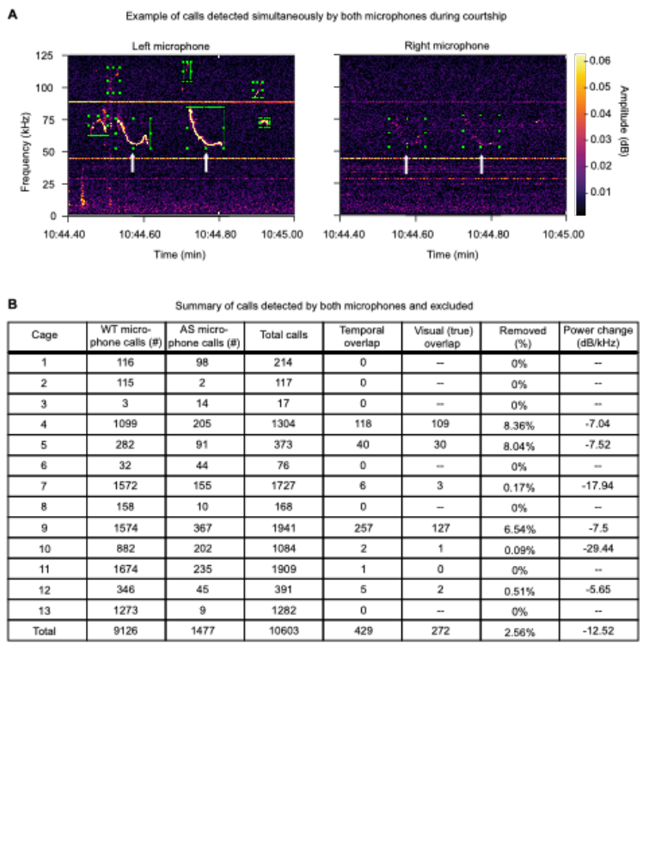
Additional File 1: Supplementary Figure 1. Detection and exclusion of calls detected by both microphones during courtship. A) An example of USVs produced by the mouse in the left chamber and detected on both the left and right microphone simultaneously. White arrows highlight calls detected by both microphones, and excluded on the right microphone. B) Summary table showing the total number of calls with temporal overlap and the percentage of calls with true overlap that were removed from analysis. Less than three percent of calls were removed, and there was a substantial difference in power between true calls and calls recorded from the opposite chamber.
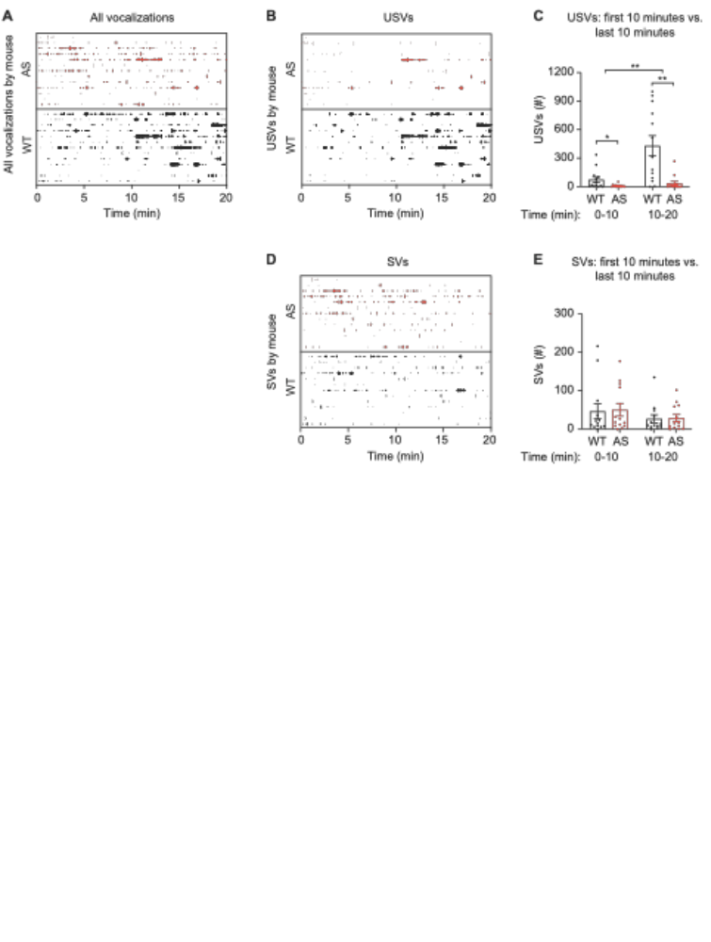
Additional File 2: Supplementary Figure 2. Male mice produce the majority of USVs after 10 minutes of courtship. Data are additional analyses from courtship test in Figure 2. A) Plot showing the start time of each vocalization made during courtship. WT: n = 13 mice, Ube3a^{m-/p+} (AS): n = 13 mice. B) Plot showing the start time of each USV made during courtship. C) Mice made more USVs in the second 10-min of the test (two-way RM ANOVA, main effect of time: F_{(1,12)} = 13.65, p = 0.005; main effect of genotype: F_{(1,12)} = 19.59, p = 0.0016; genotype x time interaction: F_{(1,12)} = 10.06, p = 0.0028; ** on graph represents interaction). Post hoc tests revealed that WT mice made more USVs than AS mice both in the first 10 min of the test (p = 0.0495, Uncorrected Fisher’s LSD) and the second 10 min of the test (p = 0.0015). D) Plot showing the start time of each SV made during courtship. E) SV production was not statistically different between the first 10 min and second 10 min of the test (two-way RM ANOVA, main effect of time: F_{(1,12)} = 4.45, p = 0.057; main effect of genotype: F_{(1,12)} = 0.047, p = 0.84; genotype x time interaction: F_{(1,12)} = 0.007, p = 0.94). Data represent mean ± SEM; **p < 0.01; black: WT, red: Ube3a^{m-/p+} (AS).
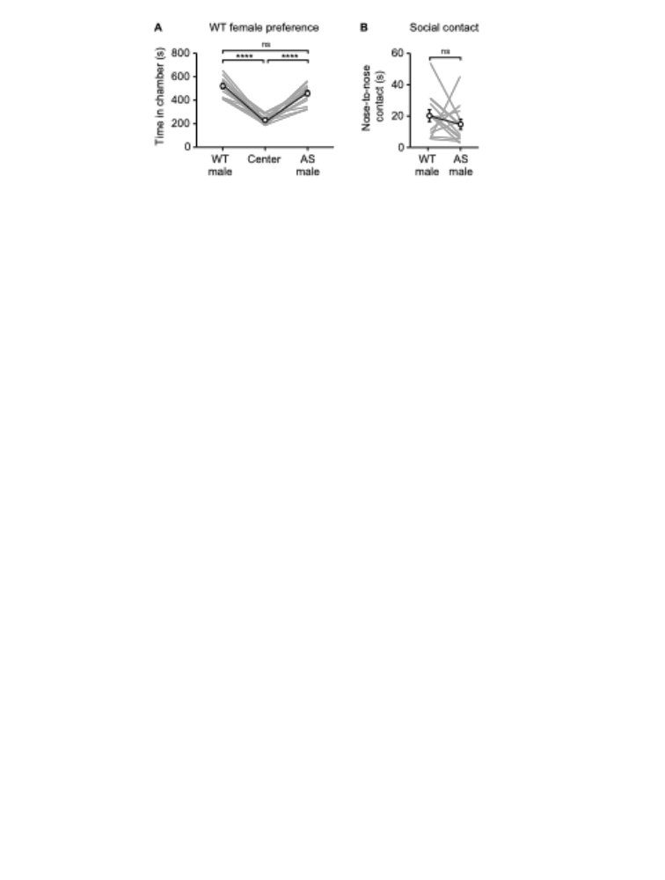
Additional File 3: Supplementary Figure 3. WT female mice do not show behavioral preference for WT or Ube3a^{m-/p+} males during courtship. Data are additional analyses from courtship test in Figure 2. A) WT females (n = 13) spent significantly more time in social chambers than in the center chamber (two-way ANOVA, main effect of chamber: F_{(2,24)} = 40.75, p < 0.0001, post hoc WT male vs. Center: p < 0.0001, post hoc AS male vs. Center: p < 0.0001). Females did not show a preference between the WT and Ube3a^{m-/p+} male (post hoc WT male vs. AS male: p = 0.17). B) WT females had no difference in time spent in nose-to-nose contact with each male (t₍₁₂₎ = 1.029, p = 0.32, paired t-test). Data represent mean ± SEM; ****p < 0.0001.
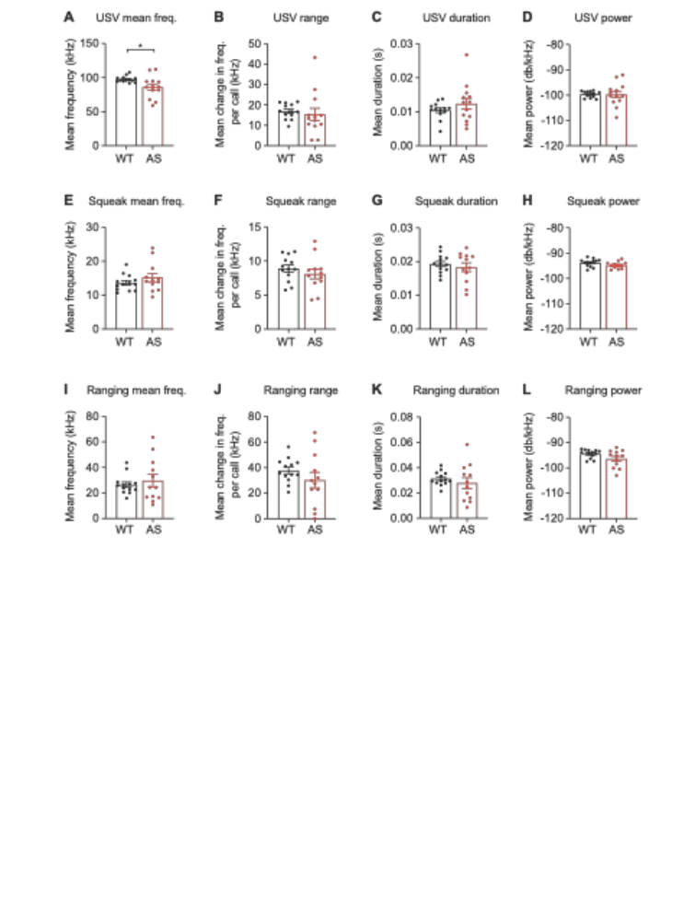
Additional File 4: Supplementary Figure 4. Spectral properties of USVs, squeaks, and ranging calls during distress. Data are additional analyses from distress test in Figure 5A-G. (A) Ube3a^{m-/p+} (AS) male mice produced distress USVs with a lower mean frequency (t₍₁₂₄₎ = 2.478, p = 0.020; WT: n = 13 mice, AS: n = 13 mice). There was no genotype difference in (B) frequency range (t₍₂₄₎ = 0.47, p = 0.64), (C) call duration (t₍₂₄₎ = 1.097, p = 0.28), or (D) power of USVs (t₍₂₄₎ = 0.035, p = 0.973). There was no genotype difference in (E) mean frequency (t₍₂₃₎ = 1.13, p = 0.27), (F) frequency range (t₍₂₃₎ = 0.92, p = 0.37), (G) call duration (t₍₂₃₎ = 0.65, p = 0.524), or (H) power (t₍₂₃₎ = 1.65, p = 0.11) of squeaks (WT: n = 13 mice, AS: n = 12 mice). There was no genotype difference in (I) mean frequency (t₍₂₃₎ = 0.62, p = 0.54), (J) frequency range (t₍₂₃₎ = 1.15, p = 0.26), (K) call duration (t₍₂₃₎ = 0.78, p = 0.44), or (L) power (t₍₂₃₎ = 1.82, p = 0.081) of ranging USVs (WT: n = 13 mice, AS: n = 12 mice).

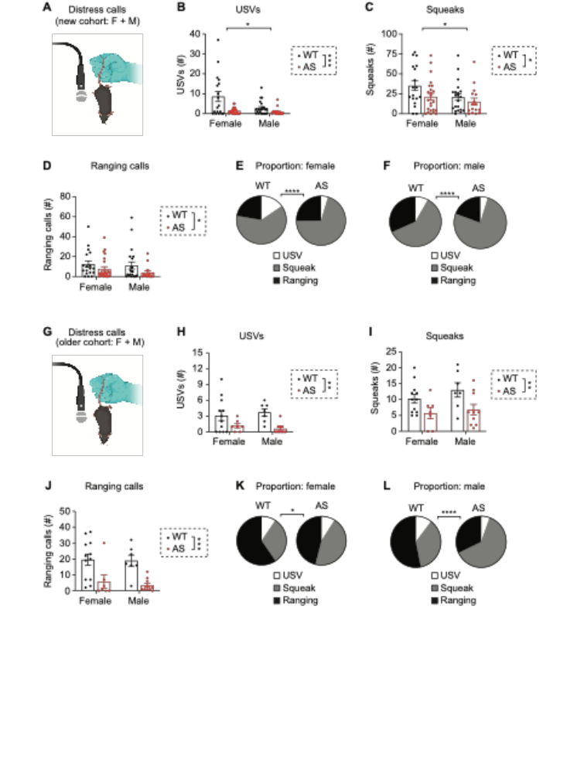Additional File 5: Supplementary Figure 5. Female and male Ube3a^{m-/p+} mice produce fewer distress vocalizations of each type. Data are additional analyses from distress test in Figure 5H-I. (A) Distress testing in adult sex-balanced cohort (n = 72: Female WT: n=16 mice, Male WT: n=20 mice, Female Ube3a^{m-/p+}: n=20 mice, Male Ube3a^{m-/p+}: n=16). (B) Total distress USVs by genotype in adult sex-balanced cohort (two-way ANOVA: main effect of genotype: F_{(1, 75)} = 12.89, p = 0.0007; main effect of sex: F_{(1, 72)} = 6.35, p = 0.014, interaction: F_{(1, 72} = 4.57, p = 0.036). (C) Total distress squeaks by genotype in adult sex-balanced cohort (main effect of genotype: F_{(1, 72)} = 4.21, p = 0.043, main effect of sex: F_{(1, 72)} = 4.55, p = 0.036, interaction: F_{(1, 72)} = 0.724, p = 0.39). (D) Total ranging calls during distress testing by genotype in adult sex-balanced cohort (main effect of genotype: F_{(1, 72)} = 4.58, p = 0.035, main effect of sex: F_{(1, 72)} = 0.83, p = 0.36, interaction: F_{(1, 72)} = 0.172, p = 0.68). (E) Distress call type by genotype in adult female mice (p < 0.0001, Fisher’s exact test) (WT: n = 1,012 calls, AS: n = 728 calls). (F) Distress call type by genotype in adult male mice (p < 0.0001) (WT: n = 730 calls, AS: n = 320 calls). (G) Distress testing in aged sex-balanced cohort (n = 36: Female WT: n=12 mice, Male WT: n=7 mice, Female Ube3a^{m-/p+}: n=7 mice, Male Ube3a^{m-/p+}: n=10). (H) Total distress USVs by genotype in aged cohort (two-way ANOVA: main effect of genotype: F_{(1, 32)} = 11.5, p = 0.0019; main effect of sex: F_{(1, 36)} = 0.003, p = 0.95, interaction: F_{(1, 36)} = 0.62, p = 0.436). (I) Total distress squeaks by genotype in aged cohort (main effect of genotype: F_{(1, 36)} = 9.39, p = 0.0044, main effect of sex: F_{(1, 36)} = 1.199, p = 0.282, F_{(1, 36)} = 0.226, p = 0.638). (J) Total ranging calls during distress testing by genotype in aged cohort (main effect of genotype: F_{(1, 36)} = 19.05, p = 0.0001, main effect of sex: F_{(1, 36)} = 0.193, p = 0.6635, interaction: F_{(1, 36)} = 0.07, p = 0.793). (K) Distress call type by genotype in aged female mice (p = 0.0404) (WT: n = 395 calls, AS: n = 89 calls). (L) Distress call type by genotype in aged male mice (p < 0.0001) WT: n = 250 calls, AS: n = 109 calls). Data represent mean ± SEM; ****p < 0.0001; ***p < 0.001; **p < 0.01; *p < 0.05; black: WT, red: Ube3a^{m-/p+} (AS).
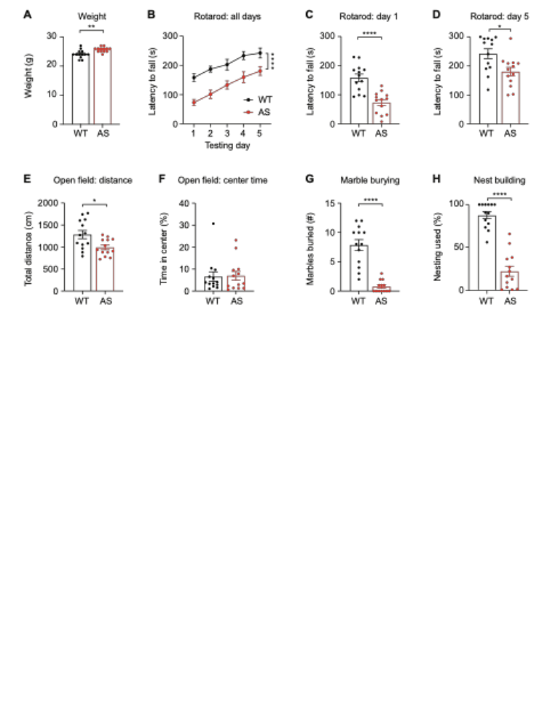
Additional File 6: Supplemental Figure 6. Ube3a^{m-/p+} mice have impaired performance on all individual tests in behavioral battery. Data are additional analyses from Figure 6. (A) Ube3a^{m-/p+} mice had increased weight (t₍₂₄₎ = 3.37, p = 0.0025, unpaired t-test; WT: n = 13, AS: n = 13). (B) Ube3a^{m-/p+} mice had a shorter latency to fall during rotarod (two-way ANOVA, main effect of genotype: F_{(4,48)} = 25.61, p < 0.0001). Rotarod performance was impaired both (C) at baseline on Day 1 (t₍₂₄₎ = 5.097, p < 0.0001) and (D) after training on Day 5 (t₍₂₄₎ = 2.76, p = 0.011). E) Ube3a^{m-/p+} mice traveled a shorter distance during open field than WT mice (t₍₂₄₎ = 2.72, p = 0.012), but (F) did not show a difference in center time (t₍₂₄₎ = 0.125, p = 0.901). (G) Ube3a^{m-/p+} mice buried fewer marbles than WT mice (t₍₂₄₎ = 7.17, p < 0.0001). (H) Ube3a^{m-/p+} mice used less nesting material than WT mice in a nest building assay (t₍₂₄₎ = 9.11). Data represent mean ± SEM; ****p < 0.0001; ***p < 0.001; **p < 0.01; *p < 0.05; black: WT, red: Ube3a^{m-/p+} (AS).
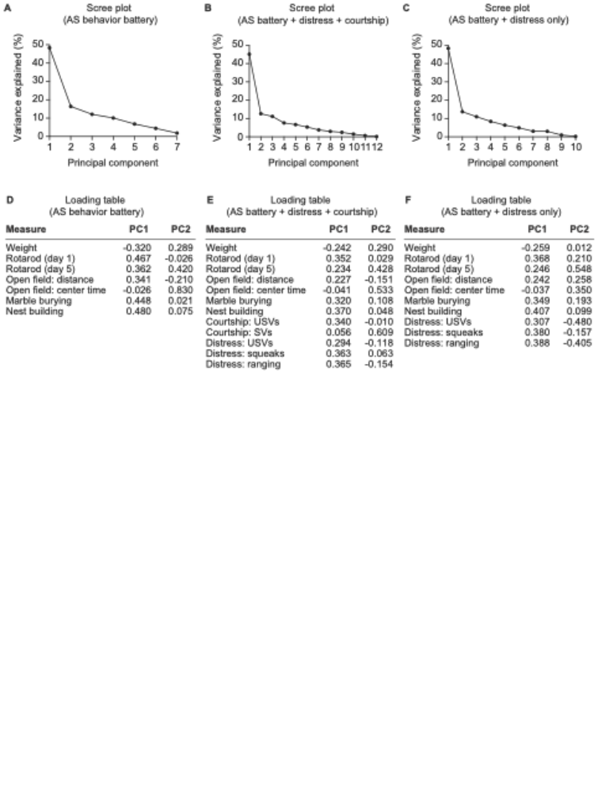
Additional File 7: Supplemental Figure 7. Scree plots and loading tables for principal component analyses. Data are additional analyses from Figure 6. (A) Scree plot for the Angelman behavior battery alone. (B) Scree plot for the Angelman behavior battery plus distress and courtship vocalizations. (C) Scree plot for the Angelman behavior battery and only distress vocalizations. (D) Principal component 1 and 2 loading values for the model with the Angelman behavior battery alone. (E) Principal component 1 and 2 loading values for the model with Angelman behavior battery plus courtship and distress vocalizations. (F) Principal component 1 and 2 loading values for the model with Angelman behavior battery distress vocalizations only.

