Manuscript:
Vector Potential Index: Bridging competence and contribution as an integrative measure of relative transmission capability

Table of Content
 |  | page
Figure S1 | Geographic extent of the Eastern Temperate Forests terrestrial ecological region of North America | 2
 | Absolute VPI of select North American WNV vector species
Material S1 | Description of included data and distribution of variance across study outcomes, as quantified by I² | 3
Table S1 | Absolute enzootic and epizootic WNV VPI of select mosquito vector species of North America. | 4
 | References of additional data sources | 5

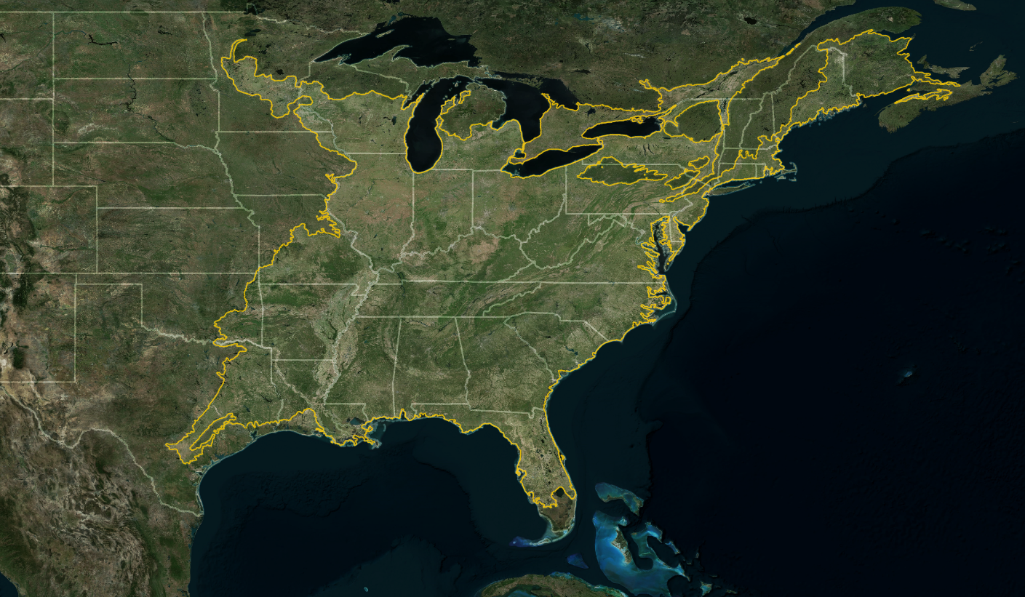
Figure S1. Geographic extent of the Eastern Temperate Forests terrestrial ecological region of North America. Level I ecological region shapefile available through the Commission for Environmental Cooperation’s North American Environmental Atlas (http://www.cec.org). Background aerial map Earth Start Geographics SIO, Microsoft Corporation © 2024, available through Bing Maps and accessed through QGIS v 3.16.16.
Material S1: Absolute VPI of select North American WNV vector species
To compare WNV vector potential of Culex tarsalis with vector species of the Eastern Temperate Forests ecoregion, we quantified VPI₁₀ of these species (Table S1). Overall proportions of host use were calculated using blood-meal analysis data that met all inclusion criteria outlined in the methods except population origin, where we expanded the acceptable area of origin to the contiguous United States. Additional data sources included in the analysis are identified below Table S1. Heterogeneity across included host use studies and overall proportions for each vector species were quantified as described in the main manuscript.
A substantial amount of variance in the host use data set was not attributed to chance (I² = 99%). For both the avian and mammalian host use subset, this variance was largely explained by differences in the mosquito species investigated (I² = 53% and I² = 57%), while a lower amount of variance was explained by between-study (I² = 35% and I² = 26%) and within-study (I² = 12% and I² = 16%) differences, respectively.

Table S1. Absolute enzootic and epizootic WNV VPI of select mosquito vector species of North America.
 | Host use |  |  | Overall proportion |  |  |  | Absolute VPI₁₀
Species | Ref | Obs | N | WNV vector competence | Avian host use | Mammal host use | enzootic |  | epizootic
Psorophora ferox | 7 | 10 | 743 | 0.000 | 0.036 | 0.956 | 0 |  | 0
Aedes japonicus | 2 | 2 | 60 | 0.646 | 0.000 | 1.000 | 0 |  | 0
Aedes taeniorhynchus | 4 | 8 | 870 | 0.017 | 0.029 | 0.965 | 1 |  | 1
Coquillettidia perturbans | 12 | 16 | 1435 | 0.022 | 0.113 | 0.882 | 1 |  | 1
Aedes canadensis | 6 | 6 | 1685 | 0.029 | 0.019 | 0.817 | 1 |  | 1
Culex coronator | 2 | 4 | 56 | 0.076 | 0.089 | 0.911 | 1 |  | 1
Culex nigripalpus | 7 | 20 | 15992 | 0.078 | 0.425 | 0.441 | 1 |  | 1
Culex quinquefasciatus | 21 | 36 | 5083 | 0.088 | 0.741 | 0.235 | 1 |  | 1
Culex pipiens | 16 | 19 | 3786 | 0.098 | 0.879 | 0.088 | 1 |  | 1
Culex restuans | 17 | 19 | 1993 | 0.108 | 0.907 | 0.076 | 1 |  | 1
Aedes sollicitans | 7 | 7 | 1922 | 0.119 | 0.024 | 0.980 | 1 |  | 1
Aedes cantator | 2 | 2 | 53 | 0.137 | 0.019 | 0.962 | 1 |  | 1
Aedes aegypti | 3 | 5 | 283 | 0.158 | 0.004 | 0.997 | 1 |  | 1
Aedes vexans | 17 | 24 | 5207 | 0.210 | 0.018 | 0.965 | 1 |  | 1
Culiseta inornata | 4 | 5 | 1535 | 0.214 | 0.007 | 0.994 | 1 |  | 1
Aedes triseriatus | 9 | 12 | 804 | 0.251 | 0.047 | 0.950 | 1 |  | 1
Aedes albopictus | 7 | 9 | 1512 | 0.682 | 0.020 | 0.968 | 1 |  | 1
Culex salinarius | 11 | 12 | 667 | 0.509 | 0.183 | 0.806 | 1 |  | 4
Culex tarsalis | 8 | 19 | 14744 | 0.394 | 0.763 | 0.202 | 4 |  | 3
Culex erraticus | 9 | 18 | 3356 |  | 0.357 | 0.411
Ref: number of identified studies, Obs: number of observations included in proportional meta-analysis,
N: total number of tested specimens

Additional data sources:

Apperson, C. S., Hassan, H. K., Harrison, B. A., Savage, H. M., Aspen, S. E., Farajollahi, A., Crans, W. J., Daniels, T. J., Falco, R. C., Benedict, M., Anderson, M., McMillen, L., & Unnasch, T. R. (2004). Host Feeding Patterns of Established and Potential Mosquito Vectors of West Nile Virus in the Eastern United States. Vector Borne and Zoonotic Diseases, 4(1), 71–82. https://doi.org/10.1089/153036604773083013
Campbell, R., Thiemann, T. C., Lemenager, D., & Reisen, W. K. (2013). Host-Selection Patterns of Culex tarsalis (Diptera: Culicidae) Determine the Spatial Heterogeneity of West Nile Virus Enzootic Activity in Northern California. Journal of Medical Entomology, 50(6), 1303–1309. https://doi.org/10.1603/ME13089
Cupp, E. W., Zhang, D., Yue, X., Cupp, M. S., Guyer, C., Sprenger, T. R., & Unnasch, T. R. (2004). Identification of Reptilian and Amphibian Blood Meals from Mosquitoes in an Eastern Equine Encephalomyelitis Virus Focus in Central Alabama. American Journal of Tropical Medicine and Hygiene, 71(3), 272–276.
Greenberg, J. A., Lujan, D. A., DiMenna, M. A., Wearing, H. J., & Hofkin, B. V. (2013). Identification of Blood Meal Sources in Aedes vexans and Culex quinquefasciatus in Bernalillo County, New Mexico. Journal of Insect Science (Online), 13, 75. https://doi.org/10.1673/031.013.7501
Guinn, A., Su, T., Thieme, J., Cheng, M.‑L., Brown, M. Q., & Thiemann, T. (2022). Characterization of the Blood-Feeding Patterns of Culex quinquefasciatus (Diptera: Culicidae) in San Bernardino County, California. Journal of Medical Entomology, 59(5), 1756–1765. https://doi.org/10.1093/jme/tjac077
Hannon, E. R., Jackson, K. C., Biggerstaff, B. J., Raman, V., & Komar, N. (2019). Bloodmeal Host Selection of Culex quinquefasciatus (Diptera: Culicidae) in Las Vegas, Nevada, United States. Journal of Medical Entomology, 56(3), 603–608. https://doi.org/10.1093/jme/tjy237
Lujan, D. A., Greenberg, J. A., Hung, A. S., Dimenna, M. A., & Hofkin, B. V. (2014). Evaluation of Seasonal Feeding Patterns of West Nile Virus Vectors in Bernalillo County, New Mexico, United States: Implications for Disease Transmission. Journal of Medical Entomology, 51(1), 264–268. https://doi.org/10.1603/me13163
Molaei, G., Cummings, R. F., Su, T., Armstrong, P. M., Williams, G. A., Cheng, M.‑L., Webb, J. P., & Andreadis, T. G. (2010). Vector-Host Interactions Governing Epidemiology of West Nile Virus in Southern California. The American Journal of Tropical Medicine and Hygiene, 83(6), 1269–1282. https://doi.org/10.4269/ajtmh.2010.10-0392
Tempelis, C. H., Hayes, R. O., Hess, A. D., & Reeves, W. C. (1970). Blood-Feeding Habits of Four Species of Mosquito Found in Hawaii. The American Journal of Tropical Medicine and Hygiene, 19(2), 335–341. https://doi.org/10.4269/ajtmh.1970.19.335
Tempelis, C. H., Reeves, W. C., Bellamy, R. E., & Lofy, M. F. (1965). A Three-Year Study of the Feeding Habits of Culex tarsalis in Kern County, California. The American Journal of Tropical Medicine and Hygiene, 14, 170–177. https://doi.org/10.4269/ajtmh.1965.14.170
Tempelis, C. H., & Washino, R. K. (1967). Host-Feeding Patterns of Culex tarsalis in the Sacramento Valley, California, with Notes on Other Species. Journal of Medical Entomology, 4(3), 315–318. https://doi.org/10.1093/jmedent/4.3.315
Thiemann, T. C., Wheeler, S. S., Barker, C. M., & Reisen, W. K. (2011). Mosquito Host Selection Varies Seasonally with Host Availability and Mosquito Density. PLoS Neglected Tropical Diseases, 5(12), e1452. https://doi.org/10.1371/journal.pntd.0001452

