1 Supplementary Note
1.1 fastGxE
1.1.1 Model details
Our model is described in detail in the main text. For clarity and convenience, we first restate it here. Let $y$ denote an $n$-vector of phenotypic measurements, $X_{E}$ an $n$ by $q$ matrix of environmental factors with the column vector $x_{E}^{(k)}$ ($k∈\left\{1,⋯, q\right\}$) representing the $k$th environmental factor, and $X_{G}$ an $n$ by $m$ genotype matrix with the column vector $x_{G}^{(j)}$ ($j∈\left\{1,⋯, m\right\}$) representing the genotypes for $j$th SNP. We examine one SNP at a time and denote $x_{G}$ as an $n$-vector of genotypes for the SNP of focus. We standardize the phenotypic vector, each genotype vector, and each environment factor vector to have a mean of zero and a standard deviation of one. For the SNP of focus, we consider the following model:
$$\begin{aligned}y=x_{G}β_{G}+\sum_{k=1}^{q}{x_{E}^{\left(k\right)}β_{E}^{\left(k\right)}}+\sum_{k=1}^{q}{{(x_{G}⊙x}_{E}^{\left(k\right)})β_{GxE}^{\left(k\right)}}+ \\ \sum_{j=1}^{m}{x_{G}^{\left(j\right)}β_{G}^{\left(j\right)}}+\sum_{k=1}^{q}{\sum_{j=1}^{m}{\left(x_{G}^{\left(j\right)}⊙x_{E}^{\left(k\right)}\right)β_{GxE}^{\left(jk\right)}}}+e,\#\left(1\right)\end{aligned}$$
where $β_{G}$ is the genetic main effect size for the SNP of focus; $β_{E}^{(k)}$ is the main effect size of $k$th environmental factor; $β_{GxE}^{\left(k\right)}$ is the interaction effect between the SNP of focus and $k$th environmental factor; $β_{G}^{\left(j\right)}\sim N(0, σ_{β_{G}}^{2})$ is the genetic main effect size of $j$th SNP; $β_{GxE}^{(jk)}\sim N(0, σ_{β_{GxE}}^{2})$ is the interaction effect between the $j$th SNP and $k$th environmental factor; $⊙$ denotes the Hadamard product, representing element-wise multiplication between two vectors; and $e$ is an $n$-vector of residual errors with each element following a normal distribution $N(0, σ_{e}^{2})$ with mean zero and error variance $σ_{e}^{2}$.

We define $g=\sum_{j=1}^{m}{x_{G}^{\left(j\right)}β_{G}^{\left(j\right)}}$ as the genome-wide polygenetic effects and $v=\sum_{k=1}^{q}{\sum_{j=1}^{m}{(x_{G}^{\left(j\right)}⊙x_{E}^{\left(k\right)})β_{GxE}^{\left(jk\right)}}}$ as the genome-wide polygenetic GxE effects. The model in equation (1) can be rewritten as
$$\begin{aligned}y=x_{G}β_{G}+\sum_{k=1}^{q}{x_{E}^{\left(k\right)}β_{E}^{\left(k\right)}}+\sum_{k=1}^{q}{{(x_{G}⊙x}_{E}^{\left(k\right)})β_{GxE}^{\left(k\right)}}+g+v+e.\#\left(2\right)\end{aligned}$$
The variance for $g$ can be derived as
$$var\left(g\right)=\sum_{j=1}^{m}{x_{G}^{\left(j\right)}x_{G}^{\left(j\right)}'σ_{β_{G}}^{2}=}X_{G}{X'}_{G}σ_{β_{G}}^{2}=mK_{G}σ_{β_{G}}^{2},$$
where $K_{G}$ is the genetic relationship matrix (GRM) calculated using $m$ genome-wide SNPs in the form of $K_{G}=X_{G}{X'}_{G}/m$; and $σ_{g}^{2}=mσ_{β_{G}}^{2}$ is the polygenetic variance. The variance for $v$ can be derived as
$$var\left(v\right)=\sum_{j=1}^{m}{\sum_{k=1}^{q}{(x_{G}^{\left(j\right)}⊙x_{E}^{\left(k\right)})(x_{G}^{\left(j\right)}⊙x_{E}^{\left(k\right)})'σ_{β_{GxE}}^{2}}}=\sum_{j=1}^{m}{\sum_{k=1}^{q}{diag(x_{G}^{\left(j\right)})x_{E}^{\left(k\right)}{x'}_{E}^{\left(k\right)}diag(x_{G}^{\left(j\right)})σ_{β_{GxE}}^{2}}}=σ_{β_{GxE}}^{2}\sum_{j=1}^{m}{[diag(x_{G}^{\left(j\right)})(\sum_{k=1}^{q}{x_{E}^{\left(k\right)}{x'}_{E}^{\left(k\right)}}})diag(x_{G}^{\left(j\right)})]=σ_{β_{GxE}}^{2}\sum_{j=1}^{m}{[diag(x_{G}^{\left(j\right)})X_{E}}{X^{'}}_{E}diag(x_{G}^{\left(j\right)})]=σ_{β_{GxE}}^{2}\sum_{j=1}^{m}{\left(x_{G}^{\left(j\right)}{x^{'}}_{G}^{\left(j\right)}\right)⊙\left(X_{E}{X^{'}}_{E}\right)}=σ_{β_{GxE}}^{2}(X_{G}{X^{'}}_{G}){⊙(X}_{E}{X^{'}}_{E})=mqσ_{β_{GxE}}^{2}K_{G}⊙K_{G}=mqσ_{β_{GxE}}^{2}K_{GxE},$$
where $K_{E}=X_{E}{X'}_{E}/q$ is the covariance measuring the similarity among individuals in terms of their environmental exposures; $K_{G×E}$ is the GxE relationship matrix in the form of $K_{G×E}=K_{G}⊙K_{E}$; and $σ_{v}^{2}=mqσ_{β_{GxE}}^{2}$ is the polygenetic GxE variance. Therefore, the random effects for model in equation (2) follow a multivariate normal distribution in the following forms:
$$\begin{aligned}g\sim MVN\left(0, K_{G}σ_{g}^{2}\right), v\sim MVN\left(0, K_{GxE}σ_{v}^{2}\right), e\sim MVN\left(0, Iσ_{e}^{2}\right).\#\left(3\right)\end{aligned}$$

1.1.2 Scalable variance parameters estimation
For the model in equation (2), we first estimate the variance parameters under the null model where $β_{GxE}^{\left(k\right)}=0$ for all $k$. To facilitate computation, we further set $β_{G}=0$ in the null model following previous studies, as the genetic main effect size for the SNP of focus contributes minimally to the estimation of variance parameters(Kang, et al., 2010). Under the null, the restricted loglikelihood function to estimate variance parameters $θ=(σ_{g}^{2}, σ_{v}^{2}, σ_{e}^{2})$ is formulated as(Zhou and Stephens, 2012)
$$\begin{aligned}logL=-0.5[\log\left|V\right|+\log\left|X^{'}V^{-1}X\right|+y^{'}Py,\#\left(4\right)\end{aligned}$$
where $X=X_{E}$, $V=K_{G}σ_{g}^{2}+K_{GxE}σ_{v}^{2}+ Iσ_{e}^{2}$, $P=V^{-1}-V^{-1}X{(X'V^{-1}X)}^{-1}X'V^{-1}$. In this study, we used the efficient iterative algorithm which combines expectation-maximization and average information to maximize restricted loglikelihood function (Ning, et al., 2019). The first partial derivatives for $θ$ are
$$\begin{aligned}\frac{∂logL}{∂σ_{g}^{2}}=-0.5\left[tr\left(PK_{G}\right)-y^{'}PK_{G}Py\right],\#\left(5\right)\end{aligned}$$
$$\begin{aligned}\frac{∂logL}{∂σ_{v}^{2}}=-0.5\left[tr\left(PK_{GxE}\right)-y^{'}PK_{GxE}Py\right],\#\left(6\right)\end{aligned}$$
$$\begin{aligned}\frac{∂logL}{∂σ_{e}^{2}}=-0.5\left[tr\left(P\right)-y^{'}PPy\right].\#\left(7\right)\end{aligned}$$
The average information (AI) matrix is
$$\begin{aligned}I_{AI}=0.5\left[\begin{matrix}y^{'}PK_{G}PK_{G}Py & y^{'}PK_{G}PK_{GxE}Py & y^{'}PK_{G}PPy \\ y^{'}PK_{GxE}PK_{G}Py & y^{'}PK_{GxE}PK_{GxE}Py & y^{'}PK_{GxE}PPy \\ y^{'}PPK_{G}Py & y^{'}PPK_{GxE}Py & y^{'}PPPy\end{matrix}\right].\#\left(8\right)\end{aligned}$$
With the first partial derivatives and AI matrix, we use the following iterative equation to update the variance parameters
$$\begin{aligned}θ_{t+1}=θ_{t}+I_{AI}^{-1}\frac{∂L}{∂θ},\#\left(9\right)\end{aligned}$$
where $θ_{t}$ denotes the variance parameters at the previous iteration t while $θ_{t+1}$ represents that at the current iteration t+1.
The update equation for EM algorithm(Jensen, et al., 1997; Ning, et al., 2019) is
$$\begin{aligned}θ_{t+1}=θ_{t}+I_{EM}^{-1}\frac{∂L}{∂θ},\#\left(10\right)\end{aligned}$$
Here, the expectation-maximization (EM) information matrix is a diagonal matrix with the following elements
$$I_{EM}=\left[\begin{matrix}n/(2σ_{g}^{2}σ_{g}^{2}) & 0 & 0 \\ 0 & n/(2σ_{v}^{2}σ_{v}^{2}) & 0 \\ 0 & 0 & n/(2σ_{e}^{2}σ_{e}^{2})\end{matrix}\right].$$
To ensure rapid convergence of the variance parameters, we built a weighted information matrix as
$$\begin{aligned}I_{W}=λI_{EM}+(1-λ{)I}_{AI}.\#\left(11\right)\end{aligned}$$
With the weighted information matrix, the iterative equation to update the variance parameters is
$$\begin{aligned}θ_{t+1}=θ_{t}+I_{W}^{-1}\frac{∂L}{∂θ}.\#\left(12\right)\end{aligned}$$
For each iteration, we increase from 0 to 1 with a step size of 0.01 until all the updated variances are positive.

The above algorithm requires an iterative evaluation of the phenotypic covariance matrix ($V$) in equation (4). However, for large scale data with hundreds of thousands of samples, it is difficult to obtain such inverse. Therefore, we construct a sparse block diagonal genetic relationship matrix, following Gogarten, et al. (2019) and Li, et al. (2023), to facilitate computation. Specifically, we organize samples into subgroups such that any pair with an estimated relatedness greater than 0.05 belongs to the same subgroup. We retained all pairwise relatedness estimates within each subgroup even if they fall below 0.05 and we set pairwise relatedness estimates between subgroups to zero. This results in a sparse block-diagonal genetic relationship matrix. In particular, given s subgroups, $K_{G}$ has the following form:
$$\begin{aligned}K_{G}=\left[\begin{matrix}\begin{matrix}K_{G,1} & 0 \\ 0 & K_{G,2}\end{matrix} & \begin{matrix}0 & 0 \\ 0 & 0\end{matrix} \\ \begin{matrix}0 & 0 \\ 0 & 0\end{matrix} & \begin{matrix}⋱ & 0 \\ 0 & K_{G,s}\end{matrix}\end{matrix}\right].\#\left(13\right)\end{aligned}$$
For the element-wise product between $K_{E}$ and $K_{G}$, because it is time and memory inefficient to calculate and store all elements of $K_{E}$, we only calculate the corresponding elements of subgroups in $K_{G}$. Specifically, we first define the $n_{l}×q$ matrix $X_{E}^{(l)}$ as the environment covariate matrix for the $l$th subgroup, where $n_{l}$ is the subgroup size. We then obtain
$$\begin{aligned}K_{GxE}=K_{G}⊙K_{E}=\left[\begin{matrix}\begin{matrix}K_{G,1} & 0 \\ 0 & K_{G,2}\end{matrix} & \begin{matrix}0 & 0 \\ 0 & 0\end{matrix} \\ \begin{matrix}0 & 0 \\ 0 & 0\end{matrix} & \begin{matrix}⋱ & 0 \\ 0 & K_{G,s}\end{matrix}\end{matrix}\right]⊙\left[\begin{matrix}\begin{matrix}K_{E,1} & 0 \\ 0 & K_{E,2}\end{matrix} & \begin{matrix}0 & 0 \\ 0 & 0\end{matrix} \\ \begin{matrix}0 & 0 \\ 0 & 0\end{matrix} & \begin{matrix}⋱ & 0 \\ 0 & K_{E,s}\end{matrix}\end{matrix}\right].\#\left(14\right)\end{aligned}$$
Here,
$$K_{E,l}=\frac{X_{E}^{\left(l\right)}{X_{E}^{\left(l\right)}}^{'}}{q}.$$
Because $K_{G}$ and $K_{GxE}$ are sparse block diagonal matrices in the same format, $V$ is also a sparse block diagonal matrix, with the $l$th subgroup expressed being
$$\begin{aligned}V_{l}=K_{G,l}σ_{g}^{2}+K_{GxE,l}σ_{v}^{2}+I_{n_{l}}σ_{e}^{2}.\#\left(15\right)\end{aligned}$$
This way, we can obtain the inverse of $V$ by calculating the inverse of each sub-block separately, which is computationally efficient. With $K_{G}$, $K_{GxE}$ and $V$, we leverage efficient sparse block matrix multiplication to calculate the restricted log-likelihood function, its first partial derivatives, and the weighted information matrix.

1.1.3 Fast and scalable multivariate GxE test
Here, we describe the technical details for the GxE tests in fastGxE. For the SNP of focus, we first consider a set of distinct sparse modeling assumptions where only one $β_{GxE}^{(k)}$ is non-zero and perform single environment GxE test. Under each such modeling assumption, the null hypothesis $H_{0}: β_{GxE}^{(k)}=0 ∀k$ becomes equivalent to the null hypothesis $H_{0}:β_{GxE}^{\left(k\right)}=0$ for the specific $k$. Consequently, for each modeling assumption, we carry out a score test and compute the corresponding p-value. The score test is formulated as
$$\begin{aligned}T_{score}={(x_{G}⊙x}_{E}^{\left(k\right)})Py,\#(16)\end{aligned}$$
$$\begin{aligned}var\left(T_{score}\right)={(x_{G}⊙x}_{E}^{\left(k\right)})'P{(x_{G}⊙x}_{E}^{\left(k\right)}),\#(17)\end{aligned}$$
$$\begin{aligned}\frac{T_{score}^{2}}{var\left(T_{score}\right)}\sim χ^{2}\left(1\right),\#\left(18\right)\end{aligned}$$
where matrix $P$ is calculated in the null model without interaction effects as following
$$P=V^{-1}-V^{-1}X{\left(X'V^{-1}X\right)}^{-1}X'V^{-1},$$
$$X=\left[\begin{matrix}X_{E} & x_{G}\end{matrix}\right],$$
$$V=K_{G}σ_{g}^{2}+K_{GxE}σ_{v}^{2}+ Iσ_{e}^{2}.$$
Besides these sparse assumptions, we also consider a polygenic modeling assumption (Moore, et al., 2019) that each $β_{GxE}^{(k)}$ follows a normal distribution $N\left(0, σ_{G×E}^{2}\right)$. Under such modeling assumption, the null hypothesis $H_{0}: β_{GxE}^{(k)}=0 ∀k$ becomes equivalent to the null hypothesis $H_{0}:σ_{GxE}^{2}=0$. Consequently, we carry out a variance component test to obtain the $p$-value under such polygenic assumption. The variance component test is formulated as
$$\begin{aligned}Q=y^{'}P{\left[diag\left(x_{G}\right)X_{E}\right]}^{'}\left[diag\left(x_{G}\right)X_{E}\right]Py.\#\left(19\right)\end{aligned}$$
It has been shown that $Q$ follows a mixture of chi-square distributions:
$$\begin{aligned}Q\sim \sum_{k=1}^{q}{d_{k}χ^{2}\left(1\right)}.\#\left(20\right)\end{aligned}$$
Here, $d=[d_{k}]$ is the eigenvalue of $P^{0.5}\left[diag\left(x_{G}\right)X_{E}\right]{\left[diag\left(x_{G}\right)X_{E}\right]}^{'}P^{0.5}$, which can be computed as
$$\begin{aligned}d=eigh\left(P^{0.5}\left[diag\left(x_{G}\right)X_{E}\right]{\left[diag\left(x_{G}\right)X_{E}\right]}^{'}P^{0.5}\right) \\ =eigh\left({\left[diag\left(x_{G}\right)X_{E}\right]}^{'}P\left[diag\left(x_{G}\right)X_{E}\right]\right),\#\end{aligned}$$
where ${\left[diag\left(x_{G}\right)X_{E}\right]}^{'}P\left[diag\left(x_{G}\right)X_{E}\right]$ is a $q×q$ matrix. Following the study of Wu, et al. (2016), the p values are computed using Davies method (Davies, 1980) if it converges; and switch to the saddle-point approximation method (Liu, et al., 2009) when it does not.

We employ multiple computational techniques to optimize the computation of genome-wide multivariate GxE test. Firstly, we use a sparse GRM $K_{G}$ to enhance computational efficiency while preserving accuracy, as described in the previous section (Gogarten, et al., 2019; Jiang, et al., 2019; Li, et al., 2023). Secondly, for SNPs with non-significant genotype main effects (main effect p-value > 1.0e-3), we removed their main effect terms from the interaction test model. As a result, the $P$ matrix is simplified as $P=V^{-1}-V^{-1}X_{E}{(X_{E}'V^{-1}X_{E})}^{-1}X_{E}'V^{-1}$ for genome-wide SNPs. This way, $Py$ and $X_{E}Py$ can be precalculated and applied to genome-wide interaction tests. For each SNP analyzed, the calculation of $T_{score}$ and$Q$ only involves element-wise and dot product of vectors, resulting in a time complexity of $O(n)$. Thirdly, to boost the calculation speed of $var\left(T_{score}\right)$ and $d$, we implement an improved version of the GRAMMAR-GAMMA approximation (Svishcheva, et al., 2012). Specifically, we randomly select a certain number of SNPs (for example, 1,000) and calculate the GAMMA factor ($γ_{T}$) and GAMMA matrix ($γ_{Q}$) as
$$\begin{aligned}γ_{T}=\frac{{(x_{G}⊙x}_{E}^{\left(k\right)})P{(x_{G}⊙x}_{E}^{\left(k\right)})'}{{x^{'}}_{G}x_{G}},\#\left(21\right)\end{aligned}$$
$$\begin{aligned}γ_{Q}=\frac{diag(x_{G})X_{E}]'P[diag(x_{G})X_{E}]}{{x^{'}}_{G}x_{G}}.\#\left(22\right)\end{aligned}$$
In this study, $γ_{T}$ and $γ_{Q}$ is estimated as the average of random SNPs
$$\begin{aligned}γ_{T}=\frac{1}{1000}\sum_{r=1}^{1000}{γ_{T,r}},\#\left(23\right)\end{aligned}$$
$$\begin{aligned}γ_{Q}=\frac{1}{1000}\sum_{r=1}^{1000}{γ_{Q,r}},\#\left(24\right)\end{aligned}$$
Afterwards, for genome-wide interaction tests, we approximate $var\left(T_{score}\right)$ and $d$ as
$$\begin{aligned}var\left(T_{score}\right)=γ_{T}\left({x^{'}}_{G}x_{G}\right),\#\left(25\right)\end{aligned}$$
$$\begin{aligned}d=\left({x^{'}}_{G}x_{G}\right)eigh\left(γ_{Q}\right),\#\left(26\right)\end{aligned}$$
which again has a time complexity of $O(n)$.

1.2 Identifying the environmental factors that drive the observed GxE interaction
Here, we describe in detail our extension of SuSiE, which we refer to as mixed model SuSiE (mmSuSiE) for identifying the environmental factors that drive the observed GxE interaction effects, while controlling for both polygenetic and polygenetic GxE effects. To start, we first introduce two building blocks for mmSuSiE: the Bayesian mixed model regression with a single variable of interest in section 1.2.1. and the “mixed model single-effect regression” (mmSER) in section 1.2.2.

1.2.1 Bayesian mixed model regression with a single variable of interest
We first consider the Bayesian mixed model regression with a single variable of interest. We denote the variable of interest as an n-vector of $x$. Our goal is to perform inference on its effect size b, which is a scalar, while controlling for both polygenetic effects $g$ and polygenetic GxE effects $v$. We consider the following Bayesian mixed model regression:
$$\begin{aligned}y=xb+g+v+e,\#\left(27\right)\end{aligned}$$
$$b\sim N\left(0,σ_{0}^{2}\right), g\sim MVN\left(0, K_{G}σ_{g}^{2}\right), v\sim MVN\left(0, K_{GxE}σ_{v}^{2}\right), e\sim MVN\left(0, Iσ_{e}^{2}\right).$$
Given $σ_{0}^{2}$ and $θ=\left[\begin{matrix}σ_{g}^{2} & σ_{v}^{2} & σ_{e}^{2}\end{matrix}\right]$, the posterior computation for this model can be conveniently written in terms of the generalized least-squares estimate
$$\begin{aligned}\hat{b}=\frac{x'V^{-1}y}{x'V^{-1}x},\#\left(28\right)\end{aligned}$$
$$\begin{aligned}s^{2}=var\left(\hat{b}\right)=\frac{1}{x'V^{-1}x},\#\left(29\right)\end{aligned}$$
$$\begin{aligned}z=\frac{\hat{b}}{s^{2}}.\#\left(30\right)\end{aligned}$$
The posterior distribution for $b$ is given by
Afterwards, we have
$$\begin{aligned}b|y,σ_{0}^{2},θ\sim N\left(μ_{1},σ_{1}^{2}\right),\#\left(31\right)\end{aligned}$$
$$\begin{aligned}σ_{1}^{2}=K^{-1}=\frac{1}{\frac{1}{s^{2}}+\frac{1}{σ_{0}^{2}}},\#\left(32\right)\end{aligned}$$
$$\begin{aligned}μ_{1}=Q=\frac{σ_{1}^{2}\hat{b}}{s^{2}}.\#\left(33\right)\end{aligned}$$
We can compute the Bayes Factor (BF) for comparing this model with the null model where $b = 0$ as
$$\begin{aligned}BF\left(x,y;σ_{0}^{2},θ\right)=\frac{p(y|x,σ_{0}^{2},θ)}{p(y|x,θ, b=0)}=\sqrt{\frac{s^{2}}{s^{2}+σ_{0}^{2}}}\exp\left(\frac{z^{2}}{2}\frac{σ_{0}^{2}}{s^{2}+σ_{0}^{2}}\right).\#\left(34\right)\end{aligned}$$
The derivative of BF with respect to $σ_{0}^{2}$ is
$$\begin{aligned}\frac{BF\left(x,y;σ_{0}^{2},θ\right)}{∂σ_{0}^{2}}=BF\left(x,y;σ_{0}^{2},θ\right)\left[\frac{1}{2\left(s^{2}+σ_{0}^{2}\right)}\right]\left[z^{2}\frac{s^{2}}{s^{2}+σ_{0}^{2}}-1\right] \#\left(35\right)\end{aligned}$$

1.2.2 Mixed model single effect regression (mmSER)
mmSER contains multiple variables, but only one variable has a non-zero effect. It is defined as follows:
$$\begin{aligned}y=Xb+g+v+e,\#\left(36\right)\end{aligned}$$
$$g\sim MVN\left(0, K_{G}σ_{g}^{2}\right), v\sim MVN\left(0, K_{GxE}σ_{v}^{2}\right), e\sim MVN\left(0, Iσ_{e}^{2}\right),$$
$$b=bγ, γ∈{\left\{0,1\right\}}^{q}, γ\sim Mult\left(1,π\right), b\sim N\left(0, σ_{0}^{2}\right).$$
Here, $X=\left[\begin{matrix}x_{1} & x_{2} & \begin{matrix}⋯ & x_{q}\end{matrix}\end{matrix}\right]$ is an $n×q$ matrix containing $n$ individuals of $q$ explanatory variables, whose columns have been centered to have mean 0 to avoid the need for an intercept term; $b$ is a scalar representing the ‘single effect’; $γ∈{\left\{0,1\right\}}^{q}$ is a q-vector of indicator variables, indicating which of the $q$ variables has the non-zero effect; $Mult\left(1,π\right)$ represents a multinomial distribution with a single trial and probability vector $π$, specifying the probabilities for each variable having the non-zero effect.

Given $σ_{0}^{2}$ and $θ$, the posterior distribution on $b=bγ$ is
$$\begin{aligned}γ|X,y,σ_{0}^{2},θ\sim Mult\left(1,α\right),\#\left(37\right)\end{aligned}$$
$$\begin{aligned}b|X,y,σ_{0}^{2},θ,γ_{j}=1\sim N\left(μ_{1j},σ_{1j}^{2}\right).\#\left(38\right)\end{aligned}$$
Here, $α=\left(\begin{matrix}α_{1} & α_{2} & \begin{matrix}⋯ & α_{q}\end{matrix}\end{matrix}\right)$ is a vector of posterior inclusion probabilities (PIPs), which can be expressed in terms of BFs from a Bayesian mixed model with a single variable of interest:
$$\begin{aligned}α_{j}=Pr\left(γ_{j}=1 | X,y,σ_{0}^{2},θ\right)=\frac{π_{j}BF\left(x_{j},y;σ_{0}^{2},θ\right)}{\sum_{j^{'}=1}^{q}{π_{j^{'}}BF\left(x_{j^{'}},y;σ_{0}^{2},θ\right)}},\#\left(39\right)\end{aligned}$$
where $μ_{1j}$ and $σ_{1j}^{2}$ are the posterior mean and variance in equations (33) and (32):
$$\begin{aligned}μ_{1j}=μ_{1}\left(x_{j},y;σ_{0}^{2},θ\right),\#\left(40\right)\end{aligned}$$
$$\begin{aligned}σ_{1j}=σ_{1}\left(x_{j},y;σ_{0}^{2},θ\right).\#\left(41\right)\end{aligned}$$
The first and second moments of this posterior distribution are
$$\begin{aligned}E\left(b_{j} | X,y,σ_{0}^{2},θ\right)=α_{j}μ_{1j},\#\left(42\right)\end{aligned}$$
$$\begin{aligned}E\left(b_{j}^{2} | X,y,σ_{0}^{2},θ\right)=α_{j}\left(μ_{1j}^{2}+σ_{1j}^{2}\right).\#\left(43\right)\end{aligned}$$
We use an empirical Bayes approach to estimate the hyperparameters $θ$ and $σ_{0}^{2}$. The likelihood is
$$\begin{aligned}L_{mmSER}\left(y;σ_{0}^{2},θ\right)=p\left(y | X,σ_{0}^{2},θ\right)=p_{0}\left(y | θ\right)\sum_{j=1}^{p}{π_{j}BF\left(x_{j},y;θ,σ_{0}^{2}\right)},\#\left(44\right)\end{aligned}$$
$$\begin{aligned}logL_{mmSER}\left(y;σ_{0}^{2},θ\right)=C+log\left[\sum_{j=1}^{p}{π_{j}BF\left(x_{j},y;θ,σ_{0}^{2}\right)}\right],\#\left(45\right)\end{aligned}$$
where $p_{0}(y|θ)$ denotes the distribution of $y$ under the null model that $b=0$; $BF(x_{j},y;θ,σ_{0}^{2})$ is given in equation (34). The estimation of $σ_{0}^{2}$ can be obtained by maximizing the likelihood over $σ_{0}^{2}$ by keeping $θ$ fixed. With (35), the derivative of $L_{SEMM}\left(y;σ_{0}^{2},θ\right)$ with respect to $σ_{0}^{2}$ is
$$\begin{aligned}\frac{∂logL}{∂σ_{0}^{2}}=\frac{1}{\sum_{j=1}^{p}{π_{j}BF\left(x_{j},y;θ,σ_{0}^{2}\right)}}\sum_{j=1}^{p}{π_{j}\frac{∂BF\left(x_{j},y;θ,σ_{0}^{2}\right)}{∂σ_{0}^{2}}} \\ =\frac{1}{\sum_{j=1}^{p}{π_{j}BF\left(x_{j},y;θ,σ_{0}^{2}\right)}}\sum_{j=1}^{p}{\left\{π_{j}BF\left(x_{j},y;θ,σ_{0}^{2}\right)\left[\frac{1}{2\left(s^{2}+σ_{0}^{2}\right)}\right]\left[z^{2}\frac{s^{2}}{s^{2}+σ_{0}^{2}}-1\right]\right\}}.\#\left(46\right)\end{aligned}$$

With the first derivative, we perform one-dimension optimization to obtain the estimate for $σ_{0}^{2}$ using the limited memory Broyden-Fletcher-Goldfarb-Shanno with boundaries (L-BFGS-B).

1.2.3 Mixed model sum of single effects (mmSuSiE)
mmSuSiE contains multiple variables, with one or multiple variables exhibiting non-zero effects. mmSuSiE can be directly applied to our GxE context to identify the specific environment factors that contribute to the GxE interaction signals, while controlling for both the polygenetic and polygenetic GxE effects. To do so, we first introduce a set of multiple single-effect vectors ($b_{l}$ for l = 1, …, L) and the overall effect vector $b$ as the sum of these single effects. The mmSuSiE model can be written in the following form:
$$\begin{aligned}y=Xb+g+v+e.\#(47)\end{aligned}$$
Here,
$$g\sim N\left(0, K_{G}σ_{g}^{2}\right), v\sim N\left(0,K_{GxE}σ_{v}^{2}\right), e\sim N\left(0, Iσ_{e}^{2}\right),$$
$$b=\sum_{l=1}^{L}{b_{l}}, b_{l}=b_{l}γ_{l}, γ_{l}\sim Mult\left(1, π\right), b_{l}=N\left(0, σ_{0l}^{2}\right).$$
For generality, we have allowed the variance of each effect, $σ_{0l}^{2}$, to vary among the components, l = 1, …, L. For simplicity, we initially assume that $θ=(σ_{g}^{2}, σ_{v}^{2}, σ_{e}^{2})$ and $σ_{0}^{2}=(σ_{01}^{2}, …, σ_{0L}^{2})$ are given. A key observation in (35) is that, given $b_{1}$, …, $b_{L-1}$, estimating $b_{L}$ involves simply fitting a mmSER in (31), which is tractable. This suggests an iterative approach to fit this model: at each iteration, we can use the mmSER to estimate $b_{l}$ given current estimates of $b_{l'}$, for $l'≠l$, resulting in iterative Bayesian stepwise selection. Here, we develop a variational approximation algorithm for scalable inference on the hyperparameters $θ$ and $σ_{0}^{2}$. Specifically, we aim to find an approximation $q(b_{1}, …, b_{L})$ to the posterior distribution $p_{post}=p(b_{1}, …, b_{L}|y)$ by minimizing the Kullback-Leibler (KL) divergence from $q(b_{1}, …, b_{L})$ to $p_{post}$, written as $D_{KL}\left(q(b_{1}, …, b_{L}), p_{post}\right)$, subject to constraints on $q(b_{1}, …, b_{L})$ that make the problem tractable. While $D_{KL}\left(q(b_{1}, …, b_{L}), p_{post}\right)$ itself is difficult to compute, it can be formulated in terms of an easier-to-compute function $F$, known as the ‘evidence lower bound (ELBO):
$$\begin{aligned}D_{KL}\left(qq\left(b_{1}, …, b_{L}\right), p_{post}\right)=\log{\{p\left(y | θ,σ_{0}^{2}\right\}}-F\left(q\left(b_{1}, …, b_{L}\right);θ,σ_{0}^{2}\right).\#\left(48\right)\end{aligned}$$
Because $\log{\{p\left(y | θ,σ_{0}^{2}\right\}}$ does not depend on $q(b_{1}, …, b_{L})$, minimizing $D_{KL}$ over $q(b_{1}, …, b_{L})$ is equivalent to maximizing $F$. The approximate posterior $q(b_{1}, …, b_{L})$ is assumed to factorize as
$$\begin{aligned}q\left(b_{1}, …, b_{L}\right)=\prod_{l=1}^{L}{q_{l}\left(b_{l}\right)},\#\left(49\right)\end{aligned}$$
with $b_{1}, …, b_{L}$ assumed independent a posterior.

We aim to minimize the KL divergence between the approximate posterior above and the actual posterior. Minimizing the KL divergence is equivalent to maximizing the evidence of lower bound (ELBO) defined below:
$$\begin{aligned}ELBO=F\left(q,p,θ,σ_{0}^{2};y\right)=E_{q}\left[\log\left(p\left(y | b,θ,σ_{0}^{2}\right)\right)\right]+E_{q}\left[\log{\frac{p\left(b\right)}{q\left(b\right)}}\right].\#\left(50\right)\end{aligned}$$
Here,
$$E_{q}\left[\log\left(p\left(y | b,θ,σ_{0}^{2}\right)\right)\right]=E_{q}\left[-\frac{n}{2}\log\left(2π\right)-\frac{1}{2}\log\left|V\right|-\frac{1}{2}(y-Xb)'V^{-1}(y-Xb)\right]=-\frac{n}{2}\log\left(2π\right)-\frac{1}{2}\log\left|V\right|-\frac{1}{2}E_{q}\left[(y-Xb)'V^{-1}\left(y-Xb\right)\right],$$
$$E_{q}\left[(y-Xb)'V^{-1}(y-Xb)\right]=E_{q}\left[(y-X\sum_{l=1}^{L}{b_{l}})'V^{-1}(y-X\sum_{l=1}^{L}{b_{l}})\right]=E_{q}\left[y'V^{-1}y-2y'V^{-1}X\sum_{l=1}^{L}{b_{l}}+X\sum_{l=1}^{L}{b_{l}}V^{-1}\sum_{l=1}^{L}{{b^{'}}_{l}}X'\right]=y'V^{-1}y-2y^{'}V^{-1}\sum_{l=1}^{L}{{E_{ql}[Xb}_{l}]}+E_{q}\left[\left(X\sum_{l=1}^{L}{b_{l}}\right)V^{-1}\left(X\sum_{l=1}^{L}{b_{l}}\right)'\right]=y^{'}V^{-1}y-2y^{'}V^{-1}\sum_{l=1}^{L}{{E_{ql}[Xb}_{l}]}+\sum_{l=1}^{L}{{E_{ql}[Xb}_{l}]}V^{-1}\sum_{l=1}^{L}{{E_{ql}[Xb}_{l}]'}+\sum_{l=1}^{L}{tr\left[var\left(Xb_{l}\right)V^{-1}\right]}=\left[y-X\sum_{l=1}^{L}{{E_{ql}[b}_{l}]}\right]V^{-1}{\left[y-X\sum_{l=1}^{L}{{E_{ql}[b}_{l}]}\right]}^{'}+\sum_{l=1}^{L}{tr\left[var\left(Xb_{l}\right)V^{-1}\right]},$$
$$\sum_{l=1}^{L}{tr\left[var\left(Xb_{l}\right)V^{-1}\right]}=\sum_{l=1}^{L}{tr\left[Xvar\left(b_{l}\right)X'V^{-1}\right]}=\sum_{l=1}^{L}{tr\left[var\left(b_{l}\right)X'V^{-1}X\right]}=\sum_{l=1}^{L}{\sum_{j=1}^{p}{{x^{'}}_{j}}V^{-1}x_{j}var(b_{lj})}=\sum_{l=1}^{L}{\sum_{j=1}^{p}{{x^{'}}_{j}}V^{-1}x_{j}\left[E\left(b_{lj}^{2}\right)-{E\left(b_{lj}\right)}^{2}\right]}.$$
Therefore, we have
$$E_{q}\left[\log\left(p\left(y | b,θ,σ_{0}^{2}\right)\right)\right]=-\frac{n}{2}\log\left(2π\right)-\frac{1}{2}\log\left|V\right|-\frac{1}{2}\left[y-X\sum_{l=1}^{L}{{E_{ql}[b}_{l}]}\right]V^{-1}{\left[y-X\sum_{l=1}^{L}{{E_{ql}[b}_{l}]}\right]}^{'}-\frac{1}{2}\sum_{l=1}^{L}{\sum_{j=1}^{p}{{x^{'}}_{j}}V^{-1}x_{j}\left[E\left(b_{lj}^{2}\right)-{E\left(b_{lj}\right)}^{2}\right]}.$$
For the second term in (50), we have
$$E_{q}\left[\log{\frac{p(b)}{q(b)}}\right]=\sum_{l=1}^{L}{E_{ql}\left[\log\left(\frac{p_{l}(b)}{q_{l}(b)}\right)\right]},$$
$$E_{ql}\left[\log\left(\frac{p_{l}(b)}{q_{l}(b)}\right)\right]=l_{l}\left({\overline{r}}_{l}; p_{l}, θ\right)+\frac{n}{2}\log{(2π)}+\frac{1}{2}\log{|V|}+\frac{1}{2}E_{ql}\left[({\overline{r}}_{l}-Xb)V^{-1}({\overline{r}}_{l}-Xb)'\right]=l_{l}\left({\overline{r}}_{l}; p_{l}, θ\right)+\frac{n}{2}\log{(2π)}+\frac{1}{2}\log{|V|}+\frac{1}{2}\left[{\overline{r}}_{l}-X\sum_{l=1}^{L}{{E_{ql}[b}_{l}]}\right]V^{-1}{\left[{\overline{r}}_{l}-X\sum_{l=1}^{L}{{E_{ql}[b}_{l}]}\right]}^{'}+\frac{1}{2}\sum_{j=1}^{p}{{x^{'}}_{j}}V^{-1}x_{j}\left[E\left(b_{lj}^{2}\right)-{E\left(b_{lj}\right)}^{2}\right].$$
Overall, our variational algorithm for fitting mmSuSiE can be summarized in the following table.

Iterative Bayesian stepwise selection Algorithm for mmSuSiE
Require input: Data $X$, $y$.
Require input: Number of effects, $L$; initial estimates of hypermeters $θ$, $σ_{0}^{2}$.
Require input: Initial estimate of the posterior mean of $b_{l}$, for l = 1, …, L.
1: repeat
2: $\overline{r}=y-X\sum_{l=1}^{L}{{\overline{b}}_{l}}$. ⇒ Compute expected residuals.
3: for l in 1, …, L do
4: ${\overline{r}}_{l}=\overline{r}+X{\overline{b}}_{l}$ ⇒ Disregard the lth single effect in residuals.
5: $σ_{0l}^{2}$ is updated by maximizing $L_{mmSER}\left({\overline{r}}_{l};σ_{0l}^{2},θ\right)$
6: $(α_{l}, μ_{1l}, σ_{1l}^{2})$ is updated by fitting mmSER
7: ${\overline{b}}_{l}=α_{l}⨀ μ_{1l}, {\overline{b}}_{l}^{2}=α_{l}⨀ (σ_{1l}^{2}+μ_{1l}^{2})$
8: $\overline{r}={\overline{r}}_{l}-X{\overline{b}}_{l}$ ⇒ Update expected residuals.
9: $θ$ is updated by maximizing ELBO.
10: until the change of ELBO between consecutive iterations is below 0.001.
return $θ, σ_{0}^{2}, α_{1}, μ_{11}, σ_{11}^{2}, …, α_{L}, μ_{1L}, σ_{1L}^{2}$.

1.3 Environment covariates
Environment covariates analyzed in the study include: age, Townsend deprivation index (TDI), 6 physical activity variables (Frequency of stair climbing in last 4 weeks, Number of days/week of moderate physical activity 10+ minutes, Number of days/week of vigorous physical activity 10+ minutes, Number of days/week walked 10+ minutes, Time spent driving, Usual walking pace), 4 electronic device usage variables (Time spent using computer, Time spent watching television, Length of mobile phone use, Plays computer games), 6 sleep related variables (Sleep duration, squared deviations from the mean sleep duration, Getting up in morning, Nap during day, Sleeplessness/insomnia, Daytime dozing/sleeping), current tobacco smoking, 11 ordinal dietary intake variables (Oily fish intake, Non-oily fish intake, Processed meat intake, Poultry intake, Beef intake, Lamb/mutton intake, Pork intake, Cheese intake, Salt added to food, Hot drink temperature, Variation in diet), 9 continuous dietary intake variables (Cooked vegetable intake, Salad/raw vegetable intake, Fresh fruit intake, Dried fruit intake, Bread intake, Cereal intake, Tea intake, Coffee intake, Water intake), alcohol intake frequency, 2 social support variables (Frequency of friend/family visits, Able to confide). For Time spent driving, Time spent using a computer, and Time spent watching television, we excluded values above the 99th percentile and set values below 0.5 hours to 0.5. For Sleep duration, we removed the top and bottom 1% of values and calculated squared deviations from the mean sleep duration for each individual to derive the environmental variable Squared sleep duration residuals. For nine continuous dietary intake variables, we excluded values exceeding the 99th percentile and set values below 0.5 hours to 0.5.

2 Supplementary Figures
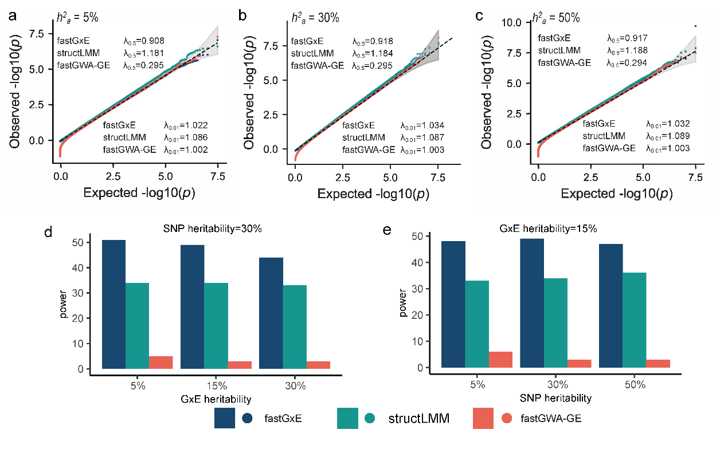
Supplementary Figure 1. Simulation comparisons of fastGxE, structLMM, and fastGWA-GE. (a-c) Quantile-quantile plots of -log10 p-values from SNPs on even-numbered chromosomes without GxE effects, under SNP heritability levels of 5% (a), 30% (b), and 50% (c); Power comparisons under varying baseline settings with different levels of GxE heritability (d), and SNP heritability (e).

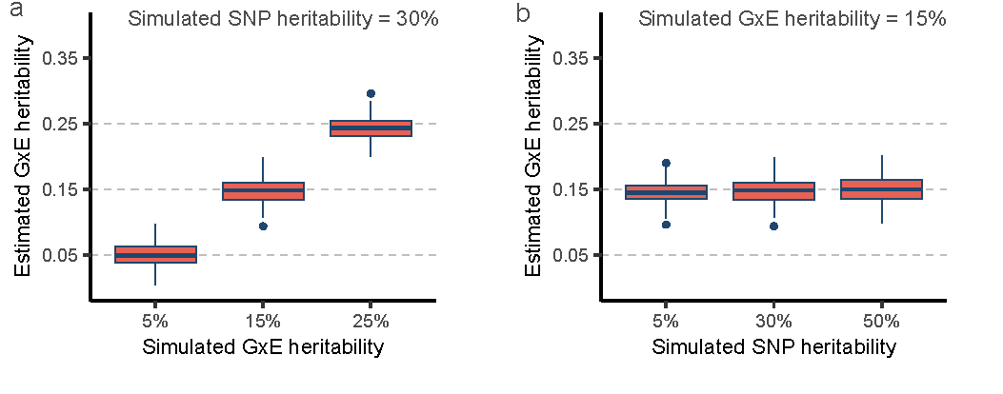
Supplementary Figure 2. Estimated GxE heritability using fastGxE versus truth in simulations under varying baseline settings with different levels of GxE heritability (a) and SNP heritability (b). Boxplots represent the distribution of estimated GxE heritability values over 100 simulation replicates.

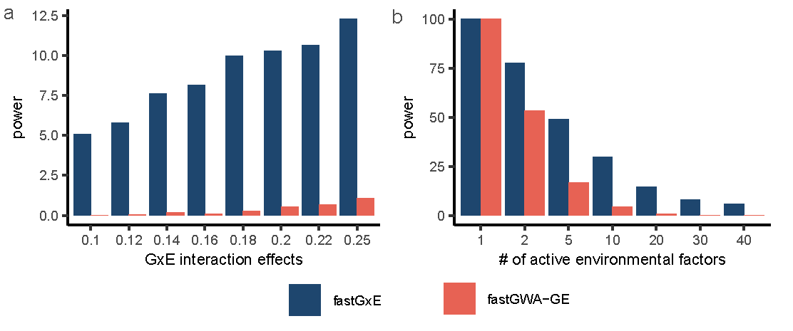
Supplementary Figure 3. Power comparison between fastGxE and fastGWA-GE in identifying the specific environmental factors driving the detected GxE associations. Power comparisons were conducted at varying levels of GxE interaction effects (a), or different numbers of active interacting environmental factors (b).

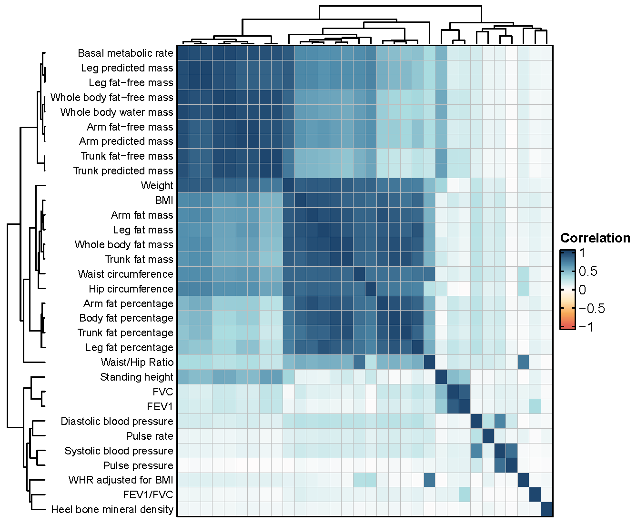
Supplementary Figure 4. Heatmap shows pair-wise Pearson correlation among 32 physical traits used for GxE analyses in UKB. Traits are clustered hierarchically based on their similarity, with blue indicating strong positive correlations and red indicating strong negative correlations.

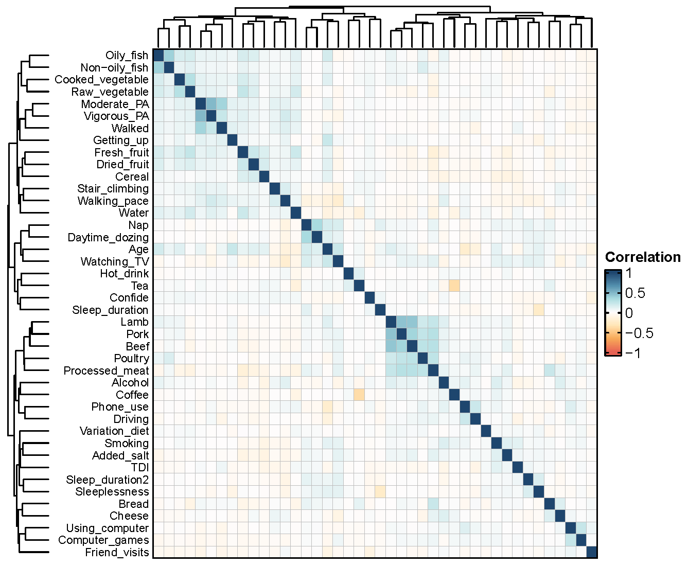
Supplementary Figure 5. Heatmaps shows pair-wise Pearson correlation among 42 environmental factors used for GxE analyses in UKB. The environmental factors include age, Townsend deprivation index, 6 physical activity variables, 4 electronic device usage variables, 6 sleep related variables, smoking status, 11 ordinal dietary intake variables, 9 continuous dietary intake variables, alcohol intake frequency, and 2 social support variables. Environmental factors are clustered hierarchically based on their similarity, with blue indicating strong positive correlations and red indicating strong negative correlations.

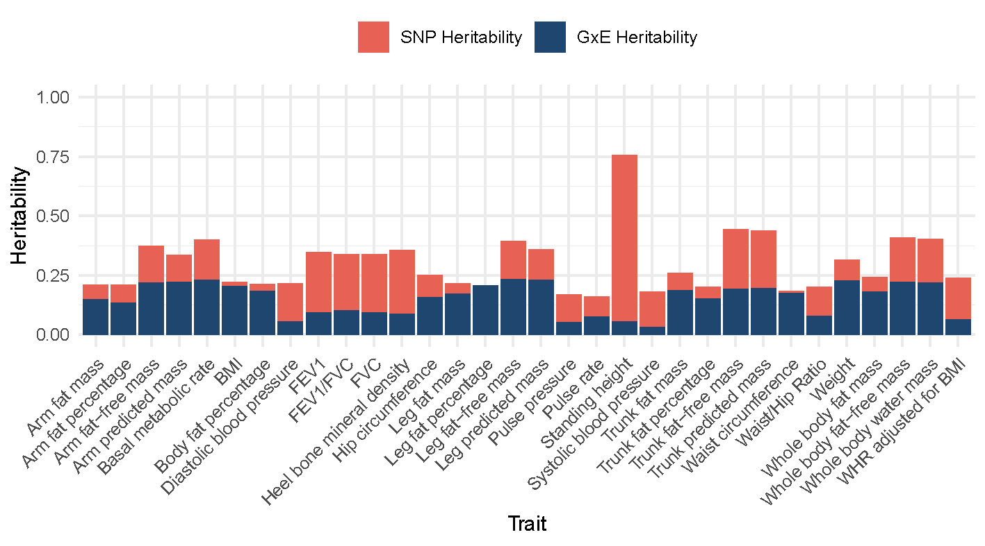
Supplementary Figure 6. Estimate of SNP heritability and GxE heritability by fastGxE for 32 physical traits in UKB.

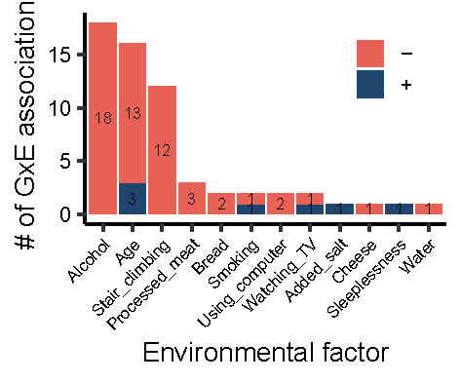
Supplementary Figure 7. Bar plot showing the number of GxE associations involving a given environmental factor across 32 physical traits in UKB. Dark red bars represent GxE associations with GxE effects opposite to the SNP main effects, while blue bars represent associations with consistent effects.

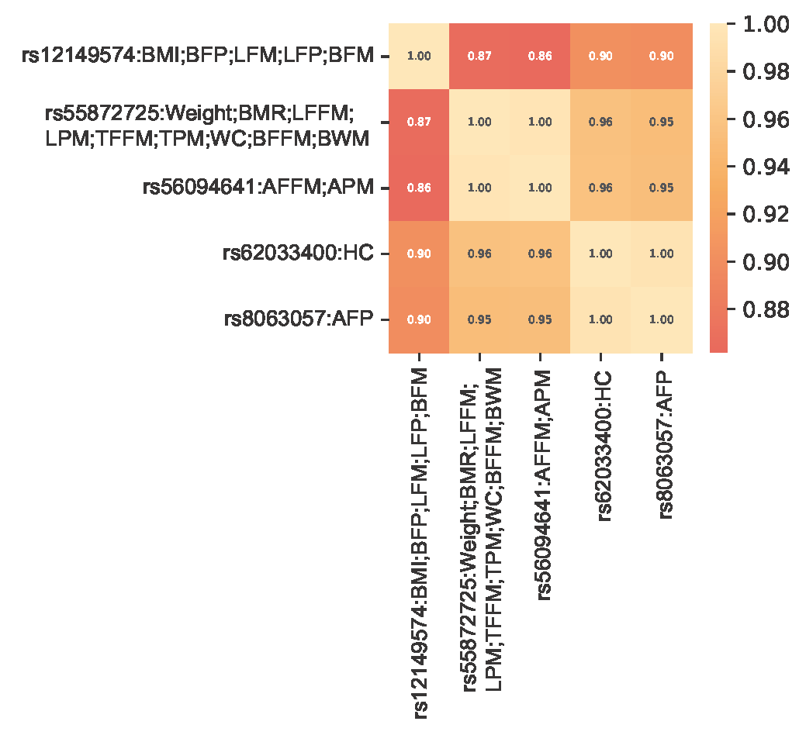
Supplementary Figure 8. Heatmap of LD r² values for the lead SNPs associated with different traits in the FTO region.

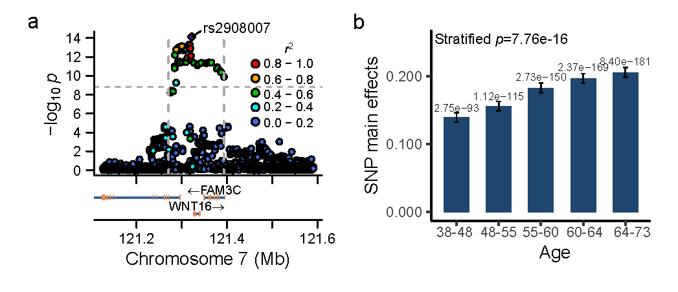

Supplementary Figure 9. WNT16 region (7:121,270,692-121,393,067), which contains GxE signals associated with heel bone mineral density (BMD). (a) Locus zoom plot showing -log10 GxE p-values for SNPs in the WNT16 region associated with BMD; (b) Estimated SNP main effects on BMD with standard errors, along with corresponding p-values, in different age quintiles for the lead GxE SNP (rs2908007).

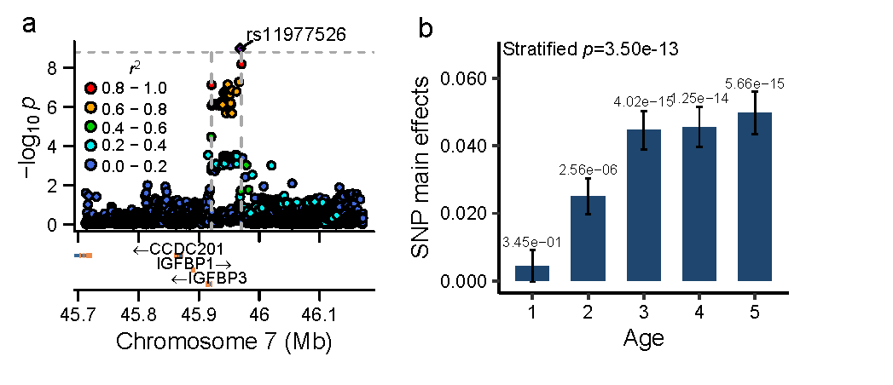
Supplementary Figure 10. IGFBP3 region (7:45,921,046-45,970,501), which contains GxE signals associated with pulse pressure (PP). (a) Locus zoom plot showing -log10 GxE p-values for SNPs in the IGFBP3 region associated with PP; (b) Estimated SNP main effects on PP with standard errors, along with corresponding p-values, in different age quintiles for the lead GxE SNP (rs11977526).

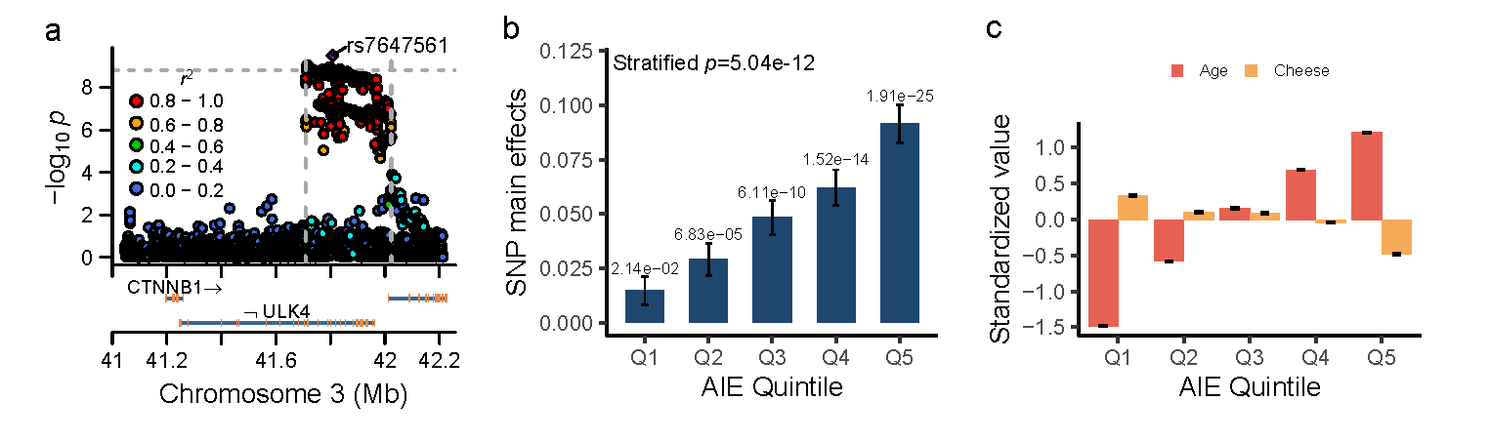

Supplementary Figure 11. ULK4 region (3:41,708,768-42,023,513), which contains GxE signals associated with pulse pressure (PP). (a) Locus zoom plot showing -log10 GxE p-values for SNPs in the ULK4 region associated with PP; (b) Estimated SNP main effects on PP with standard errors, along with corresponding p-values, in different quintiles of aggregated interacting environment (AIE) scores for the lead GxE SNP (rs7647561); (c) Standardized values of identified interacting environmental factors in different quintiles of AIE scores.

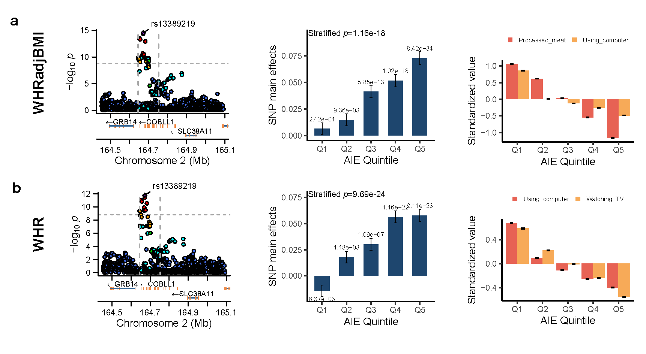
Supplementary Figure 12. COBLL1 region (2:165,501,849-165,580,775), which contains GxE signals associated with WHRadjBMI (a) and WHR (b). Locus zoom plots showing -log10 GxE p-values for SNPs in the COBLL1 region associated with WHRadjBMI and WHR (left panel); Estimated SNP main effects on WHRadjBMI and WHR with standard errors, along with corresponding p-values, in different quintiles of aggregated interacting environment (AIE) scores for the lead GxE SNP (rs13389219) (middle panel); Standardized values of identified interacting environmental factors in different quintiles of AIE scores (right panel).

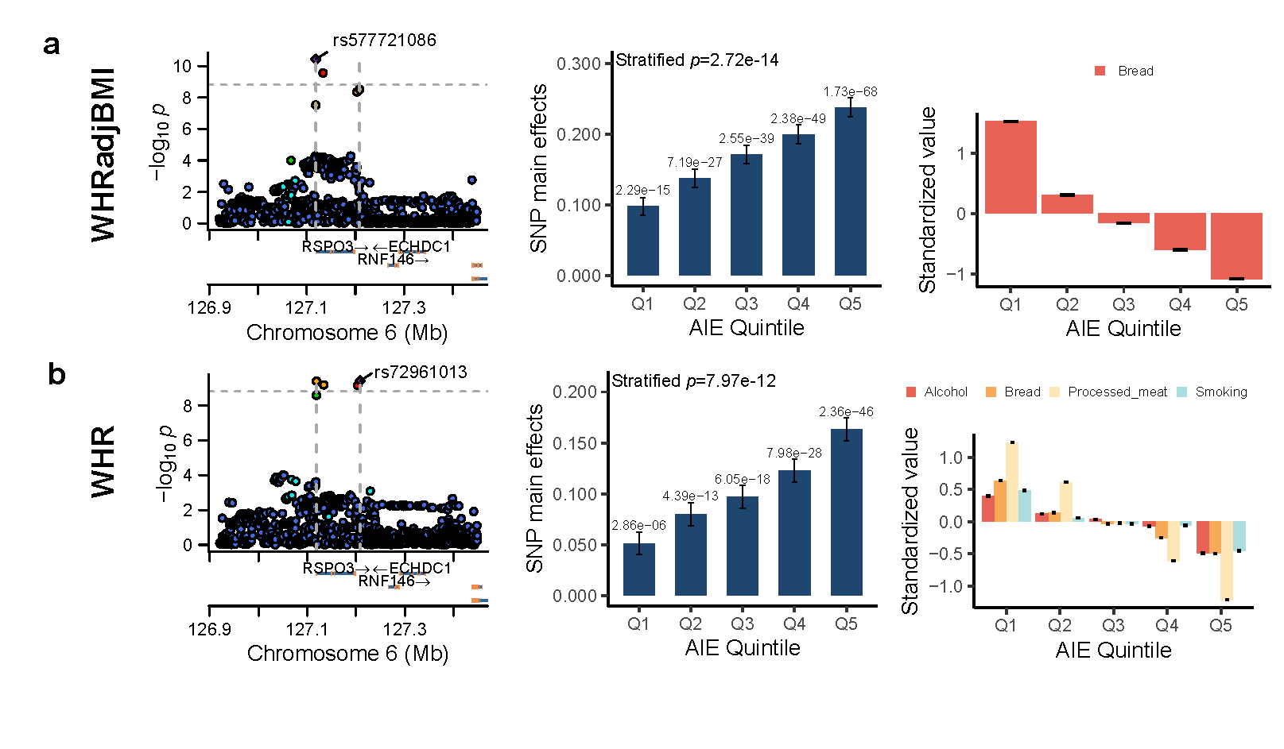
Supplementary Figure 13. RSPO3 region (6:127,118,752-127,208,635), which contains GxE signals associated with WHRadjBMI (a) and WHR (b). Locus zoom plots showing -log10 GxE p-values for SNPs in the RSPO3 region associated with WHRadjBMI and WHR (left panel); Estimated SNP main effects on WHRadjBMI and WHR with standard errors, along with corresponding p-values, in different quintiles of aggregated interacting environment (AIE) scores for the lead GxE SNPs (rs577721086 and rs72961013) (middle panel); Standardized values of identified interacting environmental factors in different quintiles of AIE scores (right panel).

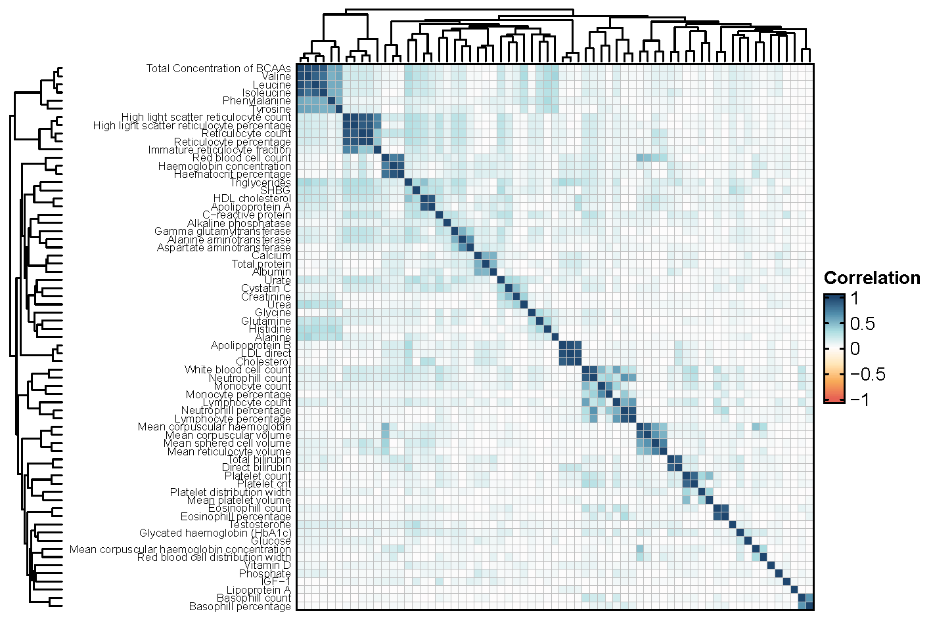

Supplementary Figure 14. Heatmap shows pair-wise Pearson correlation among 67 blood biomarkers used for GxE analyses in UKB. Traits are clustered hierarchically based on their similarity, with blue indicating strong positive correlations and red indicating strong negative correlations.

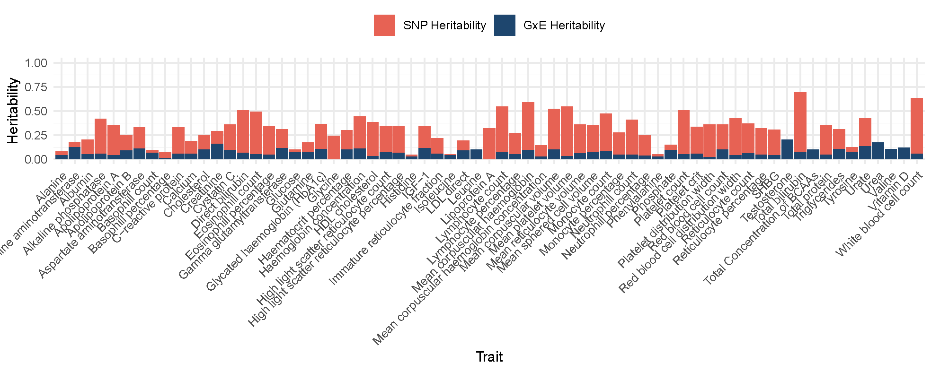
Supplementary Figure 15. Estimate of genetic heritability and GxE heritability by fastGxE for 67 blood biomarkers in the UKB

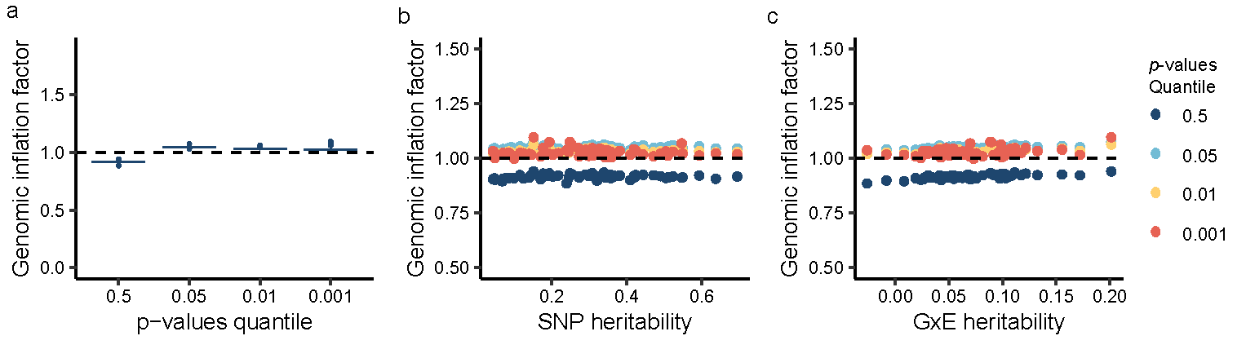
Supplementary Figure 16. Genomic inflation factors for 67 blood biomarkers. (a) Genomic inflation factors at various p-value quantiles; (b) Relationship between genomic inflation factors and SNP heritability levels across different p-value quantiles; (c) Relationship between genomic inflation factors and GxE heritability levels across different p-value quantiles.

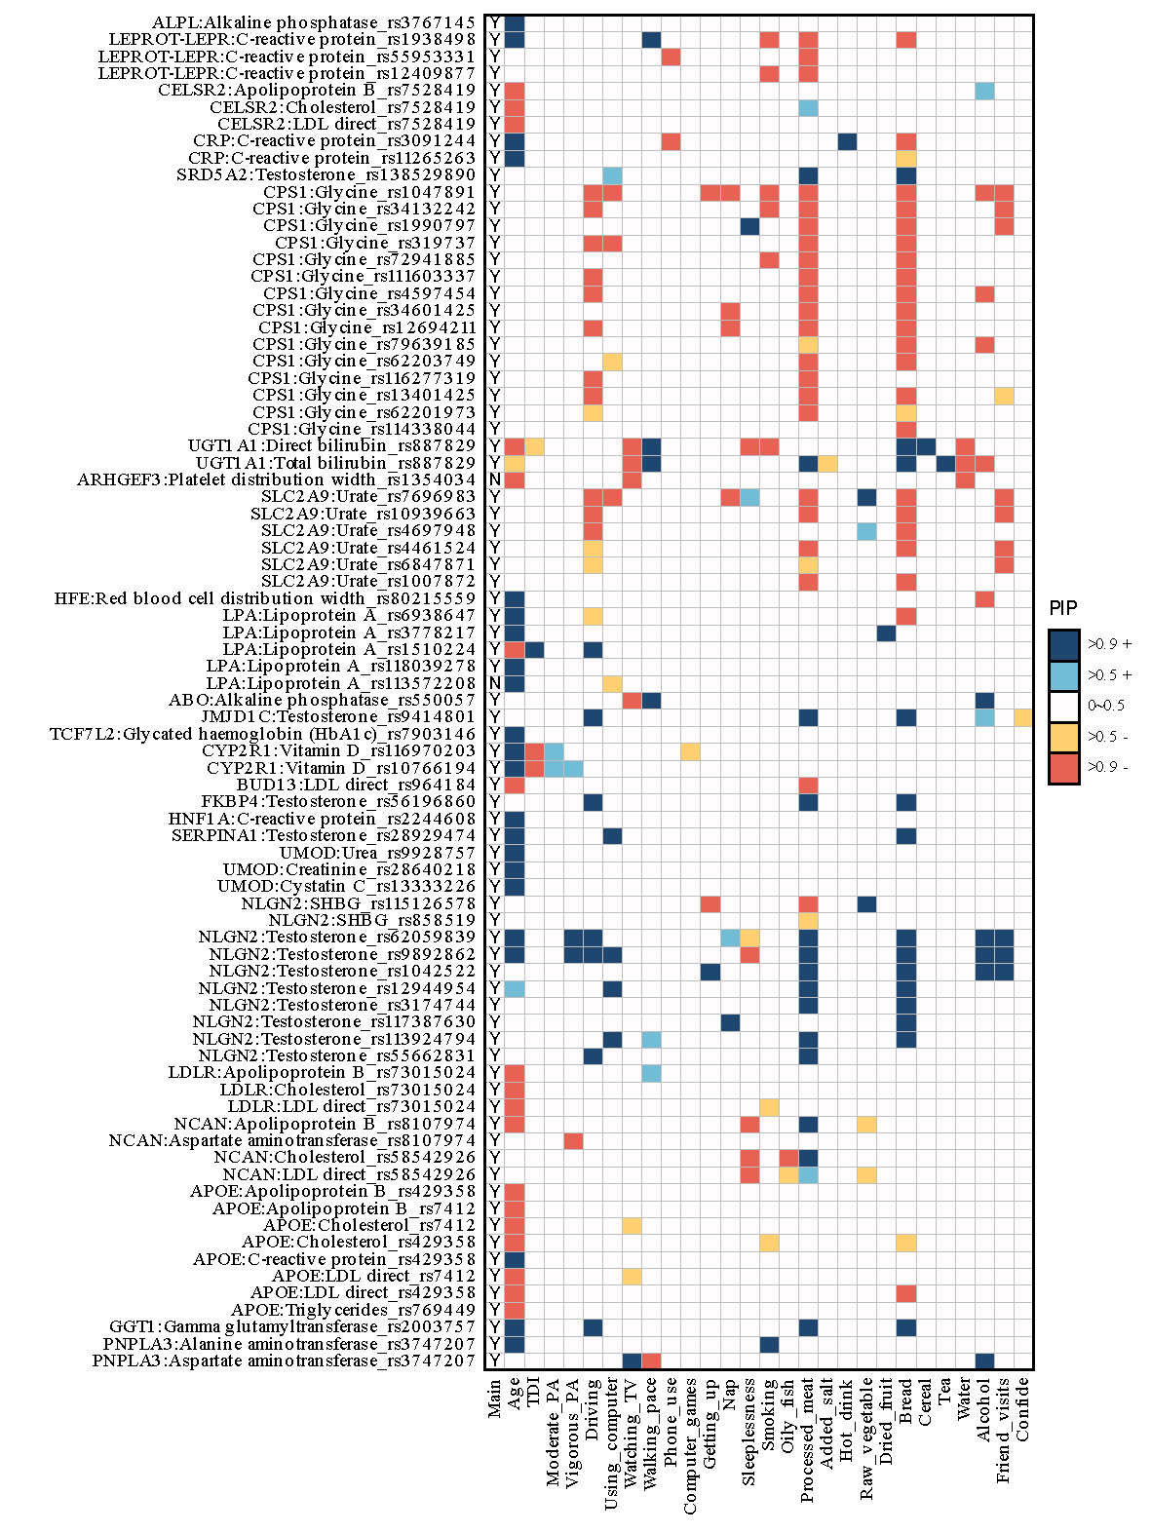

Supplementary Figure 17. A heatmap displaying the posterior inclusion probability (PIP) for GxE interactions between different environmental factors (x-axis) and the lead SNP in the identified genic region for various traits (y-axis). The first column shows whether the SNP main effect is significant (p-value < 7.46e-10).

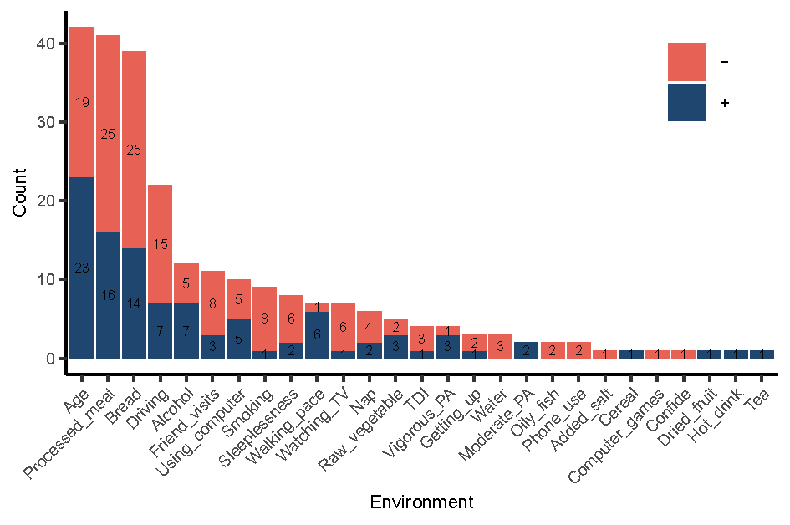
Supplementary Figure 18. Bar plot showing the number of GxE associations involving a given environmental factor across 67 blood biomarkers in UKB. Dark red bars represent GxE associations with GxE effects opposite to the SNP main effects, while blue bars represent associations with consistent effects.

3 Supplementary Tables
Supplementary Table 1. Genomic inflation factors at different p-value quantiles (q=0.5, 0.05, 0.01, and 0.001) and different GxE heritability values (5%, 15%, and 25%) for fastGxE, StructLMM and fastGWA-GE in simulations.
SNP heritibility | GxE heritibility | Methods | q=0.5 | q=0.05 | q=0.01 | q=0.001
0.30 | 0.05 | fastGxE | 0.916 | 1.059 | 1.036 | 1.021
0.30 | 0.05 | StructLMM | 1.064 | 1.039 | 1.035 | 1.030
0.30 | 0.05 | fastGWA-GE | 0.296 | 0.989 | 1.002 | 1.007
0.05 | 0.15 | fastGxE | 0.908 | 1.048 | 1.022 | 1.007
0.05 | 0.15 | StructLMM | 1.181 | 1.101 | 1.086 | 1.074
0.05 | 0.15 | fastGWA-GE | 0.295 | 0.989 | 1.002 | 1.006
0.30 | 0.15 | fastGxE | 0.918 | 1.058 | 1.034 | 1.019
0.30 | 0.15 | StructLMM | 1.184 | 1.101 | 1.087 | 1.075
0.30 | 0.15 | fastGWA-GE | 0.295 | 0.989 | 1.003 | 1.007
0.50 | 0.15 | fastGxE | 0.917 | 1.059 | 1.032 | 1.017
0.50 | 0.15 | StructLMM | 1.188 | 1.105 | 1.089 | 1.076
0.50 | 0.15 | fastGWA-GE | 0.294 | 0.989 | 1.003 | 1.004
0.30 | 0.25 | fastGxE | 0.920 | 1.057 | 1.031 | 1.018
0.30 | 0.25 | StructLMM | 1.380 | 1.198 | 1.166 | 1.141
0.30 | 0.25 | fastGWA-GE | 0.291 | 0.988 | 1.001 | 1.005

Supplementary Table 2. Description of 32 physical traits used for GxE analyses in UKB.
Field ID | Trait Name | Short Name | Sample Size
48 | Waist circumference | WC | 323,829
49 | Hip circumference | HC | 321,393
50 | Standing height | Height | 324,811
78 | Heel bone mineral density (BMD) T-score, automated | BMD | 214,580
102 | Pulse rate, automated reading | PR | 322,925
3062 | Forced vital capacity (FVC) | FVC | 297,797
3063 | Forced expiratory volume in 1-second (FEV1) | FEV1 | 297,725
4079 | Diastolic blood pressure, automated reading | DBP | 323,953
4080 | Systolic blood pressure, automated reading | SBP | 323,707
21001 | Body mass index (BMI) | BMI | 321,703
21002 | Weight | Weight | 322,699
23099 | Body fat percentage | BFP | 320,488
23100 | Whole body fat mass | BFM | 316,967
23101 | Whole body fat-free mass | BFFM | 320,198
23102 | Whole body water mass | BWM | 320,191
23105 | Basal metabolic rate | BMR | 319,438
23115 | Leg fat percentage (left) | LFP | 320,722
23116 | Leg fat mass (left) | LFM | 317,478
23117 | Leg fat-free mass (left) | LFFM | 319,346
23118 | Leg predicted mass (left) | LPM | 319,359
23123 | Arm fat percentage (left) | AFP | 320,098
23124 | Arm fat mass (left) | AFM | 315,778
23125 | Arm fat-free mass (left) | AFFM | 319,845
23126 | Arm predicted mass (left) | APM | 319,875
23127 | Trunk fat percentage | TFP | 319,342
23128 | Trunk fat mass | TFM | 318,348
23129 | Trunk fat-free mass | TFFM | 320,136
23130 | Trunk predicted mass | TPM | 320,122
FFR | FEV1/ FVC ratio | FFR | 297,299
PP | Pulse pressure | PP | 322,652
WHR | Waist/Hip Ratio | WHR | 320,743
WHRadjBMI | WHR adjusted for BMI | WHRadjBMI | 319,691
The table lists summary information for 32 physical traits in the UKB, including field ID in the UKB (1st column), trait name in the UKB (2nd column), short name (3rd column), and sample size for GxE analysis (4th column).

Supplementary Table 3. Description of confounding covariates and interacting environmental factors used for GxE analyses in UKB.
Field ID | Unique Data ID | Field Name | Short Name | Category
22000 | 22000-0.0 | Genotype measurement batch | Genotype batch | confounding
22009 | 22009-0.1 | Genetic principal components 1 | PCA1 | confounding
22009 | 22009-0.2 | Genetic principal components 2 | PCA2 | confounding
22009 | 22009-0.3 | Genetic principal components 3 | PCA3 | confounding
22009 | 22009-0.4 | Genetic principal components 4 | PCA4 | confounding
22009 | 22009-0.5 | Genetic principal components 5 | PCA5 | confounding
22009 | 22009-0.6 | Genetic principal components 6 | PCA6 | confounding
22009 | 22009-0.7 | Genetic principal components 7 | PCA7 | confounding
22009 | 22009-0.8 | Genetic principal components 8 | PCA8 | confounding
22009 | 22009-0.9 | Genetic principal components 9 | PCA9 | confounding
22009 | 22009-0.10 | Genetic principal components 10 | PCA10 | confounding
22009 | 22009-0.11 | Genetic principal components 11 | PCA11 | confounding
22009 | 22009-0.12 | Genetic principal components 12 | PCA12 | confounding
22009 | 22009-0.13 | Genetic principal components 13 | PCA13 | confounding
22009 | 22009-0.14 | Genetic principal components 14 | PCA14 | confounding
22009 | 22009-0.15 | Genetic principal components 15 | PCA15 | confounding
22009 | 22009-0.16 | Genetic principal components 16 | PCA16 | confounding
22009 | 22009-0.17 | Genetic principal components 17 | PCA17 | confounding
22009 | 22009-0.18 | Genetic principal components 18 | PCA18 | confounding
22009 | 22009-0.19 | Genetic principal components 19 | PCA19 | confounding
22009 | 22009-0.20 | Genetic principal components 20 | PCA20 | confounding
31 | 31-0.0 | Sex | Sex | confounding
21003 | 21003-0.0 | Age when attended assessment centre | Age | interacting
22189 | 22189-0.0 | Townsend deprivation index at recruitment | TDI | interacting
943 | 943-0.0 | Frequency of stair climbing in last 4 weeks | Stair climbing | interacting
884 | 884-0.0 | Number of days/week of moderate physical activity 10+ minutes | Moderate PA | interacting
904 | 904-0.0 | Number of days/week of vigorous physical activity 10+ minutes | Vigorous PA | interacting
864 | 864-0.0 | Number of days/week walked 10+ minutes | Walked | interacting
1090 | 1090-0.0 | Time spent driving | Driving | interacting
1080 | 1080-0.0 | Time spent using computer | Using computer | interacting
1070 | 1070-0.0 | Time spent watching television (TV) | Watching TV | interacting
924 | 924-0.0 | Usual walking pace | Walking pace | interacting
1110 | 1110-0.0 | Length of mobile phone use | Phone use | interacting
2237 | 2237-0.0 | Plays computer games | Computer games | interacting
1160 | 1160-0.0 | Sleep duration | Sleep duration | interacting
1170 | 1170-0.0 | Getting up in morning | Getting up | interacting
1190 | 1190-0.0 | Nap during day | Nap | interacting
1200 | 1200-0.0 | Sleeplessness / insomnia | Sleeplessness | interacting
1220 | 1220-0.0 | Daytime dozing / sleeping | Daytime dozing | interacting
20116 | 20116-0.0 | Smoking status | Smoking | interacting
1289 | 1289-0.0 | Cooked vegetable intake | Cooked vegetable | interacting
1299 | 1299-0.0 | Salad / raw vegetable intake | Raw vegetable | interacting
1309 | 1309-0.0 | Fresh fruit intake | Fresh fruit | interacting
1319 | 1319-0.0 | Dried fruit intake | Dried fruit | interacting
1329 | 1329-0.0 | Oily fish intake | Oily fish | interacting
1339 | 1339-0.0 | Non-oily fish intake | Non-oily fish | interacting
1349 | 1349-0.0 | Processed meat intake | Processed meat | interacting
1359 | 1359-0.0 | Poultry intake | Poultry | interacting
1369 | 1369-0.0 | Beef intake | Beef | interacting
1379 | 1379-0.0 | Lamb/mutton intake | Lamb | interacting
1389 | 1389-0.0 | Pork intake | Pork | interacting
1408 | 1408-0.0 | Cheese intake | Cheese | interacting
1438 | 1438-0.0 | Bread intake | Bread | interacting
1458 | 1458-0.0 | Cereal intake | Cereal | interacting
1478 | 1478-0.0 | Salt added to food | Added salt | interacting
1488 | 1488-0.0 | Tea intake | Tea | interacting
1498 | 1498-0.0 | Coffee intake | Coffee | interacting
1518 | 1518-0.0 | Hot drink temperature | Hot drink | interacting
1528 | 1528-0.0 | Water intake | Water | interacting
1548 | 1548-0.0 | Variation in diet | Variation diet | interacting
1558 | 1558-0.0 | Alcohol intake frequency | Alcohol | interacting
1031 | 1031-0.0 | Frequency of friend/family visits | Friend visits | interacting
2110 | 2110-0.0 | Able to confide | Confide | interacting
The table lists summary information for confounding covariates and interacting environmental factors in the UKB, including field ID in the UKB (1st column), unique data ID in the UKB (2nd column), filed name in the UKB (3rd column), short name (4th column), and category (4th column; confounding for confounding covariates and interacting for interacting environmental factors).

Supplementary Table 4. Genomic inflation factors at different quantiles (q=0.5, 0.05, 0.01, and 0.001) in the GxE analysis by fastGxE for 32 physical traits.
Trait Name | q=0.5 | q=0.05 | q=0.01 | q=0.001
Waist circumference | 0.942 | 1.077 | 1.059 | 1.040
Hip circumference | 0.938 | 1.070 | 1.047 | 1.038
Standing height | 0.913 | 1.049 | 1.028 | 1.008
Heel bone mineral density (BMD) T-score, automated | 0.918 | 1.055 | 1.037 | 1.031
Pulse rate, automated reading | 0.915 | 1.045 | 1.036 | 1.034
Forced vital capacity (FVC) | 0.917 | 1.048 | 1.026 | 1.018
Forced expiratory volume in 1-second (FEV1) | 0.911 | 1.042 | 1.024 | 1.009
Diastolic blood pressure, automated reading | 0.921 | 1.057 | 1.049 | 1.029
Systolic blood pressure, automated reading | 0.920 | 1.046 | 1.022 | 1.005
Body mass index (BMI) | 0.947 | 1.072 | 1.052 | 1.055
Weight | 0.942 | 1.067 | 1.050 | 1.028
Body fat percentage | 0.946 | 1.076 | 1.060 | 1.054
Whole body fat mass | 0.944 | 1.072 | 1.059 | 1.052
Whole body fat-free mass | 0.933 | 1.065 | 1.045 | 1.027
Whole body water mass | 0.934 | 1.065 | 1.046 | 1.029
Basal metabolic rate | 0.937 | 1.069 | 1.048 | 1.033
Leg fat percentage (left) | 0.940 | 1.072 | 1.055 | 1.038
Leg fat mass (left) | 0.942 | 1.070 | 1.061 | 1.050
Leg fat-free mass (left) | 0.939 | 1.069 | 1.050 | 1.044
Leg predicted mass (left) | 0.937 | 1.068 | 1.052 | 1.044
Arm fat percentage (left) | 0.950 | 1.079 | 1.070 | 1.093
Arm fat mass (left) | 0.948 | 1.077 | 1.067 | 1.083
Arm fat-free mass (left) | 0.935 | 1.065 | 1.043 | 1.029
Arm predicted mass (left) | 0.934 | 1.064 | 1.046 | 1.034
Trunk fat percentage | 0.943 | 1.069 | 1.050 | 1.041
Trunk fat mass | 0.944 | 1.068 | 1.049 | 1.046
Trunk fat-free mass | 0.929 | 1.063 | 1.045 | 1.020
Trunk predicted mass | 0.928 | 1.063 | 1.045 | 1.023
FEV1/ FVC ratio | 0.911 | 1.040 | 1.022 | 1.015
Pulse pressure | 0.924 | 1.062 | 1.046 | 1.073
Waist/Hip Ratio | 0.934 | 1.065 | 1.044 | 1.042
WHR adjusted for BMI | 0.927 | 1.061 | 1.043 | 1.054

Supplementary Table 5. Summary of previously documented GxE associations for physical traits.
Gene locus | Trait | SNP | Environment | p | DOI | Sample Size | Sample Size (our) | p (our) | Replication
WNT16 | BMD | rs6952851 | age | 5.35E-19 | 10.1093/bib/bbac547 | 260,042 | 214,580 | 1.38E-13 | Y
CHRNA5-A3-B4 | FFR | rs8042849 | smoking | 2.88E-30 | 10.1093/bib/bbac547 | 412,179 | 297,299 | 3.98E-11 | Y
CHRNA5-A3-B4 | FFR | rs56077333 | smoking | 4.55E-25 | 10.1126/sciadv.aaw3538 | 316,614 | 297,299 | 3.29E-09 | Y
CHRNA5-A3-B4 | FEV1 | rs8042849 | smoking | 5.66E-16 | 10.1093/bib/bbac547 | 412,179 | 297,725 | 5.94E-04 | Y
CHRNA5-A3-B4 | WHRadjBMI | rs8040868 | smoking | 3.02E-11 | 10.1093/bib/bbac547 | 450,560 | 319,691 | 5.54E-06 | Y
APOE | Waist circumference | rs7256200 | age | 8.03E-10 | 10.1093/bib/bbac547 | 451,361 | 323,829 | 7.82E-04 | N
FTO | BMI | rs11642015 | physical activity | 1.28E-10 | 10.1126/sciadv.aaw3538 | 346,393 | 321,703 | 3.93E-10 | Y
FTO | BMI | rs11642015 | sedentary time | 1.64E-09 | 10.1126/sciadv.aaw3538 | 346,393 | 321,703 | 3.93E-10 | Y
FTO | Waist circumference | rs1421085 | sedentary time | 2.84E-08 | 10.1126/sciadv.aaw3538 | 347,158 | 323,829 | 3.41E-13 | Y
FTO | BMI | rs1558902 | alcohol; diet; physical activity | 4.23E-16 | 10.1038/s41588-018-0271-0 | 450,681 | 321,703 | 3.87E-10 | Y
We examined previous GxE association studies for physical traits. The environmental factors considered in these previous studies were age and lifestyle. We defined previous GxE associations as the SNPs with GxE p-values below 5e-8. The table lists summary information including gene locus (1st column), trait name (2nd column), SNP ID (3rd column), interacting environmental factors (4th column), reported p value (5th column), digital object identifier (DOI) of reference (6th column), sample size in previous study (7th column), sample size in our study (8th column), p values in our study (9th column) and whether the locus is replicated by fastGxE (10th column).

Supplementary Table 6. Summary of 61 SNP-environment interacting pairs identified by fastGxE across 32 physical traits.
Gene | Lead SNP | Trait | Environment | PIP | Direction
LYPLAL1-AS1 | rs6674544 | WHRadjBMI | Sleeplessness | 0.939130488 | +
LYPLAL1-AS1 | rs6674544 | WHRadjBMI | Processed meat | 0.995315817 | -
LYPLAL1-AS1 | rs6674544 | WHRadjBMI | Alcohol | 0.994474577 | -
COBLL1 | rs13389219 | WHRadjBMI | Using computer | 0.896604346 | -
COBLL1 | rs13389219 | WHRadjBMI | Processed meat | 0.999832846 | -
RSPO3 | rs577721086 | WHRadjBMI | Bread | 0.999997092 | -
COBLL1 | rs13389219 | WHR | Using computer | 0.500958168 | -
COBLL1 | rs13389219 | WHR | Watching TV | 0.524542582 | -
RSPO3 | rs72961013 | WHR | Smoking | 0.512830493 | -
RSPO3 | rs72961013 | WHR | Processed meat | 0.992400828 | -
RSPO3 | rs72961013 | WHR | Bread | 0.512911782 | -
RSPO3 | rs72961013 | WHR | Alcohol | 0.500228493 | -
ULK4 | rs7647561 | PP | Age | 0.999999986 | +
ULK4 | rs7647561 | PP | Cheese | 0.583122647 | -
IGFBP3 | rs11977526 | PP | Age | 0.999999333 | +
FBXO32 | rs34557926 | PP | Age | 0.99999999 | -
WNT16 | rs2908007 | BMD | Age | 1 | +
CHRNA5-A3-B4 | rs8042849 | FFR | Watching TV | 0.699959776 | +
CHRNA5-A3-B4 | rs8042849 | FFR | Smoking | 0.999999998 | +
CHRNA5-A3-B4 | rs8042849 | FFR | Water | 0.5021176 | -
FTO | rs12149574 | BMI | Stair climbing | 0.535021637 | -
FTO | rs12149574 | BMI | Alcohol | 0.998267176 | -
FTO | rs55872725 | Weight | Age | 0.985409303 | -
FTO | rs55872725 | Weight | Stair climbing | 0.990992165 | -
FTO | rs55872725 | Weight | Alcohol | 0.99983389 | -
FTO | rs12149574 | BFP | Age | 0.997288259 | -
FTO | rs12149574 | BFP | Stair climbing | 0.740557824 | -
FTO | rs12149574 | BFP | Alcohol | 0.999990045 | -
FTO | rs12149574 | BFM | Age | 0.95405152 | -
FTO | rs12149574 | BFM | Stair climbing | 0.522243859 | -
FTO | rs12149574 | BFM | Alcohol | 0.999932508 | -
FTO | rs55872725 | BFFM | Alcohol | 0.510107052 | -
FTO | rs55872725 | BWM | Alcohol | 0.516798766 | -
FTO | rs55872725 | BMR | Age | 0.514866737 | -
FTO | rs55872725 | BMR | Stair climbing | 0.899607906 | -
FTO | rs55872725 | BMR | Alcohol | 0.545930521 | -
FTO | rs12149574 | LFP | Age | 0.999825043 | -
FTO | rs12149574 | LFP | Alcohol | 0.99997101 | -
FTO | rs12149574 | LFM | Age | 0.9850712 | -
FTO | rs12149574 | LFM | Alcohol | 0.999939784 | -
FTO | rs55872725 | LFFM | Stair climbing | 0.933797924 | -
FTO | rs55872725 | LFFM | Alcohol | 0.991501588 | -
FTO | rs55872725 | LPM | Stair climbing | 0.937351881 | -
FTO | rs55872725 | LPM | Alcohol | 0.98732079 | -
FTO | rs8063057 | AFP | Age | 0.529201989 | -
FTO | rs8063057 | AFP | Stair climbing | 0.992694654 | -
FTO | rs8063057 | AFP | Alcohol | 0.999968509 | -
FTO | rs56094641 | AFFM | Age | 0.534542892 | -
FTO | rs56094641 | AFFM | Stair climbing | 0.86976066 | -
FTO | rs56094641 | AFFM | Alcohol | 0.526819272 | -
FTO | rs56094641 | APM | Age | 0.533862954 | -
FTO | rs56094641 | APM | Stair climbing | 0.514718428 | -
FTO | rs56094641 | APM | Alcohol | 0.518998694 | -
FTO | rs55872725 | TFFM | Age | 0.993615974 | -
FTO | rs55872725 | TPM | Age | 0.993347005 | -
FTO | rs55872725 | WC | Age | 0.522457236 | -
FTO | rs55872725 | WC | Stair climbing | 0.996617701 | -
FTO | rs55872725 | WC | Added salt | 0.520745322 | +
FTO | rs55872725 | WC | Alcohol | 0.999986353 | -
FTO | rs62033400 | HC | Stair climbing | 0.979466308 | -
FTO | rs62033400 | HC | Alcohol | 0.992948859 | -
The table lists summary information for 61 SNP-environment interacting pairs (rows), including gene name (1st column), lead SNP (2nd column), trait name (3rd column), interacting environmental factors (4th column), posterior inclusion probability (PIP) (5th column), and whether the direction of SNP main effect and GxE effect is same (6th column; + for same and – for opposite).

Supplementary Table 7. Aggregated interacting environment (AIE) scores stratified analysis for significant GxE associations identified by fastGxE across 32 physical traits.
Genomic region | Genes | Trait | Lead SNP | p1 | p2 | p3 | p4 | p5 | Wald p-value
1:219449254-219515292 | LYPLAL1-AS1 | WHR adjusted for BMI | rs6674544 | 1.22E-01 | 1.29E-04 | 2.29E-08 | 1.96E-15 | 8.59E-30 | 5.88E-14
2:164645339-164752884 | COBLL1 | Waist/Hip Ratio | rs13389219 | 8.37E-03 | 1.18E-03 | 1.09E-07 | 1.16E-22 | 2.11E-23 | 9.69E-24
2:164645339-164752884 | COBLL1 | WHR adjusted for BMI | rs13389219 | 2.42E-01 | 9.36E-03 | 5.85E-13 | 1.02E-18 | 8.42E-34 | 1.16E-18
3:41708768-42023513 | ULK4 | Pulse pressure | rs7647561 | 2.14E-02 | 6.83E-05 | 6.11E-10 | 1.52E-14 | 1.91E-25 | 5.04E-12
6:127118752-127208635 | RSPO3 | Waist/Hip Ratio | rs72961013 | 2.86E-06 | 4.39E-13 | 6.05E-18 | 7.98E-28 | 2.36E-46 | 7.97E-12
6:127118752-127208635 | RSPO3 | WHR adjusted for BMI | rs577721086 | 2.29E-15 | 7.19E-27 | 2.55E-39 | 2.38E-49 | 1.73E-68 | 2.72E-14
7:45921046-45970501 | IGFBP3 | Pulse pressure | rs11977526 | 7.08E-01 | 7.33E-06 | 1.08E-11 | 8.56E-16 | 3.54E-18 | 3.50E-13
7:121270692-121393067 | WNT16 | Heel bone mineral density | rs2908007 | 8.09E-92 | 2.24E-111 | 4.45E-143 | 1.22E-177 | 8.38E-190 | 7.76E-16
8:123581944-123596374 | FBXO32 | Pulse pressure | rs34557926 | 4.85E-04 | 3.29E-02 | 1.04E-01 | 3.30E-04 | 7.92E-09 | 2.34E-11
15:78427159-78643826 | CHRNA5-A3-B4 | FEV1/FVC | rs8042849 | 8.88E-04 | 1.45E-01 | 7.14E-01 | 1.30E-01 | 6.31E-17 | 1.36E-16
16:53763996-53811575 | FTO | BMI | rs12149574 | 5.29E-06 | 2.76E-27 | 8.97E-30 | 4.58E-36 | 3.63E-57 | 3.84E-19
16:53763996-53811575 | FTO | Weight | rs55872725 | 5.71E-07 | 2.09E-22 | 6.16E-27 | 7.60E-49 | 7.54E-61 | 9.85E-23
16:53763996-53811575 | FTO | Body fat percentage | rs12149574 | 1.06E-02 | 3.53E-12 | 2.31E-14 | 5.93E-27 | 9.56E-46 | 4.33E-20
16:53763996-53811575 | FTO | Whole body fat mass | rs12149574 | 2.92E-04 | 1.89E-15 | 9.09E-19 | 3.01E-26 | 2.10E-53 | 3.84E-19
16:53763996-53811575 | FTO | Whole body fat-free mass | rs55872725 | 2.25E-04 | 5.65E-19 | 3.97E-22 | 1.36E-25 | 5.42E-68 | 4.55E-29
16:53763996-53811575 | FTO | Whole body water mass | rs55872725 | 2.42E-04 | 7.33E-20 | 1.82E-21 | 1.30E-25 | 1.59E-68 | 3.26E-29
16:53763996-53811575 | FTO | Basal metabolic rate | rs55872725 | 4.00E-08 | 2.88E-12 | 7.07E-28 | 3.01E-35 | 4.18E-61 | 2.75E-23
16:53763996-53811575 | FTO | Leg fat percentage | rs12149574 | 2.49E-03 | 1.69E-09 | 3.00E-14 | 7.10E-22 | 3.13E-48 | 3.48E-19
16:53763996-53811575 | FTO | Leg fat mass | rs12149574 | 4.40E-05 | 3.42E-15 | 2.58E-18 | 8.39E-24 | 9.28E-57 | 1.43E-19
16:53763996-53811575 | FTO | Leg fat-free mass | rs55872725 | 2.51E-08 | 6.62E-19 | 3.85E-27 | 2.72E-37 | 7.02E-64 | 6.58E-21
16:53763996-53811575 | FTO | Leg predicted mass | rs55872725 | 6.82E-09 | 2.96E-16 | 1.07E-28 | 1.57E-39 | 1.71E-62 | 4.23E-21
16:53763996-53811575 | FTO | Arm fat percentage | rs8063057 | 2.17E-04 | 7.48E-14 | 1.73E-20 | 2.16E-35 | 2.57E-50 | 1.55E-20
16:53763996-53811575 | FTO | Arm fat-free mass | rs56094641 | 6.12E-07 | 1.18E-08 | 4.76E-25 | 1.47E-24 | 4.88E-61 | 3.31E-24
16:53763996-53811575 | FTO | Arm predicted mass | rs56094641 | 6.62E-05 | 1.26E-13 | 3.35E-18 | 1.34E-23 | 9.21E-69 | 5.73E-29
16:53763996-53811575 | FTO | Trunk fat-free mass | rs55872725 | 4.47E-05 | 2.86E-09 | 5.06E-18 | 4.01E-27 | 6.49E-49 | 3.86E-19
16:53763996-53811575 | FTO | Trunk predicted mass | rs55872725 | 9.44E-06 | 2.54E-09 | 4.00E-16 | 1.41E-27 | 1.42E-48 | 2.52E-18
16:53763996-53811575 | FTO | Waist circumference | rs55872725 | 4.64E-05 | 1.85E-16 | 1.52E-25 | 1.75E-37 | 7.54E-55 | 7.95E-21
16:53763996-53811575 | FTO | Hip circumference | rs62033400 | 1.70E-05 | 7.20E-09 | 8.49E-32 | 6.87E-30 | 1.28E-47 | 4.52E-19
The table lists summary information for the AIE stratified analysis, including genomic region (1st column), gene (2nd column), trait name (3rd column), lead SNP (4th column), p-values of SNP main effects for five AIE quintile groups (5-9th column), and stratified Wald p-value (10th column).

Supplementary Table 8. The table summarizes eQTL and sQTL annotation results of the lead SNPs in significant GxE regions for 32 physical traits.
rsID | chr | pos | tissue | gene | QTL type | p
rs6674544 | 1 | 219628973 | Adipose_Subcutaneous | RP11-392O17.1 | eQTL | 6.18E-05
rs6674544 | 1 | 219628973 | Kidney_Cortex | RP11-392O17.1 | eQTL | 4.24E-08
rs6674544 | 1 | 219628973 | Skin_Not_Sun_Exposed_Suprapubic | RP11-392O17.1 | eQTL | 2.00E-18
rs6674544 | 1 | 219628973 | Skin_Sun_Exposed_Lower_leg | SLC30A10 | eQTL | 2.51E-04
rs6674544 | 1 | 219628973 | Skin_Sun_Exposed_Lower_leg | RP11-392O17.1 | eQTL | 2.03E-19
rs13389219 | 2 | 165528876 | Adipose_Subcutaneous | SLC38A11 | eQTL | 1.60E-07
rs13389219 | 2 | 165528876 | Artery_Tibial | SLC38A11 | eQTL | 1.86E-04
rs13389219 | 2 | 165528876 | Brain_Cerebellum | COBLL1 | eQTL | 8.42E-05
rs13389219 | 2 | 165528876 | Breast_Mammary_Tissue | SLC38A11 | eQTL | 2.83E-07
rs13389219 | 2 | 165528876 | Esophagus_Muscularis | GRB14 | eQTL | 7.45E-07
rs13389219 | 2 | 165528876 | Esophagus_Muscularis | SLC38A11 | eQTL | 4.36E-05
rs13389219 | 2 | 165528876 | Muscle_Skeletal | SLC38A11 | eQTL | 3.37E-14
rs13389219 | 2 | 165528876 | Nerve_Tibial | SCN2A | eQTL | 9.33E-11
rs13389219 | 2 | 165528876 | Nerve_Tibial | SLC38A11 | eQTL | 2.21E-05
rs13389219 | 2 | 165528876 | Nerve_Tibial | SNORA70F | eQTL | 5.62E-05
rs13389219 | 2 | 165528876 | Nerve_Tibial | AC013463.2 | eQTL | 1.24E-06
rs13389219 | 2 | 165528876 | Testis | SLC38A11 | eQTL | 1.73E-05
rs13389219 | 2 | 165528876 | Thyroid | COBLL1 | eQTL | 1.75E-05
rs13389219 | 2 | 165528876 | Thyroid | SLC38A11 | eQTL | 4.51E-11
rs13389219 | 2 | 165528876 | Adipose_Subcutaneous | SLC38A11 | eQTL | 1.60E-07
rs13389219 | 2 | 165528876 | Artery_Tibial | SLC38A11 | eQTL | 1.86E-04
rs13389219 | 2 | 165528876 | Brain_Cerebellum | COBLL1 | eQTL | 8.42E-05
rs13389219 | 2 | 165528876 | Breast_Mammary_Tissue | SLC38A11 | eQTL | 2.83E-07
rs13389219 | 2 | 165528876 | Esophagus_Muscularis | GRB14 | eQTL | 7.45E-07
rs13389219 | 2 | 165528876 | Esophagus_Muscularis | SLC38A11 | eQTL | 4.36E-05
rs13389219 | 2 | 165528876 | Muscle_Skeletal | SLC38A11 | eQTL | 3.37E-14
rs13389219 | 2 | 165528876 | Nerve_Tibial | SCN2A | eQTL | 9.33E-11
rs13389219 | 2 | 165528876 | Nerve_Tibial | SLC38A11 | eQTL | 2.21E-05
rs13389219 | 2 | 165528876 | Nerve_Tibial | SNORA70F | eQTL | 5.62E-05
rs13389219 | 2 | 165528876 | Nerve_Tibial | AC013463.2 | eQTL | 1.24E-06
rs13389219 | 2 | 165528876 | Testis | SLC38A11 | eQTL | 1.73E-05
rs13389219 | 2 | 165528876 | Thyroid | COBLL1 | eQTL | 1.75E-05
rs13389219 | 2 | 165528876 | Thyroid | SLC38A11 | eQTL | 4.51E-11
rs72961013 | 6 | 127529780 | Adipose_Subcutaneous | RSPO3 | eQTL | 1.48E-04
rs577721086 | 6 | 127440047 | Adipose_Subcutaneous | RSPO3 | eQTL | 1.22E-06
rs11977526 | 7 | 46008110 | Artery_Aorta | IGFBP3 | eQTL | 1.26E-05
rs11977526 | 7 | 46008110 | Brain_Cerebellar_Hemisphere | IGFBP3 | eQTL | 3.96E-05
rs11977526 | 7 | 46008110 | Brain_Cerebellum | IGFBP3 | eQTL | 3.04E-06
rs11977526 | 7 | 46008110 | Brain_Cortex | IGFBP3 | eQTL | 2.74E-05
rs11977526 | 7 | 46008110 | Heart_Left_Ventricle | IGFBP3 | eQTL | 1.91E-07
rs11977526 | 7 | 46008110 | Muscle_Skeletal | IGFBP3 | eQTL | 7.56E-05
rs11977526 | 7 | 46008110 | Muscle_Skeletal | SEPT7P2 | eQTL | 1.38E-05
rs11977526 | 7 | 46008110 | Nerve_Tibial | SEPT7P2 | eQTL | 1.39E-04
rs11977526 | 7 | 46008110 | Testis | AC073115.6 | eQTL | 1.55E-06
rs11977526 | 7 | 46008110 | Thyroid | IGFBP3 | eQTL | 1.33E-07
rs11977526 | 7 | 46008110 | Thyroid | RP11-638I8.1 | eQTL | 4.01E-05
rs2908007 | 7 | 120962164 | Adipose_Subcutaneous | WNT16 | eQTL | 2.38E-09
rs2908007 | 7 | 120962164 | Adipose_Subcutaneous | FAM3C | eQTL | 5.19E-05
rs2908007 | 7 | 120962164 | Adipose_Visceral_Omentum | FAM3C | eQTL | 9.72E-05
rs2908007 | 7 | 120962164 | Breast_Mammary_Tissue | FAM3C | eQTL | 6.43E-06
rs2908007 | 7 | 120962164 | Heart_Left_Ventricle | FAM3C | eQTL | 5.21E-06
rs2908007 | 7 | 120962164 | Muscle_Skeletal | FAM3C | eQTL | 4.13E-05
rs2908007 | 7 | 120962164 | Cells_Cultured_fibroblasts | CPED1 | eQTL | 8.17E-07
rs2908007 | 7 | 120962164 | Skin_Not_Sun_Exposed_Suprapubic | WNT16 | eQTL | 2.09E-07
rs2908007 | 7 | 120962164 | Skin_Not_Sun_Exposed_Suprapubic | FAM3C | eQTL | 1.49E-06
rs2908007 | 7 | 120962164 | Skin_Sun_Exposed_Lower_leg | WNT16 | eQTL | 1.36E-09
rs2908007 | 7 | 120962164 | Skin_Sun_Exposed_Lower_leg | FAM3C | eQTL | 2.65E-08
rs2908007 | 7 | 120962164 | Testis | CYCSP19 | eQTL | 1.74E-05
rs34557926 | 8 | 124607159 | Heart_Atrial_Appendage | WDYHV1 | eQTL | 1.19E-05
rs34557926 | 8 | 124607159 | Skin_Sun_Exposed_Lower_leg | WDYHV1 | eQTL | 2.76E-05
rs8042849 | 15 | 78817929 | Adipose_Subcutaneous | PSMA4 | eQTL | 1.41E-07
rs8042849 | 15 | 78817929 | Adipose_Subcutaneous | CHRNA5 | eQTL | 4.34E-20
rs8042849 | 15 | 78817929 | Adipose_Subcutaneous | RP11-650L12.2 | eQTL | 5.07E-05
rs8042849 | 15 | 78817929 | Adipose_Visceral_Omentum | CHRNA5 | eQTL | 3.60E-11
rs8042849 | 15 | 78817929 | Adrenal_Gland | PSMA4 | eQTL | 3.58E-06
rs8042849 | 15 | 78817929 | Whole_Blood | PSMA4 | eQTL | 2.47E-11
rs8042849 | 15 | 78817929 | Whole_Blood | IREB2 | eQTL | 5.05E-05
rs8042849 | 15 | 78817929 | Artery_Aorta | PSMA4 | eQTL | 8.09E-05
rs8042849 | 15 | 78817929 | Artery_Aorta | CHRNA5 | eQTL | 9.11E-05
rs8042849 | 15 | 78817929 | Artery_Tibial | ADAMTS7 | eQTL | 1.58E-07
rs8042849 | 15 | 78817929 | Artery_Tibial | CHRNA5 | eQTL | 1.14E-08
rs8042849 | 15 | 78817929 | Brain_Anterior_cingulate_cortex_BA24 | CHRNA5 | eQTL | 1.32E-06
rs8042849 | 15 | 78817929 | Brain_Caudate_basal_ganglia | CHRNA5 | eQTL | 1.69E-08
rs8042849 | 15 | 78817929 | Brain_Caudate_basal_ganglia | RP11-650L12.2 | eQTL | 1.99E-07
rs8042849 | 15 | 78817929 | Brain_Cerebellar_Hemisphere | CHRNA5 | eQTL | 8.88E-06
rs8042849 | 15 | 78817929 | Brain_Cerebellum | PSMA4 | eQTL | 7.11E-05
rs8042849 | 15 | 78817929 | Brain_Cerebellum | CHRNA5 | eQTL | 4.69E-05
rs8042849 | 15 | 78817929 | Brain_Cortex | PSMA4 | eQTL | 4.10E-06
rs8042849 | 15 | 78817929 | Brain_Cortex | CHRNA5 | eQTL | 5.75E-13
rs8042849 | 15 | 78817929 | Brain_Frontal_Cortex_BA9 | CHRNA5 | eQTL | 4.04E-08
rs8042849 | 15 | 78817929 | Brain_Hippocampus | CHRNA5 | eQTL | 6.74E-08
rs8042849 | 15 | 78817929 | Brain_Hypothalamus | PSMA4 | eQTL | 1.84E-06
rs8042849 | 15 | 78817929 | Brain_Hypothalamus | CHRNA5 | eQTL | 2.54E-08
rs8042849 | 15 | 78817929 | Brain_Nucleus_accumbens_basal_ganglia | CHRNA3 | eQTL | 3.02E-05
rs8042849 | 15 | 78817929 | Brain_Nucleus_accumbens_basal_ganglia | CHRNA5 | eQTL | 2.96E-12
rs8042849 | 15 | 78817929 | Brain_Putamen_basal_ganglia | CHRNA5 | eQTL | 3.30E-06
rs8042849 | 15 | 78817929 | Brain_Spinal_cord_cervical_c-1 | CHRNA5 | eQTL | 1.77E-06
rs8042849 | 15 | 78817929 | Brain_Substantia_nigra | CHRNA5 | eQTL | 4.31E-06
rs8042849 | 15 | 78817929 | Breast_Mammary_Tissue | CHRNA5 | eQTL | 1.08E-10
rs8042849 | 15 | 78817929 | Colon_Sigmoid | CHRNA3 | eQTL | 1.06E-07
rs8042849 | 15 | 78817929 | Colon_Sigmoid | CHRNA5 | eQTL | 3.71E-05
rs8042849 | 15 | 78817929 | Colon_Transverse | PSMA4 | eQTL | 2.61E-06
rs8042849 | 15 | 78817929 | Esophagus_Gastroesophageal_Junction | CHRNA5 | eQTL | 4.85E-06
rs8042849 | 15 | 78817929 | Esophagus_Mucosa | CHRNB4 | eQTL | 1.70E-05
rs8042849 | 15 | 78817929 | Esophagus_Mucosa | CHRNA5 | eQTL | 1.72E-09
rs8042849 | 15 | 78817929 | Esophagus_Muscularis | PSMA4 | eQTL | 7.46E-06
rs8042849 | 15 | 78817929 | Esophagus_Muscularis | CHRNA3 | eQTL | 1.77E-05
rs8042849 | 15 | 78817929 | Heart_Atrial_Appendage | PSMA4 | eQTL | 7.59E-11
rs8042849 | 15 | 78817929 | Heart_Atrial_Appendage | CHRNA5 | eQTL | 8.31E-15
rs8042849 | 15 | 78817929 | Heart_Left_Ventricle | PSMA4 | eQTL | 3.60E-13
rs8042849 | 15 | 78817929 | Heart_Left_Ventricle | CHRNA5 | eQTL | 1.04E-14
rs8042849 | 15 | 78817929 | Lung | CHRNA5 | eQTL | 2.41E-08
rs8042849 | 15 | 78817929 | Muscle_Skeletal | PSMA4 | eQTL | 3.35E-06
rs8042849 | 15 | 78817929 | Muscle_Skeletal | CHRNA3 | eQTL | 3.08E-16
rs8042849 | 15 | 78817929 | Muscle_Skeletal | CHRNA5 | eQTL | 2.13E-33
rs8042849 | 15 | 78817929 | Muscle_Skeletal | RP11-160C18.2 | eQTL | 3.56E-15
rs8042849 | 15 | 78817929 | Nerve_Tibial | PSMA4 | eQTL | 1.13E-07
rs8042849 | 15 | 78817929 | Nerve_Tibial | CHRNA3 | eQTL | 1.42E-09
rs8042849 | 15 | 78817929 | Nerve_Tibial | CHRNA5 | eQTL | 1.78E-25
rs8042849 | 15 | 78817929 | Pituitary | CHRNA5 | eQTL | 6.49E-06
rs8042849 | 15 | 78817929 | Cells_Cultured_fibroblasts | PSMA4 | eQTL | 7.67E-07
rs8042849 | 15 | 78817929 | Cells_Cultured_fibroblasts | CHRNA5 | eQTL | 8.59E-28
rs8042849 | 15 | 78817929 | Cells_Cultured_fibroblasts | RP11-650L12.2 | eQTL | 5.00E-12
rs8042849 | 15 | 78817929 | Skin_Not_Sun_Exposed_Suprapubic | CHRNA5 | eQTL | 3.73E-05
rs8042849 | 15 | 78817929 | Skin_Sun_Exposed_Lower_leg | CHRNA5 | eQTL | 2.13E-09
rs8042849 | 15 | 78817929 | Testis | RP11-650L12.2 | eQTL | 4.61E-06
rs8042849 | 15 | 78817929 | Thyroid | PSMA4 | eQTL | 1.55E-04
rs8042849 | 15 | 78817929 | Thyroid | CHRNA5 | eQTL | 3.99E-06
rs12149574 | 16 | 53840525 | Muscle_Skeletal | FTO | eQTL | 8.99E-08
rs12149574 | 16 | 53840525 | Pancreas | IRX3 | eQTL | 3.04E-05
rs55872725 | 16 | 53809123 | Muscle_Skeletal | FTO | eQTL | 6.32E-08
rs55872725 | 16 | 53809123 | Pancreas | IRX3 | eQTL | 1.08E-05
rs12149574 | 16 | 53840525 | Muscle_Skeletal | FTO | eQTL | 8.99E-08
rs12149574 | 16 | 53840525 | Pancreas | IRX3 | eQTL | 3.04E-05
rs12149574 | 16 | 53840525 | Muscle_Skeletal | FTO | eQTL | 8.99E-08
rs12149574 | 16 | 53840525 | Pancreas | IRX3 | eQTL | 3.04E-05
rs55872725 | 16 | 53809123 | Muscle_Skeletal | FTO | eQTL | 6.32E-08
rs55872725 | 16 | 53809123 | Pancreas | IRX3 | eQTL | 1.08E-05
rs55872725 | 16 | 53809123 | Muscle_Skeletal | FTO | eQTL | 6.32E-08
rs55872725 | 16 | 53809123 | Pancreas | IRX3 | eQTL | 1.08E-05
rs55872725 | 16 | 53809123 | Muscle_Skeletal | FTO | eQTL | 6.32E-08
rs55872725 | 16 | 53809123 | Pancreas | IRX3 | eQTL | 1.08E-05
rs12149574 | 16 | 53840525 | Muscle_Skeletal | FTO | eQTL | 8.99E-08
rs12149574 | 16 | 53840525 | Pancreas | IRX3 | eQTL | 3.04E-05
rs12149574 | 16 | 53840525 | Muscle_Skeletal | FTO | eQTL | 8.99E-08
rs12149574 | 16 | 53840525 | Pancreas | IRX3 | eQTL | 3.04E-05
rs55872725 | 16 | 53809123 | Muscle_Skeletal | FTO | eQTL | 6.32E-08
rs55872725 | 16 | 53809123 | Pancreas | IRX3 | eQTL | 1.08E-05
rs55872725 | 16 | 53809123 | Muscle_Skeletal | FTO | eQTL | 6.32E-08
rs55872725 | 16 | 53809123 | Pancreas | IRX3 | eQTL | 1.08E-05
rs8063057 | 16 | 53812433 | Muscle_Skeletal | FTO | eQTL | 2.47E-06
rs56094641 | 16 | 53806453 | Muscle_Skeletal | FTO | eQTL | 6.45E-08
rs56094641 | 16 | 53806453 | Pancreas | IRX3 | eQTL | 8.31E-06
rs56094641 | 16 | 53806453 | Muscle_Skeletal | FTO | eQTL | 6.45E-08
rs56094641 | 16 | 53806453 | Pancreas | IRX3 | eQTL | 8.31E-06
rs55872725 | 16 | 53809123 | Muscle_Skeletal | FTO | eQTL | 6.32E-08
rs55872725 | 16 | 53809123 | Pancreas | IRX3 | eQTL | 1.08E-05
rs55872725 | 16 | 53809123 | Muscle_Skeletal | FTO | eQTL | 6.32E-08
rs55872725 | 16 | 53809123 | Pancreas | IRX3 | eQTL | 1.08E-05
rs55872725 | 16 | 53809123 | Muscle_Skeletal | FTO | eQTL | 6.32E-08
rs55872725 | 16 | 53809123 | Pancreas | IRX3 | eQTL | 1.08E-05
rs62033400 | 16 | 53811788 | Muscle_Skeletal | FTO | eQTL | 3.94E-07
rs62033400 | 16 | 53811788 | Pancreas | IRX3 | eQTL | 4.78E-06
rs7651190 | 3 | 41765955 | Cells - Cultured fibroblasts | ULK4 | eQTL | 5.70E-128
rs7651190 | 3 | 41765955 | Thyroid | ULK4 | eQTL | 3.10E-99
rs7651190 | 3 | 41765955 | Whole Blood | ULK4 | eQTL | 8.40E-87
rs7651190 | 3 | 41765955 | Esophagus - Mucosa | ULK4 | eQTL | 2.90E-80
rs7651190 | 3 | 41765955 | Artery - Aorta | ULK4 | eQTL | 7.90E-71
rs7651190 | 3 | 41765955 | Artery - Tibial | ULK4 | eQTL | 6.70E-69
rs7651190 | 3 | 41765955 | Nerve - Tibial | ULK4 | eQTL | 2.20E-67
rs7651190 | 3 | 41765955 | Pituitary | ULK4 | eQTL | 5.10E-63
rs7651190 | 3 | 41765955 | Cells - EBV-transformed lymphocytes | ULK4 | eQTL | 9.90E-60
rs7651190 | 3 | 41765955 | Esophagus - Muscularis | ULK4 | eQTL | 9.10E-58
rs7651190 | 3 | 41765955 | Skin - Sun Exposed (Lower leg) | ULK4 | eQTL | 7.40E-57
rs7651190 | 3 | 41765955 | Stomach | ULK4 | eQTL | 3.70E-56
rs7651190 | 3 | 41765955 | Muscle - Skeletal | ULK4 | eQTL | 3.80E-55
rs7651190 | 3 | 41765955 | Brain - Nucleus accumbens (basal ganglia) | ULK4 | eQTL | 6.20E-50
rs7651190 | 3 | 41765955 | Esophagus - Gastroesophageal Junction | ULK4 | eQTL | 5.40E-43
rs7651190 | 3 | 41765955 | Brain - Cortex | ULK4 | eQTL | 1.10E-41
rs7651190 | 3 | 41765955 | Brain - Frontal Cortex (BA9) | ULK4 | eQTL | 7.10E-40
rs7651190 | 3 | 41765955 | Brain - Putamen (basal ganglia) | ULK4 | eQTL | 1.40E-38
rs7651190 | 3 | 41765955 | Colon - Transverse | ULK4 | eQTL | 1.60E-38
rs7651190 | 3 | 41765955 | Pancreas | ULK4 | eQTL | 3.00E-37
rs7651190 | 3 | 41765955 | Adipose - Subcutaneous | ULK4 | eQTL | 7.40E-37
rs7651190 | 3 | 41765955 | Spleen | ULK4 | eQTL | 1.70E-36
rs7651190 | 3 | 41765955 | Skin - Not Sun Exposed (Suprapubic) | ULK4 | eQTL | 4.60E-36
rs7651190 | 3 | 41765955 | Brain - Caudate (basal ganglia) | ULK4 | eQTL | 1.10E-32
rs7651190 | 3 | 41765955 | Brain - Anterior qcingulate cortex (BA24) | ULK4 | eQTL | 2.80E-32
rs7651190 | 3 | 41765955 | Adipose - Visceral (Omentum) | ULK4 | eQTL | 1.80E-31
rs7651190 | 3 | 41765955 | Colon - Sigmoid | ULK4 | eQTL | 5.00E-30
rs7651190 | 3 | 41765955 | Brain - Hypothalamus | ULK4 | eQTL | 6.70E-27
rs7651190 | 3 | 41765955 | Lung | ULK4 | eQTL | 7.00E-27
rs7651190 | 3 | 41765955 | Brain - Spinal cord (cervical c-1) | ULK4 | eQTL | 1.10E-25
rs7651190 | 3 | 41765955 | Brain - Cerebellar Hemisphere | ULK4 | eQTL | 1.70E-25
rs7651190 | 3 | 41765955 | Adrenal Gland | ULK4 | eQTL | 7.70E-25
rs7651190 | 3 | 41765955 | Brain - Cerebellum | ULK4 | eQTL | 6.90E-22
rs7651190 | 3 | 41765955 | Brain - Hippocampus | ULK4 | eQTL | 2.50E-21
rs7651190 | 3 | 41765955 | Minor Salivary Gland | ULK4 | eQTL | 1.30E-20
rs7651190 | 3 | 41765955 | Artery - Coronary | ULK4 | eQTL | 3.00E-20
rs7651190 | 3 | 41765955 | Prostate | ULK4 | eQTL | 3.70E-19
rs7651190 | 3 | 41765955 | Breast - Mammary Tissue | ULK4 | eQTL | 1.20E-18
rs7651190 | 3 | 41765955 | Brain - Substantia nigra | ULK4 | eQTL | 7.40E-18
rs7651190 | 3 | 41765955 | Brain - Amygdala | ULK4 | eQTL | 1.70E-17
rs7651190 | 3 | 41765955 | Heart - Left Ventricle | ULK4 | eQTL | 4.40E-15
rs7651190 | 3 | 41765955 | Kidney - Cortex | ULK4 | eQTL | 1.30E-11
rs7651190 | 3 | 41765955 | Liver | ULK4 | eQTL | 2.10E-11
rs7651190 | 3 | 41765955 | Small Intestine - Terminal Ileum | ULK4 | eQTL | 2.60E-10
rs6674544 | 1 | 219628973 | Skin - Not Sun Exposed (Suprapubic) | LYPLAL1-AS1 | eQTL | 1.90E-27
rs6674544 | 1 | 219628973 | Skin - Sun Exposed (Lower leg) | LYPLAL1-AS1 | eQTL | 2.30E-25
rs6674544 | 1 | 219628973 | Kidney - Cortex | LYPLAL1-AS1 | eQTL | 5.40E-14
rs6674544 | 1 | 219628973 | Adrenal Gland | LYPLAL1-AS1 | eQTL | 1.10E-05
rs6674544 | 1 | 219628973 | Adipose - Subcutaneous | LYPLAL1-AS1 | eQTL | 4.80E-05
rs6674544 | 1 | 219628973 | Esophagus - Gastroesophageal Junction | LYPLAL1-AS1 | eQTL | 8.10E-05
rs6674544 | 1 | 219628973 | Adipose - Subcutaneous | LYPLAL1-AS1 | sQTL | 4.70E-41
rs6674544 | 1 | 219628973 | Skin - Sun Exposed (Lower leg) | LYPLAL1-AS1 | sQTL | 3.60E-36
rs6674544 | 1 | 219628973 | Skin - Sun Exposed (Lower leg) | LYPLAL1-AS1 | sQTL | 7.40E-31
rs6674544 | 1 | 219628973 | Breast - Mammary Tissue | LYPLAL1-AS1 | sQTL | 1.20E-18
rs6674544 | 1 | 219628973 | Adipose - Subcutaneous | LYPLAL1-AS1 | sQTL | 2.60E-15
rs6674544 | 1 | 219628973 | Adipose - Subcutaneous | LYPLAL1-AS1 | sQTL | 6.10E-10
rs6674544 | 1 | 219628973 | Skin - Sun Exposed (Lower leg) | LYPLAL1-AS1 | sQTL | 3.90E-07
rs6674544 | 1 | 219628973 | Adipose - Subcutaneous | LYPLAL1-AS1 | sQTL | 1.00E-06
rs6674544 | 1 | 219628973 | Skin - Sun Exposed (Lower leg) | LYPLAL1-AS1 | sQTL | 2.60E-05

Results are obtained from GTEx V8 and include SNP ID (1st column), chromosome (2nd column), SNP base position (3rd column), analyzed tissue (4th column), tested gene (5th column), QTL type (6th column) and p-value (7th column).

Supplementary Table 9. Description of 67 blood biomarkers used for GxE analyses in UKB.
Field ID | Trait Name | Short Name | Sample size
23460 | Alanine | Ala | 180258
23461 | Glutamine | Gln | 180023
23462 | Glycine | Gly | 178913
23463 | Histidine | His | 180620
23464 | Total Concentration of Branched-Chain Amino Acids (Leucine + Isoleucine + Valine) | BCAA | 179181
23465 | Isoleucine | Ile | 178899
23466 | Leucine | Leu | 179151
23467 | Valine | Val | 179626
23468 | Phenylalanine | Phe | 180148
23469 | Tyrosine | Tyr | 179541
30000 | White blood cell (leukocyte) count | WBC | 312366
30010 | Red blood cell (erythrocyte) count | RBC | 312665
30020 | Haemoglobin concentration | Hb | 312492
30030 | Haematocrit percentage | Hct | 312560
30040 | Mean corpuscular volume | MCV | 311029
30050 | Mean corpuscular haemoglobin | MCH | 310799
30060 | Mean corpuscular haemoglobin concentration | MCHC | 312832
30070 | Red blood cell (erythrocyte) distribution width | RDW | 309631
30080 | Platelet count | PLT | 311288
30090 | Platelet crit | PCT | 311208
30100 | Mean platelet (thrombocyte) volume | MPV | 310996
30110 | Platelet distribution width | PDW | 310958
30120 | Lymphocyte count | Lymph# | 312887
30130 | Monocyte count | Mono# | 312106
30140 | Neutrophill count | Neut# | 310307
30150 | Eosinophill count | Eos# | 308758
30160 | Basophill count | Baso# | 309902
30180 | Lymphocyte percentage | Lymph% | 311634
30190 | Monocyte percentage | Mono% | 311769
30200 | Neutrophill percentage | Neut% | 311359
30210 | Eosinophill percentage | Eos% | 308621
30220 | Basophill percentage | Baso% | 310470
30240 | Reticulocyte percentage | Ret% | 308120
30250 | Reticulocyte count | Ret# | 308101
30260 | Mean reticulocyte volume | MRV | 305419
30270 | Mean sphered cell volume | MSCV | 306989
30280 | Immature reticulocyte fraction | IRF | 307219
30290 | High light scatter reticulocyte percentage | HLSR% | 308229
30300 | High light scatter reticulocyte count | HLSR# | 306416
30600 | Albumin | Alb | 281050
30610 | Alkaline phosphatase | ALP | 306237
30620 | Alanine aminotransferase | ALT | 303828
30630 | Apolipoprotein A | ApoA | 278694
30640 | Apolipoprotein B | ApoB | 305679
30650 | Aspartate aminotransferase | AST | 304103
30660 | Direct bilirubin | Bilirubin-Dir | 259105
30670 | Urea | Urea | 306065
30680 | Calcium | Ca | 280077
30690 | Cholesterol | TC | 307195
30700 | Creatinine | Creatinine | 306905
30710 | C-reactive protein | CRP | 302660
30720 | Cystatin C | CysC | 306123
30730 | Gamma glutamyltransferase | GGT | 303937
30740 | Glucose | Glu | 278081
30750 | Glycated haemoglobin (HbA1c) | HbA1c | 303498
30760 | HDL cholesterol | HDL | 279867
30770 | IGF-1 | IGF-1 | 304984
30780 | LDL direct | LDL | 306714
30790 | Lipoprotein A | LipA | 245727
30810 | Phosphate | PO4 | 280797
30830 | SHBG | SHBG | 275255
30840 | Total bilirubin | Bilirubin-Tot | 300805
30850 | Testosterone | TST | 279320
30860 | Total protein | TP | 280413
30870 | Triglycerides | TG | 303321
30880 | Urate | Urate | 306857
30890 | Vitamin D | VitD | 293466
The table lists summary information for 67 blood biomarkers in the UKB, including field ID in UKB (1st column), trait name in UKB (2nd column), short name (3rd column), and sample size for GxE analysis (4th column).

Supplementary Table 10. Genomic inflation factors at different quantiles (q=0.5, 0.05, 0.01, and 0.001) in the GxE analysis by fastGxE for 67 blood biomarkers.

Trait Name | q=0.5 | q=0.05 | q=0.01 | q=0.001
Alanine | 0.911 | 1.039 | 1.026 | 1.023
Glutamine | 0.904 | 1.036 | 1.021 | 1.008
Glycine | 0.885 | 1.030 | 1.020 | 1.037
Histidine | 0.904 | 1.042 | 1.025 | 1.033
Total Concentration of Branched-Chain Amino Acids (Leucine + Isoleucine + Valine) | 0.910 | 1.043 | 1.029 | 1.025
Isoleucine | 0.908 | 1.046 | 1.029 | 1.015
Leucine | 0.907 | 1.042 | 1.025 | 1.024
Valine | 0.909 | 1.047 | 1.031 | 1.024
Phenylalanine | 0.902 | 1.039 | 1.023 | 1.001
Tyrosine | 0.908 | 1.046 | 1.028 | 1.023
White blood cell (leukocyte) count | 0.906 | 1.045 | 1.027 | 1.022
Red blood cell (erythrocyte) count | 0.922 | 1.052 | 1.025 | 1.004
Haemoglobin concentration | 0.924 | 1.059 | 1.039 | 1.017
Haematocrit percentage | 0.919 | 1.049 | 1.031 | 1.011
Mean corpuscular volume | 0.917 | 1.060 | 1.036 | 1.030
Mean corpuscular haemoglobin | 0.921 | 1.055 | 1.032 | 1.013
Mean corpuscular haemoglobin concentration | 0.912 | 1.045 | 1.026 | 1.020
Red blood cell (erythrocyte) distribution width | 0.913 | 1.053 | 1.038 | 1.039
Platelet count | 0.912 | 1.053 | 1.033 | 1.012
Platelet crit | 0.919 | 1.049 | 1.030 | 1.019
Mean platelet (thrombocyte) volume | 0.913 | 1.047 | 1.033 | 1.021
Platelet distribution width | 0.909 | 1.039 | 1.016 | 1.009
Lymphocyte count | 0.911 | 1.060 | 1.048 | 1.068
Monocyte count | 0.922 | 1.047 | 1.028 | 1.009
Neutrophill count | 0.900 | 1.038 | 1.021 | 1.015
Eosinophill count | 0.918 | 1.051 | 1.032 | 1.020
Basophill count | 0.911 | 1.051 | 1.027 | 1.016
Lymphocyte percentage | 0.918 | 1.047 | 1.033 | 1.046
Monocyte percentage | 0.912 | 1.039 | 1.027 | 1.009
Neutrophill percentage | 0.912 | 1.043 | 1.026 | 1.030
Eosinophill percentage | 0.913 | 1.049 | 1.028 | 1.004
Basophill percentage | 0.895 | 1.037 | 1.024 | 1.015
Reticulocyte percentage | 0.915 | 1.046 | 1.028 | 1.016
Reticulocyte count | 0.918 | 1.048 | 1.033 | 1.019
Mean reticulocyte volume | 0.914 | 1.055 | 1.040 | 1.029
Mean sphered cell volume | 0.925 | 1.057 | 1.035 | 1.028
Immature reticulocyte fraction | 0.921 | 1.045 | 1.028 | 1.023
High light scatter reticulocyte percentage | 0.920 | 1.040 | 1.021 | 1.017
High light scatter reticulocyte count | 0.925 | 1.046 | 1.027 | 1.037
Albumin | 0.917 | 1.048 | 1.028 | 1.016
Alkaline phosphatase | 0.919 | 1.050 | 1.033 | 1.041
Alanine aminotransferase | 0.930 | 1.057 | 1.040 | 1.047
Apolipoprotein A | 0.919 | 1.047 | 1.028 | 1.032
Apolipoprotein B | 0.931 | 1.053 | 1.047 | 1.075
Aspartate aminotransferase | 0.918 | 1.051 | 1.036 | 1.043
Direct bilirubin | 0.910 | 1.044 | 1.029 | 1.031
Urea | 0.922 | 1.050 | 1.033 | 1.015
Calcium | 0.919 | 1.048 | 1.033 | 1.023
Cholesterol | 0.928 | 1.056 | 1.045 | 1.062
Creatinine | 0.926 | 1.056 | 1.044 | 1.039
C-reactive protein | 0.916 | 1.054 | 1.034 | 1.044
Cystatin C | 0.923 | 1.050 | 1.031 | 1.015
Gamma glutamyltransferase | 0.932 | 1.061 | 1.035 | 1.046
Glucose | 0.909 | 1.043 | 1.021 | 0.998
Glycated haemoglobin (HbA1c) | 0.921 | 1.050 | 1.031 | 1.020
HDL cholesterol | 0.921 | 1.046 | 1.034 | 1.034
IGF-1 | 0.935 | 1.062 | 1.049 | 1.031
LDL direct | 0.931 | 1.057 | 1.044 | 1.074
Lipoprotein A | 0.898 | 1.041 | 1.026 | 1.017
Phosphate | 0.924 | 1.052 | 1.035 | 1.015
SHBG | 0.922 | 1.058 | 1.046 | 1.039
Total bilirubin | 0.917 | 1.045 | 1.028 | 1.018
Testosterone | 0.940 | 1.074 | 1.063 | 1.096
Total protein | 0.914 | 1.042 | 1.027 | 1.018
Triglycerides | 0.928 | 1.051 | 1.033 | 1.012
Urate | 0.923 | 1.052 | 1.033 | 1.033
Vitamin D | 0.923 | 1.054 | 1.035 | 1.024

Supplementary Table 11. Summary of previously documented GxE associations for blood biomarkers.
Gene locus | Trait | SNP | Environment | p | DOI | Sample Size | Sample Size (our) | p (our) | Replication | Reason to fail replication
ADH1B | Alanine aminotransferase | rs1229984 | Alcohol intake frequency. | 1.94E-12 | 10.1038/s41467-022-31625-5 | NA | 303828 | NA | N | Fail to pass the Hardy-Weinberg equilibrium: p=2.51e-13 in UKB data
ADH1B | Alanine aminotransferase | rs1229984 | Alcohol intake versus 10 years previously | 7.03E-08 | 10.1038/s41467-022-31625-5 | NA | 303828 | NA | N
ABO | Alkaline phosphatase | rs505922 | Coffee type | 1.02E-11 | 10.1038/s41467-022-31625-5 | NA | 306237 | 2.74E-11 | Y
ABO | Alkaline phosphatase | rs505922 | Alcohol intake frequency. | 1.40E-10 | 10.1038/s41467-022-31625-5 | NA | 306237 | 2.74E-11 | Y
ABO | Alkaline phosphatase | rs505922 | Cereal type | 5.76E-09 | 10.1038/s41467-022-31625-5 | NA | 306237 | 2.74E-11 | Y
NCAN | Apolipoprotein B | rs58489806 | Average weekly beer plus cider intake | 3.50E-09 | 10.1038/s41467-022-31625-5 | NA | 305679 | 2.78E-16 | Y
NCAN | Apolipoprotein B | rs58489806 | Never eat eggs, dairy, wheat, sugar | 1.94E-07 | 10.1038/s41467-022-31625-5 | NA | 305679 | 2.78E-16 | Y
APOE | Triglycerides | rs34954997 | Average weekly beer plus cider intake | 1.96E-09 | 10.1038/s41467-022-31625-5 | NA | 303321 | 2.54e10 (rs769449 LD r2=0.45) | Y
APOE | LDL direct | rs62117160 | Age | 8.75E-12 | 10.1038/s41467-024-50726-x | 310,574 | 306,714 | 2.10E-12 | Y
APOE | Cholesterol | rs814573 | Age | 2.49E-09 | 10.1038/s41467-024-50726-x | 311,166 | 307,195 | 1.55E-15 | Y
ARHGEF3 | Platelet distribution width | rs1354034 | Age | 9.09E-16 | 10.1038/s41467-024-50726-x | 316,707 | 310,958 | 9.44E-16 | Y
CELSR2 | Cholesterol | rs12740374 | Age | 1.26E-12 | 10.1038/s41467-024-50726-x | 311,166 | 307,195 | 1.37E-13 | Y
CELSR2 | LDL direct | rs12740374 | Age | 4.51E-13 | 10.1038/s41467-024-50726-x | 310,574 | 306,714 | 7.57E-14 | Y
HMGCR | LDL direct | rs12916 | Age | 2.87E-08 | 10.1038/s41467-024-50726-x | 310,574 | 306,714 | 8.33E-03 | N | Differences in population composition
PCSK9 | LDL direct | rs11591147 | Age | 4.09E-08 | 10.1038/s41467-024-50726-x | 310,574 | 306,714 | 6.63E-08 | N | Differences in population composition
SMARCA4 | Cholesterol | rs56125973 | Age | 6.40E-17 | 10.1038/s41467-024-50726-x | 311,166 | 307,195 | 3.11E-13 | Y
SMARCA4 | LDL direct | rs112107114 | Age | 8.38E-18 | 10.1038/s41467-024-50726-x | 310,574 | 306,714 | 6.49E-14 | Y
TCF7L2 | Glycated haemoglobin (HbA1c) | rs7903146 | Age | 1.06E-08 | 10.1038/s41467-024-50726-x | 311,027 | 303,498 | 1.06E-09 | Y
TRIB1 | Cholesterol | rs28601761 | Age | 8.89E-10 | 10.1038/s41467-024-50726-x | 311,166 | 307,195 | 3.98E-07 | N | Differences in population composition
TRIB1 | LDL direct | rs28601761 | Age | 6.40E-10 | 10.1038/s41467-024-50726-x | 310,574 | 306,714 | 1.83E-06 | N | Differences in population composition
We examined previous GxE association studies for blood biomarkers. The environmental factors considered in these previous studies were age and lifestyle. We defined previous GxE associations as the SNPs with GxE p-values below 5e-8. The table lists summary information including gene locus (1st column), trait name (2nd column), SNP ID (3rd column), interacting environmental factors (4th column), reported p value (5th column), digital object identifier (DOI) of reference (6th column), sample size in previous study (7th column), sample size in our study (8th column), p values in our study (9th column), whether the locus is replicated by fastGxE (10th column), and the possible reason to fail replication (11th column).

Supplementary Table 12. Summary of 246 SNP-environment interacting pairs identified by fastGxE across 67 blood biomarkers.
Gene | Lead SNP | Trait | Environment | pip | direct
ALPL | rs3767145 | Alkaline phosphatase | Age | 1.000 | +
LEPROT-LEPR | rs1938498 | C-reactive protein | Age | 0.999 | +
LEPROT-LEPR | rs1938498 | C-reactive protein | Walking_pace | 0.989 | +
LEPROT-LEPR | rs1938498 | C-reactive protein | Smoking | 0.966 | -
LEPROT-LEPR | rs1938498 | C-reactive protein | Processed_meat | 0.999 | -
LEPROT-LEPR | rs1938498 | C-reactive protein | Bread | 1.000 | -
LEPROT-LEPR | rs55953331 | C-reactive protein | Phone_use | 0.919 | -
LEPROT-LEPR | rs55953331 | C-reactive protein | Processed_meat | 0.999 | -
LEPROT-LEPR | rs12409877 | C-reactive protein | Smoking | 0.997 | -
LEPROT-LEPR | rs12409877 | C-reactive protein | Processed_meat | 0.987 | -
CELSR2 | rs7528419 | Apolipoprotein B | Age | 1.000 | -
CELSR2 | rs7528419 | Apolipoprotein B | Alcohol | 0.862 | +
CELSR2 | rs7528419 | Cholesterol | Age | 1.000 | -
CELSR2 | rs7528419 | Cholesterol | Processed_meat | 0.811 | +
CELSR2 | rs7528419 | LDL direct | Age | 1.000 | -
CRP | rs3091244 | C-reactive protein | Age | 0.996 | +
CRP | rs3091244 | C-reactive protein | Phone_use | 0.933 | -
CRP | rs3091244 | C-reactive protein | Hot_drink | 0.948 | +
CRP | rs3091244 | C-reactive protein | Bread | 0.998 | -
CRP | rs11265263 | C-reactive protein | Age | 1.000 | +
CRP | rs11265263 | C-reactive protein | Bread | 0.720 | -
SRD5A2 | rs138529890 | Testosterone | Using_computer | 0.502 | +
SRD5A2 | rs138529890 | Testosterone | Processed_meat | 0.987 | +
SRD5A2 | rs138529890 | Testosterone | Bread | 1.000 | +
CPS1 | rs1047891 | Glycine | Driving | 1.000 | -
CPS1 | rs1047891 | Glycine | Using_computer | 1.000 | -
CPS1 | rs1047891 | Glycine | Getting_up | 1.000 | -
CPS1 | rs1047891 | Glycine | Nap | 1.000 | -
CPS1 | rs1047891 | Glycine | Smoking | 1.000 | -
CPS1 | rs1047891 | Glycine | Processed_meat | 1.000 | -
CPS1 | rs1047891 | Glycine | Bread | 1.000 | -
CPS1 | rs1047891 | Glycine | Alcohol | 1.000 | -
CPS1 | rs1047891 | Glycine | Friend_visits | 1.000 | -
CPS1 | rs34132242 | Glycine | Driving | 0.957 | -
CPS1 | rs34132242 | Glycine | Smoking | 1.000 | -
CPS1 | rs34132242 | Glycine | Processed_meat | 0.998 | -
CPS1 | rs34132242 | Glycine | Bread | 1.000 | -
CPS1 | rs34132242 | Glycine | Friend_visits | 1.000 | -
CPS1 | rs1990797 | Glycine | Sleeplessness | 0.997 | +
CPS1 | rs1990797 | Glycine | Processed_meat | 0.997 | -
CPS1 | rs1990797 | Glycine | Bread | 1.000 | -
CPS1 | rs1990797 | Glycine | Friend_visits | 0.998 | -
CPS1 | rs319737 | Glycine | Driving | 0.951 | -
CPS1 | rs319737 | Glycine | Using_computer | 0.994 | -
CPS1 | rs319737 | Glycine | Processed_meat | 1.000 | -
CPS1 | rs319737 | Glycine | Bread | 1.000 | -
CPS1 | rs72941885 | Glycine | Smoking | 0.994 | -
CPS1 | rs72941885 | Glycine | Processed_meat | 1.000 | -
CPS1 | rs72941885 | Glycine | Bread | 0.999 | -
CPS1 | rs111603337 | Glycine | Driving | 1.000 | -
CPS1 | rs111603337 | Glycine | Processed_meat | 1.000 | -
CPS1 | rs111603337 | Glycine | Bread | 0.998 | -
CPS1 | rs4597454 | Glycine | Driving | 1.000 | -
CPS1 | rs4597454 | Glycine | Processed_meat | 0.940 | -
CPS1 | rs4597454 | Glycine | Bread | 1.000 | -
CPS1 | rs4597454 | Glycine | Alcohol | 0.995 | -
CPS1 | rs34601425 | Glycine | Nap | 0.993 | -
CPS1 | rs34601425 | Glycine | Processed_meat | 0.974 | -
CPS1 | rs34601425 | Glycine | Bread | 1.000 | -
CPS1 | rs12694211 | Glycine | Driving | 0.955 | -
CPS1 | rs12694211 | Glycine | Nap | 0.968 | -
CPS1 | rs12694211 | Glycine | Processed_meat | 0.958 | -
CPS1 | rs12694211 | Glycine | Bread | 0.980 | -
CPS1 | rs79639185 | Glycine | Processed_meat | 0.525 | -
CPS1 | rs79639185 | Glycine | Bread | 1.000 | -
CPS1 | rs79639185 | Glycine | Alcohol | 0.979 | -
CPS1 | rs62203749 | Glycine | Using_computer | 0.503 | -
CPS1 | rs62203749 | Glycine | Processed_meat | 0.977 | -
CPS1 | rs62203749 | Glycine | Bread | 0.995 | -
CPS1 | rs116277319 | Glycine | Driving | 1.000 | -
CPS1 | rs116277319 | Glycine | Processed_meat | 0.999 | -
CPS1 | rs13401425 | Glycine | Driving | 0.934 | -
CPS1 | rs13401425 | Glycine | Processed_meat | 0.998 | -
CPS1 | rs13401425 | Glycine | Bread | 0.970 | -
CPS1 | rs13401425 | Glycine | Friend_visits | 0.580 | -
CPS1 | rs62201973 | Glycine | Driving | 0.794 | -
CPS1 | rs62201973 | Glycine | Processed_meat | 0.996 | -
CPS1 | rs62201973 | Glycine | Bread | 0.542 | -
CPS1 | rs114338044 | Glycine | Bread | 1.000 | -
UGT1A1 | rs887829 | Direct bilirubin | Age | 0.918 | -
UGT1A1 | rs887829 | Direct bilirubin | TDI | 0.676 | -
UGT1A1 | rs887829 | Direct bilirubin | Watching_TV | 1.000 | -
UGT1A1 | rs887829 | Direct bilirubin | Walking_pace | 1.000 | +
UGT1A1 | rs887829 | Direct bilirubin | Sleeplessness | 0.934 | -
UGT1A1 | rs887829 | Direct bilirubin | Smoking | 0.983 | -
UGT1A1 | rs887829 | Direct bilirubin | Bread | 1.000 | +
UGT1A1 | rs887829 | Direct bilirubin | Cereal | 1.000 | +
UGT1A1 | rs887829 | Direct bilirubin | Water | 1.000 | -
UGT1A1 | rs887829 | Total bilirubin | Age | 0.696 | -
UGT1A1 | rs887829 | Total bilirubin | Watching_TV | 0.996 | -
UGT1A1 | rs887829 | Total bilirubin | Walking_pace | 0.999 | +
UGT1A1 | rs887829 | Total bilirubin | Processed_meat | 0.923 | +
UGT1A1 | rs887829 | Total bilirubin | Added_salt | 0.737 | -
UGT1A1 | rs887829 | Total bilirubin | Bread | 1.000 | +
UGT1A1 | rs887829 | Total bilirubin | Tea | 0.934 | +
UGT1A1 | rs887829 | Total bilirubin | Water | 0.971 | -
UGT1A1 | rs887829 | Total bilirubin | Alcohol | 1.000 | -
ARHGEF3 | rs1354034 | Platelet distribution width | Age | 1.000 | -
ARHGEF3 | rs1354034 | Platelet distribution width | Watching_TV | 0.992 | -
ARHGEF3 | rs1354034 | Platelet distribution width | Water | 0.958 | -
SLC2A9 | rs7696983 | Urate | Driving | 1.000 | -
SLC2A9 | rs7696983 | Urate | Using_computer | 0.966 | -
SLC2A9 | rs7696983 | Urate | Nap | 1.000 | -
SLC2A9 | rs7696983 | Urate | Sleeplessness | 0.851 | +
SLC2A9 | rs7696983 | Urate | Processed_meat | 1.000 | -
SLC2A9 | rs7696983 | Urate | Raw_vegetable | 0.976 | +
SLC2A9 | rs7696983 | Urate | Bread | 1.000 | -
SLC2A9 | rs7696983 | Urate | Friend_visits | 1.000 | -
SLC2A9 | rs10939663 | Urate | Driving | 0.998 | -
SLC2A9 | rs10939663 | Urate | Processed_meat | 0.944 | -
SLC2A9 | rs10939663 | Urate | Bread | 1.000 | -
SLC2A9 | rs10939663 | Urate | Friend_visits | 1.000 | -
SLC2A9 | rs4697948 | Urate | Driving | 1.000 | -
SLC2A9 | rs4697948 | Urate | Raw_vegetable | 0.784 | +
SLC2A9 | rs4697948 | Urate | Bread | 1.000 | -
SLC2A9 | rs4461524 | Urate | Driving | 0.872 | -
SLC2A9 | rs4461524 | Urate | Processed_meat | 0.971 | -
SLC2A9 | rs4461524 | Urate | Bread | 1.000 | -
SLC2A9 | rs4461524 | Urate | Friend_visits | 0.904 | -
SLC2A9 | rs6847871 | Urate | Driving | 0.534 | -
SLC2A9 | rs6847871 | Urate | Processed_meat | 0.892 | -
SLC2A9 | rs6847871 | Urate | Friend_visits | 0.954 | -
SLC2A9 | rs1007872 | Urate | Processed_meat | 0.985 | -
SLC2A9 | rs1007872 | Urate | Bread | 0.970 | -
HFE | rs80215559 | Red blood cell distribution width | Age | 0.994 | +
HFE | rs80215559 | Red blood cell distribution width | Alcohol | 1.000 | -
LPA | rs6938647 | Lipoprotein A | Age | 1.000 | +
LPA | rs6938647 | Lipoprotein A | Driving | 0.883 | -
LPA | rs6938647 | Lipoprotein A | Bread | 0.927 | -
LPA | rs3778217 | Lipoprotein A | Age | 0.999 | +
LPA | rs3778217 | Lipoprotein A | Dried_fruit | 0.957 | +
LPA | rs1510224 | Lipoprotein A | Age | 1.000 | -
LPA | rs1510224 | Lipoprotein A | TDI | 0.980 | +
LPA | rs1510224 | Lipoprotein A | Driving | 0.955 | +
LPA | rs118039278 | Lipoprotein A | Age | 1.000 | -
LPA | rs113572208 | Lipoprotein A | Age | 1.000 | +
LPA | rs113572208 | Lipoprotein A | Using_computer | 0.553 | -
ABO | rs550057 | Alkaline phosphatase | Watching_TV | 1.000 | -
ABO | rs550057 | Alkaline phosphatase | Walking_pace | 0.903 | +
ABO | rs550057 | Alkaline phosphatase | Alcohol | 1.000 | +
JMJD1C | rs9414801 | Testosterone | Driving | 0.998 | +
JMJD1C | rs9414801 | Testosterone | Processed_meat | 1.000 | +
JMJD1C | rs9414801 | Testosterone | Bread | 1.000 | +
JMJD1C | rs9414801 | Testosterone | Alcohol | 0.896 | +
JMJD1C | rs9414801 | Testosterone | Confide | 0.549 | -
TCF7L2 | rs7903146 | Glycated haemoglobin (HbA1c) | Age | 1.000 | +
CYP2R1 | rs116970203 | Vitamin D | Age | 0.997 | +
CYP2R1 | rs116970203 | Vitamin D | TDI | 0.966 | -
CYP2R1 | rs116970203 | Vitamin D | Moderate_PA | 0.845 | +
CYP2R1 | rs116970203 | Vitamin D | Computer_games | 0.503 | -
CYP2R1 | rs10766194 | Vitamin D | Age | 0.995 | +
CYP2R1 | rs10766194 | Vitamin D | TDI | 1.000 | -
CYP2R1 | rs10766194 | Vitamin D | Moderate_PA | 0.602 | +
CYP2R1 | rs10766194 | Vitamin D | Vigorous_PA | 0.505 | +
BUD13 | rs964184 | LDL direct | Age | 1.000 | -
BUD13 | rs964184 | LDL direct | Processed_meat | 0.909 | -
FKBP4 | rs56196860 | Testosterone | Driving | 0.965 | +
FKBP4 | rs56196860 | Testosterone | Processed_meat | 0.997 | +
FKBP4 | rs56196860 | Testosterone | Bread | 1.000 | +
HNF1A | rs2244608 | C-reactive protein | Age | 1.000 | +
SERPINA1 | rs28929474 | Testosterone | Age | 0.997 | +
SERPINA1 | rs28929474 | Testosterone | Using_computer | 0.981 | +
SERPINA1 | rs28929474 | Testosterone | Bread | 0.999 | +
UMOD | rs9928757 | Urea | Age | 1.000 | +
UMOD | rs28640218 | Creatinine | Age | 1.000 | +
UMOD | rs13333226 | Cystatin C | Age | 1.000 | +
NLGN2 | rs62059839 | Testosterone | Age | 1.000 | +
NLGN2 | rs62059839 | Testosterone | Vigorous_PA | 0.999 | +
NLGN2 | rs62059839 | Testosterone | Driving | 1.000 | +
NLGN2 | rs62059839 | Testosterone | Nap | 0.522 | +
NLGN2 | rs62059839 | Testosterone | Sleeplessness | 0.890 | -
NLGN2 | rs62059839 | Testosterone | Processed_meat | 1.000 | +
NLGN2 | rs62059839 | Testosterone | Bread | 1.000 | +
NLGN2 | rs62059839 | Testosterone | Alcohol | 0.993 | +
NLGN2 | rs62059839 | Testosterone | Friend_visits | 1.000 | +
NLGN2 | rs9892862 | Testosterone | Age | 0.946 | +
NLGN2 | rs9892862 | Testosterone | Vigorous_PA | 0.986 | +
NLGN2 | rs9892862 | Testosterone | Driving | 1.000 | +
NLGN2 | rs9892862 | Testosterone | Using_computer | 0.998 | +
NLGN2 | rs9892862 | Testosterone | Sleeplessness | 0.999 | -
NLGN2 | rs9892862 | Testosterone | Processed_meat | 1.000 | +
NLGN2 | rs9892862 | Testosterone | Bread | 1.000 | +
NLGN2 | rs9892862 | Testosterone | Alcohol | 0.973 | +
NLGN2 | rs9892862 | Testosterone | Friend_visits | 0.957 | +
NLGN2 | rs1042522 | Testosterone | Getting_up | 0.913 | +
NLGN2 | rs1042522 | Testosterone | Processed_meat | 1.000 | +
NLGN2 | rs1042522 | Testosterone | Bread | 1.000 | +
NLGN2 | rs1042522 | Testosterone | Alcohol | 0.978 | +
NLGN2 | rs1042522 | Testosterone | Friend_visits | 0.998 | +
NLGN2 | rs12944954 | Testosterone | Age | 0.513 | +
NLGN2 | rs12944954 | Testosterone | Using_computer | 1.000 | +
NLGN2 | rs12944954 | Testosterone | Processed_meat | 1.000 | +
NLGN2 | rs12944954 | Testosterone | Bread | 1.000 | +
NLGN2 | rs3174744 | Testosterone | Processed_meat | 1.000 | +
NLGN2 | rs3174744 | Testosterone | Bread | 1.000 | +
NLGN2 | rs117387630 | Testosterone | Nap | 0.991 | +
NLGN2 | rs117387630 | Testosterone | Bread | 0.989 | +
NLGN2 | rs113924794 | Testosterone | Using_computer | 0.999 | +
NLGN2 | rs113924794 | Testosterone | Walking_pace | 0.530 | +
NLGN2 | rs113924794 | Testosterone | Processed_meat | 0.914 | +
NLGN2 | rs113924794 | Testosterone | Bread | 1.000 | +
NLGN2 | rs55662831 | Testosterone | Driving | 0.993 | +
NLGN2 | rs55662831 | Testosterone | Processed_meat | 0.999 | +
NLGN2 | rs115126578 | SHBG | Getting_up | 0.914 | -
NLGN2 | rs115126578 | SHBG | Processed_meat | 1.000 | -
NLGN2 | rs115126578 | SHBG | Raw_vegetable | 0.971 | +
NLGN2 | rs858519 | SHBG | Processed_meat | 0.518 | -
LDLR | rs73015024 | Apolipoprotein B | Age | 1.000 | -
LDLR | rs73015024 | Apolipoprotein B | Walking_pace | 0.517 | +
LDLR | rs73015024 | Cholesterol | Age | 1.000 | -
LDLR | rs73015024 | LDL direct | Age | 1.000 | -
LDLR | rs73015024 | LDL direct | Smoking | 0.782 | -
NCAN | rs8107974 | Apolipoprotein B | Age | 0.996 | -
NCAN | rs8107974 | Apolipoprotein B | Sleeplessness | 0.997 | -
NCAN | rs8107974 | Apolipoprotein B | Processed_meat | 0.951 | +
NCAN | rs8107974 | Apolipoprotein B | Raw_vegetable | 0.560 | -
NCAN | rs58542926 | Cholesterol | Sleeplessness | 0.971 | -
NCAN | rs58542926 | Cholesterol | Oily_fish | 0.987 | -
NCAN | rs58542926 | Cholesterol | Processed_meat | 0.908 | +
NCAN | rs58542926 | LDL direct | Sleeplessness | 0.991 | -
NCAN | rs58542926 | LDL direct | Oily_fish | 0.507 | -
NCAN | rs58542926 | LDL direct | Processed_meat | 0.539 | +
NCAN | rs58542926 | LDL direct | Raw_vegetable | 0.508 | -
NCAN | rs8107974 | Aspartate aminotransferase | Vigorous_PA | 0.997 | -
APOE | rs429358 | C-reactive protein | Age | 1.000 | +
APOE | rs429358 | Apolipoprotein B | Age | 1.000 | -
APOE | rs7412 | Apolipoprotein B | Age | 1.000 | -
APOE | rs7412 | Cholesterol | Age | 1.000 | -
APOE | rs7412 | Cholesterol | Watching_TV | 0.896 | -
APOE | rs429358 | Cholesterol | Age | 1.000 | -
APOE | rs429358 | Cholesterol | Smoking | 0.869 | -
APOE | rs429358 | Cholesterol | Bread | 0.571 | -
APOE | rs7412 | LDL direct | Age | 1.000 | -
APOE | rs7412 | LDL direct | Watching_TV | 0.758 | -
APOE | rs429358 | LDL direct | Age | 1.000 | -
APOE | rs429358 | LDL direct | Bread | 0.994 | -
APOE | rs769449 | Triglycerides | Age | 1.000 | -
GGT1 | rs2003757 | Gamma glutamyltransferase | Age | 1.000 | +
GGT1 | rs2003757 | Gamma glutamyltransferase | Driving | 0.997 | +
GGT1 | rs2003757 | Gamma glutamyltransferase | Processed_meat | 1.000 | +
GGT1 | rs2003757 | Gamma glutamyltransferase | Bread | 1.000 | +
PNPLA3 | rs3747207 | Aspartate aminotransferase | Watching_TV | 0.997 | +
PNPLA3 | rs3747207 | Aspartate aminotransferase | Walking_pace | 1.000 | -
PNPLA3 | rs3747207 | Aspartate aminotransferase | Alcohol | 0.991 | +
PNPLA3 | rs3747207 | Alanine aminotransferase | Age | 0.974 | +
PNPLA3 | rs3747207 | Alanine aminotransferase | Smoking | 0.990 | +

The table lists summary information for 61 SNP-environment interacting pairs (rows), gene name (1st column), lead SNP (2nd column), trait name (3rd column), interacting environmental factors (4th column), posterior inclusion probability (PIP) (5th column), and whether the direction of SNP main effect and GxE effect is same (6th column; + for same and – for opposite).

Supplementary Table 13. Aggregated interacting environment (AIE) scores stratified analysis for significant GxE associations identified by fastGxE across 67 blood biomarkers.
Genomic region | Genes | Trait | Lead SNP | p1 | p2 | p3 | p4 | p5 | Wald p-value
1:21893876-21901457 | ALPL | Alkaline phosphatase | rs3767145 | 9.84E-20 | 5.34E-45 | 2.34E-59 | 1.42E-69 | 7.64E-83 | 9.11E-15
1:65892888-66213043 | LEPROT | C-reactive protein | rs1938498 | 2.39E-52 | 1.05E-81 | 2.43E-100 | 4.11E-134 | 4.33E-163 | 5.23E-29
1:65892888-66213043 | LEPROT | C-reactive protein | rs55953331 | 2.91E-29 | 1.62E-46 | 1.15E-64 | 1.38E-81 | 1.29E-103 | 3.46E-21
1:65892888-66213043 | LEPROT | C-reactive protein | rs12409877 | 1.24E-18 | 2.19E-29 | 1.49E-38 | 3.35E-47 | 1.99E-85 | 5.70E-18
1:109814880-109822166 | CELSR2 | Apolipoprotein B | rs7528419 | 2.58E-59 | 1.51E-87 | 5.88E-119 | 5.10E-150 | 4.76E-189 | 1.01E-16
1:109814880-109822166 | CELSR2 | Cholesterol | rs7528419 | 7.98E-17 | 4.11E-23 | 9.25E-49 | 6.42E-70 | 1.15E-105 | 7.44E-19
1:109814880-109822166 | CELSR2 | LDL direct | rs7528419 | 3.41E-29 | 1.20E-34 | 1.47E-71 | 5.17E-105 | 6.31E-131 | 3.89E-19
1:159615532-159729047 | CRP | C-reactive protein | rs3091244 | 8.26E-56 | 1.35E-112 | 3.83E-111 | 3.11E-130 | 6.13E-156 | 4.90E-27
1:159615532-159729047 | CRP | C-reactive protein | rs11265263 | 6.33E-60 | 1.53E-75 | 1.61E-97 | 7.87E-100 | 1.90E-133 | 4.14E-19
2:31609942-33038262 | SRD5A2 | Testosterone | rs138529890 | 5.22E-02 | 1.51E-05 | 5.33E-17 | 2.13E-21 | 1.47E-30 | 8.98E-24
2:211292581-211898472 | CPS1 | Glycine | rs1047891 | 0.00E+00 | 0.00E+00 | 0.00E+00 | 0.00E+00 | 0.00E+00 | 0.00E+00
2:211292581-211898472 | CPS1 | Glycine | rs34132242 | 2.85E-50 | 6.54E-86 | 6.55E-124 | 1.07E-166 | 3.34E-187 | 1.33E-53
2:211292581-211898472 | CPS1 | Glycine | rs1990797 | 3.80E-58 | 3.14E-80 | 1.10E-119 | 2.13E-144 | 4.17E-183 | 3.82E-43
2:211292581-211898472 | CPS1 | Glycine | rs319737 | 6.33E-45 | 7.94E-66 | 1.15E-99 | 1.59E-130 | 1.58E-149 | 3.89E-40
2:211292581-211898472 | CPS1 | Glycine | rs72941885 | 3.86E-54 | 5.50E-85 | 1.15E-104 | 1.53E-135 | 3.49E-143 | 6.98E-31
2:211292581-211898472 | CPS1 | Glycine | rs111603337 | 2.85E-46 | 1.99E-70 | 1.39E-101 | 2.42E-119 | 3.73E-135 | 2.15E-31
2:211292581-211898472 | CPS1 | Glycine | rs4597454 | 1.56E-38 | 2.82E-61 | 2.19E-76 | 6.42E-106 | 1.06E-121 | 6.92E-30
2:211292581-211898472 | CPS1 | Glycine | rs34601425 | 2.63E-24 | 1.65E-57 | 1.04E-72 | 6.60E-82 | 9.15E-102 | 2.31E-26
2:211292581-211898472 | CPS1 | Glycine | rs12694211 | 3.25E-27 | 2.56E-62 | 7.46E-83 | 2.38E-83 | 1.11E-111 | 1.44E-29
2:211292581-211898472 | CPS1 | Glycine | rs79639185 | 2.27E-31 | 1.15E-69 | 2.37E-65 | 1.14E-92 | 8.34E-112 | 1.05E-24
2:211292581-211898472 | CPS1 | Glycine | rs62203749 | 3.68E-30 | 8.43E-45 | 2.77E-66 | 4.50E-75 | 1.03E-88 | 6.07E-21
2:211292581-211898472 | CPS1 | Glycine | rs116277319 | 3.24E-13 | 3.09E-35 | 7.90E-43 | 4.12E-50 | 4.19E-62 | 2.13E-17
2:211292581-211898472 | CPS1 | Glycine | rs13401425 | 3.78E-36 | 6.24E-57 | 9.90E-85 | 3.06E-74 | 5.81E-100 | 2.34E-20
2:211292581-211898472 | CPS1 | Glycine | rs62201973 | 6.08E-14 | 5.40E-31 | 2.95E-40 | 9.92E-48 | 2.64E-68 | 1.19E-18
2:211292581-211898472 | CPS1 | Glycine | rs114338044 | 4.48E-24 | 3.04E-47 | 2.82E-42 | 5.12E-55 | 3.93E-81 | 2.42E-15
2:234504098-234698976 | UGT1A1 | Direct bilirubin | rs887829 | 0.00E+00 | 0.00E+00 | 0.00E+00 | 0.00E+00 | 0.00E+00 | 6.82E-73
2:234504098-234698976 | UGT1A1 | Total bilirubin | rs887829 | 0.00E+00 | 0.00E+00 | 0.00E+00 | 0.00E+00 | 0.00E+00 | 1.01E-40
3:56849749-56865776 | ARHGEF3 | Platelet distribution width | rs1354034 | 1.88E-11 | 1.23E-01 | 3.58E-01 | 3.89E-05 | 3.72E-12 | 5.37E-23
4:9760490-10416360 | SLC2A9 | Urate | rs7696983 | 0.00E+00 | 0.00E+00 | 0.00E+00 | 0.00E+00 | 0.00E+00 | 2.01E-76
4:9760490-10416360 | SLC2A9 | Urate | rs10939663 | 3.68E-85 | 5.25E-162 | 2.28E-196 | 2.13E-262 | 0.00E+00 | 4.03E-33
4:9760490-10416360 | SLC2A9 | Urate | rs4697948 | 4.32E-07 | 3.85E-28 | 5.45E-40 | 7.65E-59 | 4.49E-82 | 1.03E-21
4:9760490-10416360 | SLC2A9 | Urate | rs4461524 | 1.18E-14 | 6.79E-43 | 1.14E-50 | 6.74E-71 | 1.24E-101 | 4.14E-18
4:9760490-10416360 | SLC2A9 | Urate | rs6847871 | 1.57E-35 | 3.36E-60 | 1.23E-78 | 1.73E-101 | 1.59E-151 | 7.87E-20
4:9760490-10416360 | SLC2A9 | Urate | rs1007872 | 7.14E-03 | 7.43E-06 | 1.49E-13 | 4.78E-21 | 5.71E-43 | 1.28E-13
6:25616453-26123502 | HFE | Red blood cell distribution width | rs80215559 | 1.50E-37 | 6.87E-55 | 8.24E-75 | 9.70E-68 | 2.88E-113 | 1.34E-11
6:160265593-161443939 | LPA | Lipoprotein A | rs6938647 | 0.00E+00 | 0.00E+00 | 0.00E+00 | 0.00E+00 | 0.00E+00 | 2.66E-36
6:160265593-161443939 | LPA | Lipoprotein A | rs3778217 | 1.08E-21 | 1.25E-41 | 3.22E-56 | 3.27E-64 | 8.35E-89 | 1.60E-16
6:160265593-161443939 | LPA | Lipoprotein A | rs1510224 | 3.27E-28 | 1.48E-44 | 2.60E-63 | 5.75E-122 | 1.16E-177 | 6.51E-25
6:160265593-161443939 | LPA | Lipoprotein A | rs118039278 | 0.00E+00 | 0.00E+00 | 0.00E+00 | 0.00E+00 | 0.00E+00 | 4.08E-24
6:160265593-161443939 | LPA | Lipoprotein A | rs113572208 | 1.07E-11 | 1.39E-01 | 5.25E-01 | 3.22E-02 | 1.77E-07 | 1.44E-16
9:136132908-136155000 | ABO | Alkaline phosphatase | rs550057 | 0.00E+00 | 0.00E+00 | 0.00E+00 | 0.00E+00 | 0.00E+00 | 1.23E-23
10:64822828-65400352 | JMJD1C | Testosterone | rs9414801 | 3.43E-13 | 1.74E-16 | 2.84E-31 | 1.22E-61 | 5.75E-72 | 6.76E-45
10:114749734-114818754 | TCF7L2 | Glycated haemoglobin (HbA1c) | rs7903146 | 2.97E-13 | 2.56E-13 | 5.75E-27 | 7.69E-39 | 1.38E-54 | 3.38E-13
11:14579376-14934686 | CYP2R1 | Vitamin D | rs116970203 | 9.79E-47 | 1.34E-88 | 1.57E-106 | 4.77E-137 | 7.65E-189 | 6.93E-21
11:14579376-14934686 | CYP2R1 | Vitamin D | rs10766194 | 6.59E-32 | 1.42E-58 | 2.31E-61 | 7.01E-104 | 1.04E-135 | 1.00E-17
11:116623213-116657561 | BUD13 | LDL direct | rs964184 | 1.78E-01 | 9.99E-07 | 4.86E-09 | 1.04E-25 | 2.26E-48 | 3.12E-18
12:2908330-2977954 | FKBP4 | Testosterone | rs56196860 | 3.56E-04 | 4.47E-16 | 4.70E-28 | 1.47E-33 | 7.56E-58 | 1.57E-39
12:121384495-121484936 | HNF1A | C-reactive protein | rs2244608 | 8.54E-76 | 5.63E-87 | 7.76E-104 | 1.91E-112 | 2.98E-133 | 2.38E-13
14:94838142-94844947 | SERPINA1 | Testosterone | rs28929474 | 3.19E-01 | 6.05E-05 | 8.33E-07 | 4.98E-14 | 3.90E-25 | 2.05E-15
16:20350459-20407196 | UMOD | Urea | rs9928757 | 2.59E-01 | 1.42E-01 | 2.04E-02 | 3.52E-08 | 1.54E-16 | 1.16E-11
16:20350459-20407196 | UMOD | Creatinine | rs28640218 | 5.84E-05 | 3.84E-10 | 6.11E-24 | 2.27E-40 | 1.89E-54 | 1.61E-24
16:20350459-20407196 | UMOD | Cystatin C | rs13333226 | 2.17E-03 | 2.15E-04 | 8.46E-13 | 3.24E-28 | 4.35E-44 | 7.94E-23
17:7310006-7651906 | NLGN2 | SHBG | rs115126578 | 4.18E-102 | 3.88E-108 | 4.14E-154 | 2.35E-150 | 1.17E-168 | 2.89E-22
17:7310006-7651906 | NLGN2 | SHBG | rs858519 | 2.82E-263 | 7.47E-284 | 5.60E-303 | 1.81E-298 | 1.8025e-313 | 4.50E-15
17:7310006-7651906 | NLGN2 | Testosterone | rs62059839 | 1.17E-27 | 3.04E-56 | 4.72E-82 | 4.36E-128 | 1.42E-169 | 1.36E-105
17:7310006-7651906 | NLGN2 | Testosterone | rs9892862 | 3.32E-13 | 2.90E-36 | 9.43E-62 | 8.16E-85 | 5.62E-118 | 1.74E-81
17:7310006-7651906 | NLGN2 | Testosterone | rs1042522 | 7.87E-10 | 1.47E-26 | 1.73E-40 | 7.07E-54 | 7.82E-82 | 1.36E-50
17:7310006-7651906 | NLGN2 | Testosterone | rs12944954 | 2.92E-07 | 2.94E-22 | 9.59E-23 | 1.19E-43 | 7.03E-67 | 1.56E-39
17:7310006-7651906 | NLGN2 | Testosterone | rs3174744 | 3.58E-09 | 2.74E-12 | 4.46E-21 | 5.10E-42 | 3.48E-40 | 8.99E-25
17:7310006-7651906 | NLGN2 | Testosterone | rs117387630 | 1.11E-01 | 5.47E-04 | 1.47E-10 | 1.39E-09 | 1.13E-29 | 2.52E-17
17:7310006-7651906 | NLGN2 | Testosterone | rs113924794 | 9.57E-06 | 1.40E-03 | 5.74E-13 | 8.25E-16 | 5.79E-32 | 1.03E-16
17:7310006-7651906 | NLGN2 | Testosterone | rs55662831 | 3.25E-04 | 3.54E-10 | 3.23E-13 | 8.67E-27 | 5.32E-31 | 1.27E-17
19:11185919-11210912 | LDLR | Apolipoprotein B | rs73015024 | 8.50E-38 | 2.78E-70 | 1.04E-97 | 1.69E-131 | 1.14E-157 | 8.26E-18
19:11185919-11210912 | LDLR | Cholesterol | rs73015024 | 1.79E-29 | 3.90E-57 | 5.70E-89 | 7.63E-125 | 4.41E-159 | 2.74E-19
19:11185919-11210912 | LDLR | LDL direct | rs73015024 | 8.79E-37 | 7.33E-64 | 2.17E-109 | 1.86E-140 | 2.80E-187 | 2.96E-22
19:19325963-19793545 | NCAN | Apolipoprotein B | rs8107974 | 4.86E-02 | 8.76E-09 | 5.76E-20 | 2.52E-34 | 1.76E-56 | 2.28E-23
19:19325963-19793545 | NCAN | Aspartate aminotransferase | rs8107974 | 3.64E-01 | 1.40E-02 | 7.79E-11 | 3.22E-16 | 5.55E-19 | 4.66E-11
19:19325963-19793545 | NCAN | Cholesterol | rs58542926 | 1.32E-07 | 2.04E-17 | 8.42E-32 | 3.39E-44 | 5.52E-67 | 2.77E-17
19:19325963-19793545 | NCAN | LDL direct | rs58542926 | 8.17E-05 | 2.12E-13 | 1.24E-27 | 2.09E-40 | 9.37E-61 | 3.93E-18
19:45232161-45427125 | APOE | Apolipoprotein B | rs429358 | 2.63E-134 | 6.27E-204 | 3.22E-273 | 0.00E+00 | 0.00E+00 | 1.55E-22
19:45232161-45427125 | APOE | Apolipoprotein B | rs7412 | 0.00E+00 | 0.00E+00 | 0.00E+00 | 0.00E+00 | 0.00E+00 | 1.01E-24
19:45232161-45427125 | APOE | Cholesterol | rs7412 | 7.42E-121 | 1.45E-235 | 2.3814e-319 | 0.00E+00 | 0.00E+00 | 1.83E-43
19:45232161-45427125 | APOE | Cholesterol | rs429358 | 1.83E-32 | 2.71E-84 | 1.57E-108 | 6.09E-168 | 1.47E-212 | 6.62E-29
19:45232161-45427125 | APOE | C-reactive protein | rs429358 | 2.59E-164 | 1.47E-208 | 2.55E-201 | 3.81E-237 | 1.44E-282 | 1.45E-28
19:45232161-45427125 | APOE | LDL direct | rs7412 | 2.40E-251 | 0.00E+00 | 0.00E+00 | 0.00E+00 | 0.00E+00 | 6.69E-48
19:45232161-45427125 | APOE | LDL direct | rs429358 | 1.55E-49 | 4.25E-110 | 4.44E-138 | 1.11E-207 | 3.76E-292 | 1.08E-35
19:45232161-45427125 | APOE | Triglycerides | rs769449 | 3.05E-02 | 1.07E-05 | 8.05E-06 | 1.59E-15 | 7.46E-33 | 6.88E-12
22:24986145-25004608 | GGT1 | Gamma glutamyltransferase | rs2003757 | 6.80E-182 | 4.77E-271 | 1.72E-299 | 0.00E+00 | 0.00E+00 | 1.66E-55
22:44324727-44395451 | PNPLA3 | Alanine aminotransferase | rs3747207 | 3.02E-12 | 1.66E-28 | 1.56E-37 | 3.93E-52 | 8.55E-78 | 5.95E-16
22:44324727-44395451 | PNPLA3 | Aspartate aminotransferase | rs3747207 | 1.77E-12 | 4.30E-28 | 7.48E-50 | 5.04E-60 | 1.30E-87 | 3.92E-25
The table lists summary information for the AIE stratified analysis, including genomic region (1st column), gene (2nd column), trait name (3rd column), lead SNP (4th column), p-values of SNP main effects for five AIE quintile groups (5-9th column), and stratified Wald p-value (10th column).

Supplementary Table 14. The table summarizes eQTL annotation results of the lead SNPs in significant GxE regions for 67 blood biomarkers.
rsID | Chr. | base | Tissue | Gene | p
rs3767145 | 1 | 21895802 | Liver | ALPL | 3.52E-06
rs12409877 | 1 | 65943872 | Adipose_Subcutaneous | LEPR | 4.58E-05
rs12409877 | 1 | 65943872 | Adipose_Visceral_Omentum | LEPR | 1.28E-05
rs12409877 | 1 | 65943872 | Brain_Cerebellar_Hemisphere | LEPR | 3.51E-05
rs12409877 | 1 | 65943872 | Esophagus_Muscularis | RP4-535B20.1 | 1.06E-04
rs12409877 | 1 | 65943872 | Skin_Sun_Exposed_Lower_leg | LEPR | 1.97E-04
rs12409877 | 1 | 65943872 | Testis | LEPR | 1.05E-05
rs1938498 | 1 | 66098653 | Pancreas | LEPROT | 6.30E-05
rs55953331 | 1 | 66150510 | Breast_Mammary_Tissue | LEPR | 2.21E-05
rs7528419 | 1 | 109817192 | Adipose_Subcutaneous | PSRC1 | 1.19E-06
rs7528419 | 1 | 109817192 | Adipose_Visceral_Omentum | PSRC1 | 2.06E-06
rs7528419 | 1 | 109817192 | Whole_Blood | PSRC1 | 1.05E-15
rs7528419 | 1 | 109817192 | Brain_Cortex | PSRC1 | 6.18E-09
rs7528419 | 1 | 109817192 | Brain_Putamen_basal_ganglia | PSRC1 | 3.02E-05
rs7528419 | 1 | 109817192 | Breast_Mammary_Tissue | PSRC1 | 3.98E-07
rs7528419 | 1 | 109817192 | Colon_Sigmoid | PSRC1 | 5.64E-06
rs7528419 | 1 | 109817192 | Colon_Transverse | PSRC1 | 5.90E-05
rs7528419 | 1 | 109817192 | Esophagus_Gastroesophageal_Junction | PSRC1 | 7.80E-05
rs7528419 | 1 | 109817192 | Esophagus_Mucosa | PSRC1 | 9.95E-25
rs7528419 | 1 | 109817192 | Esophagus_Mucosa | SORT1 | 2.41E-10
rs7528419 | 1 | 109817192 | Esophagus_Mucosa | CELSR2 | 2.86E-16
rs7528419 | 1 | 109817192 | Heart_Left_Ventricle | PSRC1 | 4.07E-07
rs7528419 | 1 | 109817192 | Liver | PSRC1 | 2.39E-35
rs7528419 | 1 | 109817192 | Liver | SORT1 | 3.14E-49
rs7528419 | 1 | 109817192 | Liver | SYPL2 | 6.47E-07
rs7528419 | 1 | 109817192 | Liver | CELSR2 | 1.01E-32
rs7528419 | 1 | 109817192 | Liver | ATXN7L2 | 5.83E-07
rs7528419 | 1 | 109817192 | Muscle_Skeletal | SARS | 2.01E-04
rs7528419 | 1 | 109817192 | Muscle_Skeletal | PSRC1 | 8.71E-13
rs7528419 | 1 | 109817192 | Muscle_Skeletal | CELSR2 | 2.23E-76
rs7528419 | 1 | 109817192 | Nerve_Tibial | PSRC1 | 9.36E-09
rs7528419 | 1 | 109817192 | Pancreas | PSRC1 | 1.29E-13
rs7528419 | 1 | 109817192 | Pancreas | CELSR2 | 2.70E-13
rs7528419 | 1 | 109817192 | Pituitary | PSRC1 | 1.60E-07
rs7528419 | 1 | 109817192 | Prostate | PSRC1 | 1.87E-05
rs7528419 | 1 | 109817192 | Minor_Salivary_Gland | PSRC1 | 1.48E-08
rs7528419 | 1 | 109817192 | Minor_Salivary_Gland | SORT1 | 6.40E-06
rs7528419 | 1 | 109817192 | Minor_Salivary_Gland | CELSR2 | 2.14E-07
rs7528419 | 1 | 109817192 | Cells_Cultured_fibroblasts | PSRC1 | 2.57E-08
rs7528419 | 1 | 109817192 | Skin_Not_Sun_Exposed_Suprapubic | PSRC1 | 3.41E-12
rs7528419 | 1 | 109817192 | Skin_Not_Sun_Exposed_Suprapubic | CELSR2 | 9.80E-06
rs7528419 | 1 | 109817192 | Skin_Not_Sun_Exposed_Suprapubic | GSTM4 | 9.22E-05
rs7528419 | 1 | 109817192 | Skin_Sun_Exposed_Lower_leg | PSRC1 | 3.83E-07
rs7528419 | 1 | 109817192 | Skin_Sun_Exposed_Lower_leg | SORT1 | 1.61E-05
rs7528419 | 1 | 109817192 | Skin_Sun_Exposed_Lower_leg | CELSR2 | 3.77E-11
rs7528419 | 1 | 109817192 | Skin_Sun_Exposed_Lower_leg | GSTM4 | 2.20E-05
rs7528419 | 1 | 109817192 | Stomach | PSRC1 | 9.43E-06
rs7528419 | 1 | 109817192 | Testis | PSRC1 | 5.44E-12
rs7528419 | 1 | 109817192 | Thyroid | PSRC1 | 8.84E-07
rs7528419 | 1 | 109817192 | Adipose_Subcutaneous | PSRC1 | 1.19E-06
rs7528419 | 1 | 109817192 | Adipose_Visceral_Omentum | PSRC1 | 2.06E-06
rs7528419 | 1 | 109817192 | Whole_Blood | PSRC1 | 1.05E-15
rs7528419 | 1 | 109817192 | Brain_Cortex | PSRC1 | 6.18E-09
rs7528419 | 1 | 109817192 | Brain_Putamen_basal_ganglia | PSRC1 | 3.02E-05
rs7528419 | 1 | 109817192 | Breast_Mammary_Tissue | PSRC1 | 3.98E-07
rs7528419 | 1 | 109817192 | Colon_Sigmoid | PSRC1 | 5.64E-06
rs7528419 | 1 | 109817192 | Colon_Transverse | PSRC1 | 5.90E-05
rs7528419 | 1 | 109817192 | Esophagus_Gastroesophageal_Junction | PSRC1 | 7.80E-05
rs7528419 | 1 | 109817192 | Esophagus_Mucosa | PSRC1 | 9.95E-25
rs7528419 | 1 | 109817192 | Esophagus_Mucosa | SORT1 | 2.41E-10
rs7528419 | 1 | 109817192 | Esophagus_Mucosa | CELSR2 | 2.86E-16
rs7528419 | 1 | 109817192 | Heart_Left_Ventricle | PSRC1 | 4.07E-07
rs7528419 | 1 | 109817192 | Liver | PSRC1 | 2.39E-35
rs7528419 | 1 | 109817192 | Liver | SORT1 | 3.14E-49
rs7528419 | 1 | 109817192 | Liver | SYPL2 | 6.47E-07
rs7528419 | 1 | 109817192 | Liver | CELSR2 | 1.01E-32
rs7528419 | 1 | 109817192 | Liver | ATXN7L2 | 5.83E-07
rs7528419 | 1 | 109817192 | Muscle_Skeletal | SARS | 2.01E-04
rs7528419 | 1 | 109817192 | Muscle_Skeletal | PSRC1 | 8.71E-13
rs7528419 | 1 | 109817192 | Muscle_Skeletal | CELSR2 | 2.23E-76
rs7528419 | 1 | 109817192 | Nerve_Tibial | PSRC1 | 9.36E-09
rs7528419 | 1 | 109817192 | Pancreas | PSRC1 | 1.29E-13
rs7528419 | 1 | 109817192 | Pancreas | CELSR2 | 2.70E-13
rs7528419 | 1 | 109817192 | Pituitary | PSRC1 | 1.60E-07
rs7528419 | 1 | 109817192 | Prostate | PSRC1 | 1.87E-05
rs7528419 | 1 | 109817192 | Minor_Salivary_Gland | PSRC1 | 1.48E-08
rs7528419 | 1 | 109817192 | Minor_Salivary_Gland | SORT1 | 6.40E-06
rs7528419 | 1 | 109817192 | Minor_Salivary_Gland | CELSR2 | 2.14E-07
rs7528419 | 1 | 109817192 | Cells_Cultured_fibroblasts | PSRC1 | 2.57E-08
rs7528419 | 1 | 109817192 | Skin_Not_Sun_Exposed_Suprapubic | PSRC1 | 3.41E-12
rs7528419 | 1 | 109817192 | Skin_Not_Sun_Exposed_Suprapubic | CELSR2 | 9.80E-06
rs7528419 | 1 | 109817192 | Skin_Not_Sun_Exposed_Suprapubic | GSTM4 | 9.22E-05
rs7528419 | 1 | 109817192 | Skin_Sun_Exposed_Lower_leg | PSRC1 | 3.83E-07
rs7528419 | 1 | 109817192 | Skin_Sun_Exposed_Lower_leg | SORT1 | 1.61E-05
rs7528419 | 1 | 109817192 | Skin_Sun_Exposed_Lower_leg | CELSR2 | 3.77E-11
rs7528419 | 1 | 109817192 | Skin_Sun_Exposed_Lower_leg | GSTM4 | 2.20E-05
rs7528419 | 1 | 109817192 | Stomach | PSRC1 | 9.43E-06
rs7528419 | 1 | 109817192 | Testis | PSRC1 | 5.44E-12
rs7528419 | 1 | 109817192 | Thyroid | PSRC1 | 8.84E-07
rs7528419 | 1 | 109817192 | Adipose_Subcutaneous | PSRC1 | 1.19E-06
rs7528419 | 1 | 109817192 | Adipose_Visceral_Omentum | PSRC1 | 2.06E-06
rs7528419 | 1 | 109817192 | Whole_Blood | PSRC1 | 1.05E-15
rs7528419 | 1 | 109817192 | Brain_Cortex | PSRC1 | 6.18E-09
rs7528419 | 1 | 109817192 | Brain_Putamen_basal_ganglia | PSRC1 | 3.02E-05
rs7528419 | 1 | 109817192 | Breast_Mammary_Tissue | PSRC1 | 3.98E-07
rs7528419 | 1 | 109817192 | Colon_Sigmoid | PSRC1 | 5.64E-06
rs7528419 | 1 | 109817192 | Colon_Transverse | PSRC1 | 5.90E-05
rs7528419 | 1 | 109817192 | Esophagus_Gastroesophageal_Junction | PSRC1 | 7.80E-05
rs7528419 | 1 | 109817192 | Esophagus_Mucosa | PSRC1 | 9.95E-25
rs7528419 | 1 | 109817192 | Esophagus_Mucosa | SORT1 | 2.41E-10
rs7528419 | 1 | 109817192 | Esophagus_Mucosa | CELSR2 | 2.86E-16
rs7528419 | 1 | 109817192 | Heart_Left_Ventricle | PSRC1 | 4.07E-07
rs7528419 | 1 | 109817192 | Liver | PSRC1 | 2.39E-35
rs7528419 | 1 | 109817192 | Liver | SORT1 | 3.14E-49
rs7528419 | 1 | 109817192 | Liver | SYPL2 | 6.47E-07
rs7528419 | 1 | 109817192 | Liver | CELSR2 | 1.01E-32
rs7528419 | 1 | 109817192 | Liver | ATXN7L2 | 5.83E-07
rs7528419 | 1 | 109817192 | Muscle_Skeletal | SARS | 2.01E-04
rs7528419 | 1 | 109817192 | Muscle_Skeletal | PSRC1 | 8.71E-13
rs7528419 | 1 | 109817192 | Muscle_Skeletal | CELSR2 | 2.23E-76
rs7528419 | 1 | 109817192 | Nerve_Tibial | PSRC1 | 9.36E-09
rs7528419 | 1 | 109817192 | Pancreas | PSRC1 | 1.29E-13
rs7528419 | 1 | 109817192 | Pancreas | CELSR2 | 2.70E-13
rs7528419 | 1 | 109817192 | Pituitary | PSRC1 | 1.60E-07
rs7528419 | 1 | 109817192 | Prostate | PSRC1 | 1.87E-05
rs7528419 | 1 | 109817192 | Minor_Salivary_Gland | PSRC1 | 1.48E-08
rs7528419 | 1 | 109817192 | Minor_Salivary_Gland | SORT1 | 6.40E-06
rs7528419 | 1 | 109817192 | Minor_Salivary_Gland | CELSR2 | 2.14E-07
rs7528419 | 1 | 109817192 | Cells_Cultured_fibroblasts | PSRC1 | 2.57E-08
rs7528419 | 1 | 109817192 | Skin_Not_Sun_Exposed_Suprapubic | PSRC1 | 3.41E-12
rs7528419 | 1 | 109817192 | Skin_Not_Sun_Exposed_Suprapubic | CELSR2 | 9.80E-06
rs7528419 | 1 | 109817192 | Skin_Not_Sun_Exposed_Suprapubic | GSTM4 | 9.22E-05
rs7528419 | 1 | 109817192 | Skin_Sun_Exposed_Lower_leg | PSRC1 | 3.83E-07
rs7528419 | 1 | 109817192 | Skin_Sun_Exposed_Lower_leg | SORT1 | 1.61E-05
rs7528419 | 1 | 109817192 | Skin_Sun_Exposed_Lower_leg | CELSR2 | 3.77E-11
rs7528419 | 1 | 109817192 | Skin_Sun_Exposed_Lower_leg | GSTM4 | 2.20E-05
rs7528419 | 1 | 109817192 | Stomach | PSRC1 | 9.43E-06
rs7528419 | 1 | 109817192 | Testis | PSRC1 | 5.44E-12
rs7528419 | 1 | 109817192 | Thyroid | PSRC1 | 8.84E-07
rs13401425 | 2 | 211501601 | Adipose_Subcutaneous | CPS1 | 1.31E-04
rs13401425 | 2 | 211501601 | Artery_Tibial | LANCL1 | 1.89E-04
rs13401425 | 2 | 211501601 | Brain_Cortex | LANCL1 | 9.07E-05
rs111603337 | 2 | 211735764 | Cells_Cultured_fibroblasts | CPS1 | 1.43E-04
rs887829 | 2 | 234668570 | Esophagus_Mucosa | UGT1A6 | 1.34E-12
rs887829 | 2 | 234668570 | Esophagus_Mucosa | UGT1A9 | 5.15E-05
rs887829 | 2 | 234668570 | Esophagus_Mucosa | UGT1A7 | 3.57E-06
rs887829 | 2 | 234668570 | Liver | RPL17P11 | 1.07E-14
rs887829 | 2 | 234668570 | Liver | UGT1A8 | 6.31E-08
rs887829 | 2 | 234668570 | Liver | UGT1A3 | 3.81E-14
rs887829 | 2 | 234668570 | Skin_Not_Sun_Exposed_Suprapubic | USP40 | 1.13E-04
rs887829 | 2 | 234668570 | Skin_Not_Sun_Exposed_Suprapubic | AC114812.8 | 8.02E-11
rs887829 | 2 | 234668570 | Esophagus_Mucosa | UGT1A6 | 1.34E-12
rs887829 | 2 | 234668570 | Esophagus_Mucosa | UGT1A9 | 5.15E-05
rs887829 | 2 | 234668570 | Esophagus_Mucosa | UGT1A7 | 3.57E-06
rs887829 | 2 | 234668570 | Liver | RPL17P11 | 1.07E-14
rs887829 | 2 | 234668570 | Liver | UGT1A8 | 6.31E-08
rs887829 | 2 | 234668570 | Liver | UGT1A3 | 3.81E-14
rs887829 | 2 | 234668570 | Skin_Not_Sun_Exposed_Suprapubic | USP40 | 1.13E-04
rs887829 | 2 | 234668570 | Skin_Not_Sun_Exposed_Suprapubic | AC114812.8 | 8.02E-11
rs887829 | 2 | 234668570 | Liver | UGT1A1 | 8.70E-10
rs6847871 | 4 | 9853074 | Lung | SLC2A9 | 5.71E-07
rs1007872 | 4 | 9945148 | Adipose_Subcutaneous | SLC2A9 | 3.16E-05
rs1007872 | 4 | 9945148 | Adipose_Subcutaneous | RP11-448G15.3 | 2.00E-08
rs1007872 | 4 | 9945148 | Adipose_Visceral_Omentum | SLC2A9 | 6.83E-05
rs1007872 | 4 | 9945148 | Cells_EBV-transformed_lymphocytes | RP11-448G15.1 | 1.02E-05
rs1007872 | 4 | 9945148 | Whole_Blood | RP11-448G15.3 | 1.83E-07
rs1007872 | 4 | 9945148 | Artery_Aorta | SLC2A9 | 5.52E-08
rs1007872 | 4 | 9945148 | Artery_Tibial | SLC2A9 | 2.82E-08
rs1007872 | 4 | 9945148 | Artery_Tibial | ZNF518B | 5.84E-05
rs1007872 | 4 | 9945148 | Artery_Tibial | RP11-448G15.3 | 4.32E-07
rs1007872 | 4 | 9945148 | Esophagus_Muscularis | SLC2A9 | 7.64E-06
rs1007872 | 4 | 9945148 | Muscle_Skeletal | ZNF518B | 1.24E-05
rs1007872 | 4 | 9945148 | Nerve_Tibial | SLC2A9 | 7.49E-09
rs1007872 | 4 | 9945148 | Nerve_Tibial | RP11-448G15.3 | 4.59E-15
rs1007872 | 4 | 9945148 | Cells_Cultured_fibroblasts | WDR1 | 5.68E-05
rs1007872 | 4 | 9945148 | Skin_Sun_Exposed_Lower_leg | RP11-448G15.3 | 2.66E-04
rs1007872 | 4 | 9945148 | Small_Intestine_Terminal_Ileum | SLC2A9 | 5.14E-05
rs1007872 | 4 | 9945148 | Thyroid | SLC2A9 | 8.37E-07
rs1007872 | 4 | 9945148 | Thyroid | RP11-448G15.3 | 1.15E-05
rs7696983 | 4 | 9995829 | Artery_Tibial | SLC2A9 | 1.94E-04
rs7696983 | 4 | 9995829 | Muscle_Skeletal | SLC2A9 | 5.36E-06
rs7696983 | 4 | 9995829 | Nerve_Tibial | RP11-448G15.3 | 1.28E-04
rs7696983 | 4 | 9995829 | Cells_Cultured_fibroblasts | WDR1 | 3.31E-04
rs10939663 | 4 | 10032516 | Adipose_Subcutaneous | SLC2A9 | 5.22E-12
rs10939663 | 4 | 10032516 | Adipose_Subcutaneous | RP11-448G15.3 | 1.93E-14
rs10939663 | 4 | 10032516 | Adipose_Visceral_Omentum | RP11-448G15.3 | 3.87E-12
rs10939663 | 4 | 10032516 | Whole_Blood | SLC2A9 | 3.50E-18
rs10939663 | 4 | 10032516 | Whole_Blood | RP11-448G15.3 | 2.13E-05
rs10939663 | 4 | 10032516 | Artery_Aorta | SLC2A9 | 9.42E-10
rs10939663 | 4 | 10032516 | Artery_Aorta | RP11-448G15.3 | 4.92E-14
rs10939663 | 4 | 10032516 | Artery_Coronary | SLC2A9 | 9.04E-06
rs10939663 | 4 | 10032516 | Artery_Coronary | RP11-448G15.3 | 4.75E-06
rs10939663 | 4 | 10032516 | Artery_Tibial | SLC2A9 | 9.96E-37
rs10939663 | 4 | 10032516 | Artery_Tibial | ZNF518B | 4.57E-09
rs10939663 | 4 | 10032516 | Artery_Tibial | RP11-448G15.3 | 1.12E-15
rs10939663 | 4 | 10032516 | Brain_Cerebellar_Hemisphere | RP11-448G15.3 | 2.33E-07
rs10939663 | 4 | 10032516 | Breast_Mammary_Tissue | RP11-448G15.3 | 1.09E-11
rs10939663 | 4 | 10032516 | Colon_Sigmoid | SLC2A9 | 1.23E-20
rs10939663 | 4 | 10032516 | Colon_Sigmoid | RP11-448G15.3 | 4.53E-06
rs10939663 | 4 | 10032516 | Colon_Transverse | SLC2A9 | 8.56E-08
rs10939663 | 4 | 10032516 | Colon_Transverse | RP11-448G15.3 | 3.17E-08
rs10939663 | 4 | 10032516 | Esophagus_Gastroesophageal_Junction | SLC2A9 | 3.81E-13
rs10939663 | 4 | 10032516 | Esophagus_Mucosa | RP11-448G15.3 | 9.07E-07
rs10939663 | 4 | 10032516 | Esophagus_Muscularis | SLC2A9 | 1.79E-35
rs10939663 | 4 | 10032516 | Esophagus_Muscularis | ZNF518B | 1.26E-04
rs10939663 | 4 | 10032516 | Esophagus_Muscularis | RP11-448G15.3 | 3.51E-07
rs10939663 | 4 | 10032516 | Heart_Atrial_Appendage | RP11-448G15.3 | 2.31E-06
rs10939663 | 4 | 10032516 | Lung | RP11-448G15.3 | 7.32E-05
rs10939663 | 4 | 10032516 | Muscle_Skeletal | SLC2A9 | 3.12E-17
rs10939663 | 4 | 10032516 | Nerve_Tibial | WDR1 | 9.97E-09
rs10939663 | 4 | 10032516 | Nerve_Tibial | RP11-448G15.3 | 2.87E-32
rs10939663 | 4 | 10032516 | Pancreas | RP11-448G15.3 | 1.61E-06
rs10939663 | 4 | 10032516 | Cells_Cultured_fibroblasts | RP11-448G15.3 | 2.41E-07
rs10939663 | 4 | 10032516 | Skin_Not_Sun_Exposed_Suprapubic | WDR1 | 1.17E-05
rs10939663 | 4 | 10032516 | Skin_Not_Sun_Exposed_Suprapubic | RP11-448G15.3 | 2.04E-09
rs10939663 | 4 | 10032516 | Skin_Sun_Exposed_Lower_leg | WDR1 | 2.13E-05
rs10939663 | 4 | 10032516 | Skin_Sun_Exposed_Lower_leg | RP11-448G15.3 | 3.92E-11
rs10939663 | 4 | 10032516 | Small_Intestine_Terminal_Ileum | RP11-448G15.3 | 6.19E-07
rs10939663 | 4 | 10032516 | Spleen | SLC2A9 | 3.39E-07
rs10939663 | 4 | 10032516 | Spleen | RP11-448G15.3 | 4.14E-05
rs10939663 | 4 | 10032516 | Stomach | RP11-448G15.3 | 1.95E-06
rs10939663 | 4 | 10032516 | Testis | WDR1 | 3.30E-07
rs10939663 | 4 | 10032516 | Testis | RP11-448G15.3 | 2.76E-05
rs10939663 | 4 | 10032516 | Thyroid | RP11-448G15.3 | 2.09E-16
rs10939663 | 4 | 10032516 | Uterus | RP11-448G15.3 | 2.89E-05
rs4461524 | 4 | 10074170 | Whole_Blood | SLC2A9 | 1.31E-06
rs4461524 | 4 | 10074170 | Colon_Sigmoid | SLC2A9 | 3.62E-05
rs4461524 | 4 | 10074170 | Esophagus_Muscularis | SLC2A9 | 2.13E-07
rs4461524 | 4 | 10074170 | Testis | WDR1 | 1.80E-07
rs4461524 | 4 | 10074170 | Thyroid | SLC2A9 | 2.06E-04
rs4697948 | 4 | 10171567 | Artery_Aorta | WDR1 | 1.60E-04
rs4697948 | 4 | 10171567 | Artery_Tibial | WDR1 | 3.00E-08
rs4697948 | 4 | 10171567 | Artery_Tibial | ZNF518B | 4.62E-05
rs4697948 | 4 | 10171567 | Esophagus_Mucosa | SLC2A9 | 4.78E-05
rs4697948 | 4 | 10171567 | Cells_Cultured_fibroblasts | WDR1 | 1.77E-04
rs4697948 | 4 | 10171567 | Skin_Sun_Exposed_Lower_leg | SLC2A9 | 9.00E-05
rs4697948 | 4 | 10171567 | Testis | WDR1 | 2.98E-09
rs4697948 | 4 | 10171567 | Thyroid | SLC2A9 | 3.10E-08
rs1510224 | 6 | 160894878 | Whole_Blood | SLC22A1 | 3.55E-06
rs1510224 | 6 | 160894878 | Breast_Mammary_Tissue | SLC22A1 | 1.77E-05
rs1510224 | 6 | 160894878 | Liver | LPA | 4.65E-08
rs1510224 | 6 | 160894878 | Lung | SLC22A1 | 2.60E-07
rs1510224 | 6 | 160894878 | Skin_Not_Sun_Exposed_Suprapubic | SLC22A1 | 1.65E-05
rs1510224 | 6 | 160894878 | Skin_Sun_Exposed_Lower_leg | SLC22A1 | 8.29E-08
rs118039278 | 6 | 160985526 | Nerve_Tibial | SLC22A3 | 1.36E-04
rs118039278 | 6 | 160985526 | Skin_Not_Sun_Exposed_Suprapubic | SLC22A3 | 2.18E-05
rs118039278 | 6 | 160985526 | Skin_Sun_Exposed_Lower_leg | SLC22A3 | 2.98E-07
rs118039278 | 6 | 160985526 | Testis | LPA | 5.83E-05
rs6938647 | 6 | 160986915 | Esophagus_Mucosa | SLC22A3 | 8.66E-06
rs6938647 | 6 | 160986915 | Lung | SLC22A3 | 1.22E-05
rs6938647 | 6 | 160986915 | Skin_Not_Sun_Exposed_Suprapubic | SLC22A3 | 4.75E-06
rs6938647 | 6 | 160986915 | Skin_Sun_Exposed_Lower_leg | SLC22A3 | 1.73E-06
rs6938647 | 6 | 160986915 | Testis | PLG | 2.72E-07
rs6938647 | 6 | 160986915 | Testis | SLC22A3 | 3.89E-05
rs113572208 | 6 | 161009494 | Liver | LPA | 6.98E-06
rs113572208 | 6 | 161009494 | Cells_Cultured_fibroblasts | LPAL2 | 1.55E-04
rs550057 | 9 | 136146597 | Adipose_Subcutaneous | SURF1 | 1.78E-05
rs550057 | 9 | 136146597 | Adipose_Subcutaneous | ABO | 1.67E-12
rs550057 | 9 | 136146597 | Adipose_Visceral_Omentum | ABO | 1.13E-23
rs550057 | 9 | 136146597 | Adrenal_Gland | ABO | 4.27E-19
rs550057 | 9 | 136146597 | Whole_Blood | ABO | 8.74E-51
rs550057 | 9 | 136146597 | Artery_Coronary | ABO | 1.46E-07
rs550057 | 9 | 136146597 | Artery_Tibial | ABO | 3.77E-14
rs550057 | 9 | 136146597 | Breast_Mammary_Tissue | ABO | 2.66E-07
rs550057 | 9 | 136146597 | Colon_Sigmoid | ABO | 2.69E-11
rs550057 | 9 | 136146597 | Colon_Transverse | ABO | 3.37E-06
rs550057 | 9 | 136146597 | Esophagus_Gastroesophageal_Junction | ABO | 2.78E-05
rs550057 | 9 | 136146597 | Esophagus_Mucosa | ABO | 3.55E-17
rs550057 | 9 | 136146597 | Esophagus_Muscularis | ABO | 6.45E-12
rs550057 | 9 | 136146597 | Heart_Atrial_Appendage | SURF1 | 2.19E-07
rs550057 | 9 | 136146597 | Heart_Atrial_Appendage | ABO | 5.78E-11
rs550057 | 9 | 136146597 | Heart_Left_Ventricle | ABO | 3.02E-17
rs550057 | 9 | 136146597 | Liver | ABO | 2.74E-12
rs550057 | 9 | 136146597 | Lung | ABO | 1.11E-07
rs550057 | 9 | 136146597 | Muscle_Skeletal | ABO | 3.35E-21
rs550057 | 9 | 136146597 | Nerve_Tibial | ABO | 5.26E-07
rs550057 | 9 | 136146597 | Pancreas | ABO | 8.06E-09
rs550057 | 9 | 136146597 | Pituitary | ABO | 4.55E-10
rs550057 | 9 | 136146597 | Testis | ABO | 1.12E-08
rs10766194 | 11 | 14864214 | Adipose_Subcutaneous | RRAS2 | 1.41E-05
rs10766194 | 11 | 14864214 | Whole_Blood | COPB1 | 1.53E-09
rs10766194 | 11 | 14864214 | Artery_Tibial | RRAS2 | 7.09E-06
rs10766194 | 11 | 14864214 | Brain_Cerebellum | COPB1 | 6.50E-05
rs10766194 | 11 | 14864214 | Esophagus_Mucosa | RRAS2 | 7.81E-05
rs10766194 | 11 | 14864214 | Lung | RRAS2 | 4.19E-05
rs10766194 | 11 | 14864214 | Nerve_Tibial | RRAS2 | 2.12E-05
rs10766194 | 11 | 14864214 | Pancreas | PDE3B | 2.86E-09
rs10766194 | 11 | 14864214 | Cells_Cultured_fibroblasts | COPB1 | 4.02E-05
rs10766194 | 11 | 14864214 | Testis | RRAS2 | 2.50E-06
rs10766194 | 11 | 14864214 | Thyroid | RRAS2 | 3.95E-05
rs10766194 | 11 | 14864214 | Thyroid | CYP2R1 | 2.26E-06
rs116970203 | 11 | 14876718 | Muscle_Skeletal | CYP2R1 | 1.38E-05
rs964184 | 11 | 116648917 | Adipose_Subcutaneous | ZNF259 | 6.85E-05
rs964184 | 11 | 116648917 | Adipose_Subcutaneous | RP11-109L13.1 | 3.20E-07
rs964184 | 11 | 116648917 | Adipose_Visceral_Omentum | RP11-109L13.1 | 5.50E-05
rs964184 | 11 | 116648917 | Whole_Blood | ZNF259 | 5.11E-05
rs964184 | 11 | 116648917 | Artery_Aorta | RP11-109L13.1 | 1.13E-05
rs964184 | 11 | 116648917 | Brain_Hippocampus | ZNF259 | 1.10E-05
rs964184 | 11 | 116648917 | Colon_Sigmoid | RP11-109L13.1 | 4.50E-05
rs964184 | 11 | 116648917 | Colon_Transverse | RP11-109L13.1 | 3.81E-05
rs964184 | 11 | 116648917 | Esophagus_Muscularis | RP11-109L13.1 | 2.41E-07
rs964184 | 11 | 116648917 | Muscle_Skeletal | RP11-109L13.1 | 5.92E-07
rs964184 | 11 | 116648917 | Nerve_Tibial | RP11-109L13.1 | 6.29E-07
rs964184 | 11 | 116648917 | Cells_Cultured_fibroblasts | ZNF259 | 7.91E-06
rs964184 | 11 | 116648917 | Cells_Cultured_fibroblasts | PAFAH1B2 | 1.39E-04
rs964184 | 11 | 116648917 | Skin_Sun_Exposed_Lower_leg | RP11-109L13.1 | 1.45E-04
rs964184 | 11 | 116648917 | Testis | RP11-109L13.1 | 2.41E-06
rs2244608 | 12 | 121416988 | Adipose_Subcutaneous | SPPL3 | 1.23E-05
rs2244608 | 12 | 121416988 | Adipose_Subcutaneous | C12orf43 | 5.12E-14
rs2244608 | 12 | 121416988 | Adipose_Subcutaneous | UNC119B | 1.40E-04
rs2244608 | 12 | 121416988 | Adipose_Visceral_Omentum | C12orf43 | 1.16E-08
rs2244608 | 12 | 121416988 | Cells_EBV-transformed_lymphocytes | C12orf43 | 1.97E-05
rs2244608 | 12 | 121416988 | Whole_Blood | C12orf43 | 3.87E-05
rs2244608 | 12 | 121416988 | Artery_Aorta | C12orf43 | 6.80E-07
rs2244608 | 12 | 121416988 | Artery_Tibial | C12orf43 | 2.77E-14
rs2244608 | 12 | 121416988 | Brain_Cerebellum | SPPL3 | 9.28E-05
rs2244608 | 12 | 121416988 | Brain_Cortex | SPPL3 | 5.74E-07
rs2244608 | 12 | 121416988 | Brain_Nucleus_accumbens_basal_ganglia | SPPL3 | 8.85E-07
rs2244608 | 12 | 121416988 | Breast_Mammary_Tissue | C12orf43 | 2.96E-05
rs2244608 | 12 | 121416988 | Colon_Sigmoid | C12orf43 | 5.02E-06
rs2244608 | 12 | 121416988 | Colon_Transverse | C12orf43 | 3.08E-08
rs2244608 | 12 | 121416988 | Esophagus_Gastroesophageal_Junction | C12orf43 | 6.99E-06
rs2244608 | 12 | 121416988 | Esophagus_Mucosa | C12orf43 | 3.66E-06
rs2244608 | 12 | 121416988 | Esophagus_Muscularis | SPPL3 | 4.38E-06
rs2244608 | 12 | 121416988 | Esophagus_Muscularis | C12orf43 | 1.47E-11
rs2244608 | 12 | 121416988 | Esophagus_Muscularis | UNC119B | 9.45E-05
rs2244608 | 12 | 121416988 | Heart_Atrial_Appendage | C12orf43 | 2.42E-14
rs2244608 | 12 | 121416988 | Lung | SPPL3 | 9.28E-05
rs2244608 | 12 | 121416988 | Lung | C12orf43 | 1.13E-08
rs2244608 | 12 | 121416988 | Muscle_Skeletal | C12orf43 | 1.94E-10
rs2244608 | 12 | 121416988 | Nerve_Tibial | SPPL3 | 2.48E-07
rs2244608 | 12 | 121416988 | Nerve_Tibial | C12orf43 | 4.57E-08
rs2244608 | 12 | 121416988 | Pancreas | SPPL3 | 4.82E-05
rs2244608 | 12 | 121416988 | Pituitary | C12orf43 | 1.83E-06
rs2244608 | 12 | 121416988 | Prostate | C12orf43 | 5.62E-05
rs2244608 | 12 | 121416988 | Cells_Cultured_fibroblasts | SPPL3 | 7.93E-08
rs2244608 | 12 | 121416988 | Cells_Cultured_fibroblasts | C12orf43 | 1.23E-08
rs2244608 | 12 | 121416988 | Skin_Not_Sun_Exposed_Suprapubic | C12orf43 | 5.43E-08
rs2244608 | 12 | 121416988 | Skin_Sun_Exposed_Lower_leg | MLEC | 8.71E-10
rs2244608 | 12 | 121416988 | Skin_Sun_Exposed_Lower_leg | C12orf43 | 5.31E-05
rs2244608 | 12 | 121416988 | Testis | C12orf43 | 1.09E-04
rs2244608 | 12 | 121416988 | Thyroid | ACADS | 1.91E-08
rs28929474 | 14 | 94844947 | Artery_Tibial | IFI27L2 | 1.01E-05
rs28929474 | 14 | 94844947 | Heart_Left_Ventricle | IFI27L2 | 6.04E-06
rs3174744 | 17 | 7322245 | Adipose_Subcutaneous | CHRNB1 | 1.77E-11
rs3174744 | 17 | 7322245 | Adipose_Visceral_Omentum | CHRNB1 | 3.46E-05
rs3174744 | 17 | 7322245 | Artery_Aorta | CHRNB1 | 2.78E-05
rs3174744 | 17 | 7322245 | Artery_Tibial | CHRNB1 | 3.54E-11
rs3174744 | 17 | 7322245 | Colon_Sigmoid | CHRNB1 | 4.11E-09
rs3174744 | 17 | 7322245 | Esophagus_Gastroesophageal_Junction | CHRNB1 | 2.63E-05
rs3174744 | 17 | 7322245 | Esophagus_Muscularis | CHRNB1 | 7.67E-08
rs3174744 | 17 | 7322245 | Lung | CHRNB1 | 1.82E-12
rs3174744 | 17 | 7322245 | Muscle_Skeletal | CHRNB1 | 4.07E-31
rs3174744 | 17 | 7322245 | Nerve_Tibial | CHRNB1 | 1.15E-07
rs3174744 | 17 | 7322245 | Cells_Cultured_fibroblasts | CHRNB1 | 1.65E-08
rs3174744 | 17 | 7322245 | Cells_Cultured_fibroblasts | TNFSF12 | 9.97E-10
rs9892862 | 17 | 7439014 | Adipose_Subcutaneous | ATP1B2 | 7.62E-05
rs9892862 | 17 | 7439014 | Adipose_Subcutaneous | CHRNB1 | 1.71E-08
rs9892862 | 17 | 7439014 | Whole_Blood | TNFSF12 | 1.16E-05
rs9892862 | 17 | 7439014 | Artery_Tibial | CHRNB1 | 9.53E-05
rs9892862 | 17 | 7439014 | Artery_Tibial | ZBTB4 | 7.45E-08
rs9892862 | 17 | 7439014 | Brain_Amygdala | TNFSF13 | 1.03E-05
rs9892862 | 17 | 7439014 | Brain_Cerebellar_Hemisphere | TNFSF12 | 2.09E-08
rs9892862 | 17 | 7439014 | Esophagus_Mucosa | ATP1B2 | 9.38E-07
rs9892862 | 17 | 7439014 | Esophagus_Mucosa | EIF4A1 | 1.47E-05
rs9892862 | 17 | 7439014 | Esophagus_Muscularis | CHRNB1 | 2.73E-06
rs9892862 | 17 | 7439014 | Heart_Atrial_Appendage | SAT2 | 3.43E-05
rs9892862 | 17 | 7439014 | Muscle_Skeletal | SAT2 | 1.10E-04
rs9892862 | 17 | 7439014 | Muscle_Skeletal | CHRNB1 | 7.61E-18
rs9892862 | 17 | 7439014 | Nerve_Tibial | CHRNB1 | 2.30E-06
rs9892862 | 17 | 7439014 | Cells_Cultured_fibroblasts | CHRNB1 | 9.14E-06
rs9892862 | 17 | 7439014 | Cells_Cultured_fibroblasts | TNFSF12 | 3.02E-14
rs9892862 | 17 | 7439014 | Skin_Sun_Exposed_Lower_leg | ATP1B2 | 3.20E-08
rs9892862 | 17 | 7439014 | Skin_Sun_Exposed_Lower_leg | FGF11 | 1.30E-04
rs9892862 | 17 | 7439014 | Skin_Sun_Exposed_Lower_leg | POLR2A | 6.15E-05
rs9892862 | 17 | 7439014 | Testis | ZBTB4 | 1.26E-08
rs113924794 | 17 | 7457864 | Adipose_Subcutaneous | MPDU1 | 2.72E-05
rs113924794 | 17 | 7457864 | Adipose_Subcutaneous | TNFSF13 | 7.87E-05
rs113924794 | 17 | 7457864 | Adipose_Subcutaneous | SENP3 | 9.60E-05
rs113924794 | 17 | 7457864 | Adipose_Subcutaneous | CHRNB1 | 6.33E-09
rs113924794 | 17 | 7457864 | Adipose_Subcutaneous | TNFSF12 | 1.29E-17
rs113924794 | 17 | 7457864 | Adipose_Visceral_Omentum | CHRNB1 | 4.00E-09
rs113924794 | 17 | 7457864 | Adipose_Visceral_Omentum | AC113189.5 | 1.61E-10
rs113924794 | 17 | 7457864 | Whole_Blood | TNFSF13 | 1.95E-09
rs113924794 | 17 | 7457864 | Whole_Blood | TNFSF12 | 3.71E-08
rs113924794 | 17 | 7457864 | Artery_Aorta | TNFSF12 | 1.36E-12
rs113924794 | 17 | 7457864 | Artery_Tibial | SOX15 | 2.01E-06
rs113924794 | 17 | 7457864 | Artery_Tibial | MPDU1 | 2.79E-06
rs113924794 | 17 | 7457864 | Artery_Tibial | SENP3 | 7.76E-05
rs113924794 | 17 | 7457864 | Artery_Tibial | CHRNB1 | 2.90E-05
rs113924794 | 17 | 7457864 | Artery_Tibial | TNFSF12 | 9.89E-25
rs113924794 | 17 | 7457864 | Brain_Caudate_basal_ganglia | CHRNB1 | 1.83E-05
rs113924794 | 17 | 7457864 | Brain_Caudate_basal_ganglia | AC113189.5 | 7.65E-07
rs113924794 | 17 | 7457864 | Brain_Cerebellum | SAT2 | 1.67E-05
rs113924794 | 17 | 7457864 | Brain_Cortex | SHBG | 2.08E-07
rs113924794 | 17 | 7457864 | Colon_Sigmoid | SENP3 | 1.12E-05
rs113924794 | 17 | 7457864 | Colon_Sigmoid | TNFSF12 | 1.82E-05
rs113924794 | 17 | 7457864 | Esophagus_Gastroesophageal_Junction | TNFSF12 | 1.53E-10
rs113924794 | 17 | 7457864 | Esophagus_Mucosa | CD68 | 2.17E-05
rs113924794 | 17 | 7457864 | Esophagus_Mucosa | MPDU1 | 1.28E-05
rs113924794 | 17 | 7457864 | Esophagus_Mucosa | SENP3 | 1.05E-06
rs113924794 | 17 | 7457864 | Esophagus_Mucosa | CHRNB1 | 7.64E-06
rs113924794 | 17 | 7457864 | Esophagus_Mucosa | ZBTB4 | 1.38E-05
rs113924794 | 17 | 7457864 | Esophagus_Muscularis | CHRNB1 | 1.43E-05
rs113924794 | 17 | 7457864 | Esophagus_Muscularis | ZBTB4 | 2.44E-05
rs113924794 | 17 | 7457864 | Esophagus_Muscularis | AC113189.5 | 1.84E-05
rs113924794 | 17 | 7457864 | Esophagus_Muscularis | TNFSF12 | 1.11E-12
rs113924794 | 17 | 7457864 | Heart_Atrial_Appendage | AC113189.5 | 3.94E-05
rs113924794 | 17 | 7457864 | Muscle_Skeletal | TNFSF13 | 2.75E-05
rs113924794 | 17 | 7457864 | Muscle_Skeletal | FGF11 | 2.08E-06
rs113924794 | 17 | 7457864 | Muscle_Skeletal | TMEM102 | 3.11E-06
rs113924794 | 17 | 7457864 | Nerve_Tibial | CHRNB1 | 6.56E-05
rs113924794 | 17 | 7457864 | Nerve_Tibial | AC113189.5 | 1.87E-05
rs113924794 | 17 | 7457864 | Nerve_Tibial | TNFSF12 | 7.63E-05
rs113924794 | 17 | 7457864 | Pituitary | CHRNB1 | 1.36E-05
rs113924794 | 17 | 7457864 | Cells_Cultured_fibroblasts | TNFSF13 | 3.25E-07
rs113924794 | 17 | 7457864 | Cells_Cultured_fibroblasts | SENP3 | 1.62E-05
rs113924794 | 17 | 7457864 | Cells_Cultured_fibroblasts | CHRNB1 | 7.41E-12
rs113924794 | 17 | 7457864 | Cells_Cultured_fibroblasts | SLC35G6 | 2.39E-05
rs113924794 | 17 | 7457864 | Skin_Not_Sun_Exposed_Suprapubic | SENP3 | 5.50E-07
rs113924794 | 17 | 7457864 | Skin_Not_Sun_Exposed_Suprapubic | CHRNB1 | 1.54E-05
rs113924794 | 17 | 7457864 | Skin_Sun_Exposed_Lower_leg | MPDU1 | 5.13E-06
rs113924794 | 17 | 7457864 | Skin_Sun_Exposed_Lower_leg | SENP3 | 7.72E-07
rs113924794 | 17 | 7457864 | Skin_Sun_Exposed_Lower_leg | CHRNB1 | 6.56E-07
rs113924794 | 17 | 7457864 | Testis | SENP3 | 1.69E-10
rs113924794 | 17 | 7457864 | Thyroid | SENP3 | 2.40E-05
rs113924794 | 17 | 7457864 | Thyroid | FGF11 | 4.46E-05
rs113924794 | 17 | 7457864 | Thyroid | CHRNB1 | 4.71E-07
rs12944954 | 17 | 7485131 | Adipose_Subcutaneous | CHRNB1 | 7.74E-07
rs12944954 | 17 | 7485131 | Artery_Tibial | SNORA48 | 3.15E-05
rs12944954 | 17 | 7485131 | Lung | SNORA48 | 8.77E-07
rs12944954 | 17 | 7485131 | Muscle_Skeletal | CHRNB1 | 1.27E-05
rs858519 | 17 | 7531965 | Whole_Blood | FXR2 | 1.41E-05
rs858519 | 17 | 7531965 | Whole_Blood | CHRNB1 | 3.49E-05
rs858519 | 17 | 7531965 | Whole_Blood | TNFSF12 | 1.21E-15
rs858519 | 17 | 7531965 | Artery_Tibial | ATP1B2 | 2.88E-07
rs858519 | 17 | 7531965 | Brain_Caudate_basal_ganglia | ATP1B2 | 2.15E-05
rs858519 | 17 | 7531965 | Esophagus_Mucosa | EIF4A1 | 5.18E-05
rs858519 | 17 | 7531965 | Esophagus_Mucosa | CHRNB1 | 3.02E-05
rs858519 | 17 | 7531965 | Heart_Atrial_Appendage | SAT2 | 4.17E-08
rs858519 | 17 | 7531965 | Heart_Left_Ventricle | SAT2 | 4.68E-05
rs858519 | 17 | 7531965 | Muscle_Skeletal | SAT2 | 4.85E-06
rs858519 | 17 | 7531965 | Muscle_Skeletal | FGF11 | 7.86E-06
rs858519 | 17 | 7531965 | Muscle_Skeletal | CHRNB1 | 1.69E-14
rs858519 | 17 | 7531965 | Nerve_Tibial | ATP1B2 | 2.68E-05
rs858519 | 17 | 7531965 | Pancreas | SAT2 | 3.10E-07
rs858519 | 17 | 7531965 | Pituitary | SHBG | 4.40E-06
rs858519 | 17 | 7531965 | Cells_Cultured_fibroblasts | TNFSF13 | 4.77E-06
rs858519 | 17 | 7531965 | Cells_Cultured_fibroblasts | SENP3 | 7.44E-06
rs858519 | 17 | 7531965 | Cells_Cultured_fibroblasts | TNFSF12 | 1.54E-17
rs858519 | 17 | 7531965 | Skin_Not_Sun_Exposed_Suprapubic | SAT2 | 9.83E-05
rs858519 | 17 | 7531965 | Skin_Not_Sun_Exposed_Suprapubic | SENP3 | 5.00E-09
rs858519 | 17 | 7531965 | Skin_Not_Sun_Exposed_Suprapubic | CHRNB1 | 7.38E-05
rs858519 | 17 | 7531965 | Skin_Sun_Exposed_Lower_leg | ATP1B2 | 1.03E-04
rs858519 | 17 | 7531965 | Skin_Sun_Exposed_Lower_leg | SENP3 | 4.03E-08
rs858519 | 17 | 7531965 | Skin_Sun_Exposed_Lower_leg | CHRNB1 | 1.92E-07
rs858519 | 17 | 7531965 | Spleen | TNFSF12 | 9.88E-07
rs858519 | 17 | 7531965 | Testis | ATP1B2 | 8.39E-05
rs858519 | 17 | 7531965 | Testis | SENP3 | 3.69E-07
rs858519 | 17 | 7531965 | Thyroid | SHBG | 8.76E-05
rs62059839 | 17 | 7533015 | Adipose_Subcutaneous | TNFSF13 | 1.66E-05
rs62059839 | 17 | 7533015 | Adrenal_Gland | SHBG | 6.44E-08
rs62059839 | 17 | 7533015 | Whole_Blood | SAT2 | 8.65E-07
rs62059839 | 17 | 7533015 | Whole_Blood | TNFSF13 | 2.84E-05
rs62059839 | 17 | 7533015 | Whole_Blood | CHRNB1 | 8.94E-05
rs62059839 | 17 | 7533015 | Whole_Blood | TNFSF12 | 6.60E-25
rs62059839 | 17 | 7533015 | Brain_Cerebellum | SAT2 | 2.48E-05
rs62059839 | 17 | 7533015 | Brain_Spinal_cord_cervical_c-1 | TNFSF12 | 2.25E-07
rs62059839 | 17 | 7533015 | Colon_Transverse | SAT2 | 8.10E-07
rs62059839 | 17 | 7533015 | Esophagus_Gastroesophageal_Junction | SAT2 | 4.38E-07
rs62059839 | 17 | 7533015 | Esophagus_Mucosa | CD68 | 3.33E-07
rs62059839 | 17 | 7533015 | Esophagus_Mucosa | SAT2 | 1.03E-10
rs62059839 | 17 | 7533015 | Esophagus_Mucosa | CHRNB1 | 2.33E-06
rs62059839 | 17 | 7533015 | Esophagus_Muscularis | SAT2 | 8.00E-08
rs62059839 | 17 | 7533015 | Heart_Atrial_Appendage | SAT2 | 4.65E-09
rs62059839 | 17 | 7533015 | Heart_Atrial_Appendage | CHRNB1 | 1.18E-05
rs62059839 | 17 | 7533015 | Heart_Left_Ventricle | SAT2 | 1.02E-07
rs62059839 | 17 | 7533015 | Muscle_Skeletal | SAT2 | 1.91E-18
rs62059839 | 17 | 7533015 | Muscle_Skeletal | CHRNB1 | 3.71E-35
rs62059839 | 17 | 7533015 | Nerve_Tibial | SAT2 | 4.85E-08
rs62059839 | 17 | 7533015 | Pancreas | SAT2 | 1.13E-05
rs62059839 | 17 | 7533015 | Pituitary | SHBG | 1.47E-06
rs62059839 | 17 | 7533015 | Cells_Cultured_fibroblasts | SAT2 | 8.36E-07
rs62059839 | 17 | 7533015 | Cells_Cultured_fibroblasts | TNFSF13 | 2.92E-18
rs62059839 | 17 | 7533015 | Cells_Cultured_fibroblasts | TNFSF12 | 2.62E-29
rs62059839 | 17 | 7533015 | Skin_Not_Sun_Exposed_Suprapubic | SAT2 | 3.30E-07
rs62059839 | 17 | 7533015 | Skin_Sun_Exposed_Lower_leg | SAT2 | 1.24E-04
rs62059839 | 17 | 7533015 | Spleen | TNFSF12 | 9.73E-08
rs62059839 | 17 | 7533015 | Stomach | SAT2 | 2.29E-07
rs62059839 | 17 | 7533015 | Thyroid | SAT2 | 2.58E-05
rs1042522 | 17 | 7579472 | Adipose_Visceral_Omentum | EFNB3 | 2.68E-06
rs1042522 | 17 | 7579472 | Brain_Cerebellar_Hemisphere | EFNB3 | 1.28E-05
rs1042522 | 17 | 7579472 | Breast_Mammary_Tissue | EFNB3 | 2.95E-05
rs1042522 | 17 | 7579472 | Colon_Transverse | EFNB3 | 3.36E-06
rs1042522 | 17 | 7579472 | Esophagus_Muscularis | EFNB3 | 6.38E-07
rs1042522 | 17 | 7579472 | Pancreas | EFNB3 | 8.20E-07
rs1042522 | 17 | 7579472 | Cells_Cultured_fibroblasts | EFNB3 | 7.27E-05
rs1042522 | 17 | 7579472 | Testis | LSMD1 | 1.92E-05
rs1042522 | 17 | 7579472 | Thyroid | EFNB3 | 6.22E-09
rs55662831 | 17 | 7630193 | Whole_Blood | SAT2 | 2.21E-05
rs55662831 | 17 | 7630193 | Colon_Sigmoid | SAT2 | 2.40E-06
rs55662831 | 17 | 7630193 | Esophagus_Mucosa | SAT2 | 9.11E-07
rs55662831 | 17 | 7630193 | Muscle_Skeletal | SAT2 | 6.10E-10
rs55662831 | 17 | 7630193 | Nerve_Tibial | SAT2 | 1.86E-06
rs55662831 | 17 | 7630193 | Cells_Cultured_fibroblasts | SAT2 | 4.39E-05
rs55662831 | 17 | 7630193 | Cells_Cultured_fibroblasts | CHRNB1 | 6.70E-05
rs55662831 | 17 | 7630193 | Cells_Cultured_fibroblasts | TNFSF12 | 5.35E-05
rs55662831 | 17 | 7630193 | Skin_Sun_Exposed_Lower_leg | SAT2 | 1.96E-05
rs73015024 | 19 | 11197598 | Esophagus_Mucosa | SMARCA4 | 1.33E-04
rs73015024 | 19 | 11197598 | Muscle_Skeletal | SLC44A2 | 6.19E-05
rs73015024 | 19 | 11197598 | Esophagus_Mucosa | SMARCA4 | 1.33E-04
rs73015024 | 19 | 11197598 | Muscle_Skeletal | SLC44A2 | 6.19E-05
rs73015024 | 19 | 11197598 | Esophagus_Mucosa | SMARCA4 | 1.33E-04
rs73015024 | 19 | 11197598 | Muscle_Skeletal | SLC44A2 | 6.19E-05
rs58542926 | 19 | 19379549 | Adipose_Subcutaneous | ATP13A1 | 3.75E-07
rs58542926 | 19 | 19379549 | Adipose_Subcutaneous | TM6SF2 | 7.09E-05
rs58542926 | 19 | 19379549 | Adipose_Visceral_Omentum | ATP13A1 | 7.27E-05
rs58542926 | 19 | 19379549 | Whole_Blood | MAU2 | 6.75E-14
rs58542926 | 19 | 19379549 | Whole_Blood | GATAD2A | 3.74E-06
rs58542926 | 19 | 19379549 | Artery_Aorta | ATP13A1 | 2.07E-07
rs58542926 | 19 | 19379549 | Artery_Tibial | ATP13A1 | 2.83E-05
rs58542926 | 19 | 19379549 | Breast_Mammary_Tissue | MEF2BNB | 4.48E-06
rs58542926 | 19 | 19379549 | Colon_Sigmoid | YJEFN3 | 7.71E-05
rs58542926 | 19 | 19379549 | Esophagus_Gastroesophageal_Junction | ATP13A1 | 4.60E-05
rs58542926 | 19 | 19379549 | Esophagus_Muscularis | ATP13A1 | 5.91E-05
rs58542926 | 19 | 19379549 | Heart_Atrial_Appendage | ATP13A1 | 2.56E-05
rs58542926 | 19 | 19379549 | Heart_Left_Ventricle | ATP13A1 | 4.89E-05
rs58542926 | 19 | 19379549 | Heart_Left_Ventricle | TM6SF2 | 3.19E-05
rs58542926 | 19 | 19379549 | Lung | ATP13A1 | 7.09E-06
rs58542926 | 19 | 19379549 | Muscle_Skeletal | MAU2 | 1.75E-10
rs58542926 | 19 | 19379549 | Nerve_Tibial | ATP13A1 | 4.99E-07
rs58542926 | 19 | 19379549 | Nerve_Tibial | TM6SF2 | 2.52E-05
rs58542926 | 19 | 19379549 | Cells_Cultured_fibroblasts | ATP13A1 | 3.89E-05
rs58542926 | 19 | 19379549 | Cells_Cultured_fibroblasts | GATAD2A | 1.64E-06
rs58542926 | 19 | 19379549 | Cells_Cultured_fibroblasts | TM6SF2 | 2.70E-04
rs58542926 | 19 | 19379549 | Skin_Sun_Exposed_Lower_leg | ATP13A1 | 2.49E-04
rs58542926 | 19 | 19379549 | Skin_Sun_Exposed_Lower_leg | GATAD2A | 1.06E-05
rs58542926 | 19 | 19379549 | Skin_Sun_Exposed_Lower_leg | TM6SF2 | 7.59E-05
rs58542926 | 19 | 19379549 | Skin_Sun_Exposed_Lower_leg | YJEFN3 | 1.85E-04
rs58542926 | 19 | 19379549 | Thyroid | GMIP | 2.42E-04
rs58542926 | 19 | 19379549 | Thyroid | ATP13A1 | 5.12E-06
rs58542926 | 19 | 19379549 | Adipose_Subcutaneous | ATP13A1 | 3.75E-07
rs58542926 | 19 | 19379549 | Adipose_Subcutaneous | TM6SF2 | 7.09E-05
rs58542926 | 19 | 19379549 | Adipose_Visceral_Omentum | ATP13A1 | 7.27E-05
rs58542926 | 19 | 19379549 | Whole_Blood | MAU2 | 6.75E-14
rs58542926 | 19 | 19379549 | Whole_Blood | GATAD2A | 3.74E-06
rs58542926 | 19 | 19379549 | Artery_Aorta | ATP13A1 | 2.07E-07
rs58542926 | 19 | 19379549 | Artery_Tibial | ATP13A1 | 2.83E-05
rs58542926 | 19 | 19379549 | Breast_Mammary_Tissue | MEF2BNB | 4.48E-06
rs58542926 | 19 | 19379549 | Colon_Sigmoid | YJEFN3 | 7.71E-05
rs58542926 | 19 | 19379549 | Esophagus_Gastroesophageal_Junction | ATP13A1 | 4.60E-05
rs58542926 | 19 | 19379549 | Esophagus_Muscularis | ATP13A1 | 5.91E-05
rs58542926 | 19 | 19379549 | Heart_Atrial_Appendage | ATP13A1 | 2.56E-05
rs58542926 | 19 | 19379549 | Heart_Left_Ventricle | ATP13A1 | 4.89E-05
rs58542926 | 19 | 19379549 | Heart_Left_Ventricle | TM6SF2 | 3.19E-05
rs58542926 | 19 | 19379549 | Lung | ATP13A1 | 7.09E-06
rs58542926 | 19 | 19379549 | Muscle_Skeletal | MAU2 | 1.75E-10
rs58542926 | 19 | 19379549 | Nerve_Tibial | ATP13A1 | 4.99E-07
rs58542926 | 19 | 19379549 | Nerve_Tibial | TM6SF2 | 2.52E-05
rs58542926 | 19 | 19379549 | Cells_Cultured_fibroblasts | ATP13A1 | 3.89E-05
rs58542926 | 19 | 19379549 | Cells_Cultured_fibroblasts | GATAD2A | 1.64E-06
rs58542926 | 19 | 19379549 | Cells_Cultured_fibroblasts | TM6SF2 | 2.70E-04
rs58542926 | 19 | 19379549 | Skin_Sun_Exposed_Lower_leg | ATP13A1 | 2.49E-04
rs58542926 | 19 | 19379549 | Skin_Sun_Exposed_Lower_leg | GATAD2A | 1.06E-05
rs58542926 | 19 | 19379549 | Skin_Sun_Exposed_Lower_leg | TM6SF2 | 7.59E-05
rs58542926 | 19 | 19379549 | Skin_Sun_Exposed_Lower_leg | YJEFN3 | 1.85E-04
rs58542926 | 19 | 19379549 | Thyroid | GMIP | 2.42E-04
rs58542926 | 19 | 19379549 | Thyroid | ATP13A1 | 5.12E-06
rs8107974 | 19 | 19388500 | Adipose_Subcutaneous | ATP13A1 | 2.62E-06
rs8107974 | 19 | 19388500 | Adipose_Subcutaneous | TM6SF2 | 1.24E-04
rs8107974 | 19 | 19388500 | Adipose_Subcutaneous | YJEFN3 | 1.60E-04
rs8107974 | 19 | 19388500 | Adipose_Visceral_Omentum | ATP13A1 | 4.96E-05
rs8107974 | 19 | 19388500 | Adrenal_Gland | ATP13A1 | 4.93E-05
rs8107974 | 19 | 19388500 | Whole_Blood | MAU2 | 3.89E-13
rs8107974 | 19 | 19388500 | Whole_Blood | GATAD2A | 1.25E-05
rs8107974 | 19 | 19388500 | Artery_Aorta | ATP13A1 | 2.04E-07
rs8107974 | 19 | 19388500 | Artery_Tibial | ATP13A1 | 4.50E-05
rs8107974 | 19 | 19388500 | Artery_Tibial | ZNF682 | 9.32E-05
rs8107974 | 19 | 19388500 | Breast_Mammary_Tissue | MEF2BNB | 1.11E-06
rs8107974 | 19 | 19388500 | Colon_Transverse | YJEFN3 | 3.91E-05
rs8107974 | 19 | 19388500 | Heart_Atrial_Appendage | ATP13A1 | 6.53E-05
rs8107974 | 19 | 19388500 | Heart_Atrial_Appendage | TM6SF2 | 1.10E-04
rs8107974 | 19 | 19388500 | Heart_Left_Ventricle | TM6SF2 | 2.98E-05
rs8107974 | 19 | 19388500 | Lung | ATP13A1 | 5.94E-05
rs8107974 | 19 | 19388500 | Muscle_Skeletal | MAU2 | 2.36E-10
rs8107974 | 19 | 19388500 | Nerve_Tibial | ATP13A1 | 3.36E-06
rs8107974 | 19 | 19388500 | Nerve_Tibial | TM6SF2 | 2.07E-04
rs8107974 | 19 | 19388500 | Cells_Cultured_fibroblasts | GATAD2A | 1.99E-05
rs8107974 | 19 | 19388500 | Skin_Not_Sun_Exposed_Suprapubic | GATAD2A | 1.35E-04
rs8107974 | 19 | 19388500 | Skin_Sun_Exposed_Lower_leg | GATAD2A | 2.05E-05
rs8107974 | 19 | 19388500 | Skin_Sun_Exposed_Lower_leg | TM6SF2 | 3.94E-05
rs8107974 | 19 | 19388500 | Skin_Sun_Exposed_Lower_leg | YJEFN3 | 9.38E-06
rs8107974 | 19 | 19388500 | Thyroid | GMIP | 2.71E-04
rs8107974 | 19 | 19388500 | Thyroid | ATP13A1 | 1.64E-05
rs8107974 | 19 | 19388500 | Thyroid | TM6SF2 | 1.80E-04
rs8107974 | 19 | 19388500 | Adipose_Subcutaneous | ATP13A1 | 2.62E-06
rs8107974 | 19 | 19388500 | Adipose_Subcutaneous | TM6SF2 | 1.24E-04
rs8107974 | 19 | 19388500 | Adipose_Subcutaneous | YJEFN3 | 1.60E-04
rs8107974 | 19 | 19388500 | Adipose_Visceral_Omentum | ATP13A1 | 4.96E-05
rs8107974 | 19 | 19388500 | Adrenal_Gland | ATP13A1 | 4.93E-05
rs8107974 | 19 | 19388500 | Whole_Blood | MAU2 | 3.89E-13
rs8107974 | 19 | 19388500 | Whole_Blood | GATAD2A | 1.25E-05
rs8107974 | 19 | 19388500 | Artery_Aorta | ATP13A1 | 2.04E-07
rs8107974 | 19 | 19388500 | Artery_Tibial | ATP13A1 | 4.50E-05
rs8107974 | 19 | 19388500 | Artery_Tibial | ZNF682 | 9.32E-05
rs8107974 | 19 | 19388500 | Breast_Mammary_Tissue | MEF2BNB | 1.11E-06
rs8107974 | 19 | 19388500 | Colon_Transverse | YJEFN3 | 3.91E-05
rs8107974 | 19 | 19388500 | Heart_Atrial_Appendage | ATP13A1 | 6.53E-05
rs8107974 | 19 | 19388500 | Heart_Atrial_Appendage | TM6SF2 | 1.10E-04
rs8107974 | 19 | 19388500 | Heart_Left_Ventricle | TM6SF2 | 2.98E-05
rs8107974 | 19 | 19388500 | Lung | ATP13A1 | 5.94E-05
rs8107974 | 19 | 19388500 | Muscle_Skeletal | MAU2 | 2.36E-10
rs8107974 | 19 | 19388500 | Nerve_Tibial | ATP13A1 | 3.36E-06
rs8107974 | 19 | 19388500 | Nerve_Tibial | TM6SF2 | 2.07E-04
rs8107974 | 19 | 19388500 | Cells_Cultured_fibroblasts | GATAD2A | 1.99E-05
rs8107974 | 19 | 19388500 | Skin_Not_Sun_Exposed_Suprapubic | GATAD2A | 1.35E-04
rs8107974 | 19 | 19388500 | Skin_Sun_Exposed_Lower_leg | GATAD2A | 2.05E-05
rs8107974 | 19 | 19388500 | Skin_Sun_Exposed_Lower_leg | TM6SF2 | 3.94E-05
rs8107974 | 19 | 19388500 | Skin_Sun_Exposed_Lower_leg | YJEFN3 | 9.38E-06
rs8107974 | 19 | 19388500 | Thyroid | GMIP | 2.71E-04
rs8107974 | 19 | 19388500 | Thyroid | ATP13A1 | 1.64E-05
rs8107974 | 19 | 19388500 | Thyroid | TM6SF2 | 1.80E-04
rs769449 | 19 | 45410002 | Adipose_Subcutaneous | CTB-171A8.1 | 3.34E-05
rs769449 | 19 | 45410002 | Esophagus_Mucosa | APOC1 | 6.21E-05
rs769449 | 19 | 45410002 | Esophagus_Muscularis | CTB-129P6.4 | 9.96E-05
rs769449 | 19 | 45410002 | Thyroid | CTB-171A8.1 | 3.36E-05
rs429358 | 19 | 45411941 | Adrenal_Gland | APOC1 | 4.75E-05
rs429358 | 19 | 45411941 | Esophagus_Mucosa | APOC1 | 2.32E-05
rs429358 | 19 | 45411941 | Esophagus_Muscularis | CTB-129P6.4 | 4.14E-05
rs429358 | 19 | 45411941 | Thyroid | CTB-171A8.1 | 1.21E-04
rs429358 | 19 | 45411941 | Adrenal_Gland | APOC1 | 4.75E-05
rs429358 | 19 | 45411941 | Esophagus_Mucosa | APOC1 | 2.32E-05
rs429358 | 19 | 45411941 | Esophagus_Muscularis | CTB-129P6.4 | 4.14E-05
rs429358 | 19 | 45411941 | Thyroid | CTB-171A8.1 | 1.21E-04
rs429358 | 19 | 45411941 | Adrenal_Gland | APOC1 | 4.75E-05
rs429358 | 19 | 45411941 | Esophagus_Mucosa | APOC1 | 2.32E-05
rs429358 | 19 | 45411941 | Esophagus_Muscularis | CTB-129P6.4 | 4.14E-05
rs429358 | 19 | 45411941 | Thyroid | CTB-171A8.1 | 1.21E-04
rs429358 | 19 | 45411941 | Adrenal_Gland | APOC1 | 4.75E-05
rs429358 | 19 | 45411941 | Esophagus_Mucosa | APOC1 | 2.32E-05
rs429358 | 19 | 45411941 | Esophagus_Muscularis | CTB-129P6.4 | 4.14E-05
rs429358 | 19 | 45411941 | Thyroid | CTB-171A8.1 | 1.21E-04
rs7412 | 19 | 45412079 | Skin_Not_Sun_Exposed_Suprapubic | APOE | 1.17E-07
rs7412 | 19 | 45412079 | Skin_Not_Sun_Exposed_Suprapubic | APOE | 1.17E-07
rs7412 | 19 | 45412079 | Skin_Not_Sun_Exposed_Suprapubic | APOE | 1.17E-07
rs2003757 | 22 | 24995663 | Cells_EBV-transformed_lymphocytes | GGT1 | 1.60E-05
rs2003757 | 22 | 24995663 | Whole_Blood | GGT1 | 3.18E-08
rs2003757 | 22 | 24995663 | Brain_Cerebellar_Hemisphere | GGT1 | 1.05E-05
rs2003757 | 22 | 24995663 | Colon_Transverse | GGT1 | 6.08E-29
rs2003757 | 22 | 24995663 | Colon_Transverse | FAM211B | 1.32E-05
rs2003757 | 22 | 24995663 | Esophagus_Mucosa | GGT1 | 4.71E-27
rs2003757 | 22 | 24995663 | Liver | GGT1 | 1.14E-05
rs2003757 | 22 | 24995663 | Nerve_Tibial | GGT1 | 2.25E-05
rs2003757 | 22 | 24995663 | Nerve_Tibial | FAM211B | 9.79E-05
rs2003757 | 22 | 24995663 | Pancreas | GGT1 | 4.27E-43
rs2003757 | 22 | 24995663 | Small_Intestine_Terminal_Ileum | GGT1 | 1.79E-12
rs2003757 | 22 | 24995663 | Spleen | GGT1 | 1.84E-06
rs2003757 | 22 | 24995663 | Stomach | GGT1 | 7.80E-35
rs2003757 | 22 | 24995663 | Stomach | FAM211B | 6.88E-06
rs2003757 | 22 | 24995663 | Testis | GGT1 | 5.81E-25
rs2003757 | 22 | 24995663 | Testis | POM121L10P | 5.35E-06
rs2003757 | 22 | 24995663 | Thyroid | GGT1 | 6.36E-67
rs3747207 | 22 | 44324855 | Adipose_Subcutaneous | SAMM50 | 7.37E-09
rs3747207 | 22 | 44324855 | Adipose_Visceral_Omentum | SAMM50 | 2.58E-05
rs3747207 | 22 | 44324855 | Breast_Mammary_Tissue | SAMM50 | 2.71E-06
rs3747207 | 22 | 44324855 | Pituitary | SAMM50 | 2.13E-06
rs3747207 | 22 | 44324855 | Skin_Not_Sun_Exposed_Suprapubic | PNPLA3 | 1.28E-07
rs3747207 | 22 | 44324855 | Skin_Sun_Exposed_Lower_leg | PNPLA3 | 2.49E-06
rs3747207 | 22 | 44324855 | Adipose_Subcutaneous | SAMM50 | 7.37E-09
rs3747207 | 22 | 44324855 | Adipose_Visceral_Omentum | SAMM50 | 2.58E-05
rs3747207 | 22 | 44324855 | Breast_Mammary_Tissue | SAMM50 | 2.71E-06
rs3747207 | 22 | 44324855 | Pituitary | SAMM50 | 2.13E-06
rs3747207 | 22 | 44324855 | Skin_Not_Sun_Exposed_Suprapubic | PNPLA3 | 1.28E-07
rs3747207 | 22 | 44324855 | Skin_Sun_Exposed_Lower_leg | PNPLA3 | 2.49E-06

Results are obtained from GTEx V8 and include SNP ID (1st column), chromosome (2nd column), SNP base position (3rd column), analyzed tissue (4th column), tested gene (5th column), and p-value (6th column).

References

Davies, R.B. Algorithm AS 155: The Distribution of a Linear Combination of χ2 Random Variables. Journal of the Royal Statistical Society. Series C (Applied Statistics) 1980;29(3):323-333.
Gogarten, S.M., et al. Genetic association testing using the GENESIS R/Bioconductor package. Bioinformatics 2019;35(24):5346-5348.
Jensen, J., et al. Residual maximum likelihood estimation of (co) variance components in multivariate mixed linear models using average information. Journal of the Indian Society of Agricultural Statistics 1997;49:215-236.
Jiang, L., et al. A resource-efficient tool for mixed model association analysis of large-scale data. Nat Genet 2019;51(12):1749-1755.
Kang, H.M., et al. Variance component model to account for sample structure in genome-wide association studies. Nat Genet 2010;42(4):348-354.
Li, X., et al. Powerful, scalable and resource-efficient meta-analysis of rare variant associations in large whole genome sequencing studies. Nat Genet 2023;55(1):154-164.
Liu, H., Tang, Y.Q. and Zhang, H.H. A new chi-square approximation to the distribution of non-negative definite quadratic forms in non-central normal variables. Comput Stat Data An 2009;53(4):853-856.
Moore, R., et al. A linear mixed-model approach to study multivariate gene-environment interactions. Nat Genet 2019;51(1):180-186.
Ning, C., et al. Efficient multivariate analysis algorithms for longitudinal genome-wide association studies. Bioinformatics 2019;35(23):4879-4885.
Svishcheva, G.R., et al. Rapid variance components-based method for whole-genome association analysis. Nat Genet 2012;44(10):1166-1170.
Wu, B., Guan, W. and Pankow, J.S. On Efficient and Accurate Calculation of Significance P-Values for Sequence Kernel Association Testing of Variant Set. 2016(1469-1809 (Electronic)).
Zhou, X. and Stephens, M. Genome-wide efficient mixed-model analysis for association studies. Nat Genet 2012;44(7):821-824.

