Supplementary material: 1
UKB study participants
(n= 502,408)

Consent withdrawn
& missing data
(n=4513)

Included
(n= 497,895)

Diabetes
(n=26,206)
No diabetes
(n=471,689)

Stroke
(n=5367)
MI
(n=2250)
Angina
(n=1958)
ESRD
(n=303)
Stroke
(n=771)
ESRD
(n=875)
Angina
(n=9220)
MI
(n=9198)

Figure 1: Flowchart of selection of study participants

Figure 2: Follow-up period for MI, angina, stroke and ESRD from the mean age of diabetes diagnosis (from the age of diabetes diagnosis to the mean age of outcome of interest)
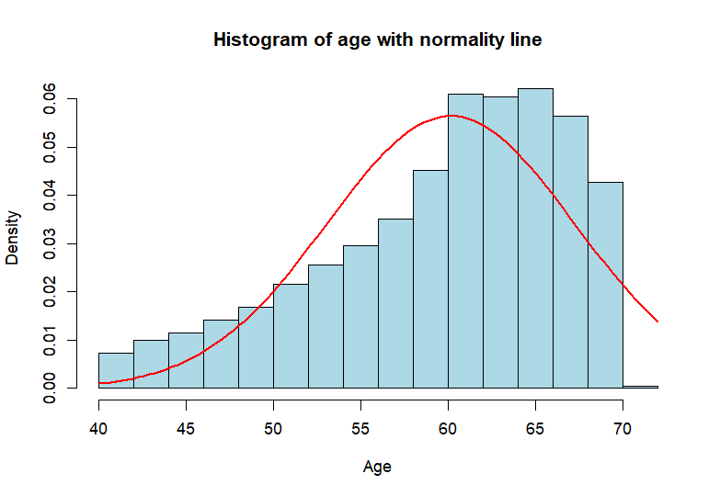

Figure 3: Histogram of age

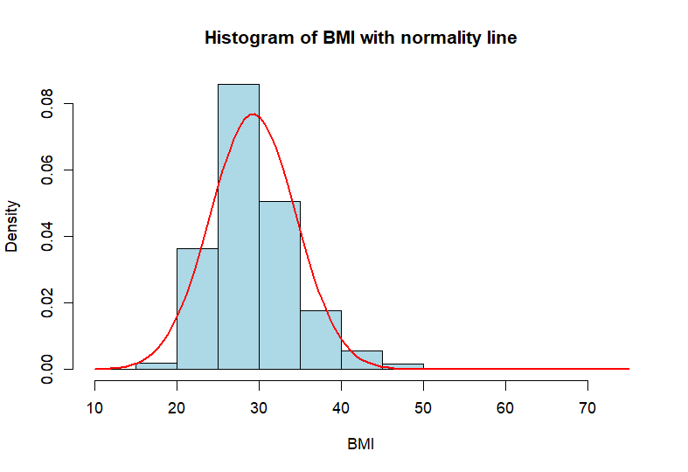
Figure 4: Histogram of BMI
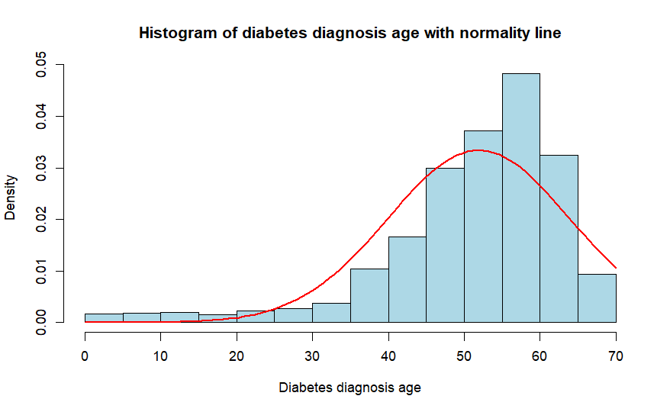
Figure 5: Histogram of diabetes diagnosis age

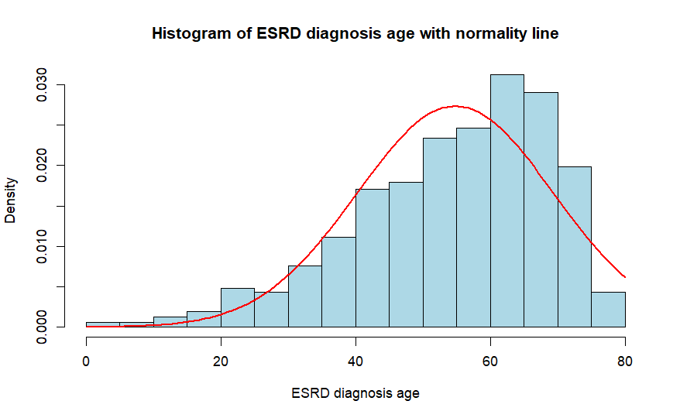
Figure 6: Histogram of hypertension diagnosis age

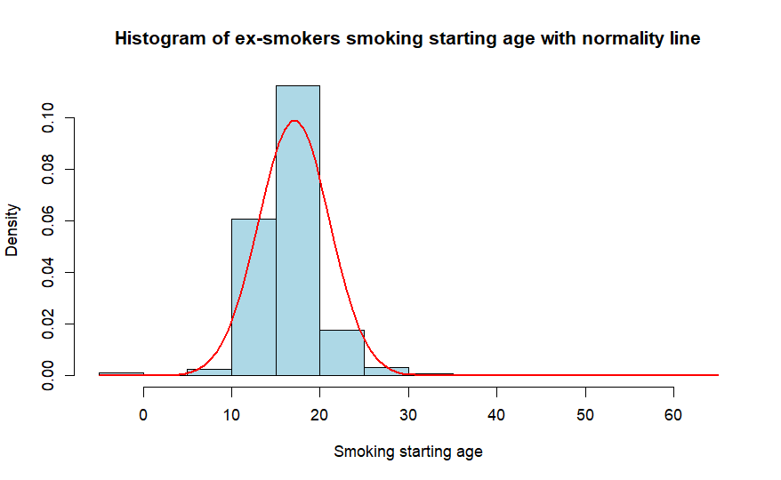
Figure 6: Histogram of ex-smokers smoking starting age

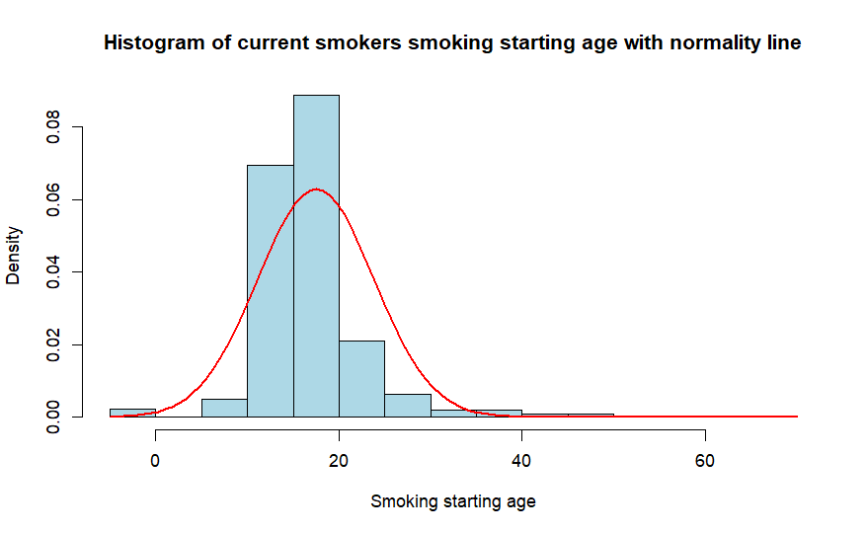
Figure 8: Histogram of current smokers smoking starting age

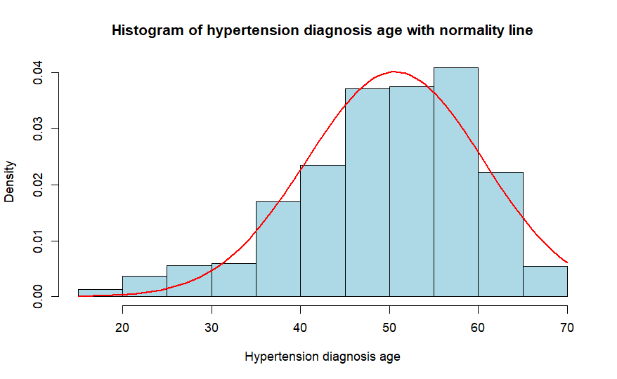
Figure 9: Histogram of hypertension diagnosis age

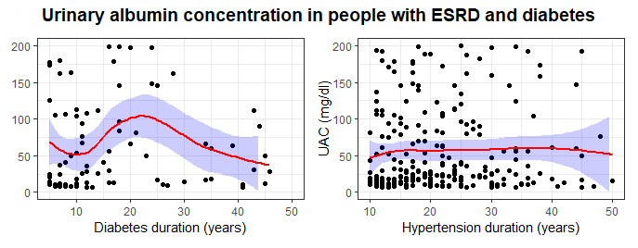
Figure 10: UAC values in people with diabetes and ESRD based on the duration of diabetes and hypertension

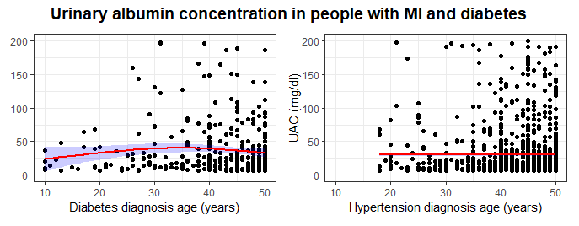
Figure 11: UAC values in people with diabetes, hypertension and myocardial infarction
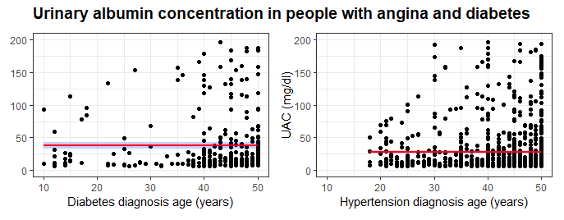
Figure 12: UAC values in people with diabetes and angina based on diabetes and hypertension diagnosis age

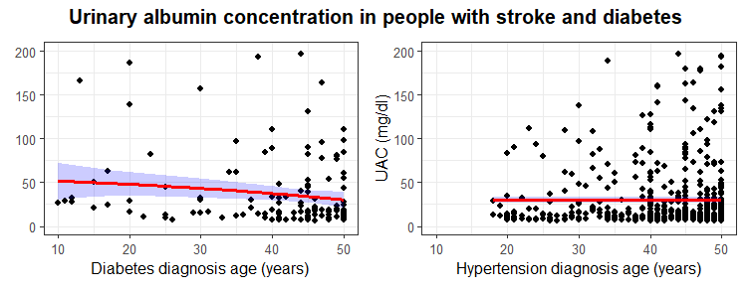
Figure 13: UAC values in people with diabetes and stroke based on diabetes and hypertension diagnosis age
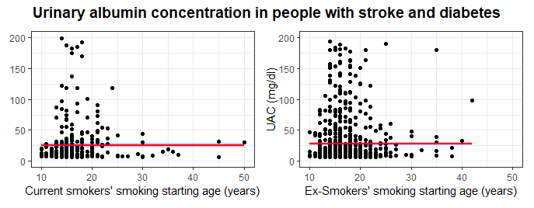
Figure 14: UAC values in people with diabetes and stroke based on smoking starting age

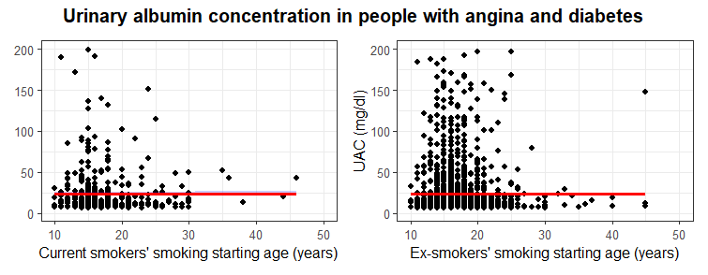
Figure 15: UAC values in people with diabetes and angina based on smoking starting age

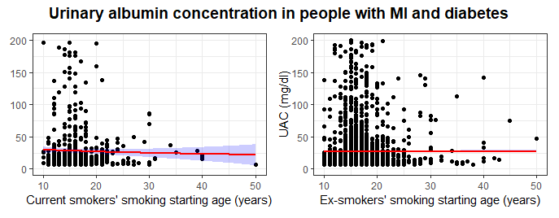
Figure 16: UAC values in people with diabetes and MI based on smoking staring age

Supplementary material 2: Missing data analyses

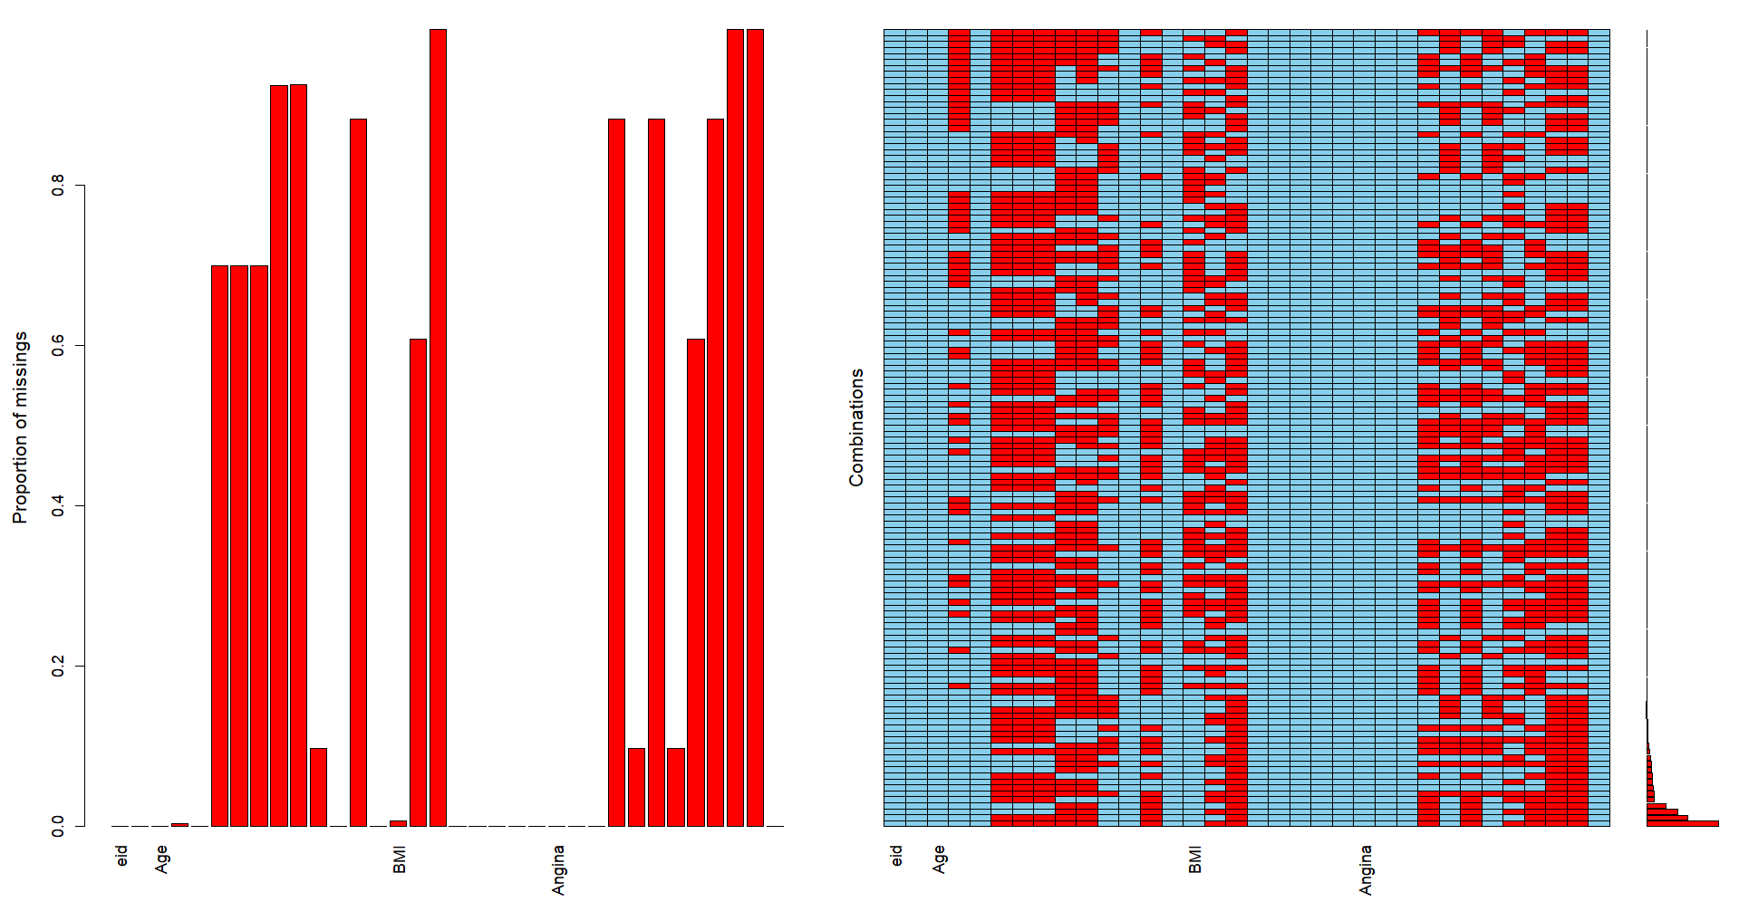
Figure 17: Multiple Imputation by Chained Equation (MICE) plot showing random distribution of missing data
Supplementary material 3: Concordance with the assumption of logistic regression
Independence of observations (Durbin-Watson Test)
Test results:
- DW statistic: 1.9989
- p-value: 0.4776
- Alternative hypothesis: True autocorrelation is greater than 0 (positive autocorrelation)
Interpretation:
- DW statistic:
The DW statistic ranges from 0-4
- A value near 2 suggests no autocorrelation
- A value significantly less than 2 suggests positive autocorrelation
- A value significantly greater than 2 suggests negative autocorrelation
Here the DW statistic is 1.9989, which is very close to 2, indicating little or no autocorrelation.
- p-value:
- The p-value (0.4776) is greater than common significance levels (e.g., 0.05 or 0.01), meaning that there is insufficient evidence to reject the null hypothesis.
- The null hypothesis is that there is no autocorrelation.

Conclusion:
- The Durbin-Watson test does not indicate significant autocorrelation in the residuals of the model.
- The residuals appear to be independent, suggesting that the assumption of no autocorrelation is likely to satisfied.

Multicollinearity (Variance Inflation Factor - VIF)
Test results:
Independent variable | Generalised VIF | Degree of freedom (DF) | GVIF^(1/2*DF)
DM diagnosis age group | 1.012 | 3 | 1.00
Sex | 1.029 | 1 | 1.01
Albuminuria diagnosis age group | 1.029 | 2 | 1.00

VIF values:
- Close to 1 indicates no multicollinearity.
- Between 1 and 5 suggests low to moderate multicollinearity.
- Above 5 indicate significant multicollinearity

Interpretation:
Generalised VIF of all three independent variables and the reciprocals are close to 1 suggests negligible multicollinearity.
Conclusion:
- VIF test shows that the models meet the logistic regression assumption of multicollinearity

Supplementary materials 4: UK Biobank codes
Data-Field – (Data used for this study - Instance 0)
Age diabetes diagnosed - Data-Field 2976
Diabetes diagnosed by doctor - Data-Field 2443
Medication for cholesterol, blood pressure, diabetes, or take exogenous hormones - Data-Field 6153
ESRD outcomes - Resource 8319
Age high blood pressure diagnosed - : Data-Field 2966
Age started smoking in current smokers - : Data-Field 3436
Age started smoking in former smokers - : Data-Field 2867
Age stopping smoking - : Data-Field 22507
Vascular/heart problems diagnosed by doctor - : Data-Field 6150

Supplementary materials 5: STROBE statement
STROBE Statement—checklist of items that should be included in reports of observational studies

 | Item No. | Recommendation | Page  No. | Relevant text from manuscript
Title and abstract | 1 | (a) Indicate the study’s design with a commonly used term in the title or the abstract | 3 | A retrospective cohort study was conducted using UK Biobank data.
Title and abstract | 1 | (b) Provide in the abstract an informative and balanced summary of what was done and what was found | 3 | Out of 26,206 people with diabetes, 8.64% (n=2,264) were on insulin; 1.16% (n=303) had ESRD, 8.58% (n=2250) had a myocardial infarction, 7.47% (n=1958) had angina, and 2.94% (n=771) had a stroke. Based on the age of diabetes diagnosis, the univariate logistic regression showed that compared to those diagnosed after the age of 60, the odds of ESRD for those diagnosed at ages: <20, 20-40, and 41-60 years were OR [2.33 (95% CI 1.50 – 3.84), 7.78 (95% CI 4.81 – 13.16), and 5.26 (95% CI 3.00 – 9.40)], respectively. Myocardial infarction and stroke did not have a statistically significant relationship with diabetes diagnosis age. Multivariate models adjusted for sex and albuminuria confirmed the increased odds of ESRD in people with younger onset and longer duration of diabetes.
Introduction
Background/rationale | 2 | Explain the scientific background and rationale for the investigation being reported | 4 | End-stage renal disease (ESRD) is one of the most expensive and debilitating complications of diabetes. Over the last three decades, in people with diabetes, the global burden of ESRD has been rising steadily, while all-cause and cardiovascular disease (CVD) mortality are declining.
Objectives | 3 | State specific objectives, including any prespecified hypotheses | 5 | We hypothesise that this disparity may be because of the younger onset of T2DM, and the risk of ESRD may be higher than CVD in people with younger onset diabetes.
Methods
Study design | 4 | Present key elements of study design early in the paper | 6 | We conducted a retrospective cohort analysis using data from the individuals who filled out the UK Biobank study questionnaire. It did not differentiate between the types of diabetes. For this study we used instance 0, which was the assessment visit. We used the full cohort for descriptive analysis.
Setting | 5 | Describe the setting, locations, and relevant dates, including periods of recruitment, exposure, follow-up, and data collection | 6 | The UK Biobank is a large, population-based cohort comprising over 500,000 volunteers aged 40-69 years recruited between 2006 and 2010, from 22 assessment centres across England, Wales and Scotland. During their assessment visits, participants provided electronic consent and completed a touchscreen-based questionnaire.
Participants | 6 | Cohort study—Give the eligibility criteria, and the sources and methods of selection of participants. Describe methods of follow-up | 6 | For exploratory analyses, inclusion criteria were self-reported diabetes (UK Biobank data field – 2443, “Diabetes diagnosed by doctor”) and exclusion criteria were those who did not answer this question or responded as “No”.  Follow-up time was from the mean age of diabetes diagnosis to the mean age of the occurrence of the events of interest.
Participants | 6 | (b) Cohort study—For matched studies, give matching criteria and number of exposed and unexposed  Case-control study—For matched studies, give matching criteria and the number of controls per case |  | Unmatched study
Variables | 7 | Clearly define all outcomes, exposures, predictors, potential confounders, and effect modifiers. Give diagnostic criteria, if applicable | 6 | The population for our study was people with diabetes; exposure was the age of diabetes diagnosis; comparison was amongst four groups of people with diabetes based on the age of diabetes diagnosis, i.e., <20, 20-40, 41-60 and >60 and the primary outcomes were ESRD, myocardial infarction, angina and stroke and the secondary outcome was UAC. We used sex, age of starting and stopping smoking, duration of diabetes and hypertension as confounding variables.
Data sources/ measurement | 8* | For each variable of interest, give sources of data and details of methods of assessment (measurement). Describe comparability of assessment methods if there is more than one group | 7 | Following the Kidney Disease Improving Global Outcome (KDIGO) guideline, we defined normoalbuminuria as a UAC value of <20 mg/dl in a spot sample of urine, microalbuminuria UAC value 20 – 200 mg/dl, and macroalbuminuria UAC value >200 mg/dl. (21) Townsend deprivation index was used to define deprivation, and based on the score, the cohort was divided into five quintiles from the least to the most deprived.
Bias | 9 | Describe any efforts to address potential sources of bias | 8 | Model discrimination was evaluated using receiver operating characteristics (ROC) and the area under the curve (AUC). The goodness of fit (GOF) was assessed by analysing the calibration plot and Hosmer and Lemeshow GOF test.  Concordance with the assumptions of logistic regression model were assessed using Durbin-Watson test for the independence of observation, and Variance Inflation Factor (VIF) for multicollinearity. Missing data were analysed using multiple imputation of chained equation (MICE).
Study size | 10 | Explain how the study size was arrived at |  | N/A
Continued on next page
Quantitative variables | 11 | Explain how quantitative variables were handled in the analyses. If applicable, describe which groupings were chosen and why | 6 | Comparison was amongst four groups of people with diabetes based on the age of diabetes diagnosis, i.e., <20, 20-40, 41-60 and >60
Statistical methods | 12 | (a) Describe all statistical methods, including those used to control for confounding | 8 | We fitted a univariate logistic regression model to assess if the age of diabetes diagnosis can predict ESRD, myocardial infarction, angina and stroke outcomes. Finally, in model 1, we used the multivariable logistic regression method to explore how the age of diagnosis of diabetes and in model 2, the duration of diabetes predicts ESRD.
Statistical methods | 12 | (b) Describe any methods used to examine subgroups and interactions | 8 | In model 1, we used the multivariable logistic regression method to explore how the age of diagnosis of diabetes and in model 2, the duration of diabetes predicts ESRD. In these models we adjusted for sex and albuminuria categories as confounding variables.
Statistical methods | 12 | (c) Explain how missing data were addressed | 8 | Missing data were analysed using multiple imputation of chained equation (MICE).
Statistical methods | 12 | (d) Cohort study—If applicable, explain how loss to follow-up was addressed  Case-control study—If applicable, explain how matching of cases and controls was addressed  Cross-sectional study—If applicable, describe analytical methods taking account of sampling strategy |  | N/A
Statistical methods | 12 | (e) Describe any sensitivity analyses |  | Model discrimination was evaluated using receiver operating characteristics (ROC) and the area under the curve (AUC). The goodness of fit (GOF) was assessed by analysing the calibration plot and Hosmer and Lemeshow GOF test.
Results
Participants | 13* | (a) Report numbers of individuals at each stage of study—eg numbers potentially eligible, examined for eligibility, confirmed eligible, included in the study, completing follow-up, and analysed | 9 | Out of a total of 497,895 eligible study participants' who consented to share their data, 5.26% (n=26,206) had diabetes. Although we did not have the precise data available from the questionnaire about the types of diabetes, but 8.26% (n=2247) study participants reported being on insulin suggesting that the number of T2DM is unlikely to be more than 2247. (Supplementary material 4 – UKB data field 6143). A flowchart of selection process is in supplementary material (Figure 1). Among the population without diabetes, 44.7% (n= 210,892) were male, compared to 60.6% (n=15,876) of male in the group with diabetes. In terms of diabetes diagnosis, 14.9% (n=3735) were diagnosed before the age of 40, 66.2 % (n=16,609) between the ages of 40 to 60, and 18.9% (n=4752) were diagnosed after the age of 60. The prevalence of hypertension in those without diabetes was 22.5% (n= 106,143), and in those with diabetes was 49.5% (n=12,975). Amongst those with ESRD, the median age of diabetes diagnosis was 54 (IQR 47-61) years, and the median age of ESRD diagnosis was 57 (IQR 47 – 67) years.
Participants | 13* | (b) Give reasons for non-participation at each stage |  | N/A
Participants | 13* | © Consider use of a flow diagram |  | Supplementary material – figure 1
Descriptive data | 14* | (a) Give characteristics of study participants (eg demographic, clinical, social) and information on exposures and potential confounders | 9 | Among the population without diabetes, 44.7% (n= 210,892) were male, compared to 60.6% (n=15,876) of male in the group with diabetes. In terms of diabetes diagnosis, 14.9% (n=3735) were diagnosed before the age of 40, 66.2 % (n=16,609) between the ages of 40 to 60, and 18.9% (n=4752) were diagnosed after the age of 60. The prevalence of hypertension in those without diabetes was 22.5% (n= 106,143), and in those with diabetes was 49.5% (n=12,975). Amongst those with ESRD, the median age of diabetes diagnosis was 54 (IQR 47-61) years, and the median age of ESRD diagnosis was 57 (IQR 47 – 67) years.
Descriptive data | 14* | (b) Indicate number of participants with missing data for each variable of interest
Descriptive data | 14* | (c) Cohort study—Summarise follow-up time (eg, average and total amount) |  | Mean follow-up period for people with diabetes who had ESRD, and stroke was 9 years and 11 years, respectively. The follow-up period for myocardial infarction and angina was 12 years. Thus, the total person years of follow-up for those who had ESRD was 235,854 person-years, for stroke 288,266 person-years, and for myocardial infarction and angina was 314,472 person-years which aggregated to 838,592 person-years follow-up. (
Outcome data | 15* | Cohort study—Report numbers of outcome events or summary measures over time | 9 | Amongst the eligible study participants, ESRD was reported by 0.2% (n=875) participants without diabetes and 1.2% (n=303) with diabetes, which corresponds to a prevalence rate of ESRD of 200 per 100,000 population without diabetes and 1,200 per 100,000 population in those with diabetes. Macrovascular complications were more prevalent in people with diabetes than without. Angina was reported in 7.5% (n=1958) individuals with diabetes compared to 2% (n=9220) in those without. Myocardial infarction was reported by 8.6% (n=2250) of individuals with diabetes compared to 2% (n=9198) in those without. Likewise, in the diabetes group, 2.9% (n=771) had a stroke compared to 1.1% (n=5367) in the group without diabetes.
Outcome data | 15* | Case-control study—Report numbers in each exposure category, or summary measures of exposure
Outcome data | 15* | Cross-sectional study—Report numbers of outcome events or summary measures
Main results | 16 | (a) Give unadjusted estimates and, if applicable, confounder-adjusted estimates and their precision (eg, 95% confidence interval). Make clear which confounders were adjusted for and why they were included | 15 | The univariate unadjusted logistic regression model showed that the risk of ESRD is significantly higher in people with diabetes who were diagnosed before the age of 60 years. Compared to those who developed diabetes above the age of 60, those who developed diabetes <20, 20 to 40 and 41 to 60, the odds of ESRD were 5.26 (95% CI 3.00 – 9.40), 7.78 (95% CI 4.81 – 13.16) and 2.33 (95% CI 1.50 – 3.84), respectively. Likewise, compared to people with diabetes who also developed hypertension above the age of 60, the age of diagnosis <20, 20 to 40 and 41 to 60 was associated with the odds of ESRD 2.20 (1.58 – 3.11), 5.03 (3.79 – 6.81), and 1.53 (1.16 – 2.06), respectively. There was no statistically significant association between the younger age of diabetes onset revealed for myocardial infarction and stroke.
Main results | 16 | (b) Report category boundaries when continuous variables were categorized
Main results | 16 | (c) If relevant, consider translating estimates of relative risk into absolute risk for a meaningful time period
Continued on next page
Other analyses | 17 | Report other analyses done—eg analyses of subgroups and interactions, and sensitivity analyses | 19, 22,23 | The logistic regression model was fitted to explore how the univariate model performed when the age of diabetes diagnosis, sex and albuminuria were adjusted in the model. In model 1, we adjusted for the age of diabetes diagnosis and in model 2, we adjusted for diabetes duration to understand how these risk factors influence ESRD outcomes.  Discrimination – Both models demonstrated excellent model performance with the area under the curve (AUC) above 80%. The concordance statistics for model 1 was 81%, and model 2 was 82%, suggesting the model's performance in predicting true positive cases of ESRD.  Calibration - The calibration plots show the reliability of both models in predicting ESRD. The alignment of observed proportions with predicted probabilities indicates robust model performance, supporting their use in clinical decision-making processes.
Discussion
Key results | 18 | Summarise key results with reference to study objectives | 24 | In this large prospective cohort of UK Biobank study participants, we found that people with younger onset diabetes are more likely to develop ESRD than myocardial infarction, angina or stroke within the follow-up time. Moreover, they are more likely to develop ESRD at a younger age than those who had myocardial infarction, angina and stroke. In addition, concurrent diagnosis of hypertension may exacerbate the risk. People who develop diabetes at a younger age are more likely to be exposed to prolonged periods of hyperglycaemia, and this study showed that the longer the duration of diabetes, the higher the risk of ESRD. The findings of higher risk of ESRD, CVD and stroke in younger onset diabetes are in keeping with multiple studies.
Limitations | 19 | Discuss limitations of the study, taking into account sources of potential bias or imprecision. Discuss both direction and magnitude of any potential bias | 27 | However, this study has several limitations. We used the questionnaire filled out by the study participants to identify cases of diabetes. It did not specify the type of diabetes. Therefore, we cannot comment on the number of type 1 and type 2 DM included in the study. However, as the median age of included participants with diabetes was 54 years, we assume that the majority of the participants would be with T2DM. The study was a retrospective cohort design with limited predictive value. The age of diagnosis of diabetes and ESRD was obtained from the questionnaire and was not verified, which is open to recall bias. UK Biobank is a voluntary dataset and is not representative of real-world data, and therefore, the findings may not be generalisable. Despite the above limitations, the findings of this study indicate that the changing T2DM epidemiology may be affecting ESRD outcomes disparately than the CVD and stroke outcomes, which is of great clinical and public health importance.
Interpretation | 20 | Give a cautious overall interpretation of results considering objectives, limitations, multiplicity of analyses, results from similar studies, and other relevant evidence | 25 | The adjusted model showed that there was no statistically significant relationship between the age of onset of diabetes with myocardial infarction and stroke, suggesting that the recent surge in the ESRD cases in people with diabetes might have been caused by the evolving epidemiology of T2DM in young and adolescents. This study also showed that the UAC value is significantly higher in current smokers who started smoking in their teenage years. Interestingly, for ex-smokers, there was a second rise in the level of the UAC, perhaps mediated by post-cessation weight gain and early post-cessation adaptation of cardiometabolic milieu. These findings suggest that teenage smoking should be actively discouraged, and those who have already started smoking should be supported to quit and remain abstinent long-term.
Generalisability | 21 | Discuss the generalisability (external validity) of the study results | 27 | UK Biobank is a voluntary dataset and is not representative of real-world data, and therefore, the findings may not be generalisable.
Other information
Funding | 22 | Give the source of funding and the role of the funders for the present study and, if applicable, for the original study on which the present article is based | 29 | This project is funded by the NIHR through a personal clinical lecturer award to the lead author (CL-2023-2024-001).

*Give information separately for cases and controls in case-control studies and, if applicable, for exposed and unexposed groups in cohort and cross-sectional studies.

Note: An Explanation and Elaboration article discusses each checklist item and gives methodological background and published examples of transparent reporting. The STROBE checklist is best used in conjunction with this article (freely available on the Web sites of PLoS Medicine at http://www.plosmedicine.org/, Annals of Internal Medicine at http://www.annals.org/, and Epidemiology at http://www.epidem.com/). Information on the STROBE Initiative is a

