Additional Files

Methods and Materials:

Clinical Assessment
The subject presented to his general care veterinarian with a primary complaint of prolonged and excessive bleeding. A coagulopathy panel was run by IDEXX (idexx.com). Prolonged PTT was diagnosed (Fig S1).

Breed analysis and health risk variant genotyping
A buccal swab was submitted for genotyping on the Embark Vet platform (Embark Veterinary, Inc., Boston, MA). Mixed breed analysis was performed as previously described []. Genotyping of health risk variants was performed on a custom Illumina Infinium BeadChip array, according to the manufacturer’s recommendation (Illumina, Inc., San Diego, CA). Quality control measures for health risk variant genotyping included 1) validation of health risk genotypes with known positive and negative controls; 2) technical replicates of each health risk genotyping assay; 3) manual review of health risk genotypes; and 4) a standard genotyping quality threshold requiring high confidence calls for over 98% of all genotype calls.

Genomic DNA isolation
Owners submitted buccal swabs directly to Embark Veterinary, Inc for DNA isolation. Genomic DNA was extracted using the Zymo Quick-DNA Microprep kit (Zymo Research, Irvine, CA) according to the manufacturer’s instructions. DNA quality and concentration were assessed using a NanoDrop™(Thermo Fisher Scientific, Waltham, MA).

Polymerase Chain Reaction
All exons of F9 were amplified via PCR for the subject dog and one clinically normal, male mixed breed dog as a negative control (Table S1). For all primer pairs, PCR was performed using with 15 ng gDNA, 0.4ul of 10mM dNTPs, 1ul of each 10uM PCR primer, 0.15ul Q5® High-Fidelity DNA Polymerase (New England Biolabs Inc, Ipswich, MA), 4ul of Q5® Reaction Buffer, and 4ul of Q5® High GC Enhancer in a total volume of 20 uL. PCR was performed on a BioRad thermocycler (BioRad, Foster City, CA) with the following parameters: 95 C for 30 seconds followed by 40 cycles of 95 C for 10 s, 60 C for 30 s, and 72 C for 1 min, then a final extension of 72 C for 7 mins. PCR products were assessed by agarose gel electrophoresis (1% agarose at 100V for 40 minutes), then submitted for Sanger sequencing.

Sanger Sequencing and Sequence Analysis
Sanger sequencing was performed by Genewiz (genewiz.com). Sequence analysis was performed with SnapGene Viewer (https://www.snapgene.com/snapgene-viewer/). Sequence traces were aligned using Clustal Omega (EMBL-EBI), and compared to CanFam3.1 canonical sequence for F9 (Figure S1, S2, Table S2). (http://genome.ucsc.edu/cgi-bin/hgGateway?hgsid=767040331_34TdcLrihjhgCKXDOS2vCAVeaywa).

cDNA and protein prediction

The proband’s cDNA sequence was manually inferred from canine F9 mRNA in RefSeq (NM_001003323.2) and translated with EMBL SixPack (https://www.ebi.ac.uk/Tools/st/emboss_sixpack/). Predictive functional analysis was performed with EMBL InterProScan (http://www.ebi.ac.uk/interpro/).

Supplementary Figures:

Figure S1. SnapGene sequence trace views of the proband (top) and a healthy male control (bottom). Forward and reverse primer traces are shown. A C/G deletion is evident in both sequence traces of the proband.

Proband, ex5_F
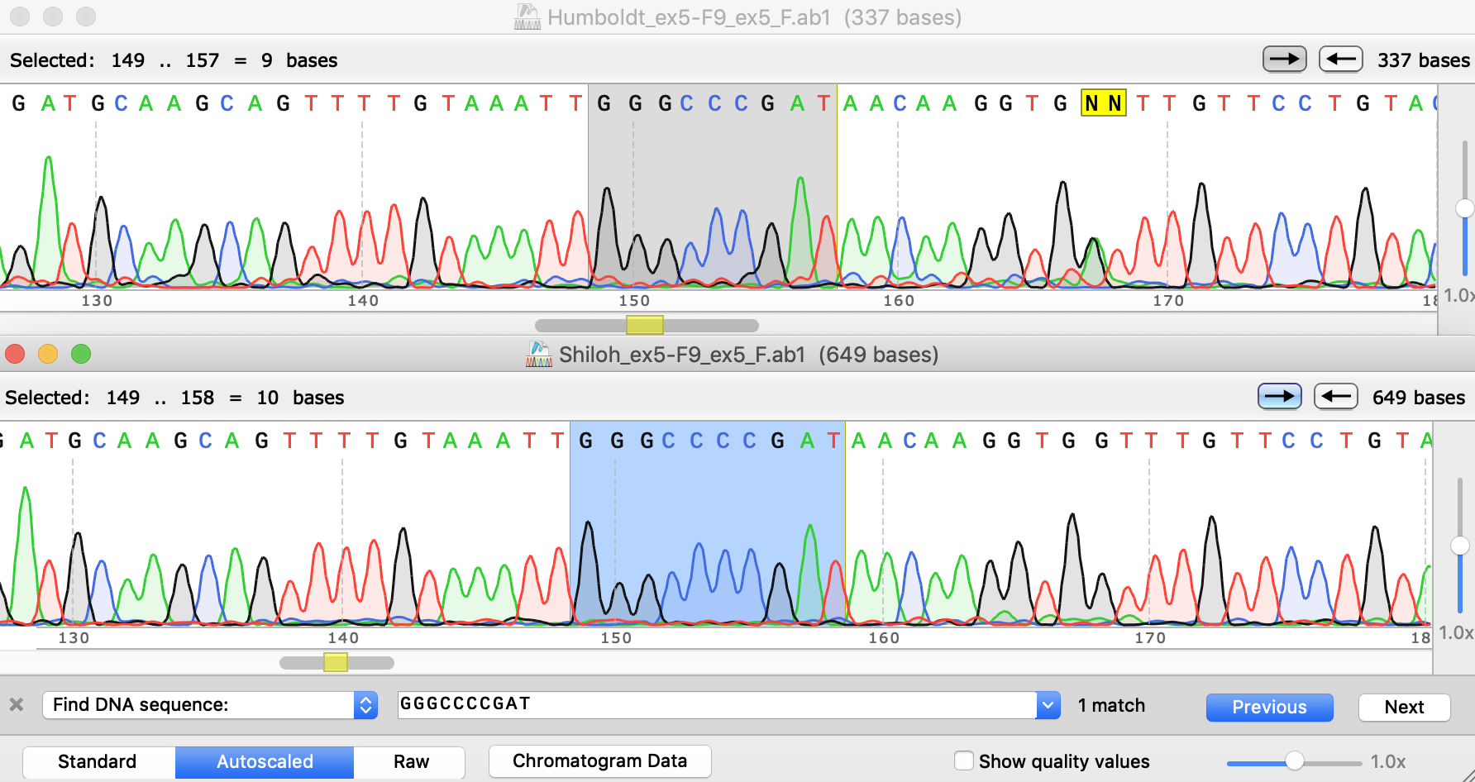
Control, ex5_F

Proband, ex5_R
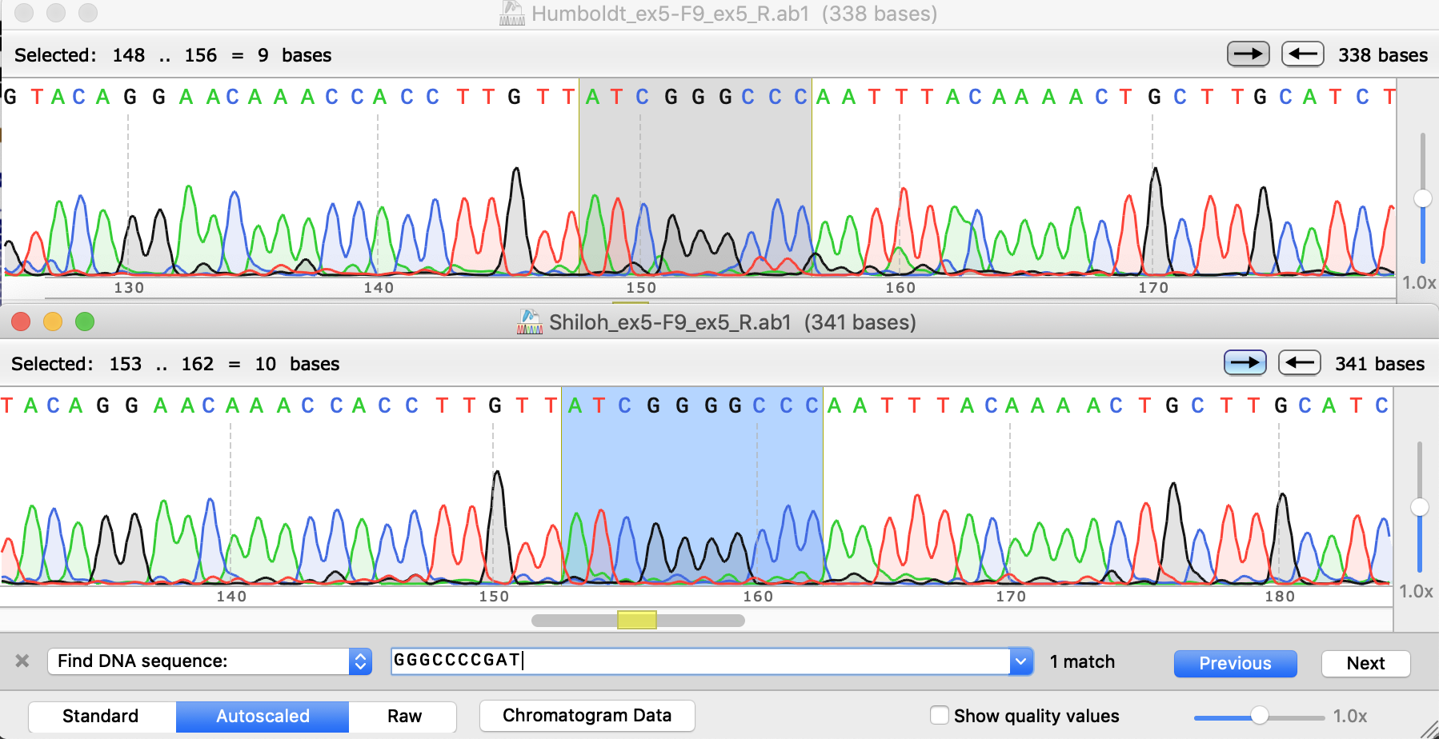

Control, ex5_R

Figure S2. Forward and reverse sequencing trace alignment to CanFam3.1 in the UCSC Genome Browser. The dash in the proband sequence demonstrates the deletion.

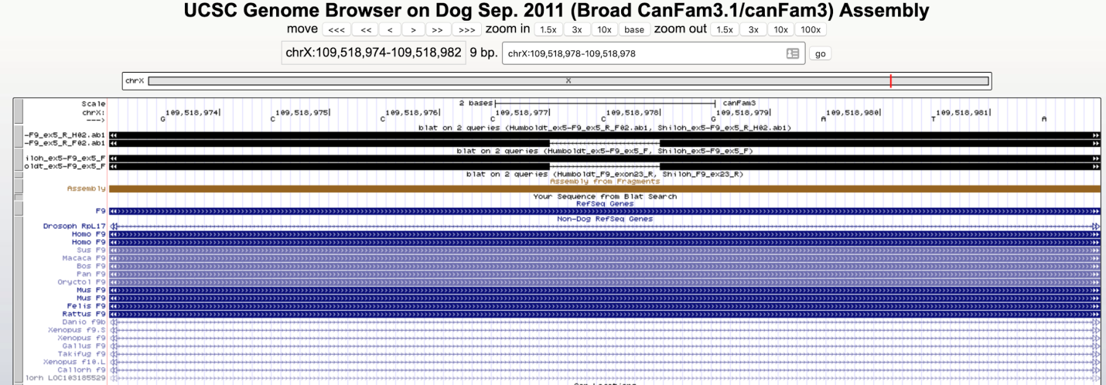

Deane-Coe PE, Chu ET, Slavney A, Boyko AR, Sams AJ. Direct-to-consumer DNA testing of 6,000 dogs reveals 98.6-kb duplication associated with blue eyes and heterochromia in Siberian Huskies. PLoS genetics. 2018 Oct 4;14(10):e1007648.

