Supplementary Information
Efficacy of a New Selective Indole-based Histone Deacetylase 10 Inhibitor in Targeted Anticancer Therapy
Amer H. Tarawneh^{1,*}, Salah A. Al-Trawnehb^{2,3,*}, Talha Z. Yesiloglu⁴, Matthes Zessin⁵, Dina Robaa⁴, Cyril Barinka⁶, Mike Schutkowski⁵, Wolfgang Sippl^{4,*}, Samir A. Ross^{3,7,*}
1 Department of Chemistry, Tafila Technical University, P.O. Box 179, Tafila, Jordan
2 Chemistry Department, Faculty of Science, Mu'tah University, Karak 61710, Jordan
3 National Center for Natural Products Research, Research Institute of Pharmaceutical Sciences, School of Pharmacy, University of Mississippi, University, MS, 38677, USA
4 Institute of Pharmacy, Martin-Luther University of Halle-Wittenberg, 06120 Halle/Saale, Germany
5 Institute of Biotechnology, Martin-Luther University of Halle-Wittenberg, 06120 Halle/Saale, Germany
6 Institute of Biotechnology of the Czech Academy of Sciences, BIOCEV, Prumyslova 595, 252 50 Vestec, Czech Republic
7 Department of BioMolecular Sciences, School of Pharmacy, University of Mississippi, University, MS, 38677, USA
* Correspondence:

Dr, A.H. Tarawneh, Department of Chemistry, Tafila Technical University, Tafila 66110, Jordan
Email: amer.tarawneh@ttu.edu.jo
Prof. S. A. Al-Trawneh, Chemistry Department, Mu'tah University, Karak 61710, Jordan
Email: laratr@mutah.edu.jo
Prof. W. Sippl, Institute of Pharmacy, Martin-Luther University of Halle-Wittenberg, 06120 Halle/Saale, Germany
Email: wolfgang.sippl@pharmazie.uni-halle.de
Prof. S. A. Ross, National Center for Natural Products Research, University of Mississippi, University, MS, 38677, USA
Email: sross@olemiss.edu

Table of Contents
Figure S1: | Predicted binding modes of compounds 2, 3, 4 and 7 in drHDAC10 (PDB ID 6UHU)
Figure S2: | RMSD plots of drHDAC10 (PDB ID 6UHU)-compound 1
Figure S3: | RMSD plots of the crystalized ligands heavy atoms in humanized drHDAC10 (PDB ID 7U6A)
Figure S4: | RMSD plots of the crystalized ligands heavy atoms in humanized drHDAC10 (PDB ID 7U6B)
Figure S5: | RMSD plots of the crystalized ligands heavy atoms in humanized drHDAC10 (PDB ID 7U69)
Figure S6: | RMSD plots of the crystalized ligands heavy atoms in humanized drHDAC10 (PDB ID 7U59)
Figure S7: | IC50 value for compound 1 and 4 against human HDAC 1
Figure S8: | IC50 value for compounds 1, 2, 3, 4, 5, 7, and tubastatin against human HDAC 6
Figure S9: | IC50 value for compounds 1, 4, 5 and 7 against human HDAC 8
Figure S10: | IC50 value for all synthesized compounds in vitro against zebrafish HDAC10 (drHDAC10).
Figure S11: | ¹H NMR and ¹³C NMR of compound 1 in DMSO-d6
Figure S12: | ¹H NMR and ¹³C NMR of compound 2 in DMSO-d6
Figure S13: | ¹H NMR and ¹³C NMR of compound 3 in DMSO-d6
Figure S14: | ¹H NMR and ¹³C NMR of compound 4 in DMSO-d6
Figure S15: | ¹H NMR and ¹³C NMR of compound 5 in DMSO-d6
Figure S16: | ¹H NMR and ¹³C NMR of compound 6 in DMSO-d6
Figure S17: | ¹H NMR and ¹³C NMR of compound 7 in DMSO-d6

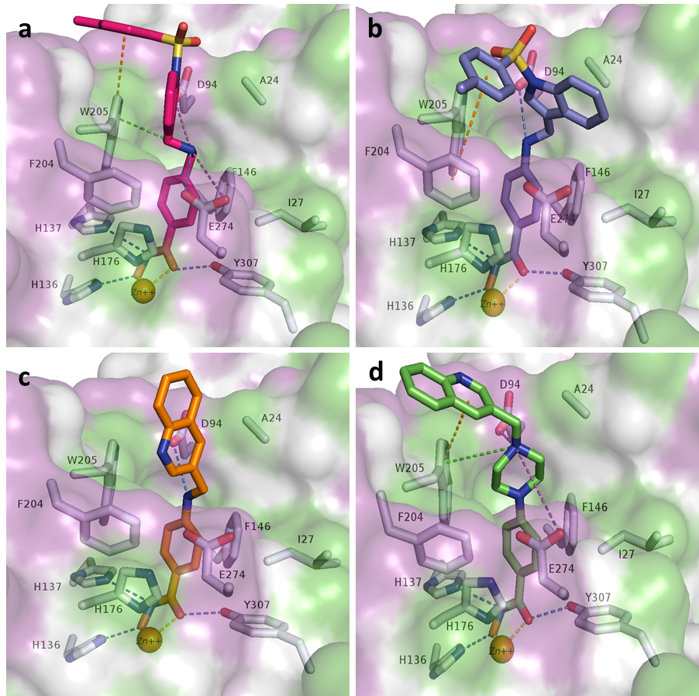Figure S1. Predicted binding modes of compounds, a) 2 (magenta sticks), b) 3 (violet sticks), c) 4 (orange sticks), and d) 7 (light green sticks) in drHDAC10 (PDB ID 6UHU). The surface of the proteins is colored according to lipophilicity; green for hydrophobic and magenta for hydrophilic. Side chains of binding site residues are shown as white sticks and the catalytic zinc ion as orange spheres. H-bond interactions are depicted as blue-dashed lines, salt bridge interactions as magenta-dashed lines, π-π interactions as orange-dashed lines, cation-π interactions as green-dashed lines, and coordination of the zinc ion by the ligand as yellow-dashed lines.

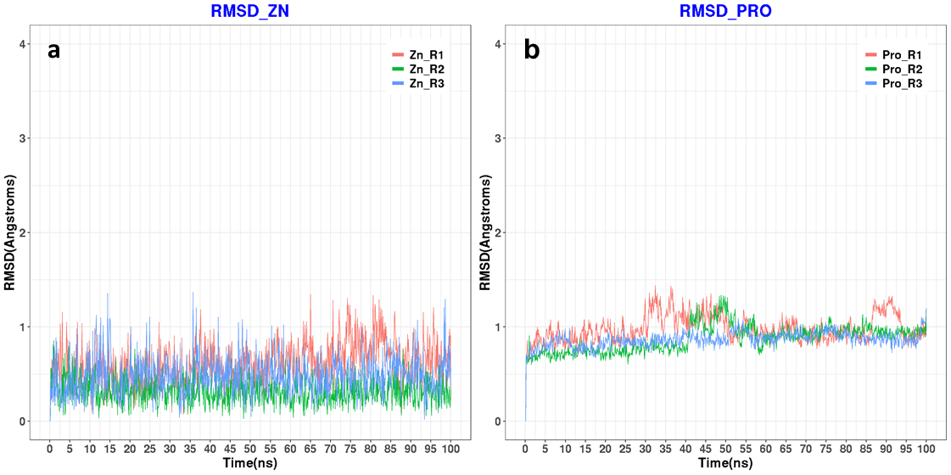Figure S2. a) RMSD plots of protein-heavy atoms in drHDAC10 (PDB ID 6UHU)-compound 1 docked complexes for 3 repeated MD runs each for 100 ns. b) RMSD plots of the Zn ion in drHDAC10 (PDB ID 6UHU)-compound 1 complexes for 3 repeated MD runs each for 100 ns.

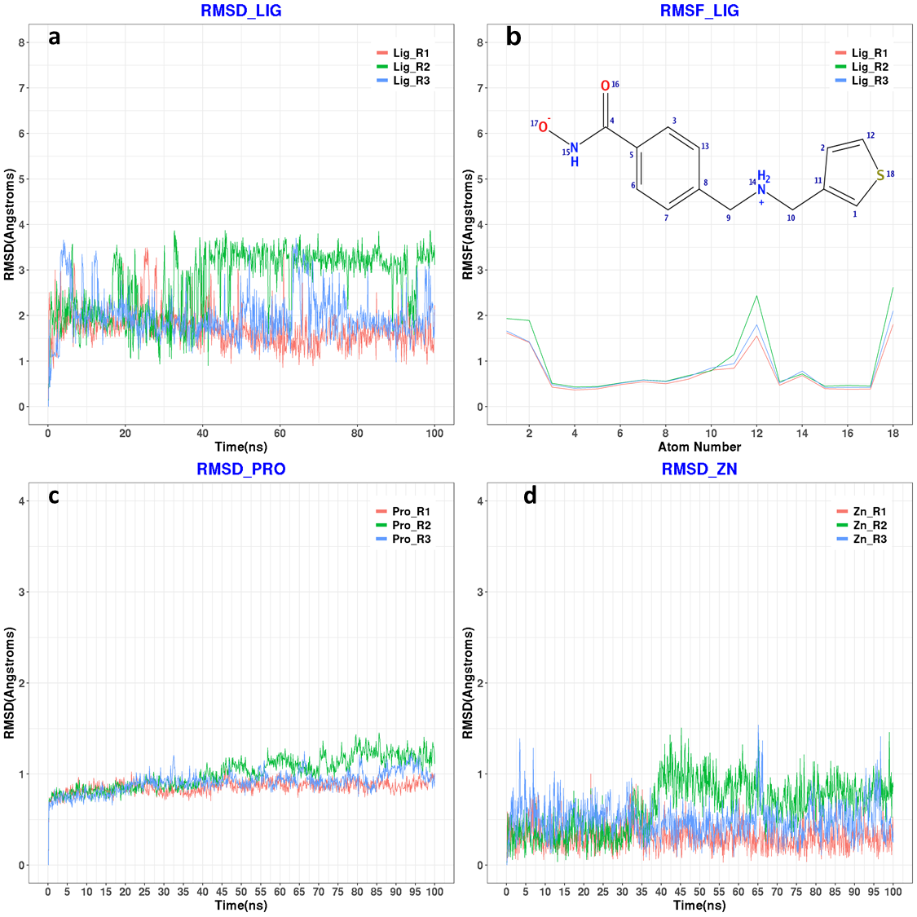
Figure S3. a) RMSD plots of the crystalized ligands heavy atoms in humanized drHDAC10 (PDB ID 7U6A) crystalized complexes for 3 repeated MD runs each for 100 ns. b) RMSF plots of the crystalized ligands heavy atoms in humanized drHDAC10 (PDB ID 7U6A) crystalized complexes for 3 repeated MD runs each for 100 ns. c) RMSD plots of protein heavy atoms in humanized drHDAC10 (PDB ID 7U6A) crystalized complexes for 3 repeated MD runs each for 100 ns. d) RMSD plots of the Zn ion in humanized drHDAC10 (PDB ID 7U6A) crystalized complexes for 3 repeated MD runs each for 100 ns.
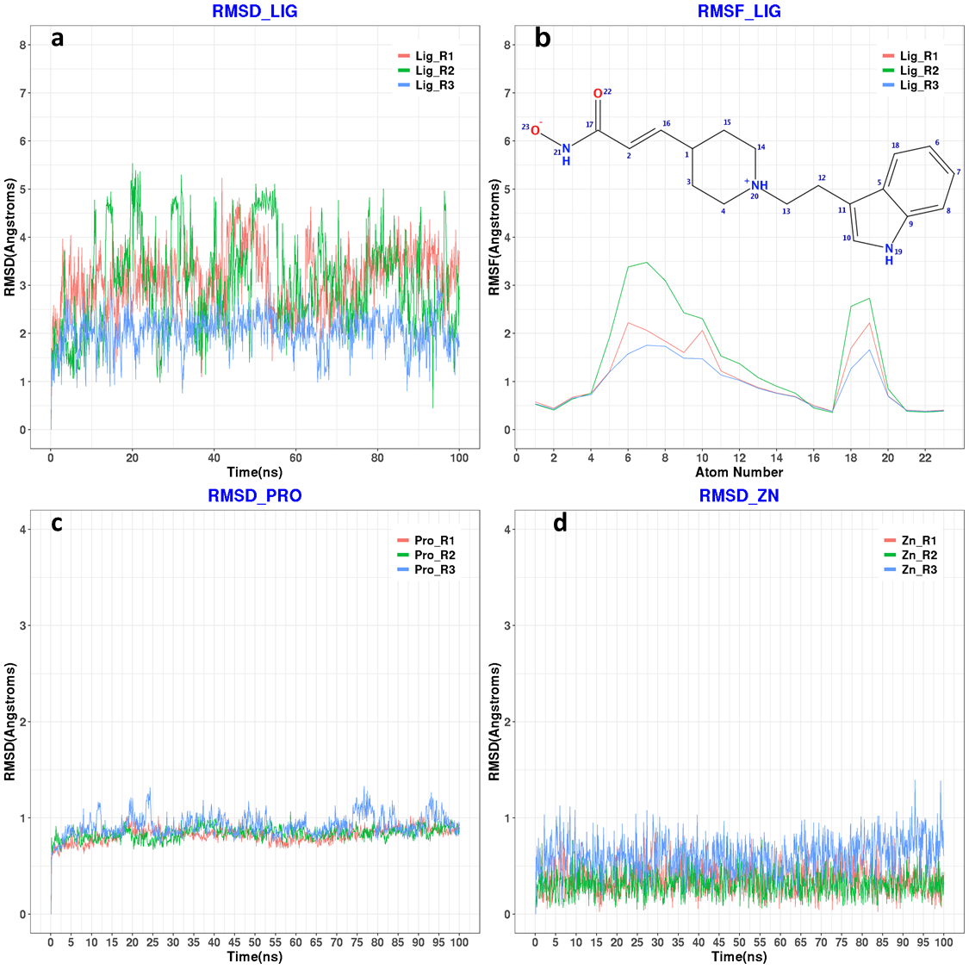
Figure S4. a) RMSD plots of the crystalized ligands heavy atoms in humanized drHDAC10 (PDB ID 7U6B) crystalized complexes for 3 repeated MD runs each for 100 ns. b) RMSF plots of the crystalized ligands heavy atoms in humanized drHDAC10 (PDB ID 7U6B) crystalized complexes for 3 repeated MD runs each for 100 ns. c) RMSD plots of protein-heavy atoms in humanized drHDAC10 (PDB ID 7U6B) crystalized complexes for 3 repeated MD runs each for 100 ns. b) RMSD plots of the Zn ion in humanized drHDAC10 (PDB ID 7U6B) crystalized complexes for 3 repeated MD runs each for 100 ns.
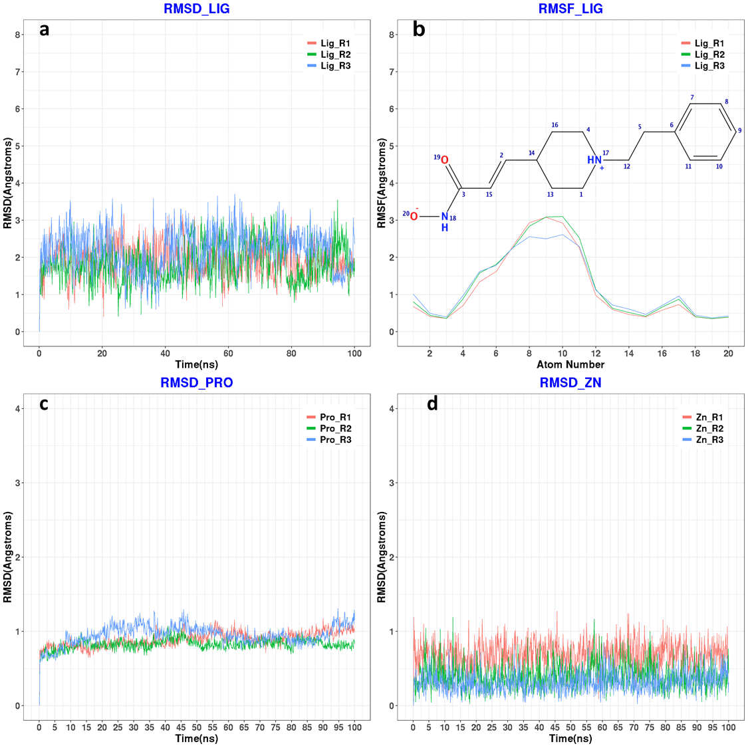
Figure S5. a) RMSD plots of the crystalized ligands heavy atoms in humanized drHDAC10 (PDB ID 7U69) crystalized complexes for 3 repeated MD runs each for 100 ns. b) RMSF plots of the crystalized ligands heavy atoms in humanized drHDAC10 (PDB ID 7U69) crystalized complexes for 3 repeated MD runs each for 100 ns. c) RMSD plots of protein-heavy atoms in humanized drHDAC10 (PDB ID 7U69) crystalized complexes for 3 repeated MD runs each for 100 ns. d) RMSD plots of the Zn ion in humanized drHDAC10 (PDB ID 7U69) crystalized complexes for 3 repeated MD runs each for 100 ns.
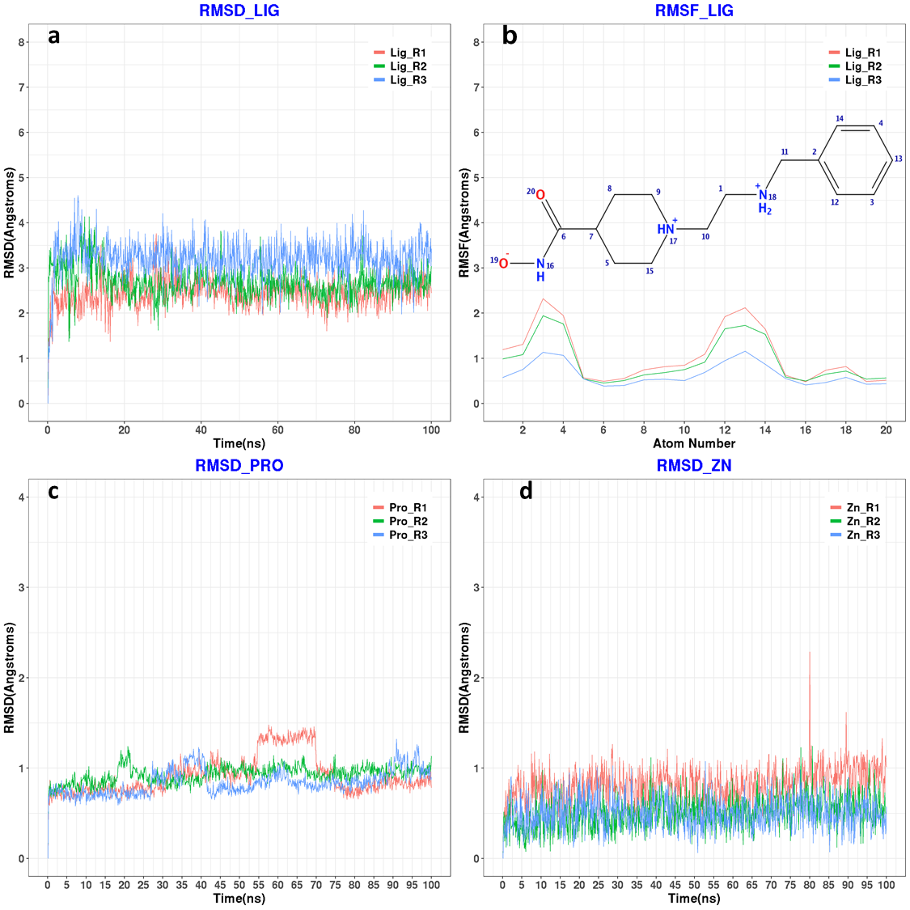
Figure S6. a) RMSD plots of the crystalized ligands heavy atoms in humanized drHDAC10 (PDB ID 7U59) crystalized complexes for 3 repeated MD runs each for 100 ns. b) RMSF plots of the crystalized ligands heavy atoms in humanized drHDAC10 (PDB ID 7U59) crystalized complexes for 3 repeated MD runs each for 100 ns. c) RMSD plots of protein-heavy atoms in humanized drHDAC10 (PDB ID 7U59) crystalized complexes for 3 repeated MD runs each for 100 ns. d) RMSD plots of the Zn ion in humanized drHDAC10 (PDB ID 7U59) crystalized complexes for 3 repeated MD runs each for 100 ns.

Figure S7. IC50 value for compound 1 and 4 against human HDAC 1.

Figure S8. IC50 value for compounds 1, 2, 3, 4, 5, 7 and tubastatin against human HDAC 6.

Figure S9. IC50 value for compounds 1, 4, 5, and 7 against human HDAC 8.

Figure S10. IC50 value for all synthesized compounds in vitro against zebrafish HDAC10 (drHDAC10).

Figure S11: 1H NMR and 13C NMR of compound 1 in DMSO-d6.
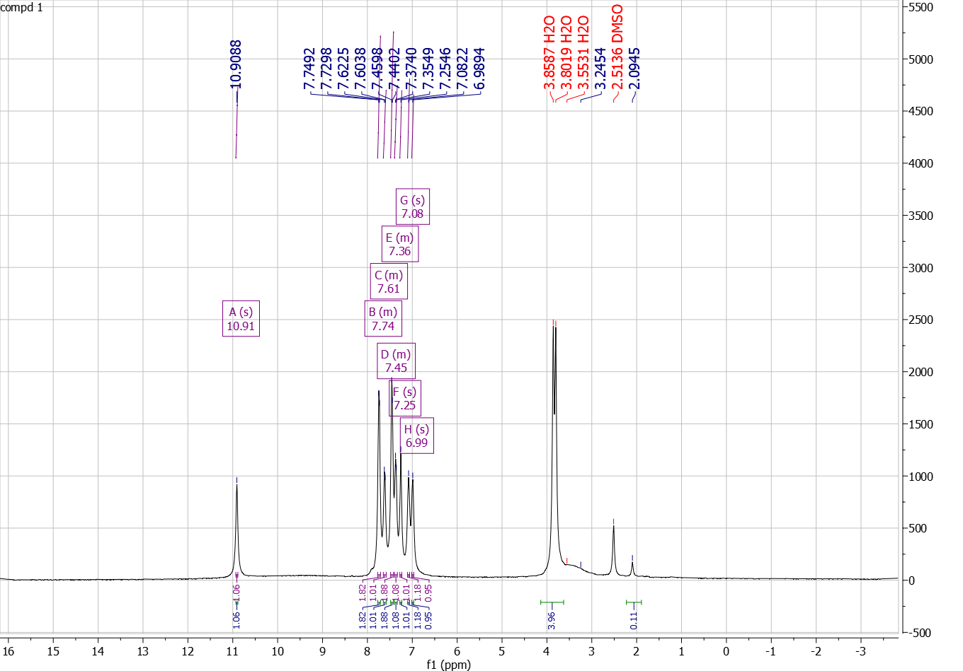
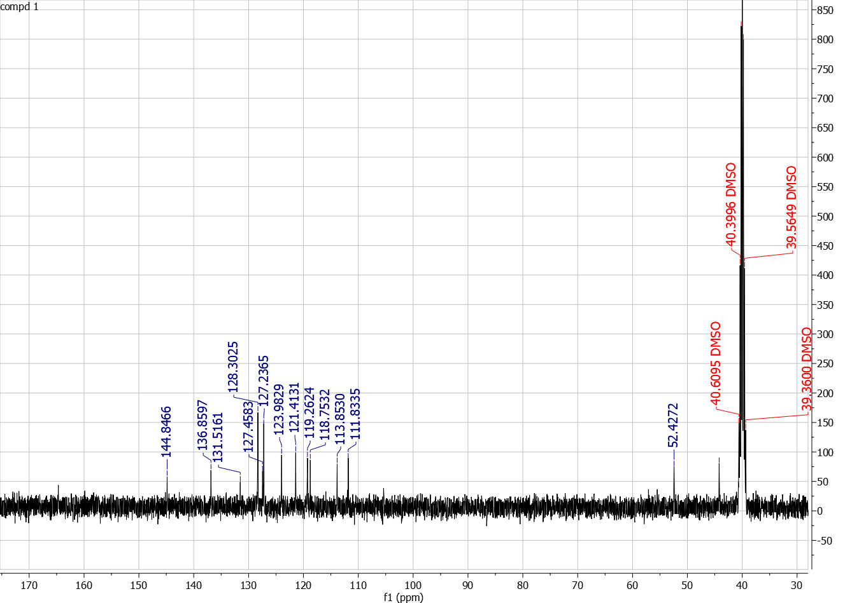
Figure S12: ¹H NMR and ¹³C NMR of compound 2 in DMSO-d6.
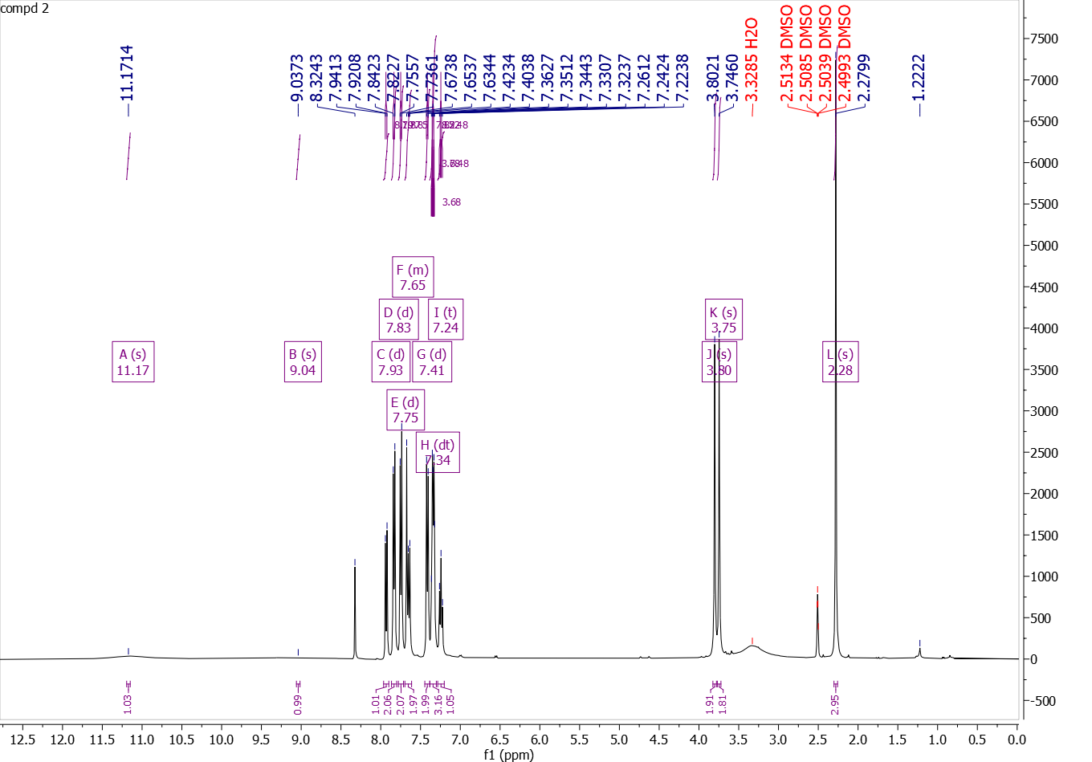
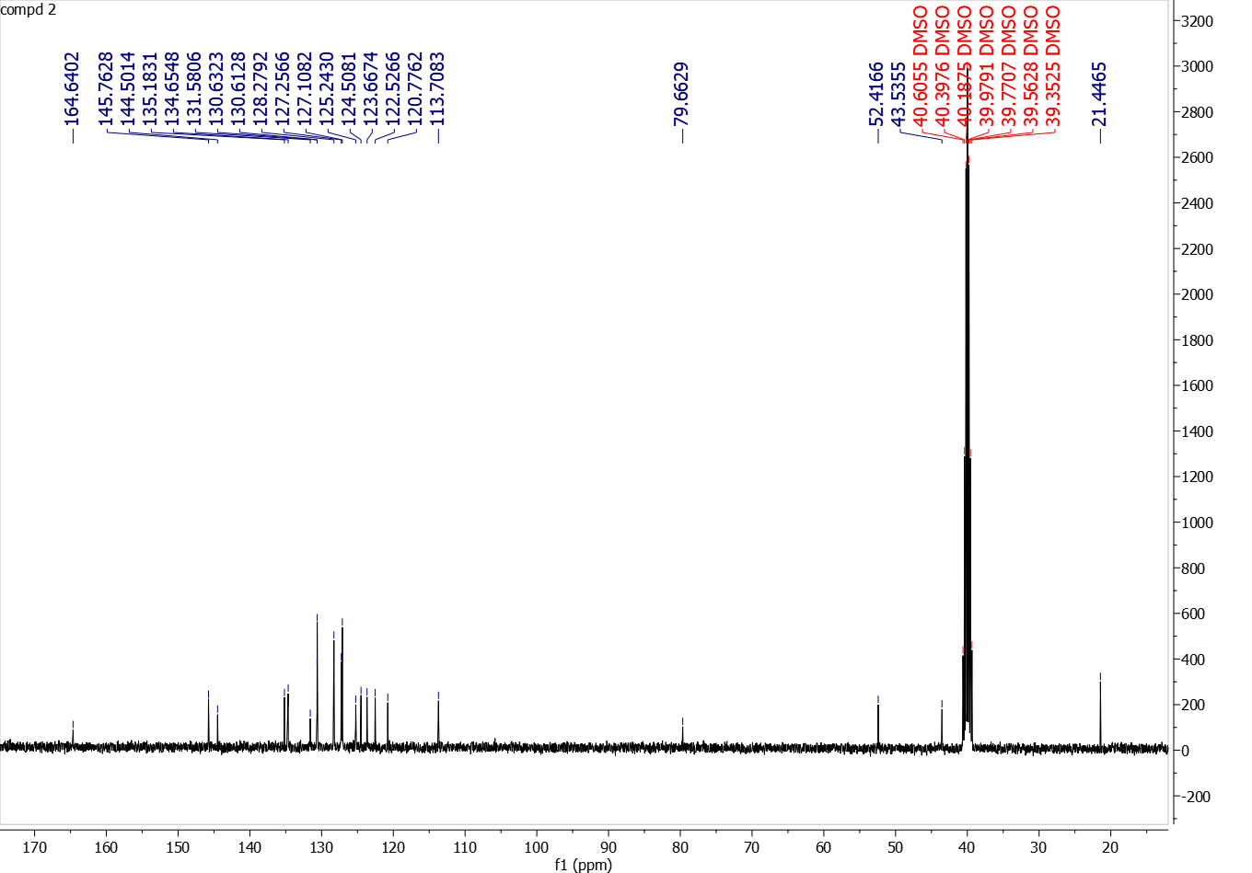

Figure S13: ¹H NMR and ¹³C NMR of compound 3 in DMSO-d6
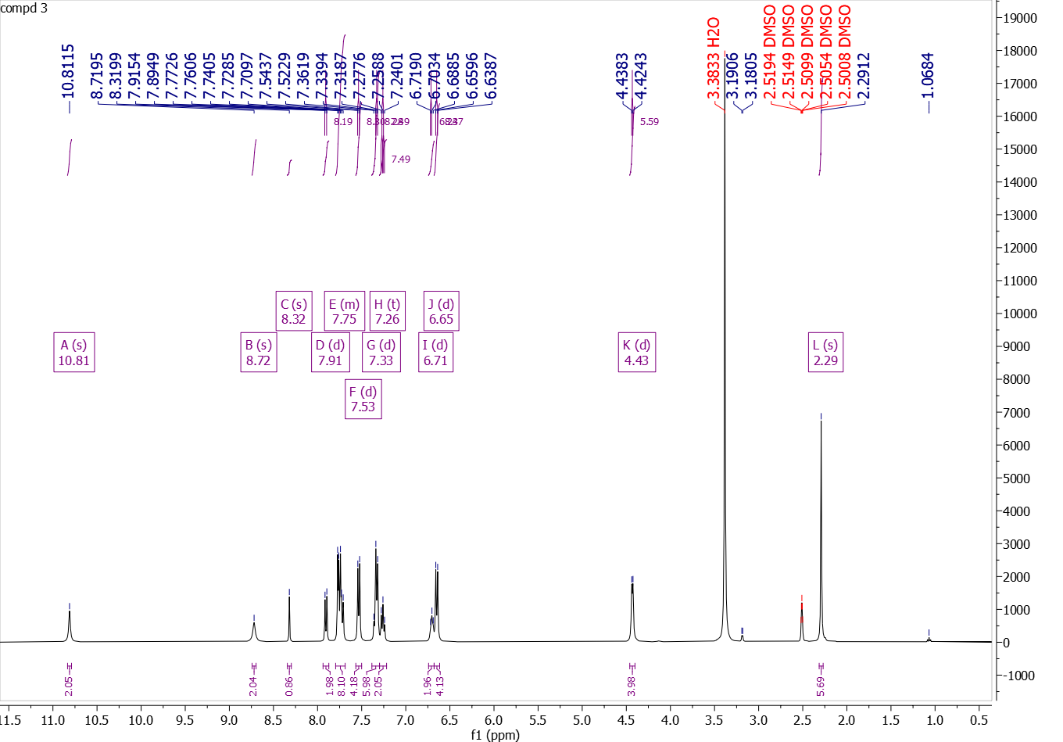
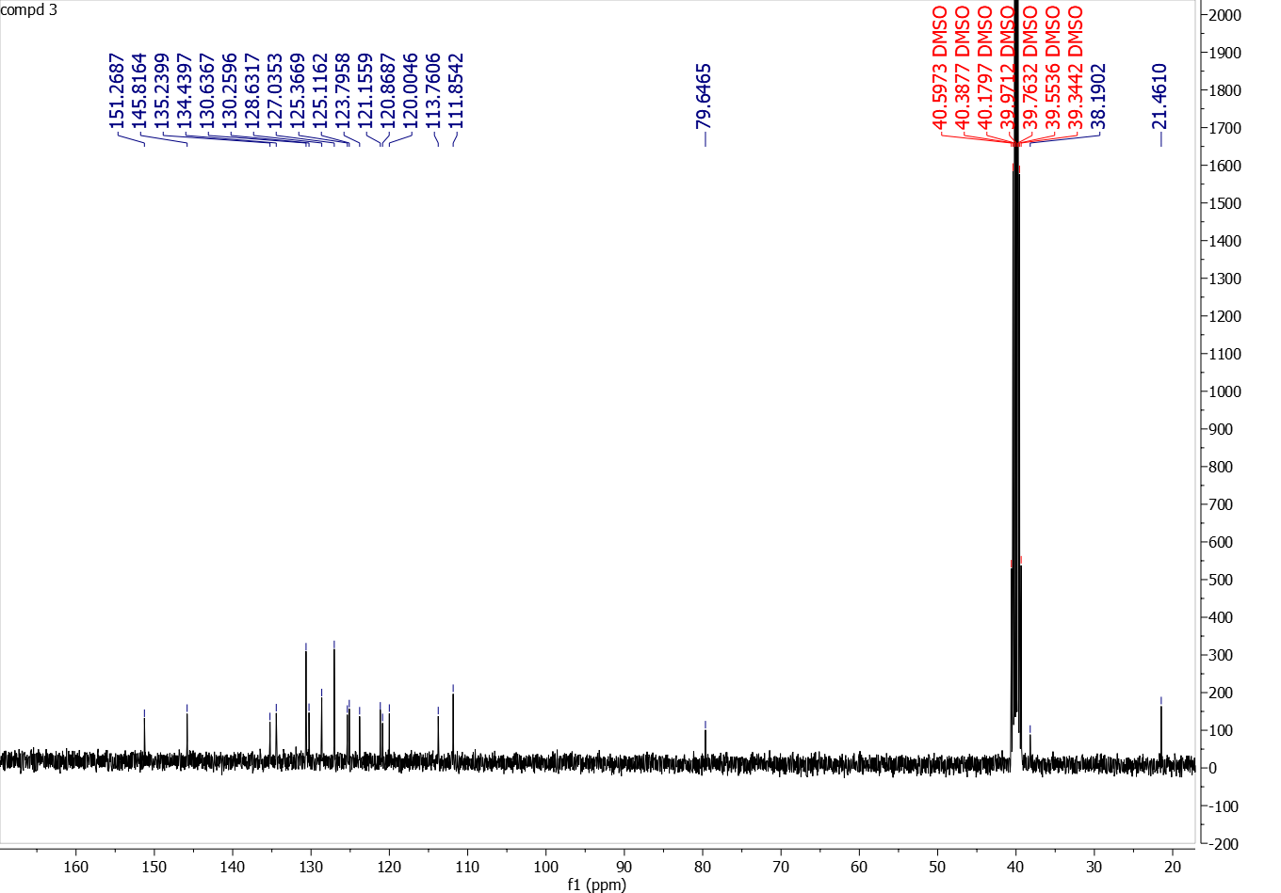

Figure S14: ¹H NMR and ¹³C NMR of compound 4 in DMSO-d6
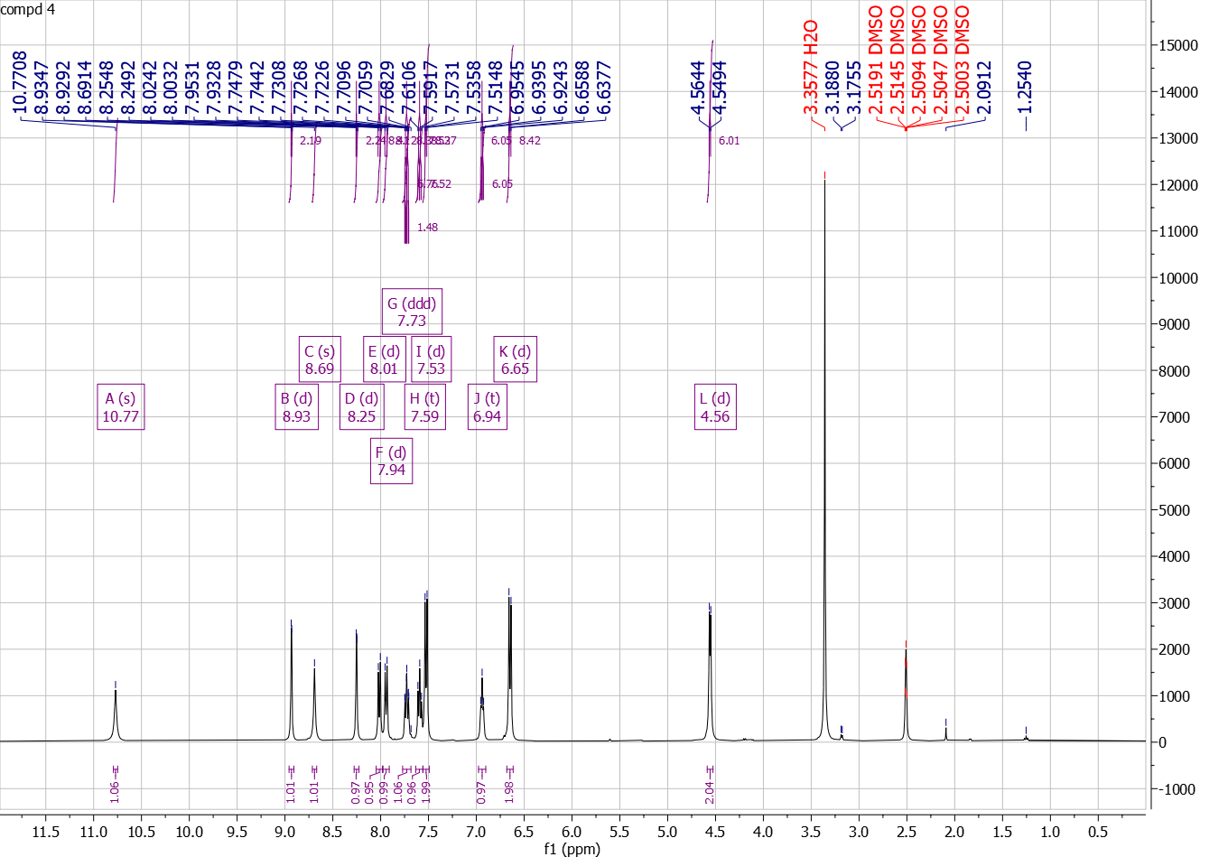
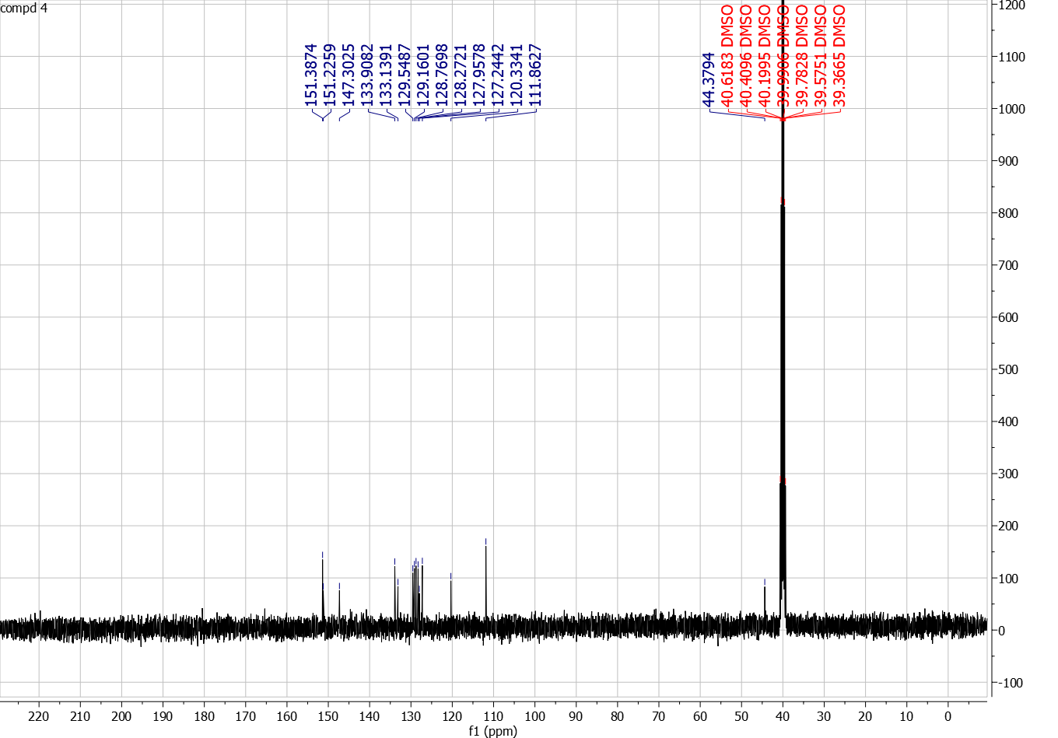

Figure S15: ¹H NMR and ¹³C NMR of compound 5 in DMSO-d6
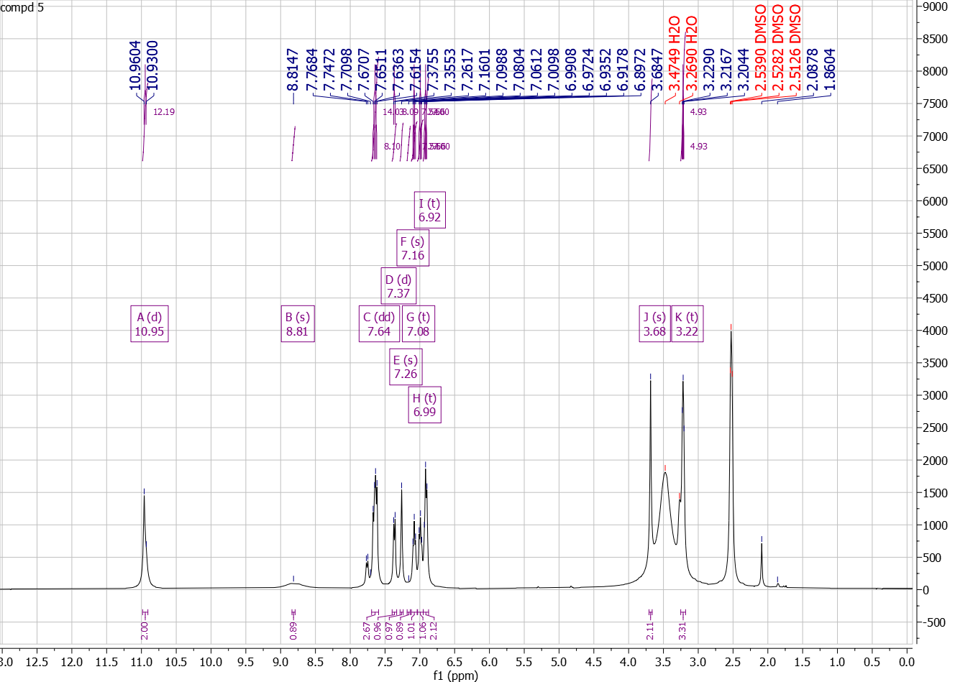
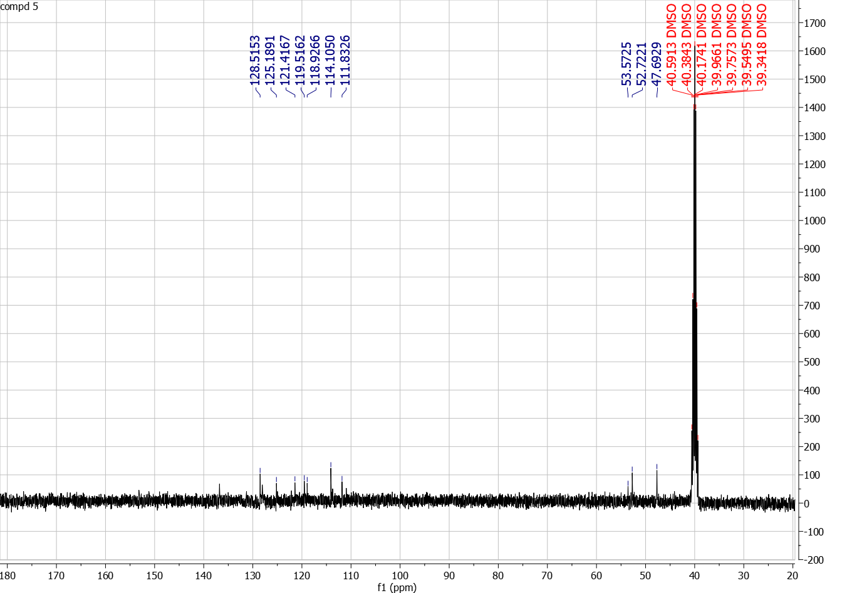

Figure S16: ¹H NMR and ¹³C NMR of compound 6 in DMSO-d6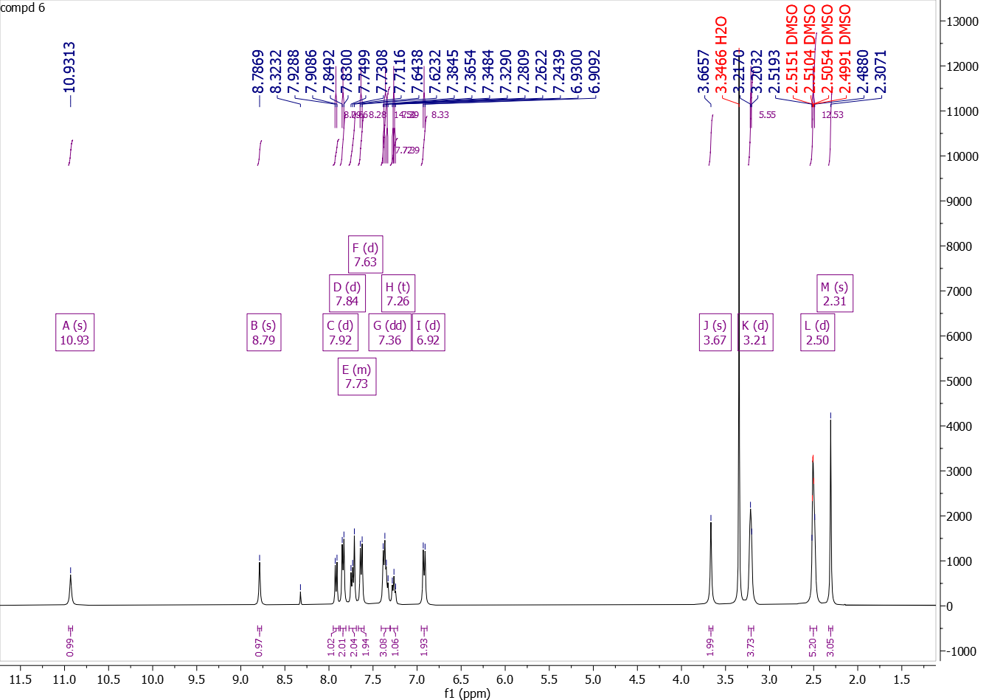
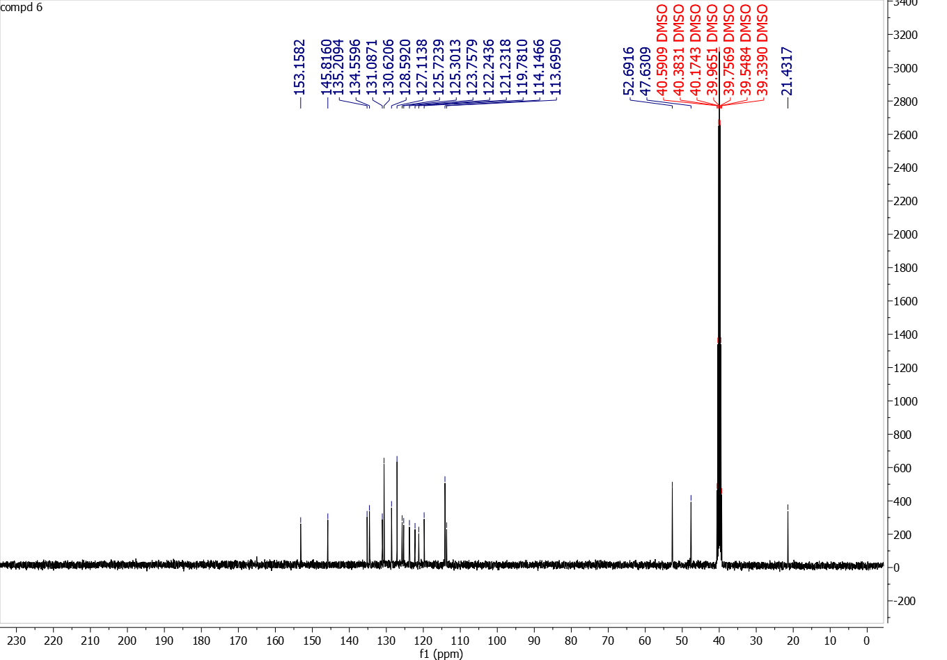

Figure S17: ¹H NMR and ¹³C NMR of compound 7 in DMSO-d6
