Supplementary Table
Table S1: Prevalence of hypertension and diabetes among individuals aged 30 & above by group of states as per the epidemiological transition level, India, 2019-21
ETL States Groups | Hypertension among men |  |  | Hypertension among women |  |  | Diabetes among men |  |  | Diabetes among women
 | % | 95%CI |  | % | 95%CI |  | % | 95%CI |  | % | 95%CI
Low ETL Group
Rajasthan | 23.6 | 23.11-24.18 |  | 21.9 | 21.41-22.41 |  | 12.1 | 11.66-12.48 |  | 10.1 | 9.73-10.46
Uttar Pradesh | 28.3 | 27.93-28.74 |  | 25.8 | 25.43-26.18 |  | 15.8 | 15.44-16.1 |  | 14.0 | 13.73-14.34
Bihar | 24.0 | 23.43-24.65 |  | 22.8 | 22.23-23.3 |  | 21.1 | 20.53-21.69 |  | 17.4 | 16.88-17.85
Meghalaya | 29.3 | 27.94-30.69 |  | 25.5 | 24.17-26.86 |  | 19.4 | 18.22-20.6 |  | 12.0 | 11.15-13
Assam | 26.0 | 25.4-26.61 |  | 26.0 | 25.42-26.64 |  | 19.6 | 19.05-20.18 |  | 16.5 | 16.03-17.08
Jharkhand | 28.9 | 28.13-29.64 |  | 24.3 | 23.67-25.03 |  | 18.5 | 17.92-19.2 |  | 13.7 | 13.21-14.29
Odisha | 30.7 | 30.05-31.41 |  | 29.2 | 28.53-29.8 |  | 20.8 | 20.21-21.42 |  | 17.5 | 17-18.07
Chhattisgarh | 34.8 | 33.98-35.55 |  | 31.4 | 30.64-32.12 |  | 14.0 | 13.39-14.54 |  | 11.7 | 11.23-12.26
Madhya Pradesh | 28.6 | 28.06-29.13 |  | 28.0 | 27.46-28.51 |  | 15.8 | 15.34-16.21 |  | 13.1 | 12.73-13.52
Lower-Middle ETL
Uttarakhand | 38.5 | 37.16-39.92 |  | 30.4 | 29.31-31.55 |  | 18.7 | 17.6-19.91 |  | 14.2 | 13.3-15.06
Sikkim | 46.8 | 44.03-49.51 |  | 41.2 | 38.45-43.91 |  | 19.0 | 16.96-21.29 |  | 15.2 | 13.18-17.51
Arunachal Pradesh | 39.8 | 38.9-40.71 |  | 31.3 | 30.43-32.14 |  | 14.6 | 14-15.3 |  | 10.7 | 10.12-11.24
Nagaland | 35.2 | 33.99-36.4 |  | 29.2 | 28.06-30.44 |  | 16.2 | 15.31-17.19 |  | 13.3 | 12.45-14.27
Manipur | 40.4 | 39.04-41.87 |  | 29.4 | 28.15-30.62 |  | 19.8 | 18.63-20.99 |  | 16.8 | 15.78-17.81
Mizoram | 29.7 | 28.15-31.24 |  | 21.6 | 20.23-23.01 |  | 18.7 | 17.44-19.96 |  | 17.0 | 15.87-18.3
Tripura | 26.3 | 25.02-27.61 |  | 26.6 | 25.36-27.95 |  | 23.0 | 21.83-24.24 |  | 21.6 | 20.41-22.8
Gujarat | 26.2 | 25.54-26.82 |  | 26.9 | 26.31-27.57 |  | 21.7 | 21.11-22.33 |  | 19.8 | 19.19-20.33
Higher-Middle ETL Group
Jammu & Kashmir | 24.7 | 23.96-25.45 |  | 28.1 | 27.32-28.87 |  | 9.8 | 9.28-10.29 |  | 10.8 | 10.28-11.36
Chandigarh | 40.5 | 35.66-45.6 |  | 34.2 | 30.2-38.43 |  | 22.6 | 18.74-27.09 |  | 26.0 | 22.32-29.96
Haryana | 32.4 | 31.6-33.18 |  | 27.8 | 27.06-28.46 |  | 18.3 | 17.67-19 |  | 15.7 | 15.15-16.3
NCT Of Delhi | 42.0 | 40.75-43.35 |  | 33.0 | 31.9-34.15 |  | 18.9 | 17.9-19.93 |  | 15.9 | 15.06-16.81
West Bengal | 25.4 | 24.67-26.14 |  | 28.2 | 27.5-29 |  | 26.5 | 25.71-27.22 |  | 22.5 | 21.78-23.19
Dadra & Nagar Haveli and Daman & Diu | 21.9 | 19.72-24.25 |  | 20.4 | 18.24-22.67 |  | 22.8 | 20.51-25.34 |  | 18.0 | 15.89-20.24
Maharashtra | 30.8 | 30.07-31.47 |  | 29.8 | 29.18-30.53 |  | 16.4 | 15.86-17.02 |  | 14.9 | 14.39-15.49
Andhra Pradesh | 35.1 | 34.07-36.13 |  | 32.6 | 31.68-33.58 |  | 25.7 | 24.81-26.7 |  | 23.4 | 22.6-24.32
Karnataka | 33.3 | 32.51-34.04 |  | 32.7 | 31.95-33.4 |  | 18.9 | 18.29-19.58 |  | 17.1 | 16.53-17.73
Lakshadweep | 31.3 | 28.36-34.31 |  | 32.4 | 29.74-35.09 |  | 24.6 | 21.93-27.44 |  | 25.5 | 23.09-28.11
Puducherry | 37.8 | 34.92-40.84 |  | 28.9 | 26.56-31.34 |  | 25.6 | 23.18-28.28 |  | 22.2 | 20.15-24.49
Andaman & Nicobar Islands | 36.9 | 34.63-39.28 |  | 33.6 | 31.33-35.97 |  | 22.1 | 20.12-24.2 |  | 19.9 | 17.95-21.98
Telangana | 38.3 | 37.48-39.09 |  | 34.1 | 33.36-34.81 |  | 21.5 | 20.85-22.24 |  | 17.4 | 16.78-17.96
Ladakh | 22.3 | 20.5-24.13 |  | 21.1 | 19.33-23.02 |  | 9.5 | 8.28-10.84 |  | 8.3 | 7.17-9.66
High ETL Group
Himachal Pradesh | 29.0 | 27.8-30.19 |  | 27.8 | 26.79-28.94 |  | 17.6 | 16.6-18.64 |  | 16.4 | 15.52-17.28
Punjab | 46.9 | 46.05-47.84 |  | 39.5 | 38.73-40.36 |  | 18.9 | 18.19-19.61 |  | 19.0 | 18.37-19.69
Goa | 34.3 | 31.94-36.78 |  | 35.8 | 33.63-38.05 |  | 29.5 | 27.2-31.82 |  | 24.3 | 22.37-26.38
Kerala | 40.0 | 38.98-41.02 |  | 37.6 | 36.73-38.48 |  | 30.6 | 29.66-31.59 |  | 26.7 | 25.9-27.51
Tamil Nadu | 36.0 | 35.22-36.75 |  | 30.7 | 30.04-31.4 |  | 26.0 | 25.36-26.68 |  | 24.2 | 23.62-24.85
India | 30.3 | 30.14-30.48 |  | 28.6 | 28.47-28.79 |  | 19.7 | 19.58-19.88 |  | 17.4 | 17.22-17.5

Table S2: Prevalence of hypertension among those aged 30 and above who have diabetes and prevalence of diabetes among those aged 30 and above who have hypertension by group of states as per the epidemiological transition level, India, 2019-21
ETL States Groups | Hypertension among Diabetic Patients |  |  |  |  |  | Diabetes among Hypertension Patients
 | Men aged 30+ |  |  | Women aged 30+ |  |  | Men aged 30+ |  |  | Women aged 30+
 | % | 95%CI |  | % | 95%CI |  | % | 95%CI |  | % | 95%CI
Low ETL Group
Rajasthan | 39.7 | 37.9-41.45 |  | 38.5 | 36.65-40.38 |  | 20.2 | 19.21-21.31 |  | 17.7 | 16.76-18.75
Uttar Pradesh | 41.9 | 40.79-43.08 |  | 40.2 | 39.03-41.32 |  | 23.3 | 22.61-24.07 |  | 21.8 | 21.15-22.56
Bihar | 33.5 | 32.01-34.97 |  | 35.1 | 33.62-36.62 |  | 29.4 | 28.06-30.75 |  | 26.8 | 25.58-28.01
Meghalaya | 43.8 | 40.36-47.27 |  | 44.8 | 40.73-48.89 |  | 29 | 26.38-31.69 |  | 21.2 | 18.82-23.72
Assam | 39.1 | 37.5-40.63 |  | 41.2 | 39.52-42.97 |  | 29.5 | 28.23-30.72 |  | 26.2 | 25.02-27.45
Jharkhand | 43 | 41.07-44.86 |  | 39.9 | 37.84-41.99 |  | 27.6 | 26.22-29.01 |  | 22.5 | 21.2-23.9
Odisha | 39.5 | 37.89-41.11 |  | 38.7 | 37.05-40.34 |  | 26.7 | 25.56-27.96 |  | 23.2 | 22.16-24.37
Chhattisgarh | 45.9 | 43.67-48.12 |  | 46.7 | 44.4-49.07 |  | 18.4 | 17.36-19.53 |  | 17.5 | 16.42-18.6
Madhya Pradesh | 37.9 | 36.47-39.4 |  | 42.4 | 40.76-43.99 |  | 20.9 | 20.03-21.83 |  | 19.9 | 18.98-20.77
Lower-Middle ETL
Uttarakhand | 48.4 | 44.98-51.88 |  | 44.9 | 41.53-48.33 |  | 23.5 | 21.57-25.63 |  | 20.9 | 19.05-22.89
Sikkim | 58.9 | 52.69-64.91 |  | 52.9 | 45.09-60.53 |  | 24 | 20.7-27.61 |  | 19.6 | 16.02-23.65
Arunachal Pradesh | 52 | 49.64-54.4 |  | 44.9 | 42.16-47.68 |  | 19.1 | 18.02-20.3 |  | 15.3 | 14.18-16.52
Nagaland | 53.8 | 50.62-56.92 |  | 48.5 | 44.85-52.21 |  | 24.8 | 23.02-26.68 |  | 22.1 | 20.14-24.25
Manipur | 50.3 | 46.91-53.64 |  | 42.1 | 38.83-45.47 |  | 24.6 | 22.6-26.69 |  | 24 | 21.92-26.32
Mizoram | 39.9 | 36.16-43.71 |  | 33.8 | 30.12-37.77 |  | 25.1 | 22.4-27.97 |  | 26.7 | 23.57-30.14
Tripura | 36.3 | 33.45-39.26 |  | 36.7 | 33.69-39.85 |  | 31.8 | 29.14-34.52 |  | 29.7 | 27.15-32.48
Gujarat | 36.5 | 34.94-38 |  | 38.6 | 37.06-40.21 |  | 30.2 | 28.95-31.57 |  | 28.3 | 27.1-29.58
Higher-Middle ETL Group
Jammu & Kashmir | 49.2 | 46.53-51.92 |  | 52.6 | 49.94-55.23 |  | 19.5 | 18.15-20.87 |  | 20.2 | 18.95-21.59
Chandigarh | 51.9 | 41.57-62.09 |  | 55.4 | 46.81-63.6 |  | 29 | 22.36-36.67 |  | 42 | 34.86-49.56
Haryana | 43.6 | 41.62-45.59 |  | 44 | 42.04-45.98 |  | 24.7 | 23.41-25.98 |  | 24.9 | 23.65-26.23
NCT of Delhi | 60 | 57.07-62.91 |  | 53.4 | 50.37-56.35 |  | 27 | 25.22-28.8 |  | 25.7 | 23.96-27.6
West Bengal | 35.5 | 33.91-37.12 |  | 40.3 | 38.59-42.09 |  | 37 | 35.36-38.63 |  | 32.1 | 30.63-33.59
Dadra & Nagar Haveli and Daman & Diu | 27.3 | 22.48-32.72 |  | 31.4 | 25.77-37.73 |  | 28.5 | 23.59-33.89 |  | 27.7 | 22.73-33.36
Maharashtra | 45.1 | 43.14-47.04 |  | 46.2 | 44.21-48.21 |  | 24.1 | 22.89-25.31 |  | 23.1 | 21.97-24.3
Andhra Pradesh | 47.7 | 45.53-49.81 |  | 48.6 | 46.55-50.75 |  | 35 | 33.23-36.73 |  | 35 | 33.28-36.69
Karnataka | 49.4 | 47.51-51.33 |  | 51.4 | 49.48-53.37 |  | 28.1 | 26.8-29.46 |  | 27 | 25.71-28.22
Lakshadweep | 49.5 | 43.1-55.85 |  | 55.7 | 49.99-61.29 |  | 38.9 | 33.53-44.55 |  | 43.9 | 39.05-48.96
Puducherry | 45.3 | 39.79-50.93 |  | 46.3 | 40.87-51.73 |  | 30.7 | 26.52-35.24 |  | 35.6 | 31.12-40.37
Andaman & Nicobar Islands | 50 | 44.81-55.25 |  | 49.4 | 43.71-55.06 |  | 29.9 | 26.5-33.62 |  | 29.2 | 25.47-33.28
Telangana | 51.6 | 49.8-53.46 |  | 50.6 | 48.68-52.45 |  | 29 | 27.78-30.34 |  | 25.8 | 24.59-26.97
Ladakh | 41.8 | 35.01-48.89 |  | 39.9 | 32.58-47.73 |  | 17.8 | 14.54-21.62 |  | 15.7 | 12.49-19.65
High ETL Group
Himachal Pradesh | 43.1 | 39.97-46.37 |  | 45.3 | 42.33-48.21 |  | 26.2 | 24.04-28.47 |  | 26.6 | 24.64-28.71
Punjab | 60.9 | 58.8-62.91 |  | 57.7 | 55.8-59.61 |  | 24.5 | 23.38-25.64 |  | 27.8 | 26.59-28.97
Goa | 47.5 | 42.86-52.13 |  | 56.4 | 51.58-61.06 |  | 40.7 | 36.56-45.07 |  | 38.3 | 34.66-42.04
Kerala | 54.9 | 53.03-56.82 |  | 55.8 | 54.02-57.53 |  | 42 | 40.43-43.69 |  | 39.6 | 38.17-41.06
Tamil Nadu | 48.2 | 46.73-49.62 |  | 44.3 | 42.86-45.7 |  | 34.8 | 33.59-36.09 |  | 34.9 | 33.69-36.18
India | 43.1 | 42.67-43.53 |  | 43.9 | 43.48-44.36 |  | 28.1 | 27.75-28.37 |  | 26.6 | 26.33-26.93

Supplementary Figures

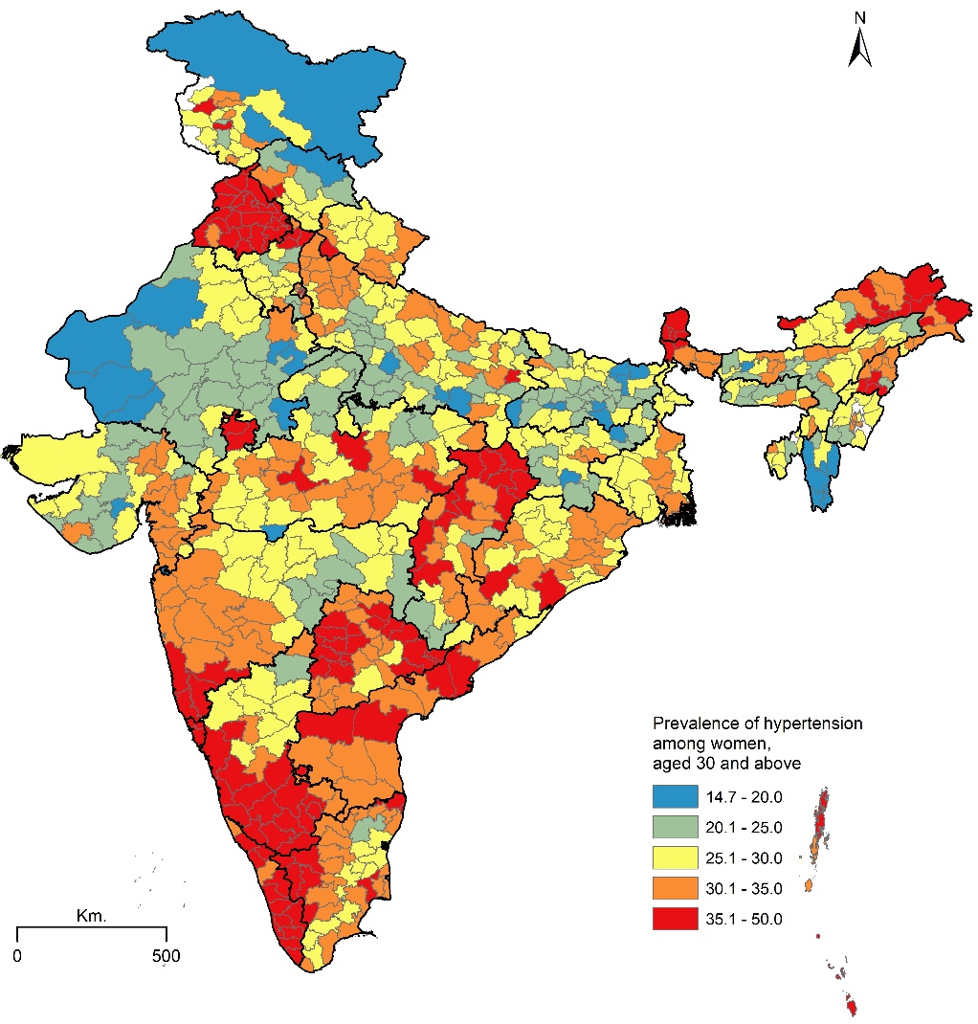
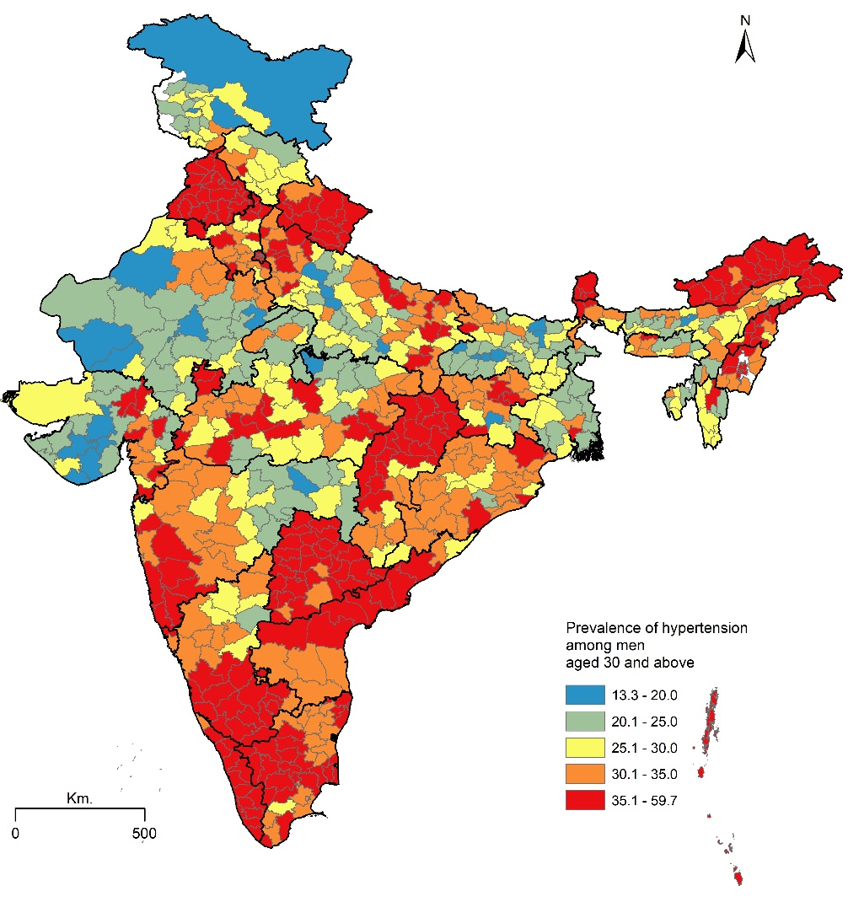
Figure S-1: Prevalence of hypertension among men Figure S-2: Prevalence of hypertension among women

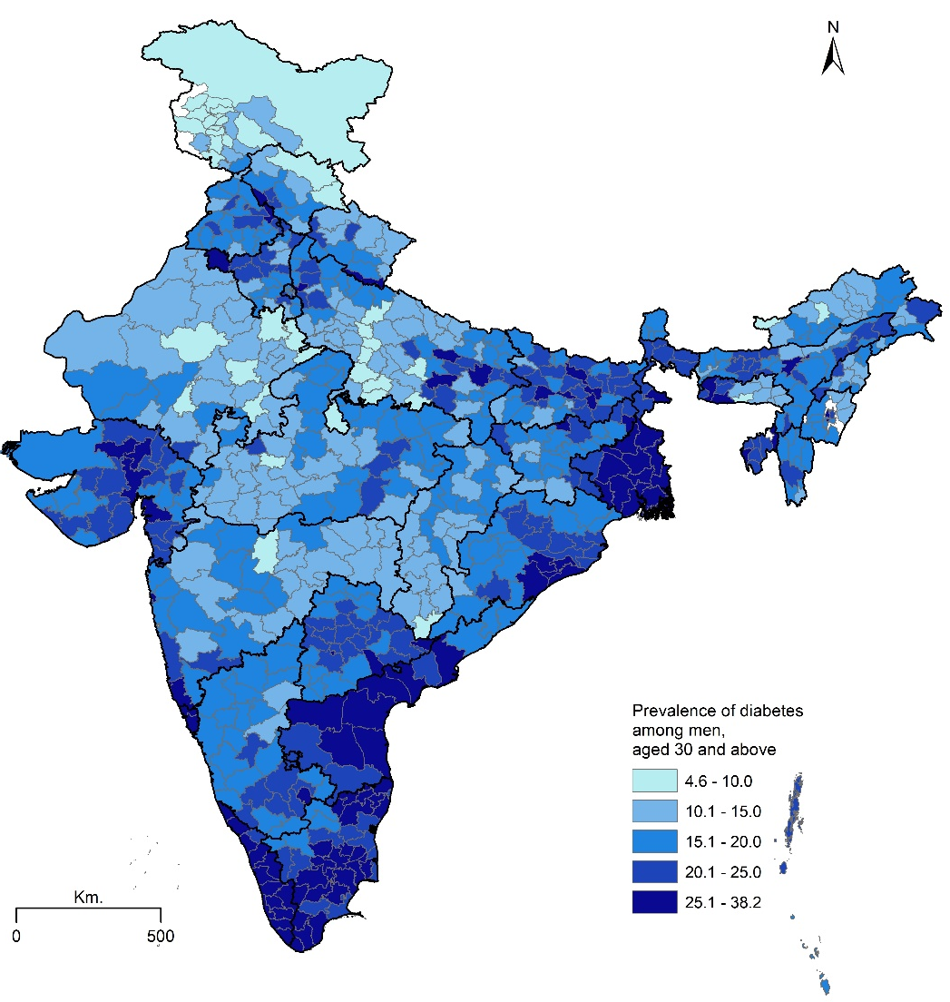
Figure S-3: Prevalence of diabetes among men Figure S-4: Prevalence of diabetes among women
