A Geoinformation approach for spatiotemporal mapping of climate change and environmental impacts on food security in Iraq
Abstract
Climate change and its associated environmental challenges pose significant threats to food security, particularly in arid and semi-arid regions such as Iraq. This study employed an integrated geoinformation approach to assess the spatiotemporal impact of key environmental stressors on agricultural productivity over the past two decades (2003–2023). The primary objective of this study was to evaluate the influence of climate variability, land degradation, and water availability on food security in Iraq. Specifically, it aims to analyse changes in land use and land cover (LULC), land surface temperature (LST), vegetation health using the Normalised Difference Vegetation Index (NDVI), drought conditions using the Palmer Drought Severity Index (PDSI), soil moisture, soil pH, and demographic trends. A geospatial analysis integrating remote sensing and Geographic Information System (GIS) techniques (in short, Geoinformatio) was conducted to identify environmental changes. Satellite-derived indices, such as the Normalised Difference Salinity Index (NDSI), Normalised Difference Turbidity Index, and Normalised Difference Tillage Index (NDTI), were used to assess soil degradation and water quality. The findings revealed a significant increase in LST, with peak temperatures rising from 46.6°C in 2003 to 49.9°C in 2023, exacerbating drought conditions and reducing agricultural viability. Soil salinity, measured using the NDSI, indicated an upward trend, reaching a peak value of 0.52 in 2013, which indicates worsening soil degradation. Water quality deteriorated, as reflected by rising turbidity levels (NDTI values peaking at 0.49 in 2008), affecting irrigation suitability. NDVI values declined from 0.41 in 2018 but showed partial recovery to 0.59 in 2023, suggesting the impact of land management efforts. This study identified high-risk zones where compounded environmental stressors threaten food security. The results underscore the effectiveness of geoinformation approaches in assessing climate impacts on agriculture and offer a scientific foundation for policymakers to develop targeted mitigation strategies. Future research should explore machine learning models for predictive analyses and region-specific adaptation measures to enhance agricultural resilience.

Keywords: Climate Change, Food Security, Geographic Information System, Remote Sensing, Sustainable Agriculture, Iraq, Environmental Monitoring
- Introduction
Food security is a fundamental global concern influenced by environmental, economic, social, and political factors. The Food and Agriculture Organization (FAO) defines food security as a condition in which “all people, at all times, have physical, social, and economic access to sufficient, safe, and nutritious food” (Practical, 2008). However, climate change and land degradation are intensifying food security challenges, particularly in regions that experience environmental stress. The decline in arable land, increasing soil salinity, desertification, and extreme weather events threaten agricultural productivity, making food security a major concern for sustainable development ( Waha et al., 2017; Hussain et al., 2019; Feizizadeh et al., 2023a).
Iraq faces significant environmental challenges that impact its food security. Climate-induced changes, such as rising temperatures, prolonged droughts, water scarcity, and soil degradation, have contributed to declining agricultural productivity. The country has experienced increasing land surface temperatures (LST) over the past few decades, leading to higher evapotranspiration rates and worsening water availability for crops (Wan et al., 2004). Additionally, Land Use and Land Cover (LULC) changes, driven by urban expansion and deforestation, have reduced arable land, exacerbating food insecurity (Wan et al., 2004). Soil degradation, particularly increasing salinity and desertification, further restricts sustainable farming practices (Al-Ansari 2013).
Drought severity in Iraq has increased, making water management a critical issue. The Palmer Drought Severity Index (PDSI) is widely used to assess drought trends and provides valuable insights into regional hydrological conditions. Similarly, vegetation indices, such as the normalised difference vegetation index (NDVI), are essential for monitoring crop health and land productivity. Lu et al. found an average water availability (precipitation minus evapotranspiration) of 249 mm/year and a declining trend in the Belt and Road region. Approximately 13% of the Belt and Road region faces water deficits (evapotranspiration exceeds precipitation), primarily in arid and semi-arid regions with high drought frequencies (Lu et al., 2025). The normalised difference salinity index (NDSI) is used to detect soil salinity, which affects plant growth, whereas the normalised difference tillage index (NDTI) helps assess soil management practices and land degradation trends. These indices collectively offer a comprehensive understanding of environmental changes and their direct implications for the sustainability of agriculture.
The integrated approach of remote sensing and GIS, also known as geoinformation technologies, provides an efficient methodological approach for monitoring environmental changes that affect food security (Feizizadeh et al., 2023ab). Remote sensing enables large-scale, real-time analyses of LULC transformations, soil degradation, and climatic variations, whereas GIS facilitates the spatial analysis and visualisation of these changes (Abdulraheem et al., 2023). These tools help policymakers design targeted interventions and promote sustainable agricultural practices and efficient resource management (Al-Quraishi, 2024).
Numerous studies have highlighted the critical role of remote sensing and geospatial analysis in assessing the impact of climate change on agriculture and food security. Research on drought and water availability in the Belt and Road region (2001–2020) demonstrated that prolonged droughts significantly reduce water resources for agriculture, leading to severe vegetation stress and declining soil moisture levels (Wan et al., 2004). The study emphasised the importance of indices such as the Palmer Drought Severity Index (PDSI) and the Standardised Precipitation Index (SPI) in monitoring drought severity and its implications for food security (Wan et al., 2004). Similarly, a study on the use of MODIS Land Surface Temperature (LST) and the normalised difference vegetation index (NDVI) for drought monitoring in the southern Great Plains, USA, found that LST increased while NDVI declined during drought events, reflecting the negative effects of heat stress on vegetation (Wan et al., 2004).
Furthermore, an analysis of LULC changes in Mathura District, India, revealed that rapid urbanization led to a significant reduction in agricultural land, further exacerbating food security challenges (Ahmed et al., 2022). Feizizadeh et al. 2021-2025, conducted several studies on the spatiotemporal monitoring of climate change environmental impacts on food security aspects in the Urmia Lake Basin, Iran. They have addressed several major environmental impacts of climate change, such as impacts on LULC changes (Feizizadeh et al., 2021ab), soil salinity and land degradation (Feizizadeh et al., 2021c;2022a), aquifer salinisation (Feizizadeh et al. 2022b; Abdollahi et al., 2025), salt dust scattering (Feizizadeh et al. 2025), sustainable food production (Feizizadeh et al. 2023a), public health (Feizizadeh et al. 2023b), and crop modification and land suitability analysis (Feizizadeh et al. 2024), based on the integrated geoinformation approaches such as machine learning methods, spatial decision-making systems, and scenario-based spatiotemporal methods. Table 1 summarises the results of some related studies and their methodological aspects for spatiotemporal modelling of climate change environmental impacts on food security assessment.

Table 1: review of some related studies for food security assessment using different methodological aspects
Study | Methodology | Key Parameters Analyzed | Data Sources | Operational Complexity | Cost Implications | Applicability & Scalability
Present Study | Geoinformation-based approach integrating Remote Sensing (RS) and GIS | LULC, LST, NDVI, NDSI, NDTI, Soil Moisture, PDSI, Demographic Data | Satellite Data (MODIS, Landsat), Ground-based Observations | Moderate (requires geospatial expertise) | Moderate (depends on data acquisition and processing infrastructure) | High (Applicable for regional/national food security assessments)
(Wan et al., 2004) | MODIS LST & NDVI for drought monitoring | Land Surface Temperature, Vegetation Health | MODIS Data (Terra/Aqua satellites) | Moderate | Low (freely available satellite data) | High (scalable to other regions but dependent on MODIS data)
(Lu et al., 2025) | GIS and remote sensing analysis of drought severity | Drought indices, precipitation patterns, water availability | MODIS, TRMM, Ground-based climate data | High (complex drought modeling) | High (requires advanced GIS models and climate databases) | High (applicable for large-scale climate change studies)
(Ethaib et al., 2022) | GIS-based estimation of water scarcity due to climate change | Precipitation, groundwater levels, temperature trends | GIS Data, Hydrological Models | High (detailed hydrological modeling required) | High (hydrological data collection and processing) | Moderate (region-specific application but useful for policy recommendations)
(Choudhury, 2024) | Statistical correlation of LST and drought trends | Land Surface Temperature, Drought Severity | Remote Sensing Data (MODIS, Landsat) | Moderate | Low (open-source remote sensing data) | High (generalizable to different climate zones)

It is well understood that the geoinformatics approach leads to monitoring environmental challenges more efficiently and cost-effectively. The applicability of this approach for large-scale implementation is supported by its ability to capture spatial and temporal variations in environmental conditions at relatively low operational costs. The methodology is adaptable across diverse agroecological zones, making it suitable for evaluating food security risks at the national and regional levels. Compared to hydrological models, which depend on site-specific precipitation and groundwater data (Roy et al., 2023), remote sensing techniques offer broader applicability by enabling consistent observations over large areas (Lu et al., 2025). This scalability is particularly relevant in regions where ground monitoring is constrained by logistical challenges.
Despite these advantages, the large-scale application of this methodology is contingent upon computational resources and expertise in geospatial data processing. Advanced data-handling techniques, such as machine learning and data-driven approaches, as well as cloud computing solutions, may be necessary to efficiently process high-resolution imagery across large territories (Du et al., 2020; Feizizadeh et al., 2022a). Furthermore, although satellite data provide valuable insights, the absence of ground-based validation in some regions may limit their accuracy, necessitating hybrid approaches that integrate remote sensing with field measurements for improved reliability (Cui et al., 2023). It is also acknowledged that from a policy perspective, the integration of multiple environmental stressors enhances the predictive capability of this method, offering a robust framework for agricultural planning and climate-adaptation strategies. However, ensuring the long-term effectiveness of this approach requires sustained investment in technological infrastructure and training programs to build expertise in remote-sensing applications. By addressing these challenges, this methodology can serve as a scalable and scientifically rigorous tool for assessing the impact of climate change on food security across different geographical contexts.
Based on the tangible environmental impacts of climate change on semi-arid and arid environments (for example, Iraq) and given Iraq’s vulnerability to climate change and environmental degradation, this study aimed to employ integrated Geoinformation approach to assess key environmental indicators being impacted by intensive climate change over the past two decades. Specifically, it seeks to analyse LULC changes and their implications for agricultural productivity and food security in Iraq. Additionally, it examines variations in land surface temperature (LST) and their correlation with the impact of climate change on soil and vegetation health. To further understand vegetation dynamics, we aimed to evaluate fluctuations in agricultural land productivity using the normalised difference vegetation index. Moreover, this study investigated drought severity trends using the Palmer Drought Severity Index (PDSI) and soil moisture data to assess their effects on crop yields and food availability. Soil degradation is also a key focus, particularly in assessing soil salinity (using the normalised difference salinity index, NDSI) and soil pH variations to determine their role in declining agricultural output. By integrating these environmental parameters through GIS-based spatial analysis, this study aims to identify high-risk regions for food insecurity, highlighting areas most affected by climate-induced changes.
Material and methods

2. 1. Study Area and dataset
This study focuses on Iraq, a Middle Eastern country covering approximately 438,317 square kilometers, as shown in Figure 1. Iraq's diverse geographical features include the fertile river valleys of the Tigris and Euphrates, which are critical for agricultural productivity. These rivers, along with their tributaries, sustain Iraq's historically agrarian society and are vital for the irrigation systems that support crop cultivation (Al-Ansari, 2013). However, the country faces numerous environmental and socioeconomic challenges, including prolonged conflict, population displacement, and severe environmental degradation, all of which contribute to food insecurity(Gasper, 2022).
Iraq’s climate ranges from semi-arid to arid, characterised by hot summers and mild winters, with irregular precipitation patterns and rising temperatures that exacerbate existing environmental stressors. These climatic changes have intensified soil salinisation, water scarcity, and desertification, threatening the sustainability of the agricultural sector (Gasper 2022; Yousif 2024). Beyond environmental factors, social and economic instability has further weakened Iraq’s ability to ensure food security for its population. Years of instability have disrupted agricultural supply chains, reduced infrastructure investment, and increased rural community vulnerability. The significance of this study lies in its potential to inform evidence-based policies aimed at enhancing agricultural productivity and improving resource management. By investigating the factors impacting food security, this study provides valuable insights into improving access to nutritious food and strengthening local food systems, which are integral to sustainable development and poverty alleviation (Amalia et al., 2023).

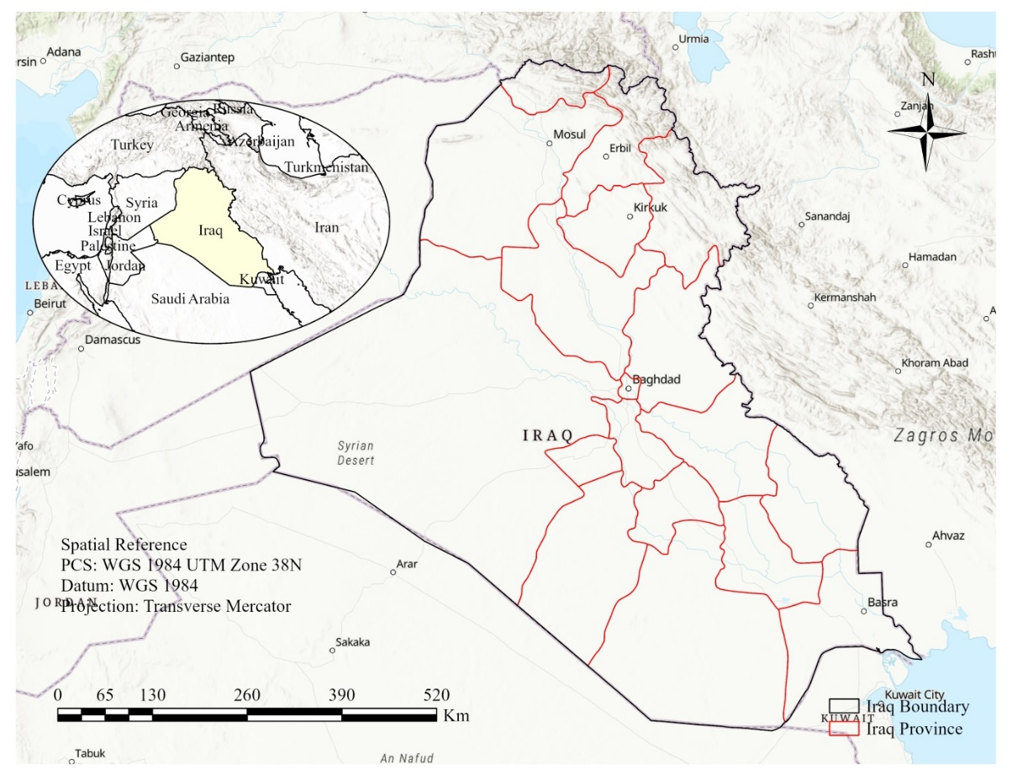
Figure 1: Location of study area and subdivision

2.1 Dataset
In this study, we employed two major categories of datasets, including satellite images and GIS datasets. To evaluate the changes in environmental parameters and their impact on food security in Iraq, remote satellite imagery from 2003 to 2023 was applied. Satellite data from Landsat 8 (OLI) and MODIS were used to analyse various indicators, including chlorophyll concentration, Land Surface Temperature (LST), and normalised difference vegetation index (NDVI), as well as to map land use/land cover change. These datasets were sourced from the United States Geological Survey (USGS) Earth Explorer portal (http://www.earthexplorer.usgs.gov) and accessed in 2023. Table 2 presents the details and characteristics of the satellite images. Accordingly, we employed Landsat images to drive the land use/land cover (LULC). LST and NDVI for environmental degradation under the impact of climate change.

In addition to earth observation products, Google Earth images were employed for enhanced visualisation and validation. In addition to satellite imagery, GIS datasets were employed to enhance spatial analysis and integrate socioeconomic factors with environmental parameters. These datasets include:

- Administrative dataset: Administrative datasets were employed to analyse the subdivision of Iraq and delineate Iraq's provinces as subregions for the spatial analysis.
- A topography dataset obtained from the Shuttle Radar Topography Mission (SRTM) with a spatial resolution of 30 m was employed to assess the topographic influences on environmental parameters.
- Soil Data: Obtained from the Food and Agriculture Organization (FAO) Harmonised World Soil Database and the International Soil Reference and Information Centre (ISRIC), this dataset provides detailed information on soil types, salinity levels, and pH, which are vital for understanding soil health and crop suitability (Amalia et al., 2023).
- Demography and population density maps: Sourced from [for example, World Pop or UN datasets], which are used to link environmental impacts to human vulnerability assessment.
- Land Use Land Cover maps were obtained from Landsat satellite imagery using classification methods and validated based on existing GIS layers as well as control points collected from the Google Earth dataset.
After obtaining all datasets, the respective edits, including geometric correction, resampling, and reclassification, were applied to ensure consistency across spatial and temporal scales. To achieve this goal, we employed software packages such as ArcGIS and Google Earth Engine for data visualisation, spatial interpolation, and trend analysis. Ground control points and field observations were used to validate the key indices, ensuring the accuracy of the detection of patterns of soil salinity, vegetation health, and land degradation.

Table 2. Characteristics of satellite images
Band Name | Wavelength (µm) | Source | Application
Red, NIR | Red: 0.620–0.670 | MODIS | Vegetation health monitoring
Red, NIR | NIR: 0.841–0.87 | MODIS | Vegetation health monitoring
Green, NIR | Green: 0.520–0.600 | Landsat 8 | Water turbidity assessment
Green, NIR | NIR: 0.845–0.885 | Landsat 8 | Water turbidity assessment
Red, NIR | Red: 0.630–0.680 | Landsat 8 | Soil salinity detection
Red, NIR | NIR: 0.845–0.885 | Landsat 8 | Soil salinity detection
Thermal Infrared Bands 31 & 32 | Band 31: 10.780–11.280, | MODIS | Surface temperature monitoring
Thermal Infrared Bands 31 & 32 | Band 32: 11.770–12.270 | MODIS | Surface temperature monitoring

2.2 Methods
This study adopted an integrated geo-information approach that combined remote sensing techniques with GIS-based spatial analysis to assess the environmental challenges affecting food security in Iraq. The methodology follows a structured framework that incorporates multiple environmental parameters, including land use and land cover (LULC) change, land surface temperature (LST), vegetation health, soil salinity, drought severity, and soil moisture variation. This study covered a temporal span of two decades (2003–2023) to capture long-term trends and spatial variations in environmental conditions affecting agricultural productivity.
The methodological framework was divided into three primary phases: (1) data acquisition and preprocessing, (2) spatial analysis and modelling, and (3) validation and interpretation. In the first phase, satellite datasets from sources such as Landsat 8 Operational Land Imager (OLI), Moderate Resolution Imaging Spectroradiometer (MODIS), and Sentinel-2 were used to extract the key environmental indices. These include the normalised difference vegetation index (NDVI) for assessing vegetation density, normalised difference salinity index (NDSI) for detecting soil salinisation, and Palmer Drought Severity Index (PDSI) for evaluating drought severity (Ren et al., 2019; (Orhan & Yakar, 2016; (Zhao and Qu, 2024)). Additionally, land surface temperature (LST) values were derived from MODIS thermal imagery to assess temperature trends, and soil moisture data were retrieved from remote sensing-based models to monitor water availability. Preprocessing steps, including radiometric calibration, atmospheric correction, and geometric alignment, were performed using ArcGIS, ENVI, and the Google Earth Engine to enhance data accuracy and comparability.
In the second phase, spatial analysis techniques were applied to integrate multiple environmental layers and evaluate their combined impacts on food security. LULC maps were generated using supervised classification techniques to identify agricultural expansion and degradation. A GIS-based Multi-Criteria Decision Analysis (MCDA) framework was employed to weigh and rank the influence of different environmental factors on agricultural sustainability (Mzuri et al., 2022).
The final phase focused on validating the results using statistical analysis and field observations. Ground control points (GCPs) were collected from field surveys to verify the accuracy of the remote-sensing-based classifications. A correlation analysis was conducted between LST, NDVI, NDSI, and PDSI to examine the interdependencies among the environmental factors. Additionally, regression models were applied to assess the predictive power of different indices in explaining agricultural decline and food insecurity patterns in the region. By integrating remote sensing, GIS, and advanced modelling techniques, this methodology provides a robust and scalable framework for the environmental monitoring. The use of high-resolution satellite data combined with field validation and geospatial modelling ensures the reliability and applicability of our findings in addressing food security concerns in Iraq. The insights gained from this approach can guide policymakers in implementing targeted land management and climate adaptation strategies to mitigate the adverse effects of environmental change on agriculture.
2.4 Preprocessing Techniques
Preprocessing is a vital step in remote sensing data analysis, ensuring the accuracy, reliability, and readiness of satellite imagery for detailed examination and advanced analyses. This step involves the correction and standardisation of raw satellite data to minimise errors and inconsistencies introduced by sensor anomalies, atmospheric conditions, and geometric distortions. The importance of preprocessing lies in its ability to enhance the interpretability of remote sensing data, providing a robust foundation for subsequent analyses such as environmental monitoring and change detection (Chander et al., 2009). As shown in Figure 2
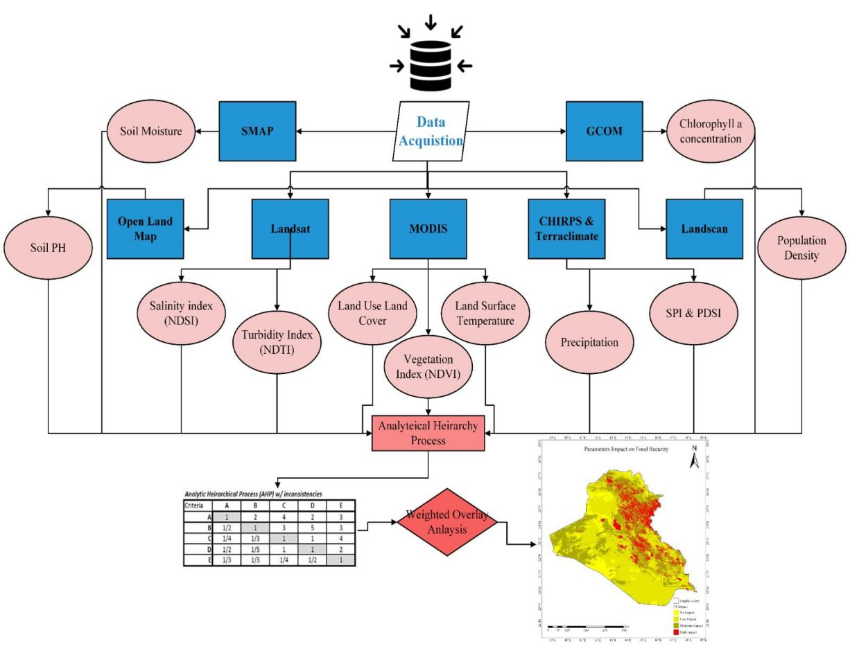
Figure 2 : Methodology Flowchart
Image Processing and Time Series Analysis
- Image processing and time series analysis
Image processing and time-series analysis are the cornerstones of extracting valuable insights from satellite imagery. The workflow begins with data acquisition, where raw images from sensors such as Landsat 8 or MODIS are retrieved. The preprocessing steps included radiometric correction to adjust for sensor-specific biases, atmospheric correction to remove the effects of aerosols and water vapour, and geometric correction to align the imagery to a consistent coordinate system (Song et al., 2001). These corrections are essential for ensuring temporal and spatial consistency, particularly in long-term studies spanning decades.
The calculation of key remote sensing indices is one of the most widely used tools in environmental monitoring. For instance, the normalised difference vegetation index (NDVI), derived from the near-infrared (NIR) and red (RED) bands, is a critical metric for assessing vegetation health and density. NDVI is computed as:
$NDVI=\frac{NIR-RED}{NIR+RED}$ (1)
NDVI has proven effective in monitoring vegetation cover and detecting changes in ecosystem health, particularly in regions prone to degradation (Pettorelli et al., 2005). Similarly, the normalised difference water index (NDWI), calculated using NIR and shortwave infrared (SWIR) bands, is invaluable for identifying water bodies and assessing water resource availability. NDWI is expressed as:
$NDWI=\frac{NIR-SWIR}{NIR+SWIR}$ (2)
These indices are applied using advanced software platforms such as Google Earth Engine, ArcGIS, and QGIS, which enable high-resolution spatial analysis and trend visualisation over time. Time series analysis, an integral part of preprocessing, involves examining changes in the NDVI, NDWI, or other indices across multiple temporal snapshots to identify patterns, anomalies, or trends in environmental parameters. For example, time-series NDVI data can reveal the impact of droughts on vegetation cover or the recovery of ecosystems following conservation efforts (Rawat & Kumar, 2015). All of these are summarised in Table 3.
Advanced Preprocessing Techniques
Preprocessing also includes more advanced techniques, such as cloud masking, which uses algorithms to identify and exclude pixels affected by cloud cover, and data normalisation to ensure comparability across sensors with different resolutions or spectral characteristics. Image fusion techniques, such as pan-sharpening, can be employed to enhance spatial resolution without compromising spectral integrity, enabling a finer-scale analysis of features such as urban expansion or agricultural plots (Pohl & Van Genderen, 1998).
Moreover, atmospheric correction algorithms, such as Dark Object Subtraction (DOS) or the Second Simulation of the Satellite Signal in the Solar Spectrum (6S), are implemented to remove the effects of atmospheric scattering, ensuring that the spectral reflectance values accurately represent ground conditions (Vermote et al., 1997).
Table 3: Datasets of all parameters
Index | Stands for | Dataset provider | Spatial resolution | objective in this study
NDVI | Normalized Difference Vegetation Index | MODIS (Moderate Resolution Imaging Spectrora diometer) | 250 meters | Used for monitoring vegetation health and crop productivity, crucial for assessing agricultural output and food supply
NDTI | Normalized Difference Tillage Index | Landsat 5,7,8 | 30 meters | Used for detecting tillage practices, which influence soil health and crop yield, affecting food production sustainability
NDSI | Normalized Difference Snow Index | Landsat 5,7,8 | 30 meters | Used for monitoring snow cover, which affects water availability for irrigation, impacting crop growth and food security
Soil Moisture | Soil Moisture | SMAP (Soil Moisture Active Passive) | 9 KM | Used for assessing soil moisture levels, vital for predicting droughts and ensuring adequate crop irrigation, directly impacting food availability
Soil pH | Soil pH | Open Land Map | 250 meters | Used for evaluating soil acidity/alkalinity, which influences crop health and yield, thereby affecting food production
LST | Land Surface Temperature | MODIS | 1 KM | Used for analyzing temperature stress on crops, which can impact crop yield and food security
Precipitation | Precipitation | CHIRPS (Climate Hazards Group InfraRed Precipitation with Station Data) | 5.6 KM | Used for analyzing rainfall patterns that directly influence crop growth and water availability, crucial for food security
Population Count | Population Count | LANDSCAN | 1 KM | Used for assessing population distribution and density, which helps in understanding the demand side of food security
LULC | Land Use/Land Cover | MODIS (Moderate Resolution Imaging Spectroradiometer) | 500 meters | Used for mapping and analyzing land use changes, including agricultural land availability, which impacts food production capacity
2.5 Correlation Matrix
The correlation matrix serves as a fundamental tool for examining the interrelationships among environmental and climatic variables critical to this study, including Land Surface Temperature (LST), Land Use Land Cover (LULC), normalised difference salinity index (NDSI), normalised difference vegetation index (NDVI), Palmer Drought Severity Index (PDSI), precipitation, soil moisture, soil pH, and standardised precipitation index (SPI). Data for these variables were meticulously gathered from credible sources, such as satellite observations (e.g. Landsat and MODIS) and meteorological stations, ensuring temporal and spatial consistency across datasets.
Preprocessing techniques were applied to ensure the reliability and comparability of the data. This included addressing missing values and outliers through data-cleaning methods, such as mean imputation and robust statistical techniques. Normalisation was performed to standardise the variables, allowing for meaningful comparisons between different units and scales. Additionally, spatial and temporal alignment was ensured by matching the data points to a uniform resolution and projection system, which is critical for accurately reflecting the dynamics between the variables (Balogun et al., 2021).
Correlation analysis identified significant relationships among the variables, highlighting their interconnectedness. For instance, a strong negative correlation between soil salinity (NDSI) and vegetation health (NDVI) revealed the adverse effects of salinity on the agricultural productivity. Similarly, precipitation exhibited a strong inverse relationship with drought severity (PDSI), emphasising the critical role of rainfall in mitigating arid conditions in the region. The results of this analysis provide a robust foundation for understanding the environmental dynamics affecting food security and guide subsequent predictive modelling and spatial analysis.
2.6 Forecasting of LULC & and LST
To predict future trends in land use/land cover (LULC) and Land Surface Temperature (LST), advanced machine learning algorithms were employed, leveraging historical data from 2003 to 2023. The prediction of LULC utilised a Random Forest (RF) classification model, chosen for its ability to manage complex, non-linear relationships and accommodate multi-dimensional input data. Historical LULC data were enriched with auxiliary variables, such as slope, elevation, and aspect, to enhance the model’s predictive accuracy. The model produced a transition matrix representing land cover changes, which was used to simulate LULC scenarios for 2033 (Gaur & Singh, 2023).
For LST prediction, a Long Short-Term Memory (LSTM) neural network was implemented. This algorithm is particularly suited for this task because of its capability to capture the temporal dependencies inherent in time-series data. The LSTM model was trained using historical temperature records and climatic variables were incorporated to improve the forecasting accuracy. By integrating the outputs from both models, a comprehensive picture of future environmental conditions was developed, highlighting potential hotspots of land degradation and rising temperatures that could exacerbate food security challenges (Sekertekin et al. 2021).
The integration of these machine learning models provides nuanced insights into future trends. For example, predictions indicate continued urban expansion at the expense of agricultural land, as well as rising LST values driven by urban heat island effects and climate change. These insights are critical for formulating adaptive strategies to address the environmental and agricultural challenges. Geographic Information Systems (GIS) formed the backbone of spatial analysis in this study, facilitating the integration and examination of diverse datasets. GIS allowed the overlaying of multiple layers, including topography, LULC, soil salinity, and climatic variables, to identify spatial patterns and trends. Techniques such as spatial interpolation were used to estimate values in areas lacking direct observations, whereas buffering and overlay analyses helped delineate zones of high environmental stress.
One of the key advantages of GIS is its ability to visualise complex datasets in a geographic context, making it an indispensable tool for decision-making. For instance, the integration of LULC and soil salinity layers revealed regions at risk of agricultural decline, while overlaying precipitation data with SPI and PDSI identified drought-prone zones. These analyses support targeted interventions for resource management, urban planning and environmental conservation (Ghosh & Kumpatla, 2022). By leveraging GIS, this study provides actionable insights into environmental degradation and its implications for food security. The ability to identify vulnerable regions and predict future scenarios underscores the role of GIS in enhancing sustainability and resilience in socio-ecological systems.
- RESULTS
We now present a detailed analysis of the key environmental and socio-economic parameters that influence food security in Iraq. We examined spatial and temporal trends in land use/land cover (LULC), Land Surface Temperature (LST), vegetation indices (NDVI, NDSI, and NDTI), precipitation variability (SPI), and population dynamics. These factors are integral to understanding the current and future states of food security in the region, and their combined effects were synthesised in the final food security map for Iraq.
3.1 Spatial analysis on Land Use Land Cover Change
The LULC analysis for Iraq over the two-decade period (2003–2023) revealed significant transformations in land cover distribution, driven by both natural and anthropogenic factors. One of the most striking trends observed is the persistent decline in vegetation cover, which is primarily attributed to deforestation, land degradation, and the cumulative impacts of climate change. This decline highlights the broader environmental challenges affecting Iraq, including reduced rainfall, increased soil salinity, and advancing desertification (Al-Ansari, 2013; AMALIA et al., 2023). As shown in Figure 3.
Agricultural areas showed fluctuating trends during the study period. Periods of expansion were often temporary and linked to favourable climatic conditions or improved irrigation, whereas contractions were more sustained, driven by water scarcity, declining soil fertility, and sociopolitical instability. These challenges underscore the vulnerability of Iraq’s agricultural sector, which is heavily reliant on the Tigris and Euphrates rivers for water resources (Yousif 2024).
Urbanisation has emerged as a dominant driver of land cover change. The rapid expansion of built-up areas, fuelled by population growth, economic development, and migration, often comes at the expense of natural and agricultural landscapes. As shown in Figure 4, between 2003 and 2023, urban areas expanded significantly, intensifying the urban heat island effect and contributing to the loss of arable land. This trend reflects a broader pattern of unplanned urban sprawl, which exacerbates environmental degradation and poses long-term challenges to sustainable land management (Mao et al., 2023).
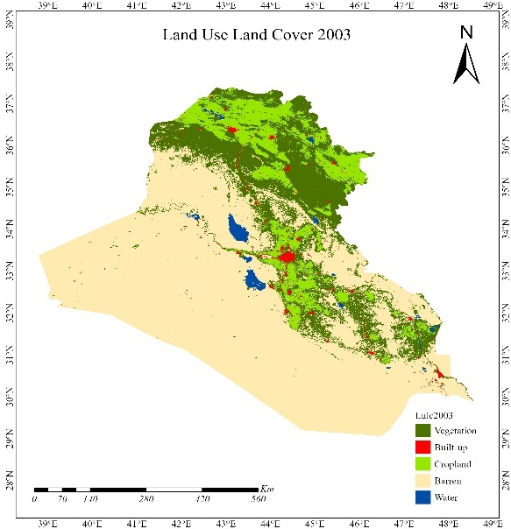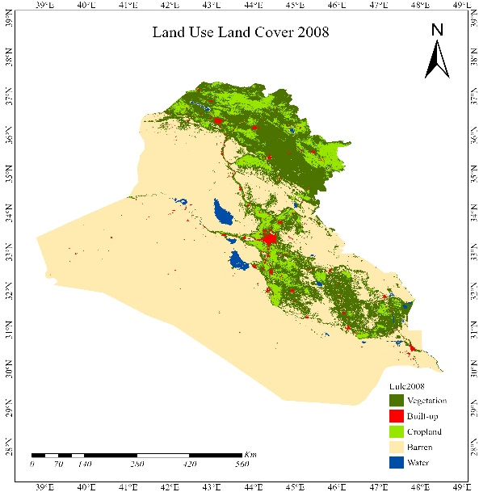
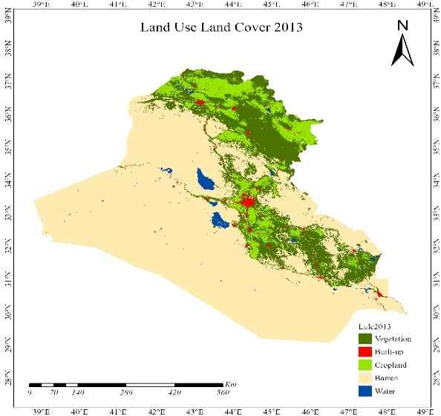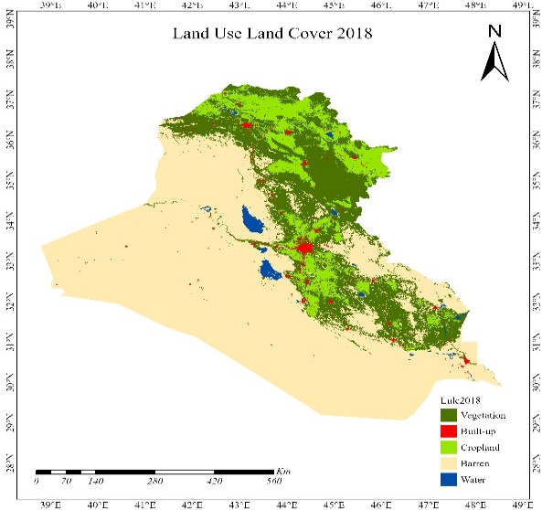
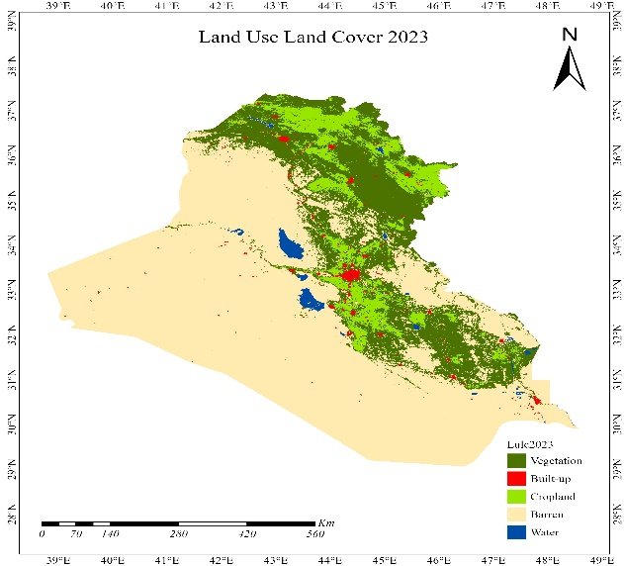
Figure 3: LULC Maps in the Study area.
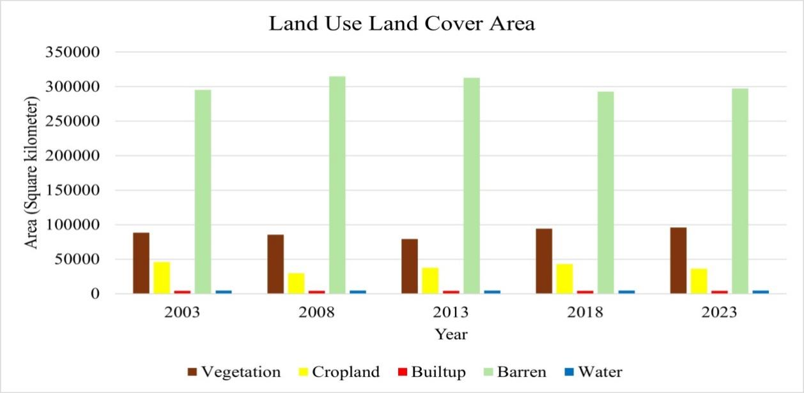
Figure 4: Graphical Representation of LULC in the study area.
  - Spatial-temporal changes of LST
The analysis of Land Surface Temperature (LST) over the same period underscores the growing threat of climate change and human activities on Iraq’s thermal environment. From 2003 to 2023, a consistent upward trend was observed in the LST across the country. The highest recorded temperatures increased from 46.6°C in 2003 to an alarming 49.9°C in 2023, highlighting the intensifying impacts of global warming (Adamo et al., 2022). This temperature increase is particularly pronounced in urban areas, where the expansion of built-up land has amplified the urban heat island effect. Urbanisation replaces vegetation and soil with impervious surfaces that absorb and retain heat, leading to localised temperature increases. The implications of these rising temperatures are multifaceted and complex. Higher LST exacerbates water scarcity by increasing evaporation rates, reducing agricultural productivity due to heat stress on crops, and raising energy demands for cooling systems, particularly in urban centres. As shown in Figure 5.
Escalating temperature extremes also pose significant health risks. Heatwaves and prolonged periods of elevated temperatures increase the prevalence of heat-related illnesses, particularly among vulnerable populations, such as the elderly, children, and those with pre-existing health conditions. In densely populated cities, where cooling infrastructure is often inadequate, the risks are even more severe (IPCC, 2022).
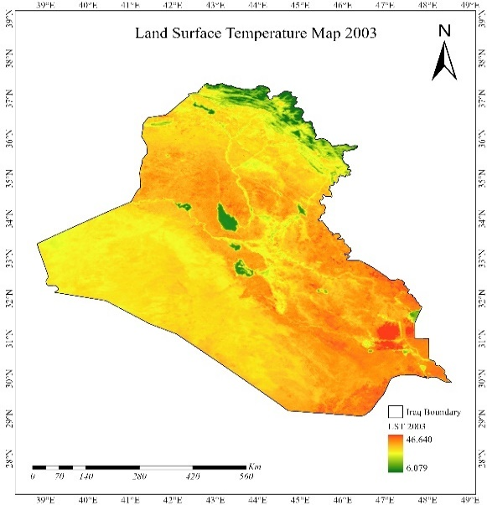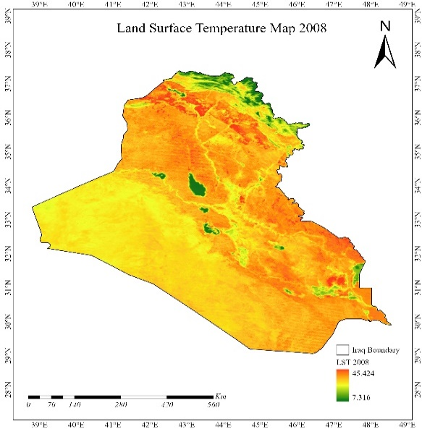
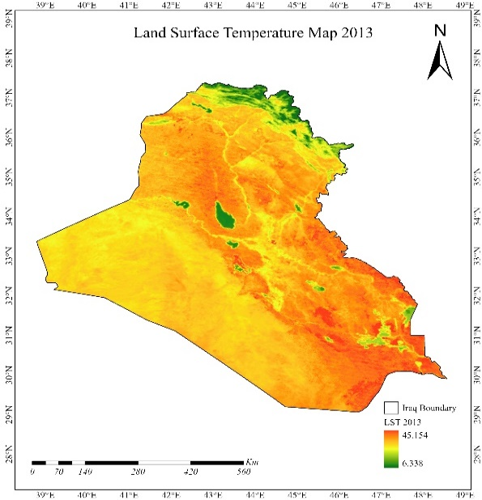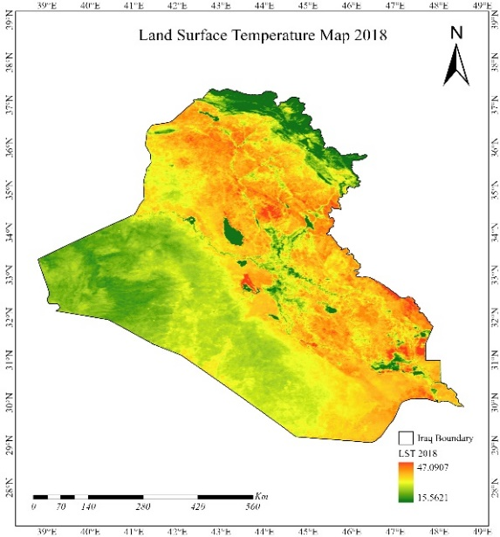
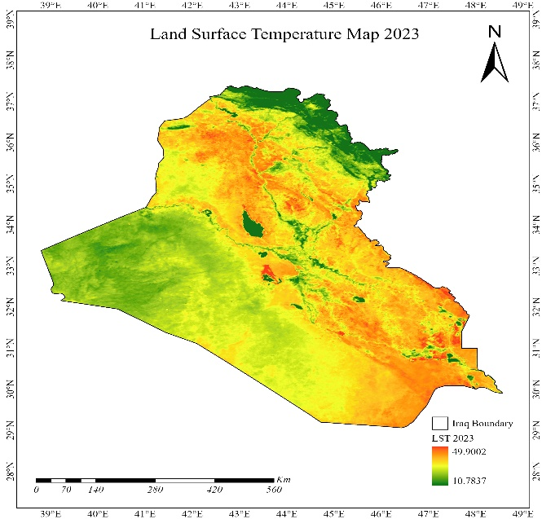
Figure 5: LST Maps in Study area.
The combined effects of LULC changes and rising LST have profound implications for Iraq’s food security. The decline in vegetation cover and agricultural land reduces food production capacity, and higher temperatures exacerbate water scarcity and soil degradation. Urban expansion further limits the availability of arable land and intensifies competition for natural resources. These trends highlight the urgent need for sustainable land management practices, climate-resilient agricultural strategies, and policies aimed at mitigating the effects of urbanisation and climate change on food systems.
3.3 Indices and Their Implications for Food Security (NDVI, NDSI, NDTI)
The analysis of three critical indices— normalised difference vegetation index (NDVI), normalised difference salinity index (NDSI), and normalised difference tillage index (NDTI)—provides valuable insights into the environmental dynamics affecting food security in Iraq between 2003 and 2023. These indices collectively illustrate the challenges posed by salinity, water quality, and vegetation health on agricultural productivity, which is a cornerstone of food security in the region.
An examination of the NDSI trends revealed a significant increase in soil salinity, particularly from 2008 to 2013. High salinity levels during these years were largely attributed to reduced precipitation, poor irrigation practices, and salt accumulation in agricultural land. The increase in salinity severely degrades soil health, reducing its fertility and water retention capacity, which in turn leads to lower crop yields and heightened vulnerability to food insecurity. These findings align with global observations of the adverse impacts of salinisation in arid and semi-arid regions (Rengasamy, 2010).
The NDTI analysis highlighted ongoing deterioration in water quality, with turbidity levels peaking during critical periods, such as 2008 and 2013. High turbidity, indicative of suspended particles and reduced water clarity, further strained Iraq’s agricultural systems by compromising the quality of the water used for irrigation. This exacerbated the stress on crops already grappling with salinity and drought, further reducing food production capacity (Al-Dabbas, 2024; Varis et al., 2017). As shown in Figure 6.
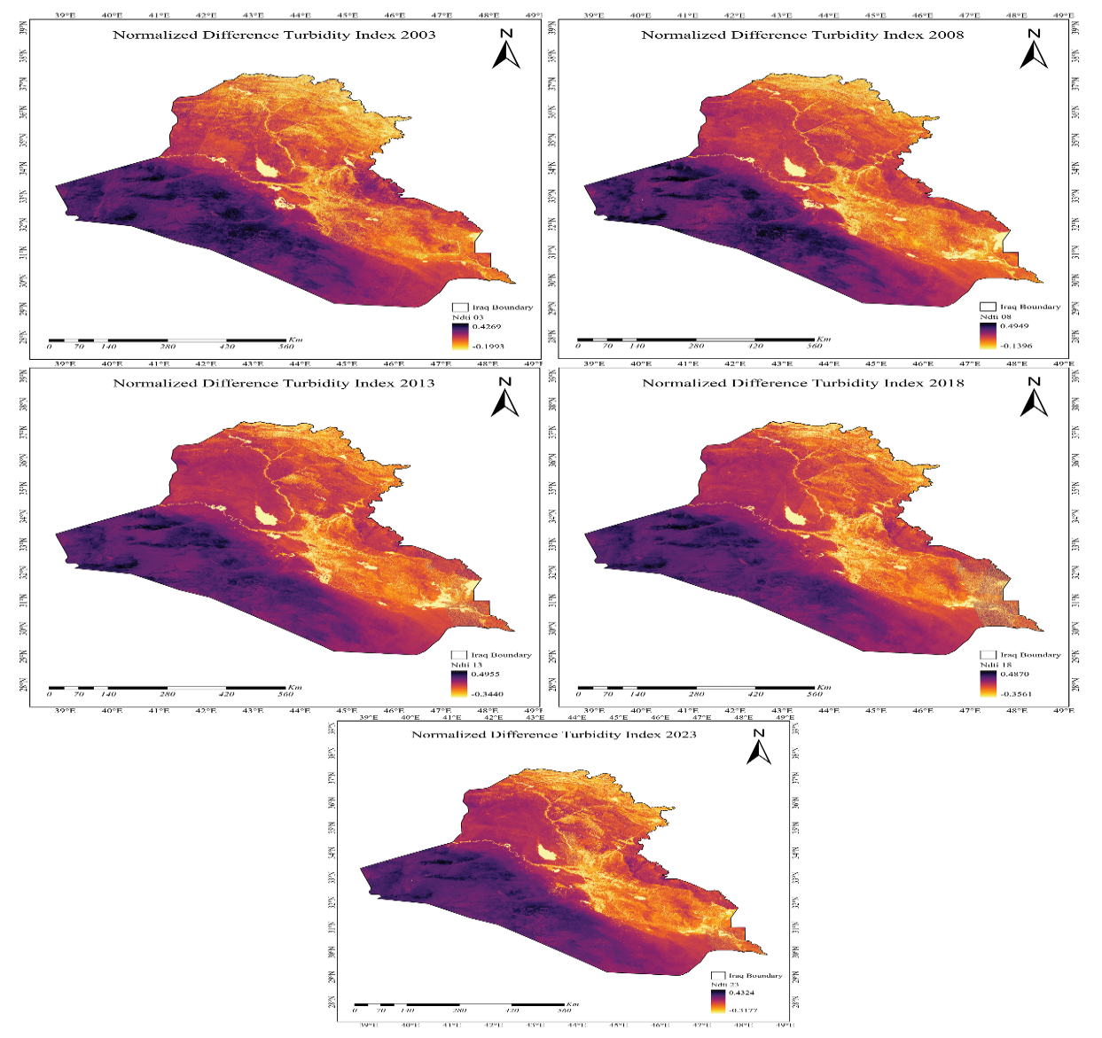
Figure 6: Normalised Difference Turbidity Index from 2003 to 2023where each picture represents a different period with a time difference of five years.
NDVI trends, which serve as indicators of vegetation health and density, revealed alarming patterns of decline in Iraq. The central and southern regions, in particular, experienced a stark reduction in NDVI values, reflecting the combined impacts of severe drought, land degradation, and socio-political instability. Between 2008 and 2013, these areas witnessed a critical drop in vegetation cover, limiting the availability of essential natural resources required for agricultural activities. However, a surprising recovery in NDVI values was observed in 2023, potentially due to reforestation efforts, improved water management, and increased rainfall in certain regions, as shown in Figure 7. If sustained, such improvements could provide a significant boost to food security by stabilising agricultural productivity and enhancing the resilience of ecosystems (Berdimbetov et al., 2021).
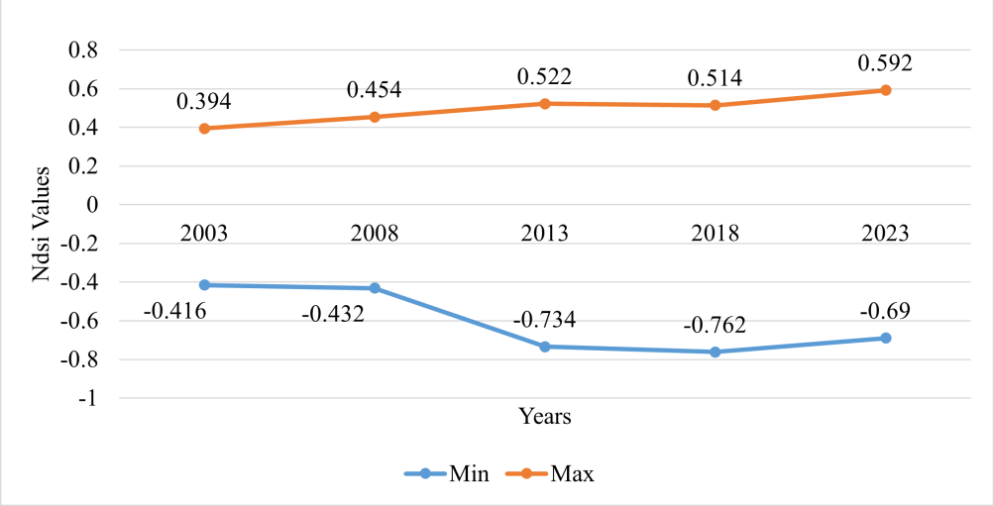
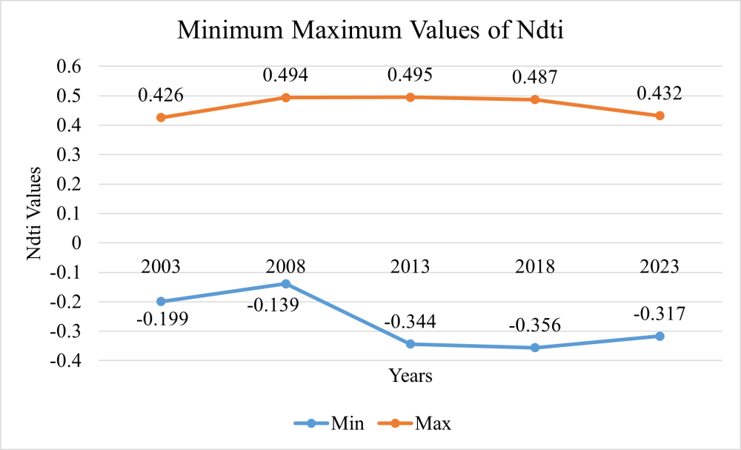
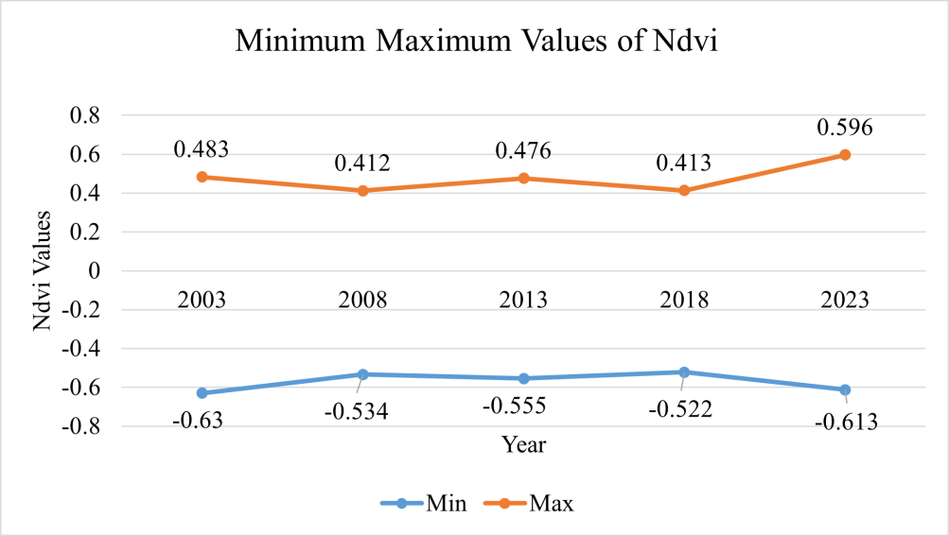
Figure 7: Environmental indices graph (a) results of time series analysis for NDSI (b) results of time series analysis for NDTI, and (c) results of time series analysis for NDVI.

  - Variability in Annual Precipitation and Its Impact on Food Security
Over the two-decade period, the annual precipitation in Iraq has shown significant variability, with notable regional differences. In 2003, rainfall ranged from a high of 1,061.67 mm in the northern mountainous regions to a low of 56.91 mm in the arid southern region. As shown in Figure 9.
A marked decline in precipitation was observed in 2008, with values dropping to between 723.82 mm in the north and 37.97 mm in the south of the region. This period of reduced rainfall exacerbated drought conditions, particularly in southern Iraq, further aggravating water scarcity and limiting the viability of rain-fed agriculture in the region. By 2013, a modest recovery in rainfall was recorded, with precipitation increasing to a range of 1,113.01–49.78 mm. While this offered temporary relief to agricultural systems, the fluctuations continued, with 2018 witnessing Iraq’s wettest year, characterised by 1,659.53 mm and 75.81 mm of precipitation in the north and south, respectively. This wet spell alleviated some drought-related challenges, but was short-lived as precipitation levels fell again in 2023 to 985.06 mm in the north and 71.40 mm in the south, as shown in Figure 8.
The persistent variability in precipitation highlights the challenges of managing water resources in Iraq’s fragile environment. These fluctuations hinder consistent agricultural productivity and elevate the risk of food insecurity, particularly in regions heavily reliant on rainfall for crop cultivation. Effective water management strategies, including investments in irrigation infrastructure and drought-resistant crop varieties, are essential for mitigating these impacts (AMALIA et al., 2023).
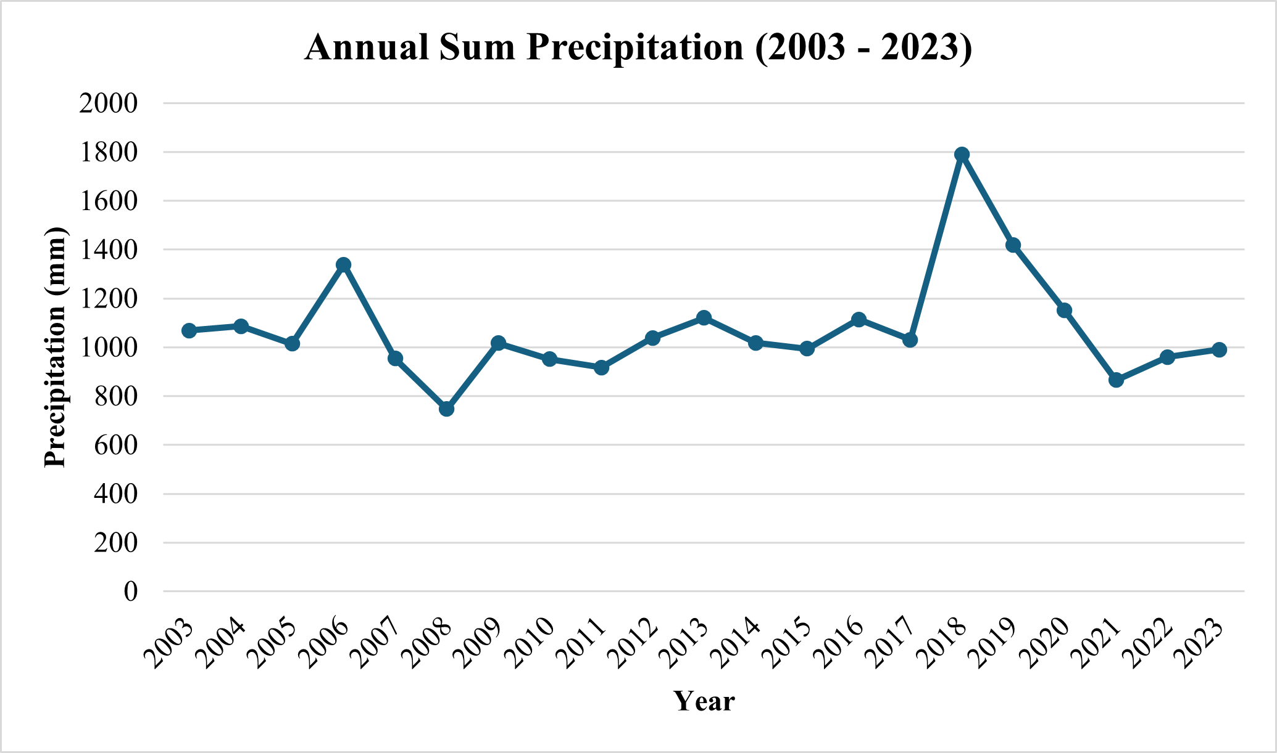
Figure 8: Annual Sum Precipitation of Iraq
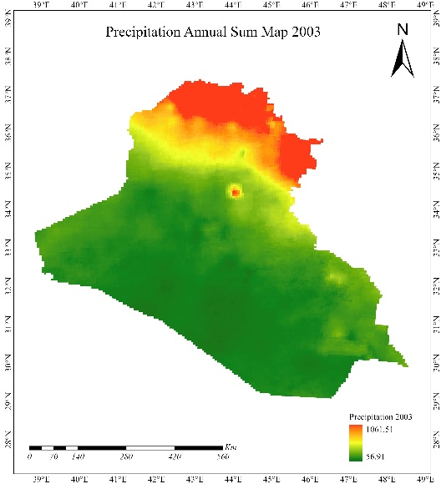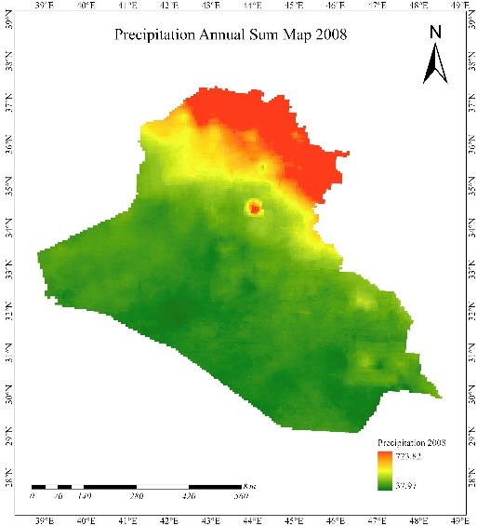
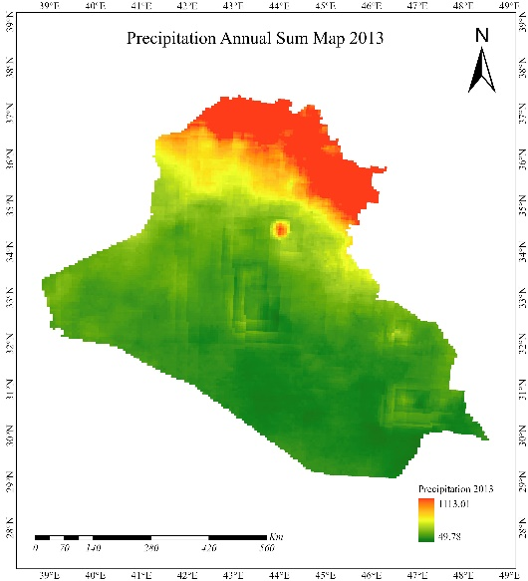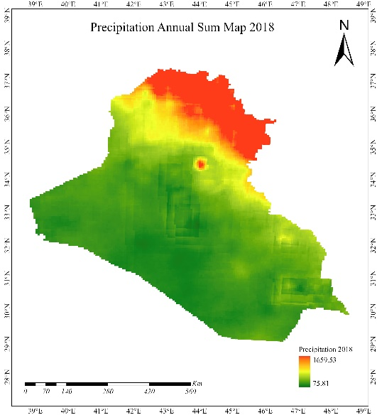
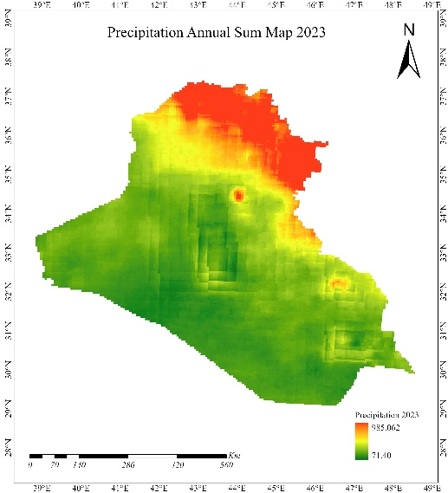
Figure 9: Maps of Annual Sum Precipitation for the study area.
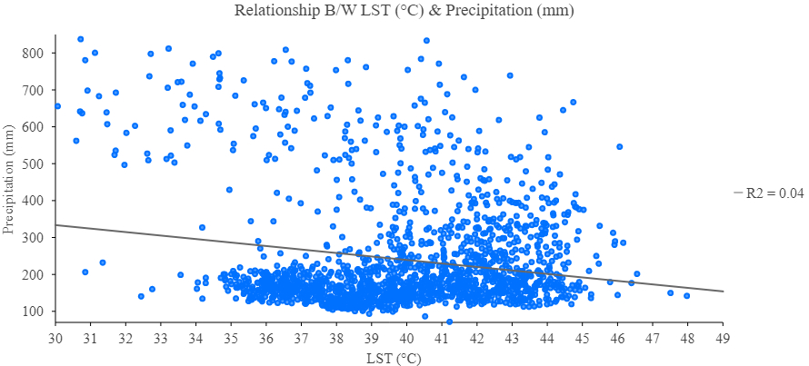
Figure 10: Relationship between LST & Precipitation
3.5 Population Analysis and Trends (2003-2023)
The population dynamics in Iraq from 2003 to 2023 reflect the interplay of socio-political, economic, and environmental factors that shape the country’s demographic trends. In 2003, Iraq’s population was approximately 35.84 million, a figure that represented relative stability despite the aftermath of the U.S.-led invasion. Over the following decade, improvements in security and socioeconomic conditions led to a gradual population recovery, with numbers rising to 40.56 million by 2013. As shown in Figure 11, this growth was bolstered by the return of displaced persons, high birth rates, and incremental improvements in living standards.
By 2018, Iraq’s population reached 45.93 million, reflecting ongoing recovery and improved socioeconomic conditions, particularly in urban centres. However, by 2023, a sharp decline was recorded, with the population falling to an estimated 14.82 million people. This dramatic reduction is likely attributable to renewed conflicts, large-scale emigration due to deteriorating living conditions, and the cumulative impact of environmental crises, such as droughts and salinisation, on rural livelihoods (Hamrah, 2023; Yaseen, 2024).
Fluctuating population trends underscore the fragility of Iraq’s socio-economic and environmental systems. With a reduced population base, the labour force available for agriculture and other sectors critical to food security diminishes. Concurrently, mass migration and displacement exacerbate the challenges of resource allocation and infrastructure development in the region. Strategic interventions aimed at stabilising Iraq’s sociopolitical landscape, coupled with efforts to address environmental degradation, are imperative to reverse these trends and ensure a sustainable future for the country.
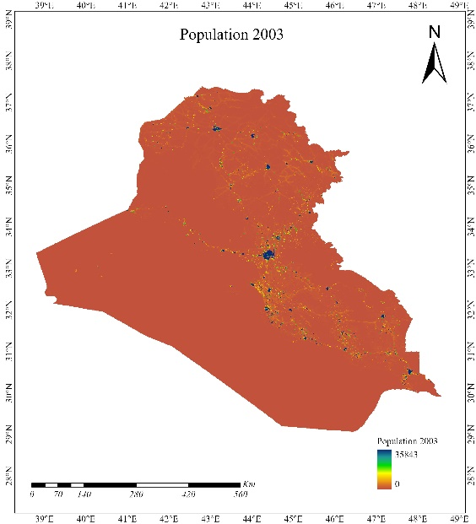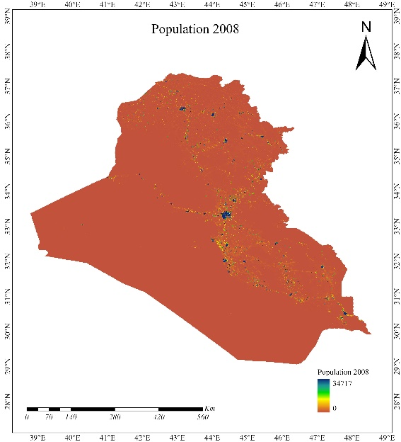
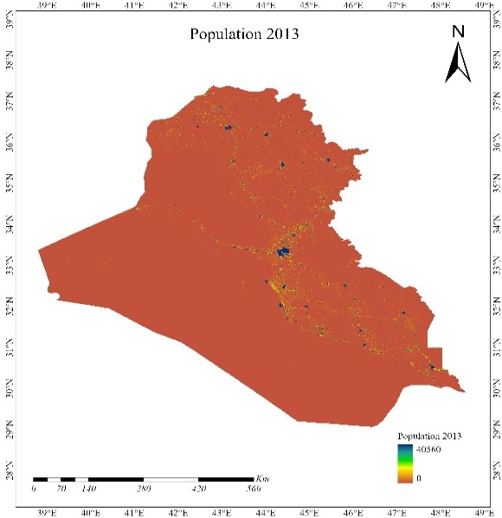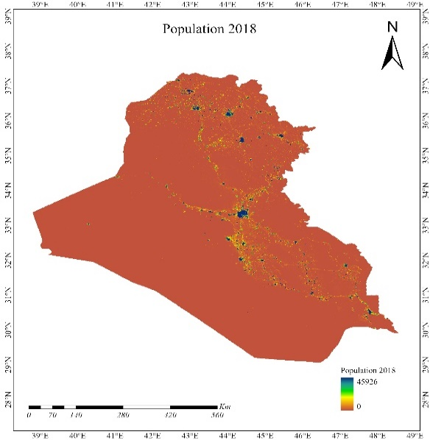
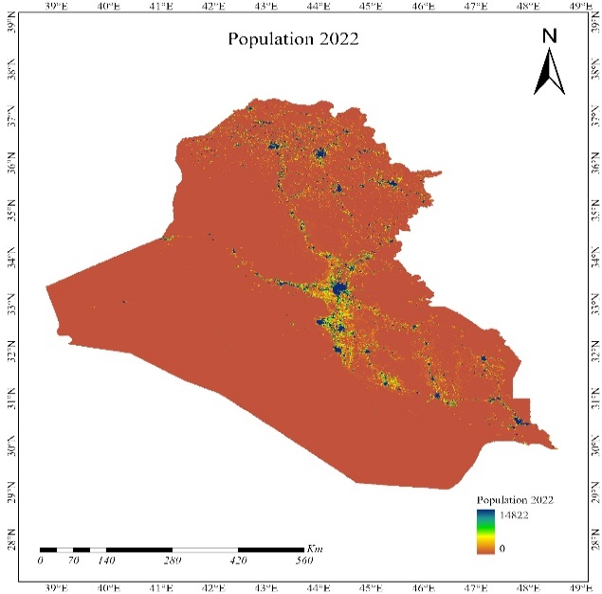
Figure 11: Maps of Population in Study Area
3.6 Soil Moisture and pH Variability
The variability in soil moisture and pH across Iraq in 2023 highlights the diverse environmental and agricultural challenges faced by the region. Soil moisture levels ranged from 0.045 to 0.47, reflecting significant spatial heterogeneity influenced by climatic conditions, irrigation practices, and soil type. Higher soil moisture values, closer to 0.47, were observed in areas with reliable precipitation or efficient irrigation infrastructure, fostering healthy vegetation growth and sustaining agricultural productivity, as shown in Figure 12. In contrast, regions with lower soil moisture levels near 0.045 were predominantly located in the arid southern and western parts of Iraq, where limited rainfall and inefficient water management exacerbate drought conditions and land degradation (Adamo et al., 2022; Al-Ansari et al., 2013; Sulaiman et al., 2019).
Similarly, soil pH values exhibited a wide range, from highly acidic (pH 0) to highly alkaline (pH 9.8) conditions, indicative of the complex interplay between soil chemistry, agricultural practices, and environmental factors, as shown in Figure 12. Alkaline soils, prevalent in irrigated regions with high salinity, hinder nutrient availability and reduce crop yields by affecting the solubility of essential minerals, such as phosphorus and iron. Acidic soils, on the other hand, can lead to aluminum toxicity and impede plant growth, particularly on degraded or over-farmed lands (Wichelns & Qadir, 2015). These variations emphasise the need for region-specific soil management practices, such as the application of gypsum to alkaline soils or lime to acidic soils, to enhance fertility and sustain agricultural productivity. Addressing soil moisture deficits and pH imbalances is critical for improving Iraq’s food security and ensuring the resilience of its agricultural systems.
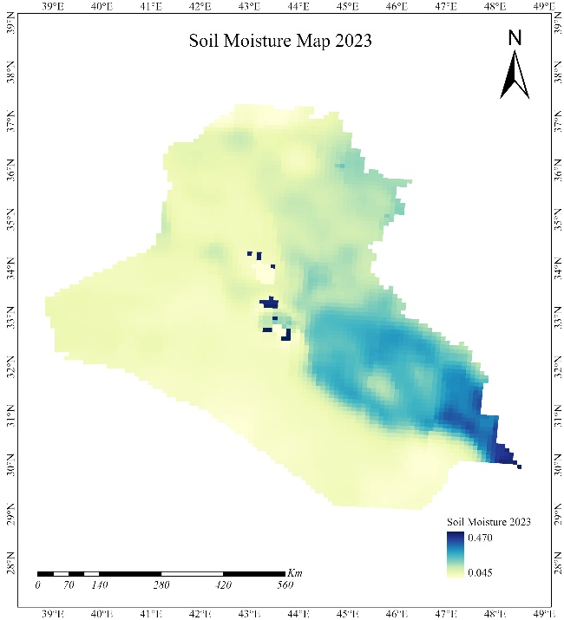 | 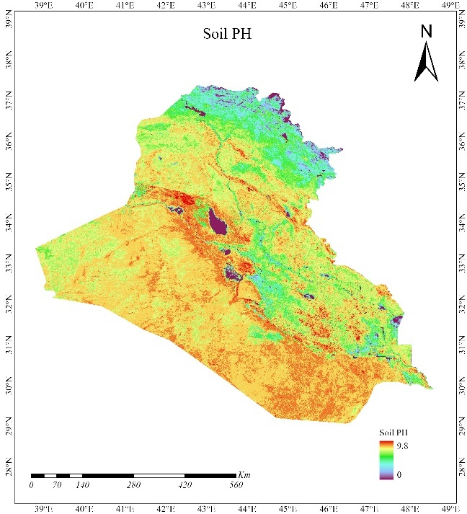
Figure 12: Soil Moisture and pH Distribution across Iraq
3.7 Food Security Impact Assessment
The final map of Iraq illustrates the impact of various environmental factors on food security, using a colour-coded system. The dark yellow areas indicate regions with no impact, where stable environmental conditions support consistent agricultural productivity. Light yellow regions experience minimal impact, with occasional challenges but generally sustainable food production levels. Light green areas represent moderate-impact zones, where environmental issues, such as reduced soil moisture and higher temperatures, moderately affect food security. Red regions face the highest impact, with severe environmental challenges threatening agricultural productivity and food availability. As shown in Figure 13.
The red regions, concentrated in southern Iraq, were identified as high-risk zones owing to the confluence of severe drought, high soil salinity, and declining vegetation cover. These areas require immediate interventions, such as improved irrigation systems, crop diversification, and soil reclamation techniques to mitigate the compounded stressors threatening agricultural output and food availability. This map highlights the urgent need for targeted interventions in the red and green areas to ensure sustainable agricultural practices and improve food security across Iraq.
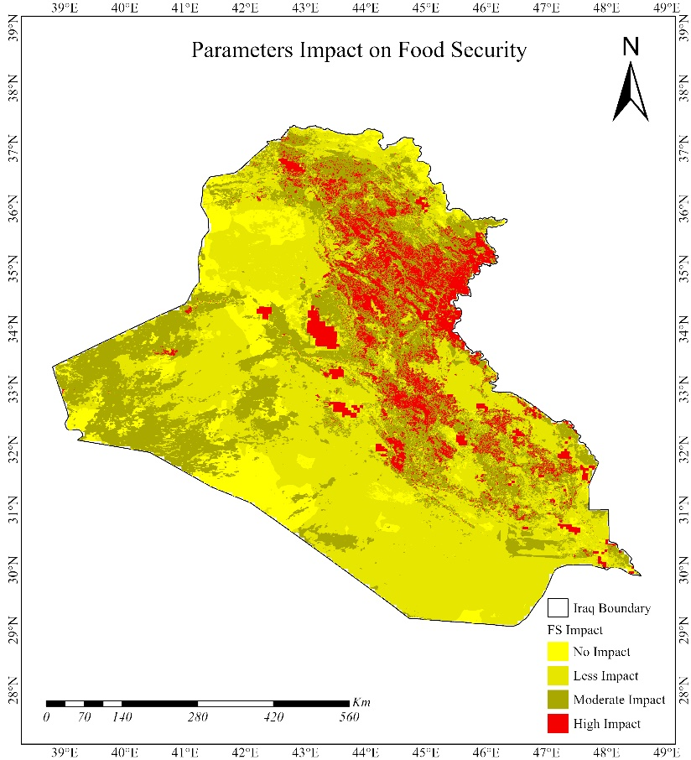
Figure 13: Food Security Map of Iraq
3.8 Relationship Between NDVI and LST in Iraq
The scatter plot illustrates the relationship between the normalised difference vegetation index (NDVI) and Land Surface Temperature (LST) in Iraq. The graph shows a weak and nearly non-existent linear correlation between NDVI and LST, as indicated by an R² value of 0. This suggests that changes in vegetation cover (as measured by NDVI) have a minimal direct impact on surface temperature across the region. Despite this, the cluster of data points around a certain NDVI range with varying LST values highlights the complexity of the interaction, where other environmental factors may influence LST independently of vegetation density. As shown in Figure 14. This analysis underscores the need to consider additional variables when assessing the relationship between vegetation and surface temperature in the context of environmental and climatic conditions (Yang et al., 2024).
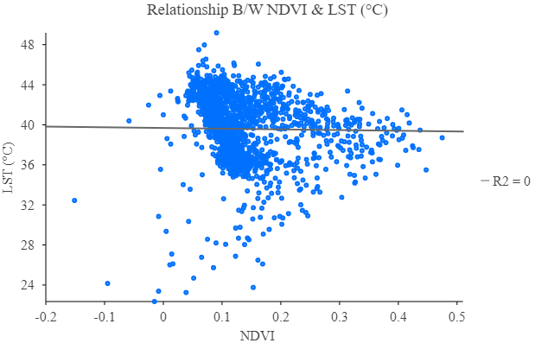
Figure 14: Scatter Plot Showing the Relationship between NDVI and LST in Iraq.

3.9 Relationship between NDVI and Precipitation in Iraq
The correlation analysis between NDVI and precipitation revealed a positive but weak association (R² = 0.09), indicating that while precipitation is a key driver of vegetation health, it does not fully determine NDVI values in Iraq. Regions with higher precipitation generally exhibited healthier and denser vegetation; however, the low correlation suggests that additional factors, such as soil fertility, land management practices, and irrigation, significantly influence vegetation dynamics.
For instance, some areas with moderate precipitation showed unexpectedly low NDVI values, likely because of high soil salinity or inadequate farming techniques. Conversely, regions with efficient water resource management demonstrated higher NDVI values despite lower precipitation levels, as shown in Figure 15. These findings emphasise the importance of adopting an integrated approach that combines sustainable water management, soil quality improvement, and adaptive farming practices to enhance vegetation health and, by extension, agricultural productivity in Iraq (Nassif et al. 2023).
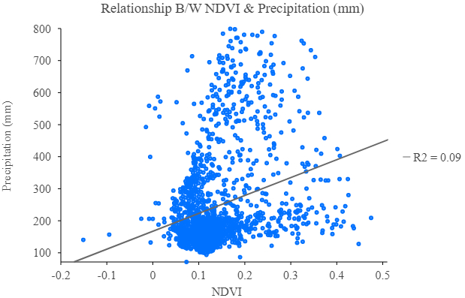
Figure 15: Scatter Plot Showing the Relationship between NDVI and Precipitation in Iraq.

3.10 Predicted LULC and LST in Iraq for 2033
Based on the analysis of LULC changes from 2003 to 2023 and machine learning-based prediction using a Random Forest classification model, Iraq's landscape in 2033 is expected to continue the trends observed over the past two decades. The prediction indicates a further decline in vegetation cover, primarily due to ongoing deforestation and land degradation. Crop land is anticipated to face continued fluctuations, with possible reductions linked to environmental stress and sociopolitical challenges. The rapid expansion of built-up areas is projected to persist, driven by urbanization and population growth, leading to a significant increase in urban land at the expense of agricultural and natural areas. Barren lands may continue to decrease as more land is converted for urban development. Water bodies may experience further reductions in surface area, exacerbating concerns about water security. These projected changes highlight the critical environmental challenges that Iraq may face by 2033, particularly concerning sustainable land management and food security, as shown in Figure 17.
By 2033, Iraq's LST is expected to increase significantly, with predicted values ranging from a low of 17.38°C to a high of 54.46°C, as shown in Figure 16 and Table 4. This increase in LST is likely driven by factors such as urban expansion, reduced vegetation cover, and climate change, which contribute to the urban heat island effect and overall warming trends. The ongoing reduction in vegetation and increase in built-up areas exacerbate the absorption and retention of heat, further elevating temperatures. These changes highlight the growing environmental stresses that could impact agricultural productivity, water resources, and food security in Iraq (Badugu et al., 2024).
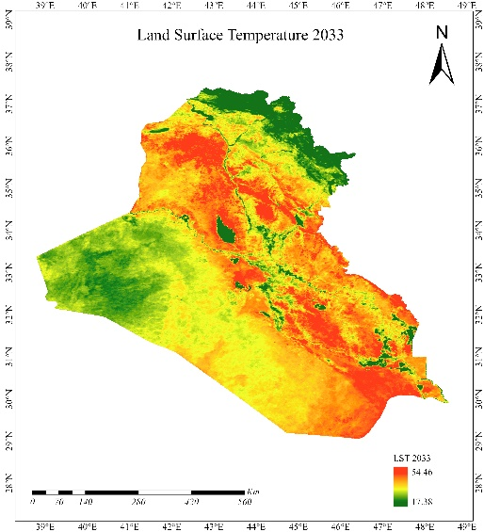 | 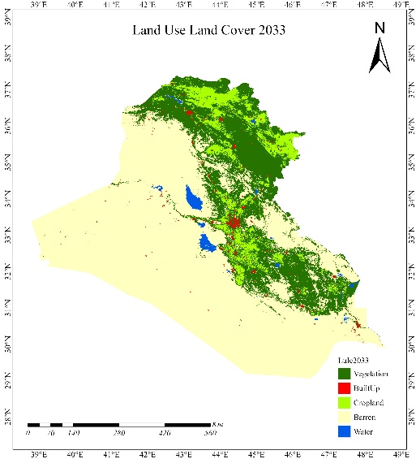
Figure 16: Predicted LULC and LST in Iraq
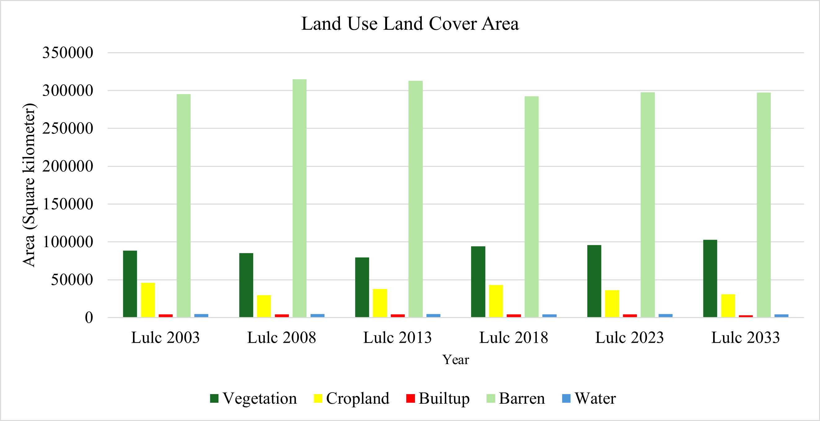
Figure 17: Graphical representation of predicted LULC in Iraq

Table 4:results of LULC changes from 2003 to 2033 in Iraq (SK²)
Class | LULC 2003 | LULC 2008 | LULC 2013 | LULC 2018 | LULC 2023 | LULC 2033
Vegetation | 88607 | 85328 | 79431 | 94296 | 95978 | 102768
Cropland | 46037 | 29470 | 37685 | 43069 | 36351 | 30989
Built-up | 4121 | 4132 | 4154 | 4196 | 4229 | 4336
Barren | 295294 | 315107 | 312798 | 292615 | 297589 | 295988
Water | 4623 | 4645 | 4614 | 4507 | 4536 | 4601
Total | 438682 | 438682 | 438682 | 438682 | 438682 | 438682

3.11 Correlation Analysis of Environmental Parameters in Iraq
The correlation matrix revealed several key relationships among the environmental parameters in Iraq. Notably, a moderate negative correlation existed between Land Use Land Cover (LULC) and both NDVI (-0.470) and precipitation (-0.585), indicating that urbanisation and land cover changes were linked to reduced vegetation cover and lower precipitation levels. Urban expansion, often occurring at the expense of agricultural and natural landscapes, disrupts vegetation density and exacerbates the water scarcity. This underscores the need for sustainable urban planning and land management practices to mitigate these effects (Al-Ansari, 2013).
A strong negative correlation between the normalised difference salinity index (NDSI) and NDVI (-0.703) indicates that higher salinity levels severely degrade vegetation health, a critical issue in the southern regions of Iraq where soil salinisation is prevalent due to poor irrigation practices and insufficient drainage systems. Similarly, the strong negative correlation between the Palmer Drought Severity Index (PDSI) and precipitation (-0.727) underscores the dominant role of rainfall in alleviating drought conditions, highlighting precipitation variability as a key driver of agricultural stability.
The weak correlations between LST and LULC (-0.025), as well as soil moisture and soil pH (-0.095), suggest minimal interaction between these variables. This matrix highlights the interconnectedness of environmental parameters in Iraq, with notable relationships between salinity and vegetation, drought indices and precipitation, and the impact of urbanisation on land cover and vegetation. Overall, these correlations underscore the complex interplay between land cover, climate, and environmental health, which are critical for addressing food security challenges in Iraq.
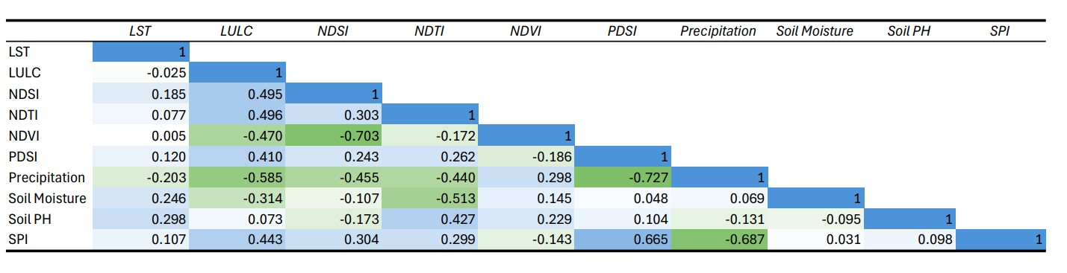
Figure 18: Correlation Analysis of Key Environmental Parameters in Iraq.
3.12 Trends in Per Capita Food Supply Variability (2000-2023)
In 2000, the per capita food supply started at a high of 66 kcal/cap/day but sharply declined to 28 kcal/cap/day by 2002, reflecting a significant decrease in food availability. The period from 2011 to 2016 saw some recovery, with the highest value during this period reaching 46 kcal/cap/day, in 2015. However, post-2016, the trend shows a general decline with minor fluctuations, reaching its lowest point in 2023 at 14 kcal/cap/day. This overall downward trend in the later years suggests worsening food security conditions, possibly due to various environmental, economic, or political factors affecting food supply stability in Iraq (AMALIA et al., 2023). As shown in Figure 19.
The persistent downward trend in recent years highlights the compounded effects of poor water management, inefficient agricultural practices, and economic challenges on the stability of the food supply. Furthermore, displacement caused by conflict and environmental crises exacerbates vulnerabilities in rural and urban communities. Addressing these issues requires a comprehensive approach that includes improving irrigation infrastructure, adopting climate-resilient crops, and fostering sociopolitical stability to safeguard food security in Iraq.
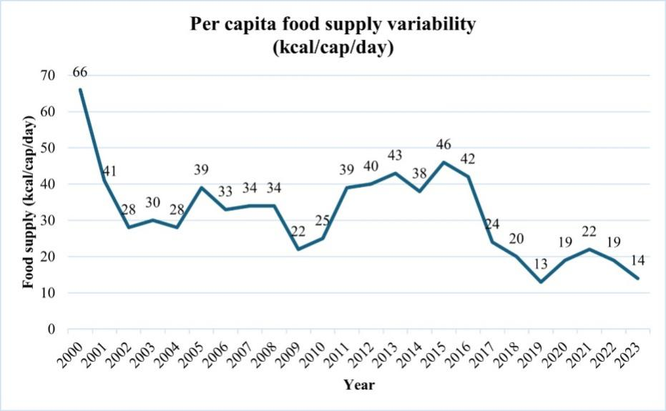
Figure 19: Graphical representation of food supply.

Discussion
This study aimed to map the multidimensional environmental impacts of climate change on food security in Iraq using an integrated geo-information approach. The findings of this study provide critical insights into the intricate dynamics between environmental challenges and food security in Iraq, revealing the multifaceted nature of these interactions over the past two decades. The observed patterns of LULC change, particularly the decline in vegetation and urban expansion, reflect the dual pressures of human activity and climate change. These transformations, compounded by the rising LST, highlight a concerning trajectory for Iraq's agricultural sustainability and food security.
results of this study indicate that natural factors, such as declining precipitation and worsening drought conditions, amplify the adverse effects of these changes, particularly in southern Iraq. Intensive drought, together with reduced rainfall, coupled with inefficient water management and soil salinisation, has diminished the availability of arable land and water resources that are essential for agriculture. These findings underscore the urgent need for adaptive strategies to enhance water-use efficiency, rehabilitate degraded lands, and mitigate the impacts of climate change on sustainable food production systems. Correlation analysis sheds light on the complex interplay of environmental parameters. For example, the inverse relationship between soil salinity and vegetation health underscores how deteriorating soil conditions inhibit the agricultural productivity. Similarly, indices such as NDVI, NDSI, and NDTI elucidate how declining water quality and rising salinity are pivotal stressors that affect Iraq’s agricultural output. These findings align with previous research, adding depth through the integration of geospatial technologies and predictive models.
results of scenario-based modelling and forecasting for the year 2033 present an alarming narrative of escalating environmental stress for the study area. The predicted further decline in vegetation cover, coupled with rising LST values exceeding 54°C in some areas, foreshadows an intensifying crisis for Iraq’s sustainable food production systems. In addition, based on the intensive LULC changes over the past decades, urban expansion is projected to continue, further encroaching on agricultural and natural lands, shrinking water bodies, and increasing soil salinisation, which exacerbates resource scarcity. These projections underscore the critical need for policymakers to prioritise sustainable land management practices, such as reforestation, conservation agriculture, and adopting climate-resilient crop varieties.

From a methodological perspective, the results of our study indicate that the integration of remote sensing and GIS as Geoinformation farmwork has proven invaluable in this study, enabling the identification of high-risk areas and providing spatially explicit data to lead targeted interventions. The integration of geospatial technologies with predictive modelling has not only enhanced the understanding of historical and current trends but also provided actionable insights into future scenarios. By leveraging these tools, policymakers can develop strategies to address the socio-economic impacts of environmental degradation, such as rural displacement, unemployment, and heightened conflict over scarce resources. The proposed geoinformation approach in our study demonstrates substantial technical feasibility because of its efficient data-driven capability, GIS-based spatial analysis, and multitemporal assessments. Unlike hydrological or purely climate model-based approaches, which often require extensive in situ measurements and localised calibration, this method leverages freely available satellite data, including MODIS and Landsat, to assess the environmental stressors influencing food security. Reliance on well-established remote sensing indices, such as the Normalised Difference Vegetation Index (NDVI) and Normalised Difference Tillage Index (NDTI), facilitates cost-effective monitoring of critical parameters, including vegetation health, soil degradation, and water availability (Lu et al., 2025; Wan et al., 2004).
This study emphasises the necessity of a multifaceted approach to address food security challenges in Iraq. Integrating environmental management with socio-economic resilience-building is paramount. This includes fostering regional cooperation to manage transboundary water resources, investing in advanced irrigation technologies, and strengthening rural livelihoods to reduce dependence on these fragile ecosystems. Moreover, the findings call for increased international collaboration and funding to support Iraq’s adaptation to climate change and pursuit of sustainable development goals. By addressing these challenges holistically, Iraq can enhance its agricultural resilience and crop modification, safeguard food security, and ensure the well-being of its population against mounting environmental and sociopolitical pressures.

Despite the effectiveness of the integrated Geoinformation approach in assessing environmental challenges and their impact on food security in Iraq, our study pointed out several limitations which should be considered by future studies, including a) lack of sufficient geospatial data source and data availability, where some earth observation products, such as MODIS (used for LST analysis), provide coarse spatial resolution that may not capture localised variations in temperature and vegetation cover. Although multitemporal analysis was conducted, some datasets were only available at specific intervals (e.g. every five years for LULC and NDVI). This may lead to gaps in the detection of short-term environmental changes. In addition, the lack of socioeconomic data integration might be necessary to mention and consider in future studies, while the lack of such a dataset imposes serious challenges for socioeconomic modelling of the impacts of climate change. Integrating economic and social data could provide a more comprehensive understanding of food security and vulnerability. b) Temporal gaps in data also turned out to be another challenge that impacts the development of sufficient research, c) uncertainty in drought indices also turned out to be another challenge in our study. In this context, PDSI and soil moisture measurements rely on climate models and satellite-derived estimates. These indices involve assumptions that may introduce uncertainties in assessing the exact severity of drought conditions which impacts the reliability of the results.

Conclusion and future work
This study provides a comprehensive analysis of the environmental and climatic challenges affecting food security in Iraq over the past two decades. The findings revealed significant LULC changes, characterised by declining vegetation, urban expansion, and rising land surface temperatures. These trends, exacerbated by climate change and human activities, impose mounting pressure on Iraq’s agricultural sector, intensifying food insecurity. The correlation analysis underscored the intricate interplay between key environmental factors, including the negative impact of soil salinity on vegetation health and the role of precipitation fluctuations in drought severity. The analysis of critical indices, such as NDVI, NDSI, and NDTI, further highlights how increasing salinity levels and deteriorating water quality compromise agricultural productivity. The projections for 2033 indicate continued environmental stress, with further declines in vegetation cover and rising temperatures, underscoring the urgent need for sustainable land-management strategies. Addressing these issues requires a multifaceted approach that integrates climate adaptation, resource-efficient agricultural practices and innovative technological solutions. In this context, the integration of remote sensing and GIS-based predictive models plays a crucial role in identifying high-risk zones and supporting data-driven decision-making by policymakers.

In conclusion, to mitigate the adverse effects of environmental degradation on food security, this study proposes the following policy recommendations and implementation framework: A) sustainable land management policies: policies that promote sustainable agricultural practices, such as precision farming, soil conservation techniques, and afforestation programs, can be enforced. Implement zoning regulations to prevent the uncontrolled expansion of urban areas into fertile agricultural land. Promote land restoration programs targeting highly degraded areas at high risk through reforestation and soil fertility enhancement initiatives. B) Water resource management and climate adaptation that establish water conservation policies, including efficient irrigation techniques (e.g. drip irrigation), to optimise water use in agriculture. Develop climate adaptation strategies to mitigate the impact of temperature increases and precipitation variability on agricultural productivity. Invest in desalination and water recycling technologies to address declining water quality and increasing soil salinity issues. C) Early warning systems and remote sensing applications that enhance food security monitoring by integrating satellite-based remote sensing and GIS technologies into national agricultural policies. An early warning system for drought, land degradation, and salinity intrusion should be developed to enable proactive interventions. Support data-driven decision-making through collaboration among research institutions, governmental agencies, and international organisations. D) Institutional and policy coordination strengthens institutional frameworks by fostering cross-sector collaboration among agricultural, environmental, and water management agencies. Policy incentives should be introduced for farmers to adopt sustainable and climate-resilient agricultural techniques. E) Integrating food security strategies with national development plans to ensure long-term resilience to environmental stressors can also be considered a policy-making strategy for mitigating the climate change environmental impacts in Iraq.
By integrating satellite-derived environmental data with socioeconomic GIS layers, this study established a comprehensive framework for assessing the impact of environmental challenges on food security. This approach not only identifies high-risk areas but also provides actionable insights for targeted interventions and sustainable land-management strategies. This study contributes to the broader discourse on food security and environmental monitoring by emphasising the importance of geospatial technologies in addressing global and regional food security challenges. The results obtained from our study serve as a critical step toward achieving long-term food security in Iraq and contribute to national stability and sustainable development. Based on the results of this study, our future research will focus on refining predictive models and exploring innovative mitigation strategies, such as climate-smart agriculture and ecosystem-based adaptation approaches.

References:
Abdollahi, Z., Feizizadeh, B., Shokati, B., Gaiolini, M., Busico, G., ` Mastrocicco, M., ` Colombani, N., 2024. S imulating the effects of retreating Urmia Lake and increased evapotranspiration rates on the nearby unconfined aquifer, Groundwater for Sustainable Development, https://doi.org/10.1016/j.gsd.2024.101307.
Abdulraheem, M. I., Zhang, W., Li, S., Moshayedi, A. J., Farooque, A. A., & Hu, J. (2023). Advancements in remote sensing for soil measurements and applications: A comprehensive review. Sustainability, 15(21), 15444.
Adamo, N., Al-Ansari, N., Sissakian, V., Fahmi, K. J., & Abed, S. A. (2022). Climate change: Droughts and increasing desertification in the Middle East, with special reference to Iraq. Engineering, 14(07), 235-273.
Ahmed, S., Khurshid, S., Ahmad, R., Sultan, W., Khan, M. M. A., Mansor, H. E., James, E., & Shamsuddin, M. K. N. (2022). Land use/land cover change analysis using geospatial technology in Mathura district, Uttar Pradesh, India. AIP Conference Proceedings,
Al-Ansari, N. (2013). Management of water resources in Iraq: Perspectives and prognoses. Engineering, 5(6), 667-684.
Al-Dabbas, M. (2024). Water Resources of Iraq: An Overview. The Geography of Iraq, 49-81.
Al-Quraishi, A. M. F. (2024). Geoinformatics Approaches to Climate Change-Induced Soil Degradation in the MENA Region: A Review.
Amalia, Z., Noveri, A. P., Susllowati, I . (2023). Anlysis of food and agriculture organization (FO) role in realizing "SDGS Zero hunger"in conflict countries case study Yeman. MANU Jurnal Pusat Penataran Ilmu dan Bahasa, 34(2), 105-119.
Badugu, A., Arunab, K., & Mathew, A. (2024). Predicting land surface temperature using data-driven approaches for urban heat island studies: a comparative analysis of correlation with environmental parameters. Modeling Earth Systems and Environment, 10(1), 1043-1076.
Balogun, A.-L., Tella, A., Baloo, L., & Adebisi, N. (2021). A review of the inter-correlation of climate change, air pollution and urban sustainability using novel machine learning algorithms and spatial information science. Urban Climate, 40, 100989.
Berdimbetov, T., Ilyas, S., Ma, Z., Bilal, M., & Nietullaeva, S. (2021). Climatic change and human activities link to vegetation dynamics in the Aral Sea Basin using NDVI. Earth Systems and Environment, 5(2), 303-318.
Chander, G., Markham, B. L., & Helder, D. L. (2009). Summary of current radiometric calibration coefficients for Landsat MSS, TM, ETM+, and EO-1 ALI sensors. Remote sensing of environment, 113(5), 893-903.
Choudhury, A. (2024). Drought trend and its association with land surface temperature (LST) over homogeneous drought regions of India (2001–2019). Discover Water, 4(1), 51.
Cui, R., Hu, Z., Wang, P., Han, J., Zhang, X., Jiang, X., & Cao, Y. (2023). Crop classification and growth monitoring in coal mining subsidence water areas based on sentinel satellite. Remote Sensing, 15(21), 5095.
Du, P., Bai, X., Tan, K., Xue, Z., Samat, A., Xia, J., Li, E., Su, H., & Liu, W. (2020). Advances of four machine learning methods for spatial data handling: A review. Journal of Geovisualization and Spatial Analysis, 4, 1-25.
Ethaib, S., Zubaidi, S. L., & Al-Ansari, N. (2022). Evaluation water scarcity based on GIS estimation and climate-change effects: A case study of Thi-Qar Governorate, Iraq. Cogent Engineering, 9(1), 2075301.
Feizizadeh, B., Yariyan, P., Yakar, M., Blaschke, T., A. Saif Almuraqabm N.,2025., An integrated hybrid deep learning data driven approaches for spatiotemporal mapping of land susceptibility to salt/dust emissions, Advances in Space Research, https://doi.org/10.1016/j.asr.2025.02.047.
Feizizadeh, B., Mohmadzadeh Alajujeh, K., Makki, M.(2023a). A scenario-based food security analysis and halophyte crop suitability assessment in dying lake environments impacted by climate change, International Journal of Applied Earth Observation and Geoinformation, https://doi.org/10.1016/j.jag.2023.103425.

Feizizadeh, B., Lakes, T., Omarzadeh, D., Pourmoradian, D.(2023b). Health effects of shrinking hyper-saline lakes: spatiotemporal modeling of the Lake Urmia drought on the local population, case study of the Shabestar County, Nature of Scientific Report, https://doi.org/10.1038/s41598-023-28332-6.

Feizizadeh, B., Omarzadeh, D., Mohammadzadeh Alajujeh, K., Blaschke, T., Makki, M. (2022a).Impacts of the Urmia Lake Drought on Soil Salinity and Degradation Risk: An Integrated Geoinformatics Analysis and Monitoring Approach. Remote Sensing. 2022, 14, 3407. https:// doi.org/10.3390/rs14143407.

Feizizadeh, B., Abdollahi, Z., Shokati, B., Lakes, T.(2022b).A GIS-based spatiotemporal impact assessment of droughts in the hyper-saline Urmia Lake Basin on the hydro-geochemical quality of nearby aquifers, Remote Sesning, 14(11), 2516; https://doi.org/10.3390/rs14112516.

Feizizadeh, B., Lakes, T., Omarzadeh, D., Sharifi, A., Blaschke, T., Karmizadeh, S., M. (2022c). Scenario-based analysis of the impacts of lake drying on sustainable food prodection, Nature of Scientific Report, https://doi.org/10.1038/s41598-022-10159-2.
Feizizadeh, B., Mohmmadzadeh Alajujeh, K., Lakes,T., Blaschke, T., Omarzadeh, D.(2021a). A comparative approach of integrated fuzzy object-based deep learning and machine learning techniques for monitoring land use/cover changes and environmental impacts assessment, GIScience and remote sesning, DOI:10.1080/15481603.2021.2000350.
Feizizadeh, B.; Omarzadeh, D.; Kazemi Garajeh, M.; Lakes, T.; Blaschke, T. (2021b). Machine learning data-driven approaches for land use/cover mapping and trend analysis using Google Earth Engine, Journal of Environmental Planning and Management, https://doi.org/10.1080/09640568.2021.2001317.
Feizizadeh, B., Kazamei, Garajeh, M., Blaschke, T., Lakes, T. (2021c). A deep learning convolutional neural network algorithm for detecting saline flow sources and mapping the environmental impacts of the Urmia Lake drought in Iran, Catena, doi.org/10.1016/j.catena.2021.105585.
Gasper, D. (2022). Rethinking Human Development and/as Human Security for the Anthropocene: An Analysis of the United Nations Development Programme Trilogy of Reports 2020–2022. The International Journal of Social Quality, 12(2), 1-24.
Gaur, S., & Singh, R. (2023). A comprehensive review on land use/land cover (LULC) change modeling for urban development: current status and future prospects. Sustainability, 15(2), 903.
Ghosh, P., & Kumpatla, S. P. (2022). GIS applications in agriculture. In Geographic Information Systems and Applications in Coastal Studies. IntechOpen.
Hamrah, S. (2023). CONTEXTUALIZATION OF SECTARIAN CONFLICT AND VIOLENCE IN IRAQ. Contextualizing Sectarianism in the Middle East and South Asia: Identity, Competition and Conflict.
Hussain, S., Shaukat, M., Ashraf, M., Zhu, C., Jin, Q., & Zhang, J. (2019). Salinity stress in arid and semi-arid climates: Effects and management in field crops. Climate change and agriculture, 13, 201-226.
IPCC. (2022). Climate Change 2022: Impacts, Adaptation, and Vulnerability. https://www.ipcc.ch/report/ar6/wg2/
Lu, J., Jia, L., Menenti, M., Zheng, C., Hu, G., & Ji, D. (2025). The impacts of drought on water availability: spatial and temporal analysis in the Belt and Road region (2001–2020). International Journal of Digital Earth, 18(1), 2449706.
Mao, F., Li, X., Zhou, G., Huang, Z., Xu, Y., Chen, Q., Yan, M., Sun, J., Xu, C., & Du, H. (2023). Land use and cover in subtropical East Asia and Southeast Asia from 1700 to 2018. Global and Planetary Change, 226, 104157.
Mzuri, R. T., Mustafa, Y. T., & Omar, A. A. (2022). Land degradation assessment using AHP and GIS-based modelling in Duhok District, Kurdistan Region, Iraq. Geocarto International, 37(25), 7908-7926.
Nassif, W. G., Lagenean, F. H., & Al-Taai, O. T. (2023). Impact of vegetation cover on climate change in different regions of Iraq. Caspian Journal of Environmental Sciences, 21(2), 333-342.
Orhan, O., & Yakar, M. (2016). Investigating land surface temperature changes using Landsat data in Konya, Turkey. The International Archives of the Photogrammetry, Remote Sensing and Spatial Information Sciences, 41, 285-289.
Pettorelli, N., Vik, J. O., Mysterud, A., Gaillard, J.-M., Tucker, C. J., & Stenseth, N. C. (2005). Using the satellite-derived NDVI to assess ecological responses to environmental change. Trends in ecology & evolution, 20(9), 503-510.
Pohl, C., & Van Genderen, J. L. (1998). Review article multisensor image fusion in remote sensing: concepts, methods and applications. International journal of remote sensing, 19(5), 823-854.
Practical, G. (2008). An introduction to the basic concepts of food security. FAO: Rome, Italy.
Rawat, J., & Kumar, M. (2015). Monitoring land use/cover change using remote sensing and GIS techniques: A case study of Hawalbagh block, district Almora, Uttarakhand, India. The Egyptian Journal of Remote Sensing and Space Science, 18(1), 77-84.
Ren, D., Wei, B., Xu, X., Engel, B., Li, G., Huang, Q., Xiong, Y., & Huang, G. (2019). Analyzing spatiotemporal characteristics of soil salinity in arid irrigated agro-ecosystems using integrated approaches. Geoderma, 356, 113935.
Rengasamy, P. (2010). Soil processes affecting crop production in salt-affected soils. Functional Plant Biology, 37(7), 613-620.
Roy, T., Kalambukattu, J. G., Biswas, S. S., & Kumar, S. (2023). Agro-climatic variability in climate change scenario: adaptive approach and sustainability. In Ecological footprints of climate change: Adaptive approaches and sustainability (pp. 313-348). Springer.
Sekertekin, A., Bilgili, M., Arslan, N., Yildirim, A., Celebi, K., & Ozbek, A. (2021). Short-term air temperature prediction by adaptive neuro-fuzzy inference system (ANFIS) and long short-term memory (LSTM) network. Meteorology and Atmospheric Physics, 133, 943-959.
Song, C., Woodcock, C. E., Seto, K. C., Lenney, M. P., & Macomber, S. A. (2001). Classification and change detection using Landsat TM data: when and how to correct atmospheric effects? Remote sensing of environment, 75(2), 230-244.
Sulaiman, S. O., Kamel, A. H., Sayl, K. N., & Alfadhel, M. Y. (2019). Water resources management and sustainability over the Western desert of Iraq. Environmental Earth Sciences, 78(16), 495.
Varis, O., Keskinen, M., & Kummu, M. (2017). Four dimensions of water security with a case of the indirect role of water in global food security. Water Security, 1, 36-45.
Vermote, E. F., Tanré, D., Deuze, J. L., Herman, M., & Morcette, J.-J. (1997). Second simulation of the satellite signal in the solar spectrum, 6S: An overview. IEEE transactions on geoscience and remote sensing, 35(3), 675-686.
Waha, K., Krummenauer, L., Adams, S., Aich, V., Baarsch, F., Coumou, D., Fader, M., Hoff, H., Jobbins, G., & Marcus, R. (2017). Climate change impacts in the Middle East and Northern Africa (MENA) region and their implications for vulnerable population groups. Regional Environmental Change, 17, 1623-1638.
Wan, Z., Wang, P., & Li, X. (2004). Using MODIS land surface temperature and normalized difference vegetation index products for monitoring drought in the southern Great Plains, USA. International journal of remote sensing, 25(1), 61-72.
Wichelns, D., & Qadir, M. (2015). Achieving sustainable irrigation requires effective management of salts, soil salinity, and shallow groundwater. Agricultural Water Management, 157, 31-38.
Yang, H., Zhong, C., Jin, T., Chen, J., Zhang, Z., Hu, Z., & Wu, K. (2024). Stronger Impact of Extreme Heat Event on Vegetation Temperature Sensitivity under Future Scenarios with High-Emission Intensity. Remote Sensing, 16(19), 3708.
Yaseen, F. A. (2024). Iraq’s Human Security and the Challenges of the Rapid Population Growth. Tikrit Journal For Political Science, 1(34).
Yousif, S. a. R. (2024). Soil Salinization Impacts on Land Degradation and Desertification Phenomenon in An-Najaf Governorate, Iraq. In Natural Resources Deterioration in MENA Region: Land Degradation, Soil Erosion, and Desertification (pp. 295-319). Springer.
Zhao, Q., & Qu, Y. (2024). The Retrieval of Ground NDVI (Normalized Difference Vegetation Index) Data Consistent with Remote-Sensing Observations. Remote Sensing, 16(7), 1212.

