Supporting Information
O₂-Triggered Electrochemical Synthesis of Acyl Chloride Promoting Cascade Reaction of Esters Formation
Zhefei Zhao^{a,b1}, Linlin Zhang^{a1}, Minhao Chenª, Ruopeng Yuª, Runtao Jinª, Fengjiao Jianª, Shengyin Shuiª, Wenjie Yanª, Zhiliang Wang^{c}, Yinghua Xu^{a,b}, Xinbiao Maoª, Youqun Chuª, Lianzhou Wang*^{c}, Huajun Zheng*^{a,b}
a: Department of Applied Chemistry, Petroleum and Chemical Industry Key Laboratory of Organic Electrochemical Synthesis, State Key Laboratory of Green Chemistry Synthesis Technology, Zhejiang University of Technology, Hangzhou 310014, P. R. China.
b: Moganshan Institute of ZJUT at Deqing, Huzhou 313200, P. R. China.
c: School of Chemical Engineering, the University of Queensland, St Lucia, Queensland, 4072, Australia.

*E-mail: zhenghj@zjut.edu.cn，l.wang@uq.edu.au

Supplementary Figures

Supplementary Fig. 1 ∣ The possible products for electrocatalysis of TCMP under different conditions. Path 1: Dechlorination hydrogenation in the absence of O₂; Path 2: Dechlorination oxygenation in the presence of O₂.

Supplementary Note 1: Dechlorination-oxygenation products, methyl 6-chloronicotinate (MCN) and 6-chloronicotinic acid (CNA), are generated through the electrocatalytic process for 6-chloronicotinoyl chloride (CNC) generation followed by the chemical process, which use CH₃OH and H₂O/OH⁻ as the nucleophiles, respectively.

Supplementary Fig. 2 | XRD spectra of Ag_{(a)} and Ag without activation.

Supplementary Note 2: As shown in the XRD spectra, the diffraction peaks at 37.9°, 44.1°, 64.3°, 77.4°, and 81.5° match well with the (111), (200), (220), (311), and (222) crystal planes of Ag (PDF # 99-0094), and no other impurity peaks can be detected, indicating the high crystallinity¹⁻³.

Supplementary Fig. 3 | SEM images of Ag_{(a)} at different magnification.

Supplementary Fig. 4 | SEM images of Ag without activation at different magnification.

Supplementary Note 3. Compared with the morphology of Ag without electrochemical cyclic voltammetry (CV) activation in supplementary Fig. 4, the Ag_{(a)} electrode exhibits the rougher surface with many aggregated particles (particle size of 100 nm), which greatly increases the specific surface area in supplementary Fig. 3.

Supplementary Fig. 5 | a-b TEM images, c HRTEM image, d the lattice fringe fitting image of Ag_{(a)}. Inset in Fig. 5 b and d is the selected area electron (SEAD) pattern and a fast Fourier transformation pattern for the corresponding area.

Supplementary Note 4. The TEM image of Ag_{(a)} displays the irregular morphology in Supplementary Fig. 5a. The corresponding SEAD graph from HRTEM presents a series of concentric rings, suggesting the polycrystalline nature of Ag_{(a)}. At the same time, the spacing between symmetric points was compared with the diffraction indices of the corresponding crystal planes in the PDF card. The distinct lattice fringes with spacing of 0.23, 0.20, 0.14, and 0.12 nm are corresponding to the (111), (200), (220), and (311) crystal planes of Ag, respectively, agreeing well with the XRD result⁴⁻⁸. The enlarged lattice stripes clearly display several interplanar spacings. The fitted interplanar spacing of 0.24, 0.20, and 0.15 nm are respectively assigned to (111), (200), and (220) planes of Ag, which is consistent with the experimental results.

Supplementary Fig. 6 | Full XPS spectra of the unactivated Ag and the Ag_{(a)}.

Supplementary Note 5. The characteristic peaks of Ag, O, and C elements can be seen in full XPS spectra of the two catalysts. The percentages of elements are recorded in Supplementary Table 1. The content of O decreases dramatically after the CV activation, manifesting the lower valence state of Ag in Ag_{(a)}.

Supplementary Fig. 7 | XPS spectra of the unactivated Ag and the Ag_{(a)}. a Ag 3d spectra after fitting. b O 1s spectra after fitting.

Supplementary Note 6. Elemental states analysis of the as-prepared materials reveals two peaks with binding energy (BE) splitting in the Ag 3d fine spectra with Δ_{BE} = 6 eV. The characteristic peaks at Ag⁺ (374.4 eV) and Ag⁰ (375.2 eV) can be attributed to Ag 3d_{3/2} orbitals, while Ag⁺ (368.4 eV) and Ag⁰ (369.2 eV) were attributed to Ag 3d_{5/2} orbitals^{9,10}. Compared to the unactivated Ag, the energy level of Ag_{(a)} shifted positively (about 0.5 eV), and the proportion of Ag⁰ increases from 4.8 % to 6.2 % (Supplementary Table 2). In Supplementary Fig.7 b, the O 1s spectra can be deconvoluted into two peaks, which are attributed to Ag-O and -OH^{8,11,12}. After CV activation treatment, the Ag-O content decreases from 78.0 % to 41.7 %, indicating a decrease in metal oxides. Additionally, the weaker and nosier oxygen signal in Ag_{(a)} also indicates a lower oxygen concentration. Based on the above, it can be concluded that the CV activation treatment of Ag catalyst is benefit for the formation of low valence stated-Ag.

Supplementary Fig. 8 ∣ Auger spectra of Ag and Ag_{(a)} excited by monochromatic Al K_{α} radiation.

Supplementary Note 7. Compared to the Ag 3d peak with almost identical positions in the valence band spectrum, the Auger electron peak is usually more sensitive to the movement of the photoelectron peak, which helps to more accurately identify the chemical states of elements. The Auger parameters are mainly influenced by atomic relaxation and polarization energy and can be used to evaluate the surface composition of Ag MVV transitions^{13,14}. Ag exhibits well-defined broad peaks of Ag M₅N₄₅N₄₅ and Ag M₄N₄₅N₄₅ at 349.3 and 354.9 eV, respectively, while these peaks of Ag_{(a)} are located at 353.1 and 358.7 eV. The positive shift of kinetic energy of Ag_{(a)} indicates a more negative chemical state and fewer oxygen species¹⁵.

Supplementary Fig. 9 | a-e The corresponding standard curves of TCMP, CCMP, CMP, MCN, and CNA. f The peak positions of mixed standard samples in HPLC.

Supplementary Fig. 10∣Liquid chromatography-mass spectrometry (LCMS) analysis of DCMP.

Supplementary Fig. 11 | Conversion and yield distribution at −0.6 V vs Ag/AgCl for 6 h electrolysis in 0.03 M TBAT solution using CH₃OH as solvent under different oxygen contents.

Supplementary Note 8. The yield of dechlorination-oxygenation products in N₂, the mixed gas (O₂/N₂, 20/80), and O₂ situation are 0 %, 83.1 %, and 96.2 %, respectively, indicating that yield of dechlorination-oxygenation products is related to the O₂ content.

Supplementary Fig. 12 | Yield distribution and conversion of TCMP at the potential of −0.6 V for 3 h electrolysis in LiOAc solution using CH₃OH as solvent with N₂ or O₂.

Supplementary Note 9. In N₂-saturated LiOAc solution using CH₃OH as solvent, only hydrodechlorination products ( 14.6 % of DCMP, 16.8 % of CCMP, and 33.0 % of CMP ) of path 1 can be detected. In contrast, in the situation of O₂ saturation, two products (56.6 % of MCN, and 33.6 % of CNA ) belong to the dechlorination-oxygenation products.

Supplementary Fig. 13∣a Yield distribution and conversion of TCMP at the potential of −0.6 V for 3 h electrolysis in 0.3 M LiOAc and LiOAc·2H₂O solution using CH₃OH as solvent with saturated O₂. B The influence of H₂O content on product distribution in 0.3 M LiOAc solution using CH₃OH as solvent with saturated O₂ at −0.6 V for 3 h.

Supplementary Note 10. As shown in Supplementary Fig. 13 a, the selectivity of CNA is improved from 33.6 % to 41.6 % by replacing LiOAc with LiOAc·2H₂O, affirming CNA is derived from the nucleophilic reaction between H₂O and CNC. To further clarify the role of H₂O in the reaction, the H₂O content in CH₃OH solution was adjusted. As displayed in Supplementary Fig. 13 b, appropriately increasing the ratio of H₂O/CH₃OH (v/v) improves the selectivity of CNA in oxygen-containing products (from 42.7 to 54.7 %). However, an over-high ratio of H₂O/CH₃OH (20/80, v/v) causes the decreased selectivity of CNA in all products, which is due to the competition of electrochemical hydrodechlorination. Based on the above, avoiding the production and presence of H₂O can achieve high selectivity of MCN.

Supplementary Fig. 14 | Reactant and products over time at various electrolytic environments.

Supplementary Note 11. The existence of O₂ is the only source for producing oxygen-containing dechlorination products. In addition, solvent also has important effects on the reactivity of the electrochemical reaction. The conversions of TCMP in CH₃CN with N₂ (1.2 %) and O₂ (25.1 %) are lower than that in CH₃OH with N₂ (11.0 % and O₂ (99.2 %). This may be due to the lower solubility of TCMP in CH₃CN than in CH₃OH¹⁶⁻¹⁸.

Supplementary Fig. 15∣Yield distribution in the potential range of 0 to −1.4 V vs Ag/AgCl for 6 h electrolysis in 0.03 M TBAT methanol solution in the mixed gases (O₂/N₂, 20/80) situation.

Supplementary Fig. 16∣Potential-dependent Bode phase plots on Ag_{(a)} under different atmospheric environment with or without substrate. a Without TCMP in saturated N₂, b with TCMP in saturated N₂, c with TCMP in saturated O₂.

Supplementary Fig. 17∣Yield distribution at various concentrations of electrolytes. a TBAT, b TBAB, c LiClO₄, d LiOAc·2H₂O, e LiOAc, and f TMAH. The above experiments were conducted in O₂-saturated CH₃OH solution containing 10 mM TCMP at the potential of −0.6 V vs Ag/AgCl for 6 h.

Supplementary Note 12. Firstly, in TBAT, TBAB, LiClO₄, LiOAc and LiOAc·2H₂O solutions, the increased electrolyte concentration promotes the competitive hydrodechlorination reaction in electrocatalysis, resulting in the decline of MCN selectivity in overall products. Particularly, the increase of lithium-ion (Li⁺) concentration obviously promotes the competitive hydrodechlorination reaction, suggesting that the concentration and variety of cations can affect the path selection in the electrochemical process, resulting in the influence for MCN generation. For TMAH, high concentrations of TMAH (0.3 and 0.5 M) lead to the formation of self-coupling products in electrochemical reaction (Supplementary Fig. 20). On the other hand, there is also competition between MCN and CNA in the chemical reaction process. In TBAT, TBAB, and LiClO₄, MCN is the main product in path 2, whereas more CNA is produced in LiOAc, LiOAc·2H₂O, and TMAH. The above results indicate that electrolytes can also influence MCN selectivity by affecting chemical reactions. TBAT, TBAB, and LiClO₄ are more conducive to the formation of MCN in the chemical reaction. For LiOAc, LiOAc·2H₂O, and TMAH, the content of CNA increases with the increased electrolyte concentration, significantly affects the formation of MCN.

Supplementary Fig. 18∣ LCMS analysis of self-coupling products.

Supplementary Fig. 19∣ MCN selectivity in path 2 (Sel._{MCN}(Path2)) obtained by the electrochemical reaction starting from TCMP ( red part) and the chemical reaction starting from theoretically equimolar CNC (blue part).

Supplementary Note 13. To further identify the influence on the chemical reaction, MCN selectivity of the chemical reaction starting from theoretically equimolar CNC was measured (blue part). The increase of electrolyte concentration almost has no effect on the MCN selectivity of the chemical step in TBAT (~ 90 %), TBAB (~ 80 %), and LiClO₄ (~ 90 %), while it distinctly affects the selectivity in LiOAc·2H₂O, LiOAc, and TMAH with decreasing trend. Meanwhile, the consistent trend with change of concentration the electrochemical reaction starting from TCMP ( red part) and the chemical reaction starting from theoretically equimolar CNC (blue part) confirms that the selectivity of MCN in path 2 is only affected by the chemical step.

Supplementary Fig. 20∣ Comparison of pH and MCN selectivity in oxygen-containing products. The above electrolysis experiments were conducted in O₂-saturated CH₃OH solution containing 10 mM TCMP at the potential of −0.6 V for 6 h.

Supplementary Note 14.
$$FE \left(\%\right)=\frac{n×The amount of target product (mol)×F}{Theoretical consumption of total charge}×100 \%$$
where n represents the number of electrons transferred to form MCN, and F is the Faraday constant (96,485 C·mol⁻¹).

- *OOH-participated dechloridation (three electrons transfer)
$$FE \left(\%\right)=\frac{0.000364 mol × 3 × 96485 C/mol}{ 318.55365 C}×100 \%=33.1 \%$$

- *O-participated dechloridation (four electrons transfer)
$$FE \left(\%\right)=\frac{0.000364 mol ×4 × 96485 C/mol}{ 318.55365 C}×100 \%=44.1 \%$$

- *OH-participated dechloridation (five electrons transfer)

$$FE \left(\%\right)=\frac{0.000364 mol × 5 × 96485 C/mol}{ 318.55365 C}×100 \%=55.1 \%$$

Supplementary Fig. 21| SEM images of Ag_{(a)} after electrocatalysis for 30 consecutive cyclic tests at different magnifications.

Supplementary Fig. 22 ∣a Full XPS spectrum, b O 1s spectrum, c Ag 3d spectrum, and d Auger spectrum of Ag_{(a)} after electrocatalysis for 30 consecutive cyclic tests.

Supplementary Fig. 23∣The model used to calculate techno-economic analysis (TEA) of electrocatalysis of TCMP to MCN. The unit is US $ per ton of MCN.

Supplementary Note 15. TEA calculation of MCN electrosynthesis under the optimized condition assumptions:
In order to understand the cost criteria and potential economic feasibility of MCN electrosynthesis technology and evaluate technical feasibility, TEA based on a modified model in Supplementary Fig. 23 was performed, which are divided into two categories: capital costs and operating costs. The capital cost assumption includes the cost of the electrolyzer, electrode, and the balance of plant. The operating cost includes electricity cost, product separation cost, maintenance cost, plant operating cost, input chemical costs (the price of TCMP, O₂, TBAT and CH₃OH) and other operating costs¹⁹⁻²¹.

The specific assumptions involved in TEA are listed as follows:
1. The total cost of the electrolyzer is assumed 10,000 $/m² with a service lifetime of 10 years. The operational time of electrolysis is assumed to be 18 h a day. The plant will convert 360 ton of TCMP to 252 ton of MCN per day.
2. The total electrode cost is 5 % of the total electrolyzer cost.
3. The balance of plant costs is set as 50 % of the capital cost.
4. The electricity price is assumed to be 0.1 $/kWh.
5. The costs of product separation is assumed to be 20 % of the electricity costs.
6. The maintenance cost is set as 2.5 % of the electrolyzer cost.
7. Plant operation costs are assumed to be 10 % of the capital costs.
8. The price of O₂, CH₃OH, TCMP and TBAT are assumed to be 90 $/ton, 300 $/ton, 140,000 $/ton and 110,000 $/ton. The price of MCN is assumed to be 420,000 $/ton.
9. Other operation costs are assumed to be 10 % of the electricity costs.

Calculations details
Capital Costs:
(1) Electrolyzer costs:
The required current is assumed as 3 × 10⁶ A. Hence, the corresponding electrolyzer area can be calculated using the following equations:
$$Area of electrolyzer \left(m^{2}\right)=\frac{Total current needed \left(A\right)}{Current density \left(A/m^{2}\right)}=\frac{3×{10}^{6}}{0.01}=3×{10}^{4} {(m}^{2})$$
$$Total cost of electrolyzer \left(\$\right)=Total surface area needed \left(m^{2}\right)×Price per m^{2} \left(\$/m^{2}\right)=3×{10}^{4}×10000=3×{10}^{8} (\$)$$

(2) Electrode costs:
$$Cost of electrode \left(\$\right)=5 \%×Cost of electrolyzer \left(\$\right)=5\%×3×{10}^{8}=1.5×{10}^{7}(\$)$$

The total capital costs can be calculated:
$$Total capital costs \left(\$/ton\right)=\frac{Total cost of electrolyzer \left(\$\right)+Cost of electrode (\$)}{Lifetime of plant×Mass of MCNproduced (ton)}=\frac{3×{10}^{8}+1.5×{10}^{7}}{10×365×252}=342.5 (\$/ton)$$

Balance of plant costs:
$$Balance of plant costs \left(\$/ton\right)=Balance of plant factor \left(\%\right)×Total capital cost \left(\$/ton\right)=50\%×342.5=171.3 (\$/ton)$$

Operating Costs:
(1) Electricity costs:
We calculate the total charge needed to restore 360 ton of TCMP per day and assume the energy losses is 20 %.
$$The total charge \left(C\right)=\frac{\frac{Mass of TCMP×{10}^{6}(g)}{Molar mass of MCN (g/mol)}×the number of electrons×Faraday constant (C/mol)}{Faradaic efficiency (\%)×(1-20\%)}=\frac{\frac{360×{10}^{6}}{171.58}×4×96485}{0.45×(1-20\%)}=2.3×{10}^{12} (C)$$
$$The corresponding current \left(A\right)=\frac{Q \left(C\right)}{t \left(s\right)}=\frac{2.3×{10}^{12}}{18×3600}=34722222.2 (A)$$
$$Energy consumption \left(kWh\right)=U \left(V\right)×I \left(A\right)×t \left(s\right)=0.6×34722222.2×18×3600= 1.35×{10}^{12}\left(J\right)=3.8×{10}^{5} (kWh)$$

Thus, the electricity cost per ton for MCN generation:
$$Electricity costs \left(\$/ton\right)=\frac{Energy consumption \left(kWh\right)×Electricity price (\$/kWh)}{Mass of MCN \left(ton\right)}=\frac{3.8×{10}^{5}×0.1}{252}=148.8 (\$/ton)$$

(2) Product separation costs:
$$Product separation costs \left(\$/ton\right)=20\%× Electricity cost \left(\$/ton\right)=20\%×148.8=74.4 (\$/ton)$$

(3) Maintenance costs:
$$Maintenance costs \left(\$/ton\right)=2.5\%× electricity cost \left(\$/ton\right)=2.5\%×148.8=3.7 (\$/ton)$$

(4) Plant operating costs:
$$Plant operating costs \left(\$/ton\right)=10\%× Total capital costs \left(\$/ton\right)=10\%×342.5=34.3 (\$/ton)$$

(5) Input chemical costs:
$$Input chemical costs \left(\$/ton\right)= \left[price of O_{2} \left(\$/ton\right)×Mass of O_{2} \left(ton\right)+price of CH_{3}OH \left(\$/ton\right)×Mass of CH_{3}OH \left(ton\right)+price of TCMP \left(\$/ton\right)×Mass of TCMP \left(ton\right)+price of TBAT \left(\$/ton\right)×Mass of TBAT \left(ton\right)\right]/Mass of MCN (ton)=\frac{47×90+4700×300+360×140000+484×110000}{252}=416881.9(\$/ton)$$

(6) Other operational costs
$$Other operational costs \left(\$/ton\right)=10\%× Electricity cost \left(\$/ton\right)=10\%×148.8=14.9 (\$/ton)$$

Therefore, the operating costs component can be calculated:
$$Operational costs \left(\$/ton\right)= Electricity costs \left(\$/ton\right)+Product separation costs \left(\$/ton\right)+Maintenance costs \left(\$/ton\right)+Plant operating costs \left(\$/ton\right)+Input chemical costs \left(\$/ton\right)+Other operational costs \left(\$/ton\right)=148.8+74.4+3.7+34.3+416881.9+14.9=417157.9(\$/ton)$$

In a word, the total cost:
$$Total costs \left(\$/ton\right)=Capital costs (\$/ton)+Balance of plant costs (\$/ton)+Operating costs (\$/ton)=342.5+171.3+417157.9=417671.7 (\$/ton)$$
The total profit:
$$The profit \left(\$/ton\right)=The market price of MCN (\$/ton)-The costs for manufacture (\$/ton)=420000-417671.7=2328.3 (\$/ton)$$

Supplementary Fig. 24∣ The changes of Conversion of TCMP, yield and selectivity of CMP with time. The reaction was conducted at 0.5 M LiClO₄ solution using CH₃OH as solvent with continuous N₂ pumping at the potential of −1.4 V vs Ag/AgCl.

Supplementary Fig. 25∣The changes of conversion of TCMP, yield and selectivity of CNA with time. The reaction was conducted at 0.5 M TBAT solution using CH₃CN as solvent with continuous O₂ pumping at the potential of −0.6 V vs Ag/AgCl.

Supplementary Fig. 26∣Potential-dependent in-situ Raman spectra without TCMP in O₂.

Supplementary Fig. 27∣Potential-dependent in-situ Raman spectra with TCMP in N₂.

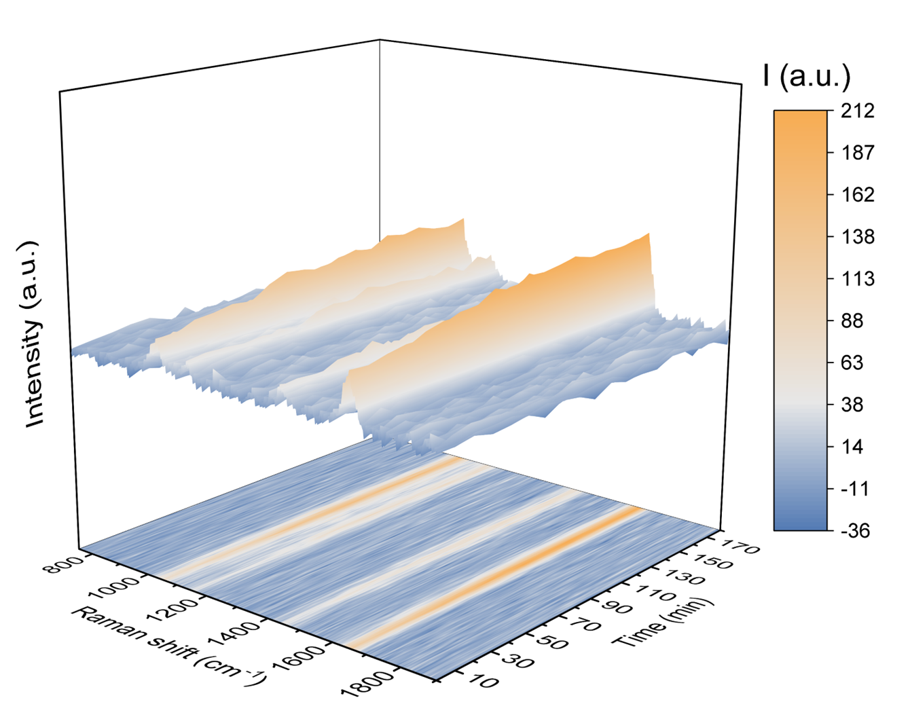
Supplementary Fig. 28∣Time-dependent in-situ Raman spectra at the potential of −0.6 V vs Ag/AgCl with TCMP in O₂.

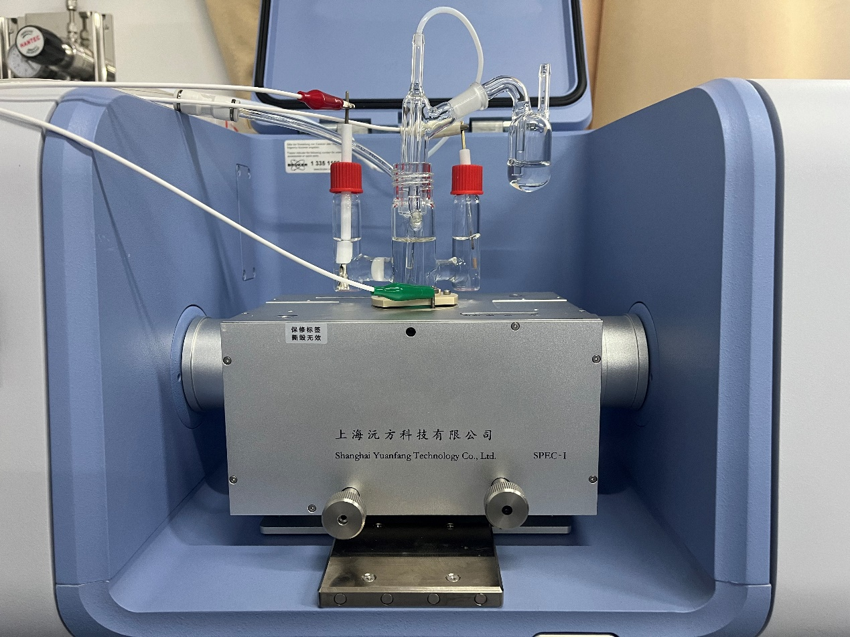
Supplementary Fig. 29∣The custom-built electrochemical cell for in-situ FTIR.

Supplementary Fig. 30∣Potential-dependent in-situ FTIR spectra a without TCMP in O₂, b with TCMP in O₂.

Supplementary Fig. 31∣Potential-dependent in-situ FTIR spectra with TCMP in N₂.

Supplementary Fig. 32∣Time-dependent EPR spectra for detection of a •OOH and •OH, and b •O radicals.

Supplementary Note 16. The quadruple and six-fold peaks assigned to DMPO-•OH and DMPO-•OOH adducts emerge with the increasing of potential. The triple peak with 1:1:1 is assigned to DMPO-•O adduct²²⁻²⁴.

Supplementary Fig. 33∣a Potential-dependent EPR spectra for detection of •C radical. b The corresponding fitting diagram.

Supplementary Fig. 34∣Time-dependent EPR spectra of DIPPMPO-•C formed in the solution a with or b without TCMP at the potential of −0.6 V vs Ag/AgCl.

Supplementary Fig. 35∣Time-dependent EPR spectra of DMPO-•H formed at 0.5 M LiClO₄ solution using CH₃OH as solvent with continuous N₂ pumping at the potential of −0.6 V vs Ag/AgCl.

Supplementary Fig. 36∣Two possible paths of the electrochemical ORR-coupled dechlorination reaction for CNC generation.

Supplementary Fig. 37∣LCMS analysis of CNC.

Supplementary Fig. 38∣LCMS analysis of deuterated products formed in the solution using CD₃OD instead of CH₃OH.

Supplementary Fig. 39∣The adsorption models and the calculated free energy of each elementary step in MCN synthesis using different oxygen intermediates over Ag(111).

Supplementary Fig. 40∣Free energy diagram in CMP synthesis from TCMP over Ag(111).

Supplementary Fig. 41∣The adsorption models of each elementary step in CMP synthesis from TCMP over Ag(111).

Supplementary Fig. 42∣Free energy diagram and the adsorption models of each elementary step in CNA synthesis from CNC over Ag(111).

Supplementary Fig. 43 | a-b The standard curves of 2-chloro-3-(trichloromethyl)pyridine and Methyl 2-chloropyridine-3-carboxylate. c The peak positions of mixed standard samples in HPLC.

Supplementary Fig. 44 | a-b The standard curves of 2-chloro-6-(trichloromethyl)pyridine and methyl 6-chloropyridine-2-carboxylate. c The peak positions of mixed standard samples in HPLC.

Supplementary Fig. 45 | a-b The standard curves of 2-chloro-6-(trichloromethyl)pyridine and ethyl 6-chloropyridine-2-carboxylate. c The peak positions of mixed standard samples in HPLC.

Supplementary Fig. 46 | a-b The standard curve of 2-chloro-3-(trichloromethyl)pyridine and ethyl 2-chloropyridine-3-carboxylate. c The peak positions of standard sample in HPLC.

Supplementary Fig. 47 | a The standard curve of ethyl 6-chloropyridine-3-carboxylate. b The peak positions of standard sample in HPLC.

Supplementary Fig. 48 | a-b The standard curves of benzotrichloride and methyl benzoate. c The peak positions of mixed standard samples in HPLC.

Supplementary Fig. 49 | a-b The standard curves of 4-chlorobenzotrichloride and methyl 4-chlorobenzoate. c The peak positions of mixed standard samples in HPLC.

Supplementary Fig. 50 | a-b The standard curves of 1,4-bis(trichloromethyl)-benzene and dimethyl terephthalate. c The peak positions of mixed standard samples in HPLC.

Supplementary Fig. 51 | Digital image of two-electrode flow electrolyzer.

Supplementary Tables

Supplementary Table 1. The proportion of different elements of Ag and Ag_{(a)} in XPS.
Sample | Ag | Ag_{(a)}
O 1s | 23.1 % | 8.7 %
C 1s | 56.6 % | 40.6 %
Ag 3d | 20.3 % | 50.7 %

Supplementary Table 2. Percentages of Ag 3d and O 1s of two catalysts in XPS.
Sample | Ag 3d |  | O 1s
Sample | Ag⁺ | Ag⁰ | Ag-O | -OH
Ag | 95.2 % | 4.8 % | 78.0 % | 22.0 %
Ag_{(a)} | 93.8 % | 6.2 % | 41.7 % | 58.3 %

Supplementary Table 3. The corresponding selectivity of products in Fig. 2d.
Atmosphere | Potential  (V vs Ag/AgCl) | Sel._{(CNA)}  (%) | Sel._{(MCN)} (%) | Sel._{(CMP)} (%) | Sel._{(CCMP)} (%) | Sel._{(DCMP)} (%)
N₂ | 0 | 0 | 0 | 0 | 0 | 100.0
N₂ | −0.2 | 0 | 0 | 0 | 0 | 100.0
N₂ | −0.4 | 0 | 0 | 0 | 0 | 100.0
N₂ | −0.6 | 0 | 0 | 34.4 | 18.4 | 47.2
N₂ | −0.8 | 0 | 0 | 34.5 | 26.0 | 39.5
N₂ | −1 | 0 | 0 | 34.9 | 31.5 | 33.6
N₂ | −1.2 | 0 | 0 | 35.0 | 31.5 | 33.5
N₂ | −1.4 | 0 | 0 | 47.6 | 32.0 | 20.4
O₂ | 0 | 15.3 | 84.7 | 0 | 0 | 0
O₂ | −0.2 | 3.1 | 96.8 | 0 | 0 | 0.1
O₂ | −0.4 | 3.4 | 94.5 | 0 | 0 | 2.1
O₂ | −0.6 | 3.0 | 93.2 | 0 | 0 | 3.7
O₂ | −0.8 | 4.3 | 91.4 | 0 | 0 | 4.3
O₂ | −1 | 4.7 | 89.9 | 0 | 0 | 5.4
O₂ | −1.2 | 4.7 | 89.3 | 0 | 0 | 6.0
O₂ | −1.4 | 4.7 | 89.0 | 0 | 0 | 6.3

Supplementary Table 4. The selectivity values of MCN at different variety and concentration of electrolytes.
Concentration | TBAT | TBAB | LiClO₄ | LiOAc·2H₂O | LiOAc | TMAH
0.01 M | 93.7 | 81.3 | 92.9 | 91.0 | 91.4 | 85.0
0.03 M | 88.7 | 78.3 | 89.4 | 78.5 | 80.8 | 80.6
0.3 M | 82.6 | 76.2 | 52.8 | 46.1 | 47.2 | 0.5
0.5 M | 73.3 | 75.1 | 23.4 | 37.4 | 36.6 | 0.4

Supplementary Table 5. The pH values of various electrolytes including substrate.
Concentration | TBAT | TBAB | LiClO₄ | LiOAc·2H₂O | LiOAc | TMAH
0.01 M | 3.94 | 2.48 | 2.31 | 8.62 | 8.64 | 10.33
0.03 M | 3.98 | 2.64 | 2.31 | 8.78 | 8.86 | 12.46
0.3 M | 4.05 | 2.74 | 2.46 | 8.95 | 9.26 | 13.61
0.5 M | 4.16 | 2.81 | 2.51 | 9.09 | 9.38 | 13.86

Supplementary Table 6. The selectivity values of MCN in oxygen-containing products (Sel. _{MCN}(path 2)) at different variety and concentration of electrolytes.
Concentration | TBAT | TBAB | LiClO₄ | LiOAc·2H₂O | LiOAc | TMAH
0.01 M | 96.46 | 97.42 | 93.86 | 91.70 | 91.44 | 85.28
0.03 M | 95.47 | 97.16 | 93.94 | 79.06 | 81.43 | 81.06
0.3 M | 96.28 | 96.13 | 94.46 | 49.88 | 53.62 | 1.55
0.5 M | 96.18 | 96.50 | 91.59 | 47.12 | 47.47 | 1.54

Supplementary Table 7. Substrate scope and the corresponding parameters for the ORR-coupled dechlorination cascading chemical reaction over Ag_{(a)} electrode.
 | Reactant | Product | Solvent | Electrolyte (M) | Potential (V vs Ag/AgCl) | Time (h) | Catalyst area (cm⁻²) | Conversion (%) | Yield (%)
a | 2-Chloro-3-  (trichloromethyl)pyridine | Methyl 2-chloropyridine  -3-carboxylate | CH₃OH | 0.03 | −1.0 | 10 | 1×1.5 | 96.2 | 66.6
b | 2-Chloro-6-  (trichloromethyl)pyridine | Methyl 6-chloropyridine  -2-carboxylate | CH₃OH | 0.03 | −1.0 | 12 | 1×1.5 | 84.9 | 69.4
c | 2-Chloro-6-  (trichloromethyl)pyridine | Ethyl 6-chloropyridine-2-carboxylate | C₂H₅OH | 0.03 | −1.0 | 16 | 1×3 | 71.6 | 62.0
d | 2-Chloro-3-  (trichloromethyl)pyridine | Ethyl 2-chloropyridine  -3-carboxylate | C₂H₅OH | 0.03 | −1.0 | 14 | 1×3 | 90.6 | 69.4
e | 2-Chloro-5-(trichloromethyl)pyridine | Ethyl 6-chloropyridine-3-carboxylate | C₂H₅OH | 0.03 | −1.4 | 10 | 1×1.5 | 95.8 | 86.4
f | Benzo trichloride | Methyl benzoate | CH₃OH | 0.03 | −0.7 | 8 | 1×3 | 80.9 | 58.8
g | 4-Chlorobenzotrichloride | Methyl 4-chlorobenzoate | CH₃OH | 0.03 | −0.7 | 8 | 1×3 | 72.1 | 72.1
h | 1,4-Bis(trichloromethyl)-benzene | Dimethyl terephthalate | CH₃OH | 0.03 | −0.7 | 7 | 1×3 | 100.0 | 72.1

Ag_{(a)} electrode, Pt electrode, and Ag/AgCl reference electrodes are used as the working, counter and reference electrodes, respectively, with Nafion 117 proton membrane for separating anode and cathode. The anode solution is 35 mL H₂SO₄, and the cathode solution is solvent + conductive agent + 10 mM substrate. The specific potential and electrolysis time are shown in the table above.

Supplementary References

1 Loza, K. & Epple, M. Silver nanoparticles in complex media: An easy procedure to discriminate between metallic silver nanoparticles, reprecipitated silver chloride, and dissolved silver species. RSC Adv. 8, 24386–24391, (2018).
2 Garg, S. et al. Oxidative dissolution of silver nanoparticles by chlorine: Implications to silver nanoparticle fate and toxicity. Environ. Sci. Technol. 50, 3890-3896, (2016).
3 Cova, C. M. et al. Microwave-assisted preparation of Ag/Ag₂S carbon hybrid structures from pig bristles as efficient her catalysts. J. Mater. Chem. A 6, 21516–21523, (2018).
4 Durante, C. et al. Electrochemical activation of carbon–halogen bonds: Electrocatalysis at silver/copper nanoparticles. Appl. Catal. 158-159, 286–295, (2014).
5 Qiu, Y. et al. Electrocatalytic decarboxylation of carboxylic acids over RuO₂ and Pt nanoparticles. Appl. Catal. 305, 121060, (2022).
6 Cao, X. et al. Green one-step synthesis of silver nanoparticles and their biosafety and antibacterial properties. Green Chem. Lett. Rev. 15, 28-34, (2021).
7 Karatzia, A. et al. Thermal behavior of silver−gold core−shell nanocubes: In situ X‑ray diffraction and in situ electron microscopy (SEM and TEM). J. Phys. Chem. C 127, 19620-19628, (2023).
8 Li, Y. et al. Improving the oxidation resistance and stability of Ag nanoparticles by coating with multilayered reduced graphene oxide. Appl. Surf. Sci. 425, 194–200, (2017).
9 Hsieh, Y.-C. et al. Modification of CO₂ reduction activity of nanostructured silver electrocatalysts by surface halide anions. ACS Appl. Energy Mater. 2, 102−109, (2019).
10 Brzózka, A. et al. Electrocatalytic reduction of chloroform at nanostructured silver electrodes. Electrochimica Acta 225, 574–583, (2017).
11 Hao, M. et al. Silver-nanoparticle-decorated multiwalled carbon nanotubes prepared by poly(dopamine) functionalization and ultraviolet irradiation. Compos. B. Eng. 95, 395e403, (2016).
12 Boukhvalov, D. W. et al. Atomic and electronic structures of stable linear carbon chains on agnanoparticles. Carbon 128, 296e301, (2018).
13 Al-Hada, M. et al. Pristine and oxidised Ag-nanoparticles on free-standing graphene as explored by X-ray photoelectron and auger spectroscopy. Surf. Sci. 693, 121533, (2020).
14 Parida, S. K. et al. Composition dependence of M_{4,5}N_{4,5}N_{4,5} auger transition in AgPd alloys. Mater. Res. Express. 1, 046501, (2014).
15 Zhang, S. et al. Ultra-stable oxygen species in Ag nanoparticles anchored on g-C₃N₄ for enhanced electrochemical reduction of CO₂. Electrochimica Acta 390, 138831, (2021).
16 Horstmann, S., Grybat, A. & Kato, R. Experimental determination and prediction of gas solubility data for oxygen in acetonitrile. J. Chem. Thermodyn. 36, 1015–1018, (2004).
17 Tian, H. et al. Visible light-driven, one-pot amide synthesis catalyzed by the B₁₂ model complex under aerobic conditions. ChemPlusChem 84, 237-240, (2019).
18 Sato, T. et al. Solubility of oxygen in organic solvents and calculation of the hansen solubility parameters of oxygen. Ind. Eng. Chem. Res. 53, 19331-19337, (2014).
19 Leow, W. R. et al. Chloride-mediated selective electrosynthesis of ethylene and propylene oxides at high current density. Science 368, 1228-1233, (2020).
20 Luna, P. D. et al. What would it take for renewably powered electrosynthesis to displace petrochemical processes? Science 364, (2019).
21 Wang, K. et al. Techno-economic analysis of electrocatalytic CO₂ reduction into methanol: A comparative study between alkaline flow cell and neutral membrane electrode assembly. Catalysts 13, 1005, (2023).
22 Yuan, Y. et al. Electrocatalytic ORR–coupled ammoximation for efficient oxime synthesis. Sci. Adv. 10, eado1755, (2024).
23 Seif-Eddine, M. et al. Operando film-electrochemical EPR spectroscopy tracks radical intermediates in surface-immobilized catalysts. Nat. Chem. 16, 1015–1023, (2024).
24 Kuang, C. et al. Integrating anodic sulfate activation with cathodic H₂O₂ production/activation to generate the sulfate and hydroxyl radicals for the degradation of emerging organic contaminants. Water Res. 229, 119464, (2023).

