Supplementary Information for:
Strain analysis of black-to-yellow phase transitions in CsPbI₃

Bangwei Jin¹; Ruihao Gong²; Dongchen Lan²; Dexin Yang^{1*}; Xuefeng Zhang^{1*}

- Institute of Advanced Magnetic Materials, College of Materials & Environmental Engineering, Hangzhou Dianzi University, Hangzhou 310018, China;
- College of Electrical Engineering, Zhejiang University, Hangzhou 310027, China.
*Corresponding authors: Xuefeng Zhang (zhang@hdu.edu.cn); Dexin Yang (dy263@hdu.edu.cn).

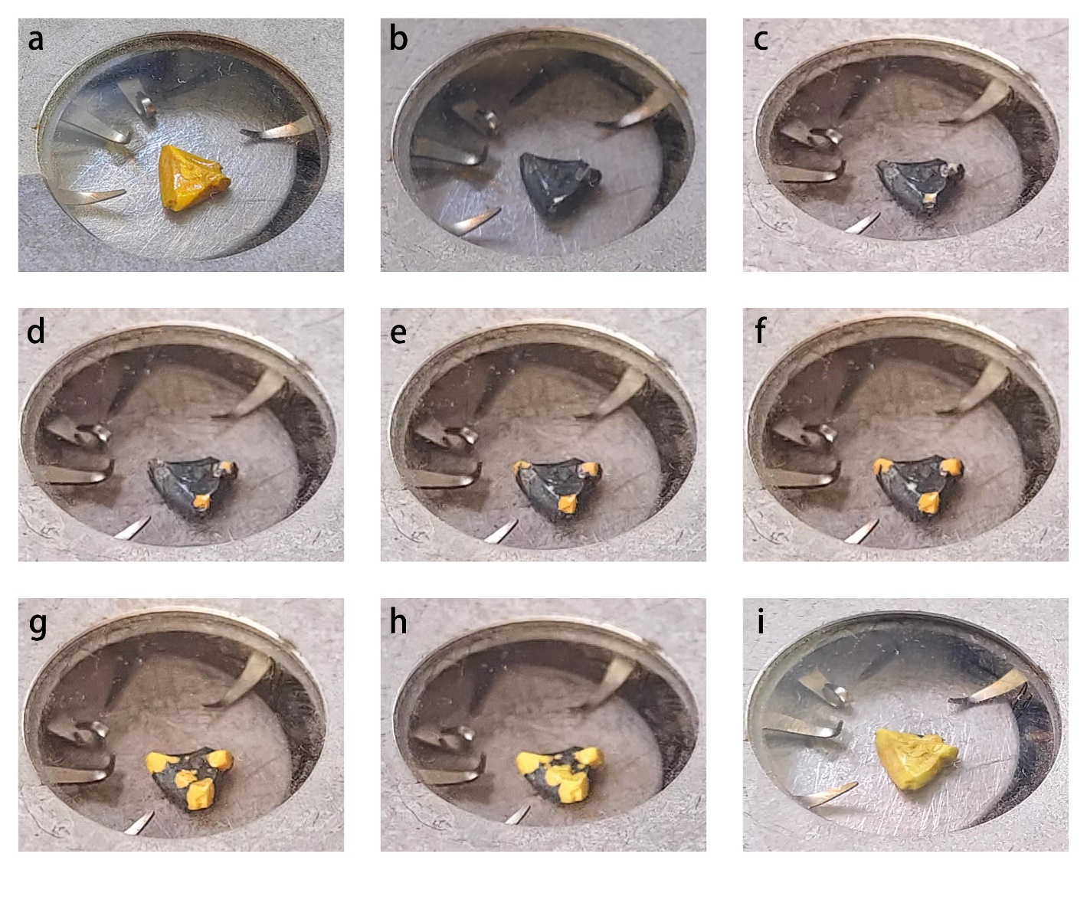
Supplementary Figure 1 | Photos of a prepared CsPbI₃ bulk crystal at different temperatures. a, A yellow δ-CsPbI₃ crystal at room temperature. b, A black CsPbI₃ crystal at 610 K heating from (a). c-i, The black CsPbI₃ crystal from (b) rapidly transformed to the yellow phase as it cooled naturally in air at 30 s (c), 40 s (d), 50 s (e), 60 s (f), 2 min (g), 5 min (h) and 10 min (i).
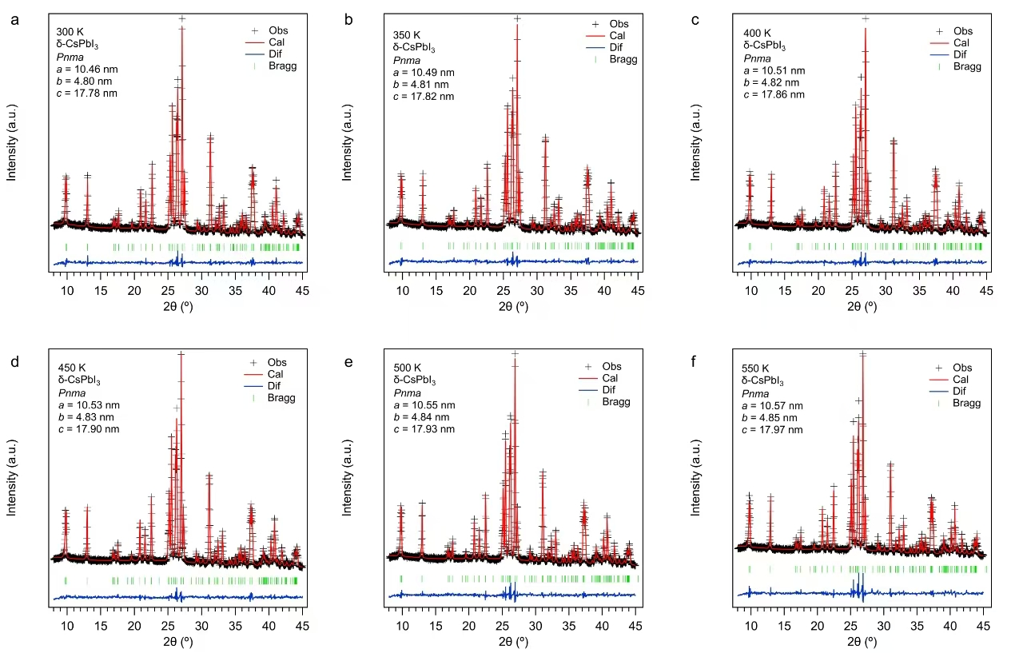
Supplementary Figure 2 | Rietveld refinement results of XRD patterns of δ-CsPbI₃ measured between 300 K and 550 K during heating. a, 300 K; b, 350 K; c, 400 K; d, 450 K; e, 500 K; and f, 550 K. The observed profile is marked by black crosses, while the calculated profile is represented by a red line. Bragg peak positions of δ-CsPbI₃ crystals are labeled by green marks. The difference diffractogram (experimental minus calculated profile) is shown in light blue.
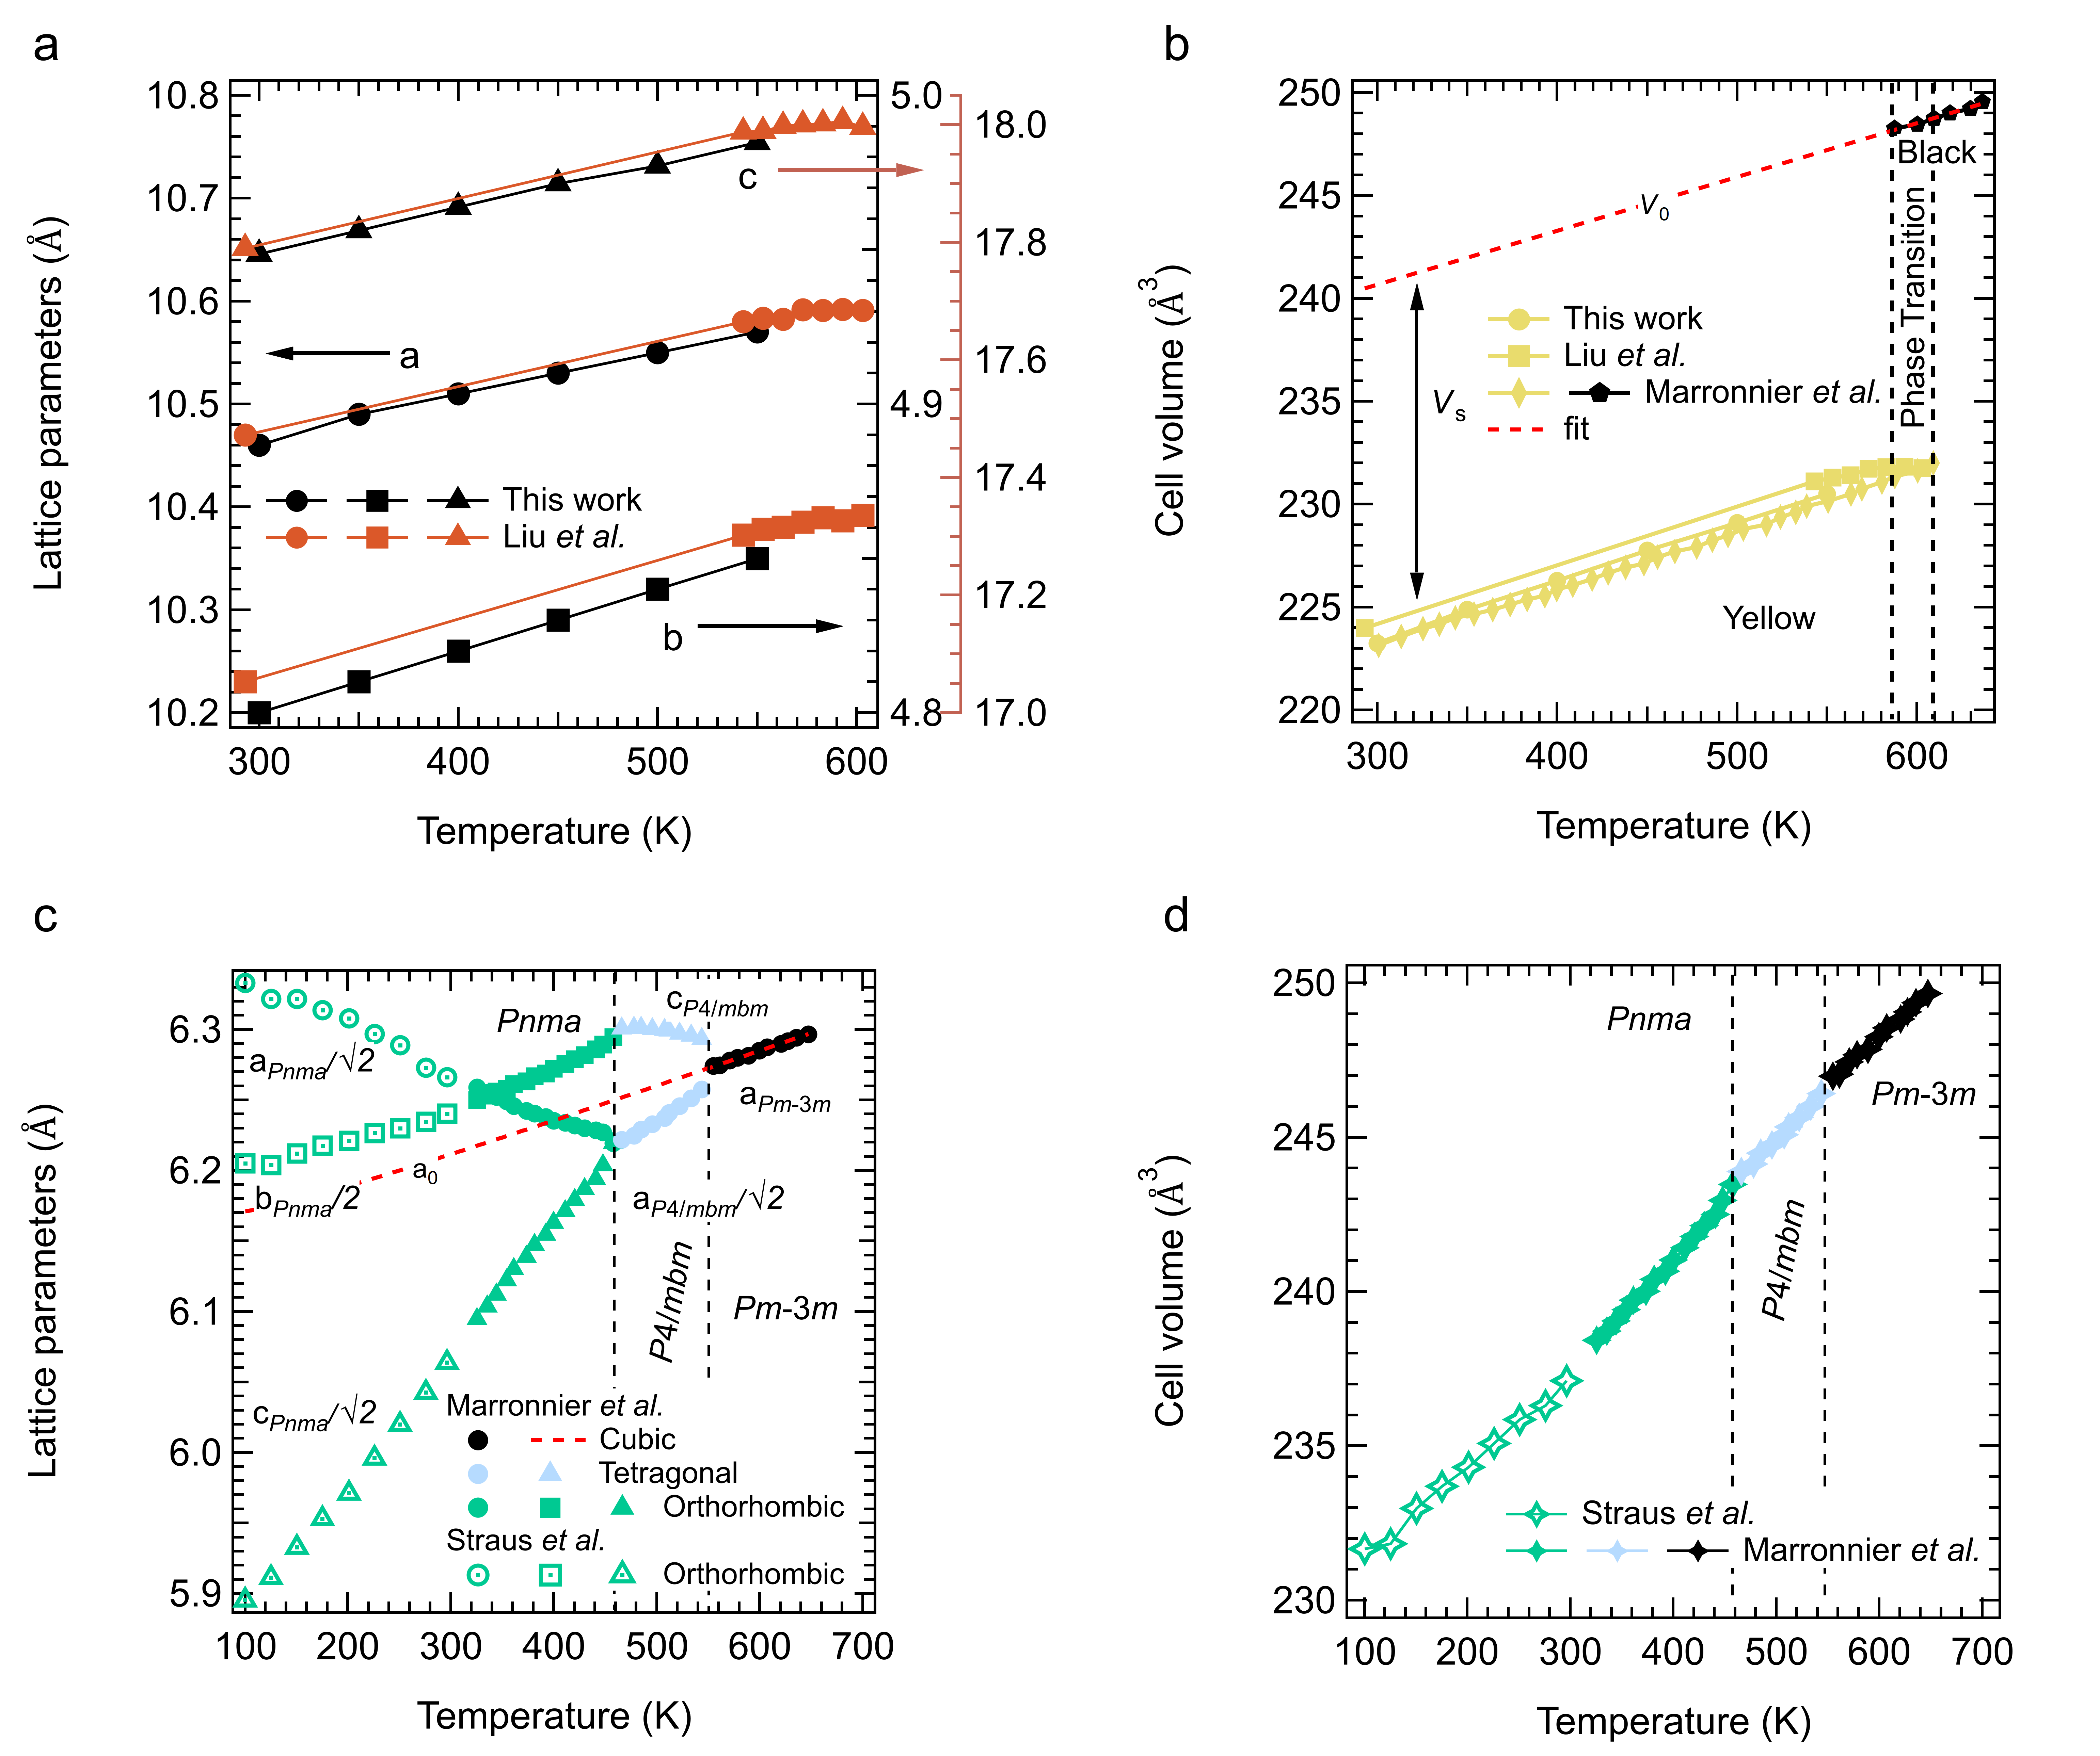
Supplementary Figure 3 | Lattice parameters and cell volume for both black and yellow CsPbI₃ crystals between 100 K and 650 K, demonstrating the yellow δ-CsPbI₃ to black α-CsPbI₃ transition during heating, and Pm$\overline{\text{3}}$m (α) ↔P4/mbm (β) ↔Pnma (γ) transition of black CsPbI₃ during cooling. a, Lattice parameters for yellow δ-CsPbI₃ as a function of temperature, including data from this study and Liu et al.¹ The black and red axes on the right side represent the lattice parameters of b and c, respectively, while the left axis represents the lattice parameter a. b, Cell volume variations compiled from this study, Liu et al.¹, and Marronnier et al.² The yellow δ-CsPbI₃ (Pnma) to black α-CsPbI₃ (Pm$\overline{\text{3}}$m) phase transition occurs at ~600 K, consistent with the DSC results in Figure 1a, showing a significant increase in cell volume during heating. The reference parameter V₀ was determined by extrapolating a linear fit to the cubic lattice parameters at high temperatures. c, Lattice parameters from Marronnier et al.² and Straus et al.³ during cooling. Curved dotted lines represent variations of a_{o}, obtained from fits of Eq. (2) to the lattice parameter of the parent cubic structure, with Θ_{s} fixed at 150 K. d, Variations of the unit cell volumes of black CsPbI₃ during cooling.

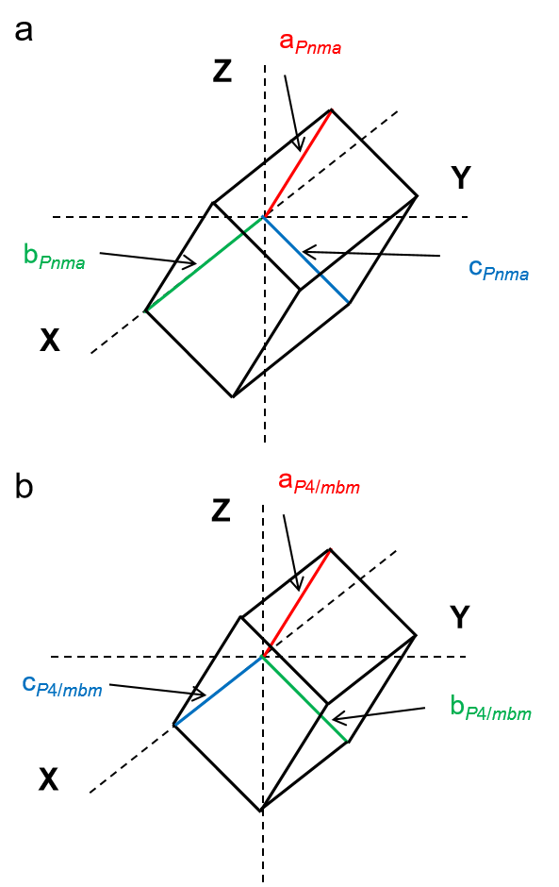
Supplementary Figure 4 | Crystallographic axes for the Pnma and P4/mbm space groups. Relationships between crystallographic axes and reference axes, for definition of strains used in Eq. (1), for the space groups Pnma (0q₂0 q₄0q₆) (a) and P4/mbm (0q₂0 000) (b) (after Carpenter 2007 Am Min 92 309)⁴.
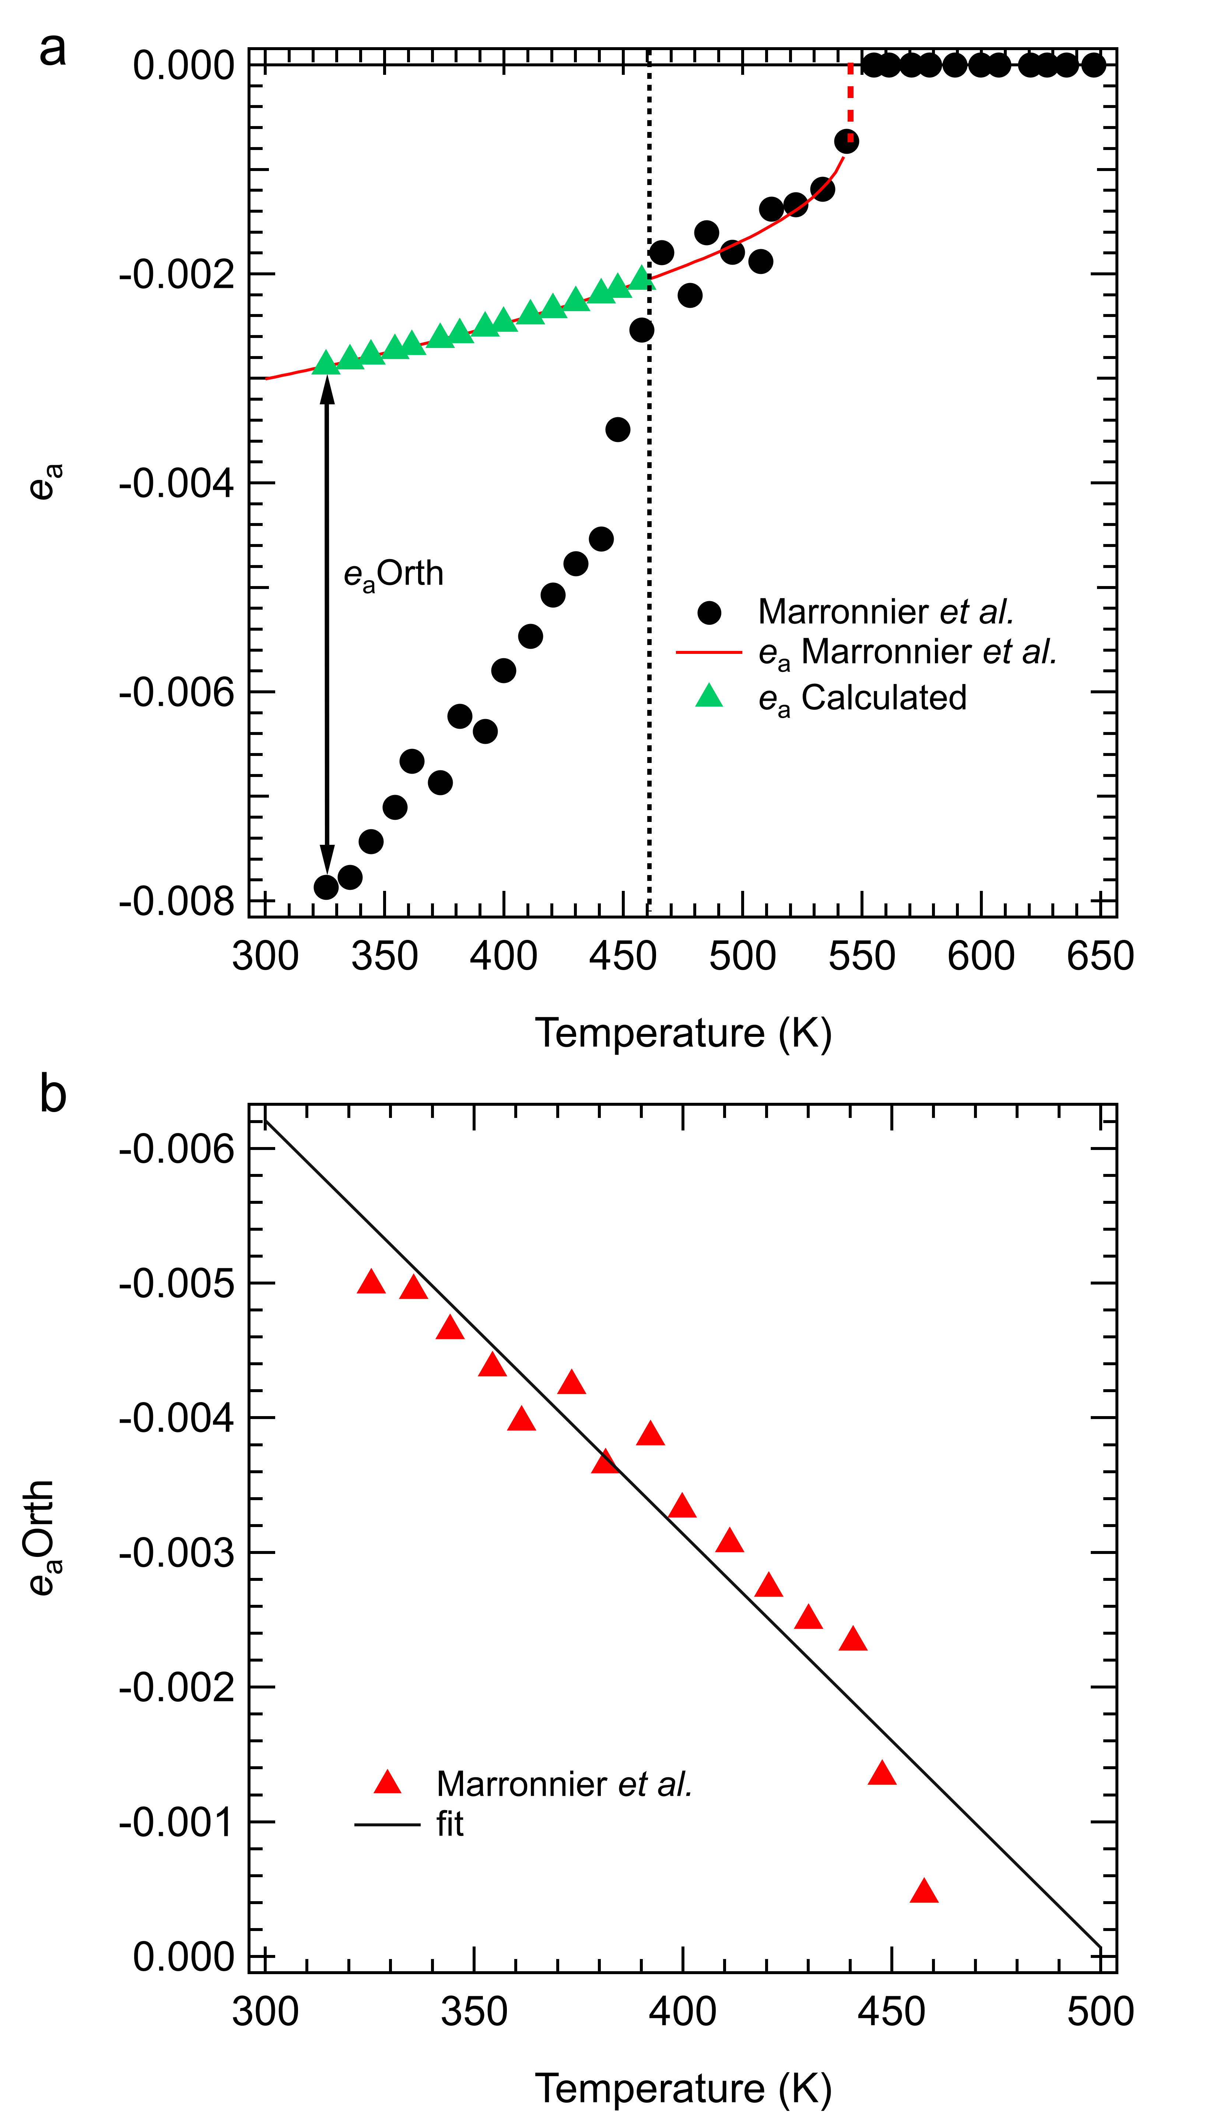
Supplementary Figure 5 | Volume strains calculated from the lattice parameters of Marronnier et al.² of a black CsPbI₃ perovskite. a, Variations of volume strain, e_{a}. The curve through data in the temperature interval 465-544 K is a fit of Eq. (4) for a first order transition, assuming e_{a}tet ∝ Q². Extrapolation of this fit to lower temperature provides a baseline which allows the volume strain associated with the P4/mbm → Pnma transition, e_{a}orth, to be estimated. b, The variation of e_{a}orth, from (a) is linear within experimental error, signifying that the P4/mbm → Pnma transition can be represented approximately as a second order transition in one order parameter with e_{a}orth ∝ Q². However, extrapolation of the fit to zero gives T_{c} = 500 K, which is above the actual transition temperature 456 K.
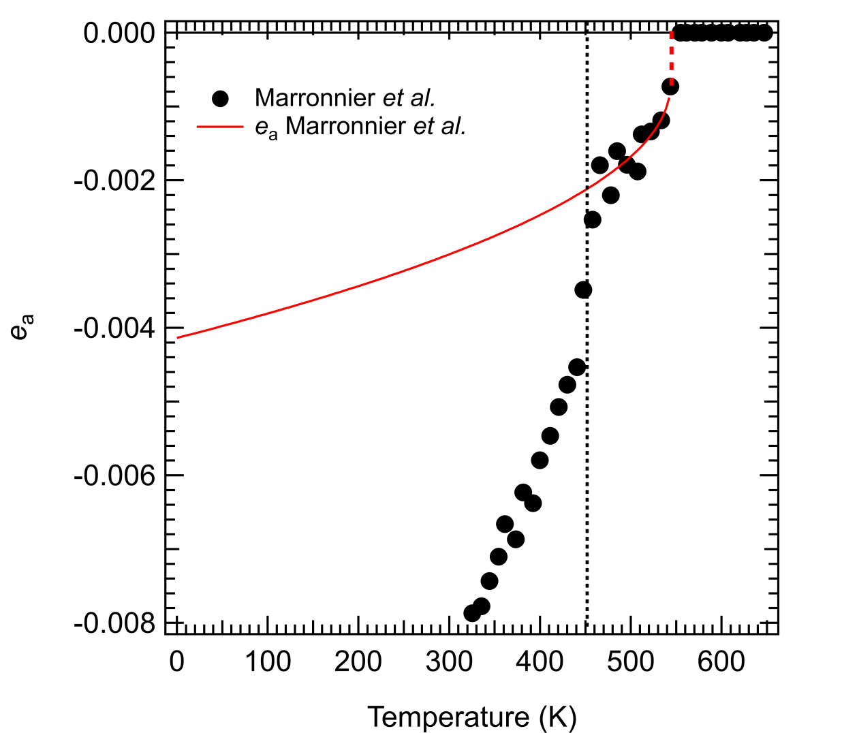
Supplementary Figure 6 | Variations of volume strain, e_{a}, above room temperature from Marronnier et al.² of a black CsPbI₃ perovskite. The curve through data in the temperature interval 465-544 K is a fit of Eq. (4) for a first order transition, assuming e_{a}tet ∝ Q². Extrapolation of this fit to 0 K gives the value of e_{a} for the tetragonal phase, e_{a}tet, as -0.0042 at 0 K, where Q = 1.

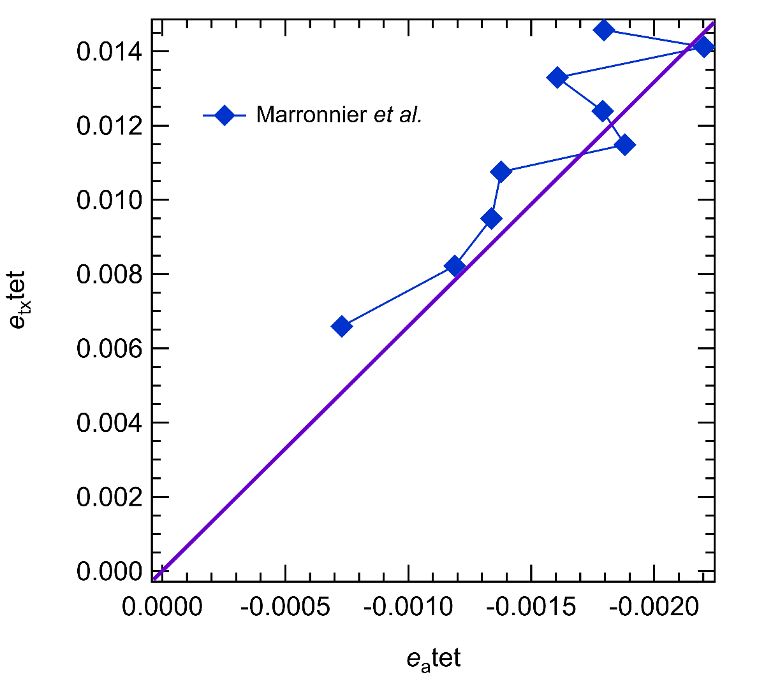
Supplementary Figure 7 | Relationship of e_{tx}tet and e_{a}tet in the tetragonal structure of a black CsPbI₃ perovskite. e_{tx}tet does not scale linearly with e_{a}tet in the temperature interval 544-466 K as expected from the relationship e_{tx} ∝ e_{a}tet ∝ Q² in Supplementary Table 2.

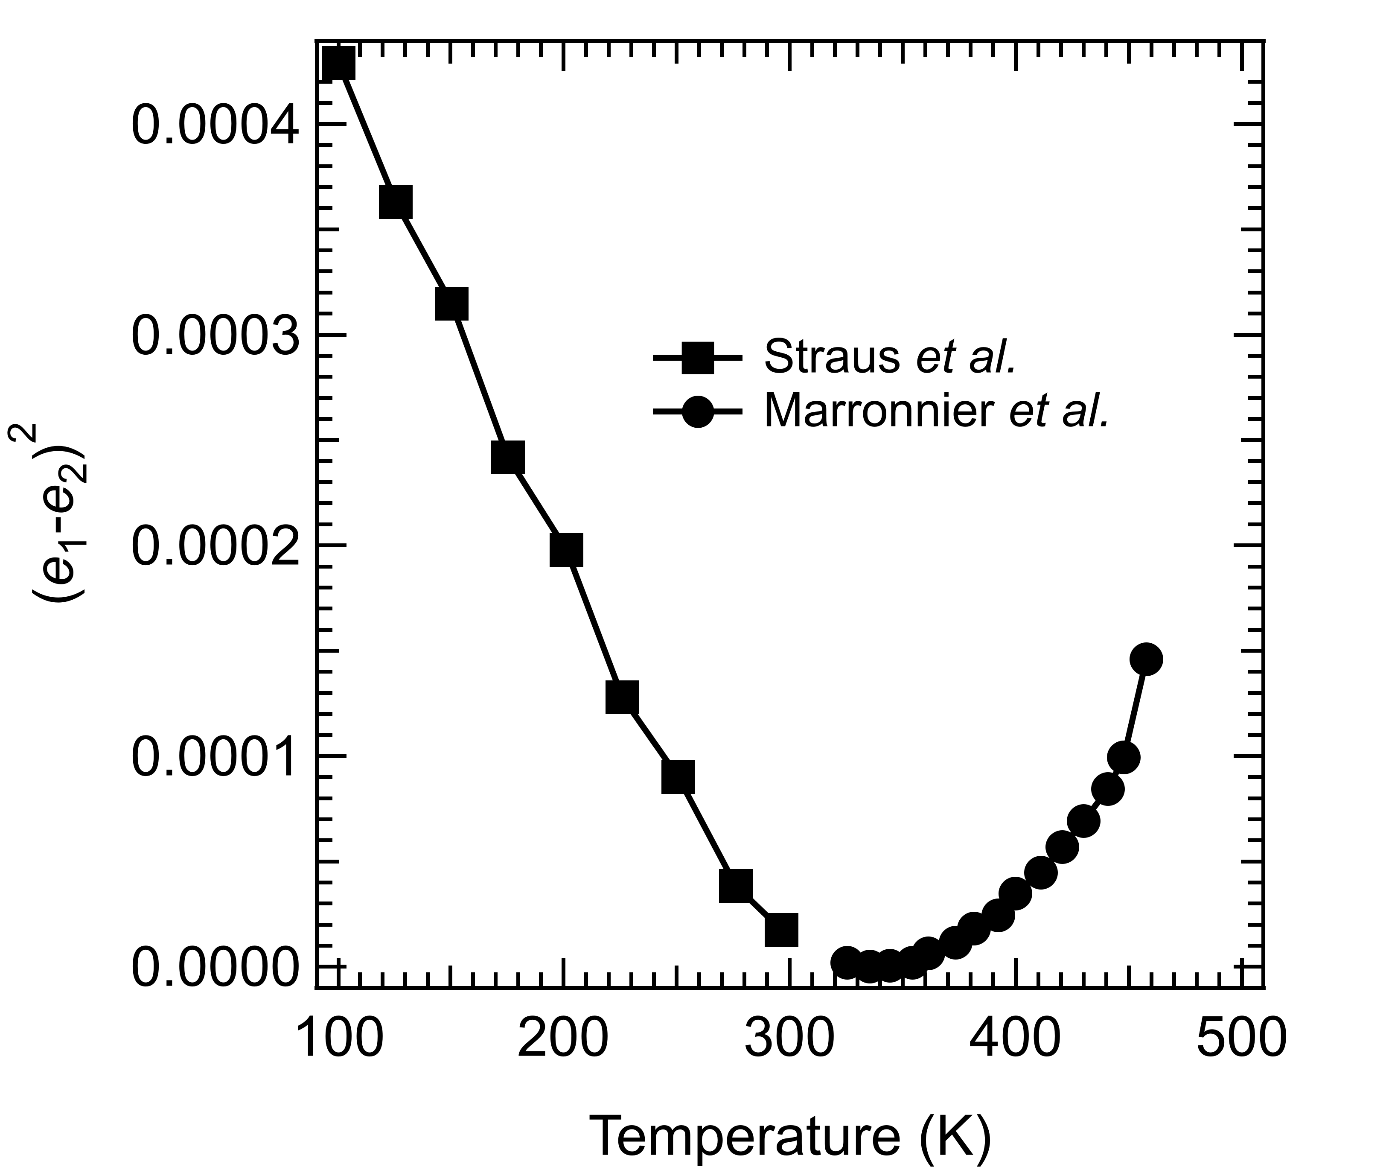
Supplementary Figure 8 | (e₁-e₂)² of black γ-CsPbI₃. An alternative representation of the same result shows (e₁-e₂)² has a rounded minimum at ~325 K.

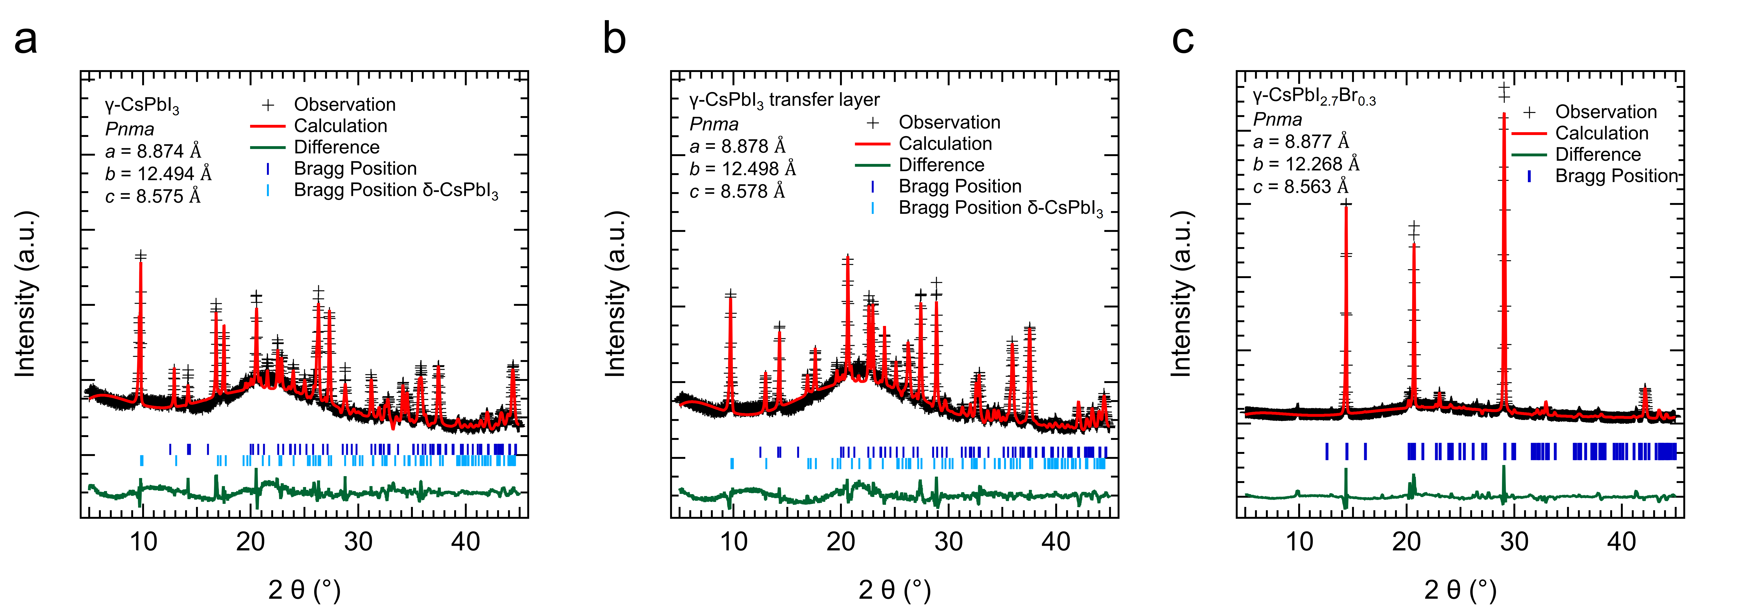
Supplementary Figure 9 | Rietveld refinement results of XRD patterns of three CsPbI₃-based thin films. a-c, XRD patterns along with theie corresponding Rietveld refinement fitting for CsPbI₃ (a), CsPbI₃ on transport layers (NiO_{x}/Me-4PACz) (b), and CsPbI_{2.7}Br_{0.3} (c) thin films on silica glass. The observed profile is marked by black crosses, while the calculated profile is shown by a red line. Bragg peak positions of γ-CsPbI₃ and δ-CsPbI₃ are labeled by deep blue and light blue symbols, respectively. The difference diffractogram, obtained by substracting calculated profies from experimental data, is shown in green.

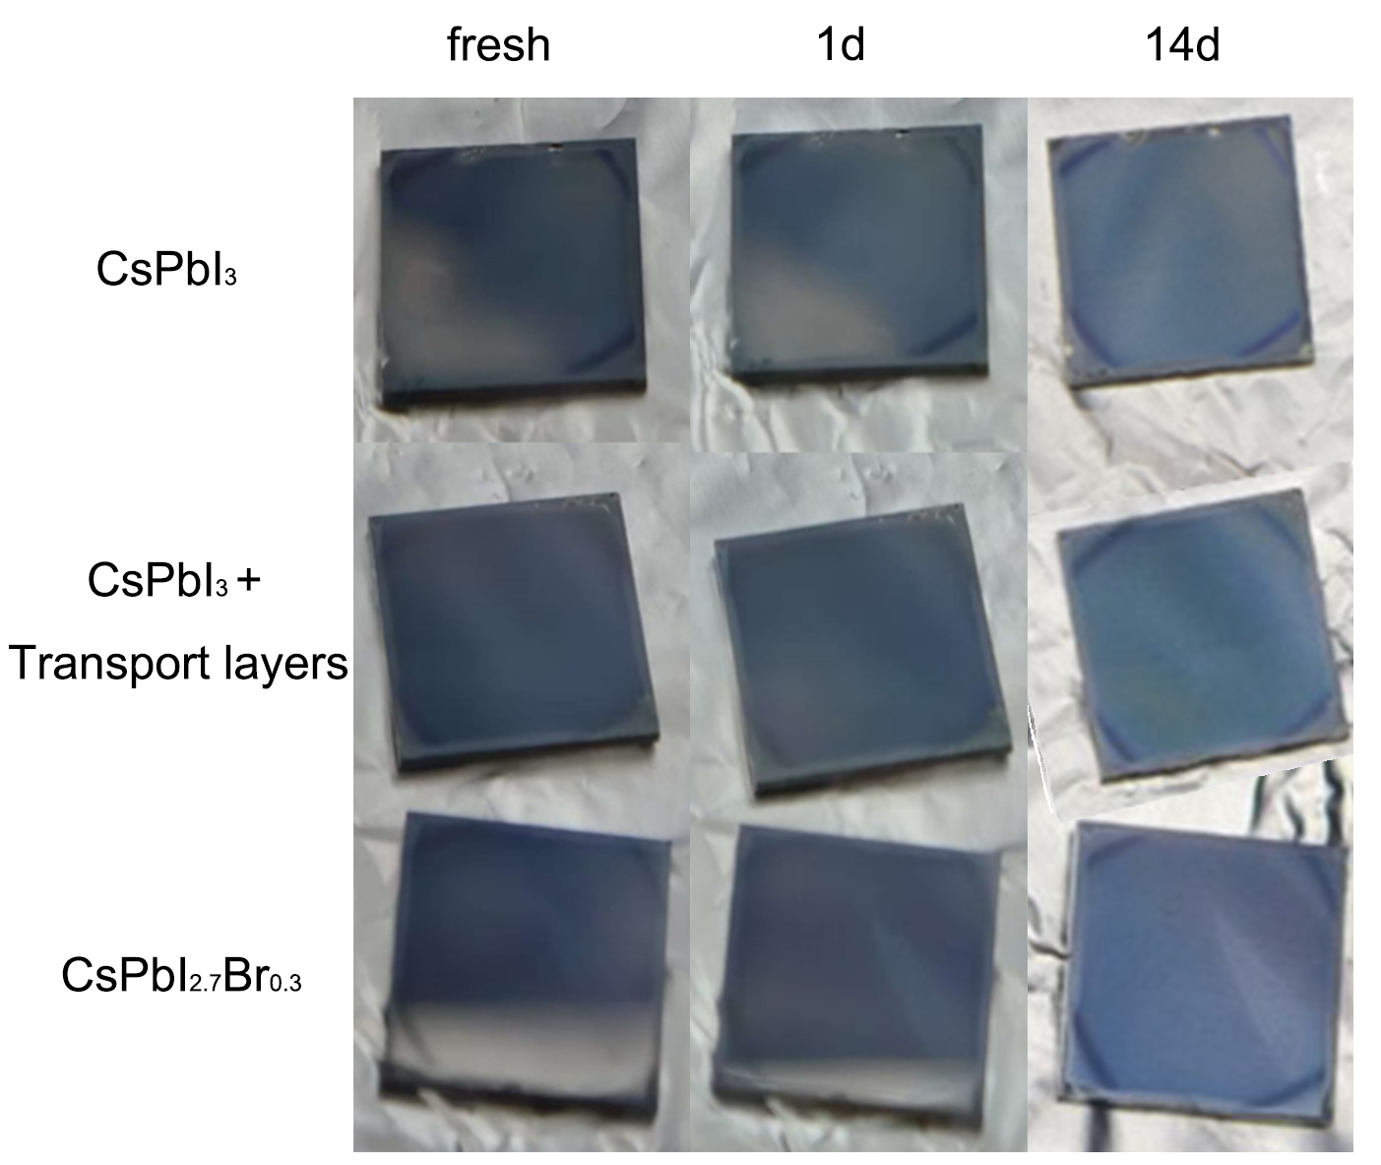
Supplementary Figure 10 | Black CsPbI₃-based thin films, grown on silica glass, transport layers, or incorporating bromines, were stored in a nitrogen-filled glovebox. CsPbI₃ and Br-doped CsPbI_{2.7}Br_{0.3} thin films on silica glass or transport layers (silica/NiO_{x}/Me-4PACz substrates) were prepared and stored in a nitrogen-filled glovebox. All films maintained their black state for up to 14 days in a nitrogen atmosphere. Photos were taken immediately after preparation (fresh), after 1 day (1d), and after 14 days (14d).

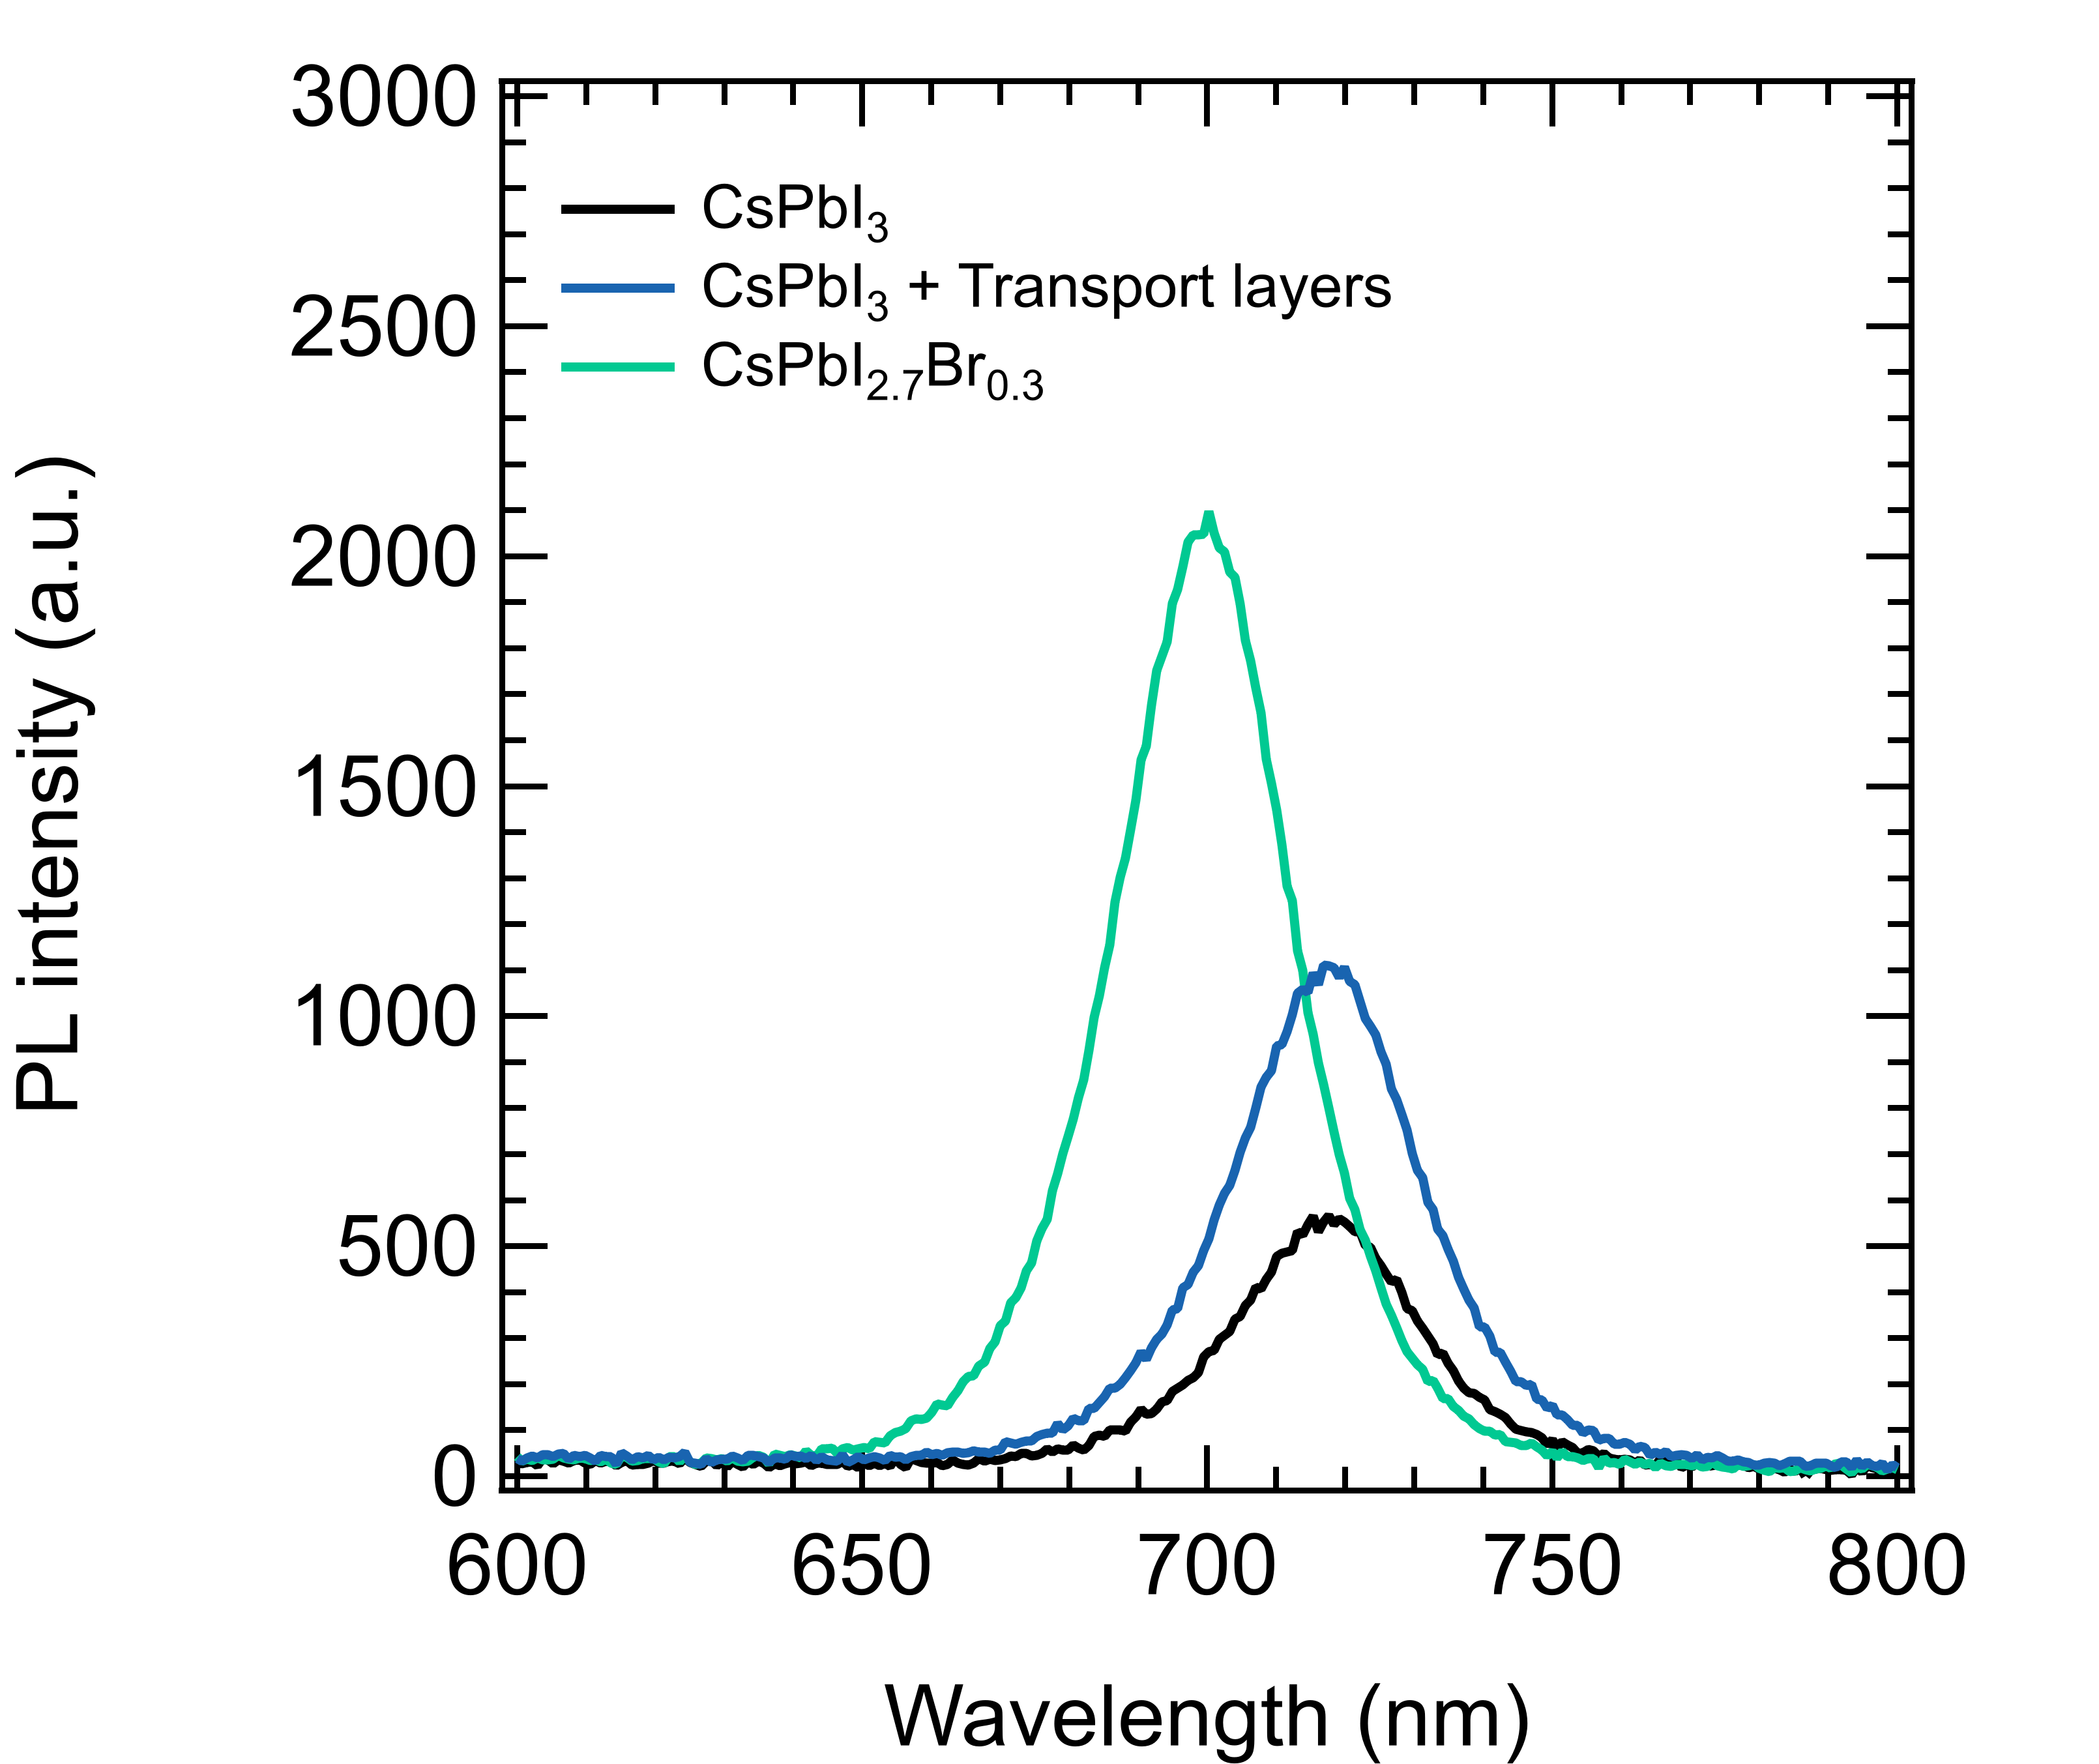
Supplementary Figure 11 | Photoluminescent (PL) properties of CsPbI₃-based thin films. PL intensities and peak positions of CsPbI₃ and CsPbI_{2.7}Br_{0.3} thin films on silica glass or transport layers (silica/NiO_{x}/Me-4PACz substrates) were collected from thin films prepared for 24 hours and excited uder a 405 nm laser.

Supplementary Table 1 | The enthalpy values at the phase-transitions of a CsPbI₃ crystal.
 |  | Exothermic |  | Endothermic
Processes | Phase transitions | Temperature (K) | |△H| (kJ/mol) | Temperature (K) | |△H| (kJ/mol)
First heat | δ → α |  |  | ~601 | ~16.6
First cool | α → β | ~545 | ~0.25
First cool | β → γ | ~456 | ~0.20
Second heat | γ → α | ~456-~500 K | ~16.08
Second heat | α → γ |  |  | ~602 | ~16.5

Supplementary Table 2 | Relationships between strain components and order parameter components derived from Equation 1 by setting the equilibrium condition $\frac{∂G}{∂e_{i}}=0$, and expressions for strain components in terms of lattice parameters for the settings shown in Figure 3 (following Carpenter et al 2001 Am Mineral 86⁵, 348–363, McKnight et al 2009 JPCM 21 015901⁶).
P4/mbm | Pnma
$$e_{a}=-\frac{λ_{1}q_{2}^{2}}{\frac{1}{3}\left(C_{11}^{o}+2C_{12}^{o}\right)}$$ | $$e_{a}=-\frac{\left(λ_{1}q_{2}^{2}+{2λ}_{2}q_{4}^{2}\right)}{\frac{1}{3}\left(C_{11}^{o}+2C_{12}^{o}\right)}$$
$$e_{ox}=e_{4}=e_{5}=e_{6}=0$$ | $$e_{ox}=e_{5}=e_{6}=0$$
$$e_{tx}=-\frac{2λ_{3}q_{2}^{2}}{\frac{1}{2}\left(C_{11}^{o}-C_{12}^{o}\right)}$$ | $$e_{tx}=-\frac{2\left(λ_{3}q_{2}^{2}-λ_{4}q_{4}^{2}\right)}{\frac{1}{2}\left(C_{11}^{o}-C_{12}^{o}\right)}$$
 | $$e_{4}=-\frac{λ_{5}q_{4}^{2}}{2q_{2}^{2}\left(λ_{6}+λ_{7}\right){+C}_{44}^{o}}$$
$$e_{1}=\frac{c-a_{o}}{a_{o}}$$ | $$e_{1}=\frac{\frac{b}{2}-a_{o}}{a_{o}}$$
$$e_{2}=e_{3}=\frac{\frac{a}{\sqrt{2}}-a_{o}}{a_{o}}$$ | $$e_{2}=\frac{\frac{a}{\sqrt{2}}-a_{o}}{a_{o}}$$
 | $$e_{3}=\frac{\frac{c}{\sqrt{2}}-a_{o}}{a_{o}}$$
 | $$e_{4}=\frac{\frac{a}{\sqrt{2}}-a_{o}}{a_{o}}-\frac{\frac{c}{\sqrt{2}}-a_{o}}{a_{o}}$$

Supplementary Table 3 | Lattice parameters and spontaneous strains of black CsPbI₃-based films in Supplementary Figure 9, and the strains are calculated using the equations from Supplementary Table 2.
Lattice parameters and strains | CsPbI₃ | CsPbI₃ with transport layers | CsPbI_{2.7}Br_{0.3}
a | 8.873606 Å | 8.877571 Å | 8.774514 Å
b | 12.494306 Å | 12.497684 Å | 12.26754 Å
c | 8.574962 Å | 8.577571 Å | 8.563174 Å
e₁ | 0.008526494 | 0.008455802 | 0.000481456
e₂ | 0.012955374 | 0.013063065 | 0.012021245
e₁-e₂ | -0.00442888 | -0.004607263 | -0.011539789

Supplementary References
1 Liu, J., Phillips, A. E., Keen, D. A. & Dove, M. T. Thermal Disorder and Bond Anharmonicity in Cesium Lead Iodide Studied by Neutron Total Scattering and the Reverse Monte Carlo Method. The Journal of Physical Chemistry C 123, 14934-14940 (2019). https://doi.org/10.1021/acs.jpcc.9b02936
2 Marronnier, A. et al. Anharmonicity and Disorder in the Black Phases of Cesium Lead Iodide Used for Stable Inorganic Perovskite Solar Cells. ACS Nano 12, 3477-3486 (2018). https://doi.org/10.1021/acsnano.8b00267
3 Straus, D. B., Guo, S., Abeykoon, A. M. & Cava, R. J. Understanding the Instability of the Halide Perovskite CsPbI₃ through Temperature-Dependent Structural Analysis. Advanced Materials 32, 2001069 (2020). https://doi.org/https://doi.org/10.1002/adma.202001069
4 Carpenter, M. A. Elastic anomalies accompanying phase transitions in (Ca,Sr)TiO₃ perovskites: Part I. Landau theory and a calibration for SrTiO₃. American Mineralogist 92, 309-327 (2007). https://doi.org/10.2138/am.2007.2295
5 Carpenter, M. A., Becerro, A. I. & Seifert, F. Strain analysis of phase transitions in (Ca,Sr)TiO₃ perovskites. American Mineralogist 86, 348-363 (2001). https://doi.org/10.2138/am-2001-2-319
6 McKnight, R. E. A., Howard, C. J. & Carpenter, M. A. Elastic anomalies associated with transformation sequences in perovskites: I. Strontium zirconate, SrZrO3. Journal of Physics: Condensed Matter 21, 015901 (2008). https://doi.org/10.1088/0953-8984/21/1/015901

