Climate change increases toxic cadmium loads more than nutritional metals in spinach

Aleksandra Pieńkowska^{1,2}, Alexandra Glöckle^{1,2}, Natalia Sánchez^{1,2}, Shitalben Khadela¹, Paul-Georg Richter¹, Ines Merbach⁴, Martin Herzberg⁵, Joachim Kilian⁶, Mark Stahl⁶, Luis Daniel Prada Salcedo³, Thomas Reitz³, E. Marie Muehe^{1,2}

¹Plant Biogeochemistry, Department Applied Microbial Ecology, Helmholtz Centre for Environmental Research UFZ, Leipzig, 04318, Germany
²Plant Biogeochemistry, Department of Geosciences, University of Tübingen, Tübingen, 72076, Germany
³Department Soil Ecology, Helmholtz Centre for Environmental Research UFZ, Leipzig, 04318 Germany
⁴Bad Lauchstädt Research Station, Helmholtz Centre for Environmental Research UFZ, Bad Lauchstädt, 06246, Germany
⁵Department Analytical Chemistry, Helmholtz Centre for Environmental Research UFZ, Leipzig, 04318, Germany
⁶Center for Plant Molecular Biology, University of Tübingen, Tübingen, 72076, Germany

Supplementary Information
To whom correspondence should be sent:
E. Marie Muehe, Plant Biogeochemistry
Helmholtz Centre for Environmental Research UFZ, 04318 Leipzig, Germany
Phone: 0049-0341-6025-1336, email: marie.muehe@ufz.de

Running title: Climate impact on metal levels in spinach
Keywords: crops, heavy metal, nutrients, elevated temperature, elevated CO₂, soil moisture

Table S1. Metal concentrations in spinach grown under different climatic conditions. Metal concentrations in (A) roots and (B) leaves normalized to dry weight of four soil-spinach combinations: Schlunzig soil with Spinach var. Lazio (Cd_{soil} = 1.1ppm_{w}, Zn_{soil} =192ppm_{w}), Großschirma soil with Spinach var. Butterflay (Cd_{soil} = 0.6 ppm_{w}, Zn_{soil} =188 ppm_{w}), Tübingen soil with Spinach var. Metador (Cd_{soil} = 0.2 ppm_{w}, Zn_{soil} =77 ppm_{w}), Schladebach soil with Spinach var. Corvair (Cd_{soil} = 0.1ppm_{w}, Zn_{soil} =34ppm_{w}) under today’s (mid-day 20.5°C, 500 ppm_{v} CO₂, 47 % WHC_{max}) and future (mid-day 23.9°C, 800 ppmv CO₂, 45 % WHC_{max}) climatic conditions. Twelve biological replicates were compared for climatic impact within each soil-spinach combination using t-tests. The p-values are represented as follows: "***" = p < 0.001, "**" = p < 0.01, "*" = p < 0.05, and "NS" = p > 0.05.
 | Schlunzig soil  Spinach var. Lazio |  |  | Großschirma soil  Spinach var. Butterflay |  |  |  |  | Tübingen soil  Spinach var. Metador |  |  |  | Schladebach soil  Spinach var. Corvair
Climate | Today |  | Future | Today |  |  | Future |  | Today |  | Future |  | Today |  | Future
A: Spinach roots
Cd | 8.2±0.60 |  | 9.8±0.8 | 3.9±0.3* |  |  | 5.2±0.5* |  | 1.8±0.1 |  | 2.9±0.8 |  | 2.1±0.1 |  | 2.9±0.6
Zn | 184±22 |  | 211±17 | 68±6* |  |  | 109±16* |  | 189±23 |  | 214±54 |  | 107±11 |  | 146±18
Mn | 194±24 |  | 270±28 | 42±4 |  |  | 53±5 |  | 127±9 |  | 248±88 |  | 163±9* |  | 210±13*
Mg | 14.9±0.6 |  | 15.1±1.0 | 6.8±0.5 |  |  | 7.7±0.4 |  | 13.7±0.6 |  | 21.2±6.3 |  | 14.8±0.8 |  | 16.5±0.8
B: Spinach shoots
Mn | 35±2*** | 56±4*** |  |  | 43±10* | 77±9* |  | 44±2* |  | 53±4* |  | 32±3 |  | 37±3
Mg | 8.2±0.3 | 8.9±0.8 |  |  | 6.6±0.4 | 7.4±0.5 |  | 8.1±0.3 |  | 8.8±0.4 |  | 10.1±1.1** |  | 14.7±0.9**

Table S2. Cadmium and zinc bioconcentration factors of four soil-spinach combinations: Schlunzig soil with Spinach var. Lazio (Cd_{soil} = 1.1ppm_{w}, Zn_{soil} =192ppm_{w}), Großschirma soil with Spinach var. Butterflay (Cd_{soil} = 0.6 ppm_{w}, Zn_{soil} =188 ppm_{w}), Tübingen soil with Spinach var. Metador (Cd_{soil} = 0.2 ppm_{w}, Zn_{soil} =77 ppm_{w}), Schladebach soil with Spinach var. Corvair (Cd_{soil} = 0.1ppm_{w}, Zn_{soil} =34ppm_{w}) under today’s (mid-day 20.5°C, 500 ppm_{v} CO₂, 47 % WHC_{max}) and future (mid-day 23.9°C, 800 ppmv CO₂, 45 % WHC_{max}) climatic conditions. Twelve biological replicates were compared for climatic impact within each soil-spinach combination using t-test. Statistically significantly different combinations are highlighted in gray, and p-values are represented as follows: "***" = p < 0.001, "**" = p < 0.01, "*" = p < 0.05, and "NS" = p > 0.05.
Soil | Spinach variety | Climate | Cd bioconcentration factor (-) | Zn bioconcentration factor (-)
Schlunzig | Lazio | Today | 1.6±0.1** | 0.4±0.0**
Schlunzig | Lazio | Future | 2.5±0.2** | 0.6±0.0**
Großschirma | Butterflay | Today | 6.0±0.5*** | 0.5±0.1
Großschirma | Butterflay | Future | 7.6±0.6*** | 0.7±0.1
Tübingen | Metador | Today | 1.3±0.1 | 0.9±0.0
Tübingen | Metador | Future | 1.7±0.1 | 0.9±0.0
Schladebach | Corvair | Today | 5.6±0.5 | 1.6±0.2
Schladebach | Corvair | Future | 7.5±0.4 | 1.8±0.2

Table S3. Metabolites in the Schlunzig-Lazio combination. Classification of water-extractable rhizosphere soil metabolites into their respective metabolic classes and concentrations under today’s and future climatic conditions. Concentrations are expressed in pmol∙g⁻¹ dry soil. Mean ± standard error of four biological replicates.
Metabolite | Today | Future | Metabolite | Today | Future | Metabolite | Today | Future
Amino acid |  |  | C-sources |  |  | Fermentates
Alanine | 10.3±1.7 | 17.6±3.8 | 4-methyl-Pentanoic acid | 13.1±0.800 | 7.4±1.500 | Methanol | 313.4±23.7 | 311.1±45.7
Arginine | 0.0±0.0 | 0.0±0.0 | Butyric acid | 38.9±3.700 | 40.9±3.900 | Propanoic acid | 83.3±6.90 | 77.2±8.80
Asparagine | 0.0±0.0 | 0.7±0.3 | Fructose | 1.5±0.500 | 1.5±0.600 | Krebs intermediates
Cysteine | 0.0±0.0 | 0.0±0.0 | Fucose | 0.1±0.100 | 0.3±0.100 | Citric acid | 0.4±0.20 | 0.2±0.10
Glutamic acid | 3.4±0.6 | 7.1±2.6 | Galacturonic acid | 0.0±0.000 | 0.1±0.000 | Fumaric acid | 6.4±2.40 | 4.9±2.00
Glutamine | 2.2±1.5 | 2.6±1.0 | Glucose | 2.7±0.800 | 1.9±0.800 | Malic acid | 2.0±1.40 | 2.5±1.10
Glycine | 11.7±0.1 | 11.6±1.5 | Inositol | 0.8±0.100 | 1.0±0.300 | Pyruvic acid | 17.4±5.10 | 23.0±6.40
Histidine | 0.0±0.0 | 0.3±0.1 | Isobutyric acid | 25.8±2.600 | 29.3±7.200 | Succinic acid | 17.7±8.80 | 19.7±6.20
Isoleucine | 4.3±1.3 | 8.7±2.4 | Mannose | 0.2±0.100 | 0.3±0.100 | Metal chelators
Leucine | 9.3±3.2 | 14.8±3.5 | Pentanoic acid | 24.4±2.500 | 27.9±2.300 | Hydroquinone | 0.2±0.00 | 0.3±0.10
Lysine | 1.1±0.2 | 0.9±0.3 | Sucrose | 0.9±0.300 | 1.3±0.500 | Malonic acid | 1.3±0.80 | 2.1±0.90
Methionine | 0.0±0.0 | 0.0±0.0 | Xylose | 0.2±0.100 | 0.3±0.100 | Oxalic acid | 6.0±2.30 | 25.3±14.70
Phenylalanine | 3.1±0.9 | 5.6±1.4 | Fermentates |  |  | Tartaric acid | 0.2±0.10 | 0.2±0.10
Proline | 1.8±0.3 | 3.1±1.1 | Acetic acid | 2389.2±222.2 | 2471.9±278.8 | Pathogen suppressors
Serine | 12.9±0.9 | 7.7±1.1 | Ethanol | 147.1±7.200 | 167.3±6.200 | 3-Hydroxybenzoic acid | 0.5±0.10 | 0.7±0.30
Threonine | 4.7±0.7 | 6.6±1.5 | Hexanol | 2.7±0.200 | 2.5±0.300 | 4-Hydroxybenzoic acid | 2.2±0.30 | 2.8±0.60
Tyrosine | 1.2±0.1 | 0.7±0.2 | Isopropanol | 1.0±0.300 | 1.3±0.300 | Acetonitrile | 49.1±2.50 | 53.2±4.50
Valine | 6.3±1.7 | 13.9±3.7 | Lactic acid | 236.6±34.20 | 134.8±22.40 | Salicylic acid | 1.6±0.20 | 0.9±0.30
Table S4. Metabolites in the Tübingen-Metador combination. Classification of water-extractable rhizosphere soil metabolites into their respective metabolic classes and concentrations under today’s and future climatic conditions. Concentrations are expressed in pmol∙g⁻¹ dry soil. Mean ± standard error of four biological replicates.
Metabolite | Today | Future | Metabolite | Today | Future | Metabolite | Today | Future
Amino acid |  |  | C-sources |  |  | Fermentates
Alanine | 3.2±0.6 | 4.4±2.5 | 4-methyl-Pentanoic acid | 4.5±1.700 | 6.1±2.100 | Methanol | 197.8±24.1 | 390.8±11.6
Arginine | 0.0±0.0 | 0.0±0.0 | Butyric acid | 30.5±5.800 | 52.1±4.300 | Propanoic acid | 53.2±7.50 | 80.8±13.1
Asparagine | 0.0±0.0 | 0.0±0.0 | Fructose | 0.5±0.300 | 0.3±0.200 | Krebs intermediates
Cysteine | 0.0±0.0 | 0.0±0.0 | Fucose | 0.2±0.200 | 0.0±0.000 | Citric acid | 0.1±0.10 | 0.1±0.10
Glutamic acid | 1.5±0.0 | 2.2±0.9 | Galacturonic acid | 0.0±0.000 | 0.0±0.000 | Fumaric acid | 2.4±0.10 | 4.1±2.00
Glutamine | 0.6±0.6 | 0.0±0.0 | Glucose | 0.8±0.400 | 0.5±0.400 | Malic acid | 1.3±0.70 | 0.0±0.00
Glycine | 6.6±1.7 | 8.7±4.0 | Inositol | 0.2±0.100 | 0.2±0.100 | Pyruvic acid | 9.2±1.10 | 14.4±7.40
Histidine | 0.0±0.0 | 0.2±0.2 | Isobutyric acid | 15.7±15.700 | 7.4±7.400 | Succinic acid | 4.9±0.70 | 6.4±1.60
Isoleucine | 1.8±1.0 | 0.9±0.6 | Mannose | 0.1±0.000 | 0.0±0.000 | Metal chelators
Leucine | 3.5±2.3 | 1.5±0.8 | Pentanoic acid | 21.1±5.300 | 37.6±3.400 | Hydroquinone | 0.3±0.00 | 0.3±0.20
Lysine | 0.4±0.2 | 0.5±0.3 | Sucrose | 1.0±0.400 | 0.5±0.300 | Malonic acid | 2.5±0.10 | 8.9±1.80
Methionine | 0.0±0.0 | 0.0±0.0 | Xylose | 0.1±0.100 | 0.1±0.000 | Oxalic acid | 27.0±6.40 | 143.9±27.9
Phenylalanine | 1.4±0.9 | 0.6±0.4 | Fermentates |  |  | Tartaric acid | 0.2±0.10 | 0.2±0.10
Proline | 0.5±0.1 | 0.5±0.2 | Acetic acid | 1804.5±365.3 | 2651.8±302.0 | Pathogen suppressors
Serine | 6.0±2.1 | 9.0±6.1 | Ethanol | 110.8±13.00 | 419.8±183.1 | 3-Hydroxybenzoic acid | 0.3±0.00 | 0.5±0.20
Threonine | 2.6±1.0 | 2.2±1.3 | Hexanol | 2.0±0.400 | 2.8±0.500 | 4-Hydroxybenzoic acid | 1.2±0.00 | 2.3±0.80
Tyrosine | 0.8±0.4 | 0.6±0.4 | Isopropanol | 0.7±0.100 | 2.0±0.500 | Acetonitrile | 38.0±5.40 | 59.5±5.00
Valine | 3.0±1.5 | 1.7±0.9 | Lactic acid | 128.0±25.40 | 148.5±79.70 | Salicylic acid | 0.9±0.00 | 1.3±0.60
Table S5. Metabolites in the Schladebach-Corvair combination. Classification of water-extractable rhizosphere soil metabolites into their respective metabolic classes and concentrations under today’s and future climatic conditions. Concentrations are expressed in pmol∙g⁻¹ dry soil. Mean ± standard error of four biological replicates.
Metabolite | Today | Future | Metabolite | Today | Future | Metabolite | Today | Future
Amino acid |  |  | C-sources |  |  | Fermentates
Alanine | 4.8±1.8 | 3.9±0.4 | 4-methyl-Pentanoic acid | 7.5±2.900 | 7.0±1.200 | Methanol | 256.7±56.9 | 284.5±41.6
Arginine | 0.0±0.0 | 0.0±0.0 | Butyric acid | 34.7±6.900 | 30.5±2.300 | Propanoic acid | 72.3±17.7 | 67.8±6.60
Asparagine | 0.0±0.0 | 0.0±0.0 | Fructose | 1.3±0.300 | 21.1±20.300 | Krebs intermediates
Cysteine | 0.3±0.1 | 0.0±0.0 | Fucose | 0.0±0.000 | 0.0±0.000 | Citric acid | 0.1±0.10 | 0.0±0.00
Glutamic acid | 0.9±0.2 | 1.5±0.4 | Galacturonic acid | 0.0±0.000 | 0.0±0.000 | Fumaric acid | 1.3±0.10 | 1.2±0.50
Glutamine | 0.0±0.0 | 0.0±0.0 | Glucose | 1.5±0.200 | 21.3±19.200 | Malic acid | 2.2±2.10 | 1.5±1.30
Glycine | 7.1±2.6 | 6.6±1.0 | Inositol | 0.5±0.100 | 1.1±0.500 | Pyruvic acid | 7.2±1.80 | 10.7±1.70
Histidine | 0.0±0.0 | 0.0±0.0 | Isobutyric acid | 41.3±8.400 | 30.6±6.400 | Succinic acid | 5.4±0.80 | 7.8±1.20
Isoleucine | 1.5±0.5 | 1.2±0.1 | Mannose | 0.1±0.000 | 0.2±0.100 | Metal chelators
Leucine | 2.7±0.8 | 2.4±0.3 | Pentanoic acid | 24.5±4.400 | 24.8±3.300 | Hydroquinone | 0.1±0.00 | 0.1±0.00
Lysine | 0.6±0.1 | 0.2±0.1 | Sucrose | 1.1±0.400 | 1.1±0.300 | Malonic acid | 0.0±0.00 | 0.0±0.00
Methionine | 0.0±0.0 | 0.2±0.2 | Xylose | 0.2±0.000 | 0.3±0.200 | Oxalic acid | 0.0±0.00 | 0.9±0.50
Phenylalanine | 1.2±0.4 | 1.0±0.1 | Fermentates |  |  | Tartaric acid | 0.0±0.00 | 0.0±0.00
Proline | 1.1±0.4 | 0.8±0.1 | Acetic acid | 2153.9±551.0 | 1764.6±155.3 | Pathogen suppressors
Serine | 7.5±3.8 | 6.1±0.9 | Ethanol | 121.9±27.50 | 129.6±28.10 | 3-Hydroxybenzoic acid | 0.8±0.20 | 0.7±0.10
Threonine | 2.1±0.8 | 1.2±0.4 | Hexanol | 2.1±0.700 | 2.0±0.200 | 4-Hydroxybenzoic acid | 1.5±0.30 | 2.7±1.30
Tyrosine | 0.5±0.2 | 0.4±0.1 | Isopropanol | 0.9±0.400 | 0.8±0.100 | Acetonitrile | 38.3±8.90 | 34.2±1.10
Valine | 2.3±0.8 | 1.8±0.2 | Lactic acid | 137.3±32.10 | 164.9±27.90 | Salicylic acid | 1.3±0.20 | 1.1±0.50

Table S6. Root-associated microbial communities statistically correlated with climate, Cd, and/or Zn. 16S rRNA-assigned OTUs are identified to the lowest taxonomic level, with functions based on literature and their mean relative abundance ± standard error (n = 3 biological replicates).
OTU number | Taxa | Function | Today | Future
Schlunzig soil with spinach var. Lazio
783 | Ellin6055 | Metal immobilization¹ | 0.000±0.000 | 0.002±0.000
785 | A4b | Complex OC degradation² | 0.010±0.001 | 0.005±0.000
821 | Georgfuchsia | Metal resistance³ | 0.006±0.001 | 0.014±0.000
950 | Dokdonella | Nitrification⁴ | 0.005±0.001 | 0.016±0.001
1010 | Sphingopyxis | Complex OC degradation⁵ | 0.007±0.001 | 0.002±0.001
1068 | Terrimonas | Metal immobilization⁶ | 0.001±0.001 | 0.004±0.001
1357 | Nannocystis | Complex OC degradation⁷ | 0.007±0.002 | 0.001±0.001
2006 | Chitinophagaceae | Nitrification⁸ | 0.000±0.000 | 0.002±0.000
Tübingen soil with spinach var. Metador
743 | Flavobacterium | Plant-growth promotion⁹ | 0.102±0.010 | 0.023±0.007
Schladebach soil with spinach var. Corvair
634 | Acidibacter | Metal resistance¹⁰ | 0.013±0.003 | 0.032±0.003
1418 | Fibrobacteraceae | Complex OC degradation¹¹ | 0.000±0.000 | 0.006±0.001
1761 | Sandaracinus | Complex OC degradation¹² | 0.000±0.000 | 0.002±0.000

Table S7. Characterization of agricultural soils and spinach varieties used for the study.
Soil-spinach combination | Schlunzig soil  Spinach var. Lazio | Großschirma soil  Spinach var. Butterflay | Tübingen soil  Spinach var. Metador | Schladebach soil  Spinach var. Corvair
Soil characteristics
Soil origin | Schlunzig | Großschirma | Tübingen | Schladebach
Geographic coordinates | 50°47'29.3"N 12°30'02.6"E | 50°57'42.7"N 13°16'44.6"E | 48°32'48.0"N 9°02'30.7"E | 51°18'30.6"N 12°06'16.4"E
Date of sampling | August 2022 | December 2022 | August 2022 | November 2020
pH (CaCl₂) | 6.0 | 6.2 | 6.3 | 6.9
Texture (USDA) | Loam | Silty loam | Silty loam | Clay loam
Max WHC (%) | 51.69±0.58 | 56.73±1.86 | 54.37±1.26 | 35.47±0.4
TC (%) | 4.03±0.18 | 3.56±0.45 | 2.56±0.01 | 1.85±0.29
TN (%) | 0.58±0.01 | 0.42±0.07 | 0.17 ± 0.01 | 0.32±0.06
CEC (cmolc/kg) | 16 | 14 | 75.6 | 1.5
Citation | Sächsisches Landesamt für Umwelt, Landwirtschaft und Geologie (2020)¹³ | Sächsisches Landesamt für Umwelt, Landwirtschaft und Geologie (2020)¹³ | Drabesch et al., 2024¹⁴ | -
Spinach characteristics
Spinach variety | Lazio | Butterflay | Metador | Corvair
Product number | 2549 | G410 | 360 | 1044
Producer | Kiepenkerl | Bingenheimer Saatgut | Kiepenkerl | Dürr Samen
Recommended growing season | Summer and autumn | Spring and autumn | Spring and autumn | Spring, summer, autumn
Soil | Schlunzig | Großschirma | Tübingen | Schladebach
Table S8. Greenhouse conditions during pot studies. Averaged values ± standard deviation over the spinach growth period.
Soil-spinach combination | Großschirma soil with  Spinach var. Butterflay | Schlunzig soil with Spinach var. Lazio  Tübingen soil with Spinach var. Metador  Schladebach soil with Spinach var. Corvair
Dates of experiment | May-June 2023 | September-November 2023
Today chamber | #2 | #1
Future chamber | #3 | #2
Midday temperature (°C)
Today | 20.5±0.3 | 20.6±0.6
Future | 24.2±0.3 | 23.6±1.1
Night temperature (°C)
Today | 14.0±1.6 | 16.3±1.5
Future | 15.2±0.9 | 16.3±0.6
Atmospheric CO₂ (ppm_{v})
Today | 512±18 | 523±32.5
Future | 817±10 | 796±17.2
Relative air humidity (%)
Today | 79±7 | 66±16
Future | 77±5 | 70±5
Light intensity (klx)
Today | 32±8 | 14±7
Future | 32±8 | 14±7
Midday parameters were measured between 9 am and 6 pm and night between 2 am and 5 am.
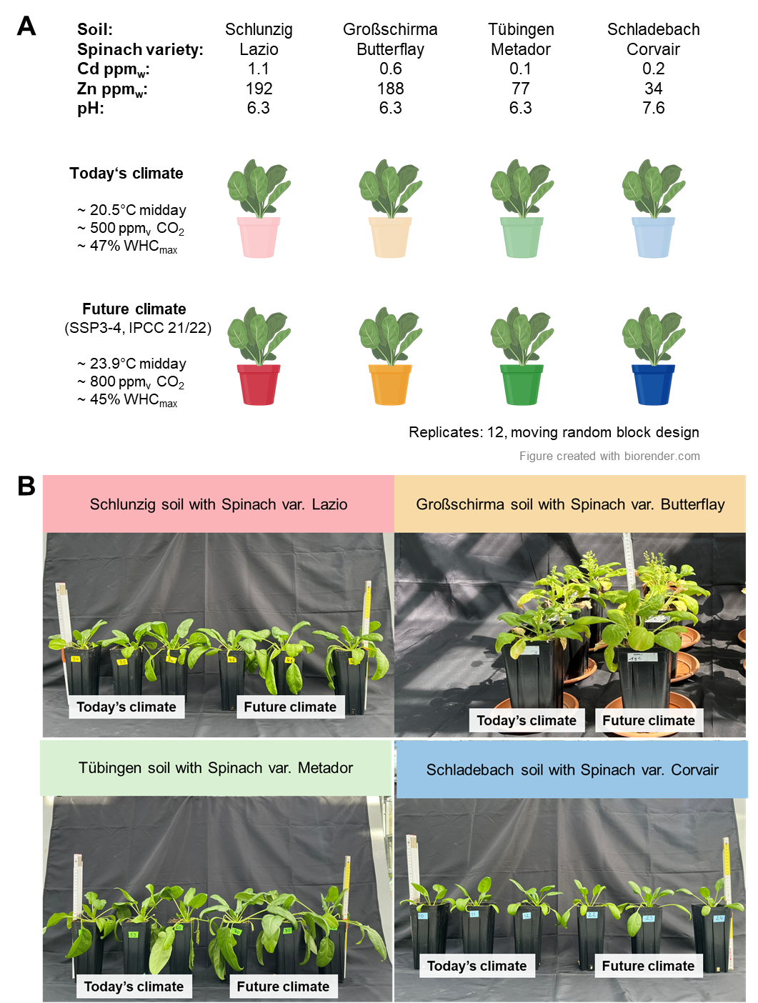
Figure S1. (A) Greenhouse pot study design of four soil-spinach combinations: Schlunzig soil with Spinach var. Lazio (red), Großschirma soil with Spinach var. Butterflay (yellow), Tübingen soil with Spinach var. Metador (green), Schladebach soil with Spinach var. Corvair (blue) under today’s and future climatic conditions. (B) Comparison of spinach grown under today’s (three pots on the left) and future climatic conditions (three pots on the right) at the end of experiments.

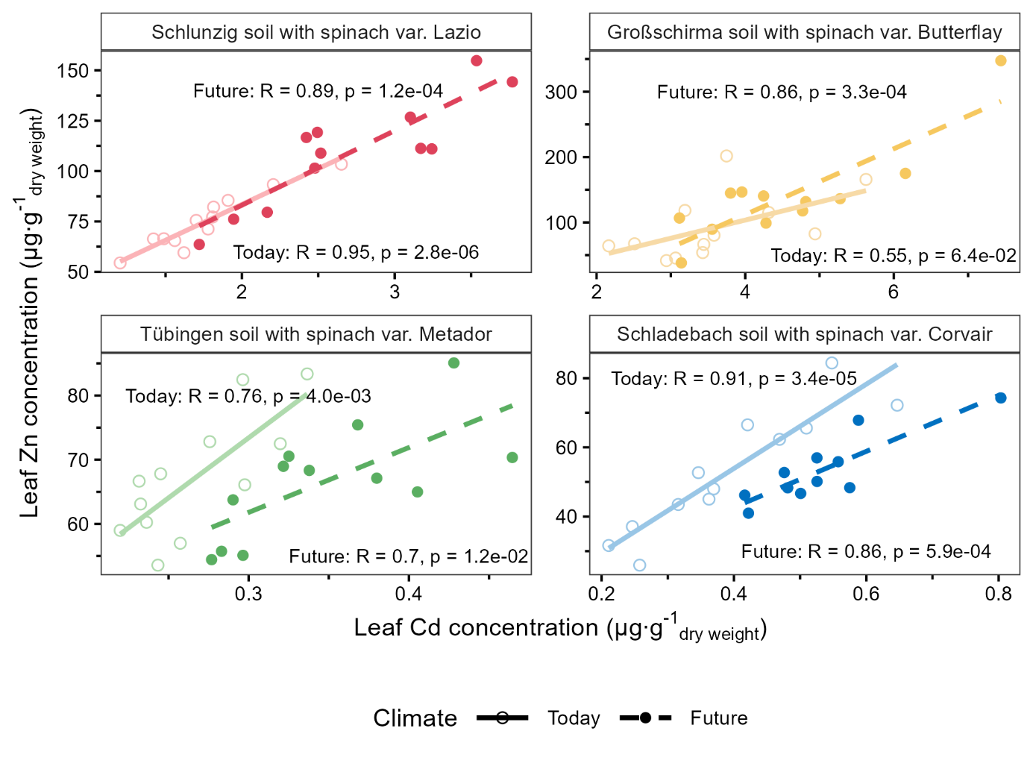
Figure S2. Pearson correlation of leaf cadmium and zinc concentrations. Leaf cadmium and zinc concentrations normalized to dry weight and total metal content normalized to edible yields of four soil-spinach combinations: Schlunzig soil with Spinach var. Lazio (red, Cd_{soil} = 1.1ppm_{w}, Zn_{soil} =192ppm_{w}), Großschirma soil with Spinach var. Butterflay (yellow, Cd_{soil} = 0.6ppm_{w}, Zn_{soil} =188ppm_{w}), Tübingen soil with Spinach var. Metador (green, Cd_{soil} = 0.2ppm_{w}, Zn_{soil} =77ppm_{w}), Schladebach soil with Spinach var. Corvair (blue, Cd_{soil} = 0.1ppm_{w}, Zn_{soil} =34ppm_{w}) under today’s (light colored empty symbols, dash model line, mid-day 20.5°C, 500 ppm_{v} CO₂, 47 % WHC_{max}) and future (dark colored filled symbols, solid model line, mid-day 23.9°C, 800 ppmv CO₂, 45 % WHC_{max}) climatic conditions. Twelve biological replicates were used to calculate the Pearson correlation coefficient (R) and p-values for the linear association between leaf cadmium and zinc.
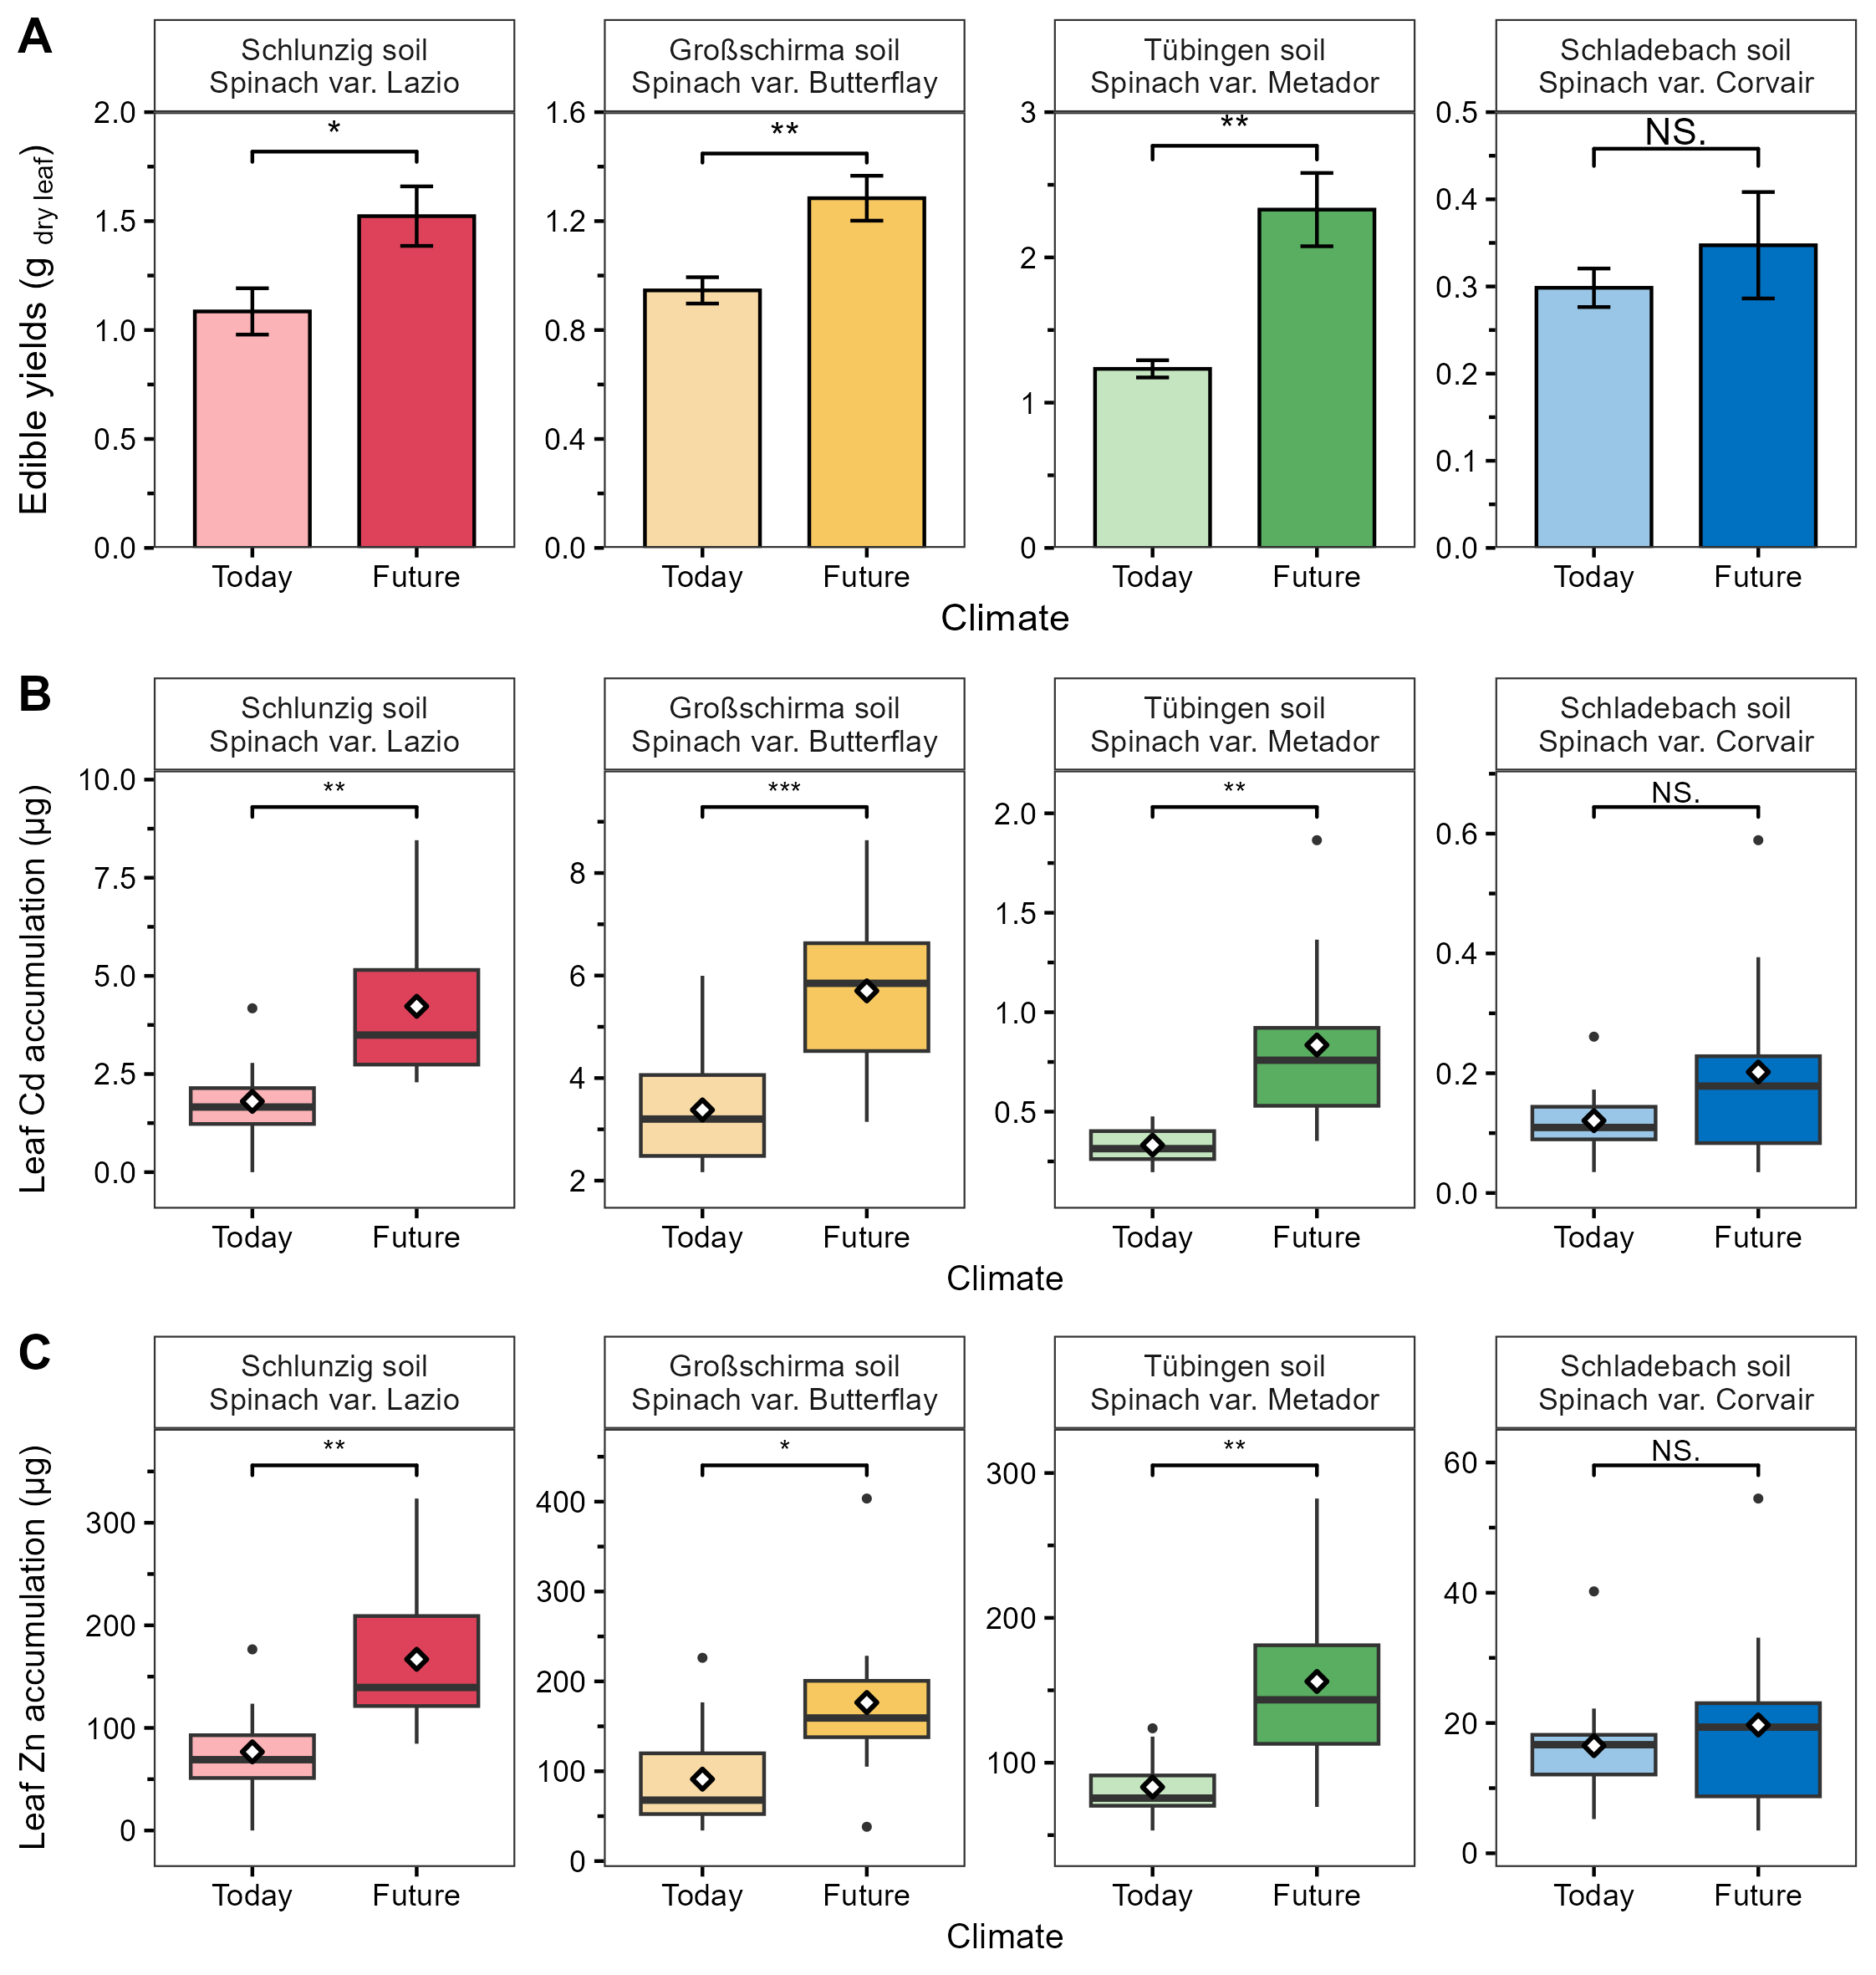
Figure S3. (A) Edible yields of spinach grown under different climatic conditions and (B) leaf cadmium accumulation and (C) leaf zinc accumulation. Edible yields normalized to dry weight and total spinach metal content normalized to edible yields of four soil-spinach combinations: Schlunzig soil with Spinach var. Lazio (red, Cd_{soil} = 1.1ppm_{w}, Zn_{soil} =192ppm_{w}), Großschirma soil with Spinach var. Butterflay (yellow, Cd_{soil} = 0.6ppm_{w}, Zn_{soil} =188ppm_{w}), Tübingen soil with Spinach var. Metador (green, Cd_{soil} = 0.2ppm_{w}, Zn_{soil} =77ppm_{w}), Schladebach soil with Spinach var. Corvair (blue, Cd_{soil} = 0.1ppm_{w}, Zn_{soil} =34ppm_{w}) under today’s (light color, mid-day 20.5°C, 500 ppm_{v} CO₂, 47 % WHC_{max}) and future (dark color, mid-day 23.9°C, 800 ppmv CO₂, 45 % WHC_{max}) climatic conditions. Twelve biological replicates, mean values ± standard errors were compared for climatic impact within each soil-spinach combination using t-test. The p-values are represented as follows: "***" = p < 0.001, "**" = p < 0.01, "*" = p < 0.05, and "NS" = p > 0.05.
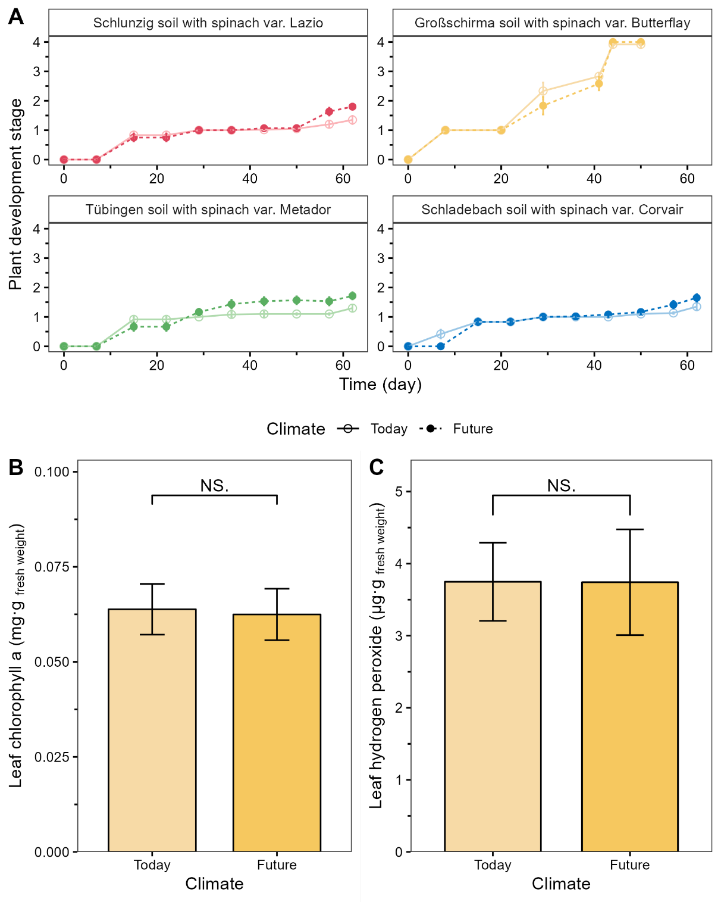
Figure S4. Performance of spinach grown under different climatic conditions (A) Developing stages of four soil-spinach combinations: Schlunzig soil with Spinach var. Lazio (red, Cd_{soil} = 1.1ppm_{w}, Zn_{soil} =192ppm_{w}), Großschirma soil with Spinach var. Butterflay (yellow, Cd_{soil} = 0.6ppm_{w}, Zn_{soil} =188ppm_{w}), Tübingen soil with Spinach var. Metador (green, Cd_{soil} = 0.2ppm_{w}, Zn_{soil} =77ppm_{w}), Schladebach soil with Spinach var. Corvair (blue, Cd_{soil} = 0.1ppm_{w}, Zn_{soil} =34ppm_{w}) under today’s (light colored continuous line, mid-day 20.5°C, 500 ppm_{v} CO2, 47 % WHC_{max}) and future (dark colored dashed line, mid-day 23.9°C, 800 ppm_{v} CO2, 45 % WHC_{max}) climatic conditions. Twelve biological replicates, mean values. The spinach development stages are denoted as numbers which represent: 0 – seeded, 1 – germination, 2 – cotyledons turn yellow, 3 – inflorescence emergence, 4 – seeds develop. (B, C) Plant health indicators of Großschirma soil with Spinach var. Butterflay (Cd_{soil} = 0.6 ppm_{w}, Zn_{soil} =188 ppm_{w}) under today’s (light color, mid-day 20.5°C, 500 ppmv CO₂, 47 % WHC_{max}) and future (dark color, mid-day 23.9°C, 800 ppm_{v} CO₂, 45 % WHC_{max}) climatic conditions at harvest. Twelve biological replicates; mean values ± standard errors were compared for climatic impact within each soil-spinach combination using t-test. The p-values are represented as follows: "***" = p < 0.001, "**" = p < 0.01, "*" = p < 0.05, and "NS" = p > 0.05.
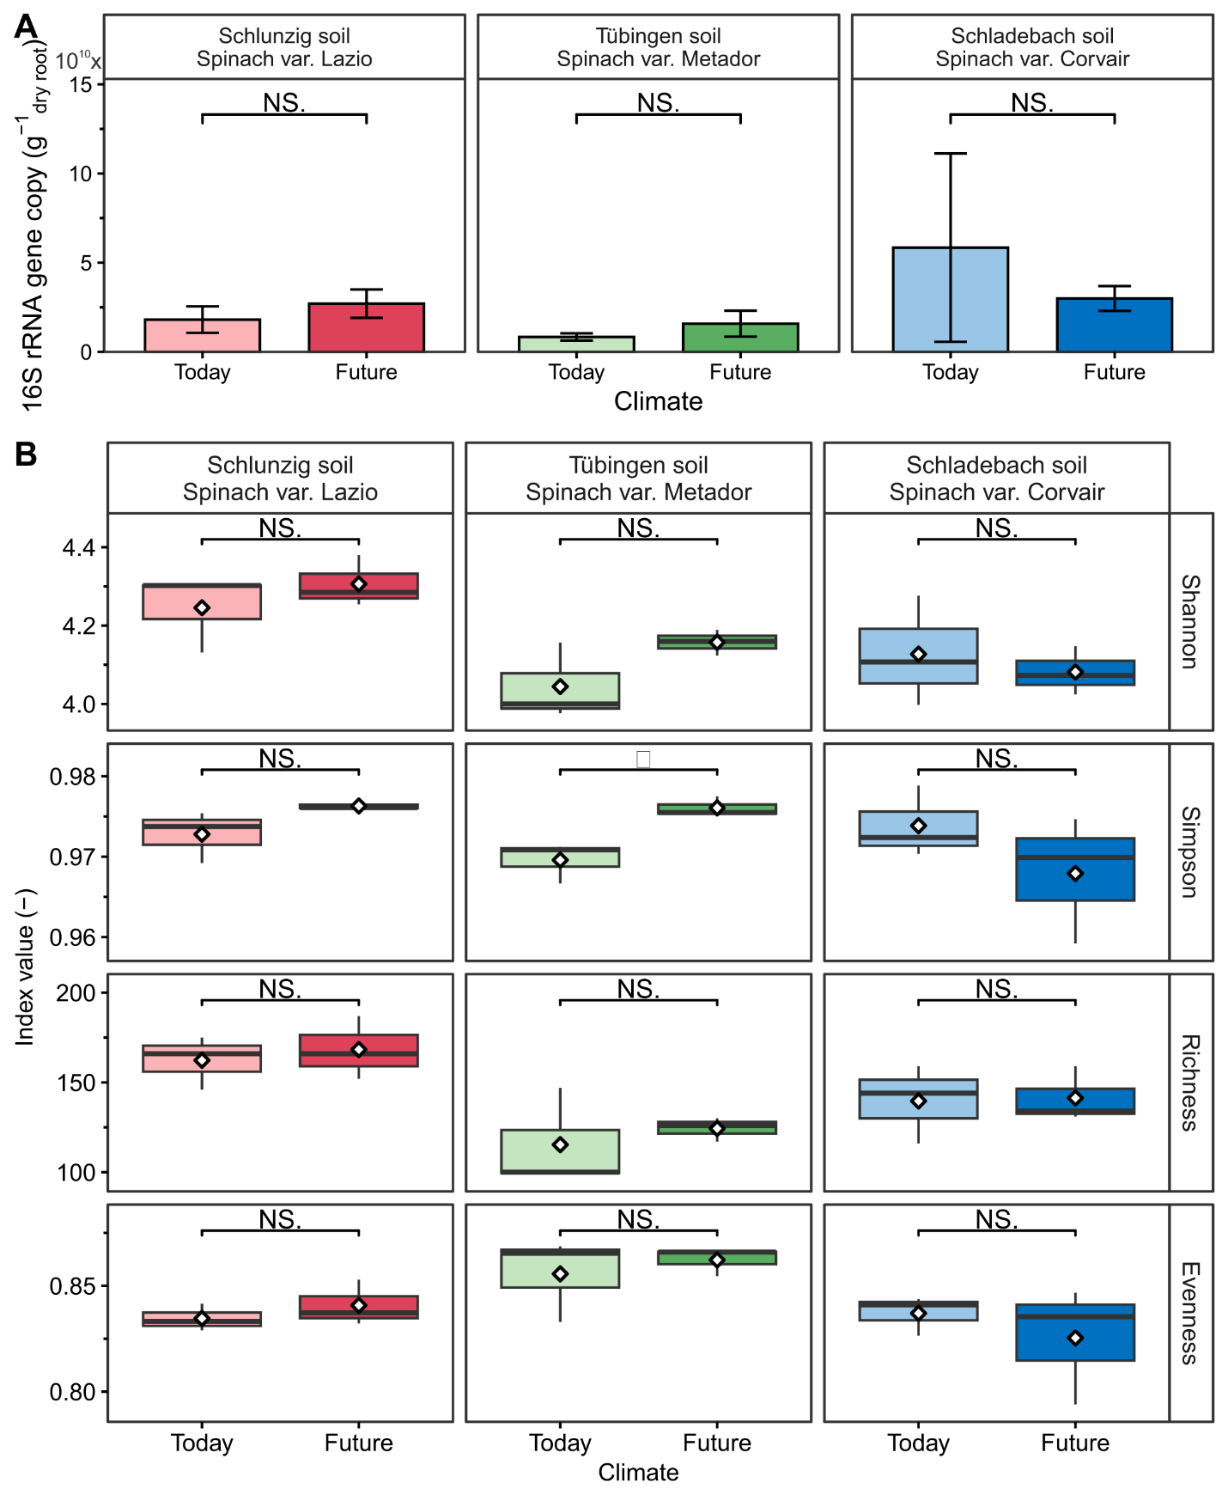
Figure S5. Root-associated microbiome abundance and diversity. (A) Bacterial 16S rRNA gene copy number (B) Shannon, simpson, richness and eveness indexes of root-associated microbial community at harvest (day 63) of three soil-spinach combinations: Schlunzig soil with Spinach var. Lazio (red, Cd_{soil} = 1.1ppm_{w}, Zn_{soil} =192ppm_{w}), Tübingen soil with Spinach var. Metador (green, Cd_{soil} = 0.2ppm_{w}, Zn_{soil} =77ppm_{w}), Schladebach soil with Spinach var. Corvair (blue, Cd_{soil} = 0.1ppm_{w}, Zn_{soil} =34ppm_{w}) under today’s (light color, mid-day 20.5°C, 500 ppm_{v} CO₂, 47 % WHC_{max}) and future (dark color, mid-day 23.9°C, 800 ppmv CO₂, 45 % WHC_{max}) climatic conditions. Three biological replicates, mean values ± standard errors were compared for climatic impact within each soil-spinach combination using t-test. The p-values are represented as follows: "***" = p < 0.001, "**" = p < 0.01, "*" = p < 0.05, and "NS" = p > 0.05.
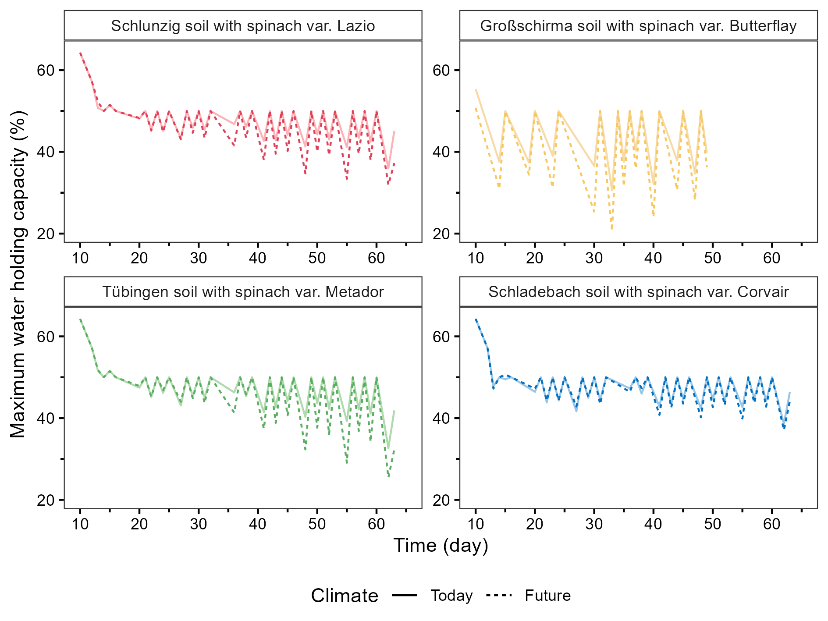
Figure S6. Percentage of maximum WHC of spinach after germination under regular irrigation. Gravimetric water content of soil under different climatic conditions. Soil gravimetric water content of four soil-spinach combinations: Schlunzig soil with Spinach var. Lazio (red, Cd_{soil} = 1.1ppm_{w}, Zn_{soil} =192ppm_{w}), Großschirma soil with Spinach var. Butterflay (yellow, Cd_{soil} = 0.6ppm_{w}, Zn_{soil} =188ppm_{w}), Tübingen soil with Spinach var. Metador (green, Cd_{soil} = 0.2ppm_{w}, Zn_{soil} =77ppm_{w}), Schladebach soil with Spinach var. Corvair (blue, Cd_{soil} = 0.1ppm_{w}, Zn_{soil} =34ppm_{w}) under today’s (light colored continuous line, mid-day 20.5°C, 500 ppm_{v} CO₂, 47 % WHC_{max}) and future (dark colored dashed line, mid-day 23.9°C, 800 ppm_{v} CO₂, 45 % WHC_{max}) climatic conditions. Twelve biological replicates, mean values.

1 An, Q. et al. Association between plant microbiota and cadmium uptake under the influence of microplastics with different particle sizes. Environment International 190, 108938 (2024).
2 Wu, Y. et al. Influence of bacterial community diversity, functionality, and soil factors on polycyclic aromatic hydrocarbons under various vegetation types in mangrove wetlands. Environmental Pollution 308, 119622 (2022).
3 Atashgahi, S. et al. Proteogenomic analysis of Georgfuchsia toluolica revealed unexpected concurrent aerobic and anaerobic toluene degradation. Environmental Microbiology Reports 13, 841-851 (2021).
4 Li, M., Zhang, J., Liang, S., Li, M. & Wu, H. Novel magnetic coupling constructed wetland for nitrogen removal: Enhancing performance and responses of plants and microbial communities. Science of the Total Environment 819, 152040 (2022).
5 Sharma, M., Khurana, H., Singh, D. N. & Negi, R. K. The genus Sphingopyxis: Systematics, ecology, and bioremediation potential-A review. Journal of Environmental Management 280, 111744 (2021).
6 She, J. et al. Survival strategies and dominant phylotypes of maize-rhizosphere microorganisms under metal (loid) s contamination. Science of The Total Environment 774, 145143 (2021).
7 Calderon, R. B. et al. Changes in the microbial community in soybean plots treated with biochar and poultry litter. Agronomy 11, 1428 (2021).
8 Wu, L. et al. Cooperation between partial-nitrification, complete ammonia oxidation (comammox), and anaerobic ammonia oxidation (anammox) in sludge digestion liquid for nitrogen removal. Environmental Pollution 254, 112965 (2019).
9 Seo, H., Kim, J. H., Lee, S.-M. & Lee, S.-W. The Plant-Associated Flavobacterium: A Hidden Helper for Improving Plant Health. The Plant Pathology Journal 40, 251 (2024).
10 Chen, S., Li, J., Zhuang, Q., Hu, Z. & Wang, Z. Cadmium alters the rhizosphere bacterial community structure in blueberry roots and increases the content of lipids in the soil. Rhizosphere 27, 100755 (2023).
11 LaForgia, M. L., Kang, H. & Ettinger, C. L. Invasive grass dominance over native forbs is linked to shifts in the bacterial rhizosphere microbiome. Microbial Ecology, 1-13 (2022).
12 Mohr, K. I., Garcia, R. O., Gerth, K., Irschik, H. & Müller, R. Sandaracinus amylolyticus gen. nov., sp. nov., a starch-degrading soil myxobacterium, and description of Sandaracinaceae fam. nov. International Journal of Systematic and Evolutionary Microbiology 62, 1191-1198 (2012).
13 Barth Natalja, F. H., Sinapius Ralf Boden-Dauerbeobachtungsprogramm des LfULG Sachsen (Sächsisches Landesamt für Umwelt, Landwirtschaft und Geologie, 2020).
14 Drabesch, S. et al. Climate induced microbiome alterations increase cadmium bioavailability in agricultural soils with pH below 7. Communications Earth & Environment 5, 637 (2024).

