SUPPLEMENTARY MATERIAL

Supplementary Table 1. Search strategy for systematic literature review.

Pubmed/Medline
Step | Search query | Results
#1 | ("Ataxia*" OR "Spinocerebellar Ataxias" OR "Machado-Joseph Disease" OR "Cerebellar Ataxia" OR "Gait Ataxia") | 607
#2 | ("SCA" OR "ATAXN*" OR "CACNA*" OR "TBP" OR "ATN" OR "PPP2R2B" OR "FGF" OR "BEAN1" OR "NOP56" OR "DAB1" OR "SPTBN2" OR "TTBK2" OR "KCN" OR "PRKCG" OR "ITPR1" OR "TMEM240" OR "PDYN" OR "PNPT1" OR "EEF2" OR "AFG3L2" OR "ELOVL*" OR "TGM6" OR "CCDC88C" OR "TRPC3" OR "MME" OR "GRM1" OR "FAT2" OR "PLD3" OR "PUM1" OR "STUB1" OR "SAMD9L" OR "NPTX1" OR "Ataxin") | 607
#3 | ("Prevalence" OR "Epidemiolog*" OR "Etiolog*" OR "Frecuen*" OR "Distribution" OR "Rate") | 607
#4 | ("Latin America" OR "LA" OR "South America" OR "Central America" OR "Belize" OR "Costa Rica" OR "El Salvador" OR "Guatemala" OR "Honduras" OR "Mexico" OR "Nicaragua" OR "Panama" OR "Argentina" OR "Bolivia" OR "Brazil" OR "Chile" OR "Colombia" OR "Ecuador" OR "French Guiana" OR "Guyana" OR "Paraguay" OR "Peru" OR "Suriname" OR "Uruguay" OR "Venezuela" OR "Cuba" OR "Dominican Republic" OR "Haiti" OR "Saint Kitts and Nevis" OR "Dominica" OR "Antigua and Barbuda" OR "Saint Vincent and the Grenadines" OR "Grenada" OR "Saint Lucia" OR "Barbados" OR "Bahamas" OR "Trinidad and Tobago") | 607
#5 | ("Animal" OR "Mouse" OR "Mice" OR "Zebrafish") | 607
Final | (#1 AND #2 AND #3 AND #4) NOT #5 | 607

LILACS
Step | Search query | Results
#1 | ("ataxia" OR "spinocerebellar ataxia" OR "autosomal dominant cerebellar ataxia" OR "hereditary ataxia" OR "Machado Joseph" OR "DRPLA" OR "cerebellar atrophy" OR "inherited ataxia" OR "cerebellar ataxia" OR "gait ataxia" OR "late onset cerebellar ataxia" OR "ILOCA" OR "episodic ataxia" OR "spastic ataxia" OR "early onset cerebellar ataxia" OR "ADCA") | 65
#2 | ("ATAXN" OR "CACNA" OR "TBP" OR "PPP2R2B" OR "BEAN1" OR "NOP56" OR "DAB1" OR "SPTBN2" OR "TTBK2" OR "PRKCG" OR "ITPR1" OR "TMEM240" OR "PDYN" OR "PNPT1" OR "EEF2" OR "AFG3L2" OR "ELOVL" OR "TGM6" OR "CCDC88C" OR "TRPC3" OR "MME" OR "GRM1" OR "FAT2" OR "PLD3" OR "PUM1" OR "STUB1" OR "SAMD9L" OR "NPTX1" OR "Ataxin") | 65
#3 | ("Prevalence" OR "Epidemiology" OR "Etiology" OR "Frequency" OR "Distribution" OR "Rate") | 65
#4 | ("Latin America" OR "LA" OR "South America" OR "Central America" OR "Belize" OR "Costa Rica" OR "El Salvador" OR "Guatemala" OR "Honduras" OR "Mexico" OR "Nicaragua" OR "Panama" OR "Argentina" OR "Bolivia" OR "Brazil" OR "Chile" OR "Colombia" OR "Ecuador" OR "French Guiana" OR "Guyana" OR "Paraguay" OR "Peru" OR "Suriname" OR "Uruguay" OR "Venezuela" OR "Cuba" OR "Dominican Republic" OR "Haiti" OR "Saint Kitts and Nevis" OR "Dominica" OR "Antigua and Barbuda" OR "Saint Vincent and the Grenadines" OR "Grenada" OR "Saint Lucia" OR "Barbados" OR "Bahamas" OR "Trinidad and Tobago") | 65
#5 | ("Animal" OR "Mouse" OR "Mice" OR "Zebrafish") | 65
Final | (#1 AND # 2 AND #3 AND #4)AND NOT #4 | 65

SCOPUS
Step | Search query | Results
#1 | TITLE-ABS-KEY ( "Ataxia" OR "Ataxias" OR "Spinocerebellar Ataxias" OR "Machado-Joseph Disease" OR "Cerebellar Ataxia" OR "Gait Ataxia" ) | 61
#2 | TITLE-ABS-KEY ( "SCA" OR "ATAXN*" OR "CACNA*" OR "TBP" OR "ATN" OR "PPP2R2B" OR "FGF" OR "BEAN1" OR "NOP56" OR "DAB1" OR "SPTBN2" OR "TTBK2" OR "KCN*" OR "PRKCG" OR "ITPR1" OR "TMEM240" OR "PDYN" OR "PNPT1" OR "EEF2" OR "AFG3L2" OR "ELOVL*" OR "TGM6" OR "CCDC88C" OR "TRPC3" OR "MME" OR "GRM1" OR "FAT2" OR "PLD3" OR "PUM1" OR "STUB1" OR "SAMD9L" OR "NPTX1" OR "Ataxin" ) | 61
#3 | TITLE-ABS-KEY ( "Prevalence" OR "Epidemiolog*" OR "Etiolog*" OR "Frecuen*" OR "Distribution" OR "Rate" ) | 61
#4 | TITLE-ABS-KEY ( "Latin America" OR "LA" OR "South America" OR "Central America" OR "Belize" OR "Costa Rica" OR "El Salvador" OR "Guatemala" OR "Honduras" OR "Mexico" OR "Nicaragua" OR "Panama" OR "Argentina" OR "Bolivia" OR "Brazil" OR "Chile" OR "Colombia" OR "Ecuador" OR "French Guiana" OR "Guyana" OR "Paraguay" OR "Peru" OR "Suriname" OR "Uruguay" OR "Venezuela" OR "Cuba" OR "Dominican Republic" OR "Haiti" OR "Saint Kitts and Nevis" OR "Dominica" OR "Antigua and Barbuda" OR "Saint Vincent and the Grenadines" OR "Grenada" OR "Saint Lucia" OR "Barbados" OR "Bahamas" OR "Trinidad and Tobago") | 61
#5 | TITLE-ABS-KEY ( "Animal" OR "Mouse" OR "Mice" OR "Zebrafish" ) | 61
Final | #1 AND # 2 AND #3 AND #4 AND NOT #5 | 61

SCIELO
Step | Search query | Results
#1 | ("Ataxia" OR "Ataxias" OR "Spinocerebellar Ataxias" OR "Ataxia cerebelosa" OR "Ataxia de la marcha") | 23
#2 | ("Prevalencia" OR "Epidemiología" OR "Etiología" OR "Frecuencia" OR "Distribución" OR "Tasa") | 23
#3 | ("América Latina" OR "Centroamérica" OR "América del Sur" OR "Belice" OR "Costa Rica" OR "El Salvador" OR "Guatemala" OR "Honduras" OR "México" OR "Nicaragua" OR "Panamá" OR "Argentina" OR "Bolivia" OR "Brasil" OR "Chile" OR "Colombia" OR "Ecuador" OR "Guayana Francesa" OR "Guyana" OR "Paraguay" OR "Perú" OR "Surinam" OR "Uruguay" OR "Venezuela" OR "Cuba" OR "República Dominicana" OR "Haití" OR "Saint Kitts and Nevis" OR "Dominica" OR "Antigua and Barbuda" OR "Saint Vincent and the Grenadines" OR "Grenada" OR "Saint Lucia" OR "Barbados" OR "Bahamas" OR "Trinidad and Tobago") | 23
Final | #1 AND #2 AND #3 | 23

WEB OF SCIENCE
Step | Search query | Results
#1 | AB=“ataxia” OR AB=“spinocerebellar ataxia” OR AB="autosomal dominant cerebellar ataxia" OR AB="hereditary ataxia" OR AB="Machado Joseph" OR AB="DRPLA" OR AB="cerebellar atrophy" OR AB="inherited ataxia" OR AB="cerebellar ataxia" OR AB="gait ataxia" OR AB="late onset cerebellar ataxia" OR AB="ILOCA" OR AB="episodic ataxia" OR AB="spastic ataxia" OR AB="early onset cerebellar ataxia" OR AB="ADCA" | 47
#2 | AB="SCA*" OR AB="ATAXN*" OR AB="CACNA*" OR AB="TBP" OR AB="ATN*" OR AB="PPP2R2B" OR AB="FGF*" OR AB="BEAN1" OR AB="NOP56" OR AB="DAB1" OR AB="SPTBN2" OR AB="TTBK2" OR AB="KCN*" OR AB="PRKCG" OR AB="ITPR1" OR AB="TMEM240" OR AB="PDYN" OR AB="PNPT1" OR AB="EEF2" OR AB="AFG3L2" OR AB="ELOVL*" OR AB="TGM6" OR AB="CCDC88C" OR AB="TRPC3" OR AB="MME" OR AB="GRM1" OR AB="FAT2" OR AB="PLD3" OR AB="PUM1" OR AB="STUB1" OR AB="SAMD9L" OR AB="NPTX1" OR AB="Ataxin" | 47
#3 | AB="Prevalence" OR AB="Epidemiolog*" OR AB="Etiolog*" OR AB="Frecuen*" OR AB="Distribution" OR AB="Rate" | 47
#4 | AB="Latin America" OR AB="LA" OR AB="South America" OR AB="Central America" OR AB="Belize" OR AB="Costa Rica" OR AB="El Salvador" OR AB="Guatemala" OR AB="Honduras" OR AB="Mexico" OR AB="Nicaragua" OR AB="Panama" OR AB="Argentina" OR AB="Bolivia" OR AB="Brazil" OR AB="Chile" OR AB="Colombia" OR AB="Ecuador" OR AB="French Guiana" OR AB="Guyana" OR AB="Paraguay" OR AB="Peru" OR AB="Suriname" OR AB="Uruguay" OR AB="Venezuela" OR AB="Cuba" OR AB="Dominican Republic" OR AB="Haiti" AB="Saint Kitts and Nevis" OR AB="Dominica" OR AB="Antigua and Barbuda" OR AB="Saint Vincent and the Grenadines" OR AB="Grenada" OR AB="Saint Lucia" OR AB="Barbados" OR AB="Bahamas" OR AB="Trinidad and Tobago" | 47
#5 | AB=("animal study" OR "in vitro" OR "cell culture" OR "mouse model" OR "clinical trial") | 47
Final | (#1 AND #2 AND #3 AND #4) NOT #5 | 47

*Results until January 21st, 2025

Supplementary Table 2. Risk of bias assessment.

Bias domain
 |  |  |  | External Validity |  |  |  | Internal Validity
Author, year | Was the study‟s target population a close representation of the national population in relation to relevant variables? | Was the sampling frame a true or close representation of the target population? | Was some form of random selection used to select the sample, OR, was a census undertaken? | Was the likelihood of non-response bias minimal? | Were data collected directly from the subjects? | Was an acceptable case definition used in the study? | Was the study instrument that measured the parameter of interest shown to have reliability and validity? | Was the same mode of data collection used for all subjects? | Was the length of the shortest prevalence period for the parameter of interest appropriate? | Were the numerator(s) and denominato r(s) for the parameter of interest appropriate? | Summary item on the overall risk of study bias
Alonso 2007 | Low risk | Low risk | High risk | High risk | Low risk | Low risk | High risk | Low risk | Low risk | High risk | Moderate risk of bias
Alvarenga 2022 | High risk | High risk | High risk | High risk | Low risk | Low risk | High risk | Low risk | High risk | High risk | High risk of bias
Cornejo-Olivas 2020 | Low risk | Low risk | High risk | High risk | Low risk | Low risk | High risk | Low risk | Low risk | High risk | Moderate risk of bias
Cornejo-Olivas 2022 | Low risk | Low risk | High risk | High risk | Low risk | Low risk | High risk | Low risk | Low risk | High risk | Moderate risk of bias
de Castilhos 2014 | Low risk | Low risk | High risk | High risk | Low risk | Low risk | High risk | Low risk | Low risk | High risk | Moderate risk of bias
Magaña 2014 | High risk | High risk | Low risk | High risk | Low risk | Low risk | High risk | Low risk | Low risk | High risk | High risk of bias
Massuyama 2024 | High risk | Low risk | High risk | High risk | Low risk | Low risk | High risk | Low risk | Low risk | High Risk | High risk of bias
Miranda 2015 | High risk | High risk | High risk | High risk | Low risk | Low risk | High risk | Low risk | High risk | High risk | High risk of bias
Moraes 2023 | High risk | High risk | Low risk | High risk | Low risk | Low risk | High risk | High risk | Low risk | High risk | High risk of bias
Nascimiento 2019 | High risk | High risk | High risk | High risk | Low risk | Low risk | High risk | Low risk | Low risk | High risk | High risk of bias
Novis 2023 | Low risk | Low risk | High risk | High risk | Low risk | Low risk | High risk | Low risk | High risk | High risk | High risk of bias
Paradisi 2016 | Low risk | Low risk | High risk | High risk | Low risk | Low risk | High risk | Low risk | Low risk | High risk | Moderate risk of bias
Perez Maturo 2020 | High risk | High risk | High risk | High risk | High risk | Low risk | High risk | Low risk | Low risk | High risk | High risk of bias
Pinto 2021 | High risk | High risk | High risk | High risk | Low risk | Low risk | High risk | Low risk | Low risk | High risk | High risk of bias
Velazquez Perez 2009 | Low risk | Low risk | High risk | High risk | Low risk | Low risk | High risk | Low risk | Low risk | High risk | Moderate risk of bias
Velazquez Perez 2020 | Low risk | Low risk | High risk | High risk | Low risk | Low risk | High risk | Low risk | Low risk | High risk | Moderate risk of bias
Zeigelboim 2015 | High risk | High risk | High risk | High risk | Low risk | Low risk | High risk | Low risk | High risk | High risk | High risk of bias

Supplementary Table 3. Certainty of evidence assessment (GRADE).

Meta-analysis | Patients (studies), N | Pooled rate (95% CI) | Certainty
SCA prevalence | 2597  (11 non-randomised studies) | 0.61 (0.31 to 0.84) | ⨁⨁◯◯  Low^{a,b,c}
SCA2 prevalence | 1684  (13 non-randomised studies) | 0.30 (0.11 to 0.59) | ⨁⨁◯◯  Lowª
MJD/SCA3 prevalence | 977  (13 non-randomised studies) | 0.34 (0.14 to 0.62) | ⨁◯◯◯  Very lowª
SCA10 | 165  (8 non-randomised studies) | 0.09 (0.03 to 0.24) | ⨁⨁◯◯  Low
a. Assessed by the tool developed by Hoy et al.
b. 95% CI (random effect).
c. Doi Plots and LFK index.

Supplementary Figure 1. Preferred Reporting Items for Systematic Reviews and Meta-Analyses (PRISMA) flowchart of the study selection process [1].

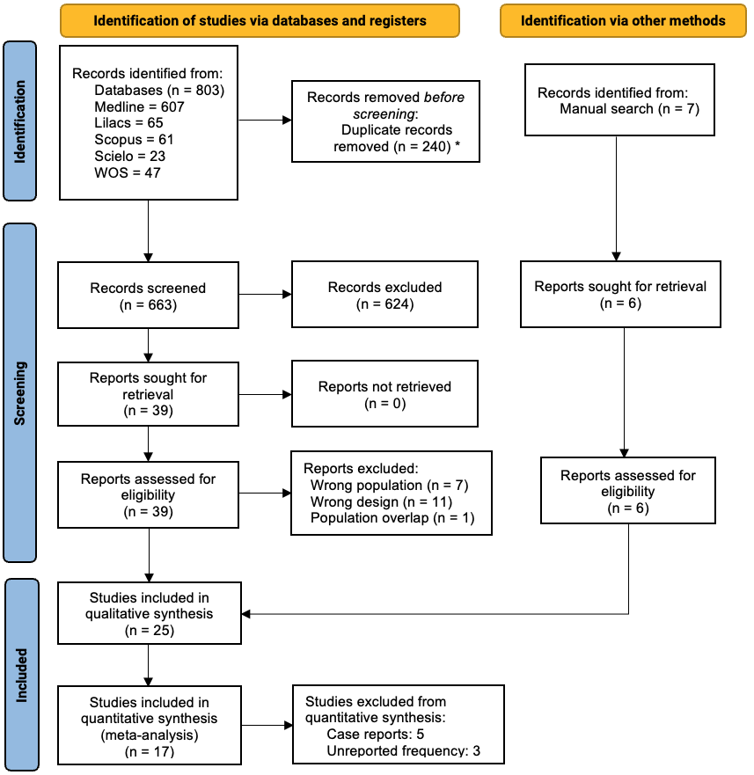
*with automation tool.

Supplementary Figure 2. Publication bias assessment through Doi plots and the LFK index for (A) all SCAs meta-analysis, (B) SCA3, (C) SCA2, (D) SCA10.

A. 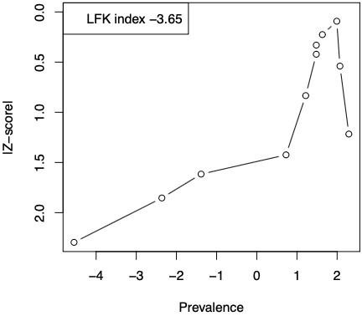 B. 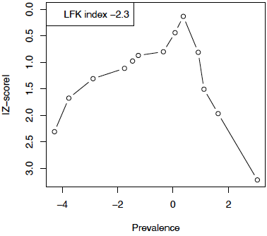

C. 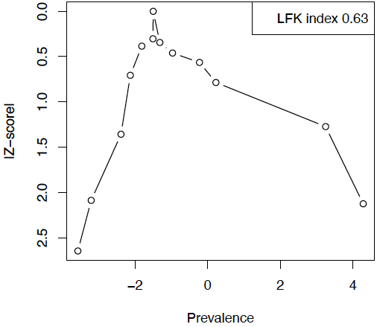 D. 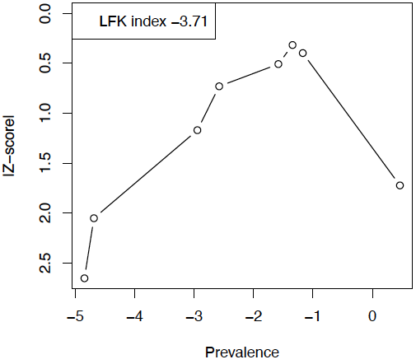

Abbr.: LFK, Luis Furuya-Kanamori; SCA, spinocerebellar ataxia.

