Supplemental materials

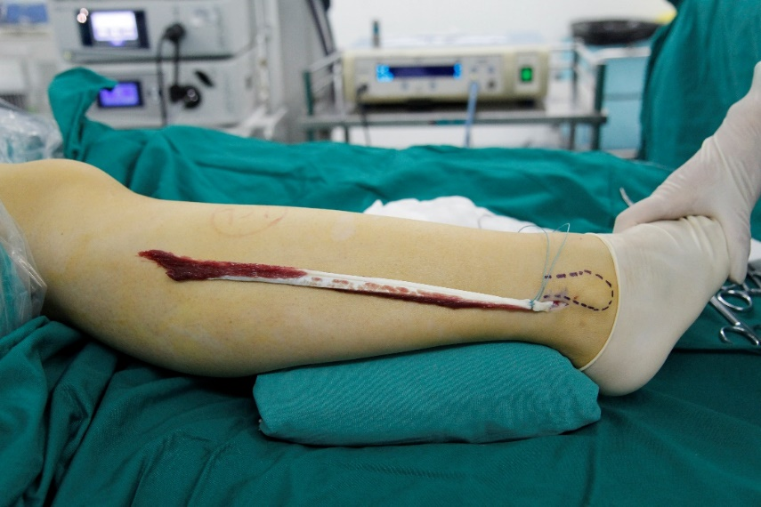

Supplemental Figure 1. Harvest of Peroneus longus tendon for reconstruction.
The full thickness and whole length of peroneus longus tendon proximal to the lateral malleolus was harvested and prepared for various reconstructive procedures.

Supplemental Figure 2. Phase contrast images of human muscle stem/progenitor cells before and after differentiation induction. Scale bars, 100μm.

Supplemental Figure 3. The surgery in mice mimicking human tendon removal.
Tendon was completely removed from mouse. Scale bars: 1mm.

Supplemental Figure 4. Murine muscle stem cells barely have tendon differentiation potential.
- Scheme of lineage tracing.
- Immunofluorescence staining of tendon tissue 4 months after injury. tdTomato+ cells indicated cells originated from Pax7+ muscle stem cells. TNC+ cells indicated tendon cells. MyHC+ cells indicated skeletal muscle cells. DAPI indicated nuclei staining. Merge indicated merged images of tdTomato, TNC, MyHC, and DAPI. The upper panel indicated lower magnification images. Scale bar: 100µm. The lower panel indicated the higher magnification images. Scale bar: 10µm.
- The statistical analysis of the percentage of TNC+ tdTomato+ cells in tendon tissue.
- Immunofluorescence staining of murine muscle stem cells directed towards myogenic or tenogenic differentiation. The undifferentiated murine muscle stem cells were stained with Pax7 and DAPI. Murine muscle stem cells after myogenic differentiation were stained with MyHC and DAPI. Murine muscle stem cells after tenogenic differentiation were stained with Scx and DAPI. Scale bars: 100µm.
- Relative expression levels of Col I, Scx, and Myh1 in murine muscle stem cells after myogenic and tenogenic differentiation, respectively. RT-qPCR assays were performed with mouse muscle stem cells before and after myogenic and tenogenic differentiation, respectively. Error bars indicated standard error and based on 4 independent experiments. *** indicated p<0.005; ** indicated p<0.01; * indicated p<0.05; ns indicated no significant changes.
- Scheme of murine muscle stem cell transplantation.
- Immunofluorescence staining of tendon tissue 2 months after injury. tdTomato+ cells indicated transplanted mouse muscle stem cells. TNC+ cells indicated tendon cells. MyHC+ cells indicated skeletal muscle cells. DAPI indicated nuclei staining. Merge indicated merged images of tdTomato, TNC, MyHC, and DAPI. The upper panel indicated lower magnification images. Scale bar: 100µm. The lower panel indicated the higher magnification images. Scale bar: 10µm.
- Statistical analysis of TNC+ tdTomato+ cells in tendon tissue.

Supplemental Figure S5. Human muscle stem/progenitor cells differentiate to skeletal muscle efficiently in vivo.
- The scheme of human muscle stem/progenitor cell transplantation.
- Immunofluorescence staining of human cells in regenerated mouse skeletal muscle. Lmainin staining indicated myofibers; Hu-Lamin A/C indicated human specific Lamin A/C representing cells with human origin. Scale bar: 100μm.
- The statistical analysis of human muscle stem/progenitor cells engrafted in the skeletal muscle of recipient mice. Error bars indicated standard error based on 5 independent experiments.

Supplemental Figure 6. Murine muscle stem cells fail to differentiate tendon after transplantation.
- The scheme of transplantation.
- Immunofluorescence staining of TNC and MyHC in tendon tissue. Mouse muscle stem cells constitutively expressing tdTomato were transplanted to pre-injured tendon in SCID recipient mice. TNC+ cells represented tendon cells; MyHC+ cells indicated skeletal muscle cells. Scale bar: 100μm.
- Statistical analysis of tendon cells differentiated from transplanted murine muscle stem cells. Error bars indicated standard error based on 5 independent experiments.
- Immunofluorescence staining of Laminin in regenerated skeletal muscle. Mouse muscle stem cells constitutively expressing tdTomato were transplanted to pre-injured TA muscle in SCID recipient mice. Laminin indicated the shape of myofiber. Scale bar: 100μm.
- Statistical analysis of transplanted tdTomato+ mouse muscle stem cells engrafted in pre-injured TA muscle in SCID recipient mice. Scale bar: 100μm.

