Supporting Information
Sustained Release of Dual p38 Inhibitors via Supramolecular Hydrogels to Enhance Cardiac Repair after MI/R Injury
Di Wang^{1,2#}, Aoxue Xu^{1,2#,} Haitao Su^{1,2#}, Youpei Zhang³, Lingling Jiang^{1,2}, Yaguang Wang^{1,2*}, Gaolin Liang^{4*}, Ye Zhang^{1,2*}
¹ Department of Anesthesiology and Perioperative Medicine, The Second Affiliated Hospital of Anhui Medical University, 678 Furong Road, Hefei, 230601, China
² Key Laboratory of Anesthesiology and Perioperative Medicine of Anhui Higher Education Institutes, Anhui Medical University, 678 Furong Road, Hefei, 230061, China
³ School of Materials Science and Engineering, Nankai University, Tianjin, 300350, China
⁴ State Key Laboratory of Bioelectronics School of Biological Sciences and Medical Engineering Southeast University, 2 Sipailou Road, Nanjing, 210096, China.
# These three authors contributed equally to this work as the first authors.
*Correspondence authors:
Yaguang Wang: wangyaguang@ahmu.edu.cn; Gaolin Liang: gliang@seu.edu.cn; Ye Zhang: zhangy@ahmu.edu.cn.

Contents
1. General methods
2. Solid-Phase Peptide Synthesis of Nap-TGY and Nap-AGY
3. Syntheses of Nap-TGY and Nap-AGY
4. Supporting Figures
1. General methods
Experimental antibodies and instruments
The anti-p38 MAPK antibodies (#9212), anti-phospho-p38 MAPK antibodies (#9216), anti-Erk1/2 MAPK antibodies (#4695), anti-phospho-Erk antibodies (#9101), anti-caspase3 antibodies (#9662), and anti-Cleaved Caspase3 antibodies (#9661) were obtained from Cell Signaling Technology (Danvers, MA, USA). The anti-cardiac troponin T/cTnT (15513-1-AP), anti-GAPDH (60004-1-Ig) antibodies were from Proteintech Group (Rosemont, IL, USA), anti-CD31 (sc-13537), and anti-vWF (sc-365712) antibodies were from Santa Cruz Biotechnology (Dallas, TX, USA). The anti-Bcl-2 antibodies (#AF6139) and anti-Bax antibodies (#AF0120) were purchased from Affinity Biosciences. A secondary antibody formulation based on horseradish peroxidase (HRP)-conjugated anti-mouse (31430) and anti-rabbit (3146) was purchased from Thermo Fisher Scientific (Waltham, USA). The p38 MAPK inhibitor SB202190 was purchased from Selleck Chemicals (Houston, Texas, USA). The goat anti-Mouse IgG (H+L) Cross-Adsorbed Secondary Antibody (A-11001, Alexa FluorTM 488) and goat anti-Rabbit IgG (H+L) Cross-Adsorbed Secondary Antibody (A-11011, Alexa FluorTM 568) were obtained from Invitrogen (Waltham, MA, USA). The Lipopolysaccharides (LPS) were purchased from Solarbio Life Science (Shanghai, China).
The hydrogelators was synthesized using solid-phase peptide synthesis. The reagents required for the synthesis include 2-Chlorotrityl chloride resin, Fmoc protected amino acid, O-benzotriazole-N, N, N', N'-tetramethyl-uronium-hexafluorophosphate (HBTU) were purchased from GL Biochem Co., Ltd. (Shanghai, China). Furthermore, DIPEA and trifluoroacetic acid (TFA) were purchased from Sigma-Aldrich Co., Ltd. (Shanghai, China). All the reagents used were commercially available without further purification. For various experiments, Merck Millipore systems (Billerica, MA, USA) purified deionized water. Additionally, Gel Nap-TGY was characterized by high resolution mass spectrometry (HR-MS). ¹H NMR and ¹³C NMR spectrum were recorded on a Varian Mercury plus 400. The circular dichroism (CD) spectra were obtained with a Chirascan V100 (Applied Photophysics, Co., Ltd., England). An MCR 302e Rotational Rheometer (Anton Paar GmbH) was used to examine rheology using a cone-and-plate geometry with a gap of 370 microns.

TEM sample preparation
Transmission electron microscopy (TEM) of Gel Nap-TGY and Gel Nap-TGY+SB was performed on 200-mesh carbon-coated copper grids for 2 minutes each. The grids were then rinsed with ultrapure water for 20 seconds. These TEM images were taken with a Talos L120C G2 transmission electron microscope (Thermo Fisher Scientific, Waltham, USA) after they were air-dried at room temperature.

Cell culture
The two cell lines, RAW264.7 macrophages and H9C2 cells were used in the experiments. Cells were cultured in Dulbecco's modified Eagle's medium (Gibco, GI, USA) containing 10% fetal bovine serum, 25 mM glucose, 4.0 mM L-glutamine, 1% sodium pyruvate, and 1% penicillin-streptomycin, respectively. These cells were maintained at 37 °C with 5% CO2 in a direct heating CO2 incubator. The culture medium was changed every two days.

CCK8 assay
Macrophages and H9C2 cells were seeded and cultured at 5×10³ cells per well in a 96-well plate for 24 hours. Cell Counting Kit-8 (CCK8) was used to determine the cytotoxicity of Gel Nap-TGY after 24 and 48 hours. As the cells were cultivated in the incubator, they were treated with different concentrations of the following groups (6.25 µM, 12.5 µM, 25 µM, 50 µM, 100 µM, 200 µM). A similar cytotoxicity assessment of Nap-AGY was done at different dose levels (6.25 µM, 12.5 µM, 25 µM, 50 µM, 100 µM, 200 µM) using the CCK8 assay. After 24 hours of co-culture with different concentrations of hydrogel, the cells were incubated at 37 °C for 2 hours with 10% CCK8 (10 µl per well, Beyotime, Shanghai, China). Finally, the multifunction board reader (VL0000D1, Thermo Fisher Scientific, Waltham, USA) measured the absorption level of the sample at 450 nm wavelength, which indirectly reflects the number of viable cells in the sample. The experiments were repeated three times.

Cell treatment
For the corresponding experiment, the cell was placed in a 60-mm dish. After waiting for logarithmic growth of the cells, a density of 3×10⁴ each well, Gel Nap-TGY was added in the medium. The cell culture fluid was carried out and washed by phosphate-buffered saline (PBS) after all treatments including the above groups (Nap-TGY 25 µM,50 µM,100 µM) and SB202190 (20 µM) in DMEM for 2 hours. The expression of p-p38 was detected by immunofluorescence and western blot after 24 hours of culture.

Cell western bolt analysis
Upon collection, the cells were washed with phosphate-buffered saline (PBS), and lysed with RIPA lysis buffer [50 mM Tris (pH 7.4), 150 mM NaCl, 1% Triton X-100, 1% sodium deoxycholate, 0.1% SDS and 1 mM EDTA (pH 8.0)] supplemented with protease and phosphatase inhibitors (Beyotime, Beijing, China) and 1 mM phenylmethylsulfonyl fluoride (PMSF). The concentration of protein was determined using Bicinchoninic Acid Assay Reagent (Solabio Life Science, Shanghai, China), equal amounts of protein (40 µg) were separated on 10% SDS–polyacrylamide gel electrophoresis, electrically transferred onto a polyvinylidene fluoride membrane (Millipore, Billerica, MA, USA) by electroblotting, and blocked with 5% skim milk (Inner Mongolia Yili Industrial Group Co., Ltd., Inner Mongolia, China). After being washed twice with TBST buffer (Tris-Buffered Saline Tween-20), membranes were incubated with primary antibodies overnight with shaking at 4 °C. Incubation and washing were repeated three times, and then secondary antibody-conjugated horseradish peroxidase was incubated for one hour at room temperature. In the final step, the membranes were washed with TBST three times, and then incubated with SuperSignal West Femto western blotting substrate (Thermo Fisher Scientific, MA, USA), and images were presented and recorded using the automatic multifunctional imaging system (Tanon 4600, Shanghai, China).

Cell immunofluorescence
In 24-well plates, 14 mm round cell coverslips were coated with L-Lysine homopolymer hydrobromide. For the next step of the experiment, macrophages were added for incubation and attached to the wall. For the control group, PBS was added to the culture medium and treated for 2 hours, unlike the other groups, which added Gel Nap-TGY, SB, or Gel Nap-TGY+SB. Upon completion of the treatment time, LPS (1 µg/ml) will be co-cultured with the medium for an additional 24 hours. The media was removed after the manipulation above, and the cell layers were collected after being washed twice with PBS. To prepare the pore plates for fluorescent staining, 4% formaldehyde was added and the cells were fixed for 15 minutes before staining. After stabilization, paraformaldehyde was discarded and washed three times with PBS. The cells were then blocked for 60 minutes in blocking buffer with 0.3% Triton-100 and 5% bovine serum albumin (BSA). After blocking, the corresponding primary antibody was added and incubated at 4 ℃ overnight. The next day, the primary antibody was aspirated and washed three times with PBS. To configure fluorescein-labeled secondary antibodies, antibody diluents were used and the sample was incubated under dark conditions for two hours. In the end, the piece was sealed with anti-fade mounting medium with DAPI (Beyotime, Shanghai, China) and the images were scanned using the full slide scanner (Olympus VS200, TKY, Japan). All fluorescence results were analyzed by ImageJ software (National Institutes of Health, MD, USA).

Degradation of the Gel Nap-TGY in vivo
To determine the retention effect of Gel Nap-TGY in vivo, TMR-NHS was used to label the SB. The TMR-NHS (5/6-Carboxy-tetramethylrhodamine N-succinimidyl ester) was purchased from Thermo Fisher Scientific Co. Ltd. The hearts, livers, spleens, lungs, and kidneys were removed on the first, third, and fifth days following TMR or Gel-TMR injection, and fixed with 4% paraformaldehyde in PBS for photography. Once the above major organs had been removed, the fluorescence of TMR was observed with a small animal live imaging system (SI Imaging AmiX, Spectral Instruments Imaging, Arizona, USA).

Release of Gel Nap-TGY+SB in vitro
The amount of SB released by Gel Nap-TGY+SB over time was conducted using HPLC, which detected its peak and computed the cumulative release rate. Specifically, 500 µl of PBS (pH 7.4) was added into 100 µl of Gel Nap-TGY+SB, which then incubated together at 37 °C for 24 hours. On the first day, 500 µl of supernatant were extracted from the mixed solution for inspection, followed by the addition of another 500 µl of PBS. This procedure was repeated on subsequent days (day 3, day 5, day 7 and day 10), maintaining the same volume of fresh PBS each time the supernatant was obtained. The concentration of SB in the supernatant was monitored by HPLC, and the efficiency of release was calculated.
Additionally, to test whether Gel Nap-TGY+SB could be selectively disassembled by phosphorylated p38, the LPS-induced macrophage model was employed. In brief, after co-incubation of LPS (1 µg/ml) with macrophages for 24 hours, the cell culture supernatant (SN) was collected. Subsequently, 500 µl fresh SN was combined with 100 µL Gel Nap-TGY+SB and incubated for 24 hours. The subsequent steps followed a similar procedure as described previously. HPLC purification was performed utilizing a Shimazu UFLC system that equipped with two LC-20AP pumps and an SPD-20A UV/vis detector, alongside a Shimazu PRC-ODS column.

2. Solid-Phase Peptide Synthesis of Nap-TGY and Nap-AGY
The compounds Nap-TGY and Nap-AGY were synthesized with solid-phase peptide synthesis, and protecting groups were removed with 95% TFA in CH₂Cl₂ for 4 h. Pure product Nap-TGY and Nap-AGY were obtained after HPLC purification.
Calculated for compound Nap-TGY [(M+H⁺)]: 802.3407; found ESI-MS (m/z) [(M+H⁺)]: 802.3450. Calculated for compound Nap-AGY [(M+H⁺)]: 772.3302, [(M+Na⁺)]: 794.3268; found ESI-MS (m/z) [(M+H⁺)]: 772.3344, [(M+Na⁺)]: 794.3159.
¹H NMR spectrum of Nap-TGY (400 MHz, DMSO-d6) δ: 9.27 (s, 1H), 8.38 – 8.29 (m, 2H), 8.10 (d, J = 7.9 Hz, 1H), 7.98 (d, J = 8.3 Hz, 1H), 7.93 (t, J = 5.8 Hz, 1H), 7.90 – 7.83 (m, 1H), 7.83 – 7.72 (m, 2H), 7.59 (d, J = 1.7 Hz, 1H), 7.48 (tt, J = 6.9, 5.2 Hz, 2H), 7.35 (s, 9H), 7.32 – 7.10 (m, 11H), 7.05 – 6.97 (m, 2H), 6.71 – 6.63 (m, 2H), 5.07 (s, 1H), 4.69 (ddd, J = 9.6, 8.0, 4.5 Hz, 1H), 4.54 (ddd, J = 10.2, 8.5, 3.9 Hz, 1H), 4.34 (td, J = 8.2, 5.2 Hz, 1H), 4.26 (dd, J = 8.3, 3.7 Hz, 1H), 4.05 (dt, J = 6.5, 3.3 Hz, 1H), 3.74 (qd, J = 16.9, 5.7 Hz, 2H), 3.59 (d, J = 14.1 Hz, 1H), 3.51 (s, 1H), 3.11 (dd, J = 14.1, 4.5 Hz, 1H), 3.03 – 2.69 (m, 5H), 1.07 (d, J = 6.3 Hz, 3H). (Figure S2)
¹³C NMR spectrum of Nap-TGY (101 MHz, DMSO-d6) δ: 173.36, 171.71, 170.62, 170.24, 169.03, 158.75, 158.44, 156.39, 138.23, 134.36, 133.37, 132.17, 130.53, 129.72, 128.48, 128.36, 128.06, 127.99, 127.89, 127.82, 127.70, 126.67, 126.60, 126.42, 125.90, 119.22, 116.24, 115.47, 67.10, 58.74, 54.58, 54.32, 54.18, 42.65, 42.33, 38.04, 37.56, 36.68, 19.96. (Figure S3)
¹H NMR spectrum of Nap-AGY (400 MHz, DMSO-d6) δ: 8.27 (d, J = 8.4 Hz, 1H), 8.20 (d, J = 7.7 Hz, 1H), 8.17 (d, J = 7.6 Hz, 1H), 8.07 (d, J = 7.9 Hz, 1H), 7.97 (t, J = 5.9 Hz, 1H), 7.85 (dd, J = 7.1, 2.1 Hz, 1H), 7.78 (dd, J = 7.4, 1.9 Hz, 1H), 7.74 (d, J = 8.5 Hz, 1H), 7.59 (s, 1H), 7.47 (tt, J = 7.0, 5.2 Hz, 2H), 7.27 – 7.09 (m, 11H), 7.04 – 6.97 (m, 2H), 6.69 – 6.62 (m, 2H), 4.53 (pd, J = 8.8, 3.7 Hz, 2H), 4.36 (td, J = 8.9, 8.5, 5.6 Hz, 1H), 4.33 – 4.25 (m, 1H), 3.70 (qd, J = 16.8, 5.4 Hz, 2H), 3.61 – 3.45 (m, 2H), 3.05 (dd, J = 14.3, 4.5 Hz, 1H), 3.01 – 2.88 (m, 2H), 2.86 – 2.67 (m, 3H), 1.21 (d, J = 6.3 Hz, 3H). (Figure S5)
¹³C NMR spectrum of Nap-AGY (101 MHz, DMSO-d6) δ: 172.49, 171.77, 170.73, 170.22, 169.38, 168.06, 155.54, 137.34, 137.26, 133.47, 132.49, 131.30, 129.67, 128.83, 128.81, 127.63, 127.50, 127.19, 127.02, 126.95, 126.84, 125.83, 125.74, 125.56, 125.04, 114.60, 53.42, 53.31, 47.90, 41.78, 41.20, 37.09, 36.90, 35.72, 17.75. (Figure S6)
Calculated for Nap-T(p)GY(p) [(M+Na⁺)]: 984.2700; found ESI-MS (m/z) [(M+Na⁺)]: 984.2587. (Figure S7)

3. Syntheses of Nap-TGY and Nap-AGY
Scheme S1. The synthetic route for hydrogelator Nap-TGY. Compound Nap-Phe-Phe-Thr-Gly-Tyr-OH (Nap-TGY) was synthesized by SPPS and purified by HPLC.

Scheme S2. The synthetic route for hydrogelator Nap-AGY. Compound Nap-Phe-Phe-Ala-Gly-Tyr-OH (Nap-AGY) was synthesized by SPPS and purified by HPLC.
4. Supporting figures
Figure S1. HR-MS spectrum of Gel Nap-TGY.
Figure S2. ¹H NMR spectrum of Gel Nap-TGY in DMSO-d6.
Figure S3. ¹³C NMR spectrum of Gel Nap-TGY in DMSO-d6.

Figure S4. HR-MS spectrum of Gel Nap-AGY.
Figure S5. ¹H NMR spectrum of Gel Nap-AGY in DMSO-d6.

Figure S6. ¹³C NMR spectrum of Gel Nap-AGY in DMSO-d6.

Figure S7. Characterizations of the hydrogels. Strain dependence of the dynamic storage moduli (G’) and the loss moduli(G’’) of Gel Nap-TGY (a), and Gel Nap-TGY+SB (b) hydrogels at 1.0 wt% in PBS, respectively. (25 ℃, frequency: 1 Hz). CD spectra of Gel Nap-TGY(c) and Gel Nap-TGY+SB (d) hydrogels at 1.0 wt% in PBS (pH 7.4).

Figure S8. Characterizations of the Gel Nap-AGY. (a) Strain dependence of the dynamic storage moduli (G’) and the loss moduli(G’’) of Gel Nap-AGY. (b) Storage (G’) and loss (G’’) moduli of Gel Nap-AGY hydrogels at different frequencies in PBS (1.0wt%, 25 ℃, frequency: 10 Hz).
Figure S9. Effect of different concentrations of compound for 24 h and 48h on RAW264.7 macrophages and H9C2 cells viability. (a-b) Cell viability of RAW264.7 macrophages incubated with different concentrations of compound Nap-TGY (a) or compound Nap-AGY (b). (c-d) Cell viability of H9C2 cells incubated with different concentrations of compound Nap-TGY (c) or compound Nap-AGY (d). The cell viabilities were measured by CCK8 assay. Data were expressed as the mean ± SEM of 3 independent experiments.

Figure S10. Phospho-P38-triggered disassembly of Gel Nap-TGY in vitro. HPLC traces of Nap-TGY and Gel Nap-TGY after incubation with cell lysates overnight. Wave length for detection: 295 nm.

Figure S11. HR-MS spectrum of Gel Nap-T(p)GY(p).
Figure S12. Effect of different concentrations of Gel Nap-AGY and Gel Nap-TGY for p38 phosphorylation on LPS-induced macrophages. (a)Western blot of the p-p38 expression in macrophages pretreatment with the Gel Nap-AGY (25 µM, 50 µM, 100 µM) or with Gel Nap-TGY (25 µM, 50 µM, 100 µM)) for 2 hours and cultured with LPS after 24 hours (n = 3). (b-c) Quantitative analysis of p-p38 and p38 expression levels using ImageJ software. Experiments were conducted in triplicate. All data were presented as means ± SEM. One-way ANOVA was used to compare between three or more groups. *P < 0.05, **P < 0.01, ***P < 0.001; ns, no statistical significance.
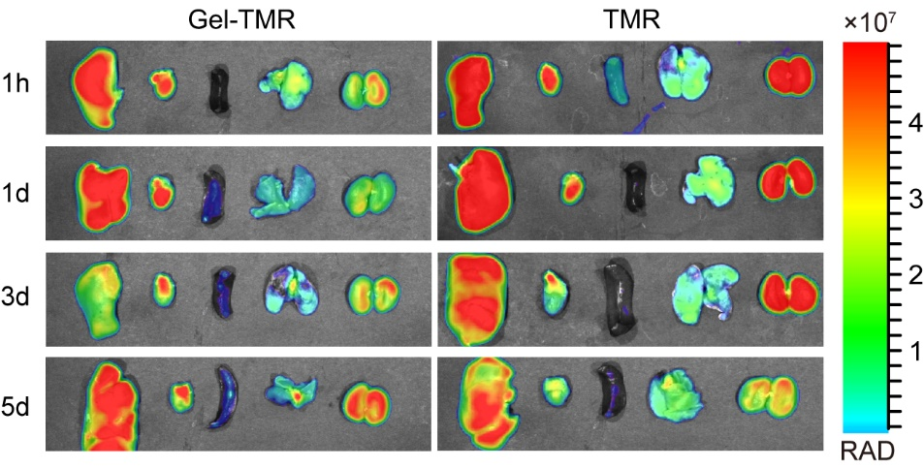
Figure S13. Main viscera fluorescent metabolism after intramyocardial injection Gel-TMR and TMR.
Figure S14. The expression level of p-p38 protein at different time points after MI/R. (a)Western blot of the p-p38 expression in ischemic myocardium at 1, 3, 7, 14, 21, and 28 days after MI/R (n = 4). (b-c) Quantitative analysis of p-p38 and p38 expression levels using ImageJ software. Experiments were conducted in triplicate. All data were presented as means ± SEM.

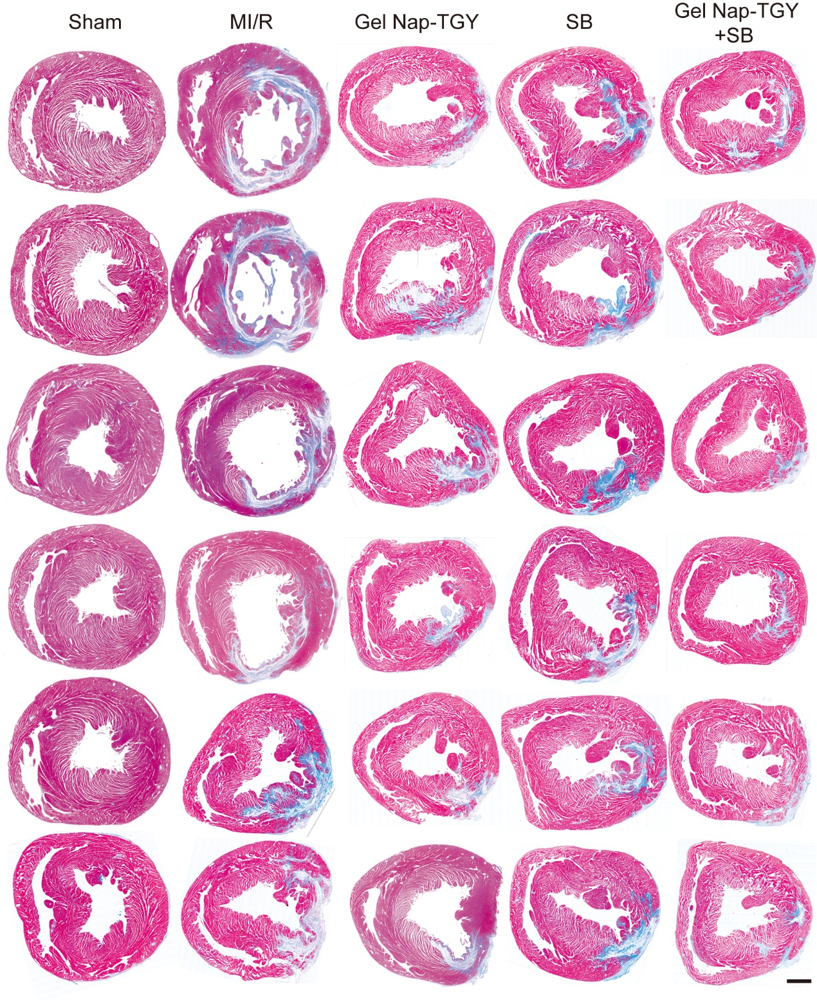
Figure S15. The optical images of Masson's trichrome stained rat heart sections in each group. (n = 6) Scar bar: 1mm.

