Table S1. Key Characteristics of Included Studies
Authors, year, and country | Study sample (N, age category, health status, fitness status) | Study setting | Study design | Exercise type, frequency, duration | Condition characteristics  (Group: delivery location, Group type: contact mode, number of contacts, type of group leader, group size)  Individual: Setting, contact mode, number of contacts) | Intervention/study duration (weeks) | Outcomes assessed | Qual  Syst rating
Opdenacker et al., 2011, Belgium | N=120, older adults 60+, healthy, previously sedentary or insufficiently active  N=186 | Community | Experimental- RCT | Exercise:  Mixed- Moderate Aerobic  Strength & Flexibility Training, 3 times/week, 40 minutes | Group condition:  Center-based, true face-face group: 3 times/week, Qualified exercise instructor, group size: 10  Individual condition: Home-based, contact mode: Virtual-SMS or Telephone contact, number of contacts: 1-3 times/month | 44 weeks | Physical Activity: % sessions attended  Functional: Number of bicep curls in 30 seconds, number of stands in 30 seconds, vertical jump, muscular fitness, peak torque recorded using six contractions at 240 deg/s, strength endurance  Health: BMI, waist circumference, % body fat, blood pressure, time to exhaustion, VO2max, exercise capacity | 0.73
Carmelli et al., 2006, Israel | N=63, older adults 75+, currently have a clinical condition, post-operative, not specified | Healthcare | Experimental- RCT | Exercise: Mixed- Moderate Aerobic, Strength & FlexibilityTraining 3 times/week, 50 minutes | Group condition: health care center-based (physical therapy clinic), standard face-face group contact, 3 times/week, health professional (licensed physical therapist), group size: 7-10  Individual condition: Home-based, contact mode: Mixed- personal and telephone, number of contacts: 1-3 times/month | 14 weeks | Physical Activity: compliance/drop-out rate | 0.69
Cowie et al., 2011, United Kingdom | N=60, older adults 60+, clinical condition (leftventricular systolic dysfunction), not specified | Healthcare | Experimental- RCT | Exercise: Moderate Aerobic, Training, 2 times/week, 60 minutes | Group condition: health care center-based (hospital), standard face-face group, 2 times/week, health professional (physiotherapist), group size: not specified  Individual condition: Home-based, contact mode: telephone, number of contacts: 2 times/month | 8 weeks | Physical Activity: Number of hours/standing/day, steps/day | 0.91
Liu et al, 2021, USA | N=60, older adults 60+, Healthy (The majority,81% perceived themselves as healthy), all participants fit to walk), not specified | online | Experimental- RCT | Exercise: Moderate Aerobic Training (Walking), no prescription (steps/day) | Group condition: online, online community group with interactive component, frequency: Other- only social group feedback/interaction, no leader, group size: Not specified but assuming it is more than dyad as the authors refer to participants communicating with participants (i.e., plural)  Individual condition: online, contact mode: Virtual-SMS or Telephone contact, n contacts: 1-2 times/week | 16 weeks | Physical activity: steps/day  Psychological: social engagement, exercise self-efficacy | 0.84
Chown et al., 2008, United Kingdom | N=239, adults 18+ (18-65), currently have a clinical condition (chronic back pain), not specified. | Healthcare | Observational-longitudinal | Exercise: Flexibility and Strength Training, 2 times/month, 30 minutes | Group condition: health care center-based, standard face-face group,: 2 times/month, group leader: health professional (physiotherapist), group size: 80  Individual condition: center-based, contact mode: face-face, 2 times/month | 30 weeks | Physical activity: programme attendance | 0.78
Sajatovic et al., 2017, USA | N=30, older adults 60+, currently have clinical condition (Parkinsons disease and co-morbid depression), not specified | Healthcare | Experimental- RCT | Exercise: Mixed- Moderate Aerobic, Strength & FlexibilityTraining, 3 times/week, 60 minutes | Group condition: health care center-based, trueface-face group, 3 times/week, group leader: qualified exercise instructor and health professional (nurse), 7-8  Individual condition: center-based, contact mode: telephone, 1-2 times/week | 40 weeks | Physical activity: programme attendance | 0.66
Galea et al., 2008, Australia | N=23, older adults 60+, currently have a clinical condition (post-operative after hip replacement), not specified | Community | Experimental- RCT | Exercise: Strength & flexibility training, 2x/week, 45 minutes | Group condition: center-based, standard face-face group, 2 times/week, group leader: health professional (physiotherapist), 11  Individual condition: home-based, contact mode: none, no contact | 8 weeks | Physical activity: number of times exercised/week, Cadence (steps/min)  Functional: seconds needed to go up 4 steps, stair power, timed up and go test (secs), Distance (in metres) walked in 6 minutes  Psychological: Quality of life | 0.77
Ada et al., 2003, Australia | N=29, older adults 60+, currently have a clinical condition (after stroke), Previously sedentary or insufficiently active | Community | Observational - longitudinal | Exercise: Aerobic (Walking on treadmill), 3x/week, 30 minutes | Group condition: center-based, standard face-face group, 3 times/week, group leader: health professional (qualified physical therapist), group size: in dyads but in group setting  Individual condition: Home-based, Virtual-SMS or telephone contact, n contacts: Non-regular, 1-3 initial contacts then no contact | 4 weeks | Physical activity: number of sessions attended, counts of activity (e.g., accelerometer epochs), cadence (steps/min)  Functional: distance walked in 6 mins, self-reported functional limitations. | 0.84
Nyrop et al., 2014, USA | N=462, adults 18+, adults, currently have a clinical condition (joint pain/arthritis), not specified | Community | Observational- Longitudinal | Exercise: Aerobic (Walking on treadmill), 3x/week, 30 minutes | Group condition: delivery location not specified, standard face-face group, 3 times/week, qualified exercise instructor, group size not specified  Individual condition: home-based, no contact | 6 weeks | Physical activity: Number walks/week, min/walk | 0.36
Norton et al., 2015, Australia | N=871, adults 18+, healthy, previously sedentary, or insufficientlyactive | Community | Experimental- RCT | Exercise: Aerobic (Walking) 7x/week, 5000 steps/day | Group condition: center-based, true face-face group, 3 times/week (30 minutes), qualified exercise instructor, group size not specified.  Individual condition: home-based, no contact | 6 weeks | Functional: Handgrip strength, flexibility  Health: body weight, BMI, waist circumference, hip circumference, sum of skinfolds, systolic and diastolic blood pressure, total cholesterol, VO2max | 0.84
Fuji et al., 2021, Japan | N=616, older adults 65+, health status not specified, mixed | Community | Observational – cross-sectional | Exercise: Mixed, no prescribed activity or duration, not applicable. | Group condition: mixed, not specified/other, no leader  Individual condition: no contact | N/A | Physical activity: total self-reported physical activity  Functional: Handgrip strength, sit-to-stand, 5 m walk test  Psychological: cognitive function (attention, memory, visuospatial, language, reasoning, overall cognition) | 0.89
Praet et al., 2008, Netherlands | N=92, adults 18+, Currently have a clinical condition (Type 2 Diabetes), not specified | Healthcare | Experimental - RCT | Exercise: Moderate aerobic exercise, 3x/ week, 60 minutes | Group condition: not specified (health care setting), standard face-face group, 3 times/week, mixed (physical therapist and exercise trainer), group size: 15-25  Individual condition: home-based, not specified, not specified | 52 weeks | Physical activity: adherence (not specified)  Health: VO2max, %- HbA1c, BMI, fasting blood glucose, insulin resistance, resting heart rate, systolic and diastolic blood pressure, total cholesterol, LDL, HDL, triglycerides  Psychological: health-related quality of life | 0.79
Williams et al., 2021, Australia | N=50, older adults 60+, currently have a clinical condition (Multiple Sclerosis), not specified | Community | Experimental - RCT | Exercise: Mixed- Moderate aerobic and strength training, 2 times/ week, 60 minutes | Group condition: center-based, standard face-face group, 2 times/week, health professional (physiotherapist), 4-6  Individual condition: home-based, Virtual-SMS or Telephone, 1-3 times/month | 8 weeks | Physical activity: adherence (% sessions completed)  Functional: Distance (m) walked in 6 minutes, Berg Balance Scale | 0.91
Leach et al., 2019, USA | N=27, female adults 18+, Currently have clinical condition (Breast cancer- Stage 1 or II), previously sedentary or insufficiently active | Academic | Experimental - RCT | Exercise: Mixed- Moderate aerobic and strength training, 3x/ week, 60 minutes | Group condition: center-based, true face-face group, 2x times/week, research assistant, group size: 3-10  Individual condition: center-based, center based-face-face contact, 2 x/week | 8 weeks | Physical activity: Walking time (MET-hours/week), Moderate (MET-hours/week)-MET-hours/week, Vigorous Physical Activity-MET-hours/week, MET-hours/week (all IPAQ)  Functional: Chest press, leg press, arm curl, time on treadmill, Sit to Stand test  Health: VO2max  Psychological: Quality of life | 0.70
Cyarto et al., 2008, USA 1 | N=167, older adults 65+, healthy, previously sedentary or insufficiently active | Community | Quasi-experimental wo/control | Exercise: Mixed- moderate balance, strength and aerobic training, 2x/ week, 30 minutes | Group condition: Centre-based (Retirement villages), true face-face group, 2 times/week, qualified exercise instructor, no of contacts not specified. group size not specified.  Individual condition: Home-based, mixed- personal and telephone, non-regular contact (1-3 times/month) | 20 weeks | Physical activity: Adherence (% sessions attended)  Functional: Balance, timed-up-and-go | 0.82
Martel et al., 2018, Canada | N=48, older adults 65+, healthy, previously sedentary or insufficiently active | Community | Experimental - RCT | Exercise: Mixed- moderate aerobic, strength and flexibility training, 2x/ week, 55 minutes | Group condition: center-based, standard face-face group, 2 times/week, mixed (health professional and qualified exercise instructor), group size: 6-8  Individual condition: home-based, face-face contact, 1-2 times/week | 12 weeks | Physical activity: Adherence (number of sessions completed), attendance (mean % of completed sessions)  Functional: walking speed, physical functioning (SF-36), sit-to-stand test, timed-up-and-go test, one leg balance, handgrip  Health: BMI  Psychological: Cognitive impairment (MoCA) | 0.66
Jansen et al., 2021, Germany | N=309, older adults 70+, healthy but at risk of falling, previously sedentary or insufficiently active | Community | Experimental - RCT | Exercise: Mixed- Moderate aerobic, strength and flexibility training, 3x/ week, Individual: 1-1.5 hours, Group 2 – 2.5 hours. | Group condition: center-based, standard face-face group, 2 times/month, health professional, group size: 8-12  Individual condition: home-based, face-face contact, 1-3 times/month | 11 weeks | Physical activity: steps/day (accelerometer), adherence (% sessions attended)  Functional: life function and disability, sit-to-stand, balance, gait performance  Psychological: fear of falling, balance confidence | 0.86
Nerz et al, 2022, Germany | N=309, older adults 70+, health status not specified, previously sedentary or insufficiently active | Community | Experimental - RCT | Exercise: Mixed- Balance and strength training, not specified/no prescription. | Group condition: center based, standard face-face group, 2 times/month, qualified exercise instructor, group size: 8-12  Individual condition: home-based, face-face contact, no of contacts not specified | 54 weeks | Physical activity: steps/day (accelerometer)  Functional: sit-to-stand, balance | 0.67
Wu et al, 2010, USA | N=64, older adults 65+, healthy but at risk of falling, not specified | Community | Experimental - RCT | Exercise: Tai Chi and Stretching, 3 times/week, 60 minutes | Group condition: online, standard online group, 3 times/week, qualified exercise instructor (Thai Chi instructor), group size not specified.  Individual condition: home-based, online, no contact, no contact (watched instructor video but no live contact) | 15 weeks | Physical activity: number of minutes exercised, adherence (% sessions attended) | 0.71
Donat, 2007, Turkey | N=42, older adults 65+, healthy, previously sedentary or insufficiently active | Healthcare | Experimental - RCT | Exercise: Balance, strengthening and stretching, 45-50 minutes, 3 times/week, | Group condition: healthcare (nursing home), standard face-face group, 3 times/week, health professional (physiotherapist), not specified  Individual condition: home-based, face-face contact, health professional (physiotherapist), 1 times/month | 8 weeks | Physical activity: group-based: attendance (recorded by physiotherapist); home-based: Number of exercises completed (self-reported) | 0.66
Cox et al., 2003, Australia | N=126, female adults, 18+, healthy, previously sedentary or insufficiently active | Community | Experimental- RCT | Exercise:  Aerobics, 30 minutes, 3 times/week | Group condition: center-based, standard face-face group, 3 times/week, qualified exercise instructor, not specified.  Individual condition: home-based, no contact (unsupervised). | 24 weeks | Physical activity: Adherence (% participants retained), drop-out, % sessions completed, % exercises completed | 0.87
Richardson et al., 2010, USA | N=324, adults 18+, clinical condition (overweight, type 2 diabetes, or coronary heart disease), previously sedentary or insufficiently active | Online | Experimental RCT | Exercise:  Aerobic (Walking), not, specified, not specified | Group condition: Online, online community with interactive component, no scheduled time, no leader, group size not specified.  Individual condition: Online, online message/email, not specified. | 16 weeks | Physical activity: Steps/day, adherence (program completion) | 0.77
Opdenacker et al., 2008, Belgium | N=186, older adults 60+, healthy, previously sedentary or insufficiently active | Community | Experimental RCT | Exercise:  Aerobic, strength, flexibility, and balance training, 60-90 minutes, 3 times/week | Group condition: center-based, true face-face group, face-face, 3 times/week, qualified exercise instructor, 10  Individual condition: Home-based, virtual - SMS or telephone contact, 2 times/month | 44 weeks | Physical activity: leisure-time, active transportation, household/garden, total (self-reported questionnaire), steps/day (pedometer), adherence (proportion) | 0.74
Harris et al., 2016, United Kingdom | N=152, male adults 18+ (18-40), healthy, previously sedentary or insufficiently active | Community | Experimental RCT | Exercise:  Aerobic (Walking)  not, specified, not specified | Group condition: Online, online community with interactive component (group feedback), no leader, not specified  Individual condition: Home-based, only online feedback (no contact). | 6 weeks | Physical activity: daily step count (app) | 0.75
Malagoni et al., 2016, Italy | N=12, adults 18+, currently have a clinical condition (post-stroke survivors), not specified | Community | Experimental RCT | Exercise: Aerobic (Walking) (indoors), 20 minutes, 6 days/week  Group based condition additionally had 40 minutes of balance, strengthening and flexibility exercise. | Group condition: centre-based, , standard face-face group, 3 times/week, health professional (physiotherapist), not specified.  Individual condition: Home-based, virtual – SMS or telephone contact, not specified. | 10 weeks | Physical activity: Adherence (% sessions attended)  Functional: 6-min walk test, timed-up-and-go, stair climbing, physical functioning (SF-36) | 0.79
Timonen et al., 2002, Finnland | N=68, older female adults, 75+, currently have a clinical condition (mobility impaired, frail), not specified | Healthcare | Experimental RCT | Exercise:  Functional and strength, 90 minutes, 2 times/week | Group condition: healthcare center-based (geriatric ward of hospital), true face-face group, 2 times/week, health professional (physiotherapist), 3-8  Individual condition: center-based, face-face, no contact (only one initial contacts) | 10 weeks | Physical activity:  Adherence: % of sessions attended  Psychological: Emotional functioning (Self-Rating Depression Scale) | 0.68
Baez et al., 2017, Italy | N=40, older adults 60+, healthy, not specified | Online | Experimental RCT | Exercise: Moderate Aerobic, Strength Training, & Flexibility, 30 minutes, 2 times /week, | Group condition: Online, true online group, 2 times/week, qualified exercise instructor, not specified  Individual condition: Home-based, online message/email, not specified | 30 weeks | Physical activity: Adherence (% programme adherence), % of exercise videos watched, and exercises completed | 0.88
Mouton et al., 2015, Belgium | N=206, older adults, 50+, healthy, not specified | Community | Experimental RCT | Exercise:  Aerobic, strength and flexibility, not specified, 1 time /week, | Group condition: Centre-based, standard face-face group, 1 time/week, health professional (trained physical educator), not specified  Individual condition: Home-based, virtual: online message/email, 1 times/month | 12 weeks | Physical activity: Retention (completed 3-month assessment) | 0.80
King et al., 1991, USA | N=357, older adults 50-65, healthy, previously sedentary or insufficiently active | Community | Experimental RCT | Exercise:  High intensity Training, & Flexibility, 3 times/week, 60 minutes | Group condition: center-based, standard face-face group, 3 times/week, qualified exercise instructor, not specified  Individual condition: Home-based, virtual: SMS or telephone contact, 1-3 times/month | 12 weeks | Physical activity: Adherence (% sessions attended) | 0.86
Helbostadt et al., 2004, Norway | N=77, older adults 75+, healthy, previously sedentary or insufficiently active | Community | Experimental RCT | Exercise:  Functional and strengthening training, 2 times/week, 60 minutes | Group condition: Centre-based, standard face-face group, 2 times/week, health professional (physiotherapist), 5-8  Individual condition: Home-based, personal contact, 1-3 times/month | 12 weeks | Physical activity: Adherence (% sessions completed), number of days walked, walking time (duration)  Functional: Fast gait walking speed, preferred walking speed, physical functioning (SF-36)  Health: health-related quality of life (bodily pain), general health (self-report)  Psychological: vitality, social function (SF-36), emotional and mental functioning (SF-12) | 0.85
Bieler et al., 2017, Denmark | N=152, older adults 60+, currently have clinical condition (hip osteoathritis), previously sedentary or insufficiently active | Community | Experimental RCT | Exercise:  Mixed- Aerobic and Functional training, 3 times/week, 60 minutes | Group condition: Outdoor, standard face-face group, 3 times/week, health professional, (qualified physical therapist), not specified  Individual condition: Home-based, personal contact, irregular:1 initial contact then no contact | 16 weeks | Physical activity: Adherence (% sessions completed) | 0.91
Christle et al., 2017, Germany | N=60, older adults 70+, clinical condition (heart disease), previously sedentary or insufficiently active | Healthcare | Experimental RCT | Exercise:  Mixed- functional and strength and flexibility, 1 times/week, 60 minutes | Group condition: healthcare center-based, standard face-face group, 1 times/week, qualified exercise instructor, 15-20  Individual condition: Centre-based, personal contact, 1-2 times/week | 26 weeks | Physical activity: Self-reported physical activity (IPAQ; % in PA category)  Functional: Health-related quality of life (physical; SF-36), quality of life (physical)  Health: General health (SF-36)  Psychological: Health-related quality of life (psychological; SF-36), negative affect, positive affect, emotional health-related quality of life, quality of life (social, total) | 0.80
Kritz et al., 2020, Australia | N=58, older adults 60+, healthy, previously sedentary or insufficiently active | Community | Observational -Longitudinal | Exercise:  Aerobic (Walking), 3 times/week, 20 minutes | Group condition: Mixed-virtual, true face-face group, 2 times/week, trained peer group exercise leader, 3-10  Individual condition: Home-based, virtual SMS or telephone contact, 2 times/month | 12 weeks | Physical activity: Physical activity (PASE)  Functional: 6-minute walk test  Health: % muscle mass, waist circumference (cm), % body fat, Body Mass Index  Psychological: Walking self-efficacy, motivation for walking | 0.90
King et al., 1995, USA | N=269, older adults 50-65+, healthy, previously sedentary or insufficiently active | Community | Experimental RCT | Exercise:  Mixed: High intensity Training, & Flexibility, 3 times/week, 60 minutes | Group condition: Centre-based, standard face-face group, 3 times/week, qualified exercise instructor, not specified  Individual condition: Home-based, virtual SMS or telephone contact, 2 times/month | 12 weeks | Physical activity: Adherence (% sessions attended, % programme adhered to) | 0.86
Aamot et al., 2016, Norway | N=83, adults 18+, currently have a clinical condition (diagnosed with myocardial infarction or acute coronary syndrome), not specified | Community | Experimental RCT | Exercise: High intensity training, 16 minutes, 2x/week | Group condition: Hospital, standard face-face group, 2 times/week, health professional (physiotherapist), 10-15  Individual condition: Home-based, personal contact, irregular: 1-3 initial contacts then no contact | 12 weeks | Functional: Health-related quality of life (physical)  Health: VO2max, peak heart rate, Body Mass Index, body fat %, muscle mass %, resting metabolic rate (kcal/day)  Psychological: Health-related quality of life (emotion, social, global) | 0.82
Freene et al., 2015, Australia | N=158, older adults 50-65+, healthy, previously sedentary or insufficiently active | Community | Quasi-experimental wo/control | Exercise: Mixed- aerobic and strength training, 1 times/week, 60 minutes | Group condition: Centre-based, standard face-face group, 1 times/week, health professional, not specified  Individual condition: Home-based, virtual SMS or telephone contact, 1-3 times/month | 26 weeks | Physical activity: Moderate-Vigorous Physical Activity (ActiGraph)  Functional: 2-minute step test  Health: Body Mass Index, waist-hip ratio, waist circumference, blood pressure, physical health (self-report; SF-12)  Psychological: Mental health composite score (SF-12) | 0.75
Zhang et al., 2019, USA | N=91, female adults 18+, healthy, not specified | Community Online | Experimental RCT | Exercise: Mixed- aerobic and strength training, no prescription (self-monitored). | Group condition: Online, online community with interactive component (group feedback), no leader  Individual condition: Online, online message/email, not specified. | 12 weeks | Physical activity: Steps/day, light PA (mins/day), MVPA (mins/day)  Functional: Number of push-ups  Health: Body Mass Index | 0.89
Beauchamp et al., 2021, Canada | N=241, Older adults, 65+, healthy, sedentary or insufficiently active. | Online | Experimental RCT | Exercise: Mixed- strength, flexibility, balance, 3 times/week, 60 minutes | Group condition: Online, , true online group, 3 times/week, older peer group exercise leader, not specified.  Individual condition:online, online contact, 3 times/week, older peer-leader. | 12 weeks | Physical Activity: Adherence (% attending at least 3 classes/week at Week 12) | 0.79
Laham et al., 2019, Australia | N=45, older adults 60+, currently have a clinical condition (chronic obstructive pulmonary disease), previously sedentary or insufficiently active | Healthcare | Experimental RCT | Exercise: Mixed- Aerobic and strength,  6x/week,  30 minutes | Group condition: health care entre-based, standard face-face group, 3 times/week, health professional (physiotherapist), not specified.  Individual condition: Home-based, center based – personal contact, 1-2 times/week | 8 weeks | Physical activity: Minutes of MVPA per day (accelerometer) | 0.68
Moeller et al., 2020, Denmark | N=153, female adults 18+, currently have clinical condition (breast cancer), previously sedentary or insufficiently active | Healthcare | Experimental RCT | Exercise: Mixed- aerobic biking, resistance, circuit. 4x/week, 60 minutes, 30 | Group condition: health care hospital-based, standard face-face group, 3 times/week,  qualified exercise instructor, 10  Individual condition: Home-based, center based – personal contact, 3 times/week | 12 weeks | Physical activity: Adherence (% completing assessments)  Functional: Knee extensions, lateral pull, leg press, context peak left and right  Health: Body weight, fat mass, bone mass, lean body mass, bone mineral density, dyspnea, pain, fatigue  Psychological: Anxiety, depression | 0.95
Iliffe et al., 2015, USA | N=1256, older adults 65+, healthy, previously active | Community | Experimental RCT | Exercise:  Moderate Aerobic, Strength Training, & Flexibility, 3x/week, 30 minutes | Group condition: centre-based, standard face-face group, 3 times/week, research assistant, 15  Individual condition: Home-based, virtual SMS or telephone, 1-3 times/month | 24 weeks | Physical activity: % participants with > 150 minutes MVPA/week, physical activity (Physical Activity Scale for the Elderly), FITT (phone)  Functional: Physical functioning (SF-36), balance, falls risk  Psychological: Social functioning, quality of life, exercise outcome expectations | 0.86
Cyarto et al., 2008, Australia¹ | N=167, older adults 65+, healthy, previously sedentary or insufficiently active | Community | Quasi-experimental wo/control | Exercise:  Functional Balance and Strength. 2x/week, 60 minutes | Group condition: centre-based, standard face-face group, 2 times/week, qualified exercise instructor, not specified.  Individual condition: Home-based, mixed- personal and telephone, non-regular contact (1-3 times/month) | 20 weeks | Physical activity: % sessions attended  Functional: 30 second sit to stand test, 30 second arm curl test, chair sit and reach, back scratch test, timed-up-and-go test, 2-min step test. | 0.95
Cyarto et al., 2006, Australia | N=119, older adults, 65+ (65-96), healthy, not specified | Community | Quasi-experimental wo/control | Exercise:  Functional Balance and Strength. 2x/week, 60 minutes | Group condition: Centre-based (Retirement villages), true face-face group, 2 times/week, qualified exercise instructor, 10  Individual condition: Home-based, telephone, 1-2 times/week | 20 weeks | Physical activity: Adherence (mean proportion of sessions completed), compliance, % sessions attended | 0.80
Tsekoura et al., 2018, Greece | N=54, older adults 65+, currently have a clinical condition (sarcopenia) previously sedentary or insufficiently active | Community | Experimental RCT | Exercise:  Mild Aerobic, Strength Training, & Flexibility, 3x/week, 30-35 minutes | Group condition: Centre-based, standard face-face group, 2 times/week, health professional, not specified  Individual condition: Home-based, personal contact, 1-3 times/month | 12 weeks | Physical activity: Adherence (% sessions attended)  Functional: Timed-Up-And-Go, 4 m walk speed, gait speed, chair stand test, handgrip strength, knee extension and flexion  Health: Body Mass Index, skeletal muscle mass, fat free mass, calf circumference  Psychological: Quality of life | 0.79
Yang et al., 2017, China | N=36, Adults 18+, currently have a clinical condition (diagnosed with mild to moderate Parkinson disease), previously sedentary or insufficiently active | Community | Experimental RCT | Exercise:  Tai chi, 7x/week, 40-45 minutes | Group condition: Hospital-based, standard face-face group, 7x times/week, qualified exercise instructor (Tai Chi instructor), 6-7  Individual condition: Hospital-based, personal contact, 3 times//week. | 13 weeks | Physical activity: Adherence (% sessions attended)  Health: Sleep quality  Psychological: Depression, cognitive impairment | 0.82
Akinci et al., 2018, Turkey | N=65, Adults 18+, currently have a clinical condition (Type 2 Diabetes), not specified | Community | Experimental RCT | Exercise: Aerobic (Walking), 3x/week, 60 minutes | Group condition: Not specified, standard face-face group, 3 times/week, not specified, health professional, not specified.  Individual condition: Home-based, virtual – online message/email, not specified | 8 weeks | Physical activity: steps/day (pedometer)  Functional: 6-minute walk test  Health: HbA1C (%), fasting blood glucose, HDL, LDL, triglycerides, total cholesterol, Body Mass Index, waist circumference, hip circumference  Psychological: Quality of life | 0.89
Brosseau et al., 2012, Canada | N=222, Adults 18+, currently have a clinical condition, (mild to moderate knee osteoarthritis), previously sedentary or insufficiently active. | Community | Experimental RCT | Exercise:  Mild aerobic training  3x/week, 65 minutes | Group condition: outdoor, true face-face group, 2 times/week, qualified exercise instructor, not specified.  Individual condition: centre-based, personal contact, non-regular: 1-3 initial contacts, then no contact. | 20 weeks | Physical activity: Adherence (% sessions attended)  Psychological: Coping with symptoms, confidence about doing things | 0.80
Kyrdalen et al., 2014, Norway | N=125, older adults 75+, healthy, previously sedentary or insufficiently active | Community | Experimental RCT | Exercise:  Mixed- functional and strength training and flexibility, 3 times/week, 60 minutes | Group condition: center-based, standard face-face group, 2 times/week, health professional, 4-8  Individual condition: Home-based, mixed personal and telephone, 1-3 times/month | 12 weeks | Physical activity: Mean number of outdoor walks during intervention, adherence (% sessions attended)  Functional: Berg balance scale, Timed-Up-And-Go, sit-to-stand, physical functioning (SF-36)  Psychological: Mental health (SF-36) | 0.88
Ramadi et al., 2015, Canada | N=3488, Adults 18+, currently have a clinical condition (diagnosed with coronary artery disease), previously sedentary or insufficiently active | Community | Observational - Longitudinal | Exercise: Aerobic moderate-vigorous intensity exercise (45 to 85% of HRR and 12-14 RPE), 3-5x/week, 20-60 minutes. | Group condition: Centre-based, standard face-face group, 2-3 times/week, supervised (not specified by whom), not specified  Individual condition: Home-based, virtual – SMS or telephone, minimum of 1 session (unspecified). | 12 weeks | Physical activity: Exercise sessions per week (self-reported), minutes per week  Functional: Exercise capacity (treadmill using Bruce or modified Bruce protocol)  Health: HR recovery, Body Mass Index, waist circumference, HDL, LDL, total cholesterol, triglycerides, fasting blood glucose | 0.85
Thøgersen-Ntoumani et al., 2019, Australia | N=116, older adults 60+, healthy, previously sedentary or insufficiently active | Community | Quasi-experimental wo/control | Exercise:  Aerobic (Walking), 3 times/week, 20 minutes | Group condition: retirement village, true face-face group, 2 times/week, trained peer group exercise leader, 3-10  Individual condition: Home-based, virtual SMS or telephone contact, 2 times/month | 16 weeks | Physical activity: Steps/day, stepping time, light physical activity (mins/day), moderate-vigorous physical activity (mins/day), sitting (mins/day), standing (mins/day) (accelerometer)  Functional: Physical health (SF-12), physical fitness (Dartmouth COOP charts)  Health: Change in health, pain  Psychological: Subjective vitality, mental health, emotional functioning, social role functioning (SF-12), social support, quality of life (Dartmouth COOP charts), anxiety, depression (HADS), loneliness | 0.88
Seo et al., 2020, Korea | N=79, Adults 18+, healthy, previously sedentary or insufficiently active | Academic | Experimental RCT | Exercise:  Aerobic (Walking), not specified, 60 minutes/day | Group condition: Online, online community with interactive component, no scheduled time, no leader, not specified  Individual condition: Online, online, not specified, no contact, (only initial contact for distributing the trackers) | 8 weeks | Physical activity: Steps/day  Health: Body weight, Body Mass Index, waist circumference, body fat, systolic and diastolic blood pressure  Psychological: Exercise motivation, perceived self-efficacy | 0.67
Caserta et al., 1998, USA | N=146, older female, adults 60+, currently have a clinical condition (obesity), previously sedentary or insufficiently active | Community | Experimental RCT | Exercise: Aerobic moderate-vigorous intensity exercise (45 to 85% of HRR and 12-14 RPE), 3x/week, 60 minutes | Group condition: Center-based, standard face-face group, 3 times/week, health professional, not specified  Individual condition: Home-based, personal contact, 1-2 times/week | 16 weeks | Physical activity: 7-day physical activity recall | 0.75
King et al., 2002, USA | N=155, older adults 60+, healthy, previously sedentary or insufficiently active | Community | Experimental RCT | Exercise: Mixed- aerobic and strength training, 4x/week, 60 minutes | Group condition: Centre-based, standard face-face group, 3 times/week, health professional, 8-10  Individual condition: Home-based, personal contact, 1-3 times/month | 56 weeks | Physical activity: Adherence (% sessions attended)  Functional: MacArthur Test, sit-to-stand test, standing balance, physical performance test, 6-minute walk test, 8-minute fast gait, 8 m usual gait, balance confidence, physical functioning (SF-36)  Psychological: Mental health | 0.93
Ching et al., 1999, Taiwan | N=20, Adults 18+, healthy, previously sedentary or insufficiently active | Community | Observational - Longitudinal | Exercise:  Mixed- Thai Chi (group) Aerobic (Walking) (Individual), Mixed- 3x/week- Individual, 7x/week group, 50 minutes | Group condition: Centre-based, standard face-face group, 3 times /week, qualified exercise instructor (Tai Chi instructor), 12  Individual condition: Home-based, not specified, 3 times/week | 52 weeks | Physical activity: Adherence (% sessions attended)  Functional: Power work rate  Health: VO2max, peak heart rate, peak O2 pulse, Ve peak, VR peak, peak heart rate, minute ventilation Ve | 0.59
Owen et al., 1987, Australia | N=156, Adults 18+, healthy, previously sedentary or insufficiently active | Community | Experimental- RCT | Exercise:  Moderate aerobic exercise, 2x/week, 60 minutes | Group condition:  Centre-based, standard face-face group, 2 times/week, qualified exercise instructor, not specified  Individual condition:  Home-based. Virtual phone, not specified/once | 12 weeks | Physical activity: Physical Activity (% meeting ACSM levels) | 0.56
Granet at al., 2023, Canada | N=83, older adults 60+, healthy, not specified | Online | Experimental RCT | Exercise:  Mixed- Aerobic, strength training and flexibility, 3x/week, 55 minutes | Group condition: Online, standard online group, 3 times/week, health professional, not specified  Individual condition:  Online, not specified | 12 weeks | Physical activity:  Adherence (n remaining in the intervention), attendance (% sessions completed)  Functional:  Balance (unipodal balance), fast gait walking speed, sit to stand 5rep, 10 rep, Muscle Power, 30 sec chair test, cardiovascular fitness- max aerobic power  Health: Body Mass Index | 0.73
Langeard et al., 2022, France | N=43, older adults, aged 70-80, healthy, previously sedentary or insufficiently active | Community | Experimental RCT | Exercise: Mixed- Aerobic and strength training, 2x/week, 60 minutes | Group condition: Online, standard online group, 2 times/week, health professional, 4  Individual condition: Centre-based – personal contact, 2 times/week | 13 weeks | Physical activity: Adherence (% sessions completed, number of sessions completed)  Function: Handgrip strength, muscle function  Health: Cardio-respiratory fitness, heart rate, body weight (kg), body fat (%), muscle mass (%) | 0.80
Middlewerd et al., 2022, Netherlands | N=77, Adults 18+, healthy, previously sedentary or insufficiently active | Academic | Quasi-experimental wo/control | Exercise:  Not specified (presuming it is Aerobic, walking as steps are measured), prescription not specified (individually tailored). | Group condition: Online, online community with interactive (feedback) component 1 time/week, no leader, 6  Individual condition: Online, no contact, not specified | 12 weeks | Physical activity: MVPA, steps/day (accelerometer), steps/day (FitBit)  Psychological: Self-efficacy, outcome expectations, social norms, intentions, barriers, self-regulation skills | 0.72
King, 1997, USA | N=269, Adults 18+, healthy, previously sedentary or insufficiently active | Community | Experimental RCT | Exercise:  Aerobic (high and low intensity) training, 3 times/ week, 60 minutes | Group condition: Centre-based , standard face-face group, 3 times/week, qualified exercise instructor, not specified  Individual condition: Home-based, virtual SMS or telephone contact, less than 1 time/month | 112 weeks | Physical activity: Adherence (% sessions attended), self-reported total MVPA/week | 0.78
Looyestyn et al., 2018, Australia | N=89, Adults 18+, healthy, previously sedentary or insufficiently active | Online | Experimental RCT | Exercise: mixed- aerobic, running/interval training, not specified, 30 minutes | Group condition: Online, online community group with interactive component, 7 days/week (online motivational posts), qualified exercise instructor, 41  Individual condition: Online, no contact, self-directed | 8 weeks | Physical activity: Adherence  Health: Cardio-respiratory fitness  Psychological: Self-efficacy, exercise attitudes, social support | 0.68
Nikitina et al., 2018, Italy | N=44, older adults 59+ (59-83), healthy, previously sedentary or insufficiently active | Online | Experimental RCT | Exercise:  strength and balance training, 2x/week, 30-40 minutes | Group condition: Online, true online group (social interaction features and classes), 2 times/week, qualified exercise instructor (coach- medical doctor), 20  Individual condition: Online, online message/email, 2 times/week | 8 weeks | Physical activity: Adherence (number of sessions attended) | 0.54
Shabbir et al., 2024, Canada | N=38, older male adults 60+, currently have a clinical condition ( diagnosed with prostate cancer of any stage, starting or continuing androgen deprivation therapy for at least six months), previously sedentary or insufficiently active | Community | Experimental RCT | Exercise: Mixed- a combined aerobic and resistance, flexibility exercise session, 4–5x/week, 60 minutes. | Group condition: center based, standard face-face group, 3 times/week, qualified exercise instructor , not specified  Individual condition: Home-based, face-face, not specified. | 24 weeks | Physical activity: Sedentary minutes/day, MVPA minutes/day (accelerometer)  Function: Sit-to-stand, handgrip strength, 6-minute walk test  Health: Fatigue, fasting blood glucose, HbA1c, HDL, Hemoglobin, LDL, PSA, testosterone, total cholesterol, triglycerides, waist circumference, waist: hip ratio, fat free mass, body fat, BMI  Psychological: Quality of life | 0.83
Arevalo et al., 2023, USA | N=30, Adults 18+, healthy, previously sedentary or insufficiently active | Community | Quasi-experimental wo/control | Exercise:  Mixed- flexibility, cardiovascular, and strength exercises, 3x/week, 60 minutes | Group condition: Centre-based, standard face-face group, 2 times/week, qualified exercise instructor, not specified  Individual condition: Home-based, face-face, 1 time/month | 12 weeks | Physical activity: Adherence (% sessions attended) | 0.72
Krumov et al., 2022, Bulgaria | N=130, Older adults 65+ (65-80), healthy, previously sedentary or insufficiently active | Healthcare | Experimental RCT | Exercise: Mixed- strength and balance exercises, not specified, not specified. | Group condition: Centre-based, standard face-face group, 3 times/week, health professional, 5-8  Individual condition: Centre-based, personal contact, not specified | 12 weeks | Physical activity: Total physical activity (self-reported, PASE)  Function: 6-minute walk test, physical functioning (SF-36)  Health: General health, bodily pain  Psychological: Vitality, social functioning, emotional functioning, overall mental health | 0.78
Karmakar et al., 2022, Hong Kong | N=107, Older adults 60+, healthy, previously sedentary or insufficiently active | Community | Experimental RCT | Exercise:  Aerobic (Walking), 3x/week, 50-70 minutes | Group condition: Centre-based, standard face-face group, 3 times/week, health professional, not specified  Individual condition: Centre-based, personal contact, 3 times/week | 15 weeks | Function: Physical performance, physical functioning (SF-36)  Health: General health, Body Mass Index, resting heart rate, systolic and diastolic blood pressure, bodily pain  Psychological: Cognitive impairment, vitality, social functioning, emotional functioning, overall mental health, physical activity enjoyment | 0.84
Wan et al., 2017, USA | N=109, Older adults 60+, currently have a clinical condition (Had a diagnosis of COPD and received medical clearance to participate), previously sedentary or insufficiently active | Healthcare | Experimental RCT | Exercise:  Aerobic (Walking),, not specified, not specified. | Group condition: Online, , online community with interactive component, no scheduled time, no leader, not specified  Individual condition: Online, telephone, not specified | 13 weeks | Physical activity: Steps/day (pedometer), adherence (% pedometer wear days) | 0.84
King et al., 1993, USA | N=151, Adults 18+, healthy, previously sedentary or insufficiently active | Community | Experimental RCT | Exercise:  Mixed: High intensity Training, & Flexibility exercises, 3x/week, 60 minutes. | Group condition: Centre-based, standard face-face group, 3 times/week, qualified exercise instructor, not specified  Individual condition: Home-based, virtual SMS or telephone contact, 1-3 times/month | 12 weeks | Physical activity: Adherence (% programme adhered to)  Psychological: Perceived stress, anxiety, depressed mood | 0.86
Desbiens et al., 2017, Canada | N=26, Older female, 60+, currently have a clinical condition ( diagnosed with stage 1-3 breast cancer), mixed | Healthcare | Experimental RCT | Exercise:  Mixed: Aerobic, strength and flexibility, 2 times/week, 50 minutes | Group condition: Not specified, standard face-face group, 2 times/week, health professional (kinesiologist), , not specified  Individual condition: Home-based, no contact, no contact (video asked to do it 2 times/week). | 12 weeks | Physical activity: Completion (% completing the programme) | 0.73
Watanabe et al., 2020, Japan | N=517, older adults 60+, healthy, previously sedentary or insufficiently active | Community | Experimental RCT | Exercise:  Mixed- aerobic PA and resistance  1x/week, 90 minutes. | Group condition: Centre-based, standard face-face group, 1 times/week, health professional, 6-30  Individual condition: Home-based, mixed (email and personal contact), 1 times/month | 12 weeks | Physical activity: Steps/day, MET hours/week (accelerometer)  Function: Handgrip strength, knee extension strength, walking speed (normal and maximal), timed-up-and-go, sit-to-stand, functional reach, chair stepping, vertical jump  Health: Anterior thigh muscle thickness | 0.80
Holland et al., 2017, Australia | N=166, older adults 60+, currently have a clinical condition (COPD), previously sedentary or insufficiently active | Community | Experimental RCT | Exercise:  Mixed- aerobic and resistance.  2x/week, 30 minutes | Group condition: Centre-based, standard face-face group, 2 times/week, health professional, not specified  Individual condition: Home-based, mixed (personal and telephone contact), 1times/week | 8 weeks | Physical activity: Adherence (% sessions attended) | 0.90
Emilia et al., 2018, Malaysia | N=62, Adults 18+ (35-45), healthy, previously sedentary or insufficiently active | Healthcare | Experimental RCT | Exercise: Aerobic (Walking), 10,000 steps/day. | Group condition: healthcare entre-based (primary care clinic), standard face-face group, 1 times/month, research assistant, 10-15  Individual condition: Home-based, no contact, no contact (only initial introductory session). | 12 weeks | Physical activity: Steps/day | 0.66
Note: 1= Cyarto et al. (2008): These studies utilized the same sample but were counted as separate studies in this analysis because their results were published in separate articles and addressed different outcomes

Details on the Search Strategy
The electronic search was conducted from the inception of the databases to 19th March 2024. An electronic search was performed from inception of the databases to 19th of March 2024. The searched databases included Web Science, Scopus, ProQuest, PubMed, ScienceDirect, Medline, PsycINFO, and Google Scholar, with additional manual searches carried out in relevant journals. We also performed backward and forward citation tracking to identify further studies that may not have appeared in the initial search results. Search terms were carefully selected to include a combination of free text terms and subject headings, where applicable, to maximize sensitivity and relevance. We sought peer-reviewed articles published in English, and searches were restricted to quantitative studies, including randomized controlled trials (RCTs) and clinical trials, focusing on adult populations, group-based versus individual interventions, physical activity outcomes, and psychosocial or physical health impacts.
With the assistance of an experienced librarian, we developed the search string to achieve a balance between broad coverage and high specificity, focusing on identifying studies that compare solo and group formats in physical activity interventions/exposures. We identified key terms that were also identified from previous systematic reviews and meta-analyses on physical activity interventions, to provide additional specificity. Relevant databases, such as MeSH, were utilized to identify key terms and incorporate subject-specific terms into our search strategy. To reduce irrelevant results, broader terms were refined to focus on the context of physical activity. For example, "exercise" was paired with terms like "intervention" and "program" to exclude general or unrelated exercise studies, while "group" and "solo" were structured with adjacencies (e.g., "group adj3 exercise") to capture relevant comparisons without unrelated group-based activities.
The following terms were searched as free text and using Boolean operators (AND/OR/NOT) in listed databases.
Adult, Adults, "aged 18 and over", "aged 18 and older"
Group, "with others", "with peers", "group-exercise", "peer-support*"
Communal, "in-center", "in-centre", accomp* (accompanied)
"group-interaction*", "group-based", collab* (collaborative), collective
"group-mediated", "group-led", cohes* (cohesive), class, social, "face to face"
buddy, group*, group-dynamics*, mentor*, peer*, peer-support*, interaction*
team-based, team exercise, group fitness, "shared exercise", "collaborative exercise"
Alone, Home*, "personal training", Individual
"Non-group", "non-social", Solo, "without support", "without others"
"solo exercise", "individual-based PA", "self-guided exercise", "alone vs with others"
center*, centre*, home, home-based, in-center, in-centre
"mall-walk*", "peer-led exercise", "group-led PA"
Intervention, Program, "exercise-program*", Programme, Trial, Exposure
"physical activity intervention", "head-to-head comparison", "controlled trial"
"effectiveness comparison", "group-based vs individual-based intervention"
Outcome, Benefit, Improve, Impact, Change, Effect, Differ
"Adherence", "Engagement", "Retention", "Health outcomes", "Social outcomes"
"Motivation", "Psychosocial outcomes", "Behavior change", "Well-being outcomes"
"Physical activ*", "physical move*", "physical training", "physical strength"
Gait, "physical performance", "physical fitness", Exercise
"mall-walk*", Swim, Walk, "resistance training", Biking, Jog, Jump, Hike, Dance, Run
"walking group", Yoga, Bike, aerobic*, cycling, exercise-class, exercise-group
running, resistance, training
Compar*, Versus, Vs, "alone vs group", "individual vs group exercise"
Qualitative, Review, "systematic review", "meta-analysis", "meta-synthesis"

Details on Specific Search Strategy for each Database
Web of Science:
TS=(adult* OR "aged 18 and over" OR "aged 18 and older" OR "adults")
AND
TS=(Group OR "with others" OR "with peers" OR "group-exercise" OR "peer-support*" OR communal OR "in-center" OR "in-centre" OR accomp* OR "group-interaction*" OR "group-based" OR collab* OR collective OR "group-mediated" OR "group-led" OR cohes* OR "class" OR social OR "face to face")
AND
TS=(Alone OR home* OR "personal training" OR individual OR "non-group" OR "non-social" OR solo OR "without support" OR "without others")
AND
TS=("physical activ*" OR "physical move*" OR "physical training" OR "physical strength" OR "quality of life" OR "gait" OR "physical performance" OR "physical fitness" OR exercise OR "mall-walk*" OR swim* OR walk* OR "resistance training" OR biking OR jog* OR jump* OR hik* OR danc* OR run* OR "walking group" OR yoga OR bike*)
AND
TS=(intervention OR program* OR trial OR "exercise-program*" OR exposure)
AND
TS=(Outcome OR benefit* OR improv* OR impact* OR change* OR effect* OR differ*)
AND
TS=(psychosocial OR physical OR psychological OR "mental health" OR social OR health OR wellbeing OR function* OR physic*)
AND
TS=(compar* OR versus OR vs)
NOT
TS=(qualitative OR review OR "systematic review" OR "meta-analysis" OR "meta-synthesis")
SCOPUS
(TITLE ( adult* OR "aged 18 and over" OR "aged 18 and older" OR "adults" ) OR ABS ( adult* OR "aged 18 and over" OR "aged 18 and older" OR "adults" ) ) AND ( TITLE ( group OR "with others" OR "with peers" OR "group-exercise" OR "peer-support*" OR communal OR "in-center" OR "in-centre" OR accomp* OR "group-interaction*" OR "group-based" OR collab* OR collective OR "group-mediated" OR "group-led" OR cohes* OR "class" OR social OR "face to face" ) OR ABS ( group OR "with others" OR "with peers" OR "group-exercise" OR "peer-support*" OR communal OR "in-center" OR "in-centre" OR accomp* OR "group-interaction*" OR "group-based" OR collab* OR collective OR "group-mediated" OR "group-led" OR cohes* OR "class" OR social OR "face to face" ) ) AND ( TITLE ( alone OR home* OR "personal training" OR individual OR "non-group" OR "non-social" OR solo OR "without support" OR "without others" ) OR ABS ( alone OR home* OR "personal training" OR individual OR "non-group" OR "non-social" OR solo OR "without support" OR "without others" ) ) AND ( TITLE ( "physical activity" OR "exercise" OR adherence OR "compliance" OR "participation" OR "engagement" OR "physical fitness" OR "exercise frequency" OR "exercise intensity" OR "duration" OR "exercise volume" OR "MVPA" OR "vigorous physical activity" OR "moderate physical activity" OR "step count" OR "pedometer" OR "accelerometer" OR "activity tracker" ) OR ABS ( "physical activity" OR "exercise" OR adherence OR "compliance" OR "participation" OR "engagement" OR "physical fitness" OR "exercise frequency" OR "exercise intensity" OR "duration" OR "exercise volume" OR "MVPA" OR "vigorous physical activity" OR "moderate physical activity" OR "step count" OR "pedometer" OR "accelerometer" OR "activity tracker" ) ) AND ( TITLE ( "physical activ*" OR "physical move*" OR "physical training" OR "physical strength" OR "quality of life" OR "gait" OR "physical performance" OR "physical fitness" OR exercise OR "mall-walk*" OR swim* OR walk* OR "resistance training" OR biking OR jog* OR jump* OR hik* OR danc* OR run* OR "walking group" OR yoga OR bike* ) OR ABS ( "physical activ*" OR "physical move*" OR "physical training" OR "physical strength" OR "quality of life" OR "gait" OR "physical performance" OR "physical fitness" OR exercise OR "mall-walk*" OR swim* OR walk* OR "resistance training" OR biking OR jog* OR jump* OR hik* OR danc* OR run* OR "walking group" OR yoga OR bike* ) ) AND ( TITLE ( intervention OR program* OR trial OR "exercise-program*" OR exposure ) OR ABS ( intervention OR program* OR trial OR "exercise-program*" OR exposure ) ) AND ( TITLE ( outcome OR benefit* OR improv* OR impact* OR change* OR effect* OR differ* ) OR ABS ( outcome OR benefit* OR improv* OR impact* OR change* OR effect* OR differ* ) ) AND ( TITLE ( psychosocial OR physical OR psychological OR "mental health" OR social OR health OR wellbeing OR function* OR physic* ) OR ABS ( psychosocial OR physical OR psychological OR "mental health" OR social OR health OR wellbeing OR function* OR physic* ) ) AND ( TITLE ( compar* OR versus OR vs ) OR ABS ( compar* OR versus OR vs ) ) AND NOT ( TITLE ( qualitative OR review OR "systematic review" OR "meta-analysis" OR "meta-synthesis" ) OR ABS ( qualitative OR review OR "systematic review" OR "meta-analysis" OR "meta-synthesis" ) )
Filter peer-reviewed, Article and English
PROQUEST:
(ti(adult* OR "aged 18 and over" OR "aged 18 and older" OR "adults") OR ab(adult* OR "aged 18 and over" OR "aged 18 and older" OR "adults") OR kw(adult* OR "aged 18 and over" OR "aged 18 and older" OR "adults"))
AND
(ti(Group OR "with others" OR "with peers" OR "group-exercise" OR "peer-support*" OR communal OR "in-center" OR "in-centre" OR accomp* OR "group-interaction*" OR "group-based" OR collab* OR collective OR "group-mediated" OR "group-led" OR cohes* OR "class" OR social OR "face to face") OR ab(Group OR "with others" OR "with peers" OR "group-exercise" OR "peer-support*" OR communal OR "in-center" OR "in-centre" OR accomp* OR "group-interaction*" OR "group-based" OR collab* OR collective OR "group-mediated" OR "group-led" OR cohes* OR "class" OR social OR "face to face") OR kw(Group OR "with others" OR "with peers" OR "group-exercise" OR "peer-support*" OR communal OR "in-center" OR "in-centre" OR accomp* OR "group-interaction*" OR "group-based" OR collab* OR collective OR "group-mediated" OR "group-led" OR cohes* OR "class" OR social OR "face to face"))
AND
(ti(Alone OR home* OR "personal training" OR individual OR "non-group" OR "non-social" OR solo OR "without support" OR "without others") OR ab(Alone OR home* OR "personal training" OR individual OR "non-group" OR "non-social" OR solo OR "without support" OR "without others") OR kw(Alone OR home* OR "personal training" OR individual OR "non-group" OR "non-social" OR solo OR "without support" OR "without others"))
AND
(ti("physical activity" OR "exercise" OR adherence OR "compliance" OR "participation" OR "engagement" OR "physical fitness" OR "adherence" OR "exercise frequency" OR "exercise intensity" OR "duration" OR "exercise volume" OR "MVPA" OR "vigorous physical activity" OR "moderate physical activity" OR "step count" OR "pedometer" OR "accelerometer" OR "activity tracker") OR ab("physical activity" OR "exercise" OR adherence OR "compliance" OR "participation" OR "engagement" OR "physical fitness" OR "adherence" OR "exercise frequency" OR "exercise intensity" OR "duration" OR "exercise volume" OR "MVPA" OR "vigorous physical activity" OR "moderate physical activity" OR "step count" OR "pedometer" OR "accelerometer" OR "activity tracker") OR kw("physical activity" OR "exercise" OR adherence OR "compliance" OR "participation" OR "engagement" OR "physical fitness" OR "adherence" OR "exercise frequency" OR "exercise intensity" OR "duration" OR "exercise volume" OR "MVPA" OR "vigorous physical activity" OR "moderate physical activity" OR "step count" OR "pedometer" OR "accelerometer" OR "activity tracker"))
AND
(ti("physical activ*" OR "physical move*" OR "physical training" OR "physical strength" OR "quality of life" OR "gait" OR "physical performance" OR "physical fitness" OR exercise OR "mall-walk*" OR swim* OR walk* OR "resistance training" OR biking OR jog* OR jump* OR hik* OR danc* OR run* OR "walking group" OR yoga OR bike*) OR ab("physical activ*" OR "physical move*" OR "physical training" OR "physical strength" OR "quality of life" OR "gait" OR "physical performance" OR "physical fitness" OR exercise OR "mall-walk*" OR swim* OR walk* OR "resistance training" OR biking OR jog* OR jump* OR hik* OR danc* OR run* OR "walking group" OR yoga OR bike*) OR kw("physical activ*" OR "physical move*" OR "physical training" OR "physical strength" OR "quality of life" OR "gait" OR "physical performance" OR "physical fitness" OR exercise OR "mall-walk*" OR swim* OR walk* OR "resistance training" OR biking OR jog* OR jump* OR hik* OR danc* OR run* OR "walking group" OR yoga OR bike*))
AND
(ti(intervention OR program* OR trial OR "exercise-program*" OR exposure) OR ab(intervention OR program* OR trial OR "exercise-program*" OR exposure) OR kw(intervention OR program* OR trial OR "exercise-program*" OR exposure))
AND
(ti(Outcome OR benefit* OR improv* OR impact* OR change* OR effect* OR differ*) OR ab(Outcome OR benefit* OR improv* OR impact* OR change* OR effect* OR differ*) OR kw(Outcome OR benefit* OR improv* OR impact* OR change* OR effect* OR differ*))
AND
(ti(psychosocial OR physical OR psychological OR "mental health" OR social OR health OR wellbeing OR function* OR physic*) OR ab(psychosocial OR physical OR psychological OR "mental health" OR social OR health OR wellbeing OR function* OR physic*) OR kw(psychosocial OR physical OR psychological OR "mental health" OR social OR health OR wellbeing OR function* OR physic*))
AND
(ti(compar* OR versus OR vs) OR ab(compar* OR versus OR vs) OR kw(compar* OR versus OR vs))
AND
NOT
(ti(qualitative OR review OR "systematic review" OR "meta-analysis" OR "meta-synthesis") OR ab(qualitative OR review OR "systematic review" OR "meta-analysis" OR "meta-synthesis") OR kw(qualitative OR review OR "systematic review" OR "meta-analysis" OR "meta-synthesis"))
Only include Scholar Journals
Pubmed:
(adults[Title/Abstract]) AND (Group[Title/Abstract] OR others[Title/Abstract] OR "with peers"[Title/Abstract] OR "group-exercise"[Title/Abstract] OR "peer-support*"[Title/Abstract] OR communal[Title/Abstract] OR "in-center"[Title/Abstract] OR "in-centre"[Title/Abstract] OR accomp*[Title/Abstract] OR "group-interaction*"[Title/Abstract] OR "group-based"[Title/Abstract] OR collab*[Title/Abstract] OR collective[Title/Abstract] OR "group-mediated"[Title/Abstract] OR "group-led"[Title/Abstract] OR cohes*[Title/Abstract] OR class[Title/Abstract] OR social[Title/Abstract] OR "face to face"[Title/Abstract]) AND (Alone[Title/Abstract] OR home*[Title/Abstract] OR "personal training"[Title/Abstract] OR individual[Title/Abstract] OR "non-group"[Title/Abstract] OR "non-social"[Title/Abstract] OR solo[Title/Abstract] OR "without support"[Title/Abstract]) AND ("physical activity"[Title/Abstract] OR exercise[Title/Abstract] OR adherence[Title/Abstract] OR compliance[Title/Abstract] OR participation[Title/Abstract] OR engagement[Title/Abstract] OR "physical fitness"[Title/Abstract] OR "exercise frequency"[Title/Abstract] OR "exercise intensity"[Title/Abstract] OR duration[Title/Abstract] OR "exercise volume"[Title/Abstract] OR MVPA[Title/Abstract] OR "vigorous physical activity"[Title/Abstract] OR "moderate physical activity"[Title/Abstract] OR "step count"[Title/Abstract] OR pedometer[Title/Abstract] OR accelerometer[Title/Abstract] OR "activity tracker"[Title/Abstract]) AND ("physical activ*"[Title/Abstract] OR "physical move*"[Title/Abstract] OR "physical training"[Title/Abstract] OR "physical strength"[Title/Abstract] OR "quality of life"[Title/Abstract] OR gait[Title/Abstract] OR "physical performance"[Title/Abstract] OR "physical fitness"[Title/Abstract] OR exercise[Title/Abstract] OR "mall-walking"[Title/Abstract] OR swimming[Title/Abstract] OR walking[Title/Abstract] OR "resistance training"[Title/Abstract] OR biking[Title/Abstract] OR jogging[Title/Abstract] OR jumping[Title/Abstract] OR hiking[Title/Abstract] OR dancing[Title/Abstract] OR running[Title/Abstract] OR "walking group"[Title/Abstract] OR yoga[Title/Abstract] OR biking[Title/Abstract]) AND (intervention[Title/Abstract] OR program*[Title/Abstract] OR trial[Title/Abstract] OR "exercise-program*"[Title/Abstract] OR exposure[Title/Abstract]) AND (Outcome[Title/Abstract] OR benefit*[Title/Abstract] OR improv*[Title/Abstract] OR impact*[Title/Abstract] OR change*[Title/Abstract] OR effect*[Title/Abstract] OR differ*[Title/Abstract]) AND (psychosocial[Title/Abstract] OR physical[Title/Abstract] OR psychological[Title/Abstract] OR "mental health"[Title/Abstract] OR social[Title/Abstract] OR health[Title/Abstract] OR wellbeing[Title/Abstract] OR function*[Title/Abstract] OR physic*[Title/Abstract]) AND (compar*[Title/Abstract] OR versus[Title/Abstract] OR vs[Title/Abstract]) NOT (qualitative[Title/Abstract] OR review[Title/Abstract] OR "systematic review"[Title/Abstract] OR "meta-analysis"[Title/Abstract] OR "meta-synthesis"[Title/Abstract])
Restriction- RCT and Clinical Trial

Science Direct:
("adults") AND ("group exercise") AND ("individual" OR "home") AND ("physical activity" OR "exercise") AND ("intervention") AND ("outcome") AND ("psychosocial")

Medline
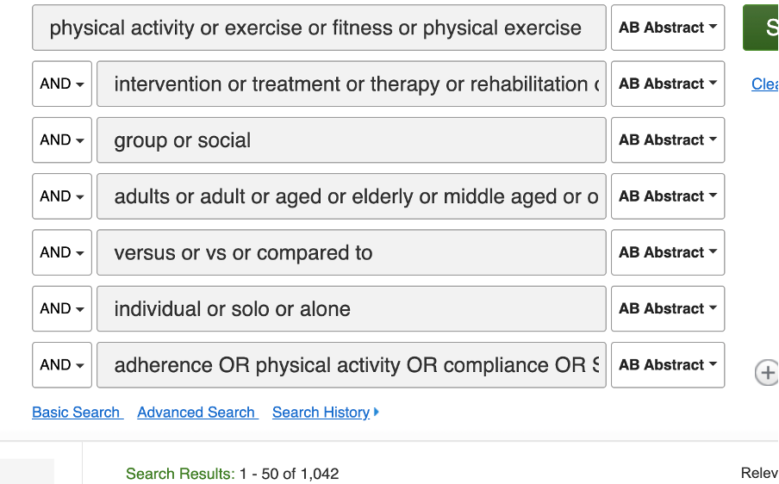

PSYCINFO
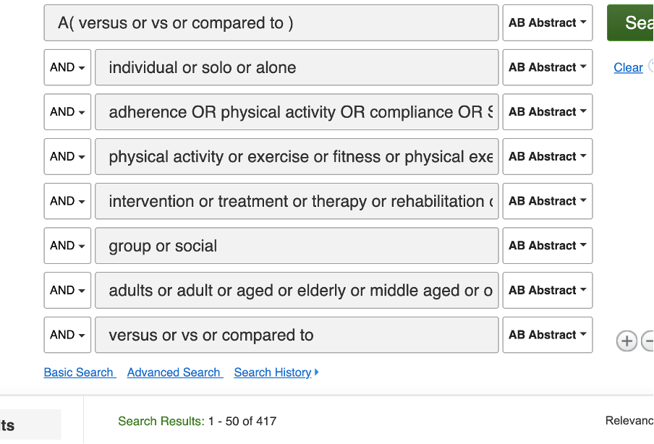
Restriction: Academic journals

Google Scholar:
"group OR collective vs. individual" AND "physical activity" AND “Adult” AND "versus OR compared to" AND "change OR intervention OR impact OR Effect OR Promote"
Other Sources (e.g. backwards and forwards search)

Table S2. GRADE assessment for behavioral, functional, psychosocial and health outcomes.
No of studies | Design | Risk of bias | Inconsistency | Indirectness | Imprecision | Publication bias | Certainty  (overall score)
Outcome: Physical Activity
116 effects,  16,886 participants | RCT/Quasi-RCT | Moderate | Serious | Serious | Serious | Non-Serious | MODERATE
Outcome: Physical Activity
9 effects  5,156  participants | Non-Experimental | Serious | Serious | Serious | Serious | Non-Serious | LOW
Outcome: Functional
140 effects,  19,707  participants | RCT/Quasi-RCT | Serious | Moderate | Non-serious | Moderate | Serious | MODERATE
Outcome: Functional
17 effects, 6,066 participants | Non-Experimental | Serious | Moderate | Moderate | Moderate | Serious | MODERATE
Outcome: Psychosocial Outcomes
93 effects, 14,307 participants | RCT/Quasi-RCT | Serious | Non-serious | Serious | Serious | Non-serious | LOW
12 effects, 3,916 participants | Non-experimental | Serious | Non-serious | Serious | Moderate | Serious | LOW
Outcome: Health Outcomes
116 effects, 16,209 participants | RCT/Quasi-RCT | Serious | Moderate | Non-serious | Serious | Non-serious | MODERATE
21 effects, 15,398 participants | Non-experimental | Serious | Moderate | Moderate | Serious | Serious | MODERATE

Figure S1. Sunset enhanced funnel plot of included studies for functional outcomes
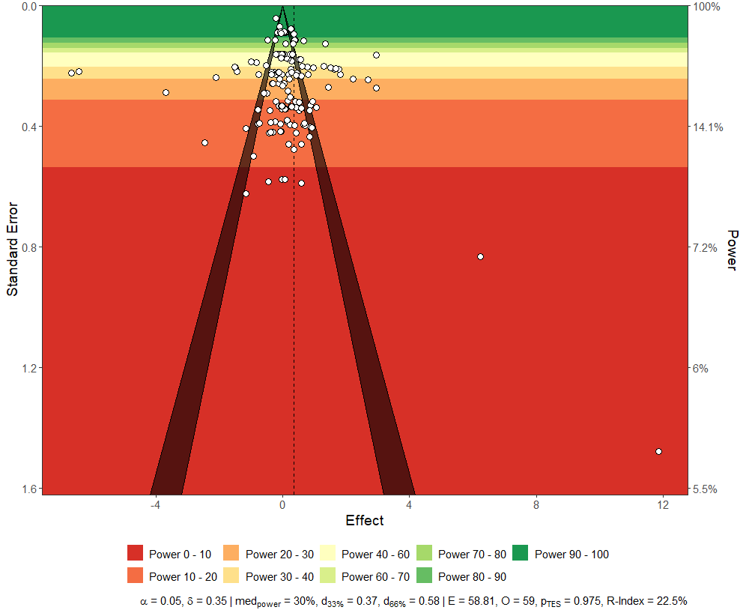

Figure S2. Sunset enhanced funnel plot of included studies for psychological outcomes
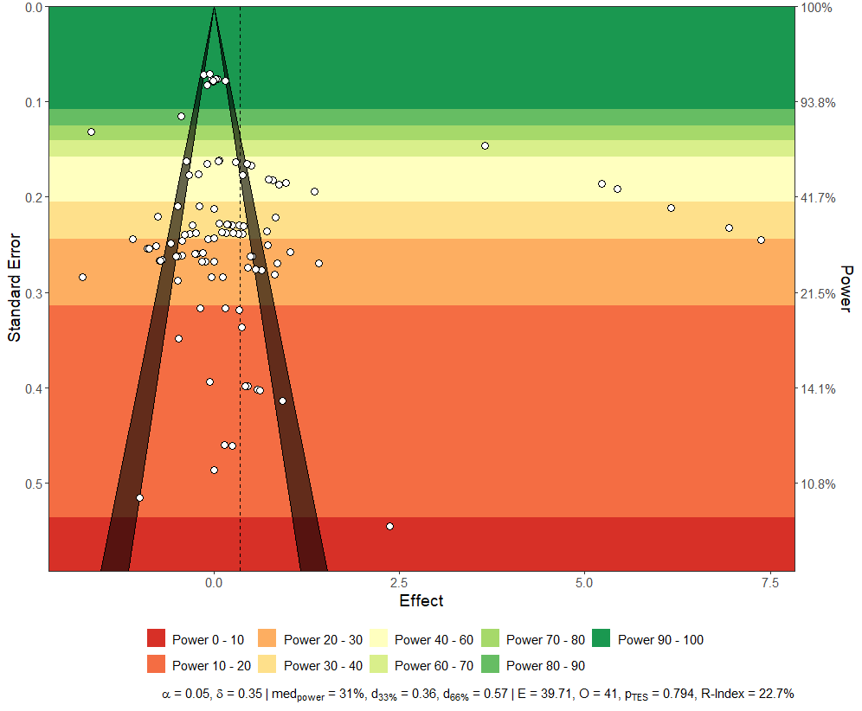

Figure S3. Sunset enhanced funnel plot of included studies for health outcomes
