Supplementary Information
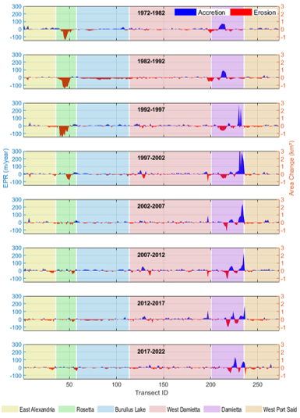
Supplementary Figure S1. EPR and area change patterns along the Nile Delta (1972-2022). Each plot shows EPR (m/year) on the left y-axis and area change (km²) on the right y-axis for various transect IDs, showing the spatial and temporal changes in shoreline positions across different segments.

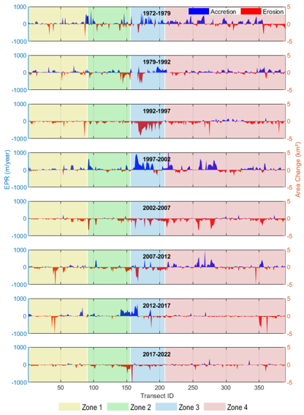
Supplementary Figure S2. EPR and area change patterns along the Indus Delta (1972-2022). Each plot shows EPR (m/year) on the left y-axis and area change (km²) on the right y-axis for various transect IDs, showing the spatial and temporal changes in shoreline positions across different segments.

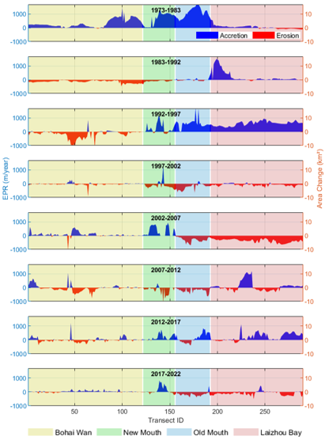
Supplementary Figure S3. EPR and area change patterns along the Yellow Delta (1973-2022). Each plot shows EPR (m/year) on the left y-axis and area change (km²) on the right y-axis for various transect IDs, showing the spatial and temporal changes in shoreline positions across different segments.
Supplementary Table S1. Mean EPR in (m/year) by Region and Time Period along Nile Delta.
Period | East Alexandria | Rosetta | Burullus Lake | West Damietta | Damietta | West Port Said
1972-1982 | 7.79 | -30.96 | -0.29 | -1.30 | 2.37 | 3.45
1982-1992 | -1.89 | -45.25 | -14.16 | -5.43 | -0.46 | -0.77
1992-1997 | -1.57 | -44.22 | 2.53 | 0.71 | 1.01 | -5.03
1997-2002 | 0.72 | -8.99 | -2.71 | 0.024 | 29.40 | -1.01
2002-2007 | 0.39 | -6.15 | -1.39 | 0.62 | 16.94 | -2.43
2007-2012 | 0.62 | -1.59 | 3.60 | 1.91 | 7.85 | 3.87
2012-2017 | -7.06 | -5.84 | -5.81 | 3.89 | -2.66 | 0.38
2017-2022 | -3.54 | -1.39 | -2.44 | -1.12 | 4.20 | -2.86
Supplementary Table S2. Mean EPR in (m/year) by Region and Time Period along Indus Delta.
Period | Zone 1 | Zone 2 | Zone 3 | Zone 4
1972-1979 | 12.18 | 5.65 | 38.84 | 18.73
1979-1992 | 10.19 | -20.45 | 4.49 | 10.30
1992-1997 | -49.79 | -47.19 | -257.42 | -54.84
1997-2002 | 27.95 | 42.82 | 182.20 | 55.86
2002-2007 | -39.87 | -70.80 | -115.44 | -84.67
2007-2012 | -40.50 | -54.50 | -99.44 | 31.87
2012-2017 | -4.53 | 68.70 | 34.48 | -33.97
2017-2022 | -24.20 | -74.69 | -79.82 | -21.69
Supplementary Table S3. Mean EPR in (m/year) by Region and Time Period along Yellow Delta.
Period | Bohai Wan | New Mouth | Old Mouth | Laizhou Bay
1973-1982 | 317.27 | 664.99 | 1105.50 | 44.74
1982-1992 | -136.41 | -88.37 | -4.49 | 211.70
1992-1997 | -173.36 | 245.40 | 604.73 | 604.15
1997-2002 | -25.75 | -110.33 | -228.96 | -84.24
2002-2007 | 70.17 | 330.23 | -302.42 | -369.83
2007-2012 | -35.00 | -174.37 | -207.97 | 86.52
2012-2017 | -2.79 | 178.00 | 123.12 | 206.13
2017-2022 | 24.70 | 110.64 | -180.81 | -103.33

