EXTENDED DATA
Extended data table 1
Overview of samples used from each dataset.
Dataset by first author | Cohorts (n) | males (%) | Age range (years)
Litviňuková M., et al. ^{[2]} | Healthy (6) | 3 (42) | 40-65
Reichart D., et al. ^{[3]} | Healthy (6) | 5 (83) | 20-69
Reichart D., et al. ^{[3]} | DCM (52) | 39 (75) | 0-79
Reichart D., et al. ^{[3]} | ACM (8) | 5 (63) | 30-69
Reichart D., et al. ^{[3]} | NCM (1) | 0 (0) | 10-19
Chaffin M., et al. ^{[4]} | Healthy (15) | 5 (33) | 33-72
Chaffin M., et al. ^{[4]} | HCM (15) | 10 (67) | 29-63
Chaffin M., et al. ^{[4]} | DCM (11) | 7 (64) | 41-65
Simonson B., et al. ^{[5]} | Healthy (8) | 4 (50) | 42-63
Simonson B., et al. ^{[5]} | IHD (7) | 2 (33) | 47-64
Kuppe C., et al. ^{[6]} | Healthy (2) | 2 (100) | 44-61
Kuppe C., et al. ^{[6]} | MI (16) | 12 (75) | 38-74
Selewa A., et al. ^{[7]} | AF (3) | 3(100) | 47-55
Perez-Shibayama C., et al. ^{[8]} | AM (5) | 3 (60)

Extended data figure 1
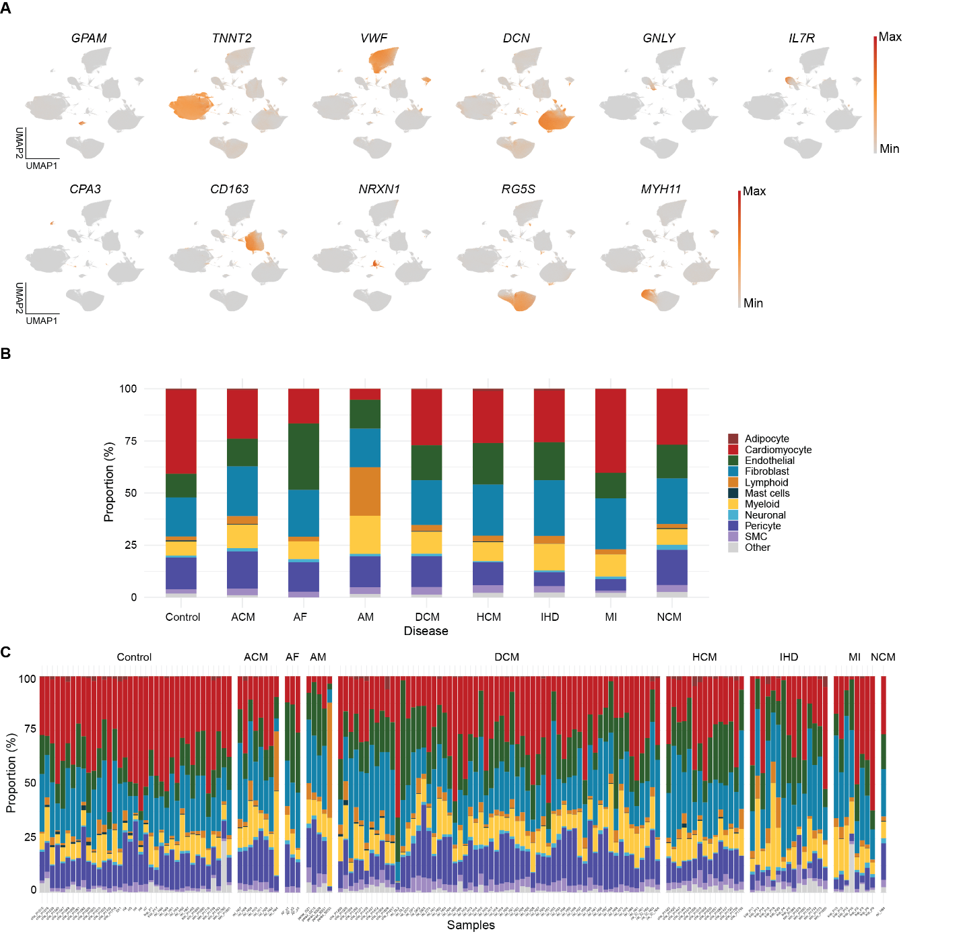
A) Marker genes expression of each cell-type illustrated in the 2-dimensial UMAP. B-C) Stacked bar plot depicting cell-type proportions of per disease and for all 154 samples, colour coded for cell types.

Extended data figure 2
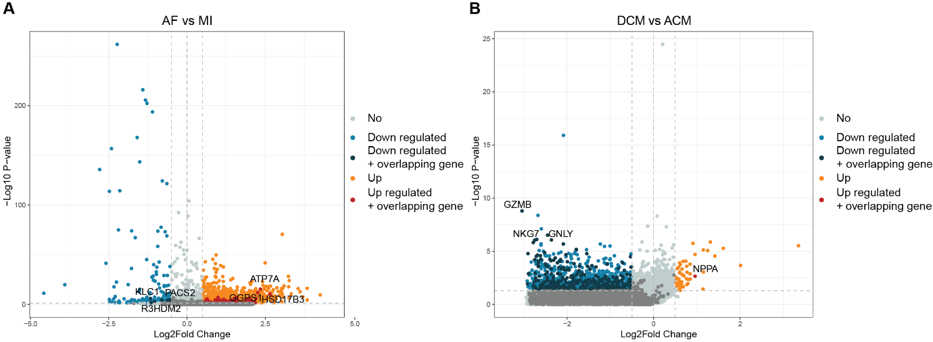
Volcano plots demonstrating bulk differential gene analysis on A) AF compared to MI and B) DCM compared to ACM. Colours indicate up- or downregulation and genes, top three upregulated overlapping genes

Extended data table 2
Overview of the categories for GO-processes.

Cardiac Function | Cellular Function | Metabolism | Neuronal signalling
Heart contraction | Cytoplasmic region | Tricarboxylic acid cycle | Vocalization behavior
Heart process | Endoplasmic reticulum lumen | Pyruvate metabolic process | Synaptic membrane
Regulation of heart rate | Organelle outer membrane | Response to oxygen levels | Presynaptic membrane
Cardiac conduction | Outer membrane | Response to hypoxia | Glutamatergic synapse
Regulation of heart contraction | Lipid droplet | Glucose catabolic process | Perikaryon
Cell communication involved in cardiac conduction | Basolateral plasma membrane | Tricarboxylic acid metabolic process | Presynaptic active zone membrane
Cardiac muscle contraction | Mitochondrial outer membrane | Glycolytic process
Regulation of blood circulation | Basal plasma membrane
Muscle system process
Intracellular calcium ion homeostasis
Cardiac muscle cell action potential
Muscle contraction

Extended data figure 3
A) Significantly upregulated genes from the differential genes expression (p < 0.05) in fibroblasts. B) Average expression of genes with targets in the Drug Gene Interaction Database per fibroblast subpopulation indicated after transformation to Z-score.
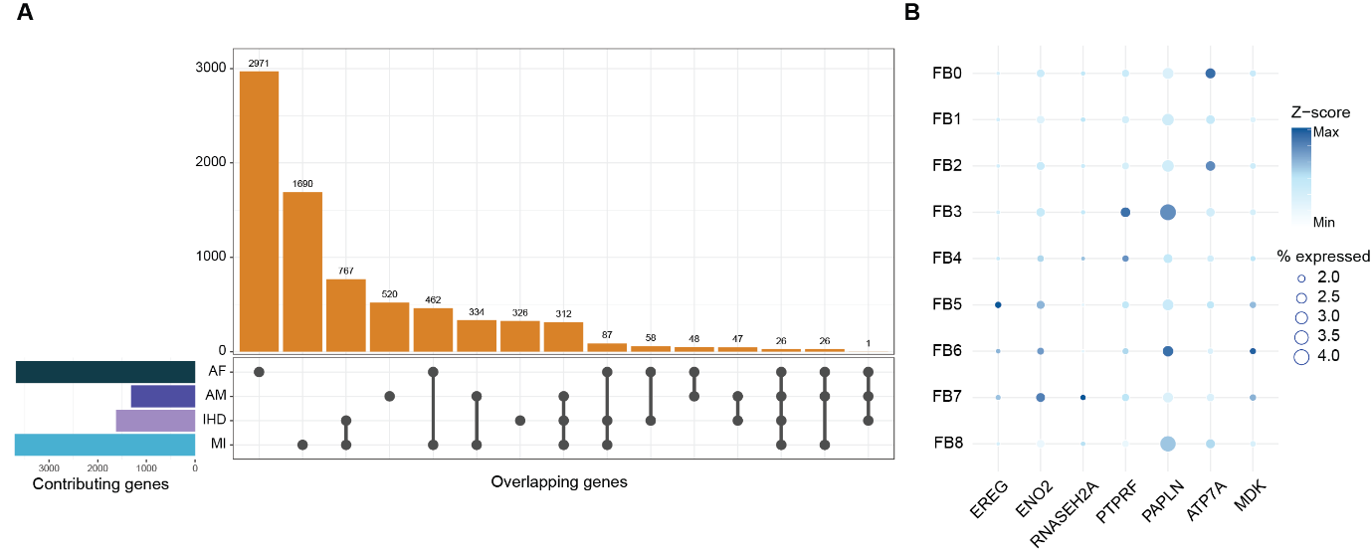

Extended data table 3
Comparison of our cardiomyocyte subpopulations with those from articles contributing datasets to this study.
 | Reichart^{[3]} | Kuppe^{[6]} | Litviňuková^{[2]} | Marker genes
CM_0 | vCM1.0 |  | vCM1 | FHL2, MYH7, MYL2, PCDH7
CM_1 | - | - | - | -
CM_2 | vCM1.1 |  |  | IGF1R, XPR1, MYO18B,
CM_3 | vCM1.2 |  |  | FNIP2, PCDH7, CCSER1
CM_4 | - | - | - | -
CM_5 | vCM3.1 |  |  | NR4A3, CYR66, ATF3
CM_6 | - | - | - | -
CM_7 |  | vCM4 | vCM5 | DLC1, EBF1, EBF2
CM_8 | vCM1.3 |  |  | GPC5, MYL4, TPM3
CM_9 |  | vCM5 |  | CAM1KD, NAMPT, A2M
CM_10 |  | vCM1 | vCM2 | MGAT4C, GRXCR2, CDH13
CM_11 |  | vCM2 | vCM4 | ANKRD1, CRYAB, ACTB

Extended data figure 4
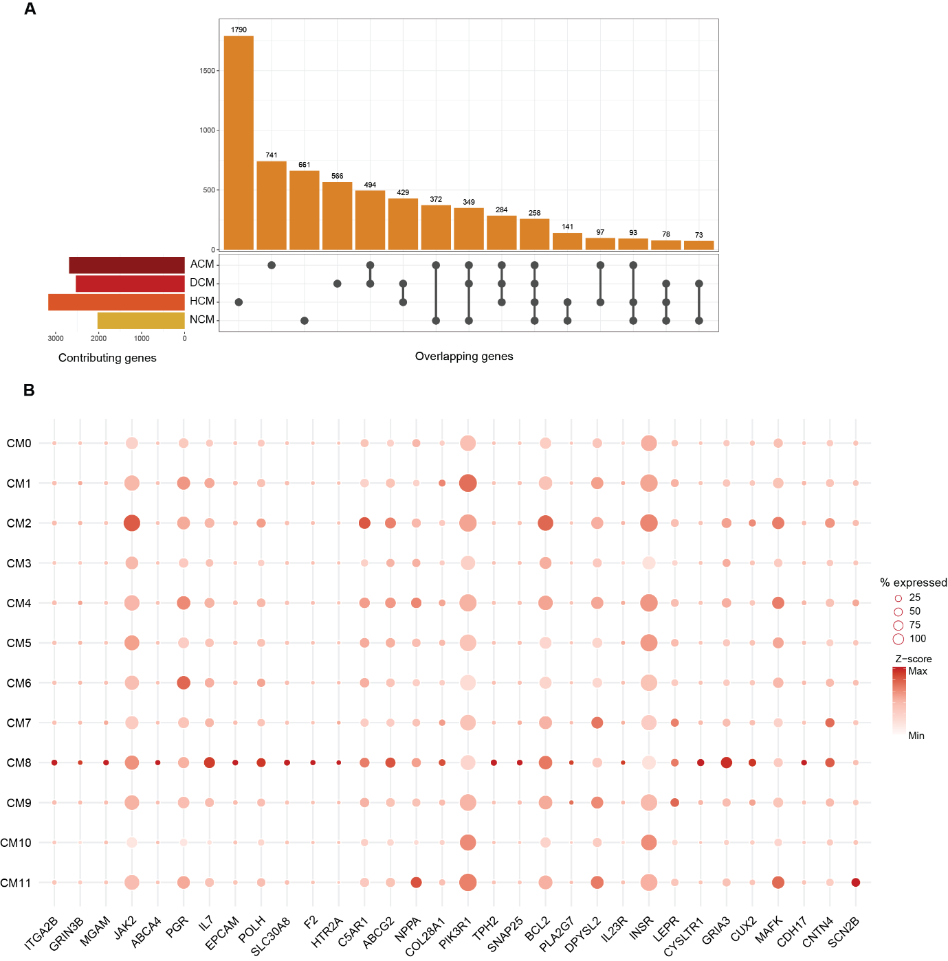
A) Significantly upregulated genes from the differential genes expression (p < 0.05) in cardiomyocytes B) Average expression of genes with targets in the Drug Gene Interaction Database per cardiomyocyte subpopulation indicated after transformation to Z-score.

Extended data table 4
Search string used for PubMed search for articles with datasets.
((((single nucleus [MeSH Terms] OR snRNA [MeSH Terms] OR single nucleus RNA[MeSH Terms]) AND (transcriptomics[MeSH Terms] OR sequencing[MeSH Terms])) OR (snRNA sequencing[MeSH Terms] OR single nucleus RNA sequencing[MeSH Terms])) OR (((single nucleus [All Fields] OR snRNA [All Fields] OR single nucleus RNA[All Fields]) AND (transcriptomics[All Fields] OR sequencing[All Fields] OR seq[All Fields])) OR (snRNAseq[All Fields] OR single nucleus RNAseq[All Fields] OR snRNA sequencing[All Fields] OR single nucleus RNA sequencing[All Fields]))) AND (cardiovascular diseases[MeSH Terms] OR (cardiovascular[MeSH Terms] AND diseases[MeSH Terms])) OR (cardiovascular diseases[All Fields] OR (cardiovascular[All Fields] AND diseases[All Fields])) OR ((cardiac [MeSH Terms] OR heart [MeSH]) AND diseases [MeSH Terms]) OR ((cardiac [All Fields] OR heart [All Fields]) AND (diseases [All Fields] OR damage [All Fields]) OR CVD[All Fields]) AND (humans[Filter]) AND (2018:2024[pdat])

Extended data table 5
Inclusion criteria for articles with datasets to be included in this study.
Inclusion Criteria
snRNA sequencing – 10x genomics V3
Human cardiac tissue
Adult donors
Healthy controls or cardiac disease
Online available original

Extended data figure 5
Flow chart illustrating the search for datasets to be incorporated into this study performed on the 20th of February, 2024.

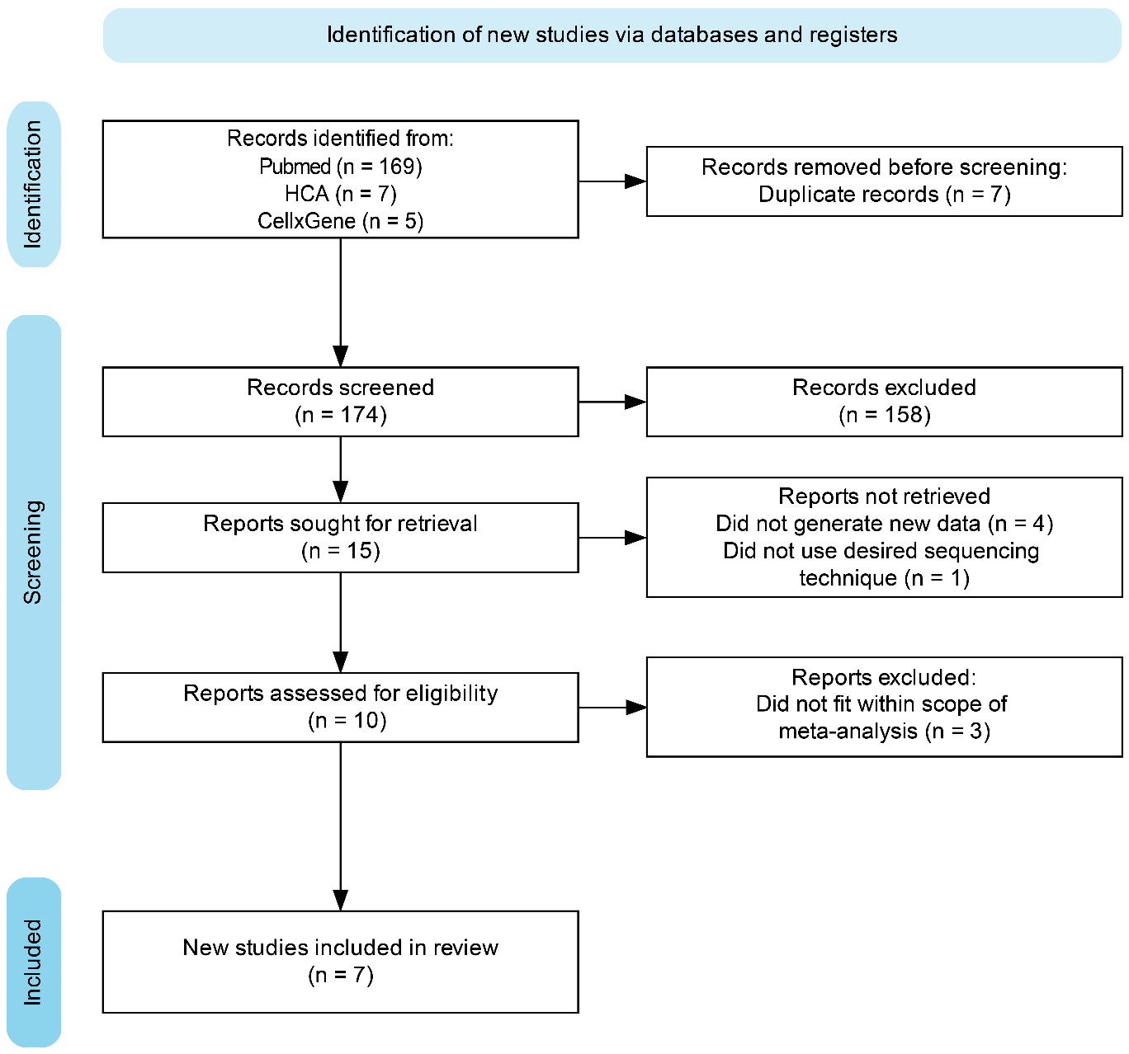

Extended figure 6
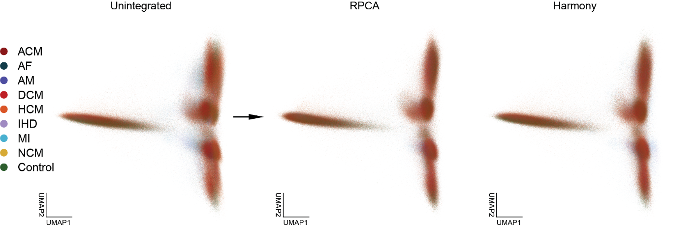
Comparison of integration methods Reciprocal PCA (RPCA) and Harmony used to merge all 154 samples into a single dataset.

