SUPPORTING INFORMATION
SUPPLEMENTARY MATERIAL

Pulmonary function assessment
All subjects were examined by an experienced pulmonary function examiner using the CareFusion Vmax Encore Autobox. The interval between the lung function test and MRI scan was ≤2 days. The percentage of the FEV1% the percentage of FVC%, and FEV1/FVC were recorded to indicate pulmonary function, with smaller values indicating poorer pulmonary health.

Smoking behaviour assessment
All smokers recorded the information of smoking behaviour, including smoking history (years of smoking), number of cigarettes smoked per day and smoking index. Smoking index was calculated by (years of smoking) * (number of cigarettes smoked per day). The smoking index of all smokers ≥200.

Cognitive function assessment: MoCA
MoCA measures visuospatial execution ability, naming ability, language ability, attention ability, abstraction ability, orientation ability and delayed recall ability, was used as the cognitive test. All subjects partook of the Montreal Cognitive Function Assessment Scale after fMRI scanning, and the assessment was completed within 10-15 minutes. Participants with a score of less than 26 on the MoCA scale were considered to have cognitive dysfunction; those with a score of ≥ 26 were considered to have normal cognitive function; those with less than 12 years of education were given an additional point to their initial score.

Resting-state fMRI scan
For magnetic resonance data acquisition, a Siemens Trio 3.0 T superconducting MRI scanner with an 8-channel head coil was adopted to acquired data. Subjects were asked to lie supine, close their eyes and remain awake, while avoiding thinking and experiencing mood swings. (1) Anatomical T1 weighted images were acquired using 3D magnetization-prepared rapid gradient-echo sequence, repetition time/echo time (TR/TE)=876/18ms, slice thickness=1.0 mm, slice number=176, matrix=224×256, FOV =240 mm×240 mm, flip angle =55°. (2) Resting-state functional scans were acquired with spin-echo E-Planar imaging (SE-EPI) sequence, TR/TE=2000/30ms, slice thickness=3.7 mm, slice number=33, matrix=64×64, FOV=240 mm×240 mm, flip angle =85°. A total of 240 volumes were acquired, and the scanning time was 8 minutes and 6 seconds.

Inclusion and exclusion criteria
All the selected COPD patients met the global agreement diagnostic criteria(Anna et al., 2018) and had dyspnoea, chronic cough or expectoration, etc. According to pulmonary function examination, the forced expiratory volume in one second (FEV1%) < 70% after inhaling bronchodilator indicates an incomplete reversible airflow limitation. None of the patients underwent oxygen therapy, and no acute attack had occurred in the past month. All smokers, including the participants in the COPD-Smoking group and the NonCOPD-Smoking group, had a smoking history ≥20 years, ≥ 5 cigarettes smoked a day and a smoking index ≥200.
Patients with other respiratory diseases, obstructive sleep apnoea, history of head trauma, intracerebral tumours and other uncured tumours, epilepsy, substance abuse, cardiovascular disease, diabetes, mental illness, Alzheimer's disease, sleep disorders, anaemia, alcohol abuse, and MR contraindications were excluded. None of the smoking subjects had ever quit smoking. All participants in this study signed informed consent prior to the examination.

Participant’s information
From October 2014 to August 2018, 85 participants were recruited to finish the experiment. 42 patients with COPD diagnosed in Anhui Provincial Hospital and followed up in an outpatient clinic were collected, including 20 COPD patients who smoked (COPD-Smoking group) and 22 non-smoking COPD patients (COPD-Nonsmoking group). 43 healthy participants were recruited and screened, among whom 22 were smokers (NonCOPD-Smoking group) and 21 were non-smokers (NonCOPD-Nonsmoking group), as shown in Table S1 and Table S2.

Table S1
Demographic Characteristics of COPD and NonCOPD group
Characteristics | COPD(n=42)  Mean±SD | NonCOPD(n=43)  Mean±SD | p
Age | 69.64±8.00 | 68.30±8.50 | 0.456
Gender (female/male) | 14/28 | 13/30 | 0.759
Education | 5.76±4.79 | 5.77±4.20 | 0.995
Smoking/Nonsmoking | 20/22 | 22/21 | 0.590
Smoking Index | 796.25±391.80 | 745.68±358.56 | 0.665
Smoking History | 41.60±9.36 | 38.82±11.58 | 0.400
FEV1% | 52.36±17.05 | 102.14±9.96 | <0.001
FVC% | 65.91±15.59 | 90.00±6.97 | <0.001
FEV1/FVC | 56.31±8.83 | 87.14±5.01 | <0.001

Table S2
Results of Cognitive function and Pulmonary function assessment (Mean±SD)
Characteristics | COPD-Smoking  (n=20) | COPD-  Nonsmoking  (n=22) | NonCOPD-Smoking  (n=22) | NonCOPD  -Nonsmoking  (n=21)
Age | 68.30±8.12 | 70.86±7.87 | 66.45±9.04 | 70.24±7.62
Education | 6.90±4.94 | 4.73±4.52 | 6.36±4.01 | 4.81±3.84
Gender(female/male) | 0/20 | 14/8 | 0/22 | 13/8
Attention ability | 5.15±1.14 | 4.32±0.99 | 5.82±0.50 | 5.86±0.48
Total score | 23.05±3.59 | 19.73±3.61 | 26.95±2.40 | 28.67±2.54
FEV1% | 50.30±17.21 | 54.23±17.08 | 101.36±9.73 | 102.95±10.37
FVC% | 67.95±16.20 | 64.05±15.14 | 90.32±7.23 | 89.67±6.85
FEV1/FVC | 54.30±9.30 | 58.14±8.16 | 87.27±5.20 | 87.00±4.92

Cognitive functions in the MoCA

We also explored the impact of COPD on other cognitive functions in the MoCA. The scores of visuospatial execution ability, naming ability, language ability, abstraction ability, delayed recall and total score were all significantly lower in the COPD group than in the NonCOPD group (Table S3). However, all the participants scored full marks for orientation ability.
Specifically, only visuospatial execution ability and abstraction ability were significantly worse in COPD-Nonsmoking than in COPD-Smoking (Figure S1 and Table S4), but no mediation effect was found. In addition, we also found that delayed recall ability was worse in the NonCOPD-Smoking group than in the NonCOPD-Nonsmoking group (Figure S1).

Table S3
Results of Cognitive function in COPD and NonCOPD group.
Characteristics | COPD(n=42)  Mean±SD | NonCOPD(n=43)  Mean±SD | p-value | t-value  df=83
Visuospatial executive | 2.14±1.56 | 3.72±1.14 | <0.001 | 5.34
Naming | 2.55±0.59 | 2.98±0.15 | <0.001 | 4.59
Attention | 4.71±1.13 | 5.83±0.48 | <0.001 | 5.99
Language | 2.45±0.63 | 2.83±0.43 | 0.002 | 3.28
Abstraction | 0.88±0.71 | 1.79±0.46 | <0.001 | 7.03
Delayed recall | 1.55±1.91 | 3.77±1.27 | <0.001 | 8.30
Total score | 21.31±3.94 | 27.79±2.59 | <0.001 | 8.99

We also analysed the impact of smoking on other cognitive functions in the MoCA. Two-way ANOVA of the MoCA score found significant interaction effect in abstraction ability, delayed recall ability and total score,a significant main effect of COPD and smoking on the visuospatial execution ability, naming ability, language ability, abstraction ability, delayed recall ability and total scores, a significant main effect of smoking on visuospatial execution ability(Table S4 and Figure S1).
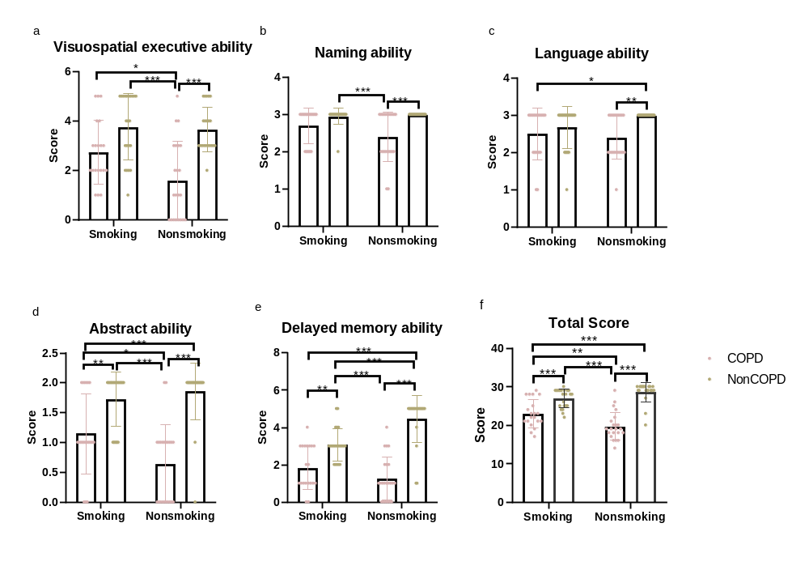
Figure S1. The cognitive function of the four groups (COPD-Smoking/COPD-Nonsmoking/NonCOPD-Smoking/NonCOPD-NonSmoking) was compared. The p values were adjusted by Bonferroni’s correction for multiple comparisons.

Table S4
Results of two way ANOVA analysis in MoCA score.
 | effect | Mean squre | F-value | p-value | LLCI | ULCI
Visuospatial  executive | COPD***  Smoking*  Intercation | 50.92  8.49  5.88 | 29.55  4.93  3.41 | <0.001  0.029  0.068 | -2.12  0.07  -0.08 | -0.98  1.20  2.19
Naming | COPD***  Smoking  Intercation | 3.79  0.32  0.60 | 21.22  1.79  3.36 | <0.001  0.185  0.071 | -0.61  -0.06  -0.03 | -0.24  0.31  0.70
Attention | COPD***  Smoking*  Intercation | 25.84  3.33  4.02 | 37.94  4.90  5.90 | <0.001  0.030  0.017 | -1.46  0.04  0.16 | -0.75  0.75  1.58
Language | COPD**  Smoking  Intercation | 3.17  0.27  0.89 | 11.11  0.96  3.11 | 0.001  0.330  0.081 | -0.62  -0.34  -0.87 | -0.16  0.12  0.05
Abstraction | COPD***  Smoking  Intercation* | 17.15  0.78  2.20 | 52.27  2.38  6.70 | <0.001  0.127  0.012 | -1.15  -0.06  -1.14 | -0.65  0.44  -0.15
Delayed recall | COPD***  Smoking  Intercation*** | 104.80  3.46  20.43 | 83.23  2.75  16.23 | <0.001  0.101  <0.001 | -2.71  -0.89  -2.93 | -1.74  0.08  -0.99
Total score | COPD***  Smoking  Intercation*** | 875.00  13.76  134.50 | 92.18  1.45  14.16 | <0.001  0.232  <0.001 | -7.75  -0.53  2.37 | -5.09  2.14  7.70

In particular, the independent samples T test showed that the visuospatial execution ability ($t_{40}= 2.57, p=0.014, Cohen^{'}s d=0.795$), abstraction ability ($t_{40}= 2.50, p=0.017, Cohen^{'}s d=0.773$) and total scores ($t_{40}= 2.99, p=0.005, Cohen^{'}s d=0.922$) were all higher in the COPD-Smoking group than in the COPD-Nonsmoking group (Table S5 and Table S6).

Table S5
Results of Cognitive function and Pulmonary function assessment.
Characteristics | COPD-Smoking(n=20) | COPD-Nonsmoking(n=22) | NonCOPD-Smoking(n=22) | NonCOPD-Nonsmoking(n=21)
Visuospatial  executive | 2.75±1.29 | 1.59±1.59 | 3.77±1.34 | 3.67±0.91
Naming | 2.70±0.47 | 2.41±0.67 | 2.95±0.21 | 3.00±0.00
Attention | 5.15±1.14 | 4.32±0.99 | 5.82±0.50 | 5.86±0.48
Language | 2.50±0.69 | 2.41±0.59 | 2.68±0.57 | 3.00±000
Abstraction | 1.15±0.67 | 0.64±0.66 | 1.73±0.46 | 1.86±0.48
Delay recall | 1.85±1.18 | 1.27±1.16 | 3.09±0.87 | 4.48±1.25
Total score | 23.05±3.59 | 19.73±3.61 | 26.95±2.40 | 28.67±2.54

Table S6
Results of independent sample T test in MoCA score (COPD-Smoking vs. COPD-Nonsmoking).
 | t-value | p-value | df | Cohens’d | LLCI | ULCI
Visuospatial executive * | 2.572 | 0.014 | 40 | 0.397 | 0.25 | 2.07
Naming | 1.620 | 0.113 | 40 | 0.250 | -0.07 | 0.65
Attention* | 2.529 | 0.016 | 40 | 0.391 | 0.17 | 1.50
Language | 0.461 | 0.647 | 40 | 0.071 | -0.31 | 0.49
Abstraction* | 2.503 | 0.017 | 40 | 0.387 | 0.10 | 0.93
Delayed recall | 1.595 | 0.119 | 40 | 0.246 | -0.15 | 1.31
Total score* | 2.985 | 0.005 | 40 | 0.461 | 1.07 | 5.57

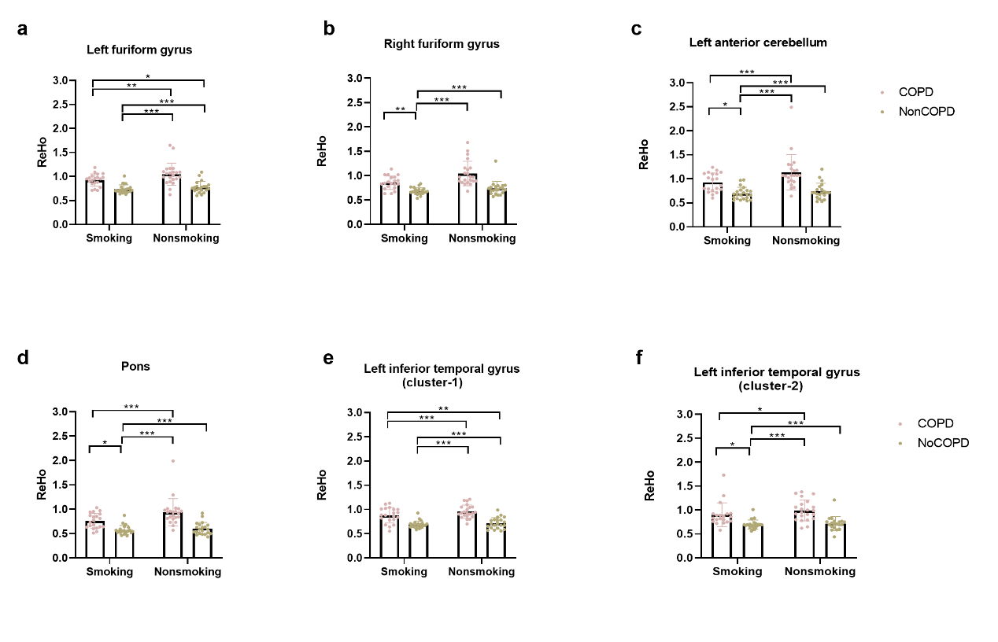
Figure S2. The ReHo values of the four groups (COPD-Smoking/COPD-Nonsmoking/NonCOPD-Smoking/NonCOPD-NonSmoking) were compared in six brain regions. The p values were adjusted by Bonferroni’s correction for multiple comparisons. a) Left fusiform gyrus; b) Right fusiform gyrus; c) Left anterior cerebellum; d) Pons; e) Left inferior temporal gyrus (cluster-1); f) Left inferior temporal gyrus (cluster-2). (*: p<0.05; **: p<0.01; ***: p<0.001).

Figure S3. The node betweenness centrality of the four groups (COPD-Smoking/COPD-Nonsmoking/NonCOPD-Smoking/NonCOPD-NonSmoking) was compared in the a) left fusiform gyrus, b) right fusiform gyrus, and c) left inferior temporal gyrus. The p value was corrected by Bonferroni’s multiple comparisons test. (*: p<0.05; **: p<0.01; ***: p<0.001).

