-Supplementary Figures
Arctic stratospheric ozone as a precursor of ENSO events since 2000s

Jae-Heung Park¹*, Ja-Ho Koo²*, Jong-Seong Kug¹*
Su-Jung Lee¹, Mi-Kyung Sung³, Joowan Kim⁴, Eun-Chul Chang⁴, Young-Min Yang^{5,6,7}
Sang Seo Park⁸, Kyung-Hwan Kwak⁹, Ji-Hoon Oh¹⁰, Hyung-Jeon Kang¹, and Soon-Il An²

¹School of Earth and Environmental Sciences, Seoul National University, Seoul, South Korea
²Department of Atmospheric Sciences, Yonsei University, Seoul, South Korea
³Korea Institute of Science and Technology, Seoul, South Korea
⁴Department of Atmospheric Science, Gongju National University, Gongju, South Korea
⁵Department of Environment & Energy, Jeonbuk National University, 567 Baekje-daero, Deokjin-gu, Jeonju-si, Jeollabuk-do 54896, Republic of Korea
⁶School of Civil, Environmental, Resources and Energy Engineering, Jeonbuk National University, 567 Baekje-daero, Deokjin-gu, Jeonju-si, Jeollabuk-do 54896, Republic of Korea
⁷Soil Environment Research Center, Jeonbuk National University, 567 Baekje-daero, Deokjin-gu, Jeonju-si, Jeollabuk-do 54896, Republic of Korea
⁸Department of Urban and Environmental Engineering, Ulsan National Institute of Science and Technology (UNIST), Ulsan, South Korea
⁹School of Natural Resources and Environmental Science, Kangwon National University, Chuncheon, South Korea
¹⁰Scripps Institution of Oceanography, University of California San Diego, La Jolla, CA, USA

Submitted to Nature Communications

Corresponding authors:
Dr. Jae-Heung Park (e-mail: jhp11010@gmail.com), School of Earth and Environmental Sciences, Seoul National University, Seoul, South Korea & Prof. Ja-Ho Koo (e-mail: zach45@yonsei.ac.kr), Department of Atmospheric Sciences, Yonsei University, Seoul, South Korea & Prof. Jong-Seong Kug (e-mail: jskug1@gmail.com), School of Earth and Environmental Sciences, Seoul National University, Seoul, South Korea
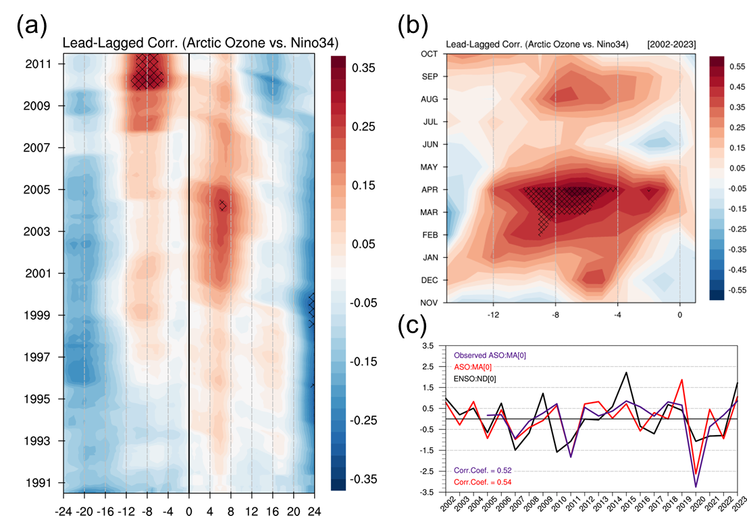
Supplementary Fig. 1 Interdecadal modulation of the relationship between ASO and ENSO from MERRA2. (a) 252-month (21-year) running lead-lagged correlation coefficients between the ASO and Niño-3.4 for the period 1980–2023 in MERRA2 (y-axis). Negative and positive values on the x-axis indicate leads of ASO and Niño3.4 at monthly timescales, respectively. Hatching indicates values above 0.25 at a 95% confidence level using a two-tailed Student’s t-test (degree of freedom: 60). (b) Lagged correlation between the ASO and Niño-3.4 indices for the period 2002–2023, where the x-axis indicates the number of months by which the ASO index leads the Niño-3.4 index; the y-axis indicates the period of November to the following October. The negative maximum is found at 7 (x-axis) during April (y-axis), indicating that the ASO in April negatively leads ENSO with a lag of 7 months. Hatching indicates the 95% confidence level using a two-tailed Student’s t-test (degree of freedom: 20). (c) Red and black lines indicate the March-April (MA) ASO index and the November-December (ND) Niño-3.4 index from 2002-2023. The correlation coefficient between them is 0.57, significant at 99% confidence level by student-t-test.
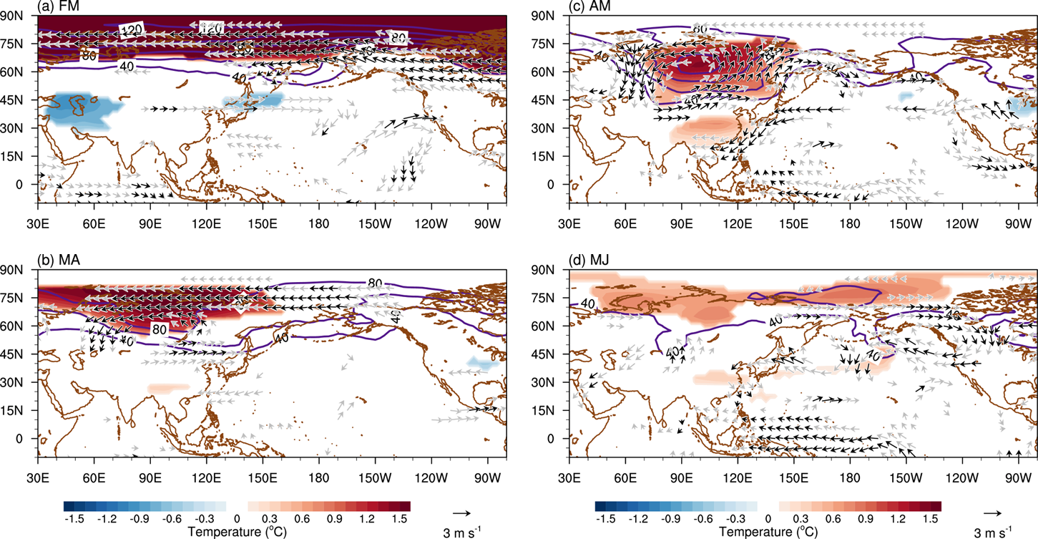
Supplementary Fig. 2 the spatiotemporal influence of springtime ASO on atmospheric circulation at 200hPa in MERRA2. (a) Regressed air temperature (shading, °C, shading bar shown at bottom), ozone concentration (contour, interval: 40 ppb), and wind anomaly (vector) at 200hPa in March–April against the springtime (March-April) ASO index for the period 2002–2023 in MERRA2. Anomalous air temperature is marked with a 95% confidence level when the Student’s t-test is satisfied. For winds, the areas satisfying 95% and 85% confidence levels by the Student’s t-test are marked with black and grey color, respectively. (b), (c), and (d) show similar figures to (a), but in March-April, April-May, May-June, respectively. For the Student’s t-test, the degree of freedom is fixed at 20.
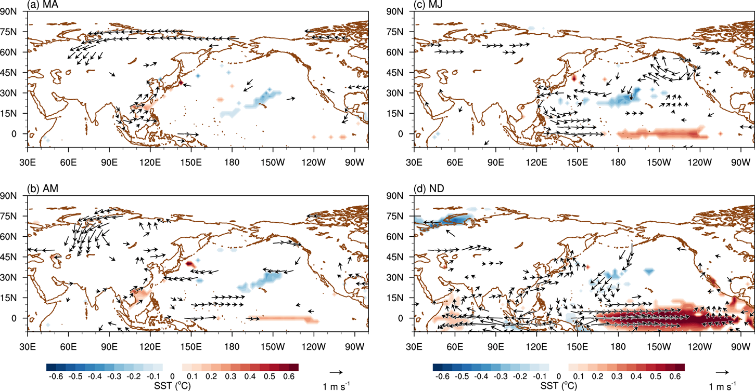
Supplementary Fig. 3 ENSO evolution in association with the springtime ASO at 850hPa in MERRA2. (a) Regressed SSTA (shading, °C, shading bar shown at bottom), low-level wind anomaly (vector, at 850 hPa) in March–April against the springtime (March-April) ASO index for the period 2002–2023. Anomalous SST and winds are marked with a 95% confidence level when the Student’s t-test is satisfied (degree of freedom: 20). (b), (c), and (d) show similar figures to the (a), but in April-May, May-June, and November-December, respectively.
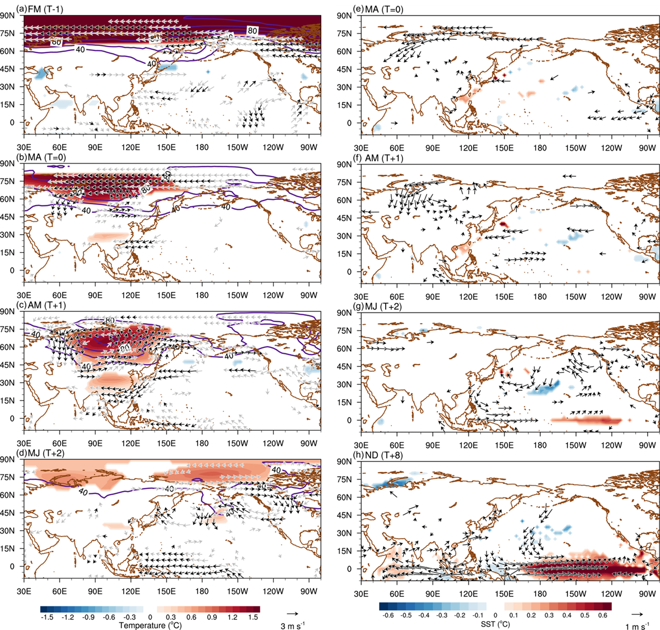
Supplementary Fig. 4 Evolution of atmospheric circulation and ENSO in terms of the springtime ASO. (a) Regressed air temperature (shading, °C, shading bar shown at bottom), ozone concentration (contour, interval: 40 ppb), and wind anomaly (vector, at 850 hPa) at 200hPa in March–April against the springtime (March-April) ASO index for the period 2002–2023, wherein previous winter (ND[-1]) ENSO signals are removed from the MA-ASO index. Anomalous air temperature is marked with a 95% confidence level when the Student’s t-test is satisfied. For winds, the areas satisfying 95% and 85% confidence levels by the Student’s t-test are marked with black and grey color, respectively. (b), (c), and (d) show similar figures to (a), but in March-April, April-May, May-June, respectively. (e) Regressed SSTA, air temperature anomaly (shading, °C, shading bar shown at bottom), low-level wind anomaly (vector, at 850 hPa) in March–April against the springtime (March-April) ASO index for the period 2002–2023. Anomalous SST and winds are marked with a 95% confidence level when the Student’s t-test is satisfied. (f), (g), and (h) show similar figures to the (a), but in April-May, May-June, and November-December, respectively.

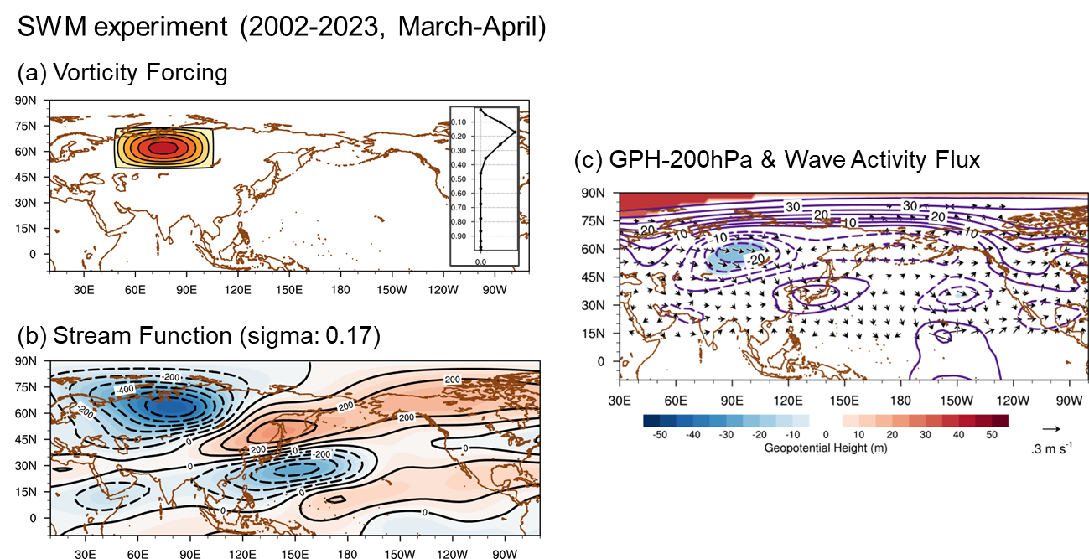
Supplementary Fig. 5 Stationary wave model experiments with springtime ASO. (a) Horizontal and vertical (inside panel) structure of steady vorticity forcing. (b) Steady response of atmospheric circulation (i.e., stream function) to the vorticity forcing described in (a) under the March–April mean state of atmosphere variables. (c) Geopotential height anomalies at 200hPa in March–April (shading, m) regressed on the ASO index and the relevant wave activity flux (vector).
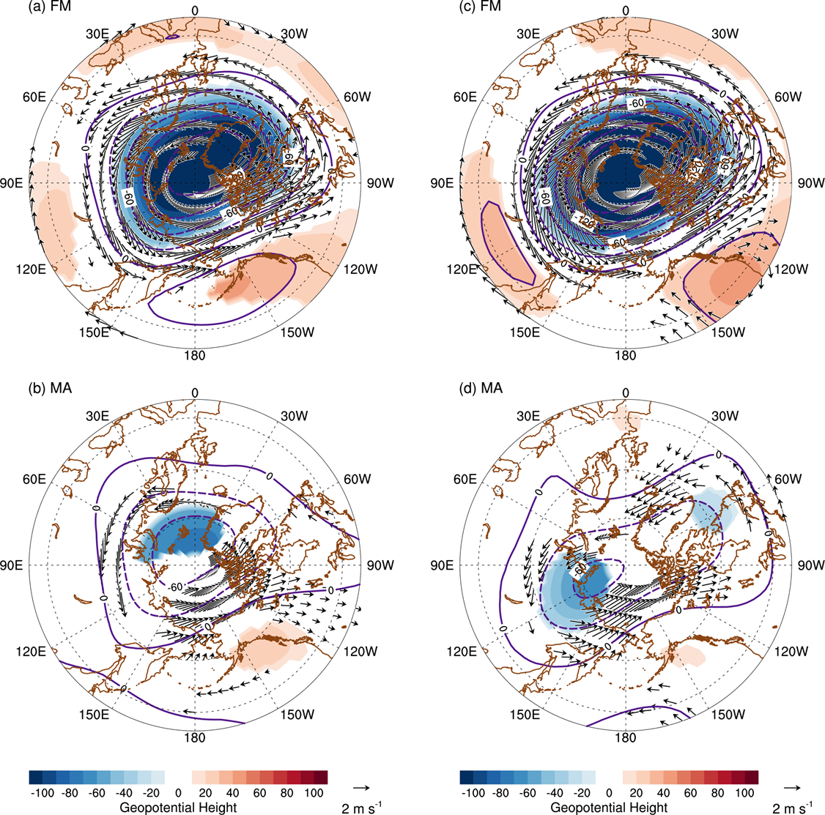
Supplementary Fig. 6 Comparison between SPV variability between 1980-2001 and 2002-2023 in MERRA2. (a) Geopotential height (shading, m2/s2) and wind (vectors, m/s) anomalies at 100hPa in February-March regressed onto zonal wind at 100hPa in February during 1980-2001. (b) Similar to (a), but in March-April. (c) and (d) are similar to (a) and (b), but during 2002-2023. 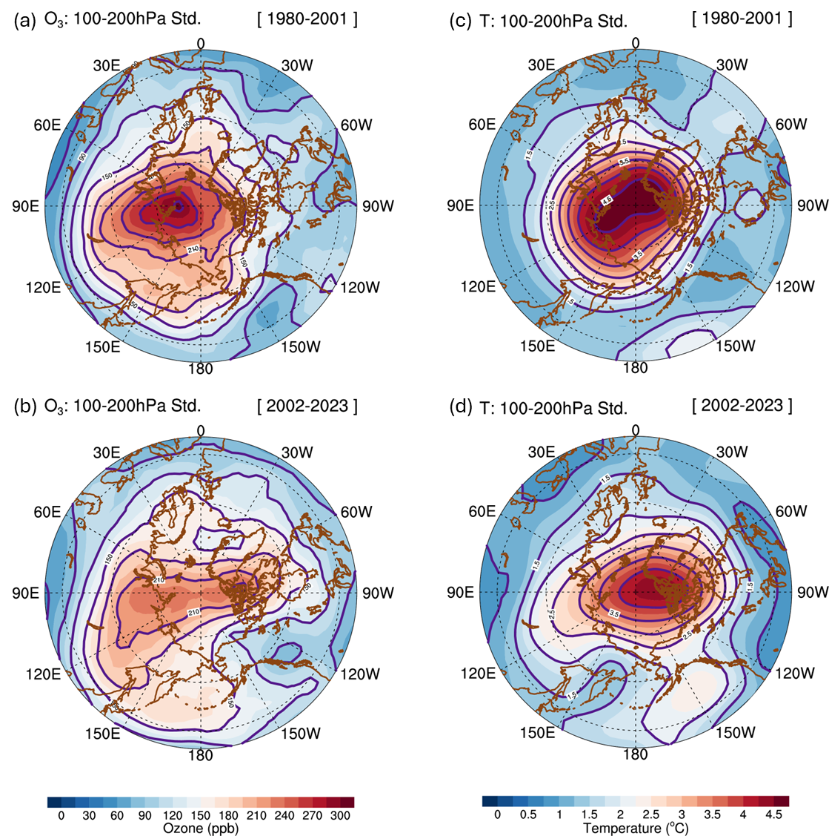
Supplementary Fig. 7 Comparison stratospheric ozone and temperature variability between 1980-2001 and 2002-2023. (a) Standard deviation of ozone(units; ppb) in March–April at 100-200hPa during 1980-2001 from ERA5. Contour intervals are 30 and shading bar shown at bottom. (b) is similar to (a), but during 2002-2023. (c) and (d) is similar to (a) and (b), respectively, but for temperature (units; °C). Contour intervals are 0.5 and shading bar shown at bottom.

