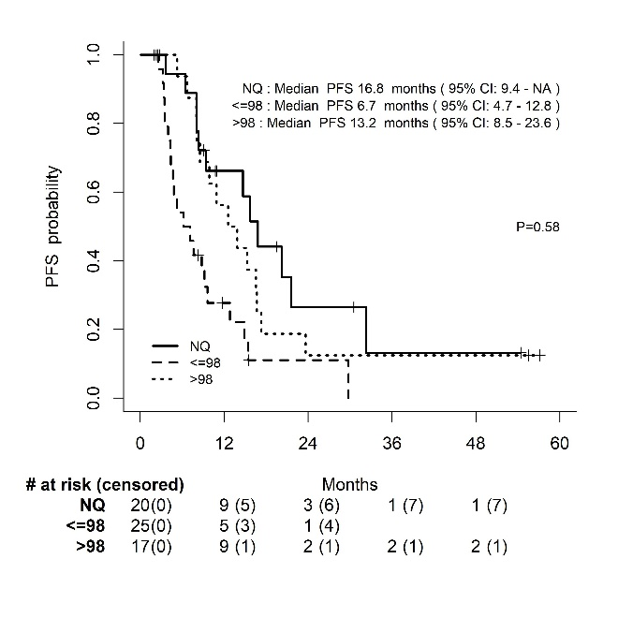
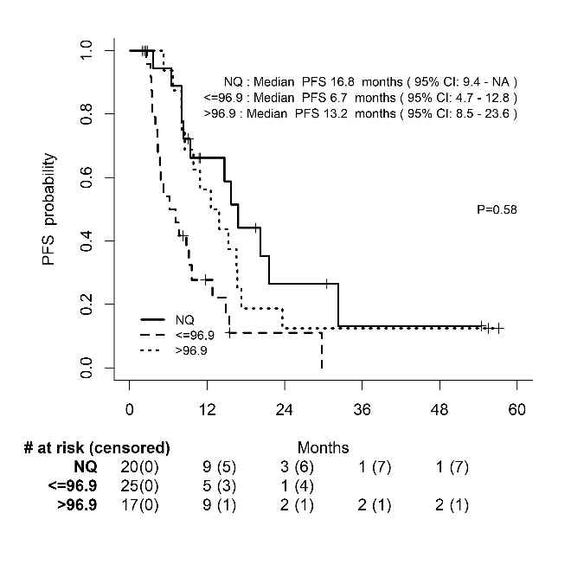
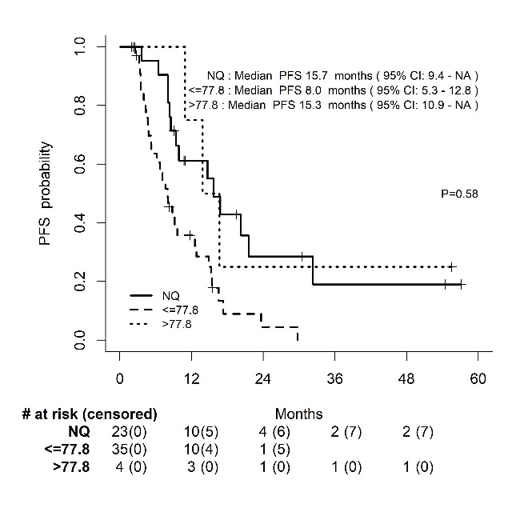
A B C

optimal ∆SUVpeak%_{week-2} optimal ∆MTVpeak%_{week-2} optimal ∆TLGpeak%_{week-2}
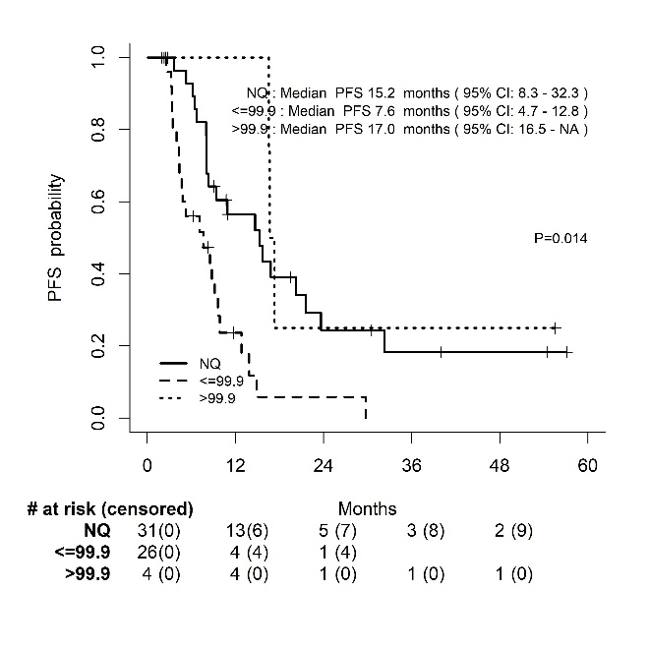
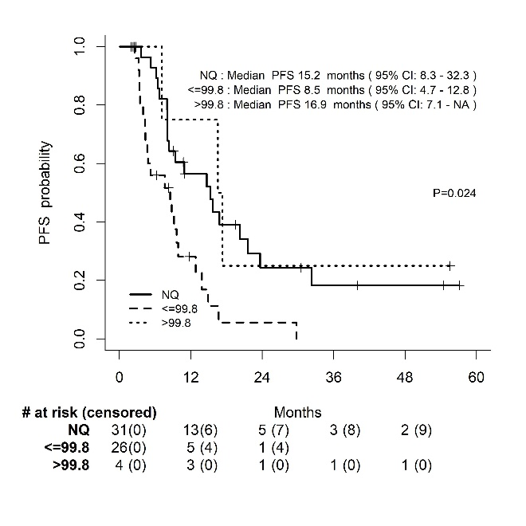
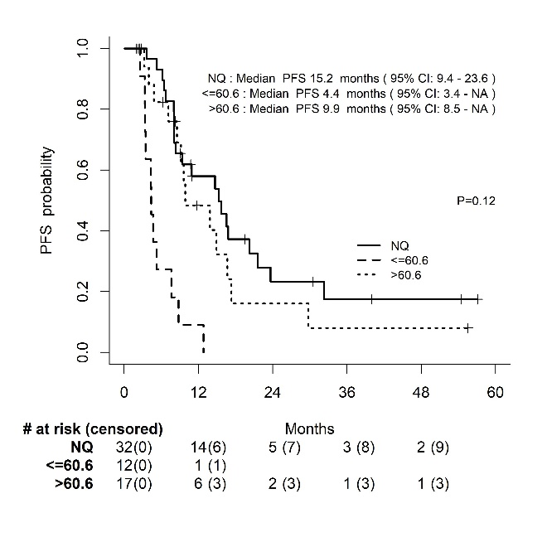
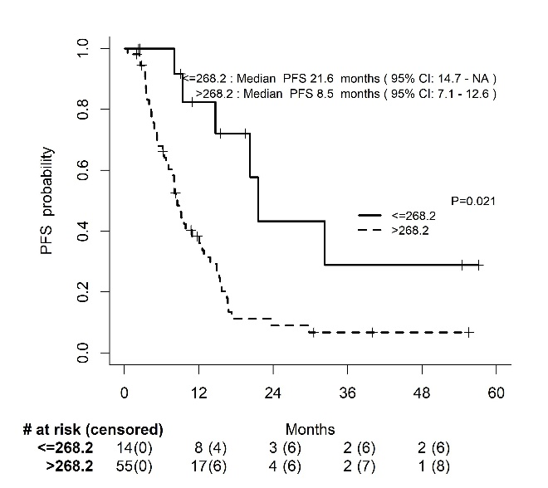
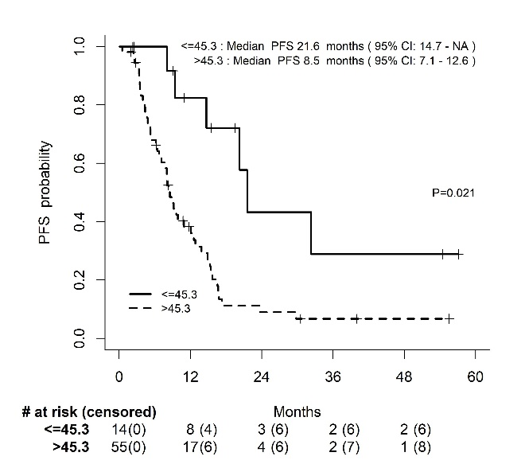
D E F

optimal ∆SUVpeak%_{week-7} optimal ∆MTVpeak%_{week-7} optimal ∆TLGpeak%_{week-7}

