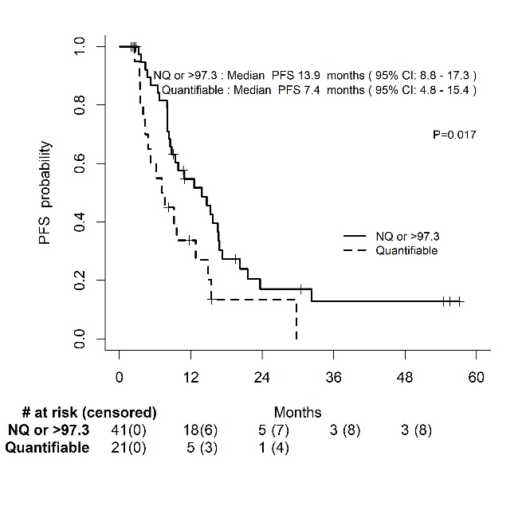
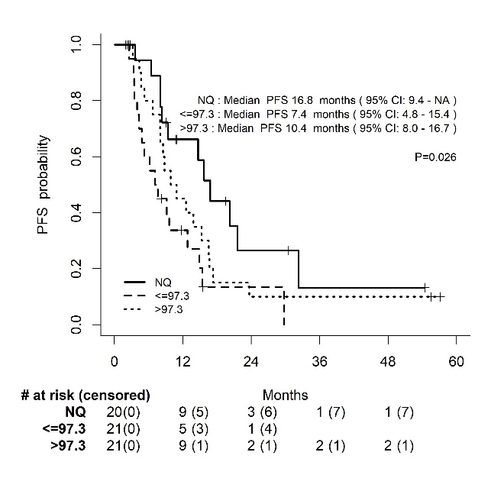
A B

median ∆TLG%_{week-2} grouped ∆TLG%_{week-2}

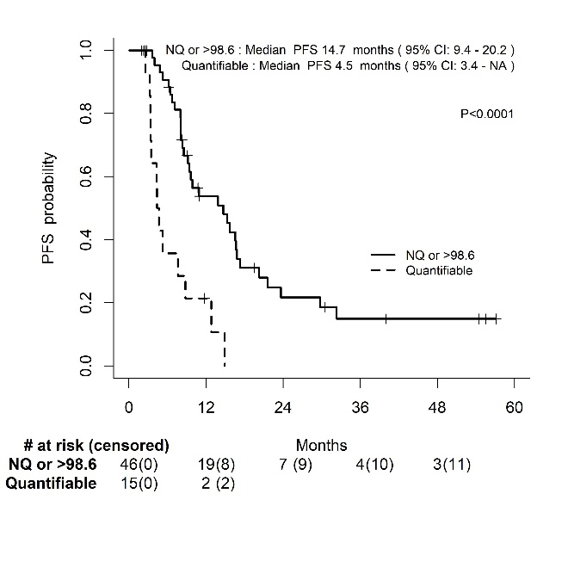
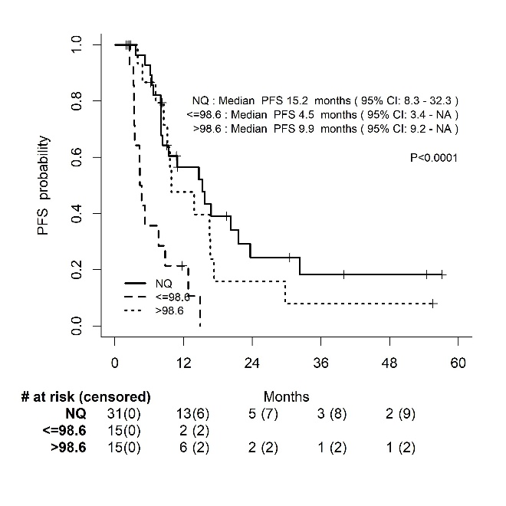
C D

median ∆TLG%_{week-7} grouped ∆TLG%_{week-7}

