Supplementary tables and figures
 |  | Array 1 | Array 2 | Array 3 | Array 4 | Array 5
Scrambled versus non-scrambled | Visually responsive | 50 | 93 | 55 | 38 | 28
Scrambled versus non-scrambled | Selective (p<0.05) | 11 | 48 | 45 | 32 | 18
Scrambled versus non-scrambled | Selective (p<0.01) | 8 | 38 | 40 | 30 | 15
Scrambled versus non-scrambled | Selective (p<0.001) | 4 | 33 | 38 | 24 | 11
Scrambled versus non-scrambled | Nsc > Scr (p<0.001) | 4 | 27 | 38 | 24 | 11
Scrambled versus non-scrambled | Scr > Nsc (p<0.001) | 0 | 6 | 0 | 0 | 0
Scrambled versus non-scrambled | Average d’ | 0,26 | 1,08 | 2,70 | 2,53 | 1,79
Category selectivity | Visually responsive | 56 | 93 | 76 | 68 | 34
Category selectivity | Selective (ANOVA p<0.05) | 15 | 22 | 20 | 62 | 14
Category selectivity | Body selective (p<0.05) | 4 | 3 | 5 | 52 | 7
Category selectivity | Face selective (p<0.05) | 5 | 3 | 4 | 4 | 3
Category selectivity | Face and body selective (p<0.05) | 0 | 0 | 0 | 4 | 3
Category selectivity | Average d’ (body vs face) | 0.67 | -0.57 | 0.22 | 1.93 | 0.49
Category selectivity | Average d’ (body vs object) | 0.46 | -0.60 | 0.06 | 2.29 | 1.06
Category selectivity | Average d’ (face vs object) | -0.33 | 0.77 | -0.11 | 0.15 | 1.14

Supplementary Table S1. Number of visually responsive and selective MUA for the LO localizer (scrambled versus non-scrambled), and the category selectivity experiment.

 | Mondrian | Human face | Human Body | Objects/fruits | Total
Array 2 | 91 | 55 | 44 | 30 | 92
Array 3 | 5 | 1 | 9 | 4 | 12
Array 4 | 1 | 6 | 16 | 1 | 22
Array 5 | 1 | 2 | 2 | 0 | 4

Supplementary Table S2. Number of responsive MUAs to selected categories after a 16 ms stimulus presentation, and to the masking Mondrian during a 250 ms stimulus presentation. The last column (Total) represents the total number of visually responsive multi-units. Note that some multi-units respond to multiple categories, so the total is not simply the sum of the visually responsive channels for other categories.

Array | Variation | Preferred class | Response window (ms) | Amount selective SUA | <= 66 ms | 83-132 ms | >= 150 ms
Array 2 | Variation 1 | Face | 130 - 280 | 3 | 0.048 | 0.18 | <0.001
Array 2 | Variation 2 | Non-scrambled | 130 - 280 | 8 | 0.003 | <0.001 | 0.004
Array 4 | Variation 1 | Body | 200 - 350 | 6 | 0.805 | <0.001 | 0.449

Supplementary Table S3. Backward masking. Significance levels (permutation test) for the z-normalized net spike rate for all selective single-units (perceived preferred class versus non-perceived preferred class) during backward masking within the response window.

 |  | -300 ms till 0 ms |  | 100 ms till 400 ms
 | Delay Group | AUC | p-value | AUC | p-value
Array 1 – Variation 1 | 16 – 183 ms | 0.50 | 1.00 | 0.50 | 1.00
Array 1 – Variation 1 | 16 – 66 ms | 0.50 | 1.00 | 0.56 | <0.001
Array 1 – Variation 1 | 83 – 132 ms | 0.50 | 1.00 | 0.40 | 0.08
Array 1 – Variation 1 | 150 – 183 ms | 0.50 | 1.00 | 0.52 | 0.71
Array 2 – Variation 1 | 16 – 183 ms | 0.50 | 1.00 | 0.50 | 1.00
Array 2 – Variation 1 | 16 – 66 ms | 0.50 | 1.00 | 0.50 | 0.96
Array 2 – Variation 1 | 83 – 132 ms | 0.50 | 1.00 | 0.60 | <0.001
Array 2 – Variation 1 | 150 – 183 ms | 0.50 | 1.00 | 0.59 | 0.001
Array 2 – Variation 2 | 16 – 183 ms | 0.50 | 1.00 | 0.51 | <0.001
Array 2 – Variation 2 | 16 – 66 ms | 0.50 | 1.00 | 0.70 | <0.001
Array 2 – Variation 2 | 83 – 132 ms | 0.50 | 1.00 | 0.58 | 0.001
Array 2 – Variation 2 | 150 – 183 ms | 0.50 | 1.00 | 0.50 | 0.90
Array 4 – Variation 1 | 16 – 183 ms | 0.50 | 1.00 | 0.50 | 1.00
Array 4 – Variation 1 | 16 – 66 ms | 0.50 | 1.00 | 0.50 | 0.88
Array 4 – Variation 1 | 83 – 132 ms | 0.50 | 1.00 | 0.49 | 0.24
Array 4 – Variation 1 | 150 – 183 ms | 0.50 | 1.00 | 0.62 | <0.001
Array 5 – Variation 1 | 16 – 183 ms | 0.50 | 1.00 | 0.50 | 1.00
Array 5 – Variation 1 | 16 – 66 ms | 0.50 | 1.00 | 0.50 | 1.00
Array 5 – Variation 1 | 83 – 132 ms | 0.50 | 1.00 | 0.49 | 0.38
Array 5 – Variation 1 | 150 – 183 ms | 0.50 | 1.00 | 0.48 | 0.15
Supplementary Table S4. Backward masking: exclusion of baseline differences between perceived and non-perceived target stimuli. Decoder results (AUC) from logistic regression trained to differentiate whether a target stimulus is perceived, based upon baseline activity (-300 till 0 ms). P-value is the result of a one-sided permutation test versus AUC results from randomly shuffled labels (250 times). As control, same type of decoder was trained on the interval 100-400 ms after stimulus onset.
 |  | Interval (ms) | Signal Loss |  |  |  |  |  |  |  | First significant bin (ms) | Analyzed class
 |  | Interval (ms) | 16 - 183 ms |  | 16 - 66 ms |  | 83 - 132 ms |  | 150 - 183 ms |  | First significant bin (ms) | Analyzed class
 |  | Interval (ms) | % | p | % | p | % | p | % | p | First significant bin (ms) | Analyzed class
Array 1 - Variation 1 | Responsive | 60 - 210 | -8.9 | 0.349 | 0.4 | 0.965 | NA | NA | NA | NA | / | Face
Array 2 - Variation 1 | Responsive | 80 - 230 | 26.6 | 1.38 * 10⁻⁶ | 22.1 | 0.007 | 25.9 | 0.005 | 73.8 | 1.23 * 10⁻¹⁰ | 105 | Face
Array 2 - Variation 1 | Selective | 80 - 230 | 59.4 | 2.71*10⁻¹¹ | 53.8 | 0.005 | 52.1 | 0.002 | 56.8 | 2.94 *10⁻⁴ |  | Face
Array 2 – Variation 2 | Responsive | 80 - 230 | 15.7 | 5.62 * 10⁻¹³ | 11.5 | 0.033 | 14.9 | 1.01 * 10⁻⁵ | 33.8 | 1.41 * 10⁻¹² | 95 | Non - scrambled
Array 2 – Variation 2 | Selective | 80 - 230 | 32.4 | 1.16*10⁻¹⁶ | 43.5 | 2.48 *10⁻⁷ | 26.3 | 1.09 *10⁻⁵ | 27.1 | 2.3 * 10⁻² |  | Non - scrambled
Array 4 - Variation 1 | Responsive | 200 - 350 | 43.6 | 1.49 * 10⁻¹² | 0.8 | 0.978 | 43.4 | 3.32 * 10⁻⁷ | 29.6 | 0.0166 | 165 | Body
Array 4 - Variation 1 | Selective | 200 - 350 | 41.4 | 1.06 * 10⁻⁸ | 9.6 | 0.789 | 39.9 | 1.48* 10⁻⁴ | 9.8 | 0.470 |  | Body
Array 5 - Variation 1 | Responsive | 140 - 290 | 21.8 | 0.211 | -18.9 | 0.483 | 9.83 | 0.82 | 36.9 | 0.246 | / | Face
Supplementary Table S5. Signal loss for unperceived stimuli during backward masking. This table summarizes the percentage signal loss (‘%’) and p-values (‘p’; independent t-test) for unperceived stimuli compared to perceived stimuli during backward masking. A positive percentage indicates that the neural response for perceived stimuli was greater than for unperceived stimuli within the specified 150 ms interval. The "First significant bin" column identifies the earliest of three consecutive time bins (in ms) where the response to perceived stimuli was significantly greater than for unperceived stimuli (p < 0.05, permutation test), calculated across all delays (16–183 ms). Values marked as "NA" indicate instances where no unperceived stimuli were recorded because the patient responded correctly 100% of the time. Arrays 1 and 5 do not report a first significant bin because no three consecutive bins met the criterion of perceived > unperceived (p < 0.05).

 | A1 (Variation 1) | A2 (Variation 2) |  | A4 (Variation 1) |  |  | A5 (Variation 1)
Delay (ms) | Responsive | Responsive | Selective | Responsive |  | Selective | Responsive | Selective
16 | 0.682 | 0.011 | 0.120 | 0.013 | 0.077 |  | 0.040 | 0.323
32 | 0.209 | 0.043 | 0.138 | 0.022 | 0.199 |  | 0.004 | 0.157
50 | 0.849 | 0.129 | 0.226 | 0.207 | 0.105 |  | 0.027 | 0.113
66 | NaN | 0.251 | 0.100 | 0.009 | 0.138 |  | 0.546 | 1.000
83 | 0.058 | 0.020 | 0.2070 | 0.122 | 0.362 |  | 0.005 | 0.067
100 | 0.145 | 0.011 | 0.355 | 0.006 | 0.071 |  | 0.088 | 1.000
116 | 0.161 | <0.001 | 0.071 | 0.145 | 0.009 |  | 0.395 | 1.000
132 | 0.003 | <0.001 | 0.335 | 0.455 | 0.727 |  | 0.245 | 1.000
150 | 0.034 | <0.001 | 0.031 | 0.203 | 0.241 |  | 0.050 | 0.512
166 | 0.001 | <0.001 | 0.015 | 0.213 | 0.426 |  | 0.094 | 1.000
183 | 0.004 | <0.001 | 0.482 | 0.77 | 0.184 |  | 0.088 | 1.000
200 | 0.001 | NaN | NaN | NaN | NaN |  | 0.096 | 0.314
Number of SUA | 42 | 79 | 8 | 17 | 6 |  | 10 | 1

Supplementary Table S6. Backward masking. P-values (Silverman’s test) for bimodal SUA response patterns during backward masking. Calculations were based on the class eliciting the strongest response (Figure S2 and S4): ‘face’ for A1 and A5, ‘body’ for A4 and ‘non-scrambled’ images for variation 2 of A2. Notably, a bimodal response pattern was observed in visually responsive units for A1 and A2 at delays ≥ 132 ms and ≥ 83 ms, respectively. In contrast, A4 and A5, as well as the selective units from A2 (which are theoretically less responsive to the Mondrians), did not exhibit bimodal responses for longer delays. Some bimodality was observed in responsive units at shorter delays in A4 and A5, likely due to Type 1 errors (see Methods for peak identification criteria and an explanation why low firing rates increase the risk of false second-peak identification and thereby Type 1 errors; see also Figure S7, S8 and S23). ‘NaN’ values indicate non-recorded conditions. No selective units were identified in A1.
 |  | Array 2 | Array 3 | Array 4 | Array 5
MUA | Visually responsive | 81 | 28 | 13 | 20
MUA | Face responsive | 77 | 24 | 12 | 18
MUA | Place responsive | 67 | 18 | 1 | 10
MUA | Face selective | 36 | 6 | 8 | 10
MUA | Place selective | 3 | 7 | 0 | 0
SUA | Visually responsive | 39 | 12 | 4 | 6
SUA | Face responsive | 37 | 11 | 4 | 5
SUA | Place responsive | 22 | 8 | 0 | 5
SUA | Face selective | 21 | 4 | 4 | 5
SUA | Place selective | 4 | 3 | 0 | 0
SUA | Sustained responders | 3 | 1 | 2 | 0
SUA | Inhibitory responders | 10 | 2 | 1 | 1
SUA | Sustained + inhibitory | 12 | 2 | 2 | 1

Supplementary Table S7. Flash suppression. Number of visually responsive and stimulus selective multi- and single units.
 |  | Array 1 | Array 2 | Array 3 | Array 4 | Array 5
MUA | Visually responsive | 32 | 74 | 32 | 12 | 21
MUA | Face selective | 22 | 35 | 8 | 4 | 0
MUA | Place selective | 0 | 4 | 4 | 0 | 8
SUA | Visually responsive | 17 | 28 | 14 | 4 | 15
SUA | Face selective | 8 | 16 | 5 | 4 | 2
SUA | Place selective | 0 | 6 | 1 | 0 | 5

Supplementary Table S8. Binocular rivalry. Number of visually responsive and stimulus selective multi- and single units.

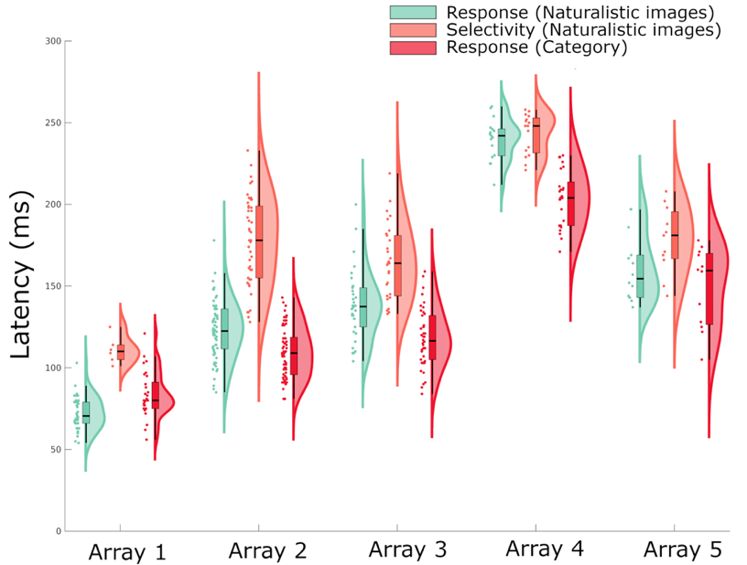
Supplementary figure S1. Response and selectivity latencies for naturalistic images and category stimuli per array. Combined scatter-, box- and violin plot showing response latency to naturalistic images (green) (non-scrambled condition from the LO localizer experiment) and to the category selectivity stimuli (red). Orange plots indicate latency for emergence of selectivity between non-scrambled and scrambled images. The used intervals for response latencies for array 1 until 5 were respectively: [60 210], [80 230], [130 280], [200 350] and [130 290]. The used intervals for selectivity latencies for array 1 until 5 were respectively: [100 250], [130 280], [130 280], [200 350] and [140 290]. For array 4, response latency was markedly different for the naturalistic images (255 ms) compared to the category selectivity stimuli (205 ms). Since the categorical (body) stimuli were more optimal stimuli to drive neural responses in array 4, we opted to use [200 350] instead of [250 400] as the latency intervals.

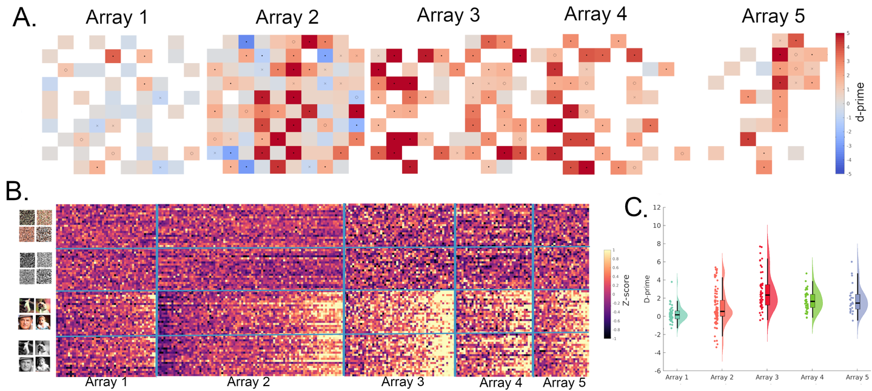
Supplementary figure S2. Effect of image scrambling on MUA. A) Two-dimensional representation of d' values across arrays, including only visually responsive multi-units. Significance of d-prime values is indicated within each square (permutation test: dot p < 0.001; circle p < 0.01; cross p < 0.05). B) Z-scored net MUA responses from all arrays for each individual stimulus. On the y-axis, each dot is grouped by category and represents a different stimulus; each dot on the x-axis represents a visually responsive MUA. The average net response to the scrambled category was subtracted from each stimulus for z-scoring, resulting in a mean Z-score of zero for the scrambled category. Within each array, MUA is sorted according to d' (Scrambled vs Non-Scrambled). C) Combined scatter, box, and violin plot of the same d' values presented in panel A.

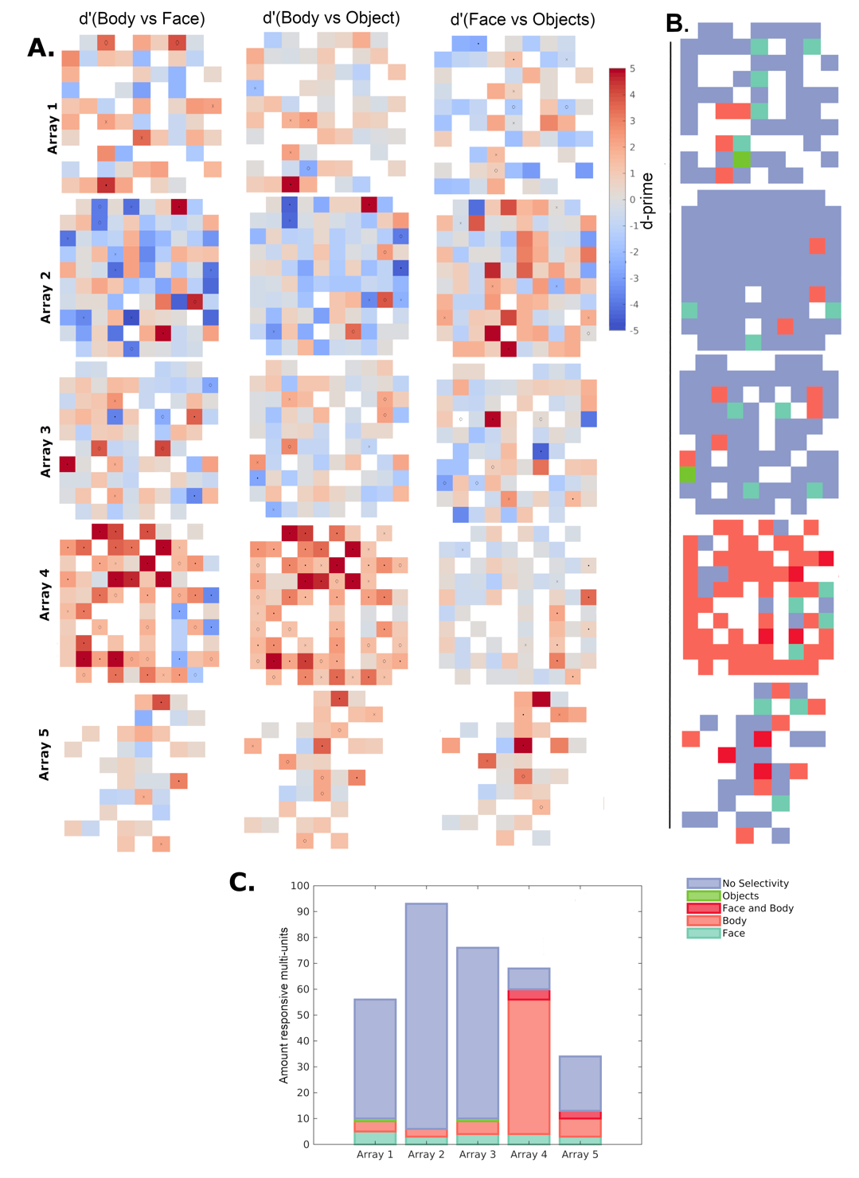
Supplementary figure S3. Category Selectivity across arrays. A. Two-dimensional representation of d' values from visually responsive multi-units across arrays. Significance of d-prime values is indicated within each square (Tukey’s HSD: dot p < 0.001; circle p < 0.01; cross p < 0.05). B. Two-dimensional visualization across each array of face, body, and object selectivity (see Methods). Note the strong body selectivity in array 4 as well as the strong face and body preference in array 5. C. Bar plot showcasing the number of visually responsive and category-selective channels per array. The same color coding applies to panels B and C.
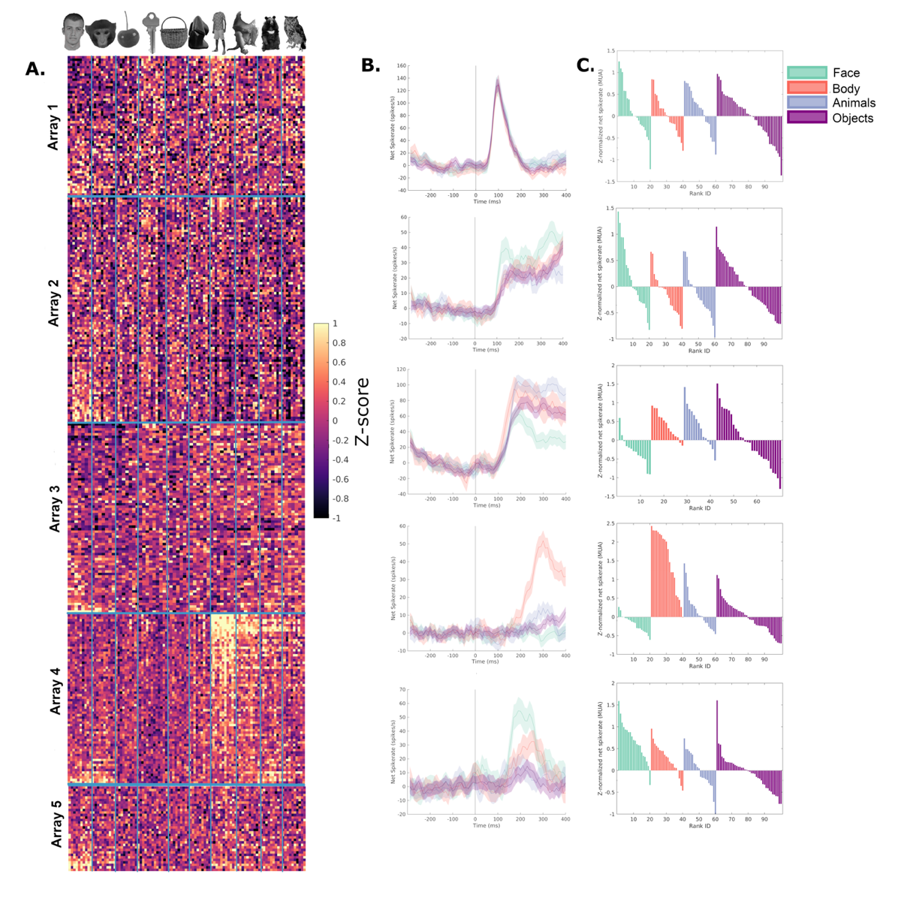
Supplementary figure S4. Category selectivity for individual MUA to individual stimuli. A. Z-scored net MUA responses per arrays for all individual stimuli. Each dot on the x-axis is grouped per category and represents a different stimulus; each dot on the y-axis represents a visually responsive MUA. Average net response to the objects category was subtracted from each stimulus for Z-scoring, resulting in mean Z-score of zero for objects. Within each array, MUA was sorted according to d’(Face vs Body). B and C. Responses of a representative multi-unit example per array. B. Mean net spike rate per category for an example MUA per array. C. Average net z-scored responses to individual stimuli ranked within their respective category (faces (human and monkey), bodies (human and monkey), animals (mammals and birds) and objects (objects-monkey, objects-human, fruits, sculptures)).
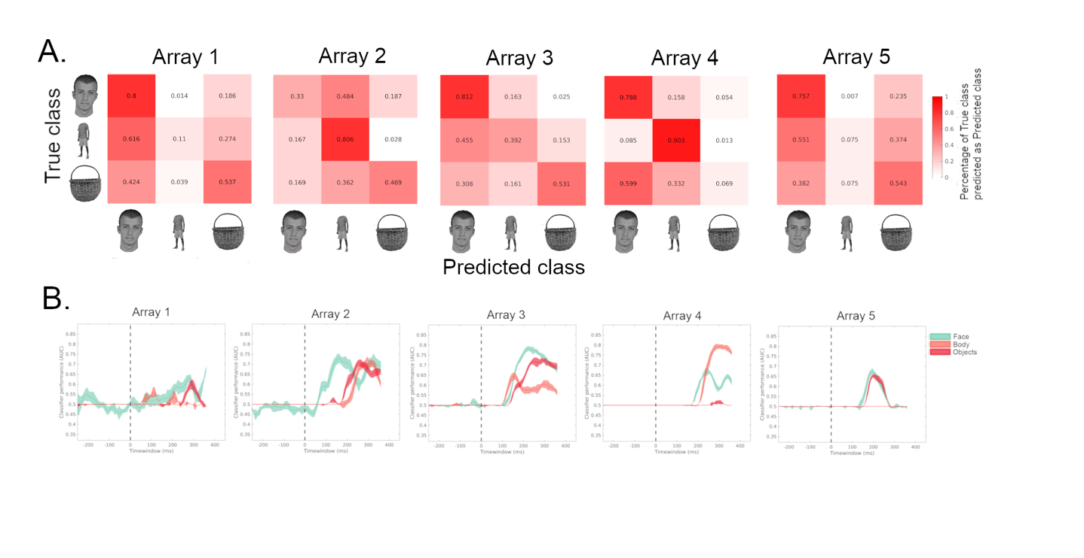
Supplementary figure S5. Classifier performance for individual categories. A) Confusion matrices per array at peak classification between human faces, human bodies and objects (objects-human, objects-monkey, fruits and sculptures). Peak classification was obtained in interval [220-320], [240-340], [240-340], [270-370] and [160-260] for A1 to A5 respectively. Ground truth labels are presented on the Y-axis, actual predictions on the X-axis. The matrices are normalized across rows to highlight the proportion of true positives across each category. B) Classification performance (AUC) over time for individual categories vs all other categories. Vertical dotted lines mark stimulus onset. Times on the x-axis represent the middle of the 100 ms interval used for classification. Peak AUCs for the preferred class were 64% for A1 (face), 75% for A2 (face), 80% for A3 (face), 80% for A4 (body), and 68% for A5 (face).

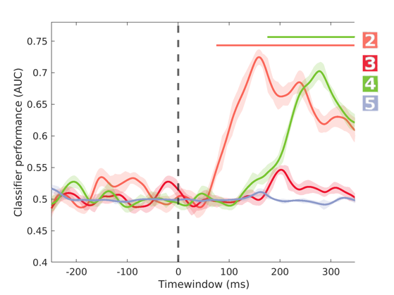
Supplementary Figure S6. Category selectivity: decoder performance for 16 ms stimulus presentations. For each array, the best class was decoded from other classes (human face, human body or objects). This control experiment was not performed for array 1. Horizontal lines indicate significance compared to random label shuffling (p <0.01 ; permutation test), and are shown only when at least five consecutive bins were significantly different.
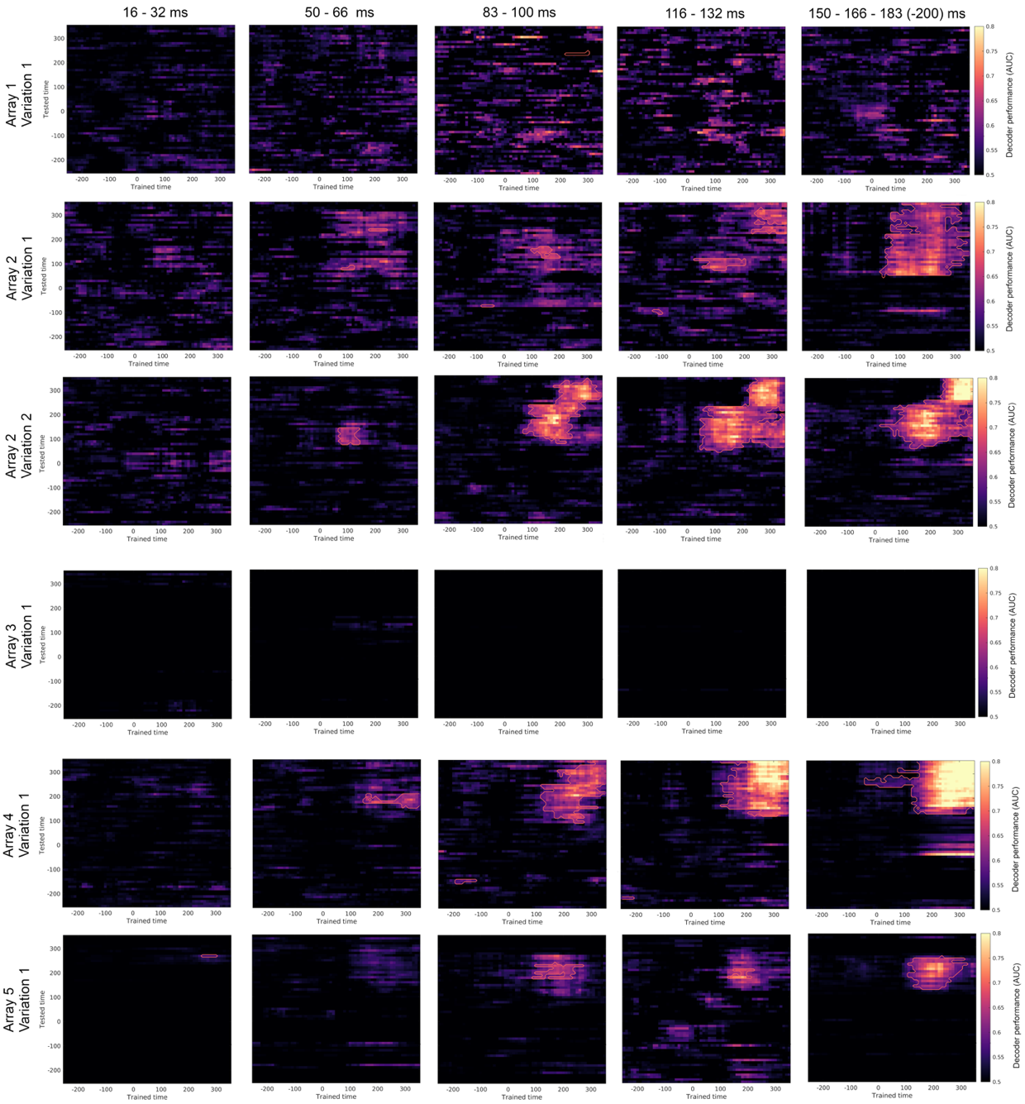
Supplementary Figure S7. Backward masking: decoding performance (AUC) for best decoded category versus all other categories. Plots separated on the y-axis represent different arrays or variations. Best decoded categories were face, face, face, body and fruits/objects for array 1, 2, 3, 4 and 5 respectively. Plots separated on the x-axis represent different delays between target stimulus and masking Mondrian. Within each plot, the x-axis represents the 100 ms bin on which the decoder is trained, while y-axis represents the 100 ms bin on which the decoder is tested. Times on the x- and y-axis represent the middle of the 100 ms interval used for classification. Highlighted contours represent significantly better decoder performance compared to randomly shuffled labels (p<0.001; permutation test). The lack of decoding in array 3 is attributable to low data quality at the day of recording.
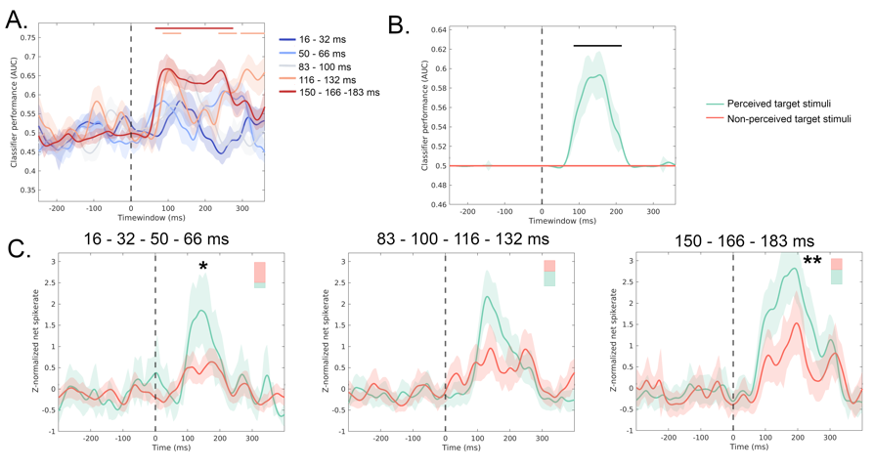
Supplementary Figure S8. Backward masking: Array 2 – Variation 1. Same plots as displayed in Figures 3A-C. Asterisks in C indicate significance between perceived and non-perceived target stimuli within the response window ([130-280]) (**p < 0.001; *p < 0.05; Permutation test).

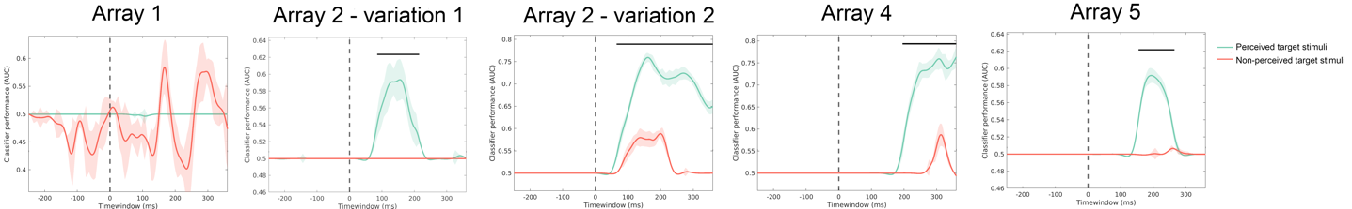
Supplementary Figure S9. Preferred class decoding based on target stimulus perception. Decoding performance is shown for instances where the target stimulus was correctly perceived (green) versus not perceived (red), pooled from all delays. Horizontal lines indicate significantly better decoding for perceived compared to non-perceived target stimuli (p < 0.001; permutation test) and are shown only when at least five consecutive bins were significant. In all arrays except A1, classification performance was significantly better when the target stimulus was perceived. However, since all delays were pooled, this perception-dependent classification effect could still be confounded by a larger amount of correctly perceived target stimuli at longer delay intervals.
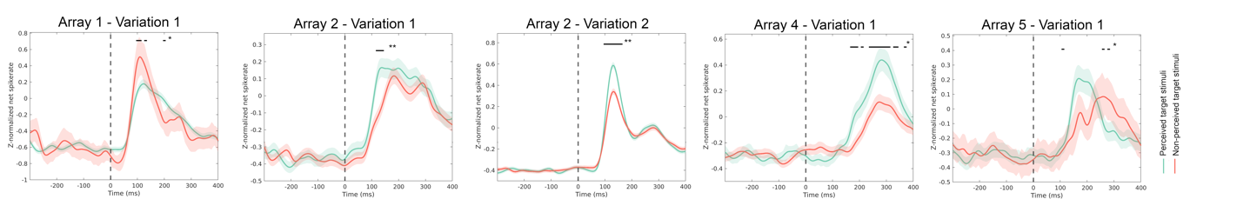
Supplementary figure S10. Backward masking: perceived vs non-perceived target stimuli. Responses are grouped over all visually responsive channels. Horizontal bars indicate significance between perceived (green) and non-perceived target stimuli (red) (* p<0.05, **p<0.01, permutation test). For each array, the category eliciting the strongest response to unmasked conditions was used ‘face’ for A1, A2 and A5, ‘non-scrambled’ for A2 (variation 2) and ‘body’ for A4.

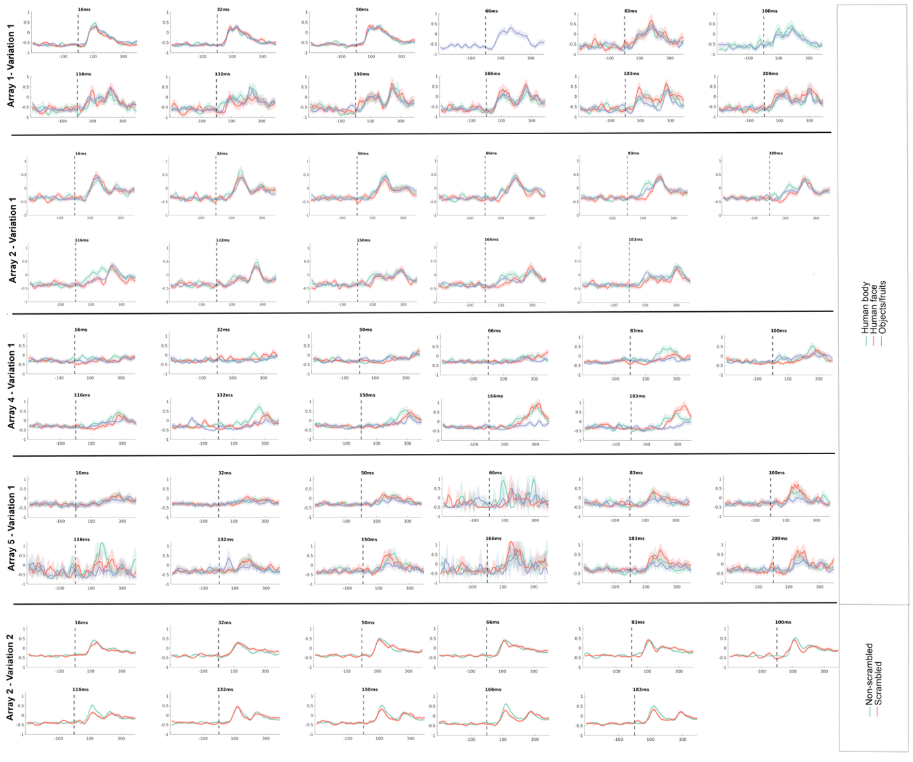
Supplementary Figure S11. Backward masking: average Z-normalized response per delay for all visually responsive single units. No distinction is made between perceived and non-perceived target stimuli. In each plot, the x-axis represents time (in milliseconds), and the y-axis represents the average Z-normalized net response for all visually responsive single units. The dotted line indicates the onset of the target stimulus. Note the distinct responses for both the target stimuli and Mondrian in arrays 1 and 2 for longer delays.
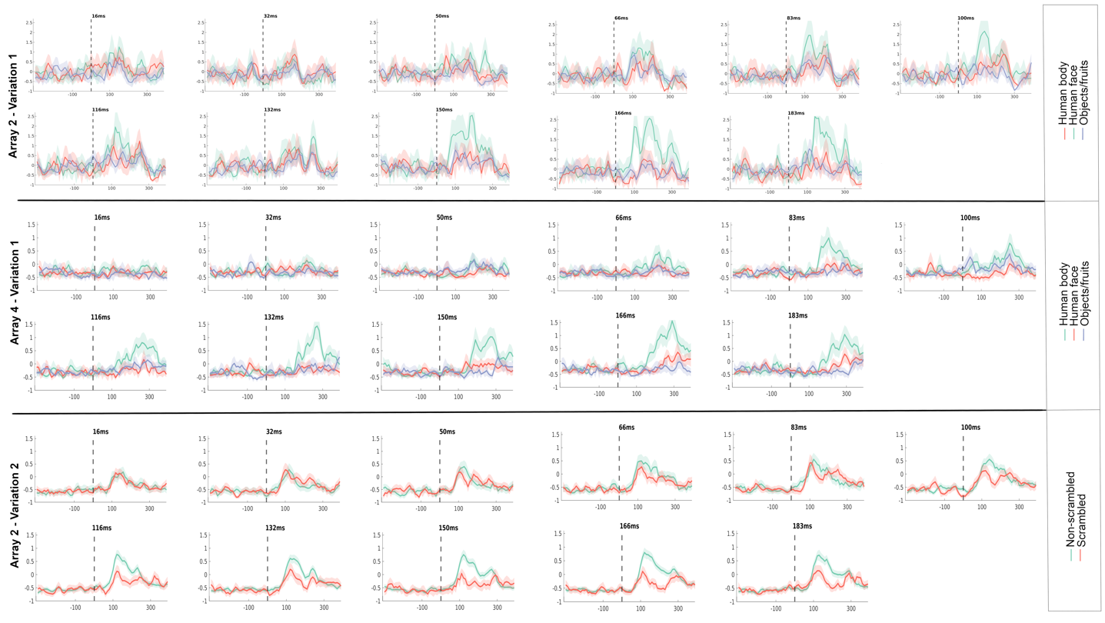 Supplementary Figure S12. Backward masking: average z-normalized response per delay for all visually selective single units (preferred class > all other classes; p < 0.01; permutation test). No distinction is made between perceived and non-perceived target stimuli. The preferred target stimulus is always plotted in green (Array 2 – Variation 1: Human faces ; Array 4 – Variation 1: Human bodies ; Array 2 – Variation 2: Non-scrambled images). In each plot, the x-axis represents time (in milliseconds), while the y-axis represents the average z-normalized net response for all visually selective single units. The dotted line indicates the onset of the target stimulus.

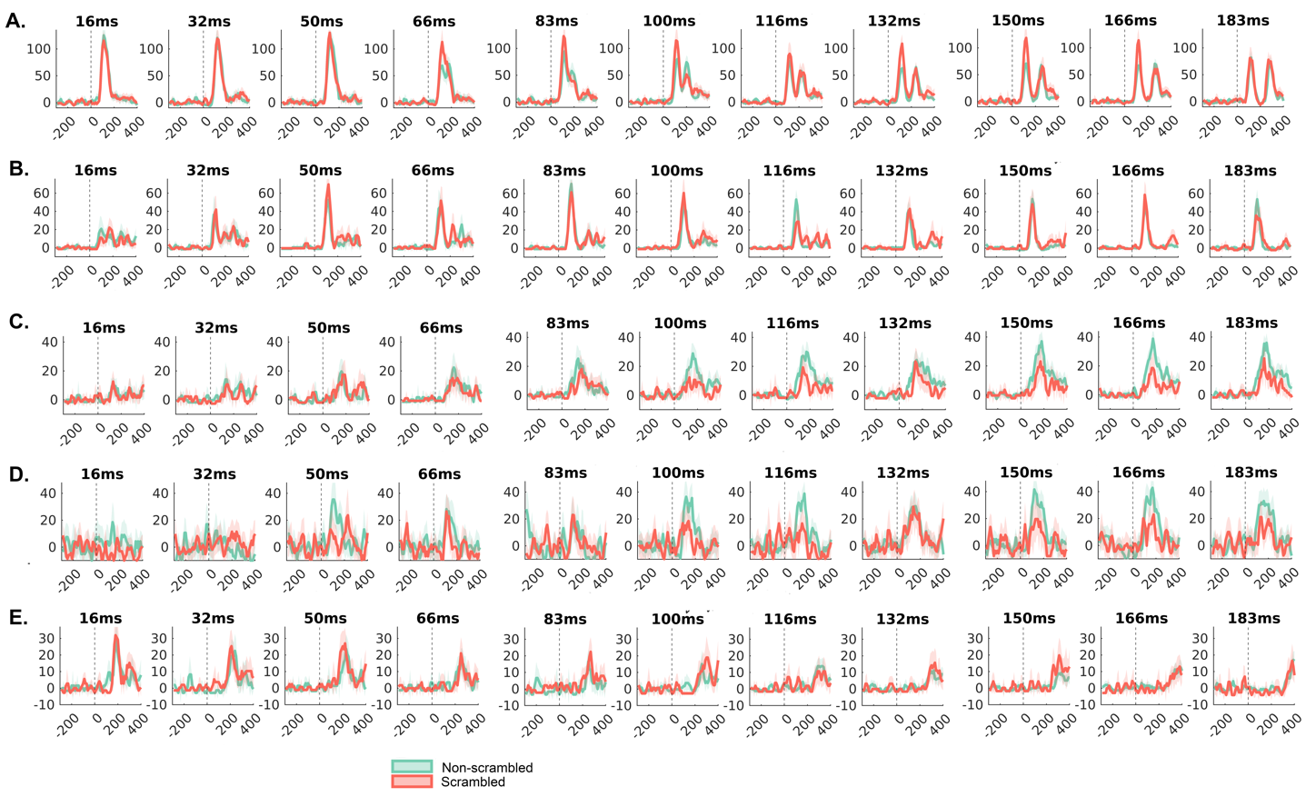
Supplementary Figure S13. Backward masking: net spike rate from example single units. Example neurons from array 2 during backward masking, variation 2, highlighting the heterogeneity within LO responses. A) Neuron responds strongly to masking mondrian and both classes of target stimuli. Both responses integrate with shorter delays. B) Neuron responds equally strong to both classes of target stimuli, with only a minimal response to masking mondrian. Response fades for the shortest delays. C-D) Both neurons respond only to the target stimuli, preferring the non-scrambled conditions. Response fades for the shortest delays. E) Neuron responds only to masking mondrian.

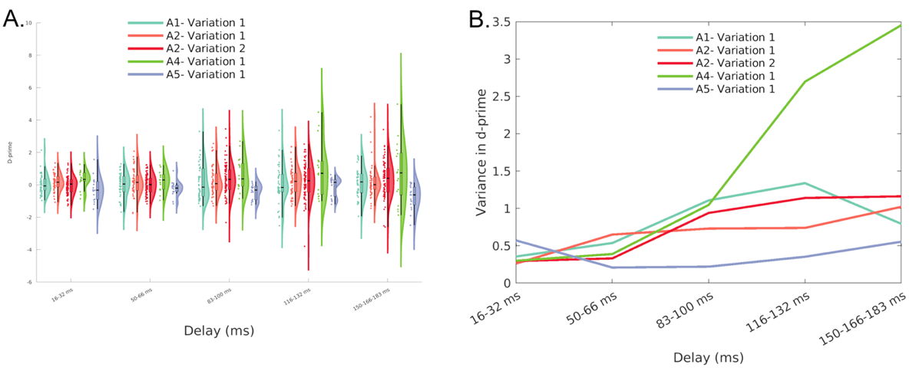
Supplementary Figure S14. Backward-masking: D-prime value. A) Combined scatterplot, boxplot and violin plot from D-prime values for all visually responsive channels per array, separated by delay. D-prime is determined between the best classifiable group and all other stimuli. B) Variance of D-prime values for different delays. Note the increasing variance in longer delays for array 4, which is believed to be in the extrastriate body area (EBA).

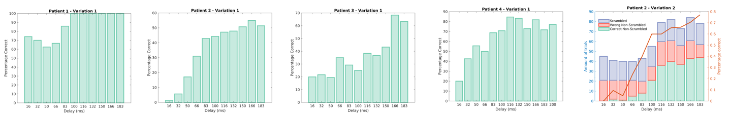
Supplementary Figure S15. Backward masking: accuracy of reported perception as a function of delay. The first four plots display the results from variation 1, while the last plot shows the results from variation 2, which was conducted only on patient 2. In the last plot, the red line indicates the percentage of correct responses, corresponding to the values on the right y-axis.
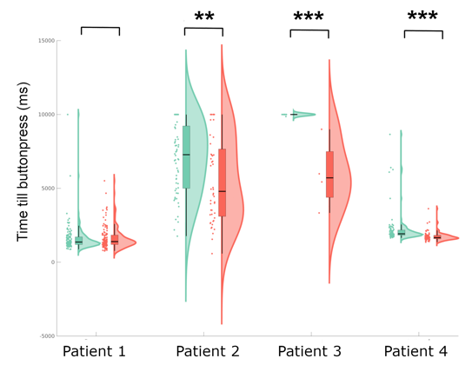
Supplementary Figure S16. Eye Dominance. Combined scatter-, box- and violin plot showing delays between trial onset and the moment of breakage of the continuous flash suppression, the moment that the direction of the arrow is perceived. Green indicates arrows presented to left eye, red to the right eye. Asterisks indicate significance level (* p < 0.05; ** p < 0.01; *** p < 0.001, permutation test).

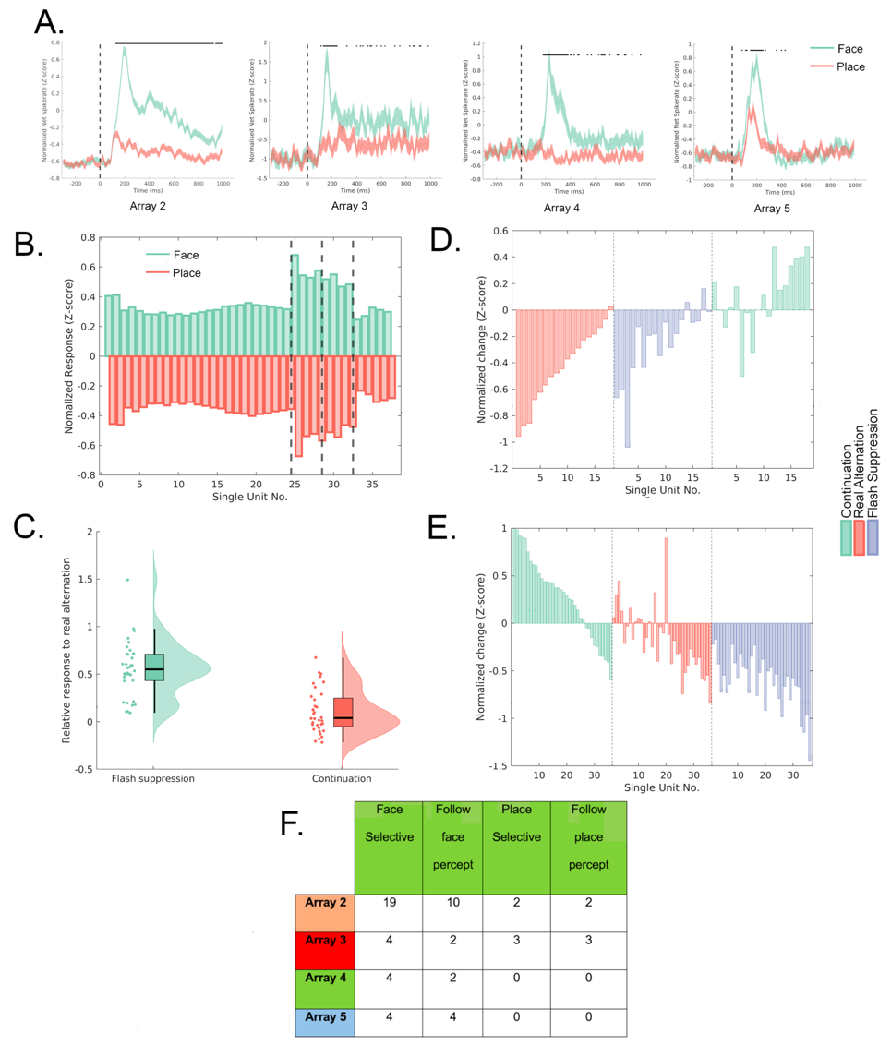
Supplementary Figure S17. Flash Suppression: single-unit selectivity. A) Average z-normalized net spike rate for all face-selective neurons per array in response to the face and place image. Horizontal bars represent significant differences between face and place (p < 0.01, permutation test). B) Z-normalized response to the face and place stimulus from all 37 face-selective single units. Vertical dotted lines separate different arrays (A2: SUA 1–24; A3: SUA 25–28; A4: SUA 29-32; A5: SUA 33-37). C) Combined scatter, box and violin plot of relative responses for all face and place selective SUA for flash suppression (non-preferred to preferred stimulus) and continuation of non-preferred stimulus, compared to real alternation (1 = response to real alternation, 0 = baseline activity during fixation period). D) Change in net spike rate (z-normalized) for all 18 face-selective single units classified as either sustained or inhibitory responders after the start of phase 2, when the face stimulus was presented in phase 1. During Continuation, the face stimulus persists with no change in perception. In Real Alternation and Flash Suppression conditions, perception shifts from face to place. Each bar represents a different single unit. All single units within the 3 conditions are ranked in ascending order based on values obtained from the Real Alternation condition. E) Change in net spike rate (z-normalized) for all face and place selective single units. During Continuation, the place stimulus persists with no change in perception. In Real Alternation and Flash Suppression conditions, perception shifts from place to face. Each bar represents a different single unit. All single units within the 3 conditions are ranked in descending order based on values obtained from the Real Alternation condition. F) Table with number of face and place selective SUA per array that modulate activity according to the percept.

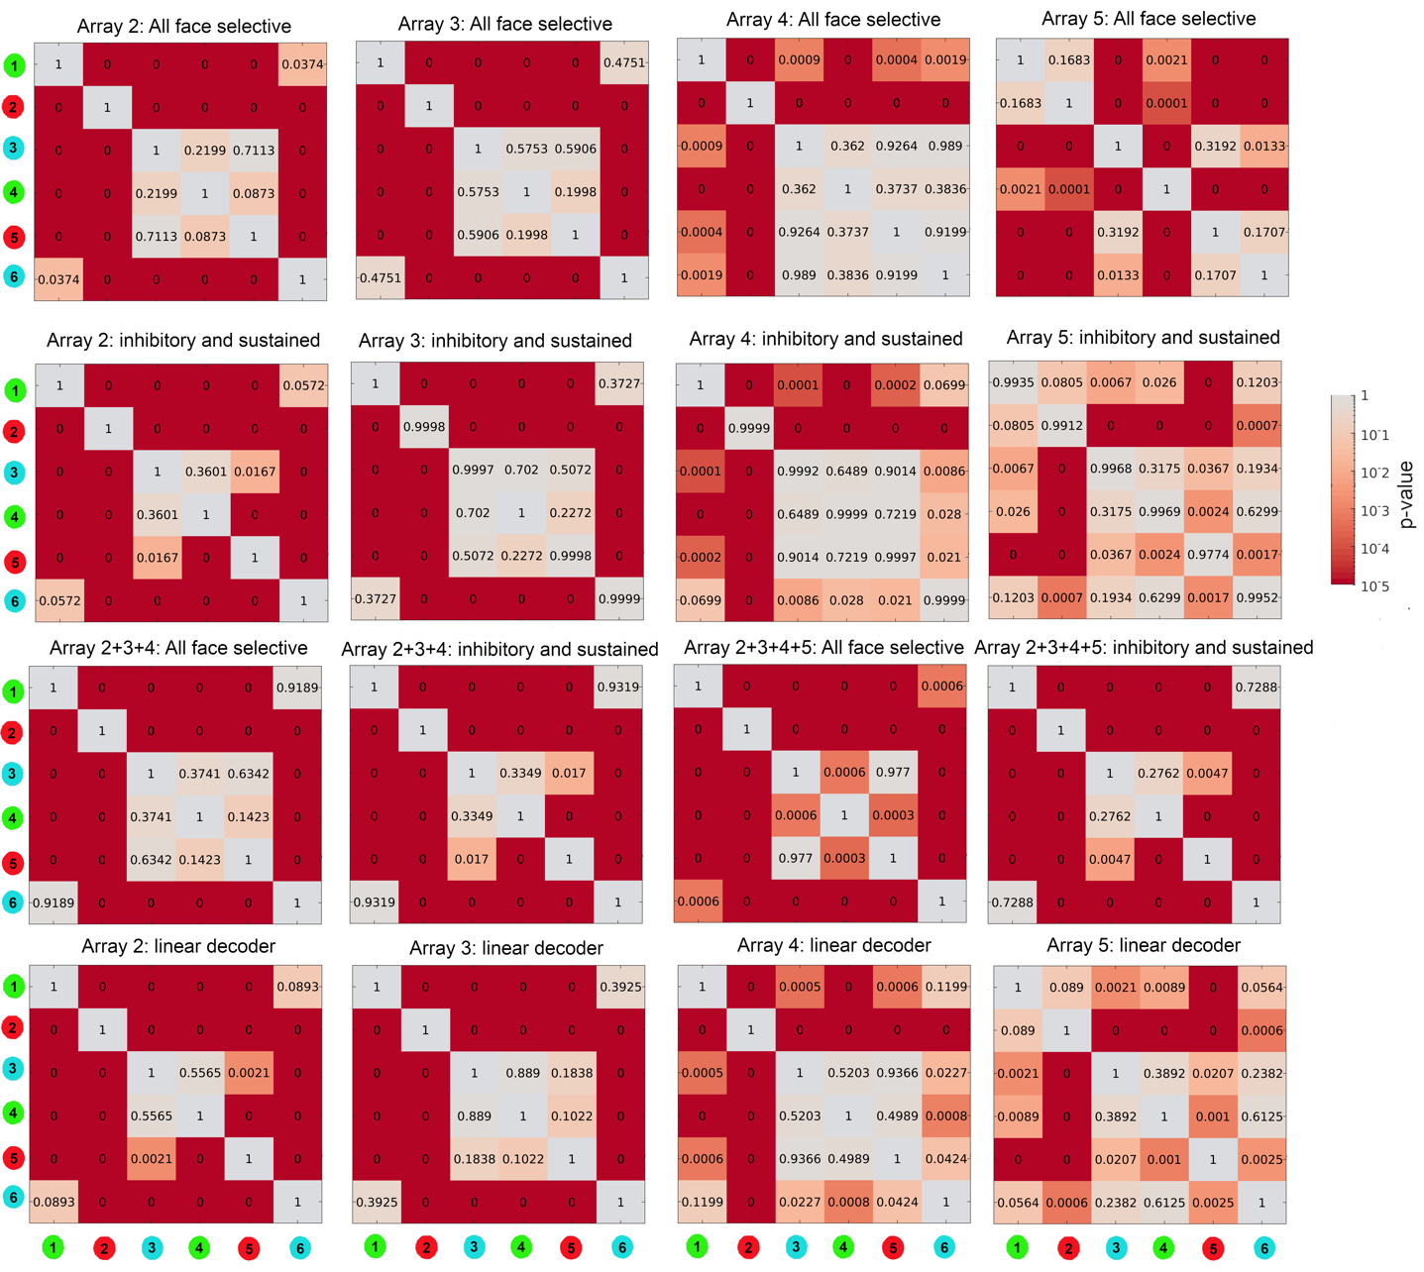
Supplementary Figure S18. Flash suppression: significance levels between different paradigms during phase 2. P-values (permutation test) during the second phase of the flash suppression experiment within the response window ([130 280], [130 280], [200 350] and [140 290] for array 2 to 5 respectively). The first 3 rows compare the z-normalized net responses. Bottom row compares decoder results. Top row shows all face-selective SUA, second row shows all inhibitory and sustained responders from face-selective SUA, third row shows the combination of arrays for all face-selective SUA as well as inhibitory and sustained responders. Values of “0” indicate p < 0.0001.
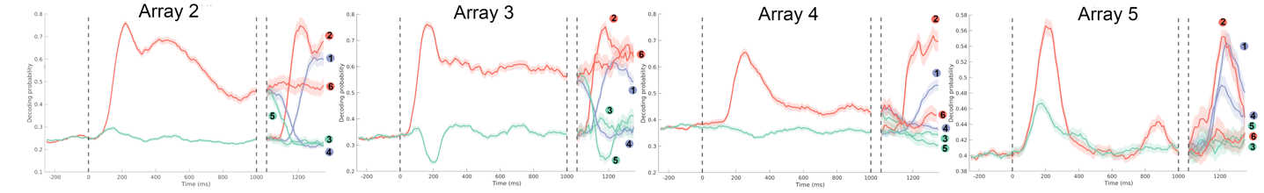
Supplementary Figure S19. Flash suppression: linear decoder. Average decoder face probability for all 6 paradigms. During phase 1, green and red plots are the average prediction for paradigm 1-3 (place) and 4-6 (face), respectively. During phase 2, average prediction is made for each paradigm separately. Red and green indicates face (paradigm 2 and 6) and place (paradigm 3 and 5) perception respectively, without flash suppression. Blue indicates flash suppression (paradigm 1 and 4). Each line plot during phase 2 is annotated with the paradigm it represents. Double dotted vertical lines separate phase 1 from phase 2.

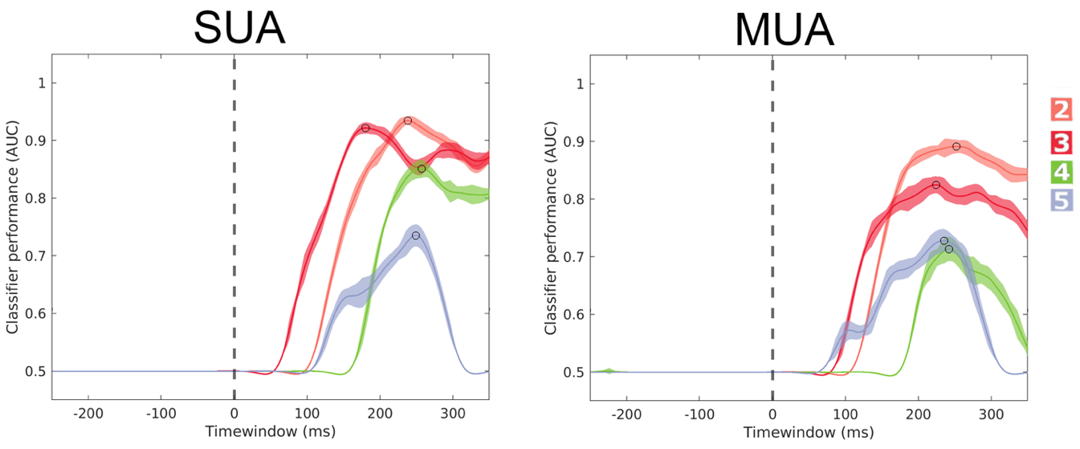
Supplementary Figure S20. Flash Suppression: classifier performance face versus place. Decoding performance over time between face and place stimulus. A logistic regression was trained on 80% of the data by 10-fold cross-validation (see Methods) and tested on the remaining 20% of trials. Times on the x-axis represent the middle of the 100 ms interval used for classification. The interval with highest AUC (the ‘best bin’) is annotated with a circle, and was used as the training interval to classify individual trials from the flash suppression experiment by Leave-One-Out (LOO) cross-validation. Peak AUC values were 95%, 92%, 86%, and 76% for arrays A2 to A5 when trained on SUA, respectively. Colored numbers indicate array number.
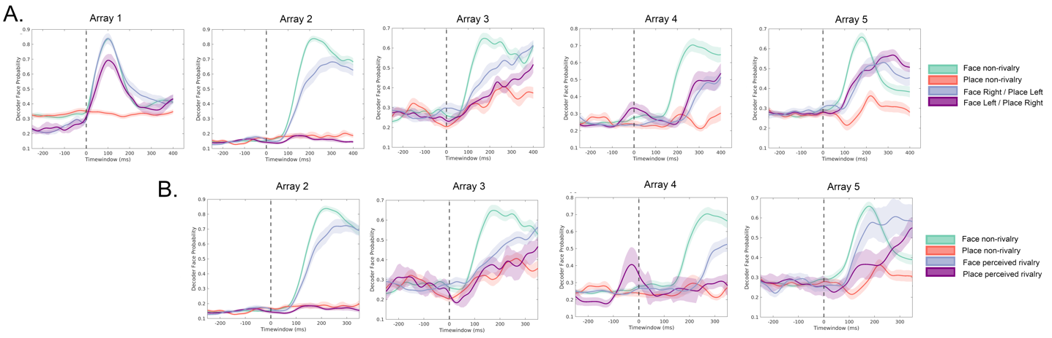
Supplementary Figure S21. Binocular rivalry: decoding after stimulus onset. A) The green and red graphs represent conditions where the face and place images were non-rivalrous presented binocularly. The blue and purple graphs depict conditions rivalrous conditions, not taking the perceived image into account. In array A1, the decoder identified the presence of a face during rivalrous conditions, regardless of whether the face was presented to the left or right eye. In A2, the classifier gave high face probability only when the face was presented to the dominant eye. For arrays 3, 4, and 5, the decoder produced intermediate results for both rivalrous conditions (face in dominant or non-dominant eye) compared to non-rivalrous face and place-perception. In array 3, but not in arrays 4 and 5, the decoder produced higher probabilities for face perception when the face was presented to the dominant eye compared to the non-dominant eye, regardless of reported perception (p < 0.05, permutation test). B) The green and red graphs represent conditions where the face and place images were non-rivalrous presented binocularly. The blue and purple graphs depict conditions under rivalry, where the face (blue) or place (purple) was perceived as first image. Array 1 is not presented because the patient did not correctly categorize images during rivalry.

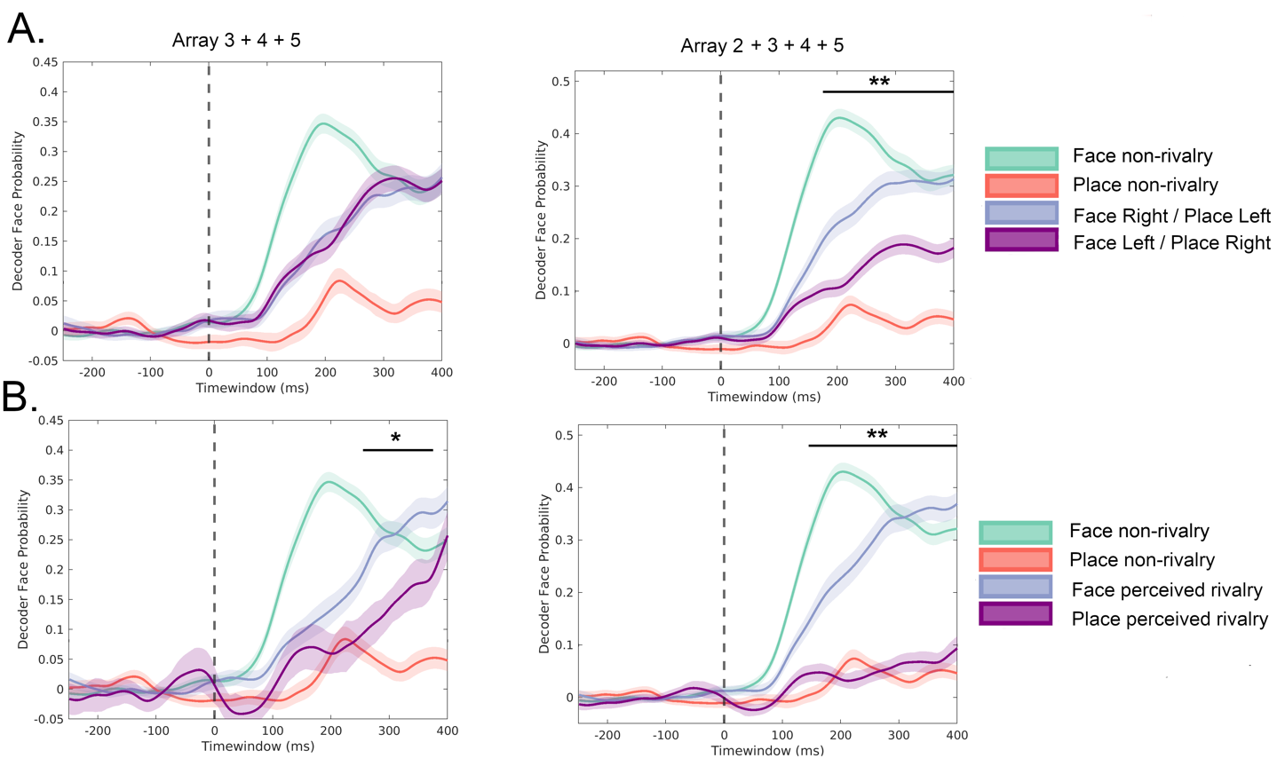
Supplementary Figure S22. Binocular rivalry: average decoding after stimulus onset over multiple arrays. A) The green and red graphs represent conditions where the face and place images were non-rivalrous presented binocularly. The blue and purple graphs depict conditions rivalrous conditions, not taking the perceived image into account. B) The green and red graphs represent conditions where the face and place images were non-rivalrous presented binocularly. The blue and purple graphs depict conditions under rivalry, where the face (blue) or place (purple) was perceived as first image. A separate average was made for array 3 + 4 + 5 (excluding array 2) because of the very strong eye dominance effect observed in array 2, as visualized in Figure S20. Horizontal bars represent significance in A and B (blue > purple graph, * p < 0.05, ** p < 0.001, permutation test).

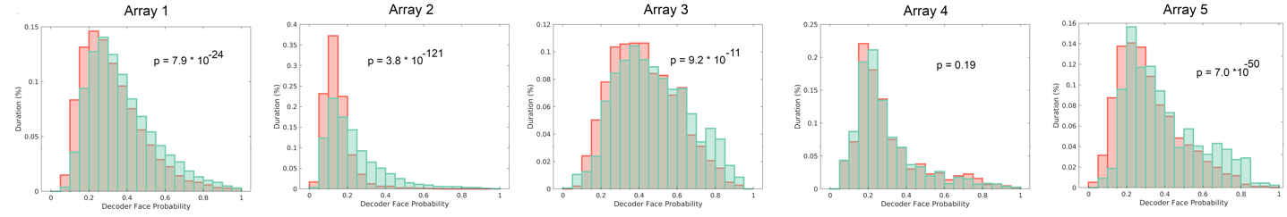
Supplementary Figure S23. Binocular rivalry. A) Histograms displaying the relative frequency of bins across all rivalrous trials, each corresponding to a specific probability of face/place perception (face = 1, place = 0). The histogram bin size is set to 0.05 (range: [0 : 0.05 : 1]). Green bars represent trials where the face stimulus was shown to the right eye, while red bars represent trials where the place stimulus was presented to the right eye. In arrays 2, 3, 4, and 5, the right eye also served as the dominant eye. P-value indicates significance between green and red bars (unpaired t-test).
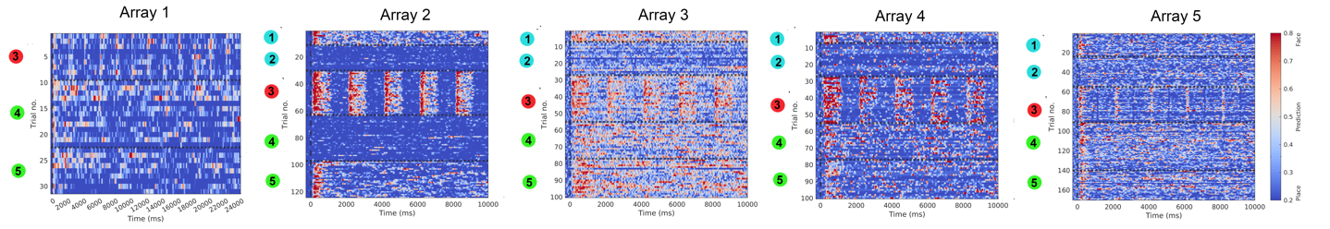
Supplementary Figure S24. Binocular rivalry. Decoding for individual trials, grouped per condition. Each line on the y-axis represents a different trial, while the x-axis represents time. Conditions 1 and 2 (blue) correspond to non-rivalrous, continuous presentation of face (1) and place (2). Condition 3 (red) involves non-rivalrous face and place presentations, alternating at 1 Hz, starting with the face. Conditions 4 and 5 (green) represent rivalrous trials, with the face presented in the left eye (4) or right eye (5). For arrays 2 through 5, the right eye is the dominant eye. Horizontal dotted lines separate different conditions from each other.

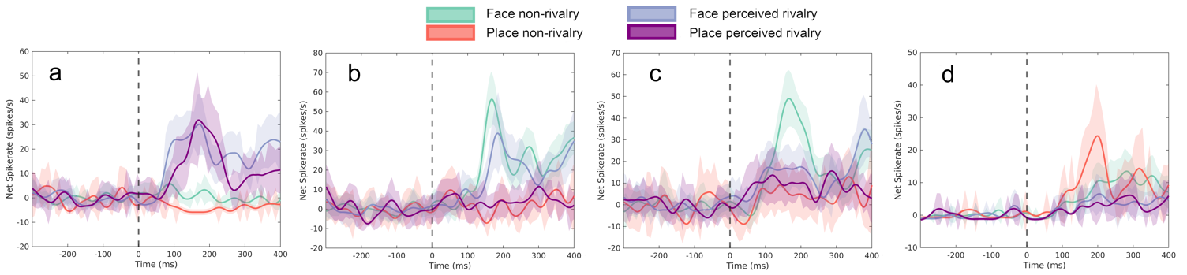
Supplementary figure S25. Binocular rivalry: example neurons from A2. Example neurons highlighting that not all neurons modulate activity according to perception. a) Only response to rivalry trials, thereby responding to the visual input rather than perceived image. b) Face selective neuron that modulates activity according to perception. c and d) Face (c) and place (d) selective neurons that don’t modulate activity according to perception.

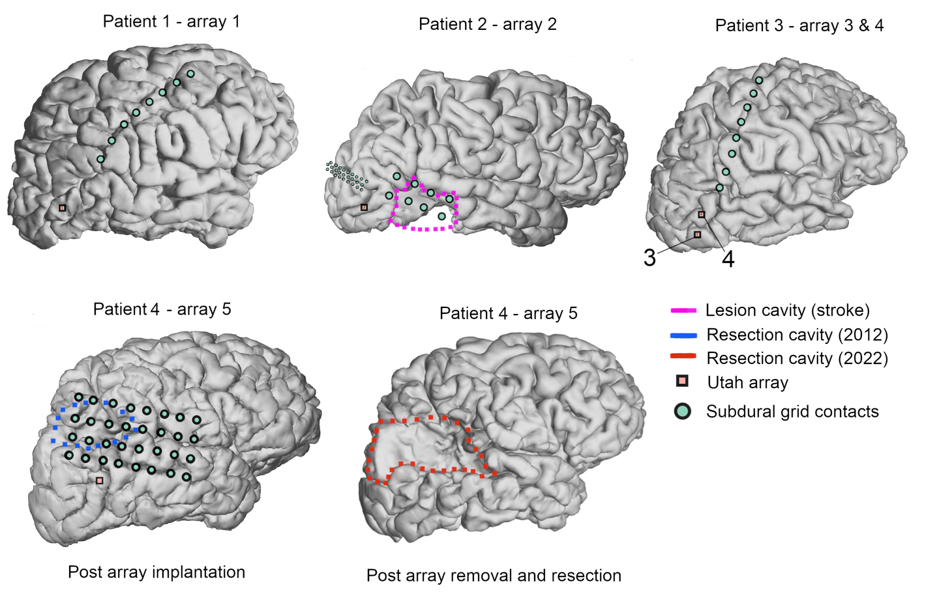
Supplementary figure S26. Array locations in all patients. Anatomical depiction of array position, subdural grid contacts and previous cavity (stroke cavity for patient 2, resection cavity for patient 4). For patient 4, post-operative cortical rendering after electrode removal and more extensive resection is included. Red dotted line highlights the performed resection from the presumed epileptogenic zone (PEZ) in patient 4.

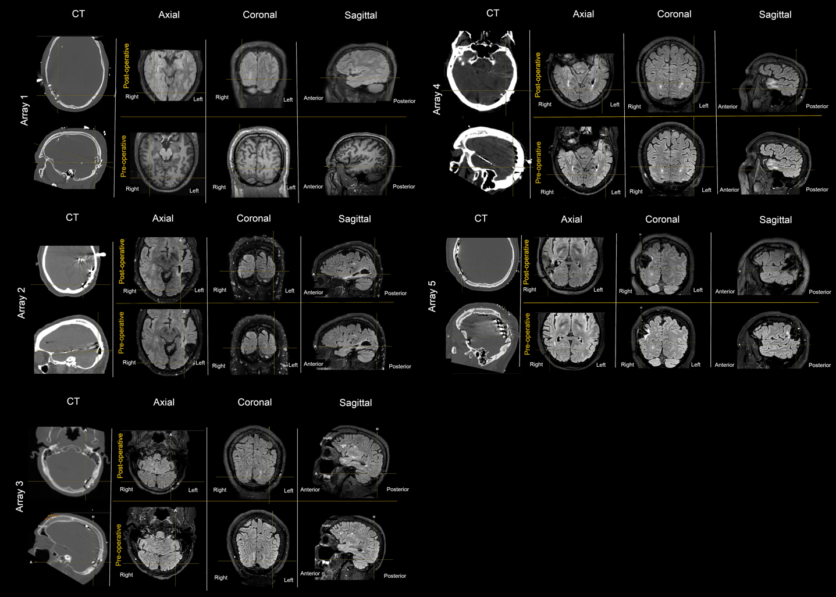
Supplementary figure S27. Array localization in all 4 patients. Axial, coronal, and sagittal slices of pre-implantation and post-explantation MRI (FLAIR) scans are presented. Pre-implantation MRI, post-explantation MRI, and post-implantation/pre-explantation CT scans were co-registered using Brainlab Elements software. The exact location of the array was determined based on CT imaging. Notably, no lesions were visible on the post-explantation MRI in the area where the array was inserted. Note that for array 5, an additional resection occurred during electrode removal, resulting in an enlargement of the previously existing resection cavity. There was no pre-operative FLAIR available with enough slices for patient 1, so a T1 was used instead.

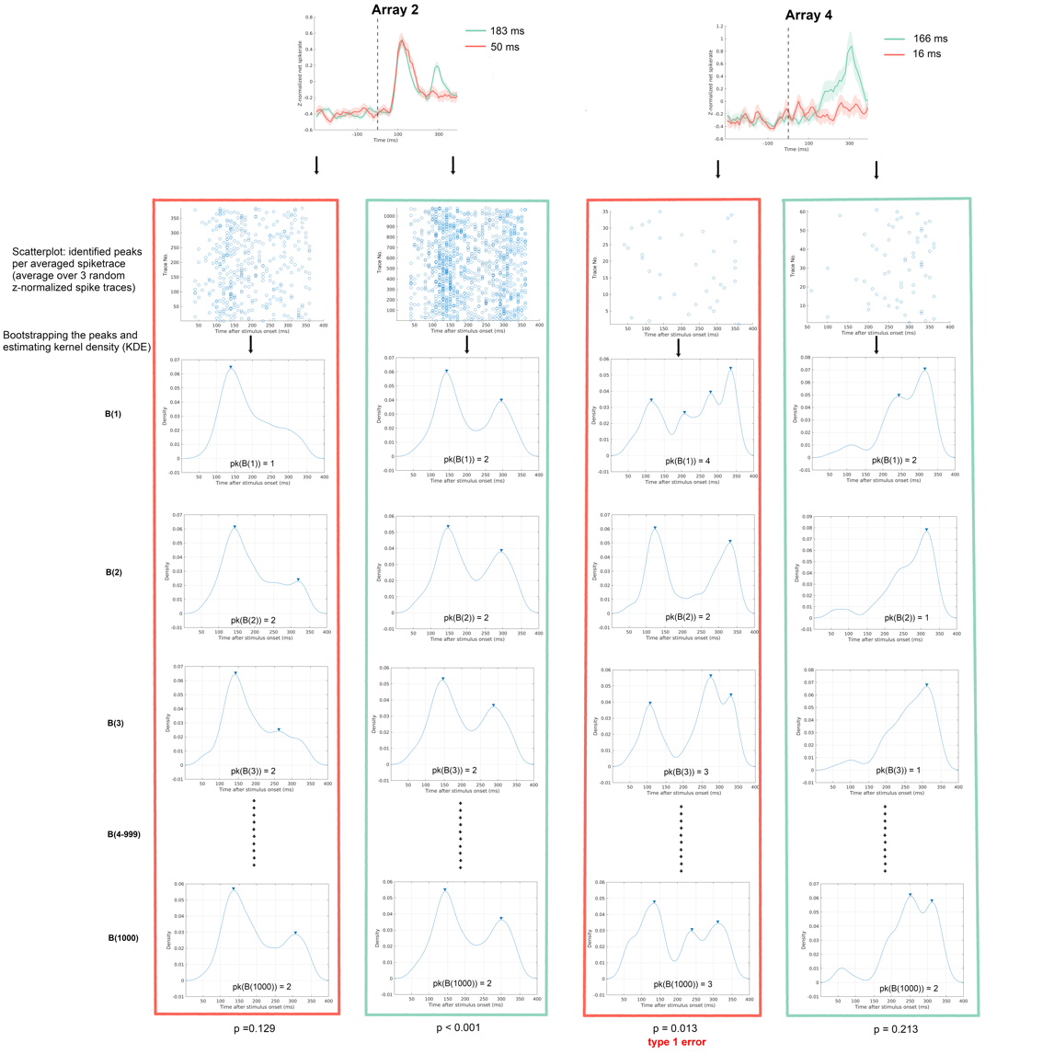
Supplementary figure S28. Backward masking: Silverman’s test and the risk of Type I errors. The upper plots show the average z-normalized spike rate for specific delays in array 2 (variation 2) and array 1 (variation 1). To reduce noise, individual traces contributing to the total average were shuffled and grouped in sets of three, with the average taken for each group. Peaks were identified in all averaged traces (scatter plot), after which the identified peaks were bootstrapped 1000 times. For each bootstrap sample, the kernel density estimate (KDE) was computed, and the number of peaks in the KDE was determined. Note the significant p-value observed in the 16 ms delay group in array 4, despite the absence of a clear visual response, indicating a Type I error.

