CLINICAL STUDY PROTOCOL

Nebulization with different size of 2% lidocaine atomized particles in awake tracheal intubation: a randomized clinical trial

TRIAL REGISTRATION: clinicaltrials.gov, NCT06420947.
Supplement 1.
This appendix has been provided by the authors to give readers additional information about their work.
Corresponding author: Zhongcong Xie and Jiaqiang Zhang
Zhongcong Xie: Department of Anesthesia, Critical Care and Pain Medicine, Massachusetts General Hospital and Harvard Medical School, 149 13th St, Room 4310, Charlestown, MA 02129. Telephone: 617-724-9308; Fax: 617-643-9277. zxie@mgh.harvard.edu.
Jiaqiang Zhang: Department of Anesthesiology and Perioperative Medicine, People’s Hospital of Zhengzhou University, Henan Provincial People’s Hospital, No. 7, Weiwu Road, Zhengzhou 450003, Henan, China. zhangjiq@zzu.edu.cn. Telephone: +86 139-3712-1360. Fax: +86 5928 8887 777.

This supplement 1 contains the following item:
Trial protocol (Version of Mar 17, 2024)

Trial protocol version V1.0, May 17, 2024

TRIAL PROTOCOL
This document reports the final version of the trial protocol.
The study group investigators and collaborators:
Department of Anesthesiology and Perioperative Medicine, People’s Hospital of Zhengzhou University, Henan Provincial People’s Hospital,Zhengzhou, China :
Jiaqiang Zhang, MD, PhD; Chenxi Li, MD; Mingyang Sun, MD; Luyao Zhang, MD; Guangzhi Wang, MD.
Department of Epidemiology and Health Statistics, College of Public Health,
Zhengzhou University, Zhengzhou, PR China:
Jie Lu, MD, PhD
Department of Anesthesia, Critical Care and Pain Medicine, Massachusetts General
Hospital and Harvard Medical School, Boston, MA, USA:
Zhongcong Xie, MD, PhD

All documentation that has been supplied by the Investigator’s designee concerning this study, and that has not been previously published, will be kept in the strictest confidence.
The study will not be commenced without the prior written approval of CREC. No changes will be made to the study protocol without the prior written approval of the Investigator or their designee and the CREC, except where necessary to eliminate an immediate hazard to the patients.

- SYNOPSIS
Study Title | Nebulization with different size of 2% lidocaine atomized particles in awake tracheal intubation: a randomized clinical trial
Trial registration number | clinicaltrials.gov, NCT06420947
Principle Investigator | Jiaqiang Zhang: Department of Anesthesiology and Perioperative Medicine, People’s Hospital of Zhengzhou University, Henan Provincial People’s Hospital
Coordinating  Investigator | Zhongcong Xie: Department of Anesthesia, Critical Care and Pain Medicine, Massachusetts General Hospital and Harvard Medical School
Study Center | People’s Hospital of Zhengzhou University, Henan Provincial People’s Hospital
Objectives | To determine the effect of nebulization with different sizes of atomized particles of 2% lidocaine on cough, reaction, and comfort during ATI in patients with predicted difficult airway.
Study Design | This is a parallel and randomized–controlled clinical study aimed to identify the optimized size of atomized particles of 2% lidocaine that can provide the best topical anesthesia during ATI.  Patients will be randomly assigned in equal numbers to four treatment groups (A3, A6, A9, or A11) using a simple randomization sequence created in SAS9.4. Participants in the A3, A6, A9, and A11 groups will receive 20 mL of 2% lidocaine by atomizer with 3-4, 6-7, 9-10, or 11-12 μm particles, respectively. After completing airway topical anesthesia, the laryngoscope will be used to expose the glottis, and a tracheal tube will be inserted. Correct placement of the tracheal tube will be confirmed by end-tidal capnography. Comfort score, reaction score, and cough score during intubation will be recorded by the observer in blind manner. Heart rate and blood pressure at the time of laryngoscope insertion, endotracheal tube insertion, inflation of the tracheal tube cuff, and 1 minute after endotracheal tube insertion will also be recorded.
Population and Sample size | Patients (aged 18 - 65 years) scheduled for ATI and the planned total sample size is 216.
Inclusion criteria | • Male or female.  • Patients aged 18–65 years.  • Patients with an American Society of Anesthesiologists (ASA) status of 1–3.  • Patients with medical history indicating difficult airways.  • Patients with histories of difficult intubation.  • Patients with Mallampati class 3 or 4.  • Patients with BMI > 26 kg/m².  • Patients with thyromental distance<60 mm (corresponding to an average distance of 3 finger breadths).  • Patients with limited mouth opening with interincisor distance<30 mm.  • Patients with head and neck movement <80°.  • Patients with a history of multiple or failed laryngoscopy  • Patients with ankylosing spondylitis.  • Patients with rheumatoid arthritis.  • Patients with degenerative osteoarthritis.  • Patients with epiglottitis.  • Patients with acromegaly.  • Patients with morbid obesity.  • Patients with subglottic stenosis.  • Patients with enlarged thyroid.  • Patients with enlarged tonsils.  • Patients with mediastinal mass.  • Patients with throat tumors.  • For adult patients, ability to understand and provide written informed consent.  • Females who are not pregnant, not lactating and are not planning a pregnancy during the study.
Exclusion criteria | • Any condition or situation likely to cause the patient (or, if applicable, the patient’s primary caregiver) to be unable or unwilling to comply with study treatment or attend all study visits.  • Patients with airway hemorrhage.  • Patients with history of coagulation diseases;  • Patients allergic to local anaesthetics.  • Previous participation in this trial.  • Participation in another clinical trial within the previous 30 days.  • Any condition (i.e significant acute or chronic medical, neurological, psychiatric illness…) in the patient, in the judgment of the principal investigator, could compromise patient’s safety, limit the patient’s ability to complete the study.
Interventions | Topical anesthesia with 20 mL of 2% lidocaine of the 3-4, 6-7, 9-10, and 11-12 μm of atomized particles will be given to the participants via nebulization before the ATI.
Endpoints | Primary Endpoints:  • Cough, reaction, and comfort scores during intubation and the adverse event incidence.  Secondary Endpoints:  • Intraoperative hemodynamic parameters [systolic blood pressure (SBP), diastolic blood pressure (DBP), mean arterial pressure (MAP)].  • Nebulization time (the time to complete the 20 ml of 2% lidocaine) with different atomized particles.  • The number of lidocaine sprays throughout the procedure and the number of times the patient vomited during the lidocaine spray.
Statistical analysis | General considerations:  • For baseline variables, sex will be described as numbers (proportion). Age, weight, height, systolic blood pressure, dystonic blood pressure, mean arterial pressure and heart rate will be presented as mean (standard deviation [SD]) for normal distributions or median (IQR Q1-Q3) for skewed distributions.  Efficacy analysis (FAS analysis):  • Primary endpoint:  Cough, reaction, and comfort scores, recorded as ordinal variables, will be presented as numbers (proportion) within a given score level and will be analyzed with the Kruskal-Wallis test followed by the Wilcoxon rank sum test for further multiple-comparison (α is adjusted using the Bonferroni method).  • Secondary Endpoints:  Nebulization time, intraoperative hemodynamic parameters [systolic blood pressure (SBP), diastolic blood pressure (DBP), mean arterial pressure (MAP)] at the time of laryngoscope insertion, endotracheal tube insertion, inflation of the tracheal tube cuff, and 1 minute after endotracheal tube insertion, if these data were normal distributions, will be presented as mean (standard deviation [SD]), analyzed by one-way analysis of variance (ANOVA) followed by the Student-Newman-Keul test for further comparison; if these data were skewed distributions, will be presented as median (IQR Q1-Q3), analyzed with the Kruskal-Wallis test, followed by Wilcoxon rank sum test for further multiple-comparison.  Safety analysis (SS analysis):  Adverse events (AE) and severe adverse events (SAE) will be recorded throughout the study. AE or SAE will be described as number (proportion), the incidence (95%CI) of AE of SAE will be calculated. test or Fishers exact test will be used to compare the difference among 4 groups.
Patient Benefit | Awake tracheal intubation (ATI) can avoid risks and bad consequences associated with the management of a difficult airway. Optimizing the particle size of atomized local topical anesthetic during awake tracheal intubation (ATI) is critical to the success and comfort of ATI in patients.

Contents
TRIAL PROTOCOL 2
1. SYNOPSIS 3
Contents 7
List of Abbreviations 10
2. INTRODUCTION 11
2.1 Background 11
2.2 Benefits and potential risks associated with the trial 12
3. OBJECTIVES 13
3.1 Primary Objective 13
3.2 Secondary Objectives 13
4. STUDY DESIGN 14
4.1 Endpoints 14
4.2 Description of the Trial (Procedures and Methodology) 14
4.3 Sample Size Calculation 14
4.4 Randomization 15
4.5 Allocation concealment 15
4.6 Blinding 15
5 STUDY POPULATION 15
5.1 Inclusion Criteria 15
5.2 Exclusion Criteria 16
5.3 Withdrawal, the end of the research and Description of the permanent or temporary stop rules 17
5.3.1Criteria for study interruption 17
5.3.2Definition and justification of the end of the research if it does not correspond to the end of the participation of the last person who takes part in the study. 17
5.3.3 Description of the permanent or temporary stop rules of an individual’s participation in research: 17
6 INTERVENTION 18
6.1 atomizers 18
6.1.1 3-4μm 18
6.1.2 6-7μm 19
6.1.3 9-10μm 20
6.1.4 11-12μm 21
6.2 Study Timelines 22
6.2.1 Preparatory phase 23
6.2.2 ATI phase 23
7. VARIABLES 24
7.1 Efficacy Parameters 24
7.1.1 Clinical Efficacy Parameters 24
7.1.1.1 Comfort score 24
7.1.1.2 Reaction score 24
7.1.1.3 Cough score 24
7.2.1 Adverse Events 25
8. STUDY CONDUCT 31
8.1 Observations 31
8.2 Study Termination 31
9. DATA QUALITY AND RECORD KEEPING 33
9.1 QUALITY CONTROL AND QUALITY ASSURANCE 33
9.2 Archiving Study Records 33
10. STATISTICAL METHODS 35
10.1 General Statistical Methods 35
10.1.1 Interim Analyses 35
10.1.2 Missing Data 35
10.2 Analysis Sets 35
10.3 Statistical Disposition 36
10.3.1 General considerations 36
10.3.2 Efficacy analyses 36
10.3.3 Safety Analyses 37
10.4 Changes in Statistical Methods 38
10.5 Statistical software 38
11. ETHICS, LEGAL, AND ADMINISTRATIVE ASPECTS 38
11.1 Informed Consent 38
11.2 Approval of Study Protocol 39
11.3 Amending the Protocol 39
11.4 Confidentiality 39
11.5 Publication Policy 39
12. REFERENCES 40
13. AP Declaration of Helsinki 42
PENDICES 42
PREAMBLE 42
GENERAL PRINCIPLES 42
RISKS, BURDENS AND BENEFITS 44
VULNERABLE GROUPS AND INDIVIDUALS 44
RESEARCH ETHICS COMMITTEES 45
PRIVACY AND CONFIDENTIALITY 45
INFORMED CONSENT 45
USE OF PLACEBO 47
POST-TRIAL PROVISIONS 47

List of Abbreviations
AE Adverse Event
ASA American Society of Anesthesiologists
ATI Awake Tracheal Intubation
ANOVA Analyzed by One-way Analysis of Variance
BMI Body Mass Index
CREC Clinical Research Ethics Committee
CONSORT Consolidated Standards of Reporting Trials
CRA Clinical Research Associate
DBP Diastolic Blood Pressure
ECG Electrocardiograph
HR Heart Rates
ICF Informed Consent Form
IQR Interquartile Range
MAP Mean Arterial Pressure
SBP Systolic Blood Pressure
SD Standard Deviation
WMA World Medical Association
SAE Serious Adverse Events

2. INTRODUCTION

2.1 Background
Airway management is important for procedures both inside and outside of the operating room ¹⁻³. Tracheal intubations are difficult in 1.9–10% of patients⁴⁻⁸. One essential approach for managing such patients is awake tracheal intubation (ATI) ^{9,10}, which can avoid risks and bad consequences associated with the management of a difficult airway.
Successful ATI depends upon effective topical application of local anesthetic to the airway¹¹. However, this process has not been optimized, and there are multiple techniques, e.g., mucosal atomization, spray-as-you-go, transtracheal injection, and nebulization¹². Nebulization of local anesthetic is simpler and more effective than others, e.g., spray-as-you-go technique¹². However, the optimization of this approach is needed.
Particle size of local anesthetics (e.g., 2% lidocaine) and inhalation affect drug deposition in the airway and consequently the success and comfort and secure of ATI¹³. Particle or droplet size affects the position of deposition of atomized particles¹⁴⁻¹⁶. For example, 1–5-μm particles are deposited in the deep lungs predominantly in bronchioles and alveoli; 5–10-μm particles are generally deposited in the bronchus and other large airways; and 10-μm particles are deposited in the oropharyngeal region mainly in the pharynx, larynx, and upper bronchus¹⁷⁻²⁰. The path for orotracheal intubation includes the oral cavity, pharyngeal cavity, glottis, and subglottis. Adequately anaesthetizing those areas of airway is important to improve conditions for ATI.
We, thus, will perform a parallel and randomized–controlled clinical study aimed to identify the optimized size of atomized particles of 2% lidocaine that can provide the best topical anesthesia during ATI.

2.2 Benefits and potential risks associated with the trial
Optimizing the particle size of atomized local topical anesthetic during awake tracheal intubation (ATI) is critical to the success and comfort of ATI in patients. Additionally, the most suitable atomized particles made ATI the most comfortable and secure for patients can be applied to other procedures. The present study is the first one to explore the clinical effects of different-sized anesthetic particles during ATI of patients.
Awake tracheal intubation is usually regarded as an effective method in the management of predicted difficult airway. However, there can still be complications during awake tracheal intubation, such as epistaxis, laryngeal trauma, laryngospasm, respiratory depression, discomfort and serious complications caused by improper manipulation, medication factors, patient factors, etc. Patient monitoring is crucial for safety during awake tracheal intubation. A physiological recorder capable of monitoring pulse oximetry, noninvasive and invasive arterial blood pressure, and ECG is recommended. We will timely detection of adverse reactions and problems, immediately rescue, prompt discontinuation of manipulation, and symptomatic treatment to avoid accidental occurrence.

3. OBJECTIVES

3.1 Primary Objective
To determine the effect of nebulization with different sizes of atomized particles of 2% lidocaine on cough, reaction, and comfort scores during ATI in patients with predicted difficult airway.

3.2 Secondary Objectives
To determine the effect of nebulization with different sizes of atomized particles of 2% lidocaine on intraoperative hemodynamic parameters during ATI in patients with predicted difficult airway.
To determine the effect of nebulization with different sizes of atomized particles of 2% lidocaine on nebulization time (the time to complete the 20 ml of 2% lidocaine) during ATI in patients with predicted difficult airway.
To determine the effect of nebulization with different sizes of atomized particles of 2% lidocaine on the number of lidocaine sprays throughout the procedure and the number of times the patient vomited during the lidocaine spray during ATI in patients with predicted difficult airway.

4. STUDY DESIGN

4.1 Endpoints
Primary endpoint:
The primary outcomes are cough score, reaction score, and comfort score at the time of endotracheal tube insertion during ATI. The adverse event incidence will be recorded after the surgery.
Secondary endpoints:
Intraoperative hemodynamic parameters [systolic blood pressure (SBP), diastolic blood pressure (DBP), mean arterial pressure (MAP)] at the time of laryngoscope insertion, endotracheal tube insertion, inflation of the tracheal tube cuff, and 1 minute after endotracheal tube insertion, respectively.
Nebulization time (the time to complete the 20 ml of 2% lidocaine) with different atomized particles.
The number of lidocaine sprays throughout the procedure and the number of times the patient vomited during the lidocaine spray.

4.2 Description of the Trial (Procedures and Methodology)
This is a parallel and randomized–controlled clinical study aimed to identify the optimized size of atomized particles of 2% lidocaine that can provide the best topical anesthesia during ATI.
Patients will be randomly assigned in equal numbers to four treatment groups (A3, A6, A9, or A11) using a simple randomization sequence created in SAS9.4. Participants in the A3, A6, A9, and A11 groups will receive 20 mL of 2% lidocaine by atomizer with 3-4, 6-7, 9-10, or 11-12 μm particles, respectively. After completing airway topical anesthesia, the laryngoscope will be used to expose the glottis, and a tracheal tube will be inserted. Correct placement of the tracheal tube will be confirmed by end-tidal capnography. Comfort score, reaction score, and cough score during intubation will be recorded by the observer in blind manner. Heart rate and blood pressure at the time of laryngoscope insertion, endotracheal tube insertion, inflation of the tracheal tube cuff, and 1 minute after endotracheal tube insertion will also be recorded.

4.3 Sample Size Calculation
Sample size estimation is performed according to the literature(²¹,²²⁻²⁵). A sample size of at least 160 individuals is determined.

4.4 Randomization
A planned 216 patients in this study will be randomly assigned to four groups in a 1:1:1:1 ratio (A3, A6, A9, or A11) at Visit 1, after signing informed consent, 54 patients per group. Statistical staff for randomization and allocation concealment will generate the randomization schedule using a simple randomization procedure through SAS 9.4.

4.5 Allocation concealment
The randomization schedule will be stored in a secure server, and will not be available to any investigators or member of study staff. After participants being enrolled and meeting eligibility criteria, they will be assigned the allocated treatments by logging onto the web-based database.

4.6 Blinding
Patients, observer, outcome assessors and the independent statistician will be blinded to the treatment allocation. Investigators who perform the intervention will not blinded to group allocation, however, allocation will not be revealed approximately 1 hour before surgery.

5 STUDY POPULATION

5.1 Inclusion Criteria
1. Male or female.
2. Patients aged 18–65 years.
3. Patients with an American Society of Anesthesiologists (ASA) status of 1–3
4. Patients with medical history indicating difficult airways.
5. Patients with histories of difficult intubation.
6. Patients with Mallampati class 3 or 4.
7. Patients with BMI > 26 kg/m².
8. Patients with thyromental distance＜60 mm (corresponding to an average distance of 3 finger breadths).
9. Patients with limited mouth opening with interincisor distance＜30 mm.
10. Patients with head and neck movement ＜80°.
11. Patients with a history of multiple or failed laryngoscopy
12. Patients with ankylosing spondylitis.
13. Patients with rheumatoid arthritis.
14. Patients with degenerative osteoarthritis.
15. Patients with epiglottitis.
16. Patients with acromegaly.
17. Patients with morbid obesity.
18. Patients with subglottic stenosis.
19. Patients with enlarged thyroid.
20. Patients with enlarged tonsils.
21. Patients with mediastinal mass.
22. Patients with throat tumors.
23. For adult patients, ability to understand and provide written informed consent
24. Females who are not pregnant, not lactating and are not planning a pregnancy during the study.

5.2 Exclusion Criteria
1. Any condition or situation likely to cause the patient (or, if applicable, the patient’s primary caregiver) to be unable or unwilling to comply with study treatment or attend all study visits.
2. Patients with airway hemorrhage
3. Patients with history of coagulation diseases;
4. Patients allergic to local anesthetics.
5. Previous participation in this trial.
6. Participation in another clinical trial within the previous 30 days.
7. Any condition (i.e significant acute or chronic medical, neurological, psychiatric illness…) in the patient, in the judgment of the principal investigator, could compromise patient’s safety, limit the patient’s ability to complete the study.

5.3 Withdrawal, the end of the research and Description of the permanent or temporary stop rules

5.3.1Criteria for study interruption
Criteria for stopping the ATI procedure: in case of signs of allergia or clinical symptoms of intolerance to the treatment.

5.3.2Definition and justification of the end of the research if it does not correspond to the end of the participation of the last person who takes part in the study.
The end date of the research is the end of the participation of the last person involved in the study.
The study will be prematurely stopped if unexpected serious adverse events occur. Similarly, unanticipated events or new information about the product may cause the investigator to discontinue the study prematurely.
In case of premature termination of the study, the investigator will transmit the information within 15 days to the Clinical Research Ethics Committee (CREC) of the People’s Hospital of Zhengzhou University (Henan Provincial People’s Hospital).

5.3.3 Description of the permanent or temporary stop rules of an individual’s participation in research:
Each patient may withdraw from the study after the decision of the competent administrative authority, or the investigator, but also after the decision of a co-investigator or the patient himself in accordance with the regulations and as mentioned in the consent form. Patients must be withdrawn from the study if they withdraw consent to participate. Such withdrawal may occur at any time during the study. Patients are not required to state their reasons for withdrawing consent.
Patients may be required to discontinue study treatment after discussion with the investigator and/or co-investigator for any of the following reasons:
• Adverse event(s);
• At the discretion of the Investigator;
• Violation of eligibility criteria; or
• Deviation from the treatment plan specified in the protocol (e.g., incorrect administration of study medication, failure to attend study visits).
In all cases, the investigator should document the reasons for the discontinuation in the ATI procedure. If there is more than one reason for discontinuation of study, one reason will be listed as the primary reason.
The study may be prematurely terminated in the event of unexpected serious adverse events or the occurrence of unanticipated events.

6 INTERVENTION
Particle size distributions are measured with laser diffraction (LD) by Winner 311XP(https://www.winner-psa.com/).

6.1 atomizers

6.1.1 3-4μm
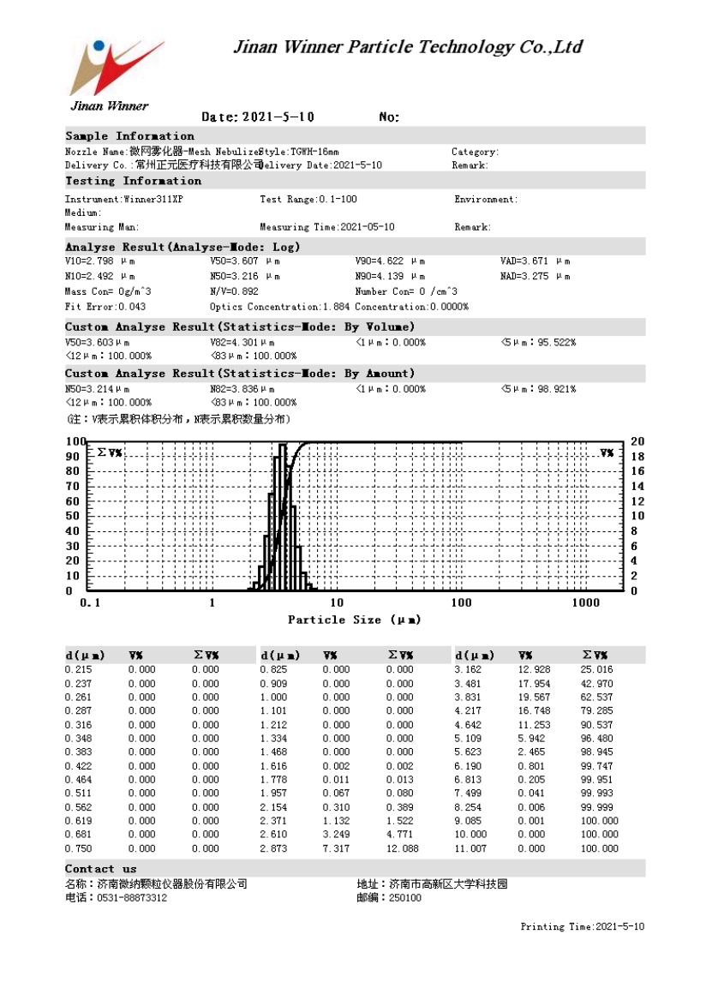

6.1.2 6-7μm
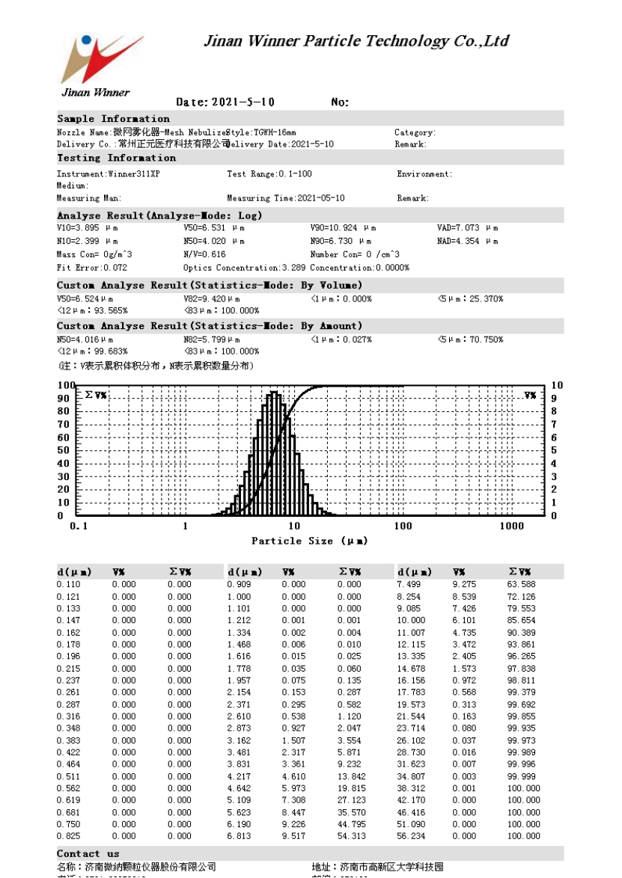

6.1.3 9-10μm
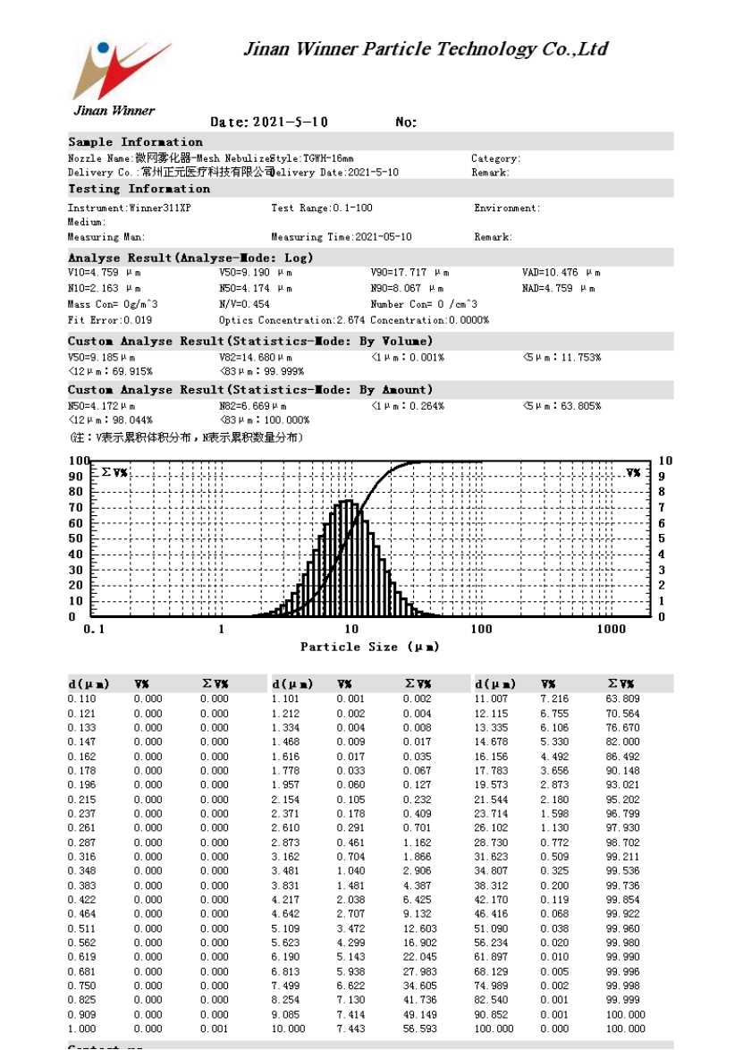

6.1.4 11-12μm
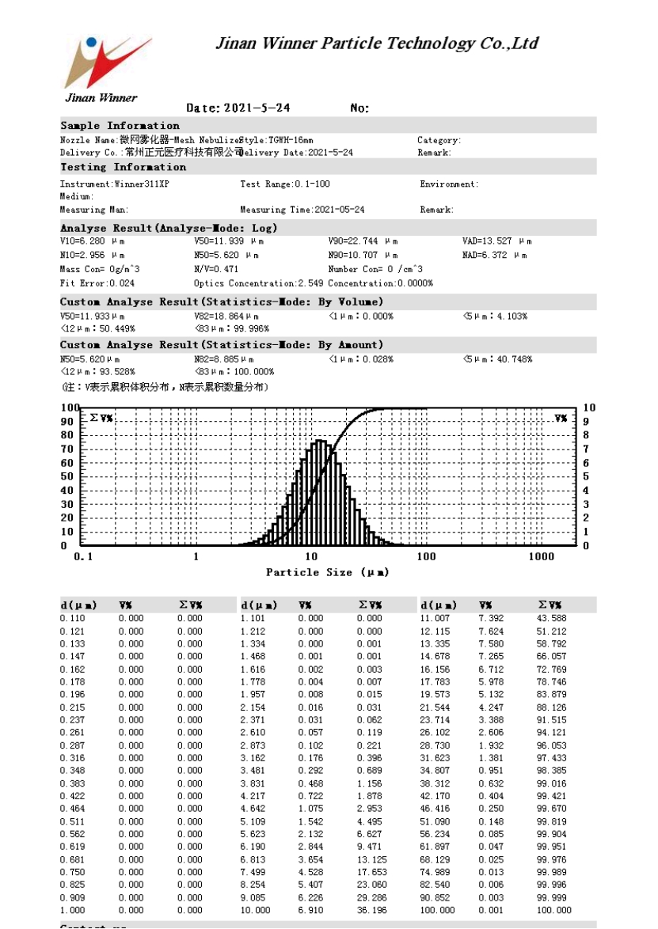

6.2 Study Timelines
The study comprises two phases of investigation: the preparatory phase and the ATI phase.

6.2.1 Preparatory phase
This phase will be performed by an investigator after verification of inclusion and non-inclusion criteria. All participants will be fasted for 8 h before the ATI. Each of the participants will receive a thorough preoperative evaluation including a complete airway examination. The ATI procedure will be explained to patients during preoperative assessment. Patients will be supine on an operating table with standard monitors and oxygen supplied via face mask. An 18-G cannula will be inserted into an upper limb vein for drug and fluid administration, and blood pressure will be monitored by puncture and catheterization of a radial artery under local anesthesia. All subjects will receive penehyclidine hydrochloride 0.5 mg and midazolam 0.02 mg/kg body weight intravenously before topical anesthesia with 2% lidocaine. Before airway topical anesthesia, the head and neck will be placed in a neutral position.

6.2.2 ATI phase
Participants will receive atomized particles of 2% lidocaine (20 mL) via nebulization with particle sizes corresponding to their assigned group. We will use a wearable and disposable vibrating mesh nebulizer (Chinese patent application No. 202021129739.8). Next, a visual laryngoscope will be placed through the mouth to visualize the epiglottis and exposed glottis area, while the patients will be given 0.5 mg of dexmedetomidine over 5 minutes, and remifentanil will be injected with 2 ng/mL target-control infusion to achieve an appropriate state of sedation. If participants feel nauseated and uncomfortable during intubation, we will use a disposable anesthesia sprayer to give an additional 2 mL of 2% lidocaine (same to all participants) per spray until the patient feel no discomfort upon inserting a sputum suction tube into the patient’s subglottis.
After completing airway topical anesthesia, participants will be asked if they had any side effects from local anesthesia, e.g., restlessness, dizziness, nausea, shivering, visual and hearing impairments, and involuntary movements. Sedation will be considered adequate when participants are calm, without apprehension, able to follow verbal commands, aroused and highly cooperative at all times, and maintained spontaneous breathing. Then, the laryngoscope will be used to expose the glottis, and a tracheal tube will be inserted. Correct placement of the tracheal tube will be confirmed by end-tidal capnography.

7. VARIABLES

7.1 Efficacy Parameters

7.1.1 Clinical Efficacy Parameters

7.1.1.1 Comfort score
Participant comfort will be scored on a four-point scale (ranging from 0 to 4)：
• 1 point: no response
• 2 points: slight gagging (one episode occurred)
• 3 points: moderate gagging (two or three episodes occurred)
• 4 points: severe gagging or patient’s inability to tolerate (more than three episodes occurred)

7.1.1.2 Reaction score
Participant reactions will be scored using a modified 6-point scale (ranging from 0 to 6):
• 1 point: no reaction
• 2 points: slight reaction (no change or a single change in the facial expression)
• 3 points: moderate reaction (grimacing facial expression)
• 4 points: severe reaction (severe facial grimace but retained ability to follow verbal commands and no reflex head movements)
• 5 points: very severe reaction (severe facial grimace associated with head movements but still able to obey verbal commands)
• 6 points: uncooperative (severe facial grimace associated with protective head and limb movements hindering the procedure and inability to obey any verbal commands)

7.1.1.3 Cough score
Cough score will be recorded based on the number of coughs.
• 1 point: no cough
• 2 points: coughing (no more than two times in sequence)
• 3 points: moderate coughing (three to five times in sequence)
• 4 points: severe coughing (more than five times in sequence)

7.2 Safety Parameters
Safety will be assessed by AEs and vital signs.

7.2.1 Adverse Events

7.2.1.1 Definitions
An adverse event (AE) is any untoward medical event that occurs in a patient or subject who has received an investigational product, and does not necessarily have a causal relationship with this treatment. An AE can therefore be any unfavorable and unintended sign (including abnormal laboratory finding), symptom, or disease temporally associated with the use of an investigational product, whether or not related to the product.
An illness present at entry to the study is considered a pre-existing condition and will not be considered an AE. However, if a pre-existing condition worsens during the study, this may be considered an AE. Pre-existing conditions will be documented. All AEs, including intercurrent illnesses, that occur during the study must be reported and documented as described below.

7.2.1.2 Assessment of Adverse Event
Volunteered, observed, and elicited AEs will be recorded. This includes AEs the patient reports spontaneously, those the Investigator observes, and those the elicited in response to questions from the study staff. Patients will be asked open-ended questions, such as “How have you been feeling during endotracheal intubation?”, at each study visit.

7.2.1.2.1 Serious Adverse Event
An adverse event is any undesirable experience associated with the use of a medical product in a patient. The event is serious and should be reported to The Clinical Research Ethics Committee (CREC) of the People’s Hospital of Zhengzhou University (Henan Provincial People’s Hospital) when the patient outcome is:
• Results in death;
• Is life-threatening. This means that the patient is at risk of death at the time of the event; it does not mean that the event hypothetically might have caused death if it were more severe;
• Requires or prolongs patient hospitalization;
• Results in persistent or significant disability or incapacity;
• Is a congenital anomaly or birth defect.
Important medical events that may not be immediately life-threatening or result in death or hospitalization but that may jeopardize the patient or require intervention to prevent one of the above outcomes usually should also be considered serious.

7.2.1.2.2 Severity
The severity of each AE must be assessed and recorded as mild, moderate, or severe.
• Mild: An AE that does not interfere with usual activities;
• Moderate: An AE that interferes with usual activities; or
• Severe: An AE that is intense or debilitating and interferes with usual activities.

7.2.1.2.3 Relationship to Study
The relationship of each AE to the study must be assessed and recorded as one of the following:
• Not related;
• Possibly related; or
• Probably or definitely related.

7.2.1.3 Recording Adverse Events
All AEs that occur during the study must be recorded in the Adverse Events page. All Adverse Event should contain a brief description of the event, date and time of onset, duration, intensity, treatment required, relationship to the study, action taken with regard to the study, outcome, and whether the event is classified as serious.

7.2.1.4 Reporting Serious Adverse Events
The Investigator must report any SAE that occurs during the study, regardless of relationship to the study, to CREC within 24 hours of discovering the event.
Directions for reporting an SAE appear below.

SERIOUS ADVERSE EVENT REPORTING INSTRUCTIONS
The Clinical Research Ethics Committee
Telephone: 0371-87160680 (for urgent issues/questions during business hours)
1. Telephone the Safety Center within 24hours of becoming aware of the event.
2. Provide the CREC personnel with the Investigator’s name, your name, the telephone number where you can be reached, your study site number, the protocol number and title, and the patient number and title, and the patient number for an urgent concern/issue.

The Investigator will review each SAE report and evaluate the relationship of the SAE to the study. Based on the Investigator’s assessment of the SAE, a decision will be made concerning the need for further action. The primary consideration governing further action is whether new findings affect the safety of patients participating in the clinical study. If the discovery of a new SAE related to the study raises concern over the safety of continued the study to patients, the Investigator will take immediate steps to notify the CREC and all Investigators participating in clinical studies of the study.
Further action that may be required includes the following:
• Modification of the protocol, including the addition of investigators;
• Discontinuation or suspension of the study;
• Modification of the existing consent form and informing current study participants of new findings; or
• Addition of any newly identified study-related AEs to the list of expected AEs.
7.2.1.5 Follow-Up of Adverse Events
The Investigator must continue to follow all SAEs and those non-serious events assessed as possibly, probably, or definitely related to the study until they resolve or until the Investigator assesses them as chronic or stable. This follow-up may extend after the end of the study.
7.2.1.6 Reporting Safety Information
The Investigator must promptly report to the Clinical Research Ethics Committee (CREC) all unanticipated problems involving risks to patients. This includes death from any cause and all SAEs assessed as possibly, probably, or definitely related to the study, and any other events required to be reported by the CREC.
7.2.1.7 Protocol Deviations Due to an Emergency or Adverse Event
In the case of an emergency or AE, departures from the protocol may be necessary. Such protocol deviations will be determined as allowable on a case-by-case basis. The Investigator or other physician in attendance in such an emergency must contact the Medical Monitor as soon as possible to discuss the circumstances of the emergency. The Medical Monitor and the Investigator will confer to decide whether the patient should continue to receive the study. All protocol deviations and the reasons for such deviations must be noted.

8. STUDY CONDUCT

8.1 Observations
Data collected in prehospital:
• Age.
• Weight.
• Height.
• Basal systolic blood pressure.
• Basal dystonic blood pressure.
• Basal mean arterial pressure.
• Basal Heart rates.
Data collected at the ATI procudure:
• Nebulization time.
• Cough score.
• Reaction score.
• Comfort score.
• The number of lidocaine sprays throughout the procedure.
• The number of times the patient vomited during the lidocaine spray.
• Systolic blood pressure at endotracheal tube insertion、inflation of tracheal tube cuff and inflation of tracheal tube cuff.
• dystonic blood pressure at endotracheal tube insertion、inflation of tracheal tube cuff and inflation of tracheal tube cuff.
• Mean arterial pressure at endotracheal tube insertion、inflation of tracheal tube cuff and inflation of tracheal tube cuff.
• Heart rates at endotracheal tube insertion、inflation of tracheal tube cuff and inflation of tracheal tube cuff.

8.2 Study Termination
If the investigator, or the observer discovers conditions arising during the study that indicate the study should be halted, the study may be terminated. Conditions that may warrant termination include, but are not limited to:
• The discovery of an unexpected, significant or unacceptable risk to the patients enrolled in the study;
• Failure of the Investigator to enter patients at an acceptable rate;
• Insufficient adherence to protocol requirements;

9. DATA QUALITY AND RECORD KEEPING

9.1 QUALITY CONTROL AND QUALITY ASSURANCE
The data concerning the study will be reported in the observation notebooks provided for the study, taking into account the different steps of the patient’s management in the protocol. Any deviation from the protocol will be reported, as well as the reason for it. The data collection must be exhaustive and will be regularly checked by a clinical research associate (C.R.A.) according to the planned procedures.
The monitoring of the trial will be carried out by CRAs.
During site monitoring visits, CRAs should be able to consult:
• the investigator’s binder containing the consents of the participants or their relatives
• the data collection books of the patients included
• patient medical observation sheets and any other source documents
• The hospital information system
The monitoring will check at least the following points:
• the existence of patients, the consent process
• compliance with inclusion and non-inclusion criteria
• the primary endpoint
• monitoring and reporting of SAEs
• the occurrence of new facts requiring the tabling of an amendment
A written monitoring visit report will be prepared for each visit.
At the end of the trial, closing procedures will be applied, with all documents and source data filed. Once the final analysis is completed and validated, the entire file and data are sealed and archived according to specific procedures in a secure facility.
In addition, all data, documents and reports may be subject to regulatory audits and inspections without prejudice to medical confidentiality.

9.2 Archiving Study Records
The data concerning this study will be archived for a minimum of 5 years from the end of the research or its early termination without prejudice to the legislative and regulatory provisions in force.
The following documents related to this research are archived for a period of 5 years following the end of the research:
* By investigators:
- The protocol and any amendments to the protocol
- Observation books (copies)
- Source records of participants who have signed a consent
- All other documents and correspondence related to the research
- Original signed informed consents from participants
All of these documents are the responsibility of the investigator for the duration of the regulatory archiving period.
The study site investigators and members of their research team will make a reasonable effort to ensure the research subjects’ confidentiality.

10. STATISTICAL METHODS

10.1 General Statistical Methods
All data collected in the database will be presented in the data listings. Analyses will be based on the intention-to-treat principle. For baseline variables, sex will be described as numbers (proportion). Age, weight, height, systolic blood pressure, dystonic blood pressure, mean arterial pressure and heart rate will be presented as mean (standard deviation [SD]) for normal distributions or median (IQR Q1-Q3) for skewed distributions. Cough, reaction, and comfort scores, recorded as ordinal variables, will be presented as numbers (proportion) within a given score level and analyzed with the Kruskal-Wallis test followed by the Wilcoxon rank sum test for further multiple-comparison (α is adjusted using the Bonferroni method). Nebulization time, intraoperative hemodynamic parameters [systolic blood pressure (SBP), diastolic blood pressure (DBP), mean arterial pressure (MAP)] at the time of laryngoscope insertion, endotracheal tube insertion, inflation of the tracheal tube cuff, and 1 minute after endotracheal tube insertion, if these data were normal distributions, will be presented as mean (standard deviation [SD]), analyzed by one-way analysis of variance (ANOVA) followed by the Student-Newman-Keul test for further comparison; if these data were skewed distributions, will be presented as median (IQR Q1-Q3), analyzed with the Kruskal-Wallis test, followed by Wilcoxon rank sum test for further multiple-comparison.

10.1.1 Interim Analyses
No interim analyses are planned.

10.1.2 Missing Data
If the missing values are numeric, they will be filled in according to the average value of the property in all other samples; if the null values are non-numeric, the highest frequency of occurrence of the feature in other objects will be used to fill in the missing value according to the statistical mode principle.

10.2 Analysis Sets
The major purpose of this study is to investigate the effect of nebulization with different sizes of atomized particles of 2% lidocaine on cough, reaction, and comfort during ATI in patients with predicted difficult airway. The primary endpoint of this study is cough score, reaction score, and comfort score, which are safety events. Therefore, the full analysis set and safety set in this study is identical.
So, it is planned that the assessment of primary endpoint will be performed based on full analysis set and safety set.
-Full analysis set (FAS) ：This is an ideal data set determined according to the ITT (intention-to-treat) principle, and will be used for efficacy analysis. All eligible patients who meet the inclusion/exclusion criteria, participate in randomization, and take any efficacy assessment after taking the relevent treatment will be included in the FAS.
-Safety set (SS)：This data set will be used for safety analysis. All eligible patients who meet the inclusion/exclusion criteria, participate in randomization, and take any safety assessment after taking the relevent treatment will be included in the SS.

10.3 Statistical Disposition
The numbers of patients in each treatment group who complete the study and who terminate early will be tabulated. For patients who terminate early, primary and secondary reasons for termination will be tabulated. Patients who exclude from each of the study populations and their reasons for exclusion will be listed.

10.3.1 General considerations
Continuous demographic and baseline characteristics, such as age, weight, height, will be summarized with mean (standard deviation [SD]) for normal distributions or median (IQR Q1-Q3) for skewed distributions. Categorical demographic and baseline characteristics such as gender will be described as numbers (proportion). Demographic and baseline characteristic tables will be presented for all study populations.

10.3.2 Efficacy analyses
All safety analyses will be based on the FAS.

10.3.2.1 Primary endpoints
The primary efficacy endpoint will be the Cough, reaction, and comfort scores. Cough, reaction, and comfort scores, recorded as ordinal variables, will be presented as numbers (proportion) within a given score level and analyzed with the Kruskal-Wallis test followed by the Wilcoxon rank sum test for further multiple-comparison (α is adjusted using the Bonferroni method).

10.3.2.2 Secondary endpoints
Only analysis of the principal secondary endpoint will be confirmatory. Analysis of the other secondary efficacy endpoints will be supportive only.
Principal secondary endpoint:
Nebulization time, intraoperative hemodynamic parameters [systolic blood pressure (SBP), diastolic blood pressure (DBP), mean arterial pressure (MAP)] at the time of laryngoscope insertion, endotracheal tube insertion, inflation of the tracheal tube cuff, and 1 minute after endotracheal tube insertion, if these data were normal distributions, will be presented as mean (standard deviation [SD]), analyzed by one-way analysis of variance (ANOVA) followed by the Student-Newman-Keul test for further comparison; if these data were skewed distributions, will be presented as median (IQR Q1-Q3), analyzed with the Kruskal-Wallis test, followed by Wilcoxon rank sum test for further multiple-comparison.
Other secondary endpoints:
The number of lidocaine sprays throughout the procedure and the number of times the patient vomited during the lidocaine are presented as median (IQR Q1-Q3), will be analyzed with the Kruskal-Wallis test followed by the Wilcoxon rank sum test for further multiple-comparison.

10.3.3 Safety Analyses
All safety analyses will be based on the SS.
Safety will be assessed by reports of AEs and vital signs findings. Listings of AEs, SAEs, deaths, and AEs leading to discontinuation will be produced. AEs will be tabulated for the following subsets:
1. All AEs,
2. Adverse events leading to discontinuation (from the study),
3. Adverse events resulting in death,
4. SAEs,
5. Adverse events related to the study.
Patients reporting the same AE more than once will be counted only once for this event in the AE summary table. For tabulation by severity, the AE with the greatest severity reported by the patient will be included in the table. Similarly, for tabulation by relationship to the study, the AE with the closest relationship to the study will be included in the table.
Summary statistics will be provided for vital signs.
AE or SAE will be described as number (proportion), the incidence (95%CI) of AE of SAE will be calculated. test or Fishers exact test will be used to compare the difference among 4 groups.

10.4 Changes in Statistical Methods
Any deviation(s) from the original Statistical Analysis Plan will be described and justified in the final study report.

10.5 Statistical software
All statistical analyses will be conducted in SPSS 21.0 (version number 6761805c6989326cbf14).

11. ETHICS, LEGAL, AND ADMINISTRATIVE ASPECTS
The procedures described in this study protocol are designed to ensure that the Investigator abide by the principles of the guidelines of the ATI and of the Declaration of Helsinki (shown in Appendix1). The investigator’s signature on this protocol constitutes acceptance of these guidelines.

11.1 Informed Consent
Before being admitted to the study, each patient, or patient’s legally authorized representative, will provide informed consent according to the regulatory and legal requirements of the participating country. The Investigator will not undertake any procedure specifically required for the clinical study until valid consent (and assent, if applicable) has been obtained. The terms of the consent (and assent, if applicable) and when it will be obtained must be documented. The original signed Informed Consent Form (ICF) will be retained by the Investigator as part of the study records.
Should a protocol amendment be made, the ICF and Assent Form may be revised to reflect the changes in the protocol.
If the ICF and Assent Form are revised, it is the responsibility of the Investigator to ensure that the amended documents are reviewed and approved by the CREC, and that it is signed by all patients currently in the study and all patients subsequently entered in the study (or by their legally authorized representatives).

11.2 Approval of Study Protocol
Before the start of the study, the study protocol and other appropriate documents will be submitted to the CREC. Written approval from the CREC must be obtained before any patients are screened. The study protocol and other appropriate documents will be submitted to other authorities as required by local legal requirements.

11.3 Amending the Protocol
This protocol is to be followed exactly. To alter the protocol, amendments must be written, receive approval from all persons who approved the original protocol, and receive CREC approval prior to implementation. Following approval, the protocol amendment(s) will be submitted to the Chinese Clinical Trial Registry, and other applications, if any, under which the study is being conducted. All amendments and administrative changes will be distributed to all protocol recipients with instructions to append them to the protocol.

11.4 Confidentiality
All study findings and documents will be regarded as confidential. The Investigator and members of his/her research team must not disclose such information.
The anonymity of participating patients must be maintained. Patients will be identified by the patient number, and/or birth date, or in such other way. The patient (e.g., the signed Informed Consent Form, the initials) must be maintained in confidence by the Investigator.

11.5 Publication Policy
The clinical study report will be a presentation of the pooled results.An Investigator shall not publish any data (poster, abstract, paper, etc.) without having obtained written approval from the Sponsor prior to submission for publication or presentation.The above policy applies to information from a prematurely discontinued or other non- completed study as well as from a completed study. Results from Investigators shall not be made available to any third party by the investigating team outside the publication procedure as described above.

12. REFERENCES

1. Cook TM, Woodall N, Frerk C, Fourth National Audit P. Major complications of airway management in the UK: results of the Fourth National Audit Project of the Royal College of Anaesthetists and the Difficult Airway Society. Part 1: anaesthesia. Br J Anaesth. 2011;106(5):617-631.
2. Petrini F, Accorsi A, Adrario E, et al. Recommendations for airway control and difficult airway management. Minerva anestesiologica. 2005;71(11):617-657.
3. Peterson GN, Domino KB, Caplan RA, Posner KL, Lee LA, Cheney FW. Management of the difficult airway: a closed claims analysis. Anesthesiology. 2005;103(1):33-39.
4. Lundstrom LH, Moller AM, Rosenstock C, et al. A documented previous difficult tracheal intubation as a prognostic test for a subsequent difficult tracheal intubation in adults. Anaesthesia. 2009;64(10):1081-1088.
5. Norskov AK, Rosenstock CV, Wetterslev J, Astrup G, Afshari A, Lundstrom LH. Diagnostic accuracy of anaesthesiologists' prediction of difficult airway management in daily clinical practice: a cohort study of 188 064 patients registered in the Danish Anaesthesia Database. Anaesthesia. 2015;70(3):272-281.
6. Detsky ME, Jivraj N, Adhikari NK, et al. Will This Patient Be Difficult to Intubate?: The Rational Clinical Examination Systematic Review. JAMA. 2019;321(5):493-503.
7. Shiga T, Wajima Zi, Inoue T, Sakamoto A. Predicting Difficult Intubation in Apparently Normal Patients: A Meta-analysis of Bedside Screening Test Performance. Anesthesiology. 2005;103(2):429-437.
8. Kheterpal S, Healy D, Aziz MF, et al. Incidence, Predictors, and Outcome of Difficult Mask Ventilation Combined with Difficult Laryngoscopy: A Report from the Multicenter Perioperative Outcomes Group. Anesthesiology. 2013;119(6):1360-1369.
9. Practice guidelines for management of the difficult airway. A report by the American Society of Anesthesiologists Task Force on Management of the Difficult Airway. Anesthesiology. 1993;78(3):597-602.
10. Janssens M, Hartstein G. Management of difficult intubation. Eur J Anaesthesiol. 2001;18(1):3-12.
11. Ahmad I, El-Boghdadly K, Bhagrath R, et al. Difficult Airway Society guidelines for awake tracheal intubation (ATI) in adults. Anaesthesia. 2020;75(4):509-528.
12. Cabrini L, Baiardo Redaelli M, Ball L, et al. Awake Fiberoptic Intubation Protocols in the Operating Room for Anticipated Difficult Airway: A Systematic Review and Meta-analysis of Randomized Controlled Trials. Anesth Analg. 2019;128(5):971-980.
13. Jaafar-Maalej C, Andrieu V, Elaissari A, Fessi H. Assessment methods of inhaled aerosols: technical aspects and applications. Expert opinion on drug delivery. 2009;6(9):941-959.
14. Dailey LA, Schmehl T, Gessler T, et al. Nebulization of biodegradable nanoparticles: impact of nebulizer technology and nanoparticle characteristics on aerosol features. Journal of controlled release : official journal of the Controlled Release Society. 2003;86(1):131-144.
15. Newman SP. Aerosol deposition considerations in inhalation therapy. Chest. 1985;88(2 Suppl):152s-160s.
16. Pilcer G, Amighi K. Formulation strategy and use of excipients in pulmonary drug delivery. International journal of pharmaceutics. 2010;392(1-2):1-19.
17. Carvalho TC, Peters JI, Williams RO, 3rd. Influence of particle size on regional lung deposition--what evidence is there? International journal of pharmaceutics. 2011;406(1-2):1-10.
18. Tsuda A, Henry FS, Butler JP. Particle transport and deposition: basic physics of particle kinetics. Comprehensive Physiology. 2013;3(4):1437-1471.
19. Howarth PH. Why particle size should affect clinical response to inhaled therapy. Journal of aerosol medicine : the official journal of the International Society for Aerosols in Medicine. 2001;14 Suppl 1:S27-34.
20. Heijerman H, Westerman E, Conway S, Touw D, Döring G. Inhaled medication and inhalation devices for lung disease in patients with cystic fibrosis: A European consensus. Journal of cystic fibrosis : official journal of the European Cystic Fibrosis Society. 2009;8(5):295-315.
21. Dhasmana S, Singh V, Pal US. Nebulisation Versus Spray-as-You-Go Airway Topical Anaesthesia in Patients with Temporomandibular Joint Ankylosis using 2 % Lignocaine. J Maxillofac Oral Surg. 2015;14(2):398-402.
22. Gupta B, Kohli S, Farooque K, et al. Topical airway anesthesia for awake fiberoptic intubation: Comparison between airway nerve blocks and nebulized lignocaine by ultrasonic nebulizer. Saudi J Anaesth. 2014;8(Suppl 1):S15-19.
23. Vasu BK, Rajan S, Paul J, Kumar L. Efficacy of atomised local anaesthetic versus transtracheal topical anaesthesia for awake fibreoptic intubation. Indian J Anaesth. 2017;61(8):661-666.
24. Xue FS, Liu HP, He N, et al. Spray-as-you-go airway topical anesthesia in patients with a difficult airway: a randomized, double-blind comparison of 2% and 4% lidocaine. Anesth Analg. 2009;108(2):536-543.
25. Woodruff C, Wieczorek PM, Schricker T, Vinet B, Backman SB. Atomised lidocaine for airway topical anaesthesia in the morbidly obese: 1% compared with 2%. Anaesthesia. 2010;65(1):12-17.

13. AP Declaration of Helsinki

PENDICES
Appendix 1

WORLD MEDICAL ASSOCIATION DECLARATION OF HELSINKI
Ethical Principles for Medical Research Involving Human Subjects
Adopted by the 18th WMA General Assembly, Helsinki, Finland, June 1964, and amended by the:
29th WMA General Assembly, Tokyo, Japan, October 1975
35th WMA General Assembly, Venice, Italy, October 1983
41st WMA General Assembly, Hong Kong, September 1989
48th WMA General Assembly, Somerset West, Republic of South Africa, October 1996 52nd WMA General Assembly, Edinburgh, Scotland, October 2000
53rd WMA General Assembly, Washington 2002 (Note of Clarification on paragraph 29 added)
55th WMA General Assembly, Tokyo 2004 (Note of Clarification on Paragraph 30 added)
59th WMA General Assembly, Seoul, October 2008
64th WMA General Assembly, Fortaleza, Brazil, October 2013

PREAMBLE

1. The World Medical Association (WMA) has developed the Declaration of Helsinki as a statement of ethical principles for medical research involving human subjects, including research on identifiable human material and data.
The Declaration is intended to be read as a whole and each of its constituent paragraphs should be applied with consideration of all other relevant paragraphs.
2. Consistent with the mandate of the WMA, the Declaration is addressed primarily to physicians. The WMA encourages others who are involved in medical research involving human subjects to adopt these principles.

GENERAL PRINCIPLES

3. The Declaration of Geneva of the WMA binds the physician with the words, “The health of my patient will be my first consideration,” and the International Code of Medical Ethics declares that, “A physician shall act in the patient's best interest when providing medical care.”
4. It is the duty of the physician to promote and safeguard the health, well-being and rights of patients, including those who are involved in medical research. The physician's knowledge and conscience are dedicated to the fulfilment of this duty.
5. Medical progress is based on research that ultimately must include studies involving human subjects.

6. The primary purpose of medical research involving human subjects is to understand the causes, development and effects of diseases and improve preventive, diagnostic and therapeutic interventions (methods, procedures and treatments). Even the best proven interventions must be evaluated continually through research for their safety, effectiveness, efficiency, accessibility and quality.
7. Medical research is subject to ethical standards that promote and ensure respect for all human subjects and protect their health and rights.
8. While the primary purpose of medical research is to generate new knowledge, this goal can never take precedence over the rights and interests of individual research subjects.
9. It is the duty of physicians who are involved in medical research to protect the life, health, dignity, integrity, right to self-determination, privacy, and confidentiality of personal information of research subjects. The responsibility for the protection of research subjects must always rest with the physician or other health care professionals and never with the research subjects, even though they have given consent.
10. Physicians must consider the ethical, legal and regulatory norms and standards for research involving human subjects in their own countries as well as applicable international norms and standards. No national or international ethical, legal or regulatory requirement should reduce or eliminate any of the protections for research subjects set forth in this Declaration.
11. Medical research should be conducted in a manner that minimises possible harm to the environment.
12. Medical research involving human subjects must be conducted only by individuals with the appropriate ethics and scientific education, training and qualifications. Research on patients or healthy volunteers requires the supervision of a competent and appropriately qualified physician or other health care professional.
13. Groups that are underrepresented in medical research should be provided appropriate access to participation in research.
14. Physicians who combine medical research with medical care should involve their patients in research only to the extent that this is justified by its potential preventive, diagnostic or therapeutic value and if the physician has good reason to believe that participation in the research study will not adversely affect the health of the patients who serve as research subjects.
15. Appropriate compensation and treatment for subjects who are harmed as a result of participating in research must be ensured.

RISKS, BURDENS AND BENEFITS

16. In medical practice and in medical research, most interventions involve risks and burdens.
Medical research involving human subjects may only be conducted if the importance
of the objective outweighs the risks and burdens to the research subjects.
17. All medical research involving human subjects must be preceded by careful assessment of predictable risks and burdens to the individuals and groups involved in the research in comparison with foreseeable benefits to them and to other individuals or groups affected by the condition under investigation.
Measures to minimise the risks must be implemented. The risks must be
continuously monitored, assessed and documented by the researcher.

18. Physicians may not be involved in a research study involving human subjects unless they are confident that the risks have been adequately assessed and can be satisfactorily managed.
When the risks are found to outweigh the potential benefits or when there is
conclusive proof of definitive outcomes, physicians must assess whether to continue, modify or immediately stop the study.

VULNERABLE GROUPS AND INDIVIDUALS

19. Some groups and individuals are particularly vulnerable and may have an increased likelihood of being wronged or of incurring additional harm.
All vulnerable groups and individuals should receive specifically considered
protection.
20. Medical research with a vulnerable group is only justified if the research is responsive to the health needs or priorities of this group and the research cannot be carried out in a non-vulnerable group. In addition, this group should stand to benefit from the knowledge, practices or interventions that result from the research.
SCIENTIFIC REQUIREMENTS AND RESEARCH PROTOCOLS

21. Medical research involving human subjects must conform to generally accepted scientific principles, be based on a thorough knowledge of the scientific literature, other relevant sources of information, and adequate laboratory and, as appropriate, animal experimentation. The welfare of animals used for research must be respected.

22. The design and performance of each research study involving human subjects must be clearly described and justified in a research protocol.
The protocol should contain a statement of the ethical considerations involved and should indicate how the principles in this Declaration have been addressed. The protocol should include information regarding funding, sponsors, institutional affiliations, potential conflicts of interest, incentives for subjects and information
regarding provisions for treating and/or compensating subjects who are harmed as a consequence of participation in the research study.
In clinical trials, the protocol must also describe appropriate arrangements for post-
trial provisions.

RESEARCH ETHICS COMMITTEES

23. The research protocol must be submitted for consideration, comment, guidance and approval to the concerned research ethics committee before the study begins. This committee must be transparent in its functioning, must be independent of the researcher, the sponsor and any other undue influence and must be duly qualified. It must take into consideration the laws and regulations of the country or countries in which the research is to be performed as well as applicable international norms and standards but these must not be allowed to reduce or eliminate any of the protections for research subjects set forth in this Declaration.
The committee must have the right to monitor ongoing studies. The researcher must provide monitoring information to the committee, especially information about any serious adverse events. No amendment to the protocol may be made without consideration and approval by the committee. After the end of the study, the
researchers must submit a final report to the committee containing a summary of the study’s findings and conclusions.

PRIVACY AND CONFIDENTIALITY

24. Every precaution must be taken to protect the privacy of research subjects and the confidentiality of their personal information.

INFORMED CONSENT

25. Participation by individuals capable of giving informed consent as subjects in medical research must be voluntary. Although it may be appropriate to consult

family members or community leaders, no individual capable of giving informed consent may be enrolled in a research study unless he or she freely agrees.
26. In medical research involving human subjects capable of giving informed consent, each potential subject must be adequately informed of the aims, methods, sources of funding, any possible conflicts of interest, institutional affiliations of the researcher, the anticipated benefits and potential risks of the study and the discomfort it may entail, post-study provisions and any other relevant aspects of the study. The potential subject must be informed of the right to refuse to participate in the study or to withdraw consent to participate at any time without reprisal. Special attention should be given to the specific information needs of individual potential subjects as well as to the methods used to deliver the information.
After ensuring that the potential subject has understood the information, the physician or another appropriately qualified individual must then seek the potential subject’s freely-given informed consent, preferably in writing. If the consent cannot
be expressed in writing, the non-written consent must be formally documented and witnessed.
All medical research subjects should be given the option of being informed about the
general outcome and results of the study.
27. When seeking informed consent for participation in a research study the physician must be particularly cautious if the potential subject is in a dependent relationship with the physician or may consent under duress. In such situations the informed consent must be sought by an appropriately qualified individual who is completely independent of this relationship.
28. For a potential research subject who is incapable of giving informed consent, the physician must seek informed consent from the legally authorised representative. These individuals must not be included in a research study that has no likelihood of benefit for them unless it is intended to promote the health of the group represented by the potential subject, the research cannot instead be performed with persons capable of providing informed consent, and the research entails only minimal risk and minimal burden.
29. When a potential research subject who is deemed incapable of giving informed consent is able to give assent to decisions about participation in research, the physician must seek that assent in addition to the consent of the legally authorised representative. The potential subject’s dissent should be respected.
30. Research involving subjects who are physically or mentally incapable of giving consent, for example, unconscious patients, may be done only if the physical or mental condition that prevents giving informed consent is a necessary characteristic of the research group. In such circumstances the physician must seek informed consent from the legally authorised representative. If no such representative is

available and if the research cannot be delayed, the study may proceed without informed consent provided that the specific reasons for involving subjects with a condition that renders them unable to give informed consent have been stated in the research protocol and the study has been approved by a research ethics committee. Consent to remain in the research must be obtained as soon as possible from the subject or a legally authorised representative.
31. The physician must fully inform the patient which aspects of their care are related to the research. The refusal of a patient to participate in a study or the patient’s decision to withdraw from the study must never adversely affect the patient- physician relationship.
32. For medical research using identifiable human material or data, such as research on material or data contained in biobanks or similar repositories, physicians must seek informed consent for its collection, storage and/or reuse. There may be exceptional situations where consent would be impossible or impracticable to obtain for such research. In such situations the research may be done only after consideration and approval of a research ethics committee.

USE OF PLACEBO

33. The benefits, risks, burdens and effectiveness of a new intervention must be tested against those of the best proven intervention(s), except in the following circumstances:
Where no proven intervention exists, the use of placebo, or no intervention, isacceptable; orWhere for compelling and scientifically sound methodological reasons the use ofany intervention less effective than the best proven one, the use of placebo, or nointervention is necessary to determine the efficacy or safety of an intervention and the patients who receive any intervention less effective than the best provenone, placebo, or no intervention will not be subject to additional risks of serious orirreversible harm as a result of not receiving the best proven intervention. Extreme care must be taken to avoid abuse of this option.

POST-TRIAL PROVISIONS
34. In advance of a clinical trial, sponsors, researchers and host country governments should make provisions for post-trial access for all participants who still need an intervention identified as beneficial in the trial. This information must also be disclosed to participants during the informed consent process.

RESEARCH REGISTRATION AND PUBLICATION AND DISSEMINATION OF RESULTS

35. Every research study involving human subjects must be registered in a publicly accessible database before recruitment of the first subject.
36. Researchers, authors, sponsors, editors and publishers all have ethical obligations with regard to the publication and dissemination of the results of research. Researchers have a duty to make publicly available the results of their research on human subjects and are accountable for the completeness and accuracy of their reports. All parties should adhere to accepted guidelines for ethical reporting. Negative and inconclusive as well as positive results must be published or otherwise made publicly available. Sources of funding, institutional affiliations and conflicts of interest must be declared in the publication. Reports of research not in accordance with the principles of this Declaration should not be accepted for publication.
UNPROVEN INTERVENTIONS IN CLINICAL PRACTICE

37. In the treatment of an individual patient, where proven interventions do not exist or other known interventions have been ineffective, the physician, after seeking expert advice, with informed consent from the patient or a legally authorised representative, may use an unproven intervention if in the physician's judgement it offers hope of saving life, re-establishing health or alleviating suffering. This intervention should subsequently be made the object of research, designed to evaluate its safety and efficacy. In all cases, new information must be recorded and, where appropriate, made publicly available.

