Supporting Information
Article title: Towards predicting flammability of Sierra Nevada mixed conifer forests: drought stress and fuel moisture are strongly linked in angiosperms but decoupled in gymnosperms
Authors: Indra Boving, Joe V Celebrezze, Leander DL Anderegg, Max Moritz

The following Supporting Information is available for this article:
This study tested flammability using a hot-plate-based flammability chamber, a novel method discussed in Celebrezze et. al. (2023). This method utilizes a hot plate heat source (Corning 10” x 10” hot plate; Model COR-6795-600D) enclosed in an aluminum-lined wooden box with a tempered glass window on the front. The hot plate was set to its maximum temperature, 550°C, which led to a steady temperature of around 270°C at the height of the sample. Samples were placed atop a brass wire mesh, suspended 1cm above the hot plate surface and tests elapsed until all phases of combustion completed or it became clear that ignition and, subsequently, combustion was not going to occur (typically, around 7-10 minutes). 5cm above the wire mesh, a propane-fueled Bunsen burner acted as a pilot ignition by igniting volatile compounds emitted by the sample. All flammability metrics were recorded from video playbacks of two iPads’ (iPad Air 2, MGTY2LL/A) footage of the flammability tests.

Table S1 Parameters garnered from pressure-volume curves, including mean values for each timepoint (fall 2020 and fall 2021) +/- standard deviation.

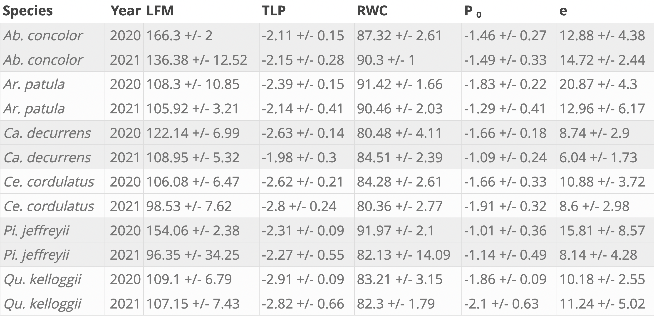

Table S2 Loadings for the first four principal components (see PCA in Figure 4) for all flammability metrics using varimax rotation. Also included are the proportions of variance explained by each of the first four principal components.
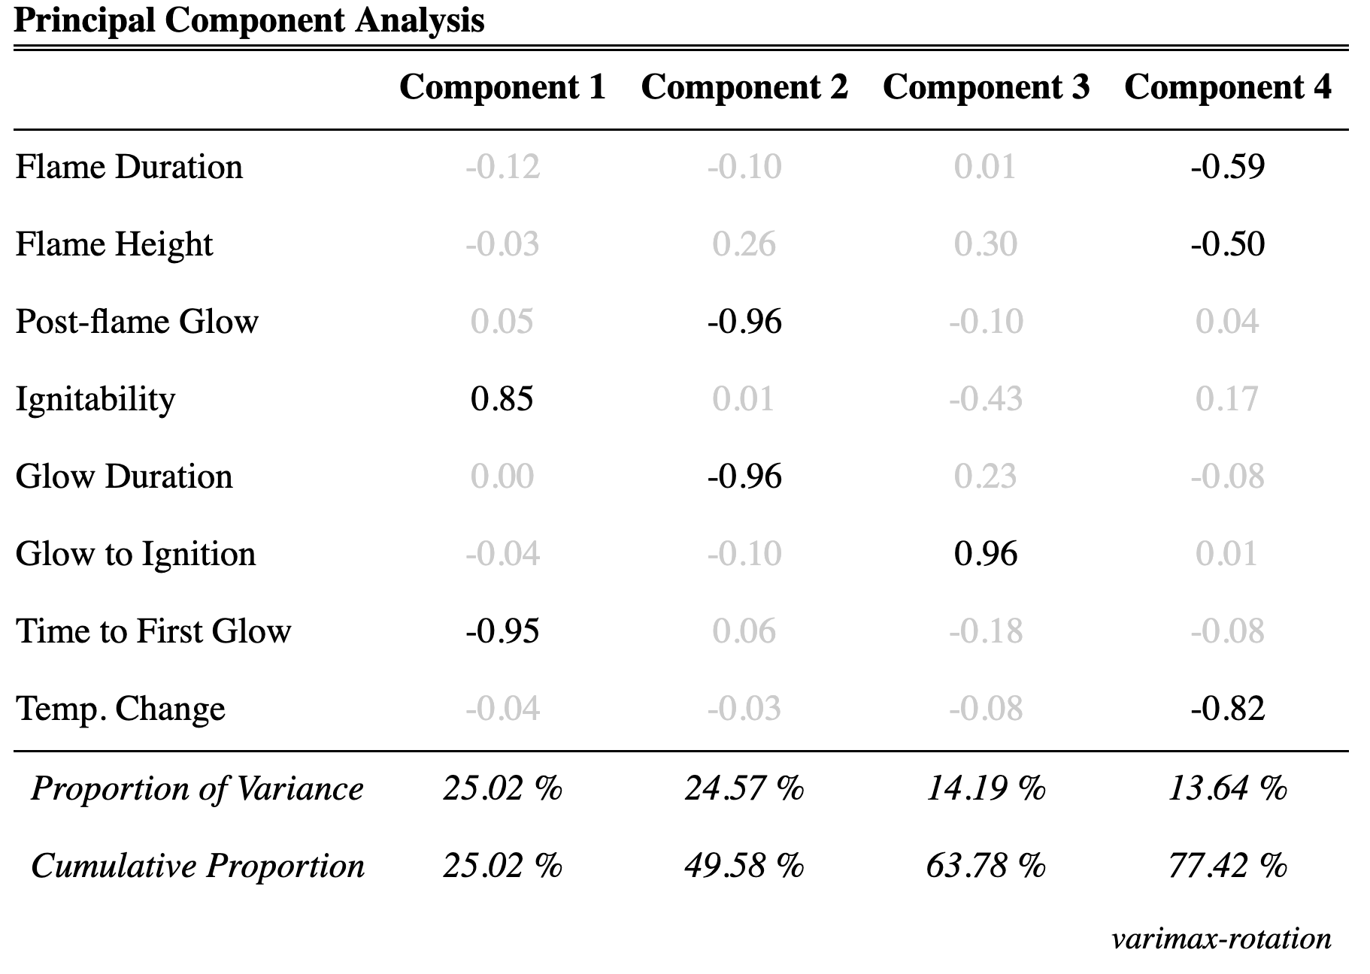
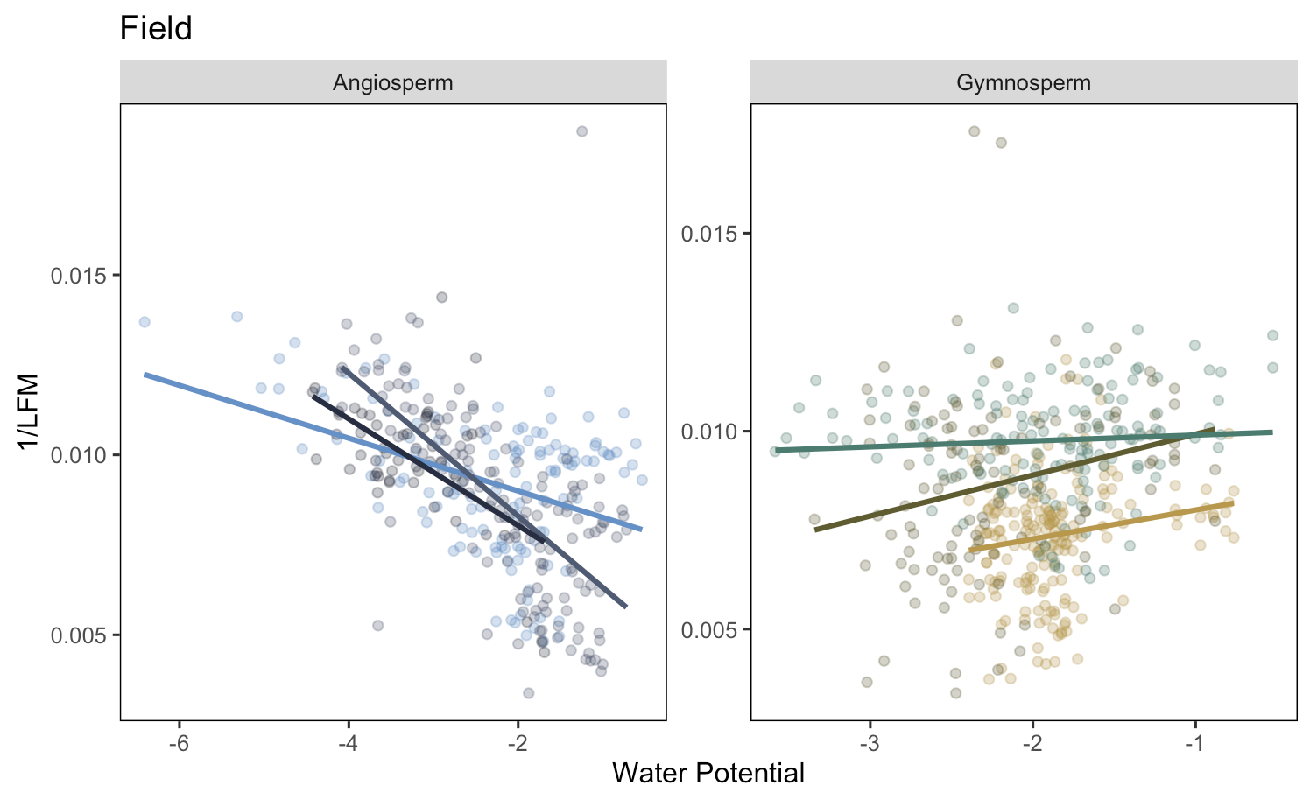
Fig. S1 Water potential vs. inverse-transformed LFM (1/LFM) as used in models of plant hydration dynamics. Inverse-transformed LFM (1/LFM) was preferred over LFM to meet model assumptions of normality.

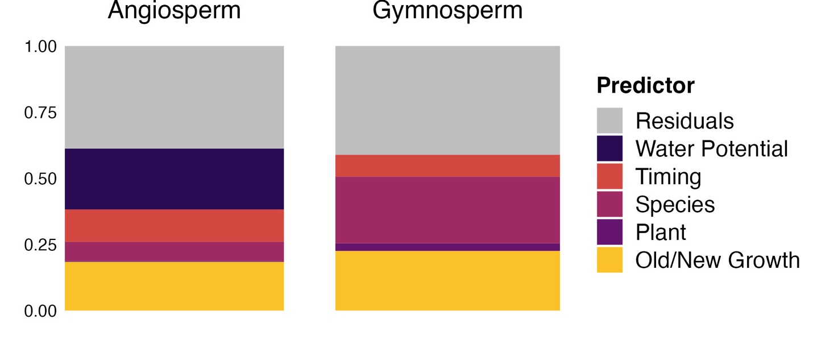
Fig. S2 Variance decompositions on transformed field-collected data, using inverse-transformed LFM (1/LFM) as the independent variable of interest.
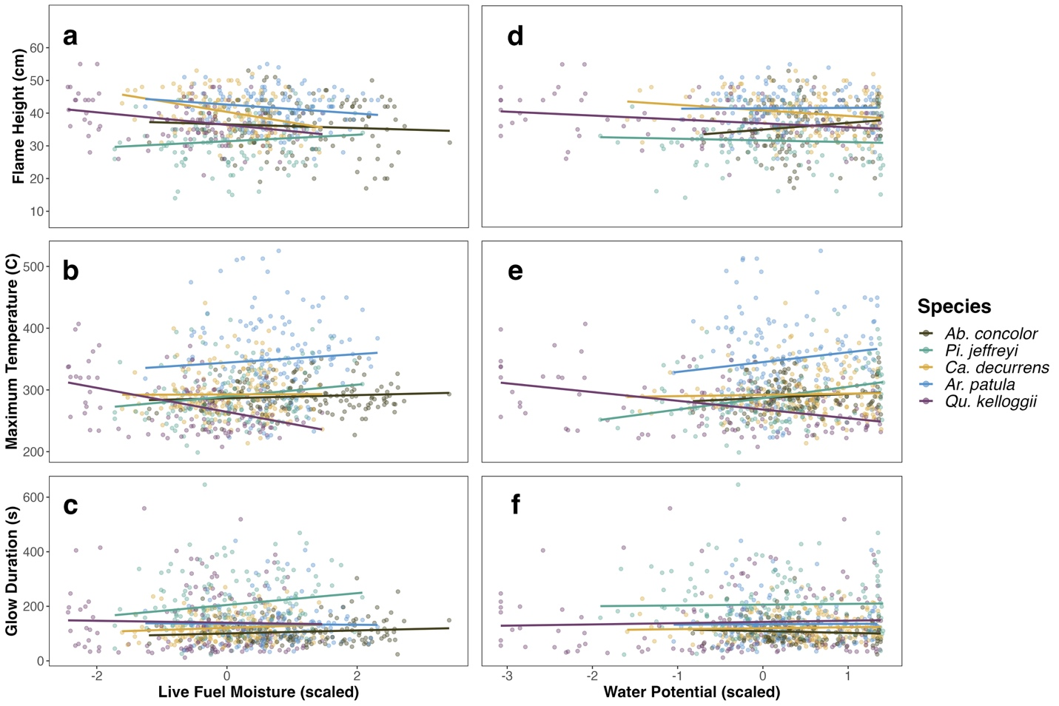
Fig. S3 Relationships between additional flammability metrics and LFM (a-e) and water potential (f-j) based on benchtop drydown experiments for five species. Effects of covariates sample date and sample weight were removed using the remef package to isolate the relationship between hydration and each flammability metric.

Table S3 Summary table showing top models for time to ignition, flame height, flame duration, temperature change, and glow duration using LFM as the primary predictor. Models run with maximum likelihood estimation.
 | Time to Ignition | Flame Height | Temp. Change | Flame Duration | Glow Duration
Coeffcient | Estimates | Estimates | Estimates | Estimates | Estimates
Intercept | 64.981 *** | 37.265 *** | 69.827 *** | 24.061 *** | 97.738 **
A. patula | -13.221 | -5.282 | -19.026 | -0.361 | 60.367
C. decurrens | 5.598 | 14.545 *** | 6.958 | -3.417 | 23.594
P. jeffreyii | -22.347 | 8.285 | 13.822 | 15.231 * | 18.844
Q. kelloggii | -47.576 *** | 4.969 | -8.895 | -9.789 | 84.377 *
Live Fuel Moisture (LFM) | 0.191 ** | -0.005 | -0.213 | -0.053 | 0.134
Sample Weight | 7.262 *** | 0.627 | 9.622 ** | 6.031 *** | 27.603 ***
Location | -3.142 | -0.641 | -3.678 | -0.148 | -5.588
LFM x A. patula | 0.032 | 0.009 | 0.125 | 0.011 | 0.138
LFM x C. decurrens | -0.097 | -0.088 ** | -0.048 | 0.043 | -0.036
LFM x P. jeffryii | 0.092 | -0.026 | 0.078 | -0.051 | -0.297
LFM x Q. kelloggii | -0.064 | -0.040 | -0.091 | 0.044 | -0.591 *
Observations | 593 | 593 | 593 | 593 | 593
Marginal R² / Conditional R² | 0.610 / 0.699 | 0.254 / 0.378 | 0.209 / 0.261 | 0.435 / 0.535 | 0.193 / 0.225
* p<0.05 ** p<0.01 *** p<0.001

Table S4 Summary table showing top models for time to ignition, flame height, flame duration, temperature change, and glow duration using water potential as the primary predictor.

 | Time to Ignition | Flame Height | Temp. Change | Flame Duration | Glow Duration
Coeffcient | Estimates | Estimates | Estimates | Estimates | Estimates
Intercept | 102.135 *** | 38.728 *** | 29.326 ** | 12.641 *** | 98.094 ***
A. patula | -25.266 *** | -6.868 *** | 16.477 | 9.228 *** | 104.338 ***
C. decurrens | -21.663 *** | 0.988 | 9.399 | 6.493 * | 27.355
P. jeffreyii | -16.196 * | 3.434 | 20.718 | 12.407 *** | -14.747
Q. kelloggii | -68.333 *** | -2.631 | -9.902 | 0.456 | 54.917 **
Water Potential (MPa) | 5.218 *** | 0.902 | -3.919 | -1.624 * | -4.565
Sample Weight | 8.013 *** | 0.325 | 10.627 *** | 5.443 *** | 22.462 ***
Location | -1.112 | -0.877 | -4.294 | -0.589 | 0.948
MPa x A. patula | -4.019 * | -1.261 * | 5.883 | 2.287 ** | 4.310
MPa x C. decurrens | -3.277 | -1.858 ** | 0.538 | 1.196 | 5.010
MPa x P. jeffryii | -1.788 | -0.863 | -3.286 | 1.176 | -1.631
MPa x Q. kelloggii | -3.686 * | -1.395 * | 0.175 | 1.565 * | 5.245
Observations | 727 | 597 | 727 | 727 | 777
Marginal R² / Conditional R² | 0.551 / 0.654 | 0.244 / 0.382 | 0.234 / 0.276 | 0.421 / 0.522 | 0.170 / 0.222
* p<0.05 ** p<0.01 *** p<0.001

Table S4: Summary of all top-performing models of interest for flammability metrics (in addition to those presented in Table 1)
Flammability Metric | Predictors | Hydration Coefficient | ∆AIC | Marginal R² / Conditional R²
Time to Ignition | LFM*species + weight | 8.097 *** | 0 | 0.586 / 0.651
Time to Ignition | LFM + species + weight | 7.466 *** | 13.332 | 0.579 / 0.653
Time to Ignition | MPa*species + weight | 11.567 *** | 50.113 | 0.558 / 0.653
Time to Ignition | MPa + species + weight | 4.466 *** | 65.586 | 0.517 / 0.617
Time to Ignition | Species | NA | 174.13 | 0.512 / 0.611
Flame Height | LFM*species + weight | -0.374 | 0 | 0.252 / 0.361
Flame Height | LFM + species + weight | -1.172 *** | 8.116 | 0.239 / 0.351
Flame Height | MPa*species + weight | 1.990 | 11.199 | 0.249 / 0.374
Flame Height | MPa + species + weight | 0.894 ** | 11.387 | 0.237 / 0.356
Flame Height | Species | NA | 49.822 | 0.226 / 0.345
Temp. Change | LFM * species + weight | -5.605 | 0 | 0.233 / 0.264
Temp. Change | LFM + species + weight | -7.697 *** | 16.043 | 0.229 / 0.259
Temp. Change | MPa*species + weight | -8.595 | 38.617 | 0.237 / 0.271
Temp. Change | MPa + species + weight | -6.517 *** | 61.625 | 0.227 / 0.259
Temp. Change | Species | NA | 131.438 | 0.211 / 0.239
Flame Duration | LFM*species + weight | -2.013 | 0 | 0.439 / 0.522
Flame Duration | LFM + species + weight | -1.470 ** | 5.896 | 0.434 / 0.520
Flame Duration | MPa*species + weight | -3.626 * | 20.007 | 0.429 / 0.520
Flame Duration | MPa + species + weight | -0.375 | 30.419 | 0.423 / 0.514
Flame Duration | Species | NA | 108.252 | 0.368 / 0.515
Glow Duration | LFM*species + weight | 3.174 | 0 | 0.179 / 0.219
Glow Duration | LFM + species + weight | 2.318 | 21.645 | 0.173 / 0.218
Glow Duration | MPa*species + weight | -10.238 | 23.6 | 0.174 / 0.216
Glow Duration | MPa + species + weight | -1.093 | 44.139 | 0.172 / 0.215
Glow Duration | Species | NA | 128.806 | 0.158 / 0.215

