Supplementary Information for
3D Spatiotemporal Activation Mapping of Cardiac Organoids Using Conformal Shell Microelectrode Arrays (MEAs)
Soo Jin Choi¹, Zhaoyu Liu², Feiyu Yang², Hanwen Wang², Derosh George¹, David H. Gracias^{1,3-8}*, Deok-Ho Kim^{2,7,9-11}*

¹Department of Chemical and Biomolecular Engineering, Johns Hopkins University, Baltimore, MD 21218.
²Department of Biomedical Engineering, Johns Hopkins University, Baltimore, MD 21218.
³Department of Materials Science and Engineering, Johns Hopkins University, Baltimore, MD 21218.
⁴Department of Chemistry, Johns Hopkins University, Baltimore, MD 21218.
⁵Laboratory for Computational Sensing and Robotics (LCSR), Johns Hopkins University, Baltimore, MD 21218.
⁶Sidney Kimmel Comprehensive Cancer Center, Johns Hopkins School of Medicine, Baltimore, MD 21205.
⁷Center for Microphysiological Systems, Johns Hopkins University, Baltimore, MD 21205.
⁸Department of Oncology, Johns Hopkins University School of Medicine, Baltimore 21205.
⁹Department of Medicine, Johns Hopkins University, Baltimore, MD 21205
¹⁰Institute for NanoBioTechnology, Johns Hopkins University, Baltimore, MD 21218
¹¹Department of Mechanical Engineering, Johns Hopkins University, Baltimore, MD 21218

*Corresponding authors: dhkim@jhu.edu, dgracias@jhu.edu

This file includes:
Supplementary figures 1-16
Supplementary method
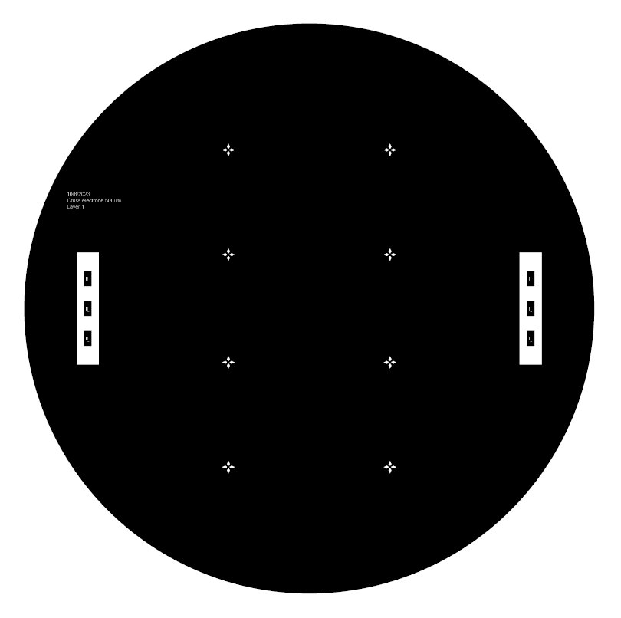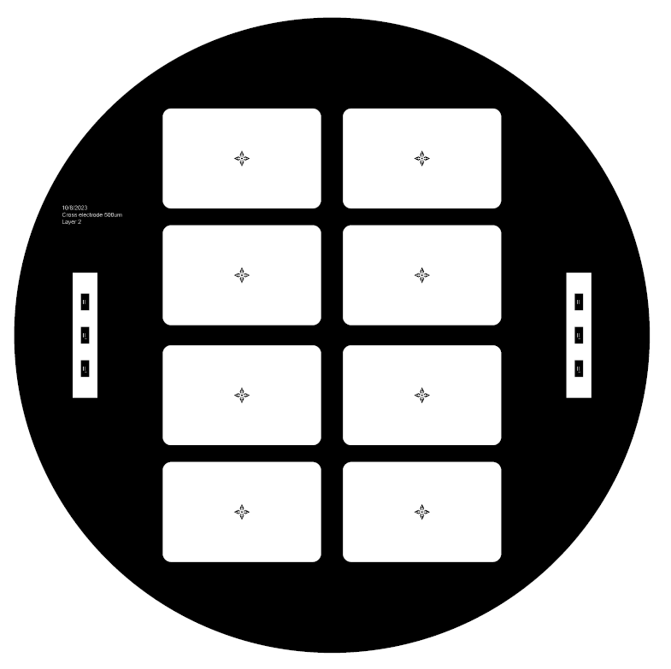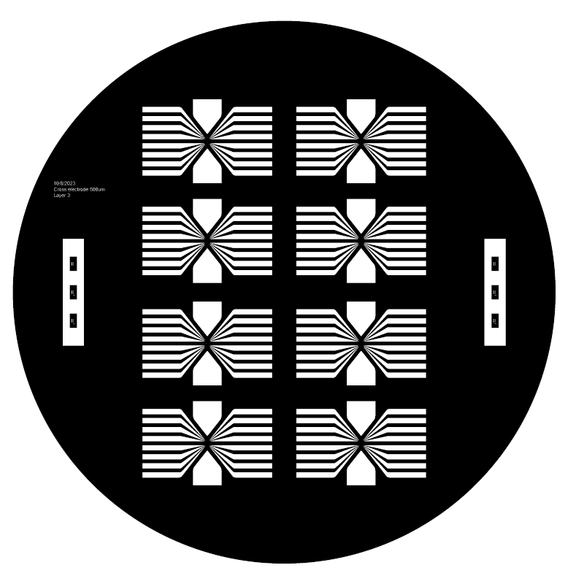
b
c
a

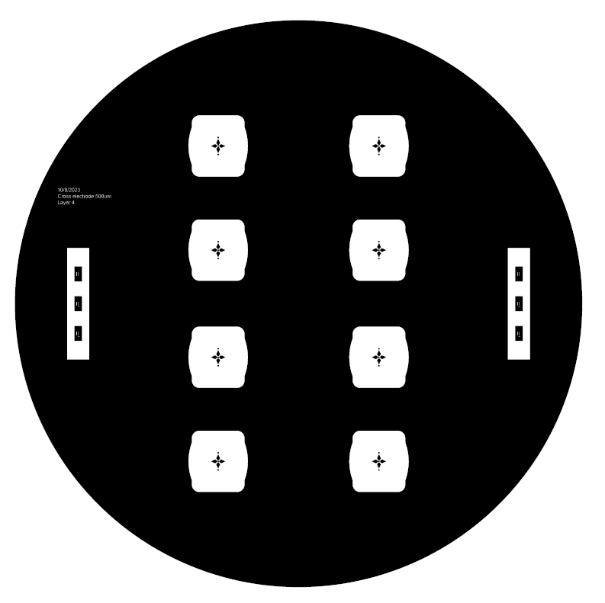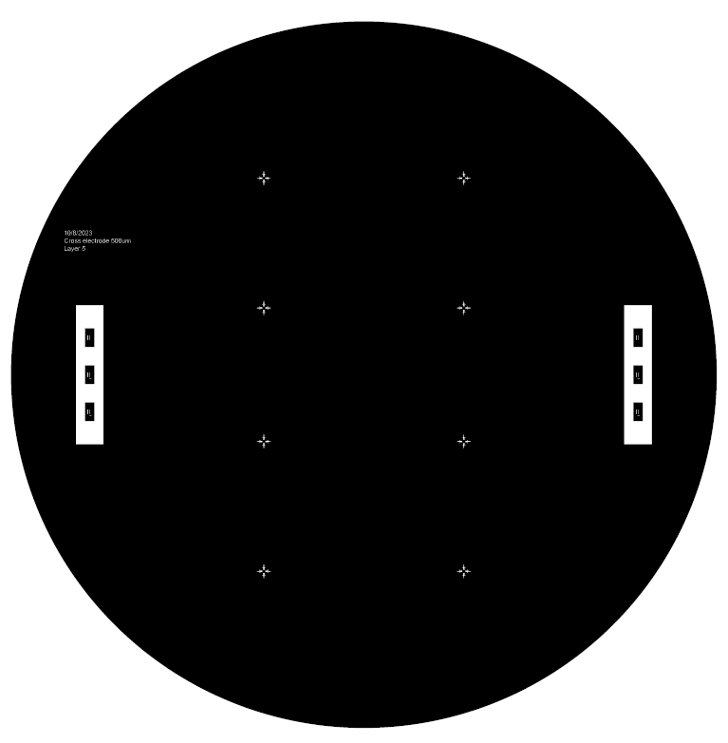
e
d
Figure S1. CAD photomasks for photolithographic fabrication of shell MEAs designed for 0.5 mm-diameter organoids. (a) Photomask for patterning the germanium layer using positive photoresist. (b) Photomask for patterning the first spin-coated layer of SU-8 2005. (c) Photomask for patterning the gold electrode layer using positive photoresist. (d) Photomask for patterning the non-folding areas of the second spin-coated layer of SU-8. (e) Photomask for patterning the folding areas of the second spin-coated SU-8.
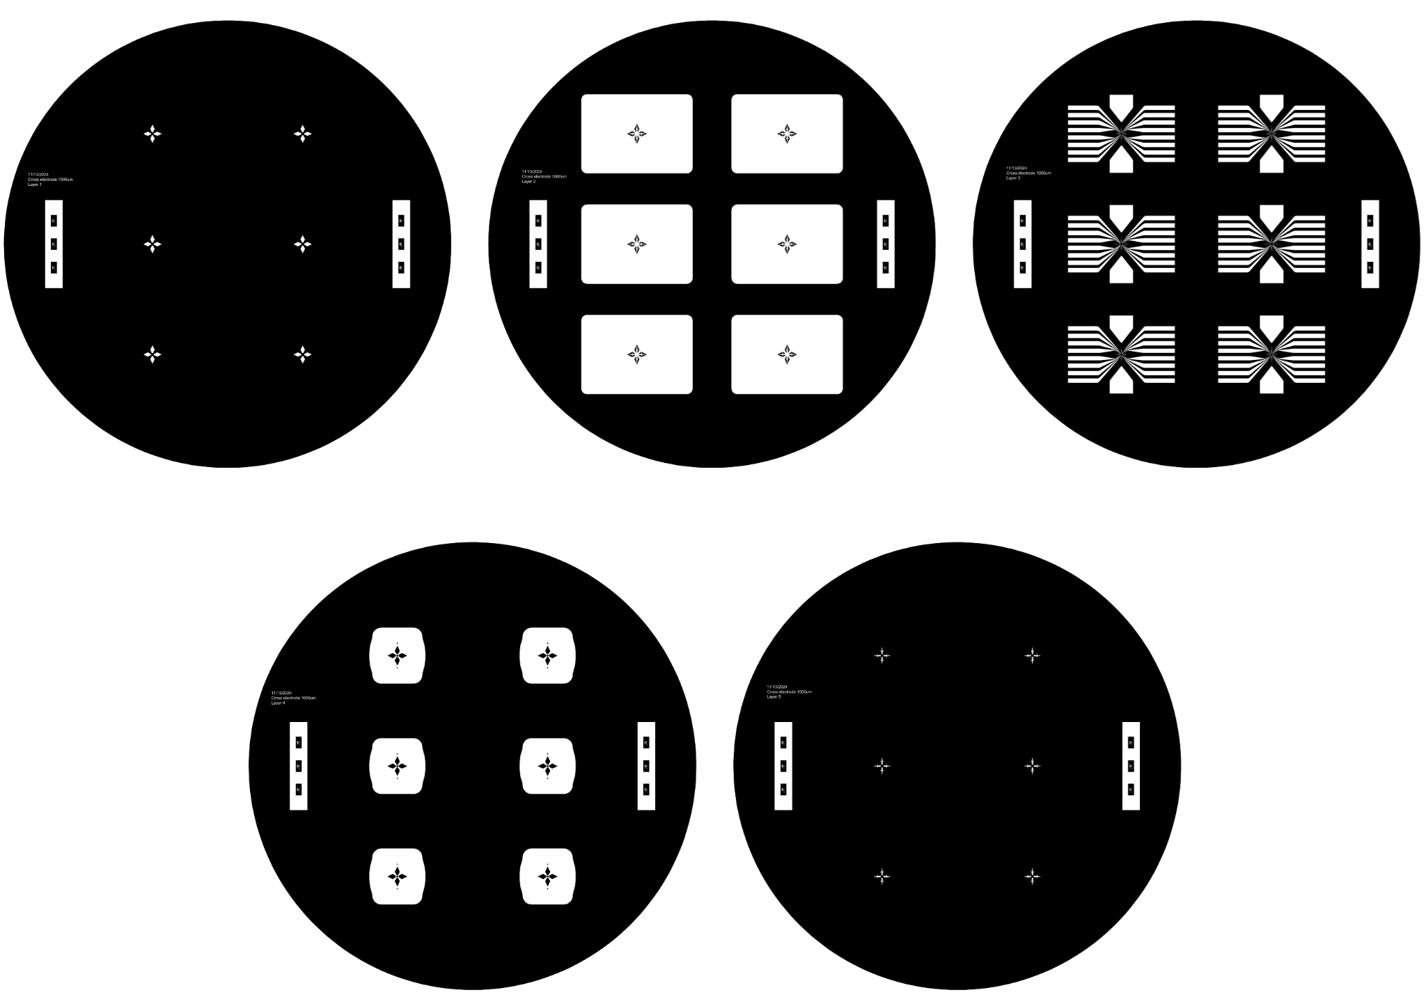Figure S2. CAD photomasks for photolithographic fabrication of shell MEAs designed for 1 mm-diameter organoids. (a) Photomask for patterning the germanium layer using positive photoresist. (b) Photomask for patterning the first spin-coated layer of SU-8 2005. (c) Photomask for patterning the gold electrode layer using positive photoresist. (d) Photomask for patterning the non-folding areas of the second spin-coated layer of SU-8. (e) Photomask for patterning the folding areas of the second spin-coated SU-8.
a
b
c
d
e
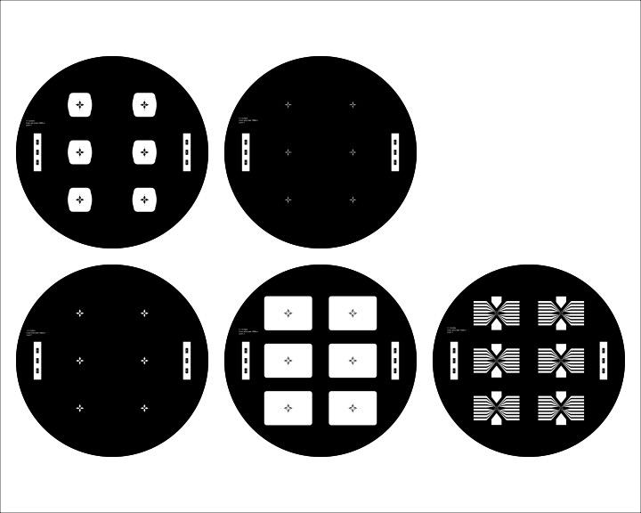
a
b
c
d
e

Figure S3. CAD photomasks for photolithographic fabrication of shell MEAs designed for 1.5 mm-diameter organoids. (a) Photomask for patterning the germanium layer using positive photoresist. (b) Photomask for patterning the first spin-coated layer of SU-8 2005. (c) Photomask for patterning the gold electrode layer using positive photoresist. (d) Photomask for patterning the non-folding areas of the second spin-coated layer of SU-8. (e) Photomask for patterning the folding areas of the second spin-coated SU-8.

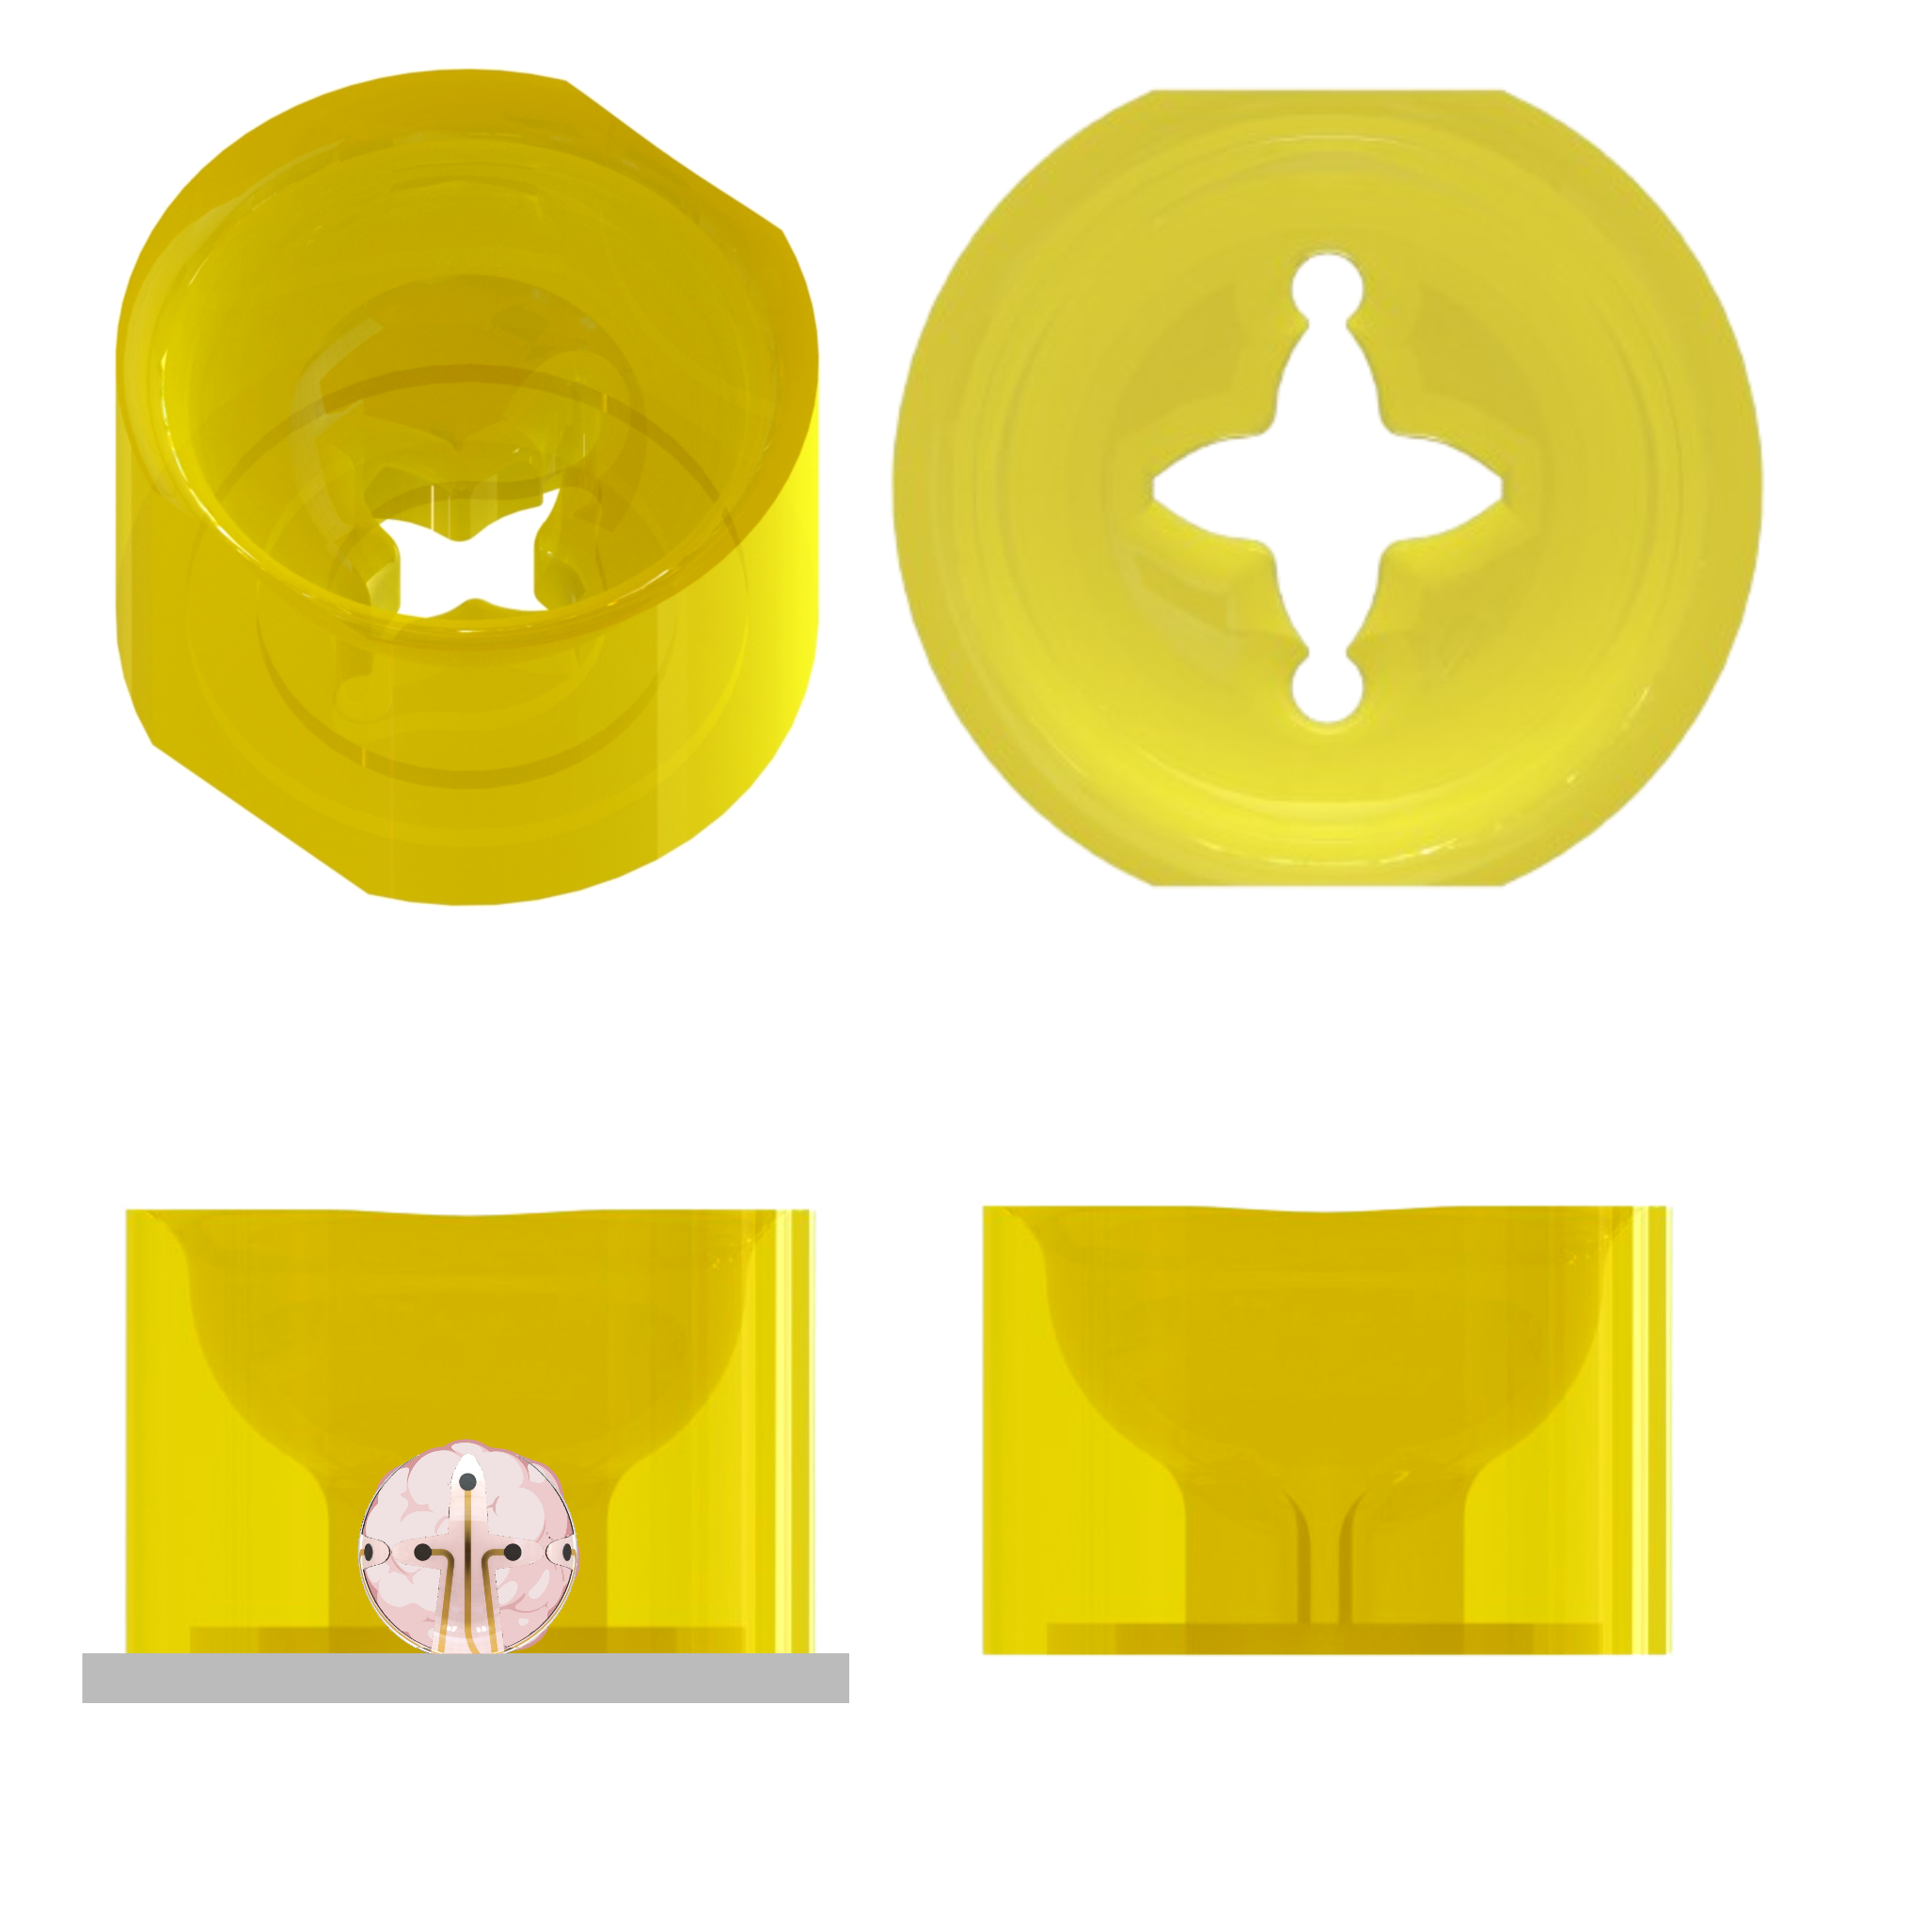
c
b
a
Figure S4. CAD design of the 3D-printed microwell. Schematics showing the (a) overall side view, (b) top view, (c) and cross-section from the side of the model. The microwell features a tapered funnel-like shape that guides organoids toward the center of the shell MEA to facilitate insertion. This design ensures that the microwell can be bonded to the device substrate without affecting the shell MEA of obstructing folding.

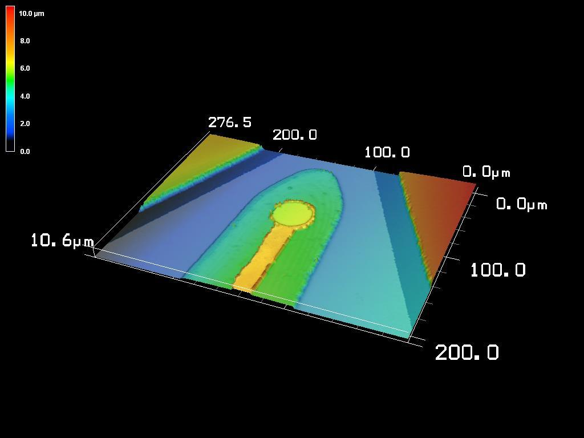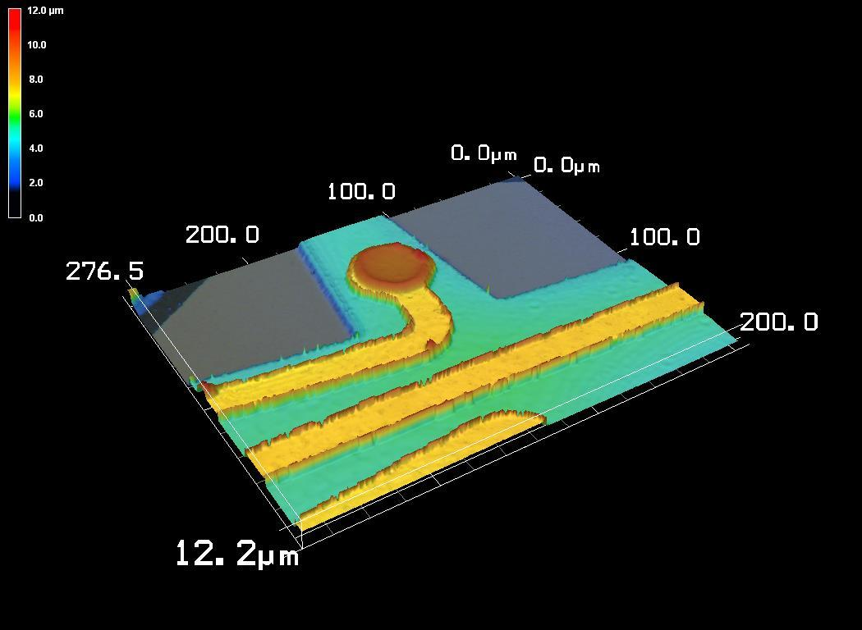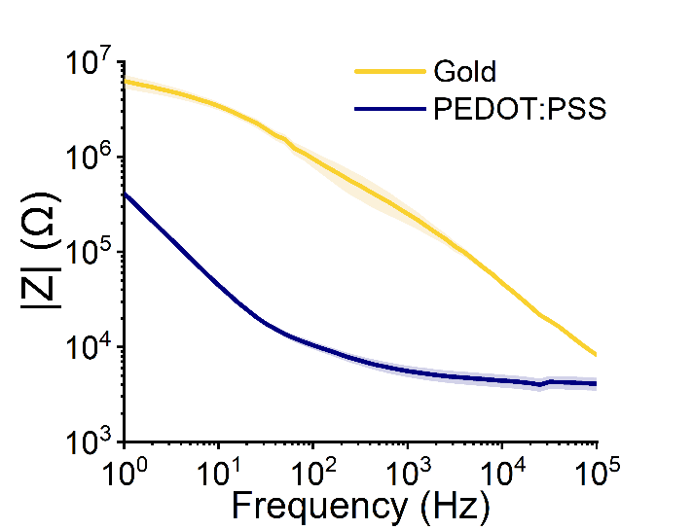
c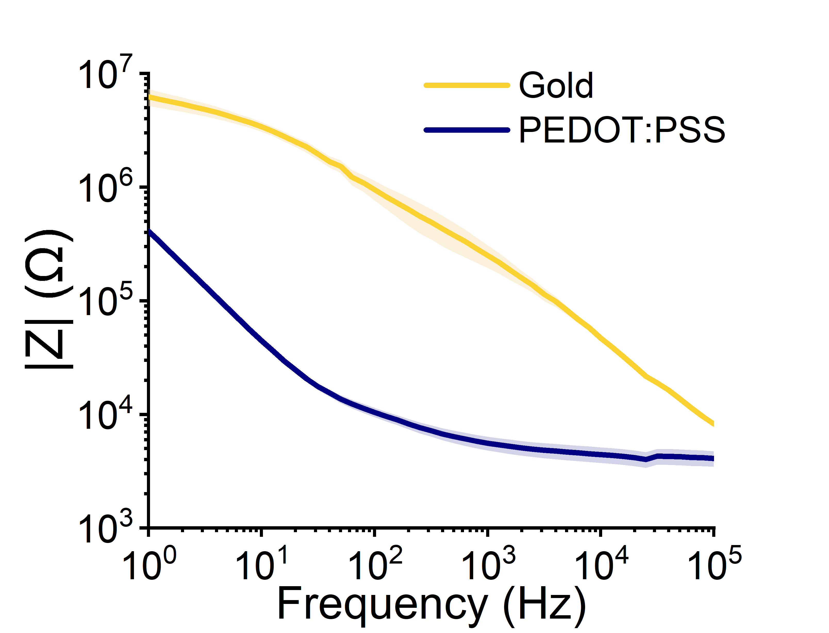
b
a
Figure S5. Characterization of non-coated and PEDOT:PSS-coated electrodes. (a-b) Laser scanning microscope images characterizing the thicknesses of a (a) non-coated gold electrode and a (b) PEDOT:PSS-coated gold electrode. (c) Electrochemical impedance spectroscopy plots of the non-coated gold electrode (yellow) and PEDOT:PSS-coated electrodes (n=8).

Organoid diameter (mm) | First spin-coated SU-8 layer | Exposure (mJ/cm²) | Second spin-coated SU-8 layer | Exposure (mJ/cm²)
0.5 | 7:3 SU-8 2005/2002 | 120 | 7:3 SU-8 2005/2002 | 240
1 | SU-8 2005 | 150 | SU-8 2005 | 300
1.5 | SU-8 2005 | 180 | SU-8 2005 | 300
Table S1. Optimized SU-8 bilayer fabrication parameters for folding around 0.5 mm, 1 mm, and 1.5 mm-diameter organoids.

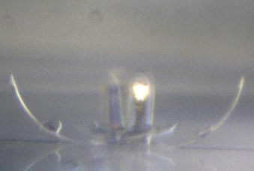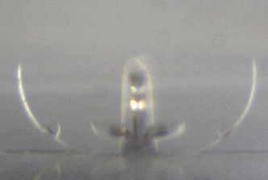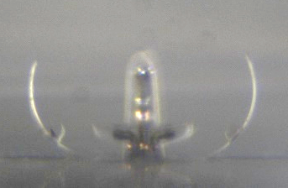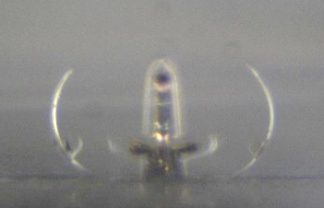

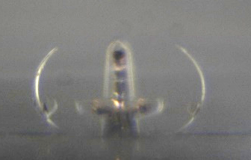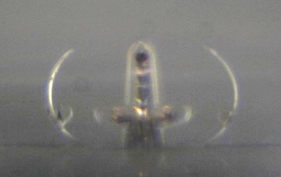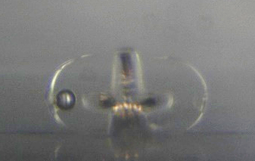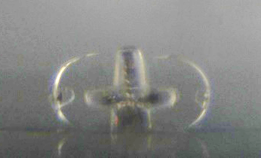
Figure S5. Sample images used for shell MEA folding characterization. Images taken with the MicroTester G2 (CellScale, Ontario, Canada) show changes in radius of curvature of the shell MEA over two hours. The shell MEA was placed in water at 37°C to simulate cell culture conditions.

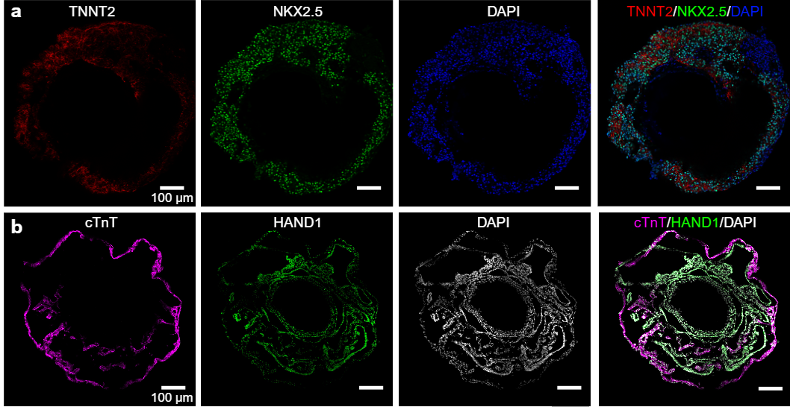
Fig. S6. Immunofluorescence images of cardiac organoid cryosections. (a) Cardiac organoid stained with TNNT2 (red), NKX2.5 (green), and DAPI (blue). Scale bar, 100 µm. (b) Cardiac organoid stained with cTnT (magenta), HAND1 (green), and DAPI (white). Scale bar, 100 µm.

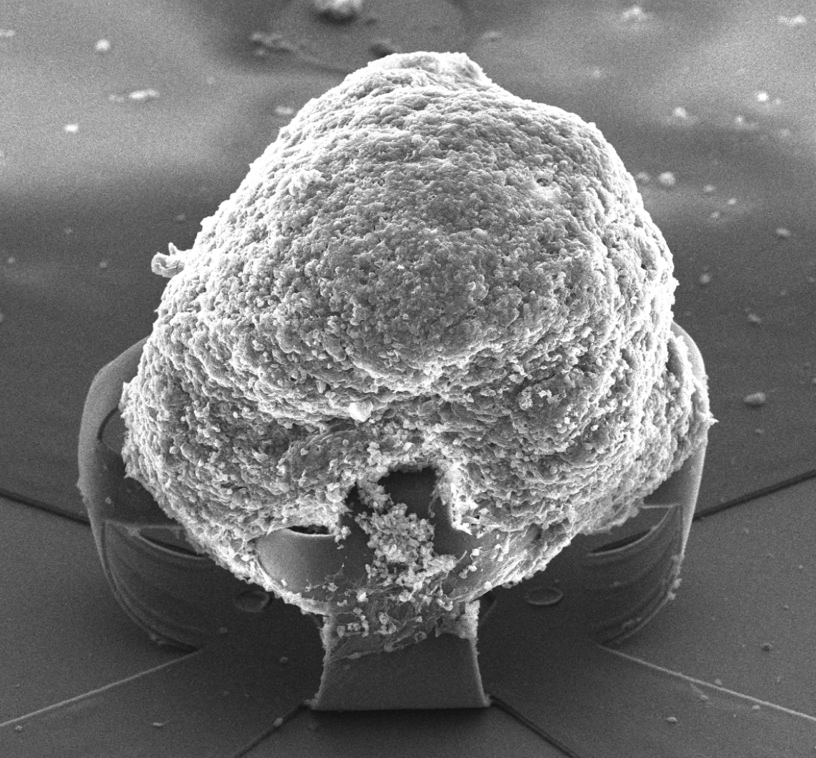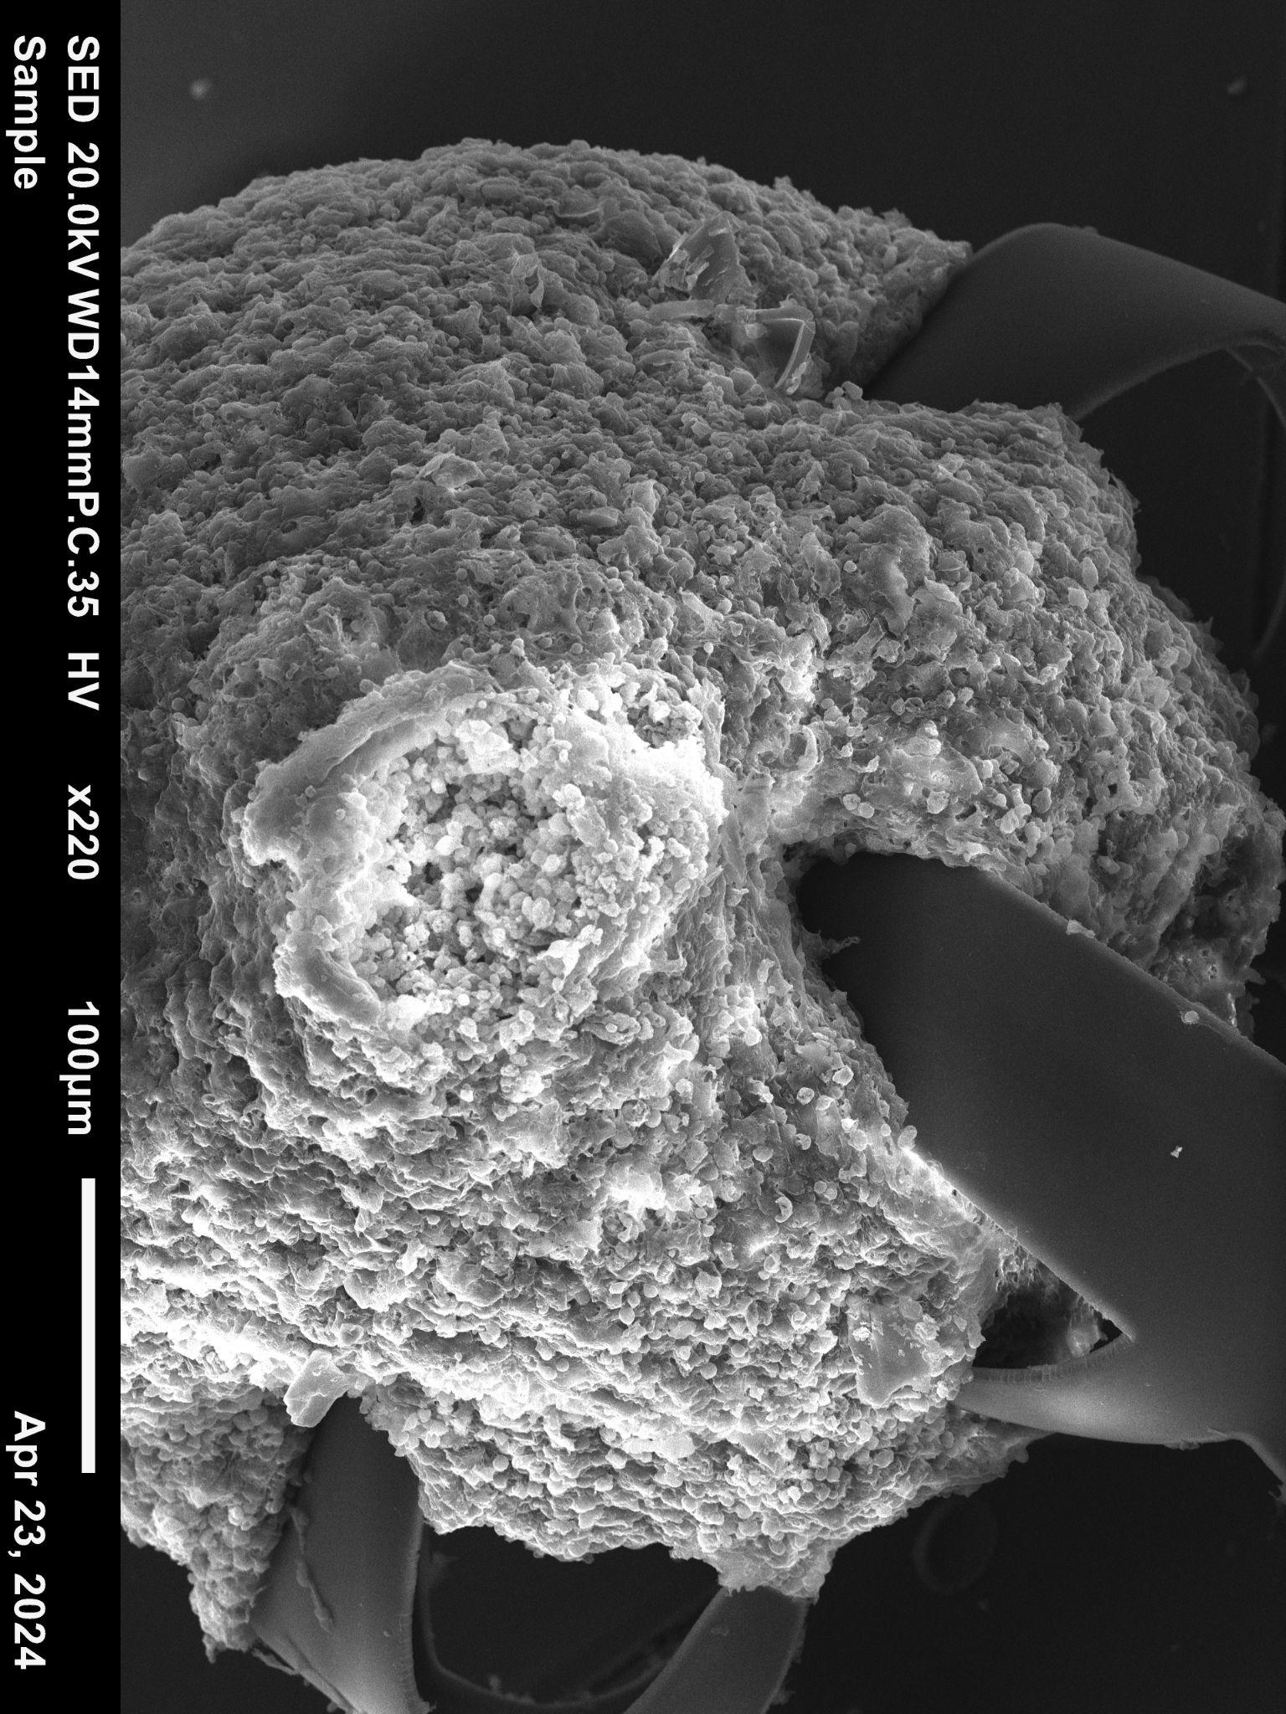
(ii)
a (i)
b
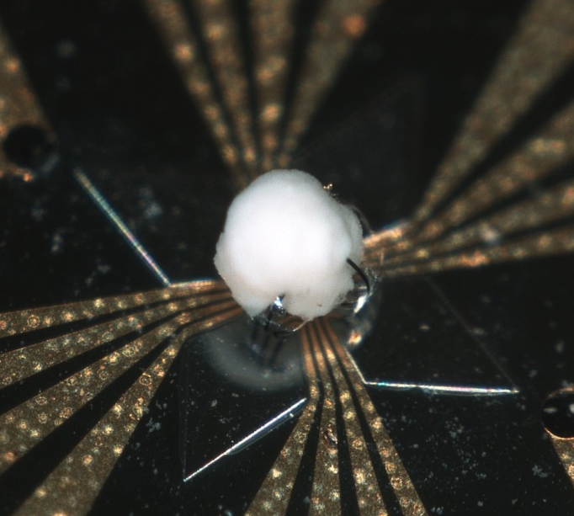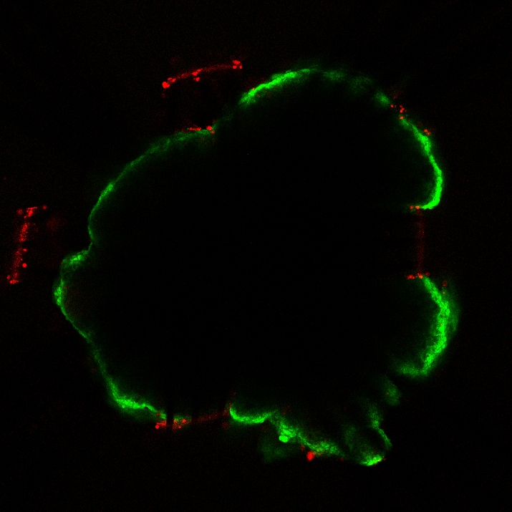
c
Figure S7. Biocompatible shell MEA can achieve conformal contact with organoids. (a) SEM images of a fixed cardiac organoid encapsulated in a shell MEA. (b) Optical image of the fixed cardiac organoid in the shell MEA. (c) Fluorescence image of a LIVE/DEAD-stained cardiac organoid. Fluorescence detection is limited to the outer edges of the organoid due to the opacity of the 1 mm-thick organoid.

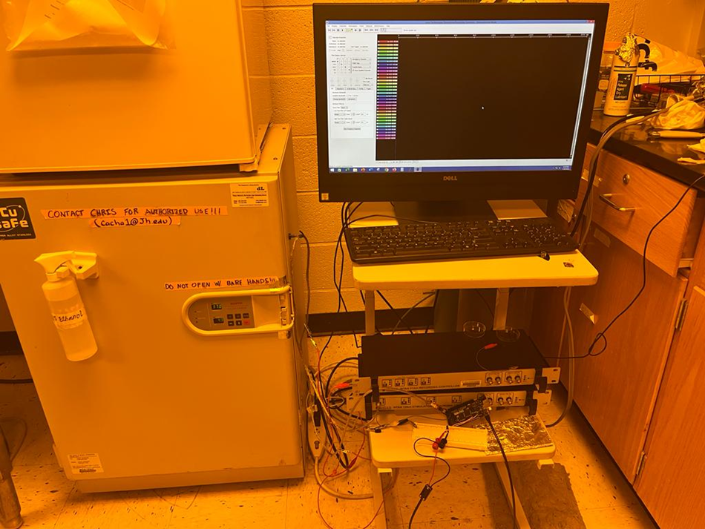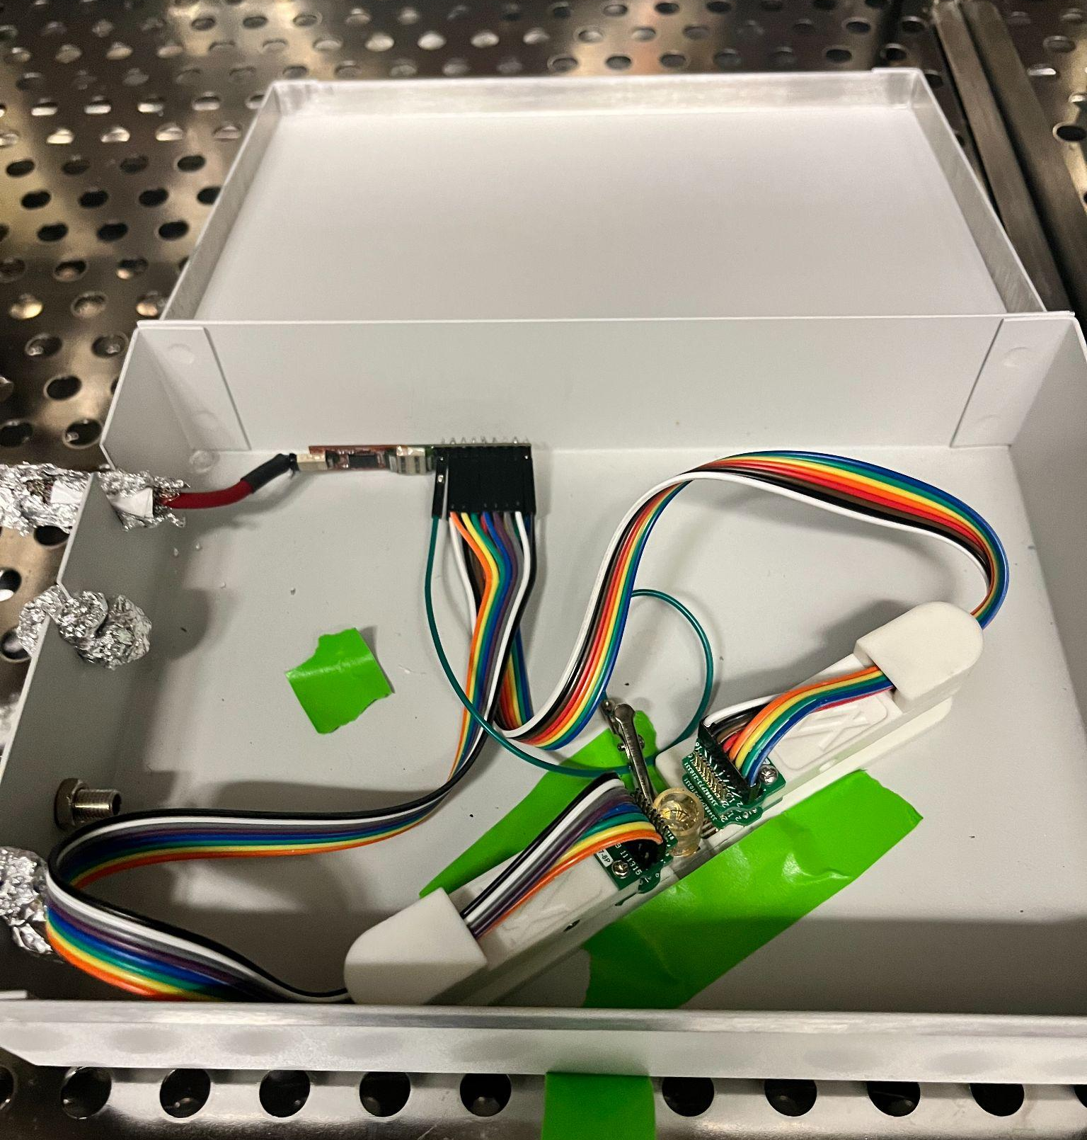
b
a
Figure S8. Experimental setup of the shell MEA recording platform. (a) Overall recording system including the shell MEA maintained in a humidified incubator with electrically shielded wires connecting to the Intan Stim/recording system. The electrophysiology was monitored in real-time from the computer. (b) The organoid-encapsulating shell MEA was housed in a Faraday cage within the incubator and connected to the 32-channel Intan Stim/recording amplifying headstage with two gold-coated 8-pin clamps.

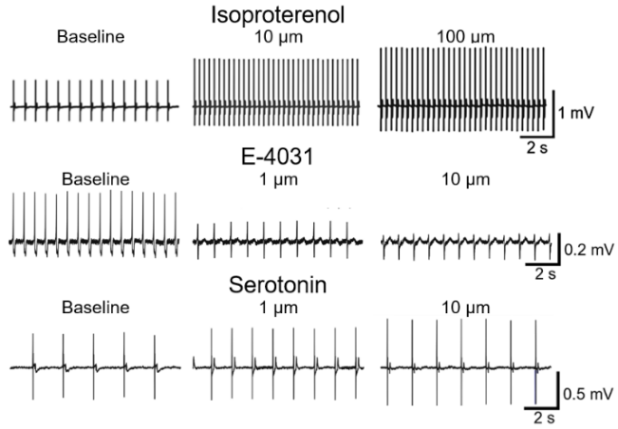
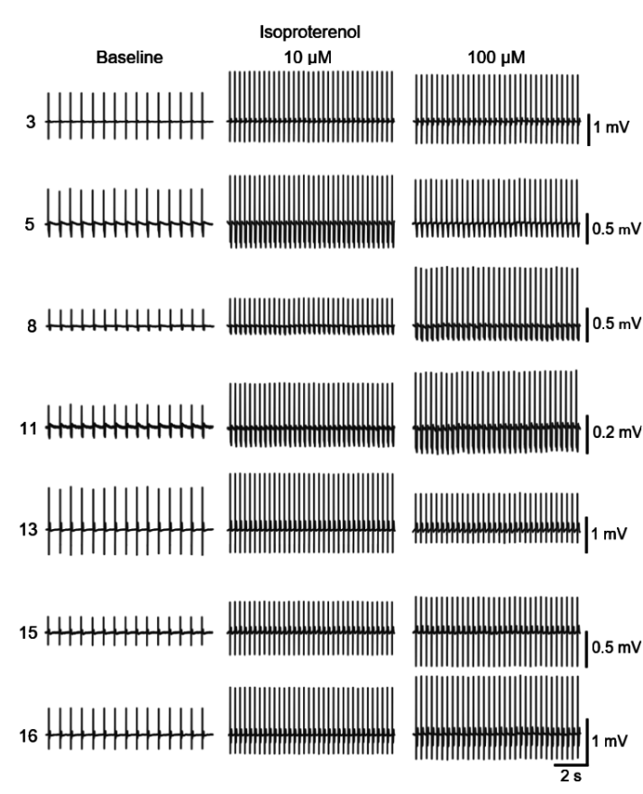
b
a

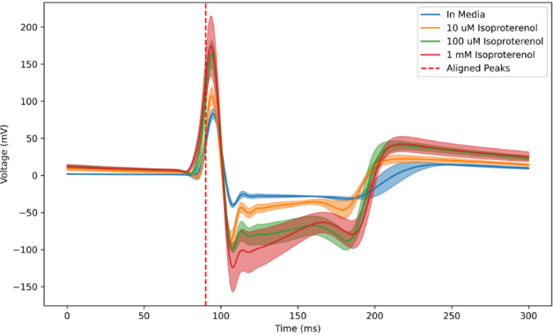
c

s

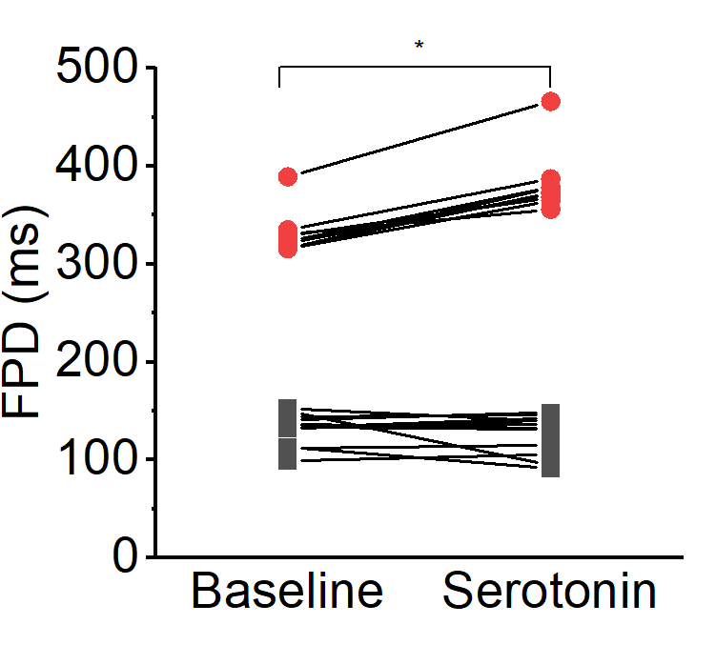
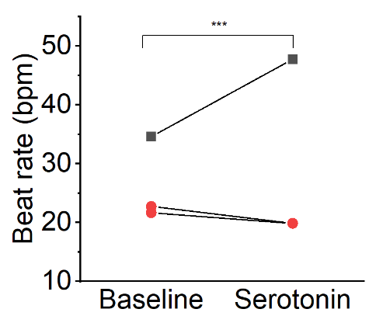
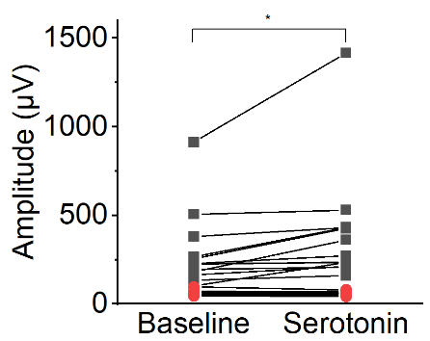
d e f

Figure S9. Additional drug responses from shell MEA-encapsulated cardiac organoids. (a) Representative traces from five electrodes of a shell MEA encapsulating a cardiac organoid. Electrophysiology was recorded for spontaneous beating, after 10 µM isoproterenol treatment, and after 100 µM isoproterenol treatment. (b) Representative traces show the changes in cardiac organoid electrophysiology after serial increases in isoproterenol, E-4031, and serotonin concentrations. (c) Overlay of beats detected from a cardiac organoid treated with 10, 100, and 1000 µM isoproterenol. (d-f) Changes in (d) potential amplitude, (e) beat rate, and (f) field potential duration (FPD) before and after 10 µM serotonin treatment.
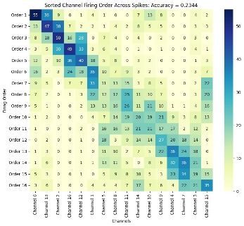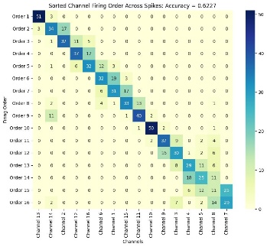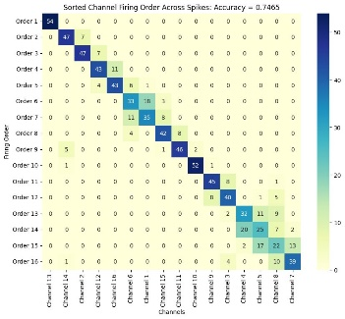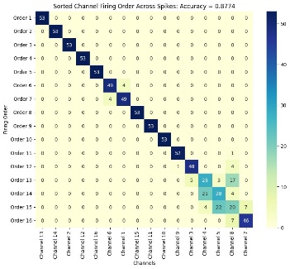
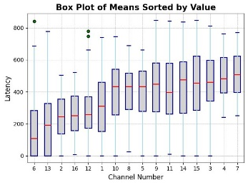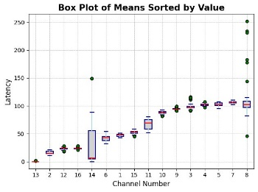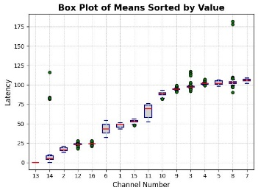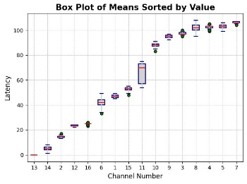
Raw data 3000 Hz 2000 Hz 1000 Hz
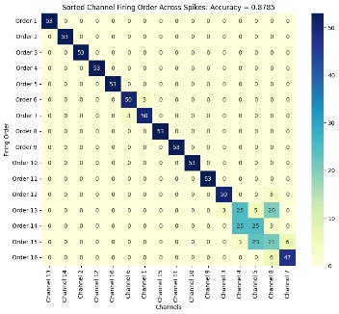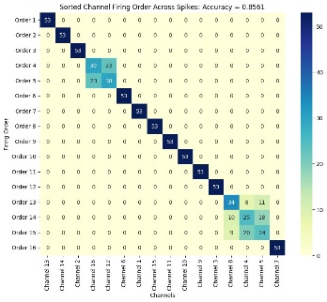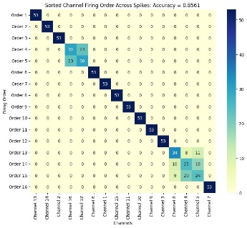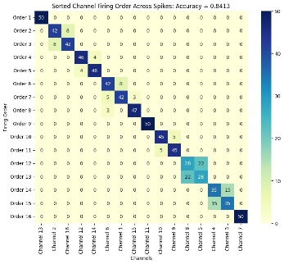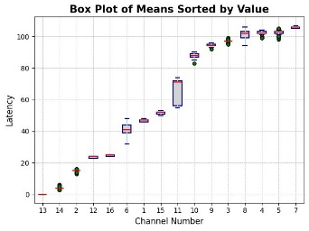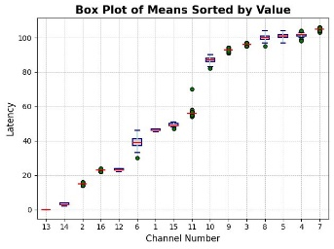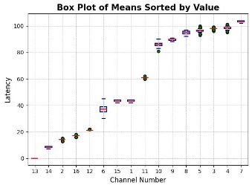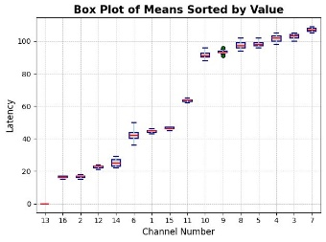
750 Hz 500 Hz 250 Hz 100 Hz
Figure S9. Effect of different low-pass filters on LAT detection and activation order accuracy. Activation order accuracy improves significantly from raw electrophysiology data to recordings applied with 3 kHz, 2 kHz, and 1 kHz low-pass filters. Maximum accuracy is observed for recording with 750 Hz low-pass filter and slightly decreases for recordings applied with 500 Hz, 250 Hz, and 100 Hz low-pass filters.
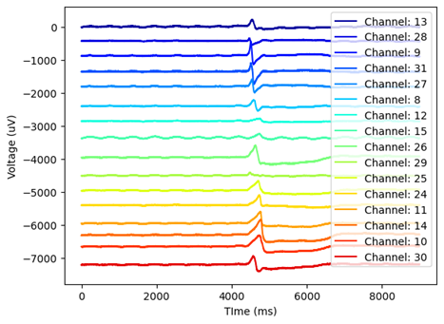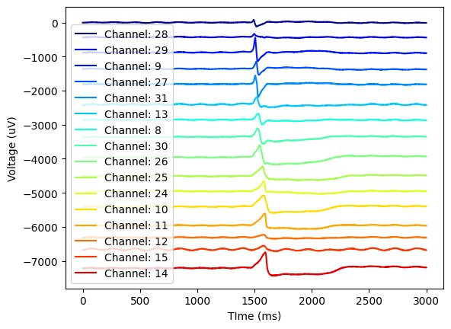
Raw data 3000 Hz
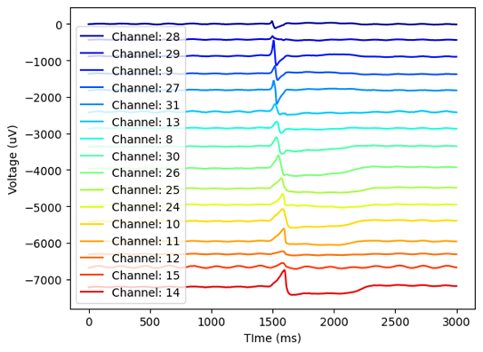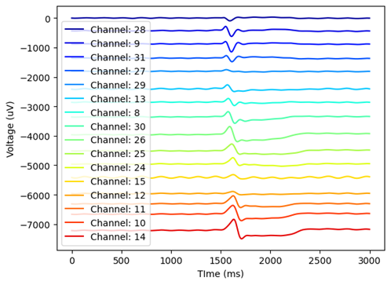
1000 Hz 100 Hz
Figure S10. Effect of different low-pass filters on waveform. Low-pass filters may remove interference but may also alter electrophysiological data. The 3000 Hz low-pass filter removes the high-frequency noise observed in several channels, including channels 29, 11, 13, and 8. The waveform detected from all 16 electrodes changes when a100 Hz low-pass filter is applied.

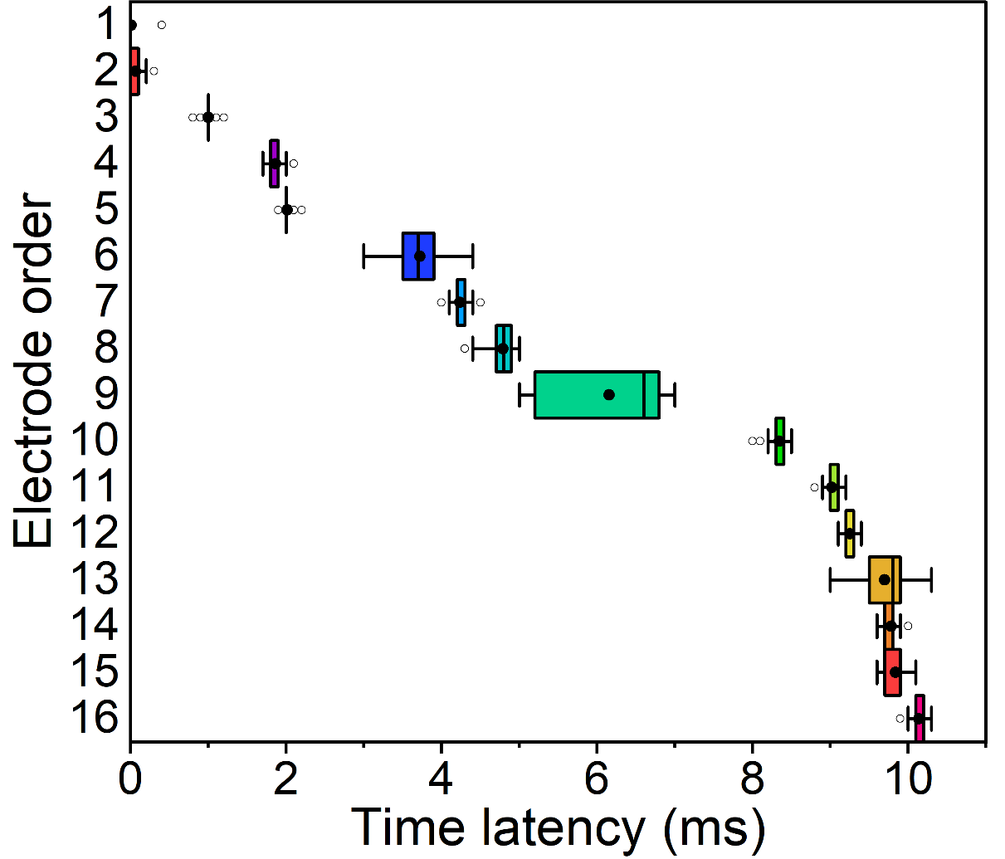
Figure S11. Activation latencies detected among the 16 electrodes from a cardiac organoid-encapsulating shell MEA. Electrodes are ordered from first to last detected LAT from top to bottom. Data are represented as mean ± SD, n=53 beats.

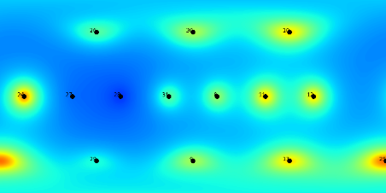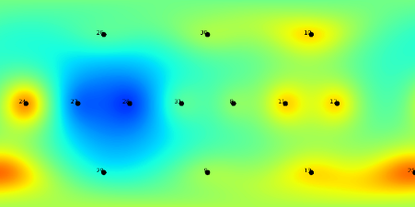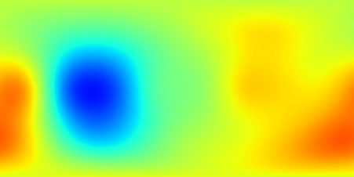
50 100 200
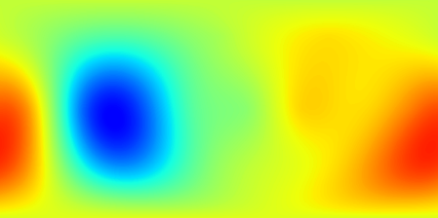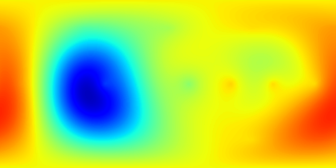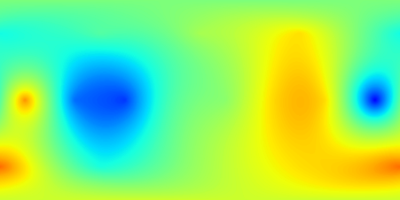
30 500 700

Figure S12. Effect of various shape parameter values on an interpolated latency map using the radial basis function (RBF) technique. Activation maps generated by interpolating latency data acquired from the 16 electrodes using the RBF requires selecting an appropriate value for the free parameter that controls spread. 2D maps are created with shape parameter values of 50, 100, 200, 300, 500, and 700. Dots in the 50 and 100 parameter plots indicate the electrode positions.

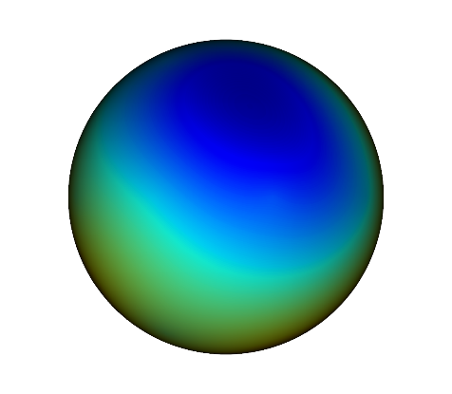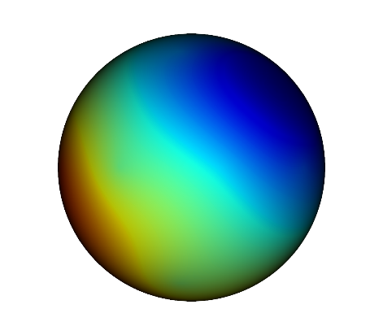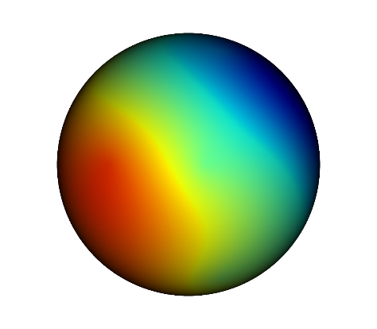
0° 40° 80°
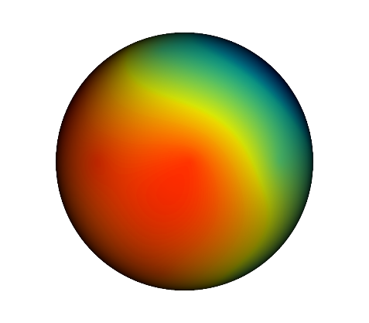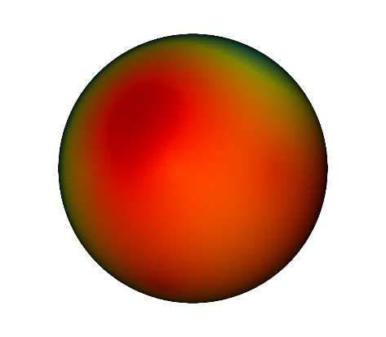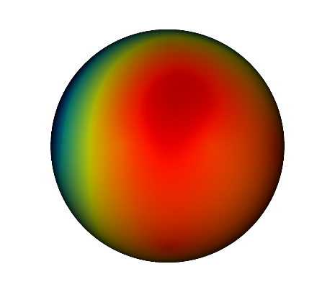
120° 160° 200°
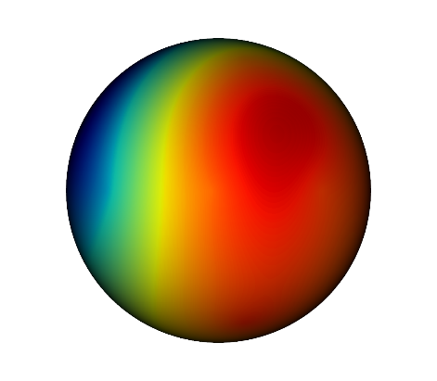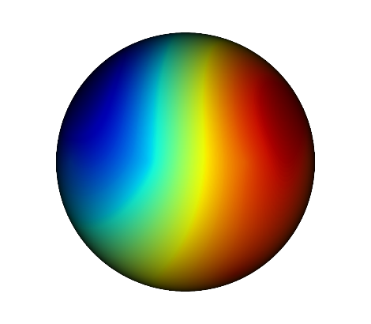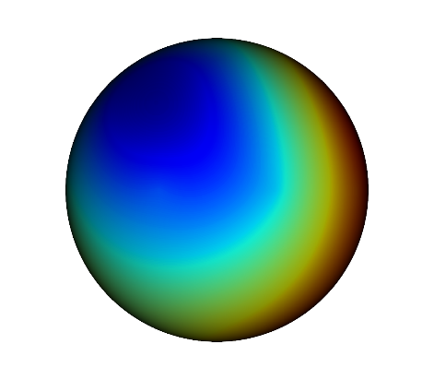
240° 280° 320°

Figure S13. 3D isochrone map of a shell MEA-encapsulated cardiac organoid. A series of snapshots showing the 3D isochrone map from different angles where the map is being rotated on the vertical axis. The 3D isochrone map shows a comprehensive view of the activation propagation pattern.

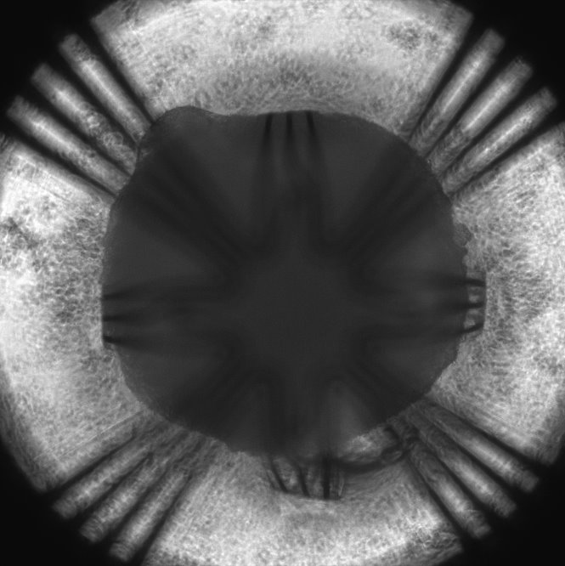
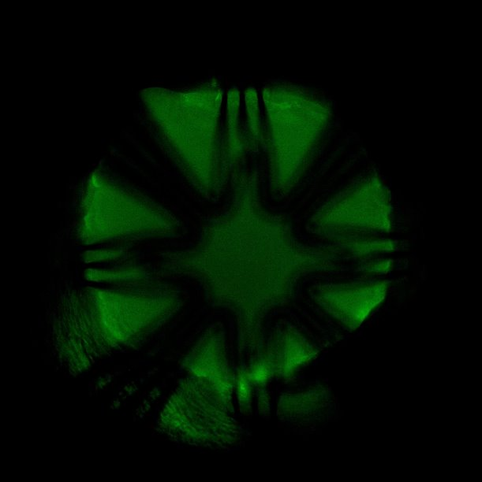
a b
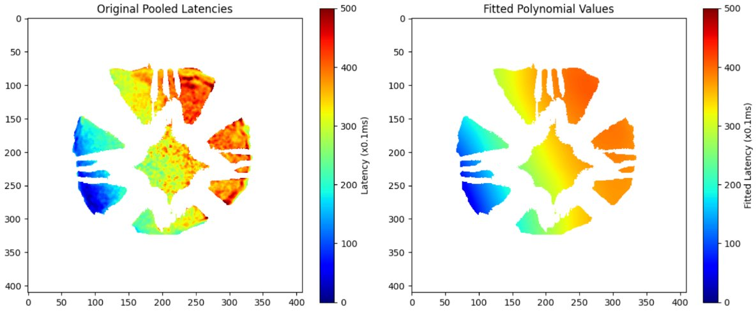

c d

e (i) (ii) (iii)
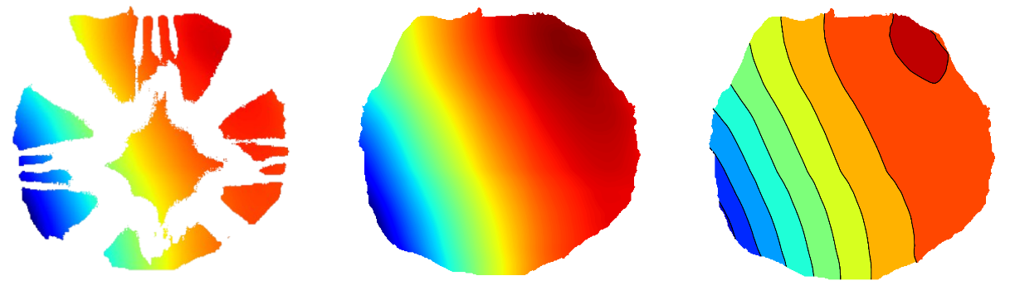
Figure S14. Calcium imaging-based activation mapping. (a) Brightfield microscopy of a shell MEA-encapsulated cardiac organoid. (b) Fluorescence microscopy of a shell MEA-encapsulated cardiac organoid stained with calcium indicator. (c) Pixel-by-pixel activation obtained from calcium imaging. (d) Smoothed activation map of the calcium imaging data. (e) The smoothed activation map was normalized to show the full color scheme and missing data in areas blocked by the electrodes were interpolated. Finally, an activation map with 5 ms isochronal lines was generated.
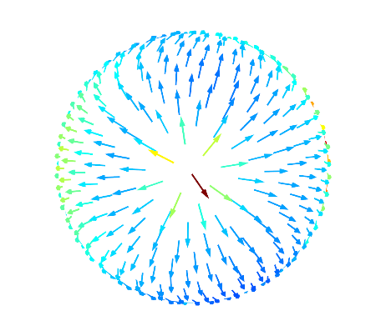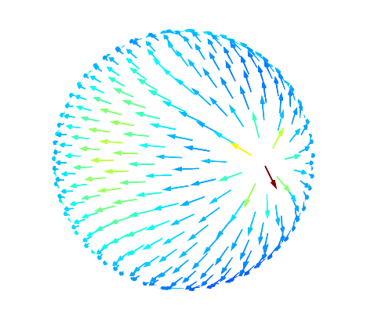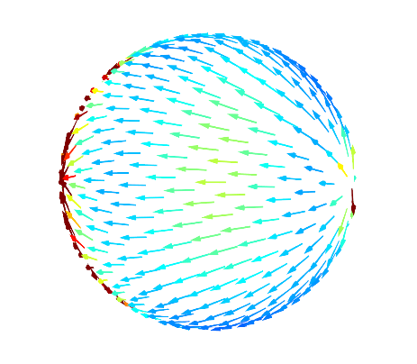
0° 40° 80°
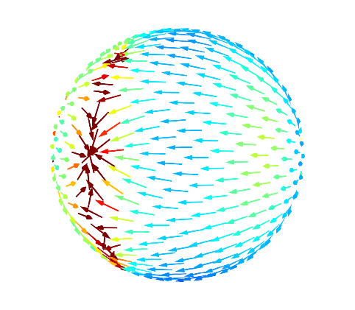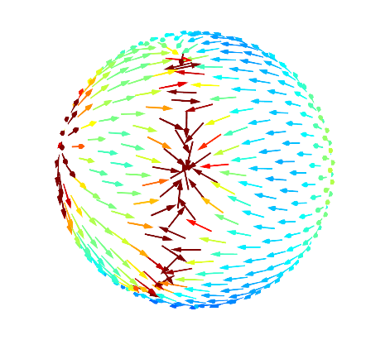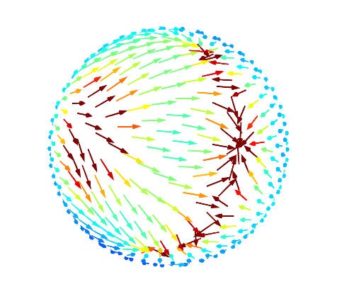
120° 160° 200°
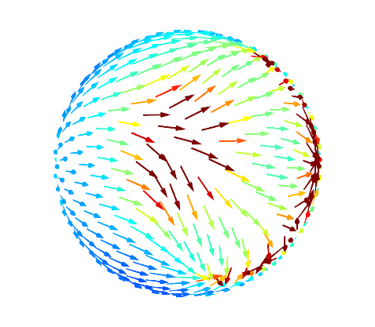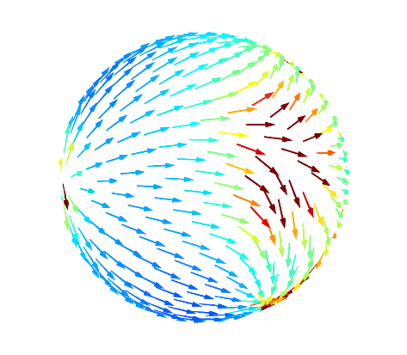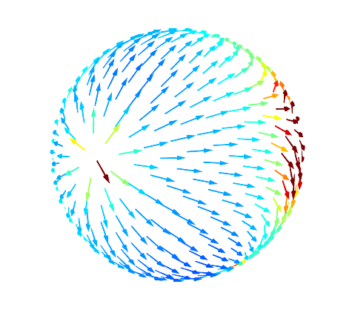
240° 280° 320°

Figure S15. 3D CV map of the shell MEA-encapsulated cardiac organoid at baseline condition. A series of snapshots showing the 3D CV map from different angles where the map is being rotated on the vertical axis. The 3D isochrone map shows a comprehensive view of the CV vectors across the organoid.
a b
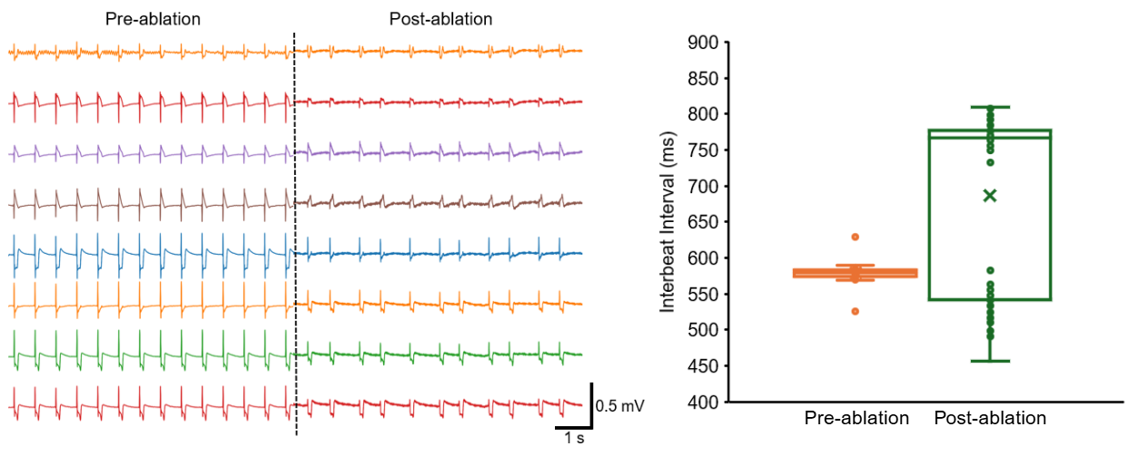
Figure S16. Shell MEA-encapsulated cardiac organoid showing electrophysiological changes after induced arrhythmia. (a) Field potential traces show changes in beating pattern after ablating a cardiac organoid with high-voltage electrical stimulation via one of the electrodes. (b) Nonuniform interbeat intervals were detected after ablating the cardiac organoid.

Activation order confusion matrix
We created confusion matrixes to assess the accuracy of the detected activation order. The confusion matrix captures the frequency with which each electrode appears at a given rank across all detected spikes.
We built the confusion matrix $(C)$by mapping electrodes to their firing order, where each entry $C_{r,i}$ represent the count of electrode $i$ firing at rank $r$ through all $N$ spikes as
$C_{r,i}=\sum_{s=1}^{N}{δ(R_{i,s}=r)}$, (1)
where $R_{i,s}$ is the rank of electrode $i$ at spike $s$, and $δ(R_{i,s}=r)=1$ if electrode $i$ fired at rank $r$ in spike $s$, and $δ(R_{i,s}=r)=0$ otherwise.To quantify the consistency of firing in a given recording, we maximize the alignment along the matrix diagonal to optimize electrode ordering by Hungarian algorithm. The accuracy of the resultant confusion matrix is computed as:
$Accuracy=\frac{\sum_{i=1}^{M}{C_{sorted,i,i}}}{\sum{C_{sorted}}}$, (2)
where $C_{sorted,i,i}$ are the diagonal elements of the confusion matrix, $\sum{C_{sorted}}$ is the sum of all elements in the confusion matrix, and $M$ is the total number of channels. A high accuracy suggests reproducible activation order, and low accuracy may indicate noise or conduction path variability.

