Figure S1 Global distribution and invasion rate of fall webworm. (A) First reports of the fall webworm in various countries from 1770 to 2019. (B) Distribution heatmap of the fall webworm in three global hotspot regions.

Figure S2 World Forest Distribution. (A) The world's forests are primarily distributed in tropical regions, followed by boreal, temperate, and subtropical zones. Brazil, Canada, and Russia together hold more than half of the world's primary forests. Among these, Brazil has no distribution of the fall webworm, while only a few temperate forests in Canada and Russia are within the distribution range of the fall webworm. (B) The top ten countries in the world by natural forest area. Among these, Russia, Canada, the United States, and China have fall webworm distribution; Brazil, Australia, the Democratic Republic of the Congo, Indonesia, Peru, and India have not yet reported the presence of the fall webworm.

Figure S3 Trends in global forest resources from 1990 to 2020. Green represents the area of natural forests, while orange represents the area of planted forests.

Figure S4 Comparison of temperature and precipitation in the native and invaded distribution areas of the fall webworm. It can be observed that after invading new areas, the fall webworm is able to adapt to lower annual mean temperature, mean diurnal temperature range, isothermality, mean temperature of the driest quarter, mean temperature of the coldest quarter, annual precipitation, precipitation of the driest month, precipitation of the driest quarter, and precipitation of the coldest quarter. It is also able to adapt to higher temperature seasonality, mean temperature of the wettest quarter, precipitation of the wettest month, precipitation seasonality, precipitation of the wettest quarter, and precipitation of the warmest quarter.

Figure S5 Pearson correlation test between 19 environmental variables in the native and invaded distribution sites of the fall webworm (dark red represents a highly positive correlation, and dark blue represents a highly negative correlation).

Figure S6 Heatmap of correlations for the remaining 9 climate variables with weaker correlations, after removing 10 variables with Spearman correlation coefficients greater than 0.8.

Figure S7 Principal component analysis (PCA) of climate differentiation between the native and invasive ranges of the fall webworm. The climate variables influencing PCA1 are primarily Annual Mean Temperature, Temperature Seasonality, Mean Temperature of the Driest Quarter, and Precipitation of the Wettest Month. The climate variables influencing PCA2 are mainly Mean Diurnal Range, Mean Temperature of the Wettest Quarter, and Annual Precipitation. The climate variables influencing PCA3 are primarily Precipitation Seasonality, and Precipitation of the Warmest Quarter.

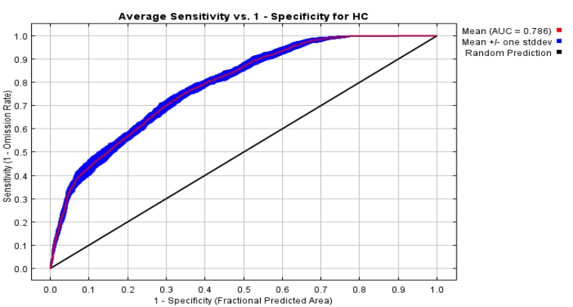
Figure S8 AUC plot of the species distribution model for the fall webworm. An AUC value between 0.5 and 0.7 indicates moderate model prediction accuracy, between 0.7 and 0.9 indicates good accuracy, and values above 0.9 suggest excellent prediction accuracy. In this study, the AUC value for the model training dataset was 0.786, indicating good model prediction accuracy.

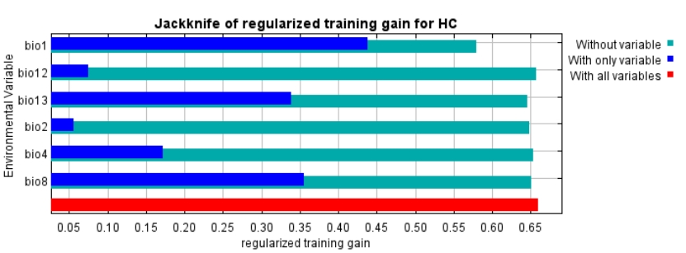
Figure S9 The stepwise evaluation of the main environmental factors. It shows that the most influential factor is the annual average temperature (bio1). Other significant factors include precipitation of the wettest month (bio13), average temperature of the wettest quarter (bio8), and standard deviation of temperature seasonality (bio4), all of which are considered to have important impacts on the distribution of the fall webworm. The least influential factors are the mean diurnal range (bio2) and annual precipitation (bio12).

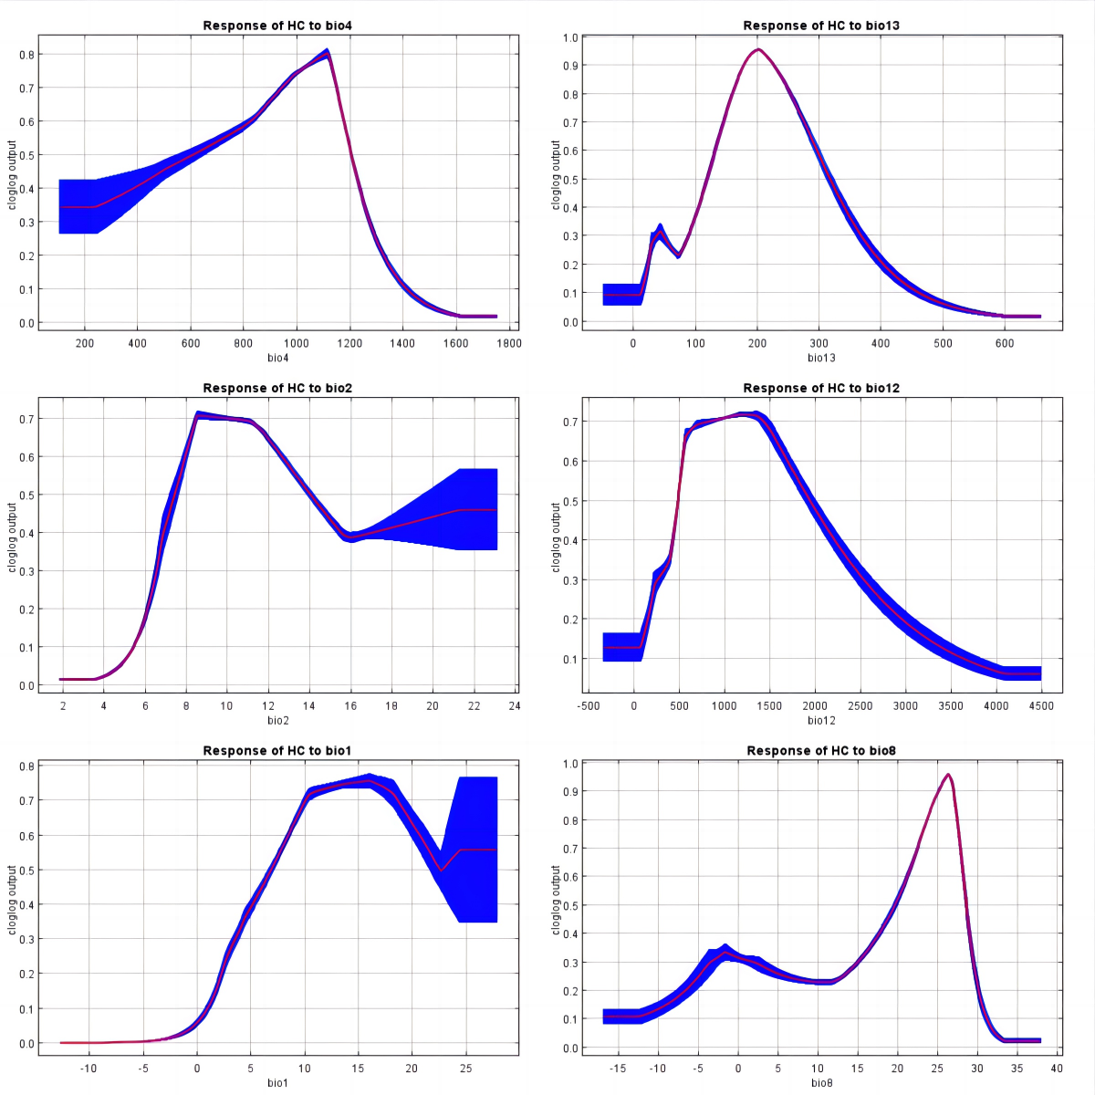
Figure S10 Response curves of the main climate factors. The optimal annual average temperature for the fall webworm is 10-18°C, the optimal mean diurnal range is 9-11°C, the optimal average temperature of the wettest quarter is 26°C, the optimal standard deviation of temperature seasonality is 1100, the optimal precipitation of the wettest month is 200 mm, and the optimal annual precipitation is 600-1400 mm.

