Table 1a. Succession of microorganisms during heap fermentation of cocoa seeds.
Medium | Days | Colonies | Microbial load (cfu/ml) | CODE | Probable Organism
 | 1
SDA |  | Two observable types of colonies (195 &125) | 1.95×10⁻² | C | Candida
MRS |  | Two colonies (182& 131) | 1.82×10⁻² | E | Lactobacillus
NA |  | Two colonies (29& 14) | 2.9×10⁻³ | B | Bacillus
 | 3
SDA |  | More than one colony. Tntc [293 |  | C | Candida
MRS |  | At least 2 types of colonies (188& Tntc) | 1.8×10⁻³ | E | Lactobacillus
NA |  | 259 | 2.5x10⁻³ | B | Bacillus
 | 5
SDA |  | At least, 2 distinct colonies (200&151) |  | D | Pseudomonas
MRS |  | Tntc [288] |  | E | Lactobacillus
NA |  | Two observable colonies (270 & tntc) |  | B | Bacillus
 | 7
SDA |  | Tntc [299] | 1.9×10⁻⁴ | I | Fungi
MRS |  | 18 & 19 | 1.85×10⁻³ | E | Lactobacillus
NA |  | Tntc [86] |  | B | Bacillus
Tntc = Too numerous to be counted; SDA =Sabourad Dextrose agar; NA = Nutrient agar; MRS = Mackonkey agar.

Table 1b. Succession of microorganisms during box fermentation of cocoa beans (Obinze et al., 2022).
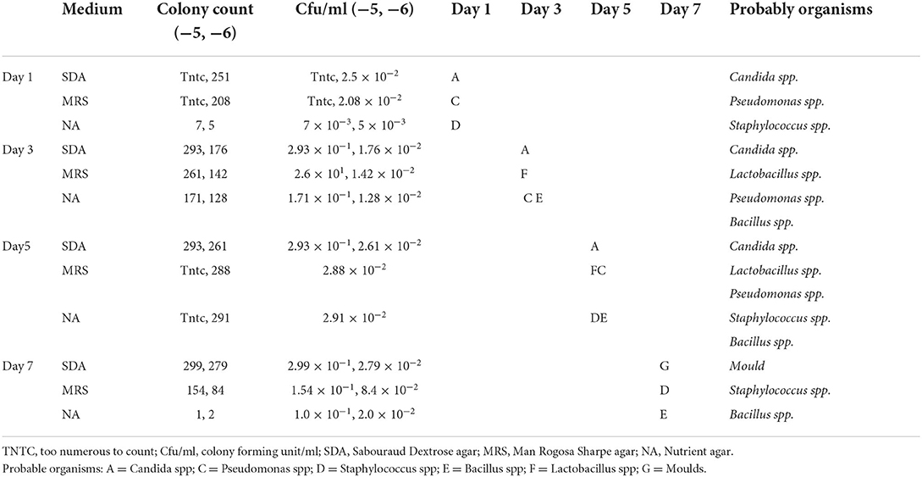

Table 2. Probable identity of microorganism involved with the formation of cocoa bean seeds during heap fermentation.

Sample | Colony characteristics | Gram  Staining | Indole  Test | Citrate  Test | Catalase  Test | Carbohydrate fermentation  Sucrose | Xylose | Lactose | Mannitol | Maltose | Probable  Organism
Aaaaaaaaaaaaa  A | Brown elevated, medium sized, with circular edges. | -ve rod | +ve | +ve | +ve | +ve | +ve | +ve | +ve | +ve | Pseudomonas spp
B | Small, light-green, elevated, with circular edges | +ve rod | -ve | +ve | +ve | +ve | +ve | +ve | +ve | +ve | Bacillus spp
C | Milk-coloured, medium-sized, elevated, circular edges | -ve rod | -ve | -ve | +ve | +ve | -ve | +ve | +ve | +ve | Candida spp
D | Large, cream-coloured, flat, circular edges | -ve rod | -ve | -ve | +ve | +ve | +ve | -ve | +ve | +ve | Pseudomonass  Spp
E | Small, orange, elevated, irregular edges | +ve rod | -ve | -ve | +ve | +ve | +ve | -ve | +ve | +ve | Lactobacillllus  Spp
F | Large, milk-coloured, dry, flat,star-shaped edges | +ve rod | -ve | -ve | +ve | +ve | +ve | -ve | +ve | +ve | Lactobacillus  Spp
G | Large, cream-coloured, dry, flat, star-shaped edges | +ve rod | -ve | -ve | -ve | +ve | +ve | +ve | +ve | +ve | Bacillus spp
H | Small, pink, elevated, with circular edges | +ve rod | +ve | +ve | +ve | +ve | +ve | +ve | +ve | +ve | Pseudomonas  Spp
I | Large, cream-coloured, elevated with bubbles, circular edges | +ve cocci | -ve | +ve | +ve |  |  |  |  |  | Fungi
J | Light-cream, medium sized, elevated, with hairy irregular edges | +ve cocci | -ve | -ve | +ve |  |  |  |  |  | Mould

Sccharomyces spp play a very important roles in box than in heap fermentation. The fungal population decreased by day 4 and increased again by day 6 before the final reduction by day 8. During heap fermentation more fungal species were involved. The fungal population reduced by day 4 and kept on increasing until day 8. Acetobacter, Lactobacillus and other fungi (Aspergillus niger, and Candida were more involved in heap fermentation.

Table 3. Microbial identification of isolates common to both box and heap fermentation
Isolate | Colony morphology | Microscopy |  | Biochemical |  |  |  |  | Probable organism
Isolate | Colony morphology | Motility | Gram rxn | Catalase | Lactose | Starch | Citrate | Oxidase | Probable organism
A  B  C  D  E  F  G  H  I  J | Moist, cloudy in nutrient Agar, raised elevation with an irregular shape of 14mm.  Has a yellow color with a raised elevation, round shape and dry consistency, 9mm  6mm in size, rod shaped yellow convex oil-like organism  10mm rod shaped whitish umbonate organism, having a moist consistency  18mm in size, irregularly shaped yellow organism, seen flat with a moist consistency  5mm elongate with a whitish appearance having a raised moist consistency  20mm with an irregular dry pink flat elevation  9mm whitish in color with a dry raised filamentous consistency  4mm, black with a dry raised filamentous consistency  8mm seen dry green with a raised dry round shape | -ve  +ve  +ve  +ve  +ve  -ve  -ve  -ve  -ve  -ve | +ve  +ve  -ve  +ve  +ve  +ve  +ve  +ve  +ve  +ve | +ve  -ve  +ve  +ve  +ve  -ve  -ve  -ve  -ve  -ve | +ve  +ve  +ve  -ve  -ve  -ve  +ve  -ve  -ve  -ve | -ve  +ve  +ve  +ve  -ve  +ve  +ve  +ve  +ve  +ve | +ve  +ve  +ve  -ve  -ve  -ve  -ve  -ve  -ve  +ve | +ve  -ve  -ve  -ve  +ve  -ve  -ve  +ve  +ve  +ve | Staphlococcus sp  Lactobacillus sp  Acetobacter sp  Bacillus sp  Micrococcus luteaus  Saccharomyces sp  Candida sp (pink yeast)  Aspergilus  flavus  Aspergilus Niger  Penicillum sp

Table 3. The proximate composition, sensory properties, and quality characteristics of the fermented and unfermented cocoa beans.
Sample | Moisture | Protein | Fat | Crude fibre | Ash | Carbohydrate
A | 9.73±0.01 | 9.01±0.02 | 11.71±0.01 | 1.88±0.01 | 6.04±0.02 | 61.62±0.01
B | 6.66±0.01 | 3.85±0.01 | 20.02±0.01 | 14.98±0.01 | 5.49±0.01 | 49.00±0.01
 | Taste | Texture | Mouthfeel | Appearance | Aroma | General acceptability
Sample A chocolate | 6.67±1.85 | 5.81±1.17 | 6.10±1.95 | 5.95±1.60 | 7.00±1.18 | 7.00±1.04
Sample B chocolate | 4.81±1.86 | 5.00±1.64 | 4.95±1.40 | 4.86±2.26 | 4.62±2.20 | 5.29±1.38
Sample C | 7.55 ± 1.32 | 6.90 ± 1.07 | 7.60 ± 1.00 | 7.55 ± 1.19 | 7.75 ± 1.25 | 7.50 ± 0.80
 | Total phenol | pH
A | 2.68± 0.02 | 6.65± 0.01
B | 4.59± 0.01 | 5.33± 0.02
C | 2.80 ±0.15 | 6.59± 0.04
A=Heap fermented cocoa beans, B=unfermented cocoa bean, C = box fermented

