Supplementary Information
Waveguide Excitation and Spin Pumping of Chirally Coupled Quantum Dots
Savvas Germanis,^{1,†} Xuchao Chen,,† René Dost,¹ Dominic J. Hallett,¹ Edmund Clarke,² Pallavi K. Patil,² Maurice S. Skolnick,¹ Luke R. Wilson,¹ Hamidreza Siampour,^{3,*} A. Mark Fox^{1,*}
¹ School of Mathematical and Physical Sciences, University of Sheffield, Hicks Building, Sheffield S3 7RH, UK
² EPSRC National Epitaxy Facility, School of Electrical and Electronic Engineering, University of Sheffield, Sheffield S1 3JD, UK
³ School of Mathematics and Physics, Queen’s University Belfast, University Road, Belfast BT7 1NN, UK
* Emails: h.siampour@qub.ac.uk, mark.fox@sheffield.ac.uk

Section S1: Cryogenic photoluminescence setup and p-shell excitation
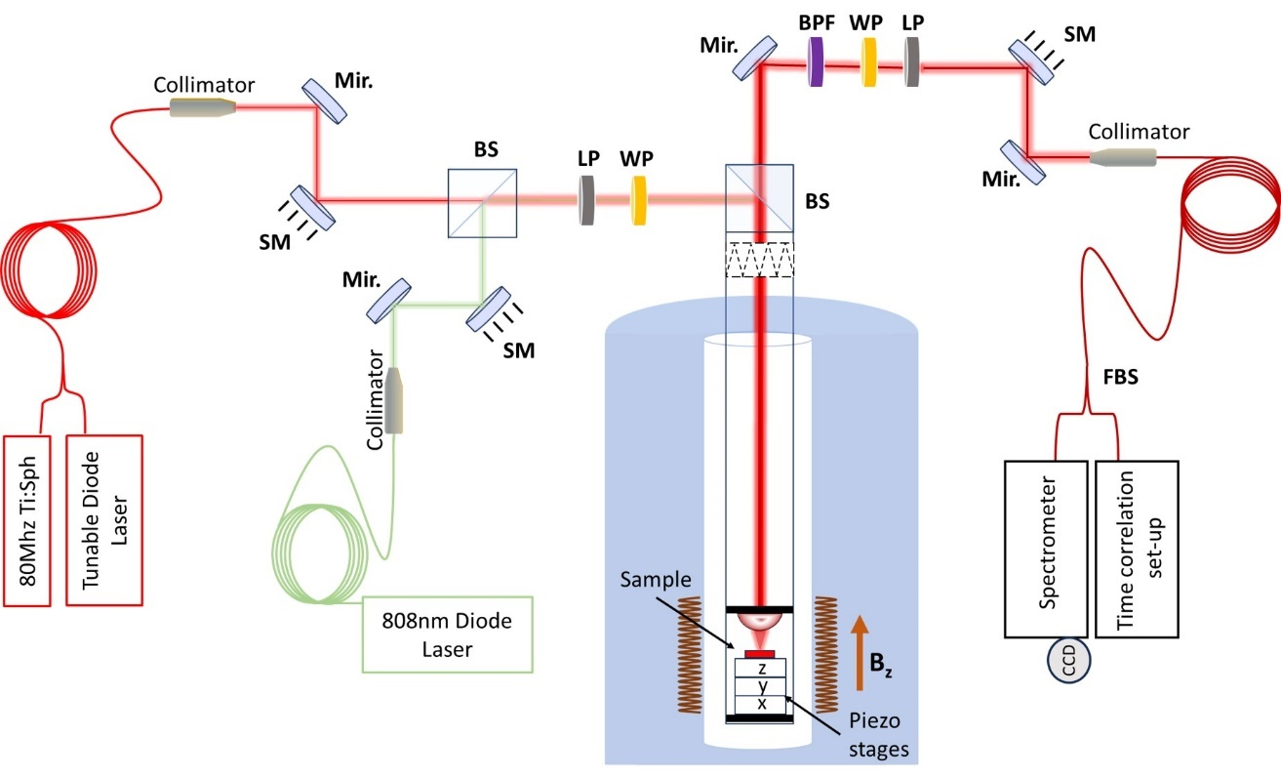
Figure S1: Schematic diagram of the experimental setup. SM: scanning mirror; Mir.: dielectric mirror; BS: beam splitter cube; LP: linear polarizer; WP: halfwave plate; BPF: narrow band pass filter (acting as a flip mirror, which is off the path when observing the full spectrum); FBS: fibre beam splitter; CCD: charged coupled device camera. The time correlation setup, used for both HBT and PL decay time measurements, includes two fast superconducting nanowire single-photon detectors (SNSPDs) and a single-photon counting module. The liquid helium cryostat features a sample space surrounded by superconducting coils, enabling magneto-photoluminescence studies with a Faraday-geometry magnetic field applied along the sample axis.
The experimental setup (Figure S1) consists of scanning dielectric mirrors (SM) and dielectric mirrors (Mir.) to direct the excitation and detection paths. On the setup's left-hand side, a linear polarizer (LP) and a half-wave plate (WP), rotate the linear polarisation of excitation laser light to be matched with the angle of linearly polarised outcoupler’s mode. On the right-hand side, the combination of LP and WP serves to enhance the collection efficiency of the setup. A narrow band-pass filter (BPF) filters the spectrum by selecting only the bandwidth containing the photoluminescence (PL) emission line under investigation for time-resolved PL and correlation measurements. When in the mode of observing the full spectrum, the BPF is off the path. Two fast superconducting nanowire single-photon detectors (SNSPDs) facilitate time-correlated measurements as parts of a Hanbury and Twist setup. A liquid helium cryostat houses the sample for magneto-photoluminescence studies under a magnetic field perpendicular to the device’s plane.
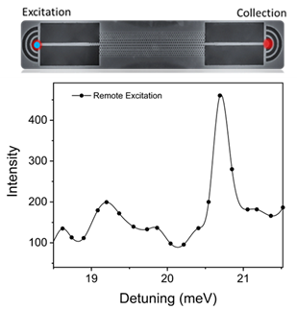
Figure S2: PL integrated intensity graph of the exciton line as a function of the CW laser excitation energy detuning from the emission of the QD exciton line in the remote, in-plane excitation experimental scheme.

Figure S2 shows a photoluminescence excitation (PLE) spectrum of QD1 in the vicinity of the p-shell transition. P-shell excitation experiments provided the ability to initialise the circularly polarized optical state efficiently through the relaxation process from p-states to the ground, preserving the spin memory of the initial p-state. Special care was taken during the measurements to maintain the stability of the quasi-resonant excitation energy, as the total diode field (comprising the built-in and applied fields) varied under different excitation conditions (direct and in-plane). This variation was primarily due to the differing excitation power densities of the photogenerated optical field and its contribution to the total diode field. This enabled us to compare the effects of local and remote excitation schemes on directional contrast measurements.
Section S2: HBT correlation measurements
Figure S3 shows Hanbury Brown–Twiss (HBT) measurements of the second-order correlation function $g^{2}\left(τ\right)$ under pulsed excitation on the p-shell absorption line, operating below the saturation regime of the exciton state. The multiphoton emission at zero delay is highly suppressed, dropping to approximately 21% of the adjacent peaks, demonstrating the ability of the QD to act as a single-photon source. The value of g²(0) is higher than in the CW results in Figure 4c on account of the different pumping conditions. Through autocorrelation measurements, we have shown strong photon antibunching behaviour in both CW and pulsed excitation schemes, validating this QD as a single-photon source suitable for chiral quantum-optical experiments. For pulsed excitation measurements, a weak non-resonant laser was used in addition to the quasi-resonant laser to stabilise charge fluctuations in the quantum dot vicinity, as the emission lines were broad under pulsed excitation. This helped to improve the signal quality, particularly in the lifetime measurements.
Figure S3: Auto-correlation PL histograms without background correction obtained using an HBT setup. The second-order correlation function under pulsed excitation conditions is shown.

Section S3: Simulation
The finite-difference time-domain (FDTD) calculations were performed with the Lumerical software package and use a simulation region of 80a in length, 16a in width, and 5a in height (where a is the lattice constant of the crystal), with a mesh size of 20 grids per lattice constant. Eight Perfectly Matched Layers (PML) are introduced at the boundary of the simulation region, with an extended thickness of 42 layers applied to the interface perpendicular to the waveguide to eliminate back-reflection and potential divergence issues.
The simulation is conducted on a GaAs/AlGaAs dielectric slab with etched nanoholes patterned as a hexagonal lattice. The following parameters are used in the simulation: refractive index n=3.406 (ϵ_{r}=11.6), hole radius of the bulk crystal r=0.3a, slab thickness t=0.7a, and lattice constant a=258nm. The radii and positions of the eight innermost nanoholes (perpendicular to the waveguide) are modified for improved slow-light performance based on ref. 21 in the manuscript.
Two linear and orthogonal electric point-dipole sources with a π/2 phase difference are introduced to simulate a circular dipole transition in Faraday geometry, around which a transmission box with a side length of 400 nm is placed. The simulation is set to run over a period of 4000 fs but can be terminated early if the total energy of the electromagnetic field drops below the shut-off threshold (i.e., 10⁻⁵).
The band structure and the mode profile of the glide-plane photonic crystal slab waveguide is calculated using 3D guided-mode expansion method (GME) implemented by Legume. There, the eigenmodes of the photonic structures are decomposed and expanded into a basis where the corresponding eigenmode problem is easy to solve (i.e. a homogeneous dielectric slab). Unless otherwise specified, a value of g_{max}=4 is used throughout the numerical calculation to improve precision. Here, g_{max}​ represents the truncation level of reciprocal lattice vectors used in the simulations. Guided modes are expanded on an infinite set of basis vectors in the reciprocal lattice, where truncation is applied to balance simulation time with accuracy. The simulation region is comprised of one single period of the glide-plane waveguide, that is, a rectangle with 16a in height (perpendicular to the waveguide) and a in width (parallel to the waveguide). Periodic boundary conditions are applied to interfaces perpendicular to the GaAs membrane.
Section S4: Experimental determination of the slow-light region
The device’s slow-light region was found by comparing the PL transmission spectrum with band structure simulations, as detailed in ref. 21. The PL transmission spectrum was recorded by exciting one end of the waveguide through the outcoupler with an 808 nm laser. The laser excites the QD ensemble and wetting layer around the outcoupler, and the PL serves as an internal light source. Subsequently, photons that propagate through the waveguide were collected from the outcoupler at the opposite end. The resulting spectrum (Figure S4a) exhibited a distinct long-wavelength cut-off, dictated by the glide-plane adaptor band gap rather than the glide-plane waveguide, which lacks a cut-off due to the absence of a band gap.
By simulating the band structure of the glide-plane adaptor and aligning it with the observed cut-off, we determined the parameters for the glide-plane waveguide and its slow-light band edge. For example, the slow-light edge for device 1, where QD1 is embedded, was deduced from PL spectrum at approximately 910 nm, consistent with the corresponding transmission spectra (Figure S4). Further details, including specific design parameters, scaling factors, and methodologies, are provided in ref. 21.
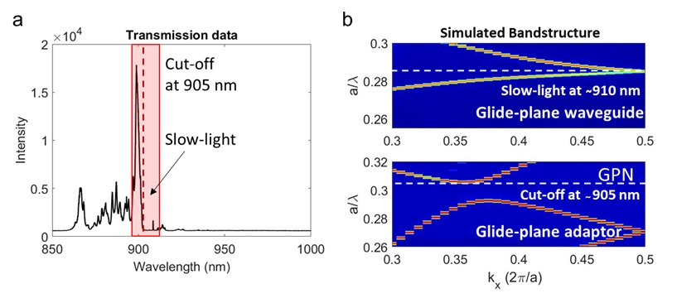
Figure S4: (a) High-power PL transmission spectrum recorded from Device 1. (b) Simulated band structure for the glide-plane waveguide (top) and the glide-plane adaptor (bottom). The lattice constant for the glide-plane slow-light section is a=258 nm, with an extended lattice constant of a′=1.07a for the glide-plane adaptor.

† S.G. and X.C. contributed equally to this work.

