Supplemental Information

SI Table of content | Page
MRI Samples | 2
SI Table 1 Overview of each included MRI cohort | 2
SI Table 2: Main characteristics for the total dataset used to address the different classes of research questions. | 7
SI Figure 1: Sample distribution of the MRI cohorts | 8
Data availability | 8
SI Table 3: Links, data owner and IRB approvals for each dataset | 8
Education in the MRI cohorts | 10
SI Table 4: Overview of education variables and recoding | 10
SI Figure 2: Distribution of education in each sample | 12
Memory testing in the MRI cohorts | 12
SI Table 5: Tests related to episodic memory included in the analyses for each sample | 13
Magnetic Resonance Imaging acquisition and preprocessing | 14
SI Table 6: Scanner acquisition parameters | 14
SI Table 7: LASSO coefficients | 15
SHARE sample distributions | 17
SI Figure 3 SHARE sample descriptives | 17
Memory testing in SHARE | 18
SI Figure 4: Response distribution for word recall

MRI Samples
A general overview of each included MRI cohort in provided in the table below.
ADNI: The Alzheimer’s Disease Neuroimaging Initiative is a multi-site project led by Doctor Michael W. Weiner to assess the progression of mild cognitive impairment (MCI) and early Alzheimer’s Disease (AD). The present study includes participants from ADNI 1, ADNIGO, ADNI2, and ADNI 3, who were cognitively healthy at baseline (DX_bl variable). Only observations in which participants were still cognitively healthy were included as determined by the ADNI team (DX variable). Participants were required to have no evidence of ischemic stroke (Hachinski Ischemic Score ≤ 4), a Geriatric Depression scale score < 6, stable medications for 4 weeks before the screening, good auditory and visual acuity, good general health, no medical contraindications to MRI and at least 6 grades of education/work history. General inclusion and exclusion criteria are described elsewhere ⁹⁴. All participants signed an informed consent form and the protocols were approved by the corresponding regional ethical committees in the US and Canada. Data was retrieved in April 2021.
BASE-II: Participants of the Berlin Aging Study II were community-dwelling older adults recruited from the greater Berlin metropolitan area through advertisements in newspapers and public areas. The baseline sample comprised 2200 participants; 1600 older adults aged 61–88 years, and 600 younger adults aged 24–40 years. Participants were invited to a medical exam and cognitive testing sessions. After completion of the cognitive examination of BASE-II, eligible participants were invited to take part in one MRI session within a time window of 2–4 weeks after cognitive testing. The MRI sample consisted of 341 older adults aged 61–82 years and 103 younger adults. MR scans and cognitive scores were obtained 2012-2013. A subsample of the MR sample was later invited for follow-up. The different elements of the study were approved by the ethics committees of the Max Planck Institute for Human Development, the Charité University ethics committee and by the ethics committees of The German Association for Psychology (DGPs). Participants signed written informed consent and received monetary compensation for their participation in BASE-II and the MRI study. Exclusion criteria were untreated diabetes and hypertension; prior stroke, head injuries or brain surgery; psychiatric illness; major depression; dementia with a score < 24 on the Mini- Mental State Examination. None of the participants took medication that might affect memory function or had a history of head injuries, medical (e.g., heart attack), neurological (e.g., epilepsy), or psychiatric disorders (e.g., depression). All participants reported normal or corrected to normal vision. Observations with MMSE < 26 or no MMSE data were discarded.
BBHI: Barcelona Brain Health Initiative study (https://bbhi.cat/en/) participants are community-dwelling individuals between 40 and 65 years of age, without self-reported neurological or psychiatric diagnosis at the time of recruitment ⁹⁵. BBHI is an ongoing longitudinal cohort study that investigates the determinants of brain and mental health in healthy middle-aged and older adults. Recruitment started in 2017, when multiple initiatives (including conferences, radio and television interviews, and social media advertisements) took place to encourage participants to join the study. It has enrolled 4,686 participants via a web-based application, who completed a first on–line questionnaire. Exclusion criteria included cognitive impairment and diagnosis of neurologic or psychiatric disorders, including Alzheimer’s disease, Parkinson’s disease, multiple sclerosis, amyotrophic lateral sclerosis, cerebral stroke, schizophrenia, and major depression. BBHI includes regular cognitive, medical, brain imaging, and biological assessments, and has several sub studies. A sample of 1,000 participants is undergoing a detailed clinical phenotyping through a multi-day in-person evaluation that includes cognitive, physical, and medical assessments, biological sample recollection, structural and functional magnetic resonance imaging (MRI), and electroencephalography (EEG). Participants of this study are invited biannually for repeated evaluations.
BETULA: The BETULA project (Umeå. Sweden) is a prospective longitudinal study on aging, memory, and dementia, which used a population-based sampling of healthy middle-aged and older adults for recruitment. For the current analyses, the MRI subsample of the study is used. Participation in the MRI study was offered to all participants who had remained in the study and completed cognitive testing at the 5th Betula test wave onwards. Exclusion criteria were severe visual or auditory handicaps, intellectual or developmental disabilities, suspected dementia, having a mother tongue other than Swedish, MRI contraindications, severe neurological disorders, or visual/motor deficits that could interfere with fMRI data collection, MMSE <24, brain or head surgery, and substantial brain anatomical deviations. Some participants were later excluded due to discovered neurological conditions, severe depression, and MRI anatomical abnormalities. All participants signed an informed consent, and the protocols were approved by the Regional Ethical Vetting Board at Umeå University. Data was retrieved in August 2022.
Cam-CAN: The Cambridge Centre for Ageing and Neuroscience cohort study is a large-scale, multi-modal, population-based adult lifespan (18–87 years old) investigation of the neural underpinnings of successful cognitive ageing. Recruitment was done by invitation letters based on the patient lists of general practitioners within the Cambridge City area. A population-based cohort of 2700 adults aged 18 or above was recruited to Stage 1 of the project, where they completed an interview including health and lifestyle questions, a core cognitive assessment, and a questionnaire of lifetime experiences and physical activity. Approximately 700 participants continued to Stage 2 where they underwent cognitive testing and provided measures of brain structure and function. In stage 3, a subset of approximately 250 adults returned for longitudinal follow-up MRI. The study is conducted in compliance with the Helsinki Declaration, and has been approved by the local ethics committee, Cambridgeshire 2. Exclusion criteria included term-time residents of colleges and universities, and participants whose Primary Care Physician judged as inappropriate to include. For phase-II, exclusion criteria additionally included cognitive impairment (MMSE < 24, memory deficit, consent difficulties), communication difficulties (hearing problems, insufficient English language, vision difficulties), medical problems by self-report of diagnosis (dementia diagnosis /Alzheimer’s Disease, Parkinson’s Disease, Motor Neuron disease, Multiple sclerosis, cancer, stroke, encephalitis, meningitis, epilepsy, head injury with serious results [coma, unconscious for >2 hours, skull fracture], recently diagnosed or uncontrolled high blood pressure, possible pregnancy, current psychiatric conditions [bipolar disorder, schizophrenia, psychosis]), mobility problems (restricted mobility which could prevent further participation, inability to walk 10 meters), substance abuse (past or current treatment for drug abuse, current drug usage), and MRI/ MEG safety and comfort exclusions.
OUS/COGNORM: The OUS/COGNORM cohort is an ongoing, prospective study coordinated by the Oslo University Hospital and Diakonhjemmet Hospital, Oslo, Norway. Patients (age ≥ 65 years) scheduled for elective gynecological, urological, or orthopedic surgery under spinal anesthesia were recruited. Participants were required to have no dementia and exclusion criteria included previous stroke with sequela, Parkinson’s disease, or other neurodegenerative diseases that are likely to affect cognition. Patients with suspected undiagnosed dementia at any time within the first five years of follow-up (n = 15), MMSE score <28 at baseline, and at least two abnormal cognitive test scores (-1.5 standard deviation [SD] below the mean normal value for age, sex, and education) were excluded. All other observations were included. All participants signed informed consent and the protocol was approved by the Norwegian Regional Committees for Medical and Health Research Ethics and the Data Protector Officer at Oslo University Hospital. Data was retrieved in March 2023.
HABS: The Harvard Aging Brain Study is an ongoing, long-term observational study that aims to enhance our understanding of brain aging and the early stages of Alzheimer's disease. The study collects PET, MRI data, neuropsychological and clinical assessments. The age range was 50-90 years at the time of baseline assessment and all patients were considered non-clinically impaired at the start of the study. Further, participants had a CDR score of 0, MMSE score ≥ 25, < 11 on the Geriatric Depression Scale, and scored above age- and education-adjusted cutoffs on the 30-Minute Delayed Recall of the Logical Memory Story A, to be included in the study. Participants with a history of alcoholism, drug abuse, head trauma, or current serious medical/psychiatric illness were excluded. Observations with MCI or AD diagnostic (DX variable) were excluded. All participants signed informed consent and the protocol was approved by the Partners Healthcare Human Research Committee. HABS data release 2.20, retrieved in August 2022 via habs.mgh.harvard.edu.
LCBC: The Center for Lifespan Changes in Brain and Cognition cohort (Oslo, Norway) consists of cognitively healthy, community-dwelling participants across the lifespan and is drawn from studies coordinated by the LCBC Research Center (LCBC www.lcbc.uio.no), approved by a Norwegian Regional Committee for Medical and Health Research Ethics. Written informed consent was obtained from all participants. The samples were recruited by a variety of methods such as newspapers and webpage ads. Most participants were recruited for observational studies, while a minority were recruited to cognitive training. All participants had to undergo a standardized health interview before being included in the study, and those with a history of neurological or psychiatric conditions or who reported concerns about their cognitive function were excluded. Additionally, all participants over the age of 40 years were required to score at least 25 on the Mini-Mental State Examination, and observations paired with MMSE ≤ 25 were excluded. Data was retrieved in November 2022.
OASIS3: The Open Access Series of Imaging Studies is a retrospective collection of multimodal data that focuses on aging and AD and is openly accessible to the scientific community. OASIS-3 includes neuroimaging, clinical and neuropsychological data. Participants were recruited through the Washington University Knight Alzheimer Disease Research Center via flyers, word of mouth, and community engagements, and were between 42 and 95 years of age. Only participants deemed cognitively normal at baseline were included. Exclusion criteria included medical conditions that precluded longitudinal participation or medical contraindications for the different study arms. All participants consented to Knight ADRC-related projects following procedures approved by the Institutional Review Board of Washington University School of Medicine. Observations were included until the last observation in which a subject was deemed cognitively healthy as determined by the Clinical Dementia Rating Scale (CDR) ⁹⁶.
PreventAD: The Pre-symptomatic Evaluation of Experimental or Novel Treatments for AD is a retrospective, long-term study that follows cognitively healthy older individuals with a familiar history of AD. It includes participants enrolled either from an observational cohort or the clinical trial of PREVENT-AD. This study comprises MRI images, blood and CSF samples, and clinical and neuropsychological assessments. Participants had to be at least 60 years old with ≥6 years of education and be cognitively unimpaired at baseline. The Montreal Cognitive Assessment (MoCA) (≥ 26/30) and CDR (= 0) scales were used to assess cognitive abilities. Other exclusion criteria at baseline included medical conditions that prevented longitudinal participation or medical contraindications to MRI, use of acetylcholinesterase inhibitors, other approved prescription cognitive enhancers, hypertension, or substance abuse. The protocols, consent forms, and study procedures were approved by the McGill Institutional Review Board and the Douglas Mental Health University Institute Research Ethics Board. Observations with RBANS > 1SD below the mean and probable MCI, as evaluated by a clinician, were excluded.
UB: The University of Barcelona cohort consisted of a series of retrospective sub studies, consisting of cognitively healthy, community-dwelling participants with normal visual function. Most were recruited for observational studies while a minority were recruited to cognitive training. Exclusion criteria varied across sub-studies, but included severe neurologic and psychiatric disorders, recent head trauma or brain surgery, cognitive deterioration, or dementia with a score < 24 on the Mini-Mental State Examination and additional neuropsychological criteria at baseline, other neurodegenerative disorders like Parkinson’s disease and chronic illness with a projected shortened lifespan. Further, observations with MMSE < 26 at later timepoints were excluded. All participants signed informed consent, and the protocols were approved by the ethical committees of the University of Barcelona and of the Hospital Clinic of Barcelona.
UKB: The UK Biobank is a major national and international health resource with the aim of improving the prevention, diagnosis and treatment of a wide range of illnesses. UKB recruited ≈500,000 people between 40-69 years in 2006-2010 from across UK through National Health Service (NHS) registers, living within a reasonable traveling distance of an assessment center. Centers are in accessible and convenient locations with a large surrounding population. The study sample was drawn from the UKB neuroimaging branch and conducted under data application number 32048. Only individuals with longitudinal MRI data were included. Participants signed informed consent, and the protocols were approved by the North West Multi-Center Research Ethics Committee [MREC]; see also https://www.ukbiobank.ac.uk/the-ethics-and-governance-council.
VETSA: The Vietnam Era Twin Study of Aging is an ongoing large-scale investigation of cognitive and brain aging in men, investigating genetic and environmental influences on cognitive aging, brain structure and function, and health. VETSA involves over 1600 male twins from the Vietnam Era Twin Registry who served during the Vietnam War era, between 1965 and 1975, though approximately 80% report no combat experience. Assessments began when participants were in their 50s (in 2003) and follow-ups are conducted every 5-6 years. The age range is 52 to 60 at baseline. Assessments include extensive neurocognitive testing, genetics, brain MRI, and plasma samples. > 1200 twins participated in waves 1, 2 and 3. The sample is relatively representative of US men in their age range. Attrition-replacement procedures were taken in wave 2. For the VETSA MRI study, participants are screened for safety issues (e.g. MRI contraindications), and both members of a twin pair had to consent to participate. For MRI, twins had to additionally be able to travel to a scanning site. Other exclusion criteria were depended on exclusion criteria for serving in the military, e.g. participants scoring in the lowest 10 percentile ranks of the Armed Forced Qualification Test (AFQT) were excluded from the military. In addition, we further excluded data from participants with incidental radiological findings, history of seizure, and diagnostic of multiple sclerosis, and AIDS.
SI Table 1 Overview of each included MRI cohort

The main sample descriptives are provided in Table 1 in the main manuscript. Since the exact sample size varies between analyses depending on data availability, the specific characteristics for the samples used to address the different research questions are provided in the table below and the sample distributions shown in the figure.
 | Obs. | N (male) | Education | Sub. Obs. |  | Baseline age |  | Time
 |  |  | (mean:level) | Mean (SD) | Min - Max | Mean (SD) | Min - Max | Mean (SD) | Min - Max
Association between education and memory function
Total sample | 54383 | 39915 | 26111:25814 | 1.37 (1.13) | 1 – 15 | 65.45 (7.74) | 50.00 – 97.39 | 0.87 (2.46) | 0 – 15.84
Association between education and brain structure
Total sample | 15157 | 6472 (3369) | 3800:3787 | 2.34 (1.64) | 1 - 14 | 65.95 (8.63) | 50.05 – 97.12 | 2.81 (3.20) | 0 – 15.84
Moderating effect of education on the association between brain and memory function
Total sample | 13135 | 5523 | 3246:3192 | 2.38 (1.70) | 1 - 14 | 65.75 (8.54) | 50.05 – 97.12 | 2.86 (3.14) | 0 – 15.00
SI Table 2: Main characteristics for the total dataset used to address the different classes of research questions.

Education – memory | Education – brain | Education – memory – brain
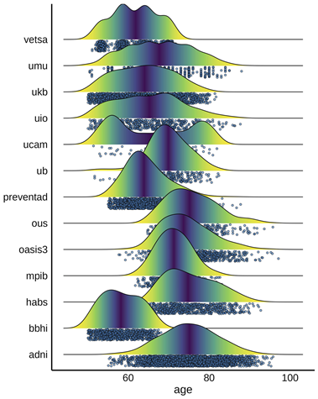 | 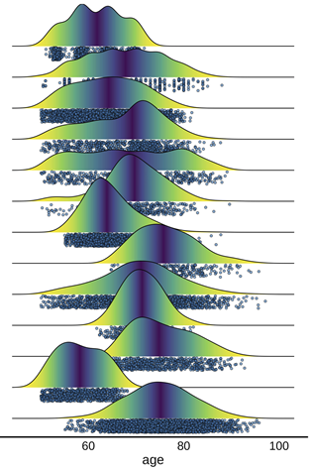 | 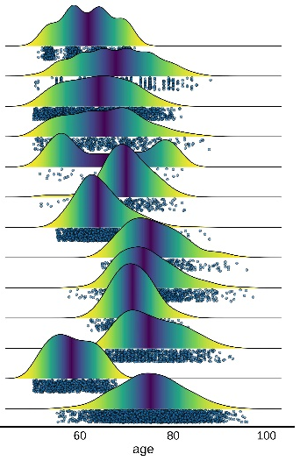
SI Figure 1: Sample distribution of the MRI cohorts used for testing education-memory (left), education-brain (middle) and education-memory-brain relationships (right).

Data availability
Sample | Link | PI and/or Admin Contact | IRB
 | Longitudinal Aging Dataset
ADNI | https://adni.loni.usc.edu/ (O) | Weiner MW; michael.weiner@ucsf.edu (PI)  ida@loni.usc.edu (AC) | Approved by the Institutional Review Boards of all of the participating institutions
BASE-II | https://www.base2.mpg.de/en (R) | Lindenberger U (lindenberger@mpib-berlin.mpg.de), Düzel E (e.duzel@ucl.ac.uk), Kühn S ( kuehn@mpib-berlin.mpg.de) (PI); Ludmila Muller (lmueller@mpib-berlin.mpg.de) | Ethics Committee of the Max-Planck-Institute
BBHI | https://bbhi.cat/en (R) | Alvaro Pascual-Leone (apleone@hsl.harvard.edu)(PI); bbhi@guttmann.com (AC) | Research institutional review board of the Institut Guttmann and protocol was approved by CEIm – Unió Catalan d’Hospitals
BETULA | http://www.ufbi.umu.se/english (R) | Lars Nyberg; lars.nyberg@umu.se (PI) | Regional Ethical Vetting Board at Umeå University
CamCAN | https://cam-can.mrc-cbu.cam.ac.uk/ (O) | Richard N Henson ( rik.henson@mrc-cbu.cam.ac.uk)(PI); https://camcan-archive.mrc-cbu.cam.ac.uk/dataaccess/ (AC) | Cambridgeshire 2 Research Ethics Committee (reference: 10/H0308/50).
OUS/COGNORM | https://www.med.uio.no/klinmed/english/research/groups/delirium/index.html | Leiv Otto Watne (l.o.watne@medisin.uio.no) (PI); Anders Martin Fjell; a.m.fjell@psykologi.uio.no (PI) | Norwegian Regional Committees for Medical and Health Research Ethics and the Data Protector Officer at Oslo University Hospital
HABS | https://habs.mgh.harvard.edu (O) | Reisa Sperling; reisa@rics.bwh.harvard.edu (PI); habs@mgh.harvard.edu (AC) | Partners Healthcare Human Research Committee
LCBC | http://lcbc.uio.no (R) | Anders M Fjell; andersmf@psykologi.uio.no / Kristine B. Walhovd; k.b.walhovd@psykologi.uio.no (PI) | Norwegian Regional Committee for Medical and Health Research Ethic; Regional Ethical Committee of South Norway
OASIS3 | https://www.oasis-brains.org/ (O) | Pamela J. LaMontagne; pjlamontagne@wustl.edu (PI); Daniel Marcus; dmarcus@wustl.edu (PI); https://www.oasis-brains.org/#contact (AC) | Institutional Review Board of Washington University School of Medicine
preventAD | https://prevent-alzheimer.net; https://openpreventad.loris.ca/ (O) | Jennifer Tremblay; jennifer.tremblay-mercier@douglas.mcgill.ca (PI); https://openpreventad.loris.ca/contact/ (AC) | The McGill Institutional Review Board and the Douglas Mental Health University Institute Research Ethics Board
UB | http://www.ub.edu/bbslab/bbslab/ (R) | David Bartrés-Faz; dbartres@ub.edu (PI) | Comisión de Bioética de la Universidad de Barcelona and Hospital Clinic
UKB | https://www.ukbiobank.ac.uk/ (O) | Rory Collins (rory.collins@ndph.ox.ac.uk) (PI); access@ukbiobank.ac.uk (AC) | Northwest Multi-Center Research Ethics Committee [MREC]; https://www.ukbiobank.ac.uk/the-ethics-and-governance-council
VETSA | https://www.vetsatwins.org/ (O | William S. Kremen ( wkremen@ucsd.edu)(PI); https://www.vetsatwins.org/for-researchers/ (AC) | VETSA and VET Registry Data Security  Policies, UCSD Human Subject Committee
SI Table 3: Links, data owner and IRB approvals for each dataset
Data availability, contact and principal investigator information, and ethical approval for the different datasets used. PI = Principal Investigator. AC = Administrative contact. IRB = Institutional Review Boards. O = Openly available. Automatic or semi-automatic data agreements. Fees may apply (e.g. UKB). R = Restricted. Ad-hoc permission is required. Contact PI or AC for specific details on access to data.

Education in the MRI cohorts
Sample | N | Years of edu (SD) | Tertiary | Above mean | Raw information | Level to Years recoding | Years to Tertiary recoding
ADNI | 2298 | 16.05 (2.75) | 1519 | 962 | Years of education (PTEDUCAT)  Range 3 – 20 years¹ | --- | > 16 years
BASE-II | 1647 | 14.34 (2.83) | 611 | 812 | Years of education  Range 7 – 18 years | --- | > 16 years
BBHI | 950 | 14.73 (2.13) | 679 | 679 | 1: Primary | 2: Secondary | 3: Tertiary | 1: 8; 2: 12; 3: 16 years | ---
BETULA | 372 | 12.27 (3.81) | 88 | 185 | Years of Education  Range 6 - 26 years² |  | > 16 years
CamCAN | 686 | 14.21 (2.65) | 425 | 425 | 1: College, university degree or higher/ 2: A/AS levels/ 3: O levels/GCSEs 4: CSEs 5: NVQ, HND or HNC/ 6: Other professional qualifications / 0: None of the above 8: No answer | 1: 16, 2: 13,  3: 11, 4: 11, 5: 13, 6: 16, 0: 7, 8: NaN years | ---
OUS/COGNORM | 114 | 14.56 (3.46) | 48 | 55 | Years of Education  Range 7 - 26 years² | --- | >= 16 years
HABS | 290 | 15.77 (3.09) | 186 | 186 | Years of education (YrsOfEd)  Range 6 – 20 years² | --- | >= 16 years
LCBC | 296 | 16.26 (2.71) | 818 | 397 | Years of Education (Compiled)³  Range 9 – 19 years | --- | >= 16 years
OASIS3 | 686 | 15.75 (2.65) | 866 | 866 | Years of Education  Range 6 – 29 years³ | --- | >= 16 years
Prevent-AD | 1033 | 15.25 (2.97) | 152 | 152 | Years of Education  Range 7 – 29 years⁴ | --- | >= 15²years
UB | 493438 | 11.32 (3.86) | 101 | 143 | Years of Education  Range 2 – 20 years² | --- | >= 15⁵ years
UKB | 372 | 13.08 (3.34) | 236670 | 236670 | 1: College,University degree, 2: A/AS levels, 3: O  levels/GCSEs 4: CSEs, 5: NVQ, HND or HNC,  5: Other professional qualifications, -7: None of the above and -3:No answer. | 1: 16, 2: 13,  3: 11, 4: 11, 5: 16, -7: 7, -3: NaN years | ---
VETSA | 1608 | 13.85 (2.09) | 455 | 844 | Years of education (Years of school completed).  Range 8 – 20 years | --- | > 16
Total | 504454 | 13.12 (3.34) | 242618 | 242376 | --- | --- | ---
SI Table 4: Overview of education variables and recoding
Education data from the MRI sample. ¹Lower cap at 6 years. ²Capped at 20 years. ³Different sources. Converted to semi-quantitative values with 9, 12, 16, and 19 years of education corresponding to basic, secondary, tertiary, and upper tertiary education. ⁴Based on Quebec norms (https://www.quebec.ca/en/education/study-quebec/education-system). ⁵Education system changes throughout through the 20th century in Spain varies the minimum years of education required to acquire tertiary education.
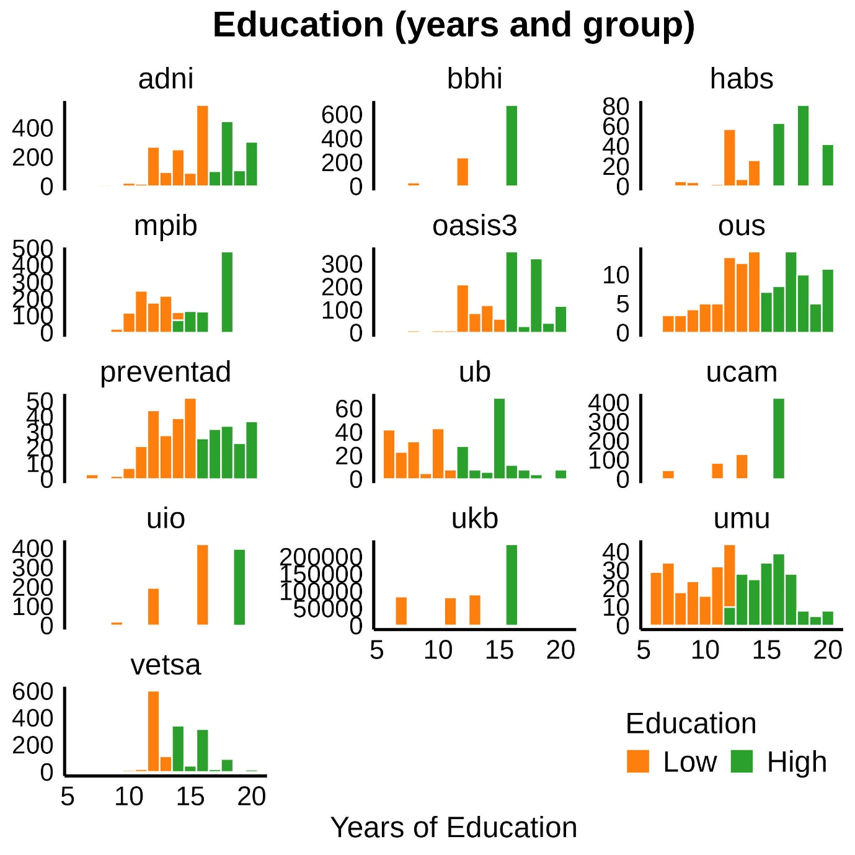
SI Figure 2: Distribution of education in each sample

Memory testing in the MRI cohorts
An overview of tests included in the memory performance score for each dataset is provided in the table below.
Dataset | Participants (Obs.) | Memory Tests
ADNI | 904 (3824) | ADNI-MEM¹
BASE-II | 1894 (3110) | VLMT short delay recall  VLMT long delay recall  VLMT learning (sum across trials)
BBHI | 966 (1266) | RAVLT learning (sum across trials)  RAVLT long delay recall  RAVLT short delay recall
BETULA | 337 (1563) | Recall of sentences²
CamCAN | 89 (172) | Story short delay recall³  Story long delay recall
OUS/COGNORM | 114 (667) | CERAD short delay recall  CERAD long delay recall
HABS | 287 (1289) | Logical memory short delay recall  Logical memory long delay recall  SRT delayed recall  SRT total recall
LCBC | 938 (1440) | CVLT short delay recall  CVLT long delay recall  CVLT learning (sum across trials)
OASIS3 | 648 (3170) | Logical memory immediate
preventAD | 306 (1057) | RBANS list recall  RBANS list learning (sum across trials)  RBANS story immediate memory  RBANS story delayed recall
UB | 161 (298) | RAVLT learning (sum across trials)  RAVLT long delay recall
UKB | 33,890 (36,520) | PAL⁴
VETSA | 1592 (3617) | CVLT short delay recall  CVLT long delay recall  CVLT learning (sum across trials)

SI Table 5: Tests related to episodic memory included in the analyses for each sample. A PC was estimated based on the first time point for which multiple memory measures were available. Participants (Obs.). Participants and Observations with memory from the initial mri sample. MMSE = Mini-mental State Examination. RAVLT = Rey Auditory Verbal Learning Test; CVLT = California Verbal Learning Test; PAL = Paired associate learning (#20197 UKB field); Logical memory = Memory subtest of the Wechsler Memory Scale. CERAD = Consortium to Establish a Registry for Alzheimer's Disease (CERAD) Word List Memory test. ADAS = Alzheimer Disease Assessment Scale. VMLT = Verbal Learning and Memory test. SRT = Buschke Selective Reminding Task. RBANS = Repeatable Battery for Assessment of Neuropsychological Status. Story recall = Story recall and recognition task of episodic memory from Wechsler Neuropsychological Battery. ¹ADNI-MEM score was computed developed by ⁹⁴ and consists of a composite score of memory which includes measures from RAVLT (learning trials, list, recognition and recalls), ADAS (learning trials, recall, and recognitions), MMSE words, and Logical memory. ²See Nilsson et al⁹⁵ ³Second wave was administered online. Calibration data (not shown here) shows in person vs. online data is comparable. ⁴See https://biobank.ndph.ox.ac.uk/showcase/refer.cgi?id=2561 for more information on PAL.

Magnetic Resonance Imaging acquisition and preprocessing
Structural T1-weighted (T1w) MPRAGE and FSPGR scans were collected using 1.5 and 3T MRI scanners. Information regarding scanners and scanner parameters across datasets are presented in the table below.
Dataset | Scanner | Field | Sequence parameters
ADNI | Multisite  (n > 50) | 1.5/ 3.0 | See https://adni.loni.usc.edu/methods/documents/mri-protocols/
BASE-II | Tim Trio Siemens | 3.0 | MPRAGE. TR: 2500 ms; TE: 4.77 ms, TI: 1100 ms; flip angle 7°, slice thickness: 1.0 mm, FoV 256 x 256, 176 slices.
BBHI | MAGNETOM Prisma Siemens | 3.0 | MPRAGE. TR: 2400 ms; TE: 2.22 ms, TI: 1000 ms; flip angle 8°, slice thickness: 1.0 mm, FoV 250 x 250, 208 slices.
BETULA | Discovery GE | 3.0 | 3D FSPGR. TR: 8.19 ms; TE: 3.2ms, TI: 450 ms; flip angle 12°, slice thickness: 1 mm, FoV: 250 x 250, 180 slices.
CanCAM | Tim Trio Siemens | 3.0 | MPRAGE. TR: 2250 ms; TE: 2.98 ms, TI: 900 ms; flip angle 9°, slice thickness: 1.0 mm, FoV 256 x 240, 192 slices.
COGNORM | Siemens Avanto |  | MPRAGE. TR: 2400 ms; TE: 3.79 ms, TI: 1000 ms; flip angle 8°, slice thickness: 1.2 mm, FoV 240 x 240, 160 slices.
 | Siemens Prisma | 3.0 | MPRAGE. TR: 2400 ms; TE: 2.22 ms, TI: 1000 ms; flip angle 8°, slice thickness: 0.8 mm, FoV 240 x 256, 208 slices, iPat = 2.
HABS^{c} | Tim Trio Siemens | 3.0 | MPRAGE. TR: 2300 ms; TE: 2.98 ms, TI: 900 ms; flip angle 9°, slice thickness: 1.2 mm, FoV 240 x 256, 160 slices.  MPRAGE. TR: 2200 ms; TE: 1.5/3.4/5.2/7.0 ms, TI: 1100 ms; flip angle 7°, slice thickness: 1.2 mm, FoV: 228 x 228, 144 slices, Multi-echo = x4.
LCBC | Siemens Avanto | 1.5 | MPRAGE. TR: 2400 ms; TE: 3.79 ms, TI: 1000 ms; flip angle 8°, slice thickness: 1.2 mm, FoV 240 x 240, 160 slices.
 | Siemens Skyra | 3.0 | MPRAGE. TR: 2300 ms; TE: 2.98 ms, TI: 850 ms; flip angle 8°, slice thickness: 1 mm, FoV: 256 x 256, 176 slices.
 | Siemens Prisma | 3.0 | MPRAGE. TR: 2400 ms; TE: 2.22 ms, TI: 1000 ms; flip angle 8°, slice thickness: 0.8 mm, FoV 240 x 256, 208 slices, iPat = 2.
OASIS3 | Siemens Vision | 1.5 | MPRAGE. TR: 9,7 ms; TE: 4.0 ms, TI: 20 ms; flip angle 10°, slice thickness: 1.25 mm, FoV: 256 x 256, 160 slices.
 | Siemens Sonata | 1.5 | MPRAGE. TR: 9,7 ms; TE: 3.9 ms, TI: 20 ms; flip angle 15°, slice thickness: 1 mm, FoV: 224 x 256, 160 slices.
 | Siemens Tim Trio | 3.0 | MPRAGE. TR: 2400 ms; TE: 3.1 ms, TI: 1000 ms; flip angle 8°, slice thickness: 1 mm, FoV 256 x 256, 176 slices.
 | Siemens Magnetom Vida | 3.0 | MPRAGE. TR: 2300 ms; TE: 2.3 ms, TI: 900 ms; flip angle 9°, slice thickness: 1.2 mm, FoV 240 x 256, 176 slices.
 | Siemens BioGraph mMR | 3.0 | MPRAGE. TR: 2300 ms; TE: 2.3 ms, TI: 900 ms; flip angle 9°, slice thickness: 1.2 mm, FoV 240 x 256, 176 slices.
preventAD | Tim Trio Siemens | 3.0 | MPRAGE. TR: 2300 ms; TE: 2.98 ms, TI: 900 ms; flip angle 9°, slice thickness: 1 mm, FoV 240 x 256, 176 slices.
UB | Tim trio Siemens | 3.0 | MPRAGE. TR: 2400 ms; TE: 2.98 ms, TI: 900 ms; flip angle 9°, slice thickness: 1 mm, FoV: 256 x 256, 240 slices.
UKB | Siemens Skyraª | 3.0 | MPRAGE. TR: 2000 ms; TE: - ms, TI: 880 ms; flip angle -, slice thickness: 1 mm, FoV: 208 x 256, 256 slices.
 | Siemens Avanto | 1.5 | MPRAGE. TR: 1000 ms; TE: 3.31 ms, TI: 1000 ms; flip angle 7°, slice thickness: 1.33 mm, FoV 256 x 256, 128 slices
 | Siemens Symphony | 1.5 | MPRAGE. TR: 1000 ms; TE: 3.31 ms, TI: 1000 ms; flip angle 7°, slice thickness: 1.33 mm, FoV 256 x 256, 128 slices
VETSA | Discovery 750× GE^{d} | 3.0 | 3D FSPGR. TR: 8.084 ms; TE: 3.164ms, TI: 600 ms; flip angle 8°, slice thickness: 1.2 mm, FoV: 256 x 256, 176 slices.
 | Tim Trio Siemens | 3.0 | MPRAGE. TR: 2170 ms; TE: 4.33 ms, TI: 1100 ms; flip angle 7°, slice thickness: 1.2 mm, FoV 256 x 256, 160 slices.
SI Table 6: Scanner acquisition parameters. TR = Repetition Time; TE = Echo Time; TI = inversion time; FoV = Field of View, iPat = in-plane acceleration. ^{a,c,d}Two matched scanners. ^{b}Several matched scanners.
For datasets not provided in Brain Imaging Data Structure (BIDS) format, data was converted to BIDS ⁹⁴. BIDS transformation of ADNI, OASIS3, and HABS data were performed with Clinica software ^{95,96}.

The alternative brain measure was derived by predicting cross-sectional memory function by cross-sectional brain structure features on an independent sample of UKB individuals not included in other brain analyses, using a Least Absolute Shrinkage and Selection Operator (LASSO) machine learning algorithm as implemented in the glmnet package ¹⁰⁷. LASSO coefficients are provided in the table below.
Region | β (x1e³)
lh_G&S_frontomargin_thickness | -4.20
lh_G_Ins_lg&S_cent_ins_thickness | 9.71
lh_G_insular_short_thickness | 7.76
lh_G_oc-temp_med-Parahip_thickness | 4.18
lh_G_postcentral_thickness | 3.60
lh_G_precentral_thickness | 21.02
lh_G_temp_sup-Plan_tempo_thickness | 1.04
lh_Pole_occipital_thickness | -44.97
lh_Pole_temporal_thickness | 13.12
lh_S_circular_insula_ant_thickness | 15.11
lh_S_interm_prim-Jensen_thickness | 0.04
lh_S_oc-temp_lat_thickness | -2.01
lh_S_oc-temp_med&Lingual_thickness | 10.74
lh_S_orbital_med-olfact_thickness | -10.29
lh_S_postcentral_thickness | 27.20
lh_S_precentral-sup-part_thickness | 8.70
lh_S_suborbital_thickness | -1.32
rh_G&S_cingul-Ant_thickness | -7.13
rh_G_oc-temp_med-Lingual_thickness | -4.10
rh_G_postcentral_thickness | 8.74
rh_G_temp_sup-Lateral_thickness | 7.73
rh_Pole_occipital_thickness | -9.24
rh_S_circular_insula_sup_thickness | -12.83
rh_S_oc-temp_med&Lingual_thickness | 17.41
rh_S_orbital_med-olfact_thickness | -6.19
rh_S_postcentral_thickness | 16.23
rh_S_temporal_sup_thickness | 0.04
lh_G_and_S_transv_frontopol_area | 7.91
lh_G_cingul-Post-ventral_area | -2.15
lh_G_occipital_middle_area | 7.85
lh_G_temp_sup-G_T_transv_area | 4.10
lh_S_central_area | -1.61
rh_G_and_S_subcentral_area | -1.89
rh_G_subcallosal_area | -13.09
rh_S_central_area | -5.28
rh_S_occipital_ant_area | 4.50
rh_S_orbital-H_Shaped_area | 1.08
rh_S_precentral-sup-part_area | -3.99
rh_S_temporal_sup_area | 4.95
Left-Inf-Lat-Vent | -16.18
Left-Cerebellum-White-Matter | 37.93
Left-Cerebellum-Cortex | 11.86
3rd-Ventricle | -68.60
Brain-Stem | -23.74
Left-Hippocampus | 17.57
Left-vessel | -2.40
Right-Inf-Lat-Vent | -31.91
Right-choroid-plexus | -27.22
SI Table 7: LASSO coefficients
Coefficients for the brain measure sensitive to memory derived with a LASSO algorithm using cross-sectional UKB brain structural data predicting memory function as indexed by paired associate learning (PAL; #20197 UKB field). See https://biobank.ndph.ox.ac.uk/showcase/refer.cgi?id=2561 for more information on PAL.

SHARE sample distributions

A. Number of timepoints per participant
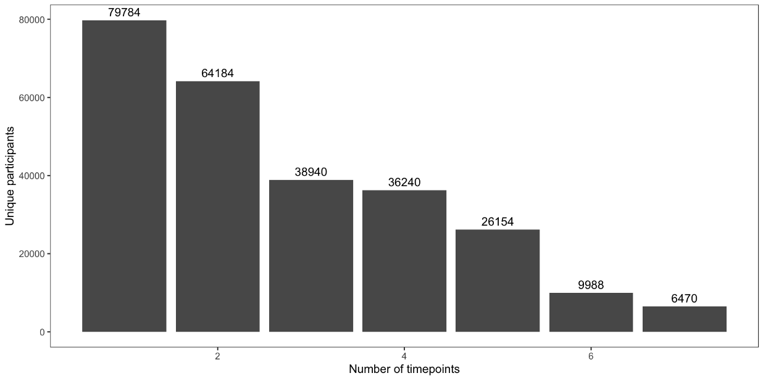
B. Number of participants per education category
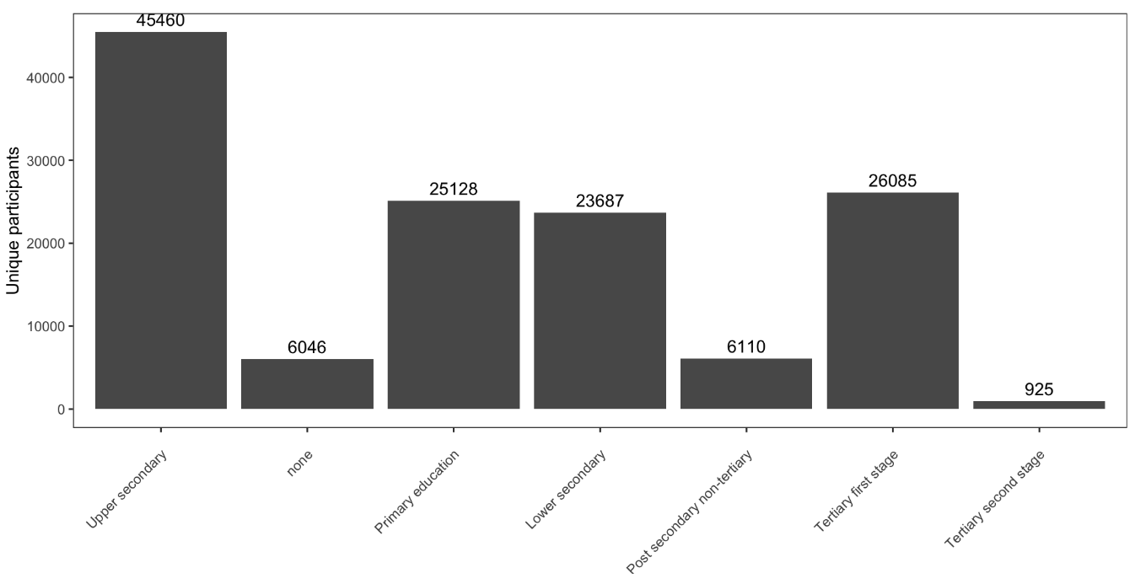
C. Age-distribution of each education category
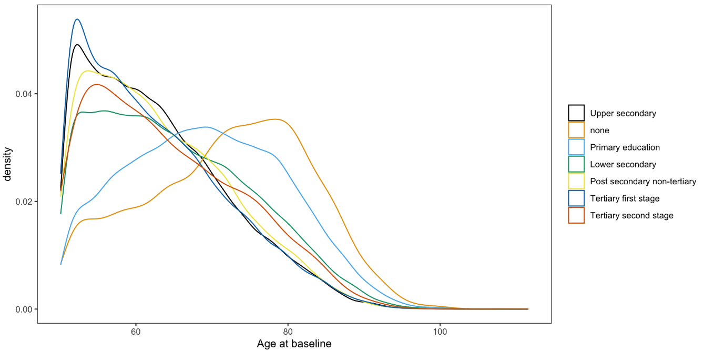
SI Figure 3: SHARE sample descriptives. A: Number of participants for each test wave (not cumulative). B. Number of participants per education category. C. Age-distribution at baseline for each education category.

Memory testing in SHARE
Memory was assessed with a 10 word verbal recall test. The word list is read out load to the participants, and then recall is tested immediately after the presentation (Recall 1) and then after a delay of approximately 5 minutes (Recall 2).
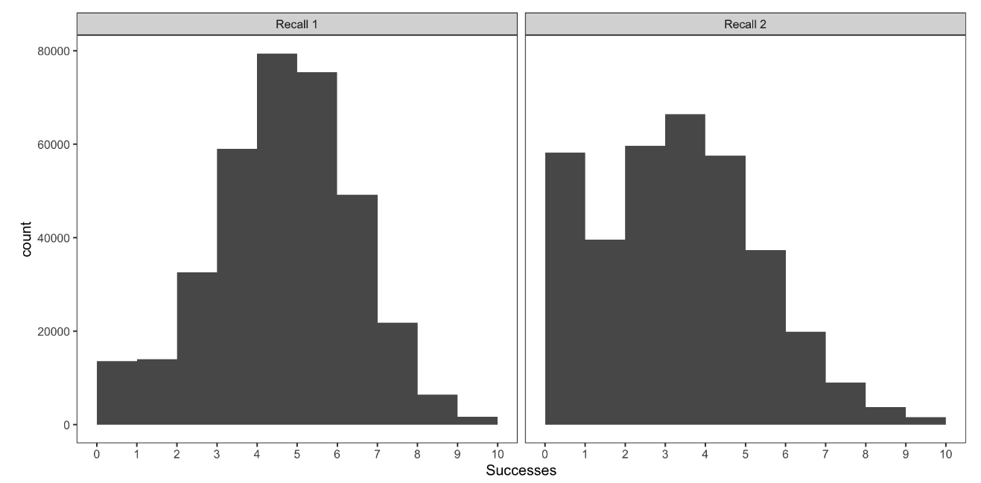
SI Figure 4: Response distribution for word recall. Number of participants (y-axis) as a function of number of words recalled (x-axis). Left: Immediate recall (Recall 1). Right: Delayed recall (Recall 2).

