APPENDIX A
MATLAB Code for Air Supply Calculations
m_wood=500*(1-0.10); %kg dry wood / 4 Hrs MW_wood= (6*12+10+16*5)*1e-3; %kg/mole MW_O₂=32e-3; %kg/mole MW_CO₂= (12+32)*1e-3; %kg/mole MW_H₂O=18e-3; %kg/mole MW_N2=14e-3; %kg/mole
%Calculation of needed air supply
n_wood=m_wood/MW_wood;%moles of wood per batch n_O₂=6*n_wood; %moles of O₂ required according to C₆H₁₀O₅ + 6O₂ --> 6CO₂ + 5H₂O m_O₂=n_O2*MW_O₂; %kg stoichiometric amount of O₂ needed for one batch m_CO₂=6*n_wood*MW_CO₂; %kg from combustion m_H₂O=5*n_wood*MW_H₂O; %kg from combustion m_air_tot=m_O₂/0.231; %kg stoichiometric amount of air needed for one batch m_N₂=0.79*m_air_tot ; %kg inert m_xs_air=2*m_air_tot ; %kg 100% excess air m_vapor=500*0.10; %kg the moist in the wood evaporates m_total=m_CO₂+m_H₂O+m_N₂+m_xs_air+m_vapor; %kg per batch m_total_inlet=m_total/(4*3600); %kg/s

APPENDIX B
TABLE B-1 MODELS AND RESULTS OF CHANGE IN THE FIREWALL HEIGHT
Case 1 | Results
Ansys Model 1  Firewall Height 2 m  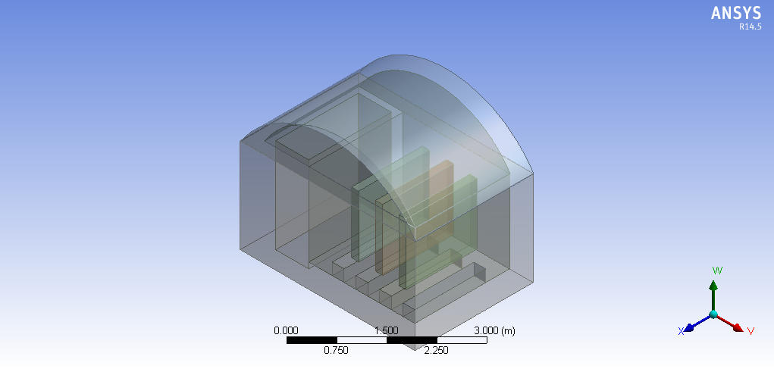  Left Side View  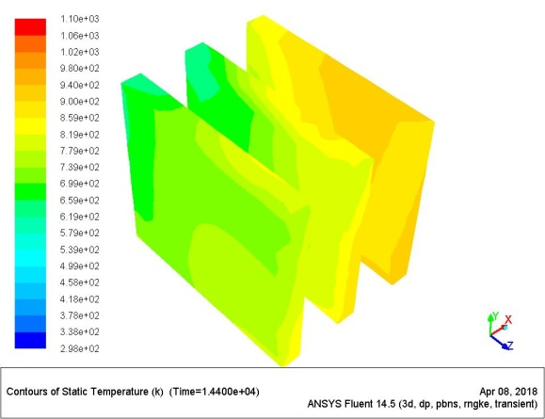 | Static Temperature Profile (K)  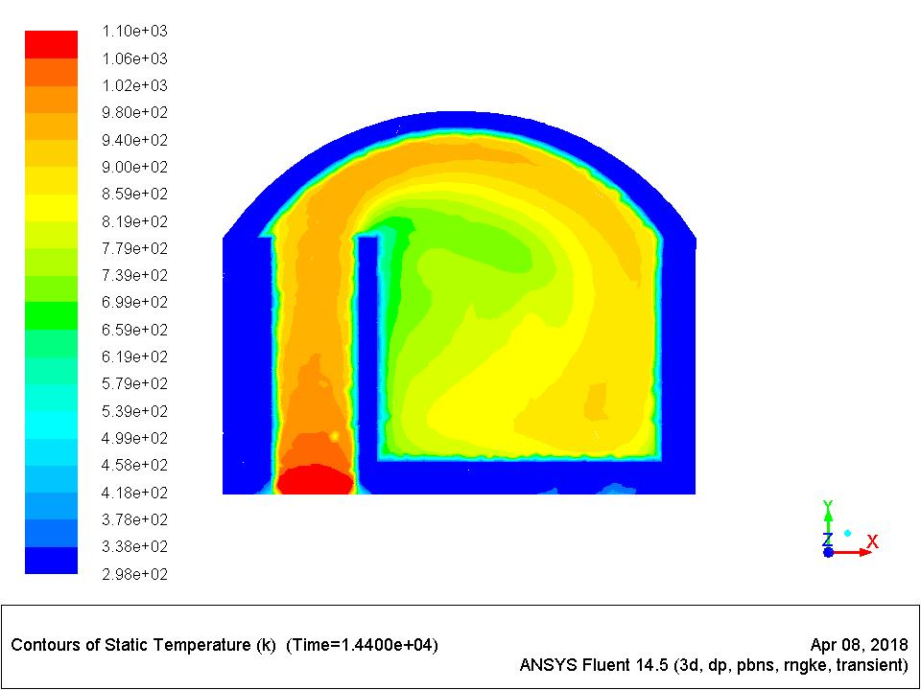  Temperature contours on the Surface of wares  Right Side view  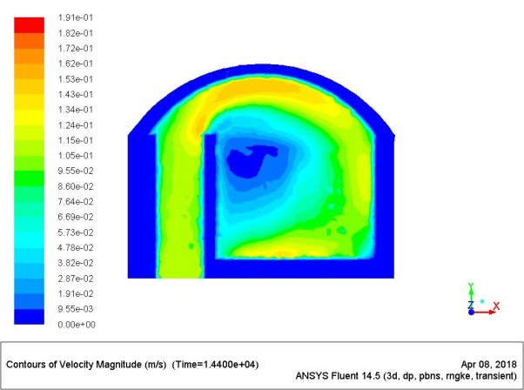  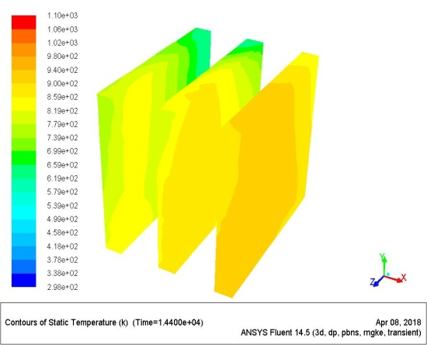  Velocity Profile (m/s)
Table B-1 (Continued)
Case 2 | Results
Ansys Model Ⅱ  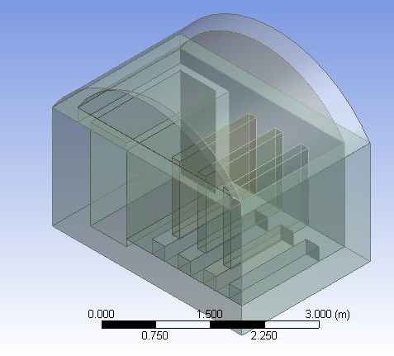  Firewall Height 1.75 m  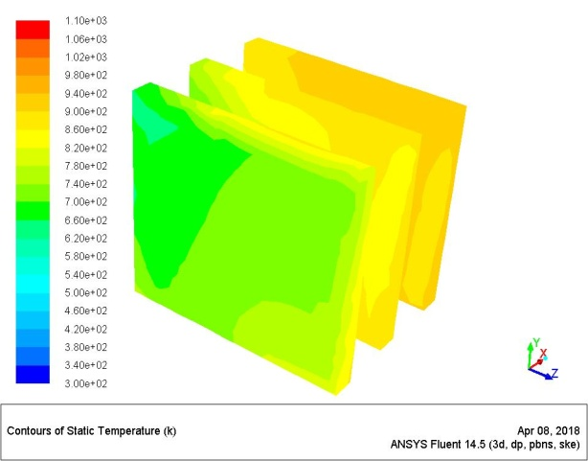  Left Side view | Static Temperature Profile (K)  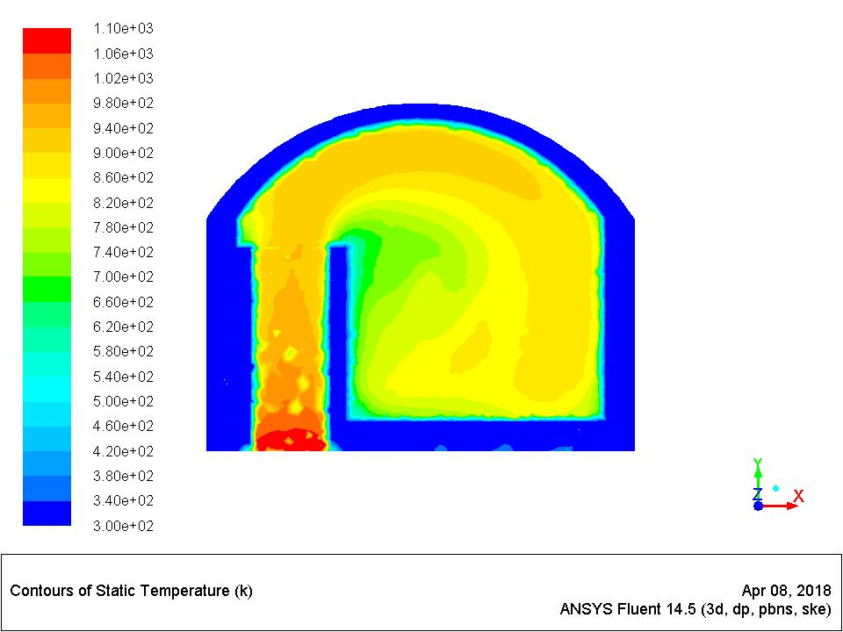  Temperature Contours on the Surface of wares  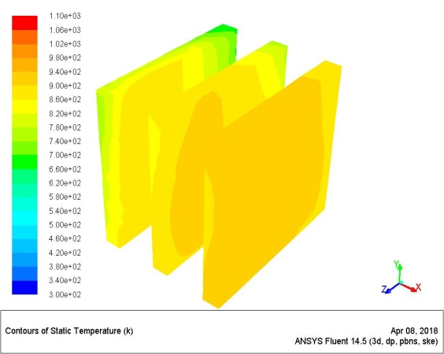  Right Side View  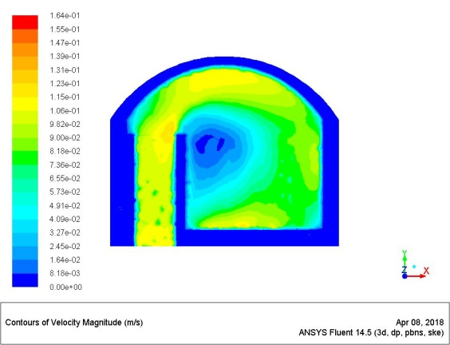  Velocity Profile (m/s)

Table B-1 (Continued)
Case 3 | Results
Ansys Model Ⅲ  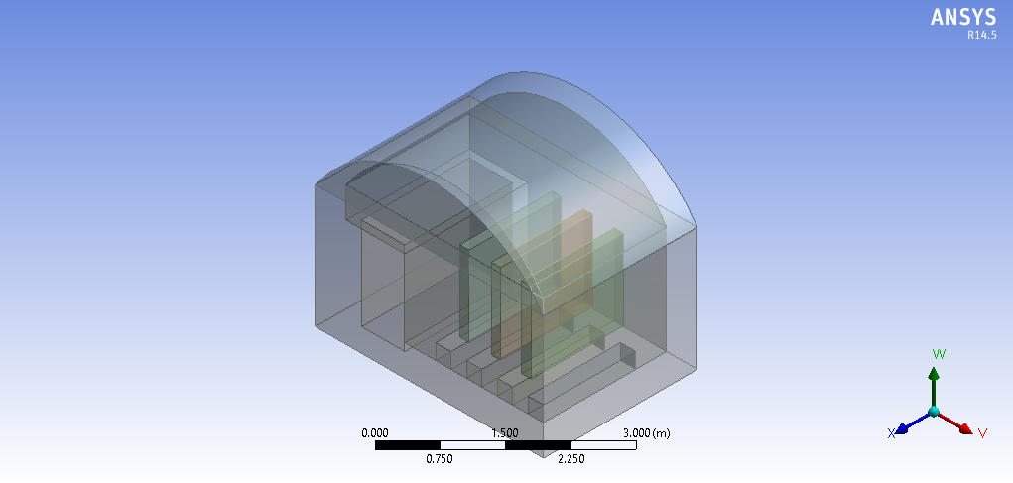  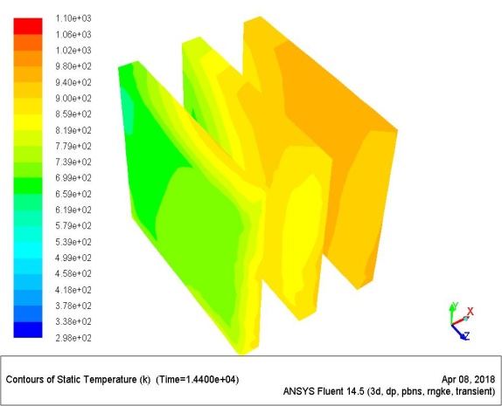  Firewall Height 1.5 m  Left Side view | 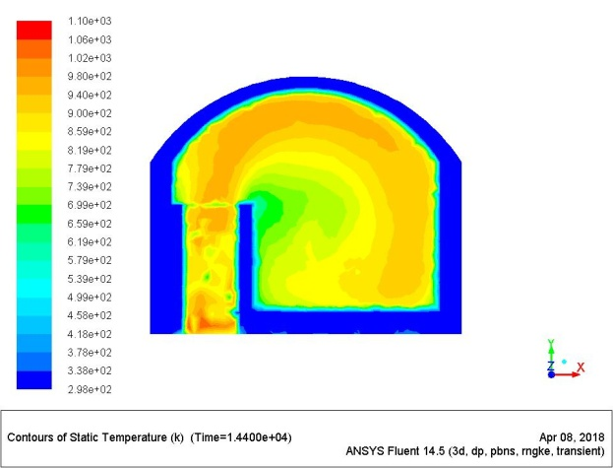  Static Temperature Profile (K)  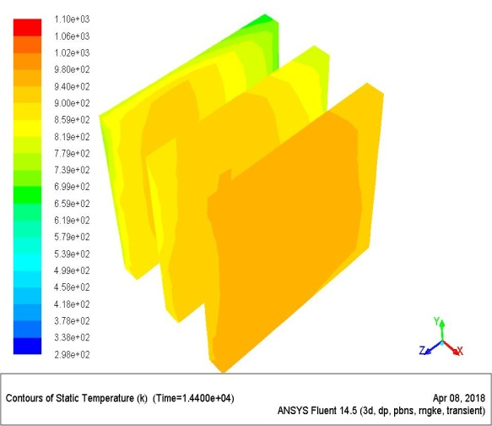  Temperature contours on the surface of wares  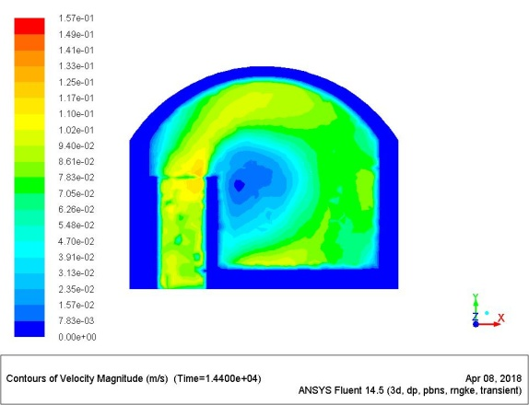  Right Side view  Velocity Profile (m/s)
Table B-1 (Continued)
Case 4 | Results
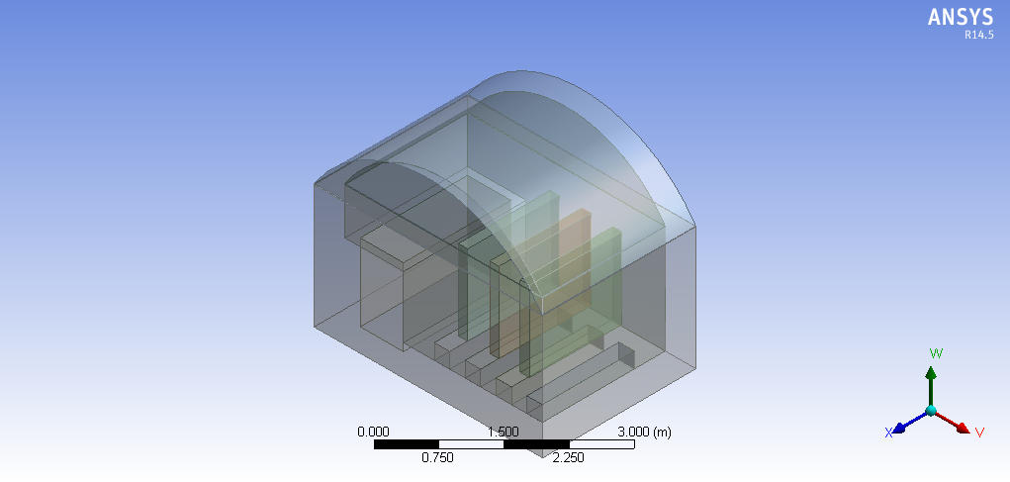  Ansys Model Ⅳ  Firewall Height 1.25 m  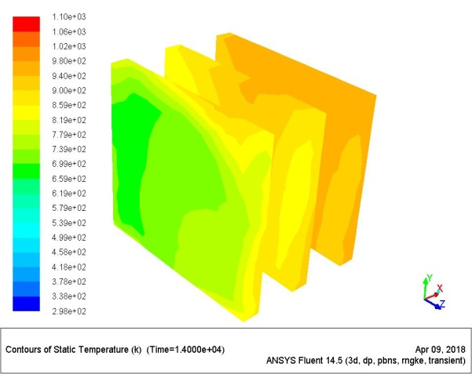  Left Side view | 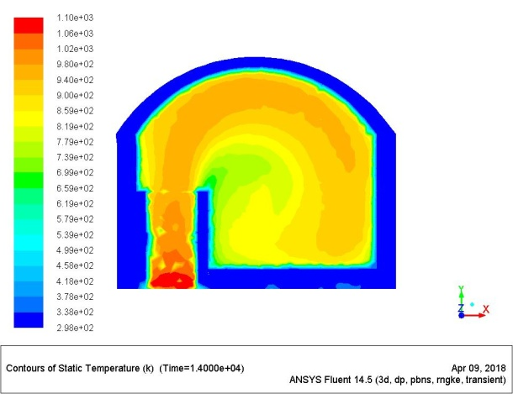  Static Temperature Profile (K)  Temperature contours on the surface of wares  Right Side view  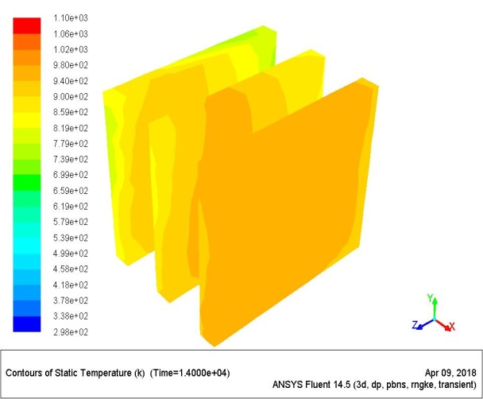  Velocity profile (m/s)  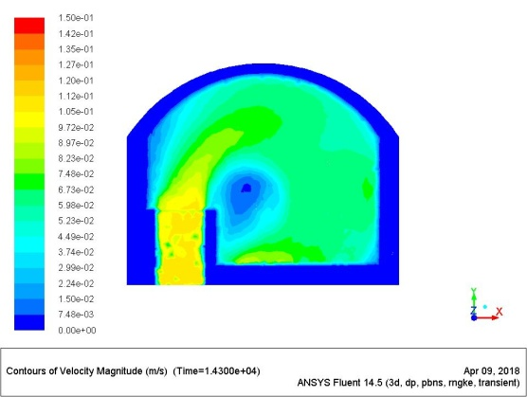
Table B-1 (Continued)
Case 5 | Results
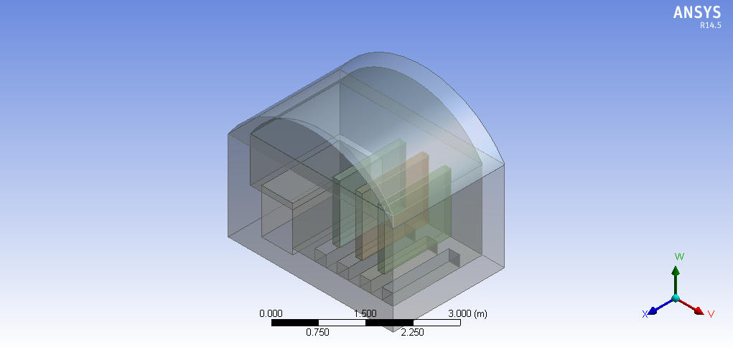  Ansys Model Ⅴ  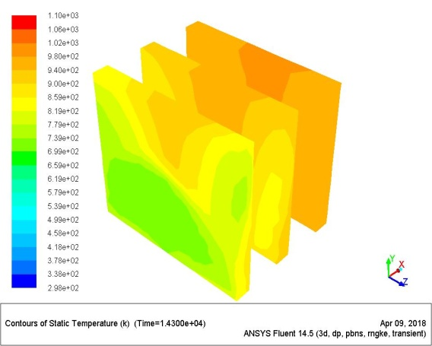  Firewall height 1 m  Left Side view | 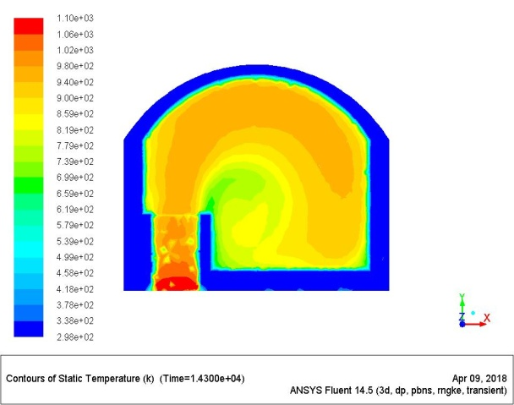  Static Temperature profile (K)  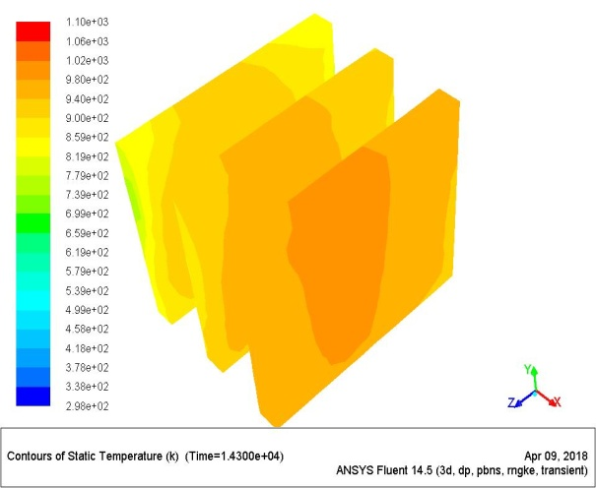  Temperature contours on the surface of wares  Right Side view  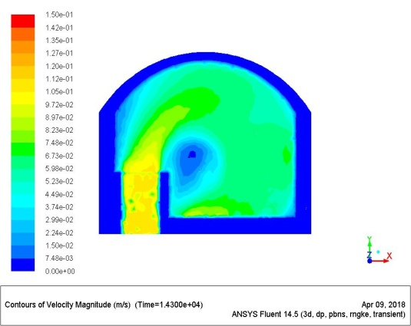  Velocity profile (m/s)
Table B-1 (Continued)
Case 6 | Results
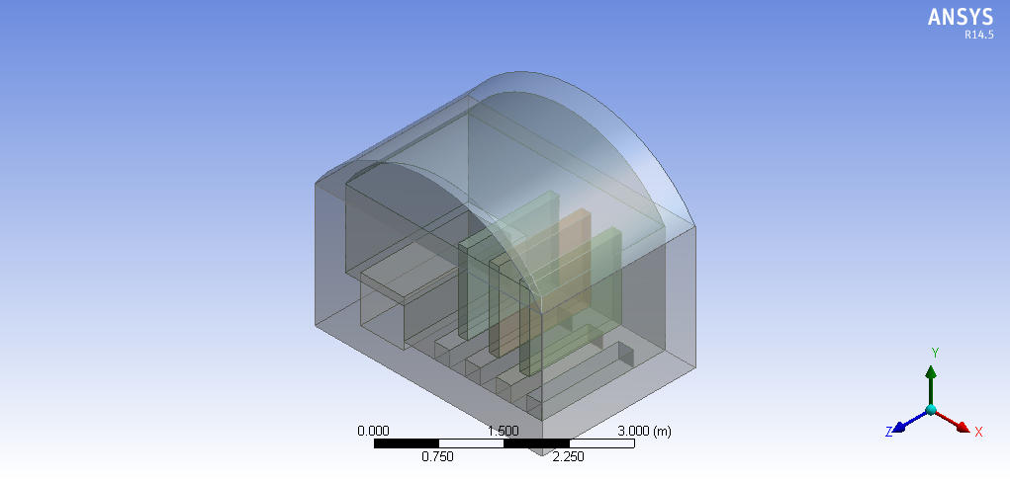  Ansys model Ⅵ  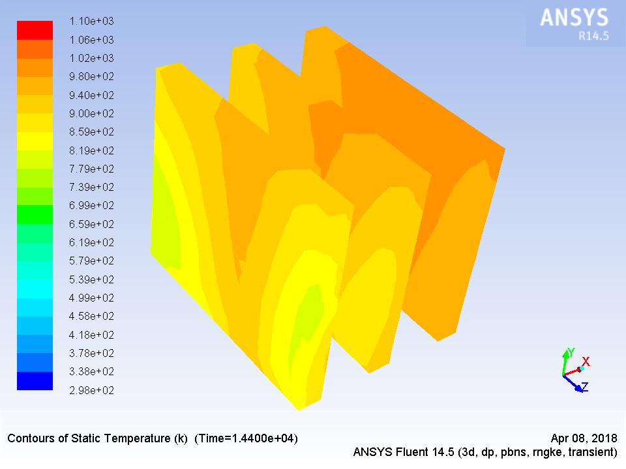  Firewall height 0.75 m  Left Side view | 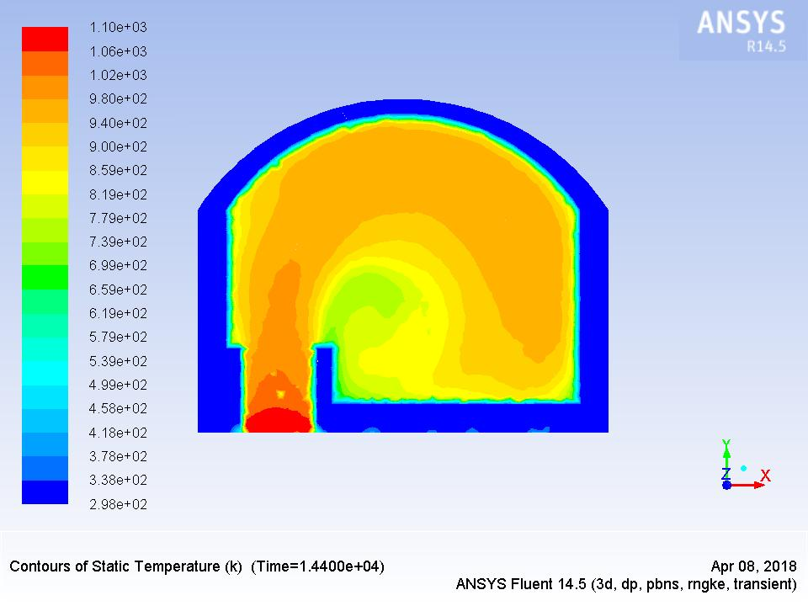  Static Temperature profile (K)  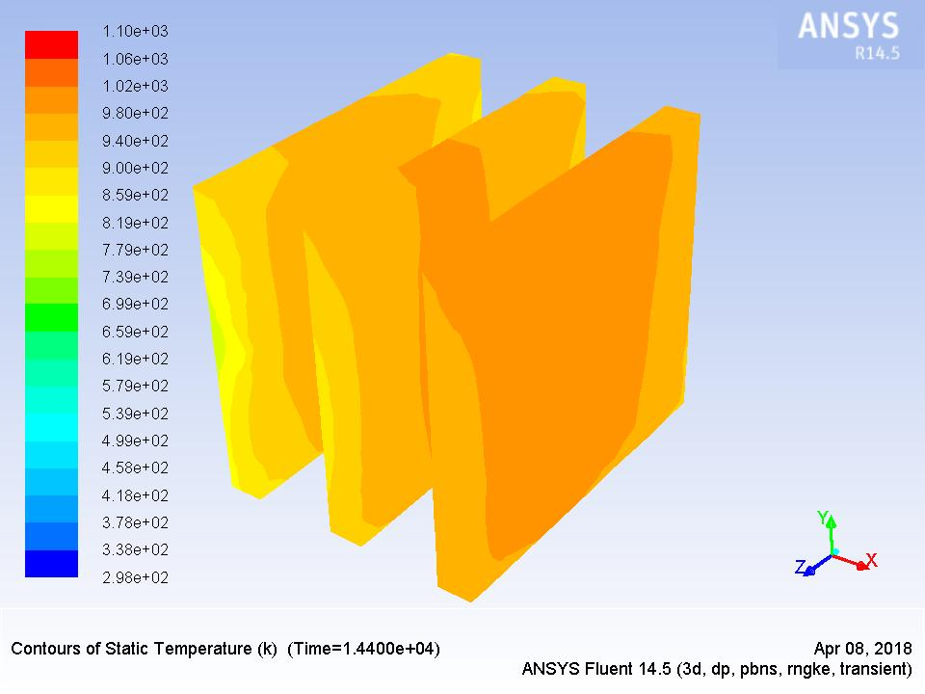  Temperature contours on surface of the wares  Right Side view  Velocity profile (m/s)  