Supplementary Information

Supplementary Figure 1. Chord diagram summarizing X-transcriptome wide analyses

Supplementary Figure 2. Expression of MCF2, HDAC8, FTX, and SLC10A3 in males and females

Supplementary Figure 3. Autosomal and X chromosome RNA sequencing quality control (QC) flow chart

Supplementary Figure 4. Y chromosome RNAseq QC flow chart

Supplementary Table 1. Pooled demographics for 767 ROS/MAP participants

Supplementary Table 2. Results of sex-stratified autosomal and X-linked analyses

Supplementary Table 3. Results of sex-stratified autosomal and X-linked analyses adjusting for APOEε4-positivity or AD neuropathological burden

Supplementary Table 4. Results including sensitivity analyses adjusting for APOEε4-positivity or AD neuropathological burden for MCF2, HDAC8, FTX, and SLC10A3 gene interactions in the DLPFC

Supplementary Table 5. Results of the three-way sex x X-linked gene x APOE-ε4 interaction analyses

Supplementary Table 6. Results of Y-linked gene associations with AD endophenotypes

Supplementary Table 7. Results of Gene Ontology: Biological Process gene set enrichment analyses for autosomal genes

Supplementary Table 8. List of significant (sex-stratified) X-linked genes reported to escape X inactivation

Supplementary Methods:
Summary of models used in regression analyses

Supplementary Methods

Summary of models used in analyses:

Model A1: Aβ OR tau tangles ~ Participant Age of Death + Sex + Post-mortem Interval + Gene

Model A2: Aβ OR tau tangles ~ Participant Age of Death + Post-mortem Interval + Gene*Sex

Model A3: Aβ OR tau tangles ~ Participant Age of Death + Post-mortem Interval + Gene
- Male- or female-stratified

Model A4: Aβ OR tau tangles ~ Participant Age of Death + Post-mortem Interval + Gene + APOEε4 status

Model B1: Longitudinal Cognition ~ Participant Age of Death + Sex + Post-mortem Interval + Latency to Death + Education + Gene

Model B2: Longitudinal Cognition ~ Participant Age of Death + Post-mortem Interval + Latency to Death + Education + Gene*Sex

Model B3: Longitudinal Cognition ~ Participant Age of Death + Post-mortem Interval + Latency to Death + Education + Gene
- Male- or female-stratified

Model B4: Longitudinal Cognition ~ Participant Age of Death + Post-mortem Interval + Latency to Death + Education + Gene + Amyloid + Tau Tangles

Supplemental Figure 1: Chord diagram summarizing X-transcriptome wide analyses

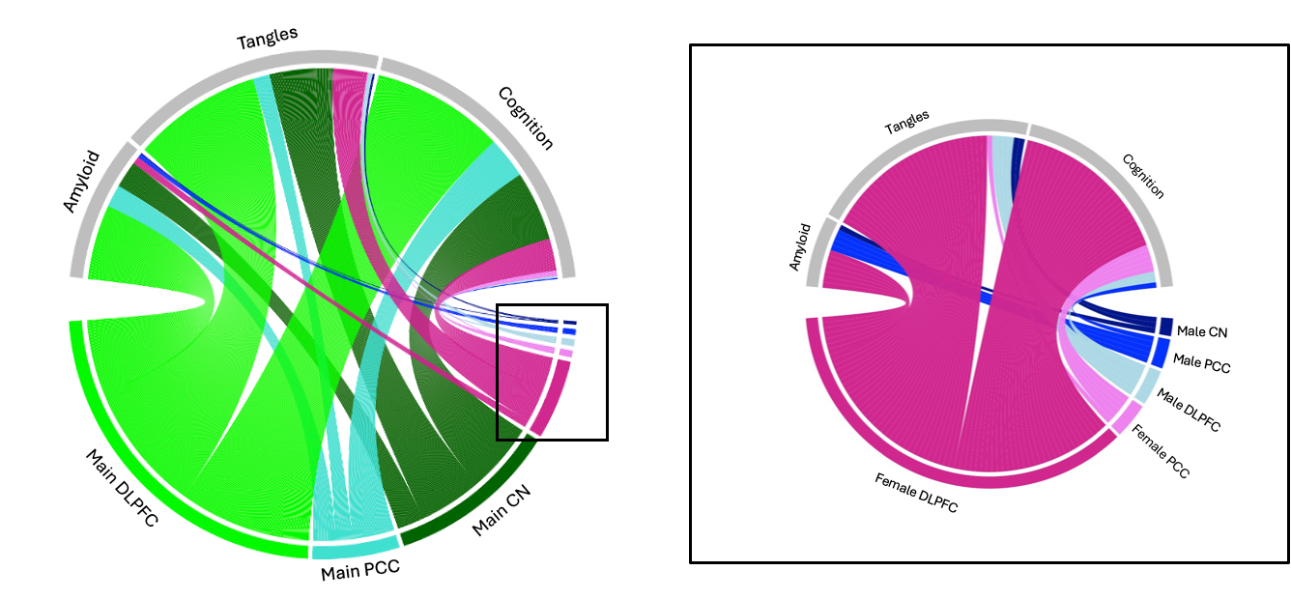

Chord diagrams summarizing the relative number of X-linked genes associated with Aβ, tau tangles, or longitudinal cognition in the Dorsolateral prefrontal cortex (DLPFC) or Posterior Cingulate Cortex (PCC) or Caudate Nucleus (CN) with chord size corresponding to number of significant genes. The right panel further highlights the significant male- and female-specific gene associations in sex-stratified analyses.

Supplemental Figure 2: Expression of MCF2, HDAC8, FTX, and SLC10A3 in males and females

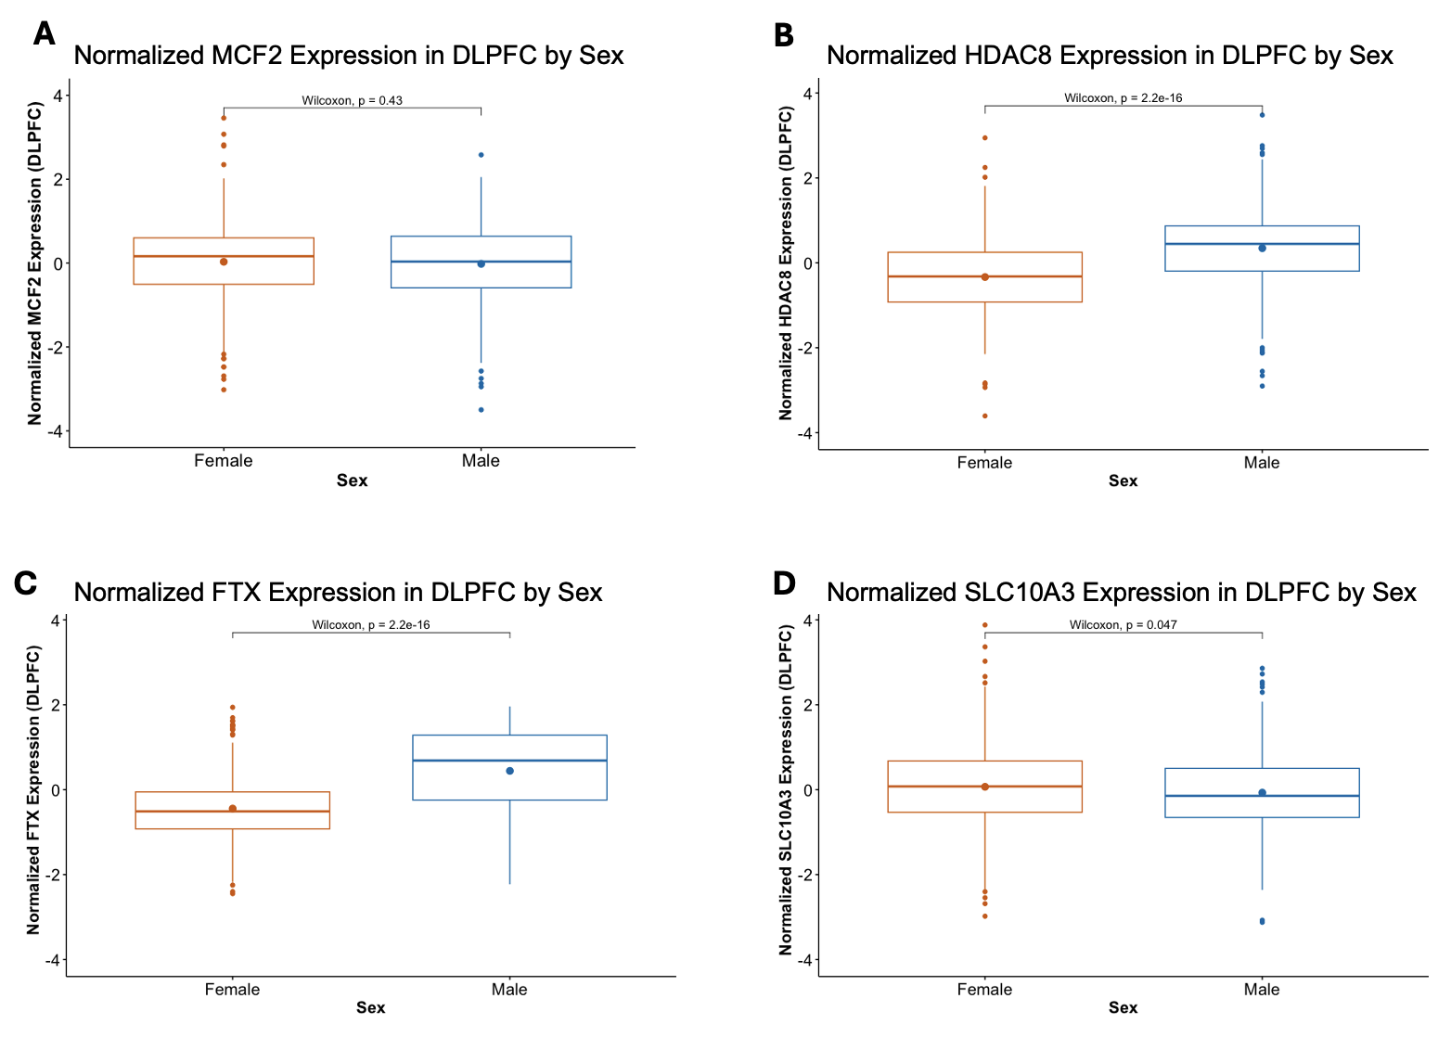

Box plots summarizing the normalized expression of MCF2, HDAC8, FTX, and SLC10A3 in the DLPFC. Females are in orange and males are in blue. Expression was compared between males and females. Wilcoxon p-values are provided for each gene.

Supplemental Figure 3: Autosomal and X chromosome RNA sequencing quality control (QC) flow chart

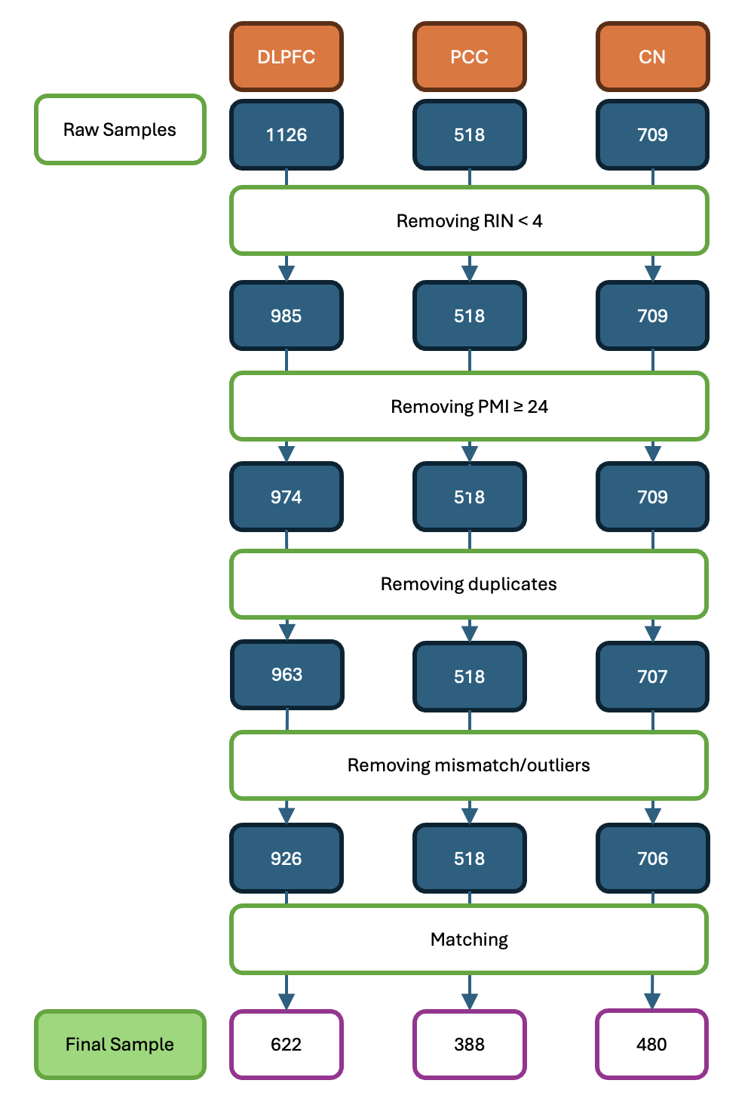

A flow chart depicting the number of participants remaining after each step of RNA sequencing quality control. The final, matched sample used for analysis is depicted at the bottom.

Supplemental Figure 4: Y chromosome RNAseq QC flow chart

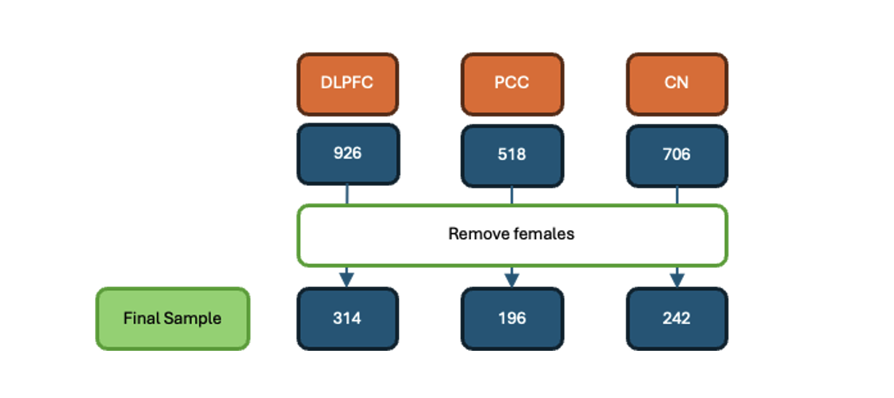
A flow chart depicting the number of participants remaining after each step of RNA sequencing quality control. Females were excluded as they do not have a Y chromosome. The final sample used for analysis is depicted at the bottom.

Supplementary Table 1: Demographics for all participants

 | TOTAL
N | 767
Age at Death (years) | 88.26±6.54
Education (years) | 16.76±3.49
Follow-up (years) | 7.41±4.92
Latency to Death (years) | 0.74±0.95
Post-mortem Interval (hours) | 7.62±4.45
% Normal Cognition | 34
% APOEε4 positive | 26
% Non-Hispanic White | 98
Amyloid (mm²) | 3.98±4.09
Tau Tangles (mm²) | 6.28±8.00
Cognition at Last Visit | -0.73±1.05
Annual Change in Cognition | -0.11±0.10

Supplementary Table 4: Summary table including sensitivity analyses for significant sex x X-linked gene interactions in the DLPFC

Outcome | Gene | Analysis | β | SE | T | P_{Uncorrected}
Tau Tangles | MCF2 | Sex x MCF2 | 0.28 | 0.07 | 3.74 | 0.0002
Tau Tangles | MCF2 | Sex x MCF2 + APOEε4 | 0.26 | 0.07 | 3.65 | 0.0003
Tau Tangles | MCF2 | Sex x MCF2 + Aβ | 0.19 | 0.07 | 2.94 | 0.003
Tau Tangles | MCF2 | Male-stratified | 0.10 | 0.05 | 1.94 | 0.052
Tau Tangles | MCF2 | Male-stratified + APOEε4 | 0.08 | 0.05 | 1.74 | 0.08
Tau Tangles | MCF2 | Male-stratified + Aβ | 0.07 | 0.04 | 1.60 | 0.11
Tau Tangles | MCF2 | Female-stratified | -0.18 | 0.06 | -3.33 | 0.001
Tau Tangles | MCF2 | Female-stratified + APOEε4 | -0.18 | 0.05 | -3.29 | 0.001
Tau Tangles |  | Female-stratified + Aβ | -0.12 | 0.05 | -2.42 | 0.02
Tau Tangles | HDAC8 | Sex x HDAC8 | -0.30 | 0.08 | -3.82 | 0.0001
Tau Tangles | HDAC8 | Sex x HDAC8 + APOEε4 | -0.29 | 0.088 | -3.86 | 0.0001
Tau Tangles | HDAC8 | Sex x HDAC8 + Aβ | -0.20 | 0.07 | -2.87 | 0.004
Tau Tangles | HDAC8 | Male-stratified | -0.08 | 0.05 | -1.60 | 0.11
Tau Tangles | HDAC8 | Male-stratified + APOEε4 | -0.08 | 0.05 | -1.61 | 0.11
Tau Tangles | HDAC8 | Male-stratified + Aβ | -0.03 | 0.05 | -0.65 | 0.51
Tau Tangles | HDAC8 | Female-stratified | 0.22 | 0.06 | 3.75 | 0.0002
Tau Tangles | HDAC8 | Female-stratified + APOEε4 | 0.21 | 0.05 | 3.74 | 0.0002
 |  | Female-stratified + Aβ | 0.17 | 0.05 | 3.39 | 0.001
Longitudinal Cognition | SLC10A3 | Sex x SLC10A3 | 0.04 | 0.01 | 3.69 | 0.0002
Longitudinal Cognition | SLC10A3 | Sex x SLC10A3 + APOEε4 | 0.04 | 0.01 | 3.69 | 0.0002
Longitudinal Cognition | SLC10A3 | Sex x SLC10A3 + Aβ + tau | 0.04 | 0.01 | 3.62 | 0.0003
Longitudinal Cognition | SLC10A3 | Male-stratified | 0.02 | 0.01 | 2.51 | 0.01ª
Longitudinal Cognition | SLC10A3 | Male-stratified + APOEε4 | 0.02 | 0.01 | 2.48 | 0.01
Longitudinal Cognition | SLC10A3 | Male-stratified + Aβ + tau | 0.02 | 0.01 | 2.31 | 0.02
Longitudinal Cognition | SLC10A3 | Female-stratified | -0.02 | 0.01 | -2.7. | 0.006
Longitudinal Cognition | SLC10A3 | Female-stratified + APOEε4 | -0.02 | 0.01 | -2.78 | 0.01
Longitudinal Cognition | SLC10A3 | Female-stratified + Aβ + tau | -0.02 | 0.01 | -2.84 | 0.005
Longitudinal Cognition | FTX | Sex x FTX | 0.04 | 0.01 | 3.82 | 0.0001
Longitudinal Cognition | FTX | Sex x FTX + APOEε4 | 0.04 | 0.01 | 3.85 | 0.0001
Longitudinal Cognition | FTX | Sex x FTX + Aβ + tau | 0.04 | 0.01 | 3.31 | 0.001
Longitudinal Cognition | FTX | Male-stratified | 0.02 | 0.01 | 3.58 | 0.0004
Longitudinal Cognition | FTX | Male-stratified + APOEε4 | 0.02 | 0.01 | 3.53 | 0.0004
Longitudinal Cognition | FTX | Male-stratified + Aβ + tau | 0.03 | 0.01 | 3.70 | 0.0002
Longitudinal Cognition | FTX | Female-stratified | -0.02 | 0.01 | -2.06 | 0.04
Longitudinal Cognition | FTX | Female-stratified + APOEε4 | -0.02 | 0.01 | -2.22 | 0.03
Longitudinal Cognition | FTX | Female-stratified + Aβ + tau | -0.01 | 0.01 | -1.31 | 0.19
All presented p-values are uncorrected. Bolded values represent those that survived FDR-correction in discovery analyses.
P-values for sensitivity analyses are not corrected.

Supplementary Table 5: Results for sex x X-linked gene x APOE-ε4 interaction analyses

Outcome | Gene | Analysis | β | SE | T | P_{uncorrected}
Tau Tangles | MCF2 | Sex x MCF2 x APOEε4 | 0.03 | 0.16 | 0.18 | 0.86
Tau Tangles | HDAC8 | Sex x HDAC8 x APOEε4 | -0.25 | 0.18 | -1.40 | 0.16
Longitudinal Cognition | SLC10A3 | Sex x SLC10A3 x APOEε4 | -0.04 | 0.02 | -1.75 | 0.08
Longitudinal Cognition | FTX | Sex x FTX x APOEε4 | 0.05 | 0.02 | 2.20 | 0.03
Longitudinal Cognition | FTX | APOEε4-negative females | -0.01 | 0.01 | -1.48 | 0.14
Longitudinal Cognition | FTX | APOEε4-positive females | -0.04 | 0.02 | -1.66 | 0.10
Longitudinal Cognition | FTX | APOEε4-negative males | 0.01 | 0.01 | 1.96 | 0.0498
Longitudinal Cognition | FTX | APOEε4-positive males | 0.05 | 0.02 | 2.85 | 0.01

