Supplement
Unstable Measures, Unreliable Effects:
Re-evaluating Replicability with Reliability Informed Confidence Intervals

Carl F Weems
Iowa State University

Contents

Supplement A
A.1 Simulations Section Code for Simulated replication studies Pages 2-17
Empirical Sections
A.2 Code used for the CI’s in the Empirical Example Pages 17-23
A. 3 Code used for the CI’s in the Predictions in RPP Pages 23-31
Supplement B
Supplement B Additional Analyses
B.1 Simulated Illustration - additional analyses Pages 32-33
B.2 Analysis Table for replicability project analysis Page 34

Supplement A
Code and Original figure generation and relevant output for each main analysis in the main paper
A.1 SIMULATIONS SECTION
Code for Simulated replication studies
Below is the R code to simulate 10000 replications of a study where n = 1000 where A is correlated with B at r=.20 and where the test retest reliability of B is .40 report the distributions of the replicated correlations and compare this to 10000 replications of a study where A is correlated with B at r=.20 but where the test retest reliability of B is .80 report the distributions of the replicated correlations and compare these to 10000 replications of a study where A is correlated with B at r=.20 but where the test retest reliability of B varies from .4 to .8 report the distributions of the replicated correlations and then compare the distributions. Report descriptive statistics and the standard deviation of the three distributions.
# Load necessary libraries
library(MASS)
library(ggplot2)
library(dplyr)

# Function to simulate correlations
simulate_correlations <- function(n, r, reliability, reps) {
correlations <- numeric(reps)
for (i in 1:reps) {
# Generate correlated data
Sigma <- matrix(c(1, r, r, 1), 2, 2)
data <- mvrnorm(n, mu = c(0, 0), Sigma = Sigma)
A <- data[, 1]
B <- data[, 2]

# Apply reliability to B
B_reliable <- B * sqrt(reliability) + rnorm(n) * sqrt(1 - reliability)

# Calculate correlation
correlations[i] <- cor(A, B_reliable)
}
return(correlations)
}

# Parameters
n <- 1000
r <- 0.20
reps <- 10000

# Simulations
correlations_40 <- simulate_correlations(n, r, 0.40, reps)
correlations_80 <- simulate_correlations(n, r, 0.80, reps)

# Varying reliability from 0.4 to 0.8
reliabilities <- runif(reps, 0.4, 0.8)
correlations_varying <- numeric(reps)
for (i in 1:reps) {
correlations_varying[i] <- simulate_correlations(n, r, reliabilities[i], 1)
}

# Combine data into one data frame
correlation_data <- data.frame(
correlation = c(correlations_40, correlations_80, correlations_varying),
reliability = factor(rep(c("0.40", "0.80", "0.4 to 0.8"), each = reps))
)

# Plot combined histogram using ggplot2 with original colors
ggplot(correlation_data, aes(x = correlation, fill = reliability)) +
geom_histogram(binwidth = 0.01, color = "black", alpha = 0.7, position = "identity") +
labs(title = "Distribution of Correlations by Reliability", x = "Correlation", y = "Frequency") +
theme_minimal() +
scale_fill_manual(values = c("0.40" = "blue", "0.80" = "green", "0.4 to 0.8" = "red"))

# Descriptive statistics
descriptive_stats <- function(correlations) {
data.frame(
mean = mean(correlations),
sd = sd(correlations),
min = min(correlations),
max = max(correlations)
)
}

stats_40 <- descriptive_stats(correlations_40)
stats_80 <- descriptive_stats(correlations_80)
stats_varying <- descriptive_stats(correlations_varying)

# Combine descriptive statistics into one table
descriptive_table <- bind_rows(
stats_40 %>% mutate(reliability = "0.40"),
stats_80 %>% mutate(reliability = "0.80"),
stats_varying %>% mutate(reliability = "0.4 to 0.8")
)
# Print descriptive statistics table
print(descriptive_table)

OUTPUT results with n= 1000
mean sd min max reliability
1 0.1266843 0.03116285 -0.01593987 0.2424047 0.40
2 0.1784227 0.03086749 0.05272367 0.2835998 0.80
3 0.1541106 0.03456820 0.01127498 0.2918135 0.4 to 0.8
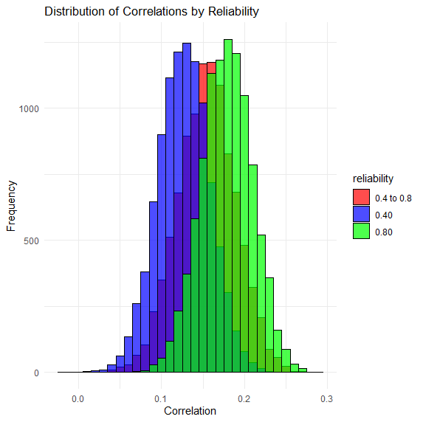
Results with N = 10,000
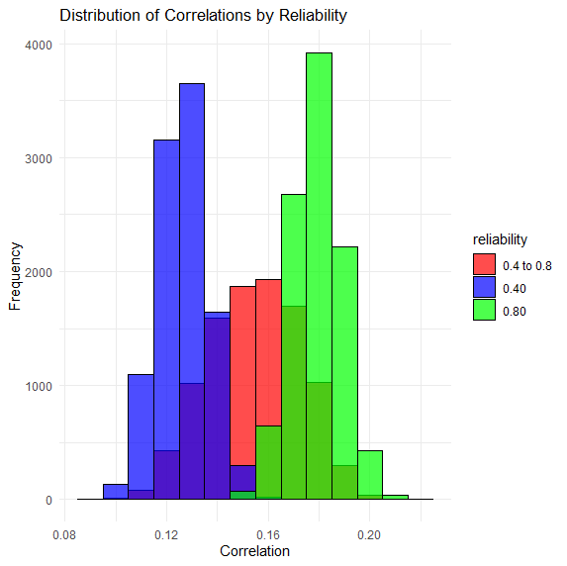

mean sd min max reliability
1 0.1265551 0.009911270 0.08952968 0.1615037 0.40
2 0.1790080 0.009677432 0.14199248 0.2157136 0.80
3 0.1544979 0.017927944 0.09809366 0.2075029 0.4 to 0.8

Below is the code to Plot the correlation/scatter plot in Figure 5 of the main paper
# Load necessary libraries
library(MASS)
library(ggplot2)
library(dplyr)

# Function to simulate correlations
simulate_correlations <- function(n, r, reliability, reps) {
correlations <- numeric(reps)
for (i in 1:reps) {
# Generate correlated data
Sigma <- matrix(c(1, r, r, 1), 2, 2)
data <- mvrnorm(n, mu = c(0, 0), Sigma = Sigma)
A <- data[, 1]
B <- data[, 2]

# Apply reliability to B
B_reliable <- B * sqrt(reliability) + rnorm(n) * sqrt(1 - reliability)

# Calculate correlation
correlations[i] <- cor(A, B_reliable)
}
return(correlations)
}

# Parameters
n <- 1500
r <- 0.20
reps <- 1000

# Varying reliability from 0.4 to 0.8
reliabilities <- runif(reps, 0.4, 0.8)
correlations_varying <- numeric(reps)
for (i in 1:reps) {
correlations_varying[i] <- simulate_correlations(n, r, reliabilities[i], 1)
}

# Combine data into one data frame
correlation_data <- data.frame(
correlation = correlations_varying,
reliability = reliabilities
)

# Scatter plot with regression line using ggplot2
plot <- ggplot(correlation_data, aes(x = reliability, y = correlation)) +
geom_point(alpha = 0.5) +
geom_smooth(method = "lm", color = "red", se = FALSE) +
labs(title = "Scatter Plot of Simulated Correlations vs. Reliability with Regression Line",
x = "Reliability",
y = "Simulated Correlation") +
theme_minimal()

# Calculate R-squared value
model <- lm(correlation ~ reliability, data = correlation_data)
r_squared <- summary(model)$r.squared

# Print R-squared value
print(paste("R-squared value for the regression line:", round(r_squared, 2)))

# Display the plot
print(plot)
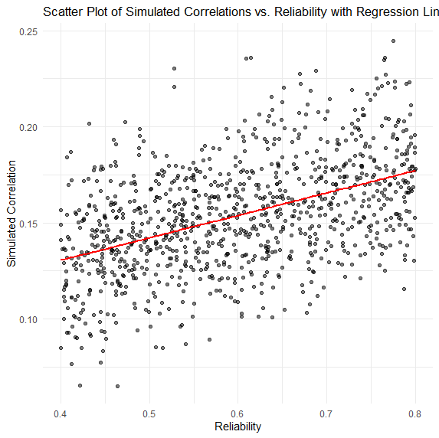
"R-squared value for the regression line: 0.22"

Below is the Code for traditional 95% CI Bootstrap in the theoretical example of r = .2
# Load necessary libraries
library(MASS)
library(boot)

# Function to calculate correlation
correlation_function <- function(data, indices) {
d <- data[indices, ]
return(cor(d$A, d$B))
}

# Parameters
n <- 1000
r <- 0.20
reps <- 10000

# Generate correlated data
Sigma <- matrix(c(1, r, r, 1), 2, 2)
data <- mvrnorm(n, mu = c(0, 0), Sigma = Sigma)
data <- data.frame(A = data[, 1], B = data[, 2])

# Bootstrapping
set.seed(123)
bootstrap_results <- boot(data, statistic = correlation_function, R = reps)

# Calculate confidence intervals
ci <- boot.ci(bootstrap_results, type = "perc")

# Print confidence intervals
print(ci)

# Plot histogram of bootstrap correlations
bootstrap_correlations <- bootstrap_results$t
hist(bootstrap_correlations, main = "Bootstrap Distribution of Correlations", xlab = "Correlation", breaks = 50)
abline(v = ci$percent[4:5], col = "red", lwd = 2, lty = 2) # Add confidence interval lines

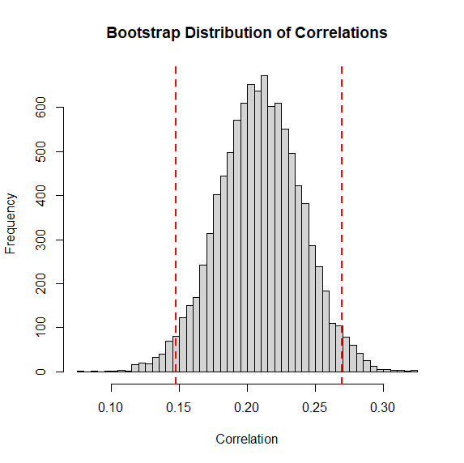

Intervals :
Level Percentile
95% ( 0.1476, 0.2697 )

Below is the code to create Bayesian Credible CI’s for the Theoretical example of r=.2
# Load necessary libraries
library(MASS)
library(brms)

# Parameters
n <- 1000
r <- 0.20
reps <- 100

# Generate correlated data
Sigma <- matrix(c(1, r, r, 1), 2, 2)
data <- mvrnorm(n, mu = c(0, 0), Sigma = Sigma)
data <- data.frame(A = data[, 1], B = data[, 2])

# Define the Bayesian model
model <- bf(B ~ A)

# Fit the Bayesian model
fit <- brm(model, data = data, chains = 4, iter = 2000, warmup = 1000, seed = 123)

# Summarize the results
summary(fit)

# Extract the posterior samples for the correlation
posterior_samples <- as_draws_df(fit)
correlation_samples <- posterior_samples$b_A

# Calculate the 95% credible interval
credible_interval <- quantile(correlation_samples, probs = c(0.025, 0.975))

# Print the credible interval
print(credible_interval)

# Plot the posterior distribution of the correlation
hist(correlation_samples, main = "Posterior Distribution of Correlation", xlab = "Correlation", breaks = 50)
abline(v = credible_interval, col = "red", lwd = 2, lty = 2) # Add credible interval lines
100 sims
2.5% 97.5%
0.1107562 0.2310432
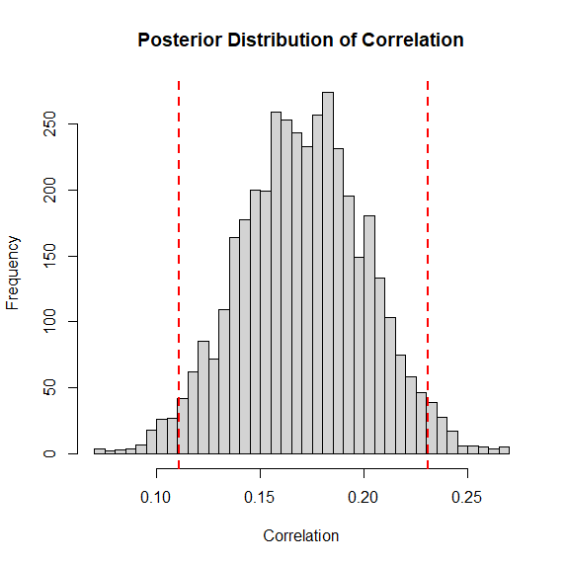
10 sims
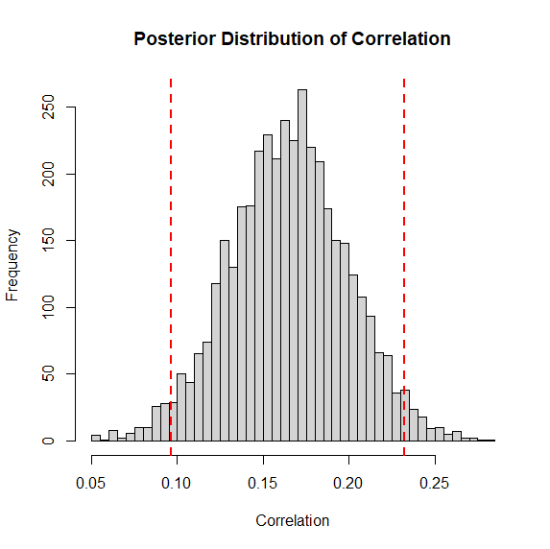
2.5% 97.5%
0.09615269 0.23246540

Below is the code to calculate Bayesian Credible CI but updated for Varying reliabilities
# Load necessary libraries
library(MASS)
library(brms)

# Parameters
n <- 1000
r <- 0.20
reps <- 10 # Number of simulations

# Function to simulate data with varying reliability
simulate_data <- function(n, r, reliability) {
Sigma <- matrix(c(1, r, r, 1), 2, 2)
data <- mvrnorm(n, mu = c(0, 0), Sigma = Sigma)
A <- data[, 1]
B <- data[, 2] * sqrt(reliability) + rnorm(n) * sqrt(1 - reliability)
return(data.frame(A = A, B = B))
}

# Varying reliability from 0.4 to 0.8
reliabilities <- runif(reps, 0.4, 0.8)

# Initialize lists to store results
credible_intervals <- list()
correlation_samples_list <- list()

# Loop over each reliability value and fit the Bayesian model
for (i in 1:reps) {
data <- simulate_data(n, r, reliabilities[i])

# Define the Bayesian model
model <- bf(B ~ A)

# Fit the Bayesian model
fit <- brm(model, data = data, chains = 4, iter = 2000, warmup = 1000, seed = 123)

# Extract the posterior samples for the correlation
posterior_samples <- as_draws_df(fit)
correlation_samples <- posterior_samples$b_A

# Calculate the 95% credible interval
credible_interval <- quantile(correlation_samples, probs = c(0.025, 0.975))

# Store the results
credible_intervals[[i]] <- credible_interval
correlation_samples_list[[i]] <- correlation_samples
}

# Combine all correlation samples into one vector for plotting
all_correlation_samples <- unlist(correlation_samples_list)

# Plot the posterior distribution of the correlation for all simulations
hist(all_correlation_samples, main = "Posterior Distribution of Correlation (Varying Reliability)", xlab = "Correlation", breaks = 50)

# Calculate overall credible interval for all simulations
overall_credible_interval <- quantile(all_correlation_samples, probs = c(0.025, 0.975))

# Add overall credible interval lines to the plot
abline(v = overall_credible_interval, col = "red", lwd = 2, lty = 2)

# Print overall credible interval
print(overall_credible_interval)
With 100 sims
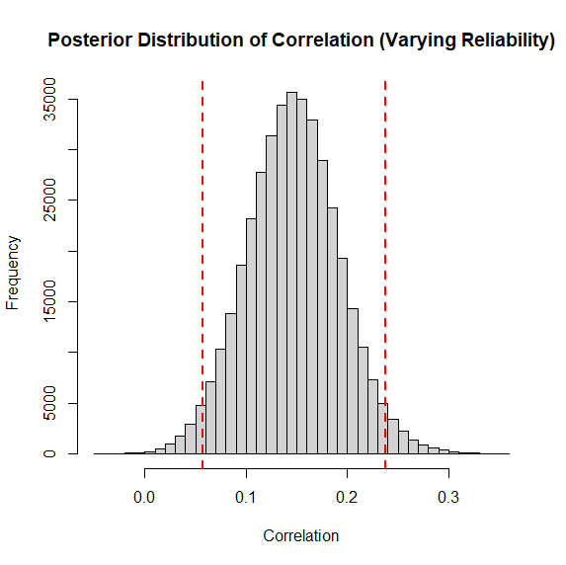
2.5% 97.5%
0.05764615 0.23815998
With 10 sims
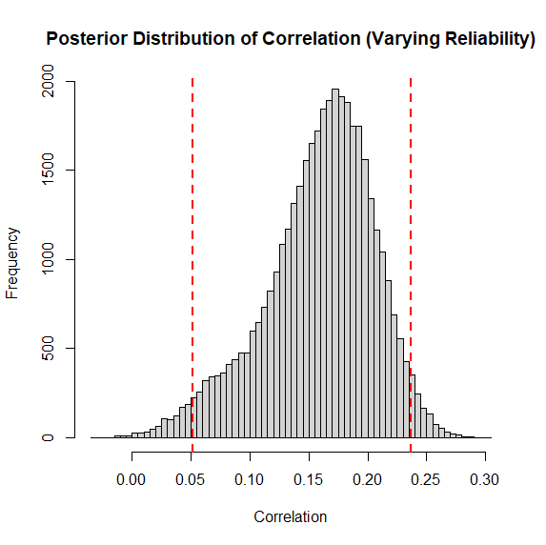
2.5% 97.5%
0.0515779 0.2364019
The simulated example of Low wide reliability
# Load necessary libraries
library(MASS)
library(brms)

# Parameters
n <- 1500
r <- 0.20
reps <- 10 # Number of simulations

# Function to simulate data with varying reliability
simulate_data <- function(n, r, reliability) {
Sigma <- matrix(c(1, r, r, 1), 2, 2)
data <- mvrnorm(n, mu = c(0, 0), Sigma = Sigma)
A <- data[, 1]
B <- data[, 2] * sqrt(reliability) + rnorm(n) * sqrt(1 - reliability)
return(data.frame(A = A, B = B))
}

# Varying reliability from empirical example
reliabilities <- runif(reps, 0.01, 0.75)

# Initialize lists to store results
credible_intervals <- list()
correlation_samples_list <- list()

# Loop over each reliability value and fit the Bayesian model
for (i in 1:reps) {
data <- simulate_data(n, r, reliabilities[i])

# Define the Bayesian model
model <- bf(B ~ A)

# Fit the Bayesian model
fit <- brm(model, data = data, chains = 4, iter = 2000, warmup = 1000, seed = 123)

# Extract the posterior samples for the correlation
posterior_samples <- as_draws_df(fit)
correlation_samples <- posterior_samples$b_A

# Calculate the 95% credible interval
credible_interval <- quantile(correlation_samples, probs = c(0.025, 0.975))

# Store the results
credible_intervals[[i]] <- credible_interval
correlation_samples_list[[i]] <- correlation_samples
}

# Combine all correlation samples into one vector for plotting
all_correlation_samples <- unlist(correlation_samples_list)

# Plot the posterior distribution of the correlation for all simulations
hist(all_correlation_samples, main = "Posterior Distribution of Correlation (Varying Reliability)", xlab = "Correlation", breaks = 50)

# Calculate overall credible interval for all simulations
overall_credible_interval <- quantile(all_correlation_samples, probs = c(0.025, 0.975))

# Add overall credible interval lines to the plot
abline(v = overall_credible_interval, col = "red", lwd = 2, lty = 2)

# Print overall credible interval
print(overall_credible_interval)

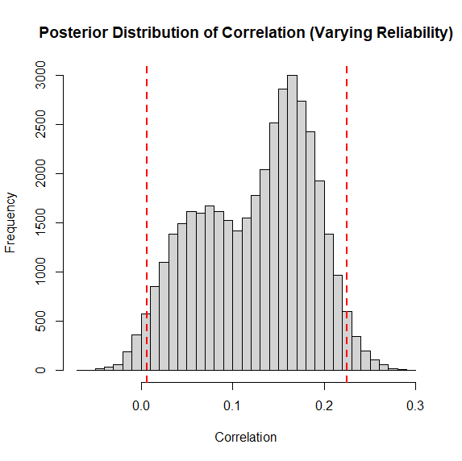
2.5% 97.5%
0.006285188 0.224560900
For the example of High narrow reliability
# Load necessary libraries
library(MASS)
library(brms)

# Parameters
n <- 1500
r <- 0.20
reps <- 10 # Number of simulations

# Function to simulate data with varying reliability
simulate_data <- function(n, r, reliability) {
Sigma <- matrix(c(1, r, r, 1), 2, 2)
data <- mvrnorm(n, mu = c(0, 0), Sigma = Sigma)
A <- data[, 1]
B <- data[, 2] * sqrt(reliability) + rnorm(n) * sqrt(1 - reliability)
return(data.frame(A = A, B = B))
}

# Varying reliability from empirical example
reliabilities <- runif(reps, 0.80, 0.95)

# Initialize lists to store results
credible_intervals <- list()
correlation_samples_list <- list()

# Loop over each reliability value and fit the Bayesian model
for (i in 1:reps) {
data <- simulate_data(n, r, reliabilities[i])

# Define the Bayesian model
model <- bf(B ~ A)

# Fit the Bayesian model
fit <- brm(model, data = data, chains = 4, iter = 2000, warmup = 1000, seed = 123)

# Extract the posterior samples for the correlation
posterior_samples <- as_draws_df(fit)
correlation_samples <- posterior_samples$b_A

# Calculate the 95% credible interval
credible_interval <- quantile(correlation_samples, probs = c(0.025, 0.975))

# Store the results
credible_intervals[[i]] <- credible_interval
correlation_samples_list[[i]] <- correlation_samples
}

# Combine all correlation samples into one vector for plotting
all_correlation_samples <- unlist(correlation_samples_list)

# Plot the posterior distribution of the correlation for all simulations
hist(all_correlation_samples, main = "Posterior Distribution of Correlation (Varying Reliability)", xlab = "Correlation", breaks = 50)

# Calculate overall credible interval for all simulations
overall_credible_interval <- quantile(all_correlation_samples, probs = c(0.025, 0.975))

# Add overall credible interval lines to the plot
abline(v = overall_credible_interval, col = "red", lwd = 2, lty = 2)

# Print overall credible interval
print(overall_credible_interval)

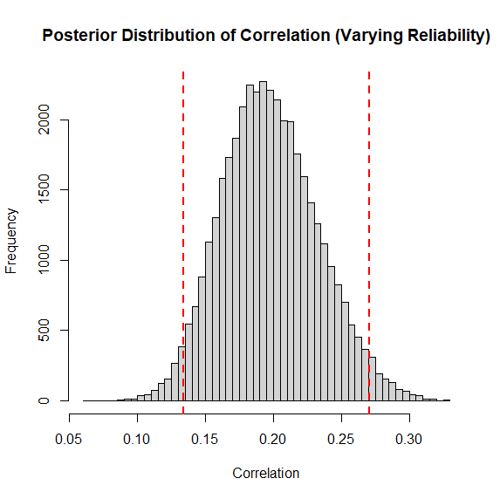
2.5% 97.5%
0.1335494 to 0.2707543

A.2 Code used for the CI’s in the Empirical Example

For Bayes CI the empirical example Varying reliability model
# Load necessary libraries
library(MASS)
library(brms)

# Parameters
n <- 141
r <- 0.318
reps <- 10 # Number of simulations

# Function to simulate data with varying reliability
simulate_data <- function(n, r, reliability) {
Sigma <- matrix(c(1, r, r, 1), 2, 2)
data <- mvrnorm(n, mu = c(0, 0), Sigma = Sigma)
A <- data[, 1]
B <- data[, 2] * sqrt(reliability) + rnorm(n) * sqrt(1 - reliability)
return(data.frame(A = A, B = B))
}

# Varying reliability from empirical example
reliabilities <- runif(reps, 0.53, 0.75)

# Initialize lists to store results
credible_intervals <- list()
correlation_samples_list <- list()

# Loop over each reliability value and fit the Bayesian model
for (i in 1:reps) {
data <- simulate_data(n, r, reliabilities[i])

# Define the Bayesian model
model <- bf(B ~ A)

# Fit the Bayesian model
fit <- brm(model, data = data, chains = 4, iter = 2000, warmup = 1000, seed = 123)

# Extract the posterior samples for the correlation
posterior_samples <- as_draws_df(fit)
correlation_samples <- posterior_samples$b_A

# Calculate the 95% credible interval
credible_interval <- quantile(correlation_samples, probs = c(0.025, 0.975))

# Store the results
credible_intervals[[i]] <- credible_interval
correlation_samples_list[[i]] <- correlation_samples
}

# Combine all correlation samples into one vector for plotting
all_correlation_samples <- unlist(correlation_samples_list)

# Plot the posterior distribution of the correlation for all simulations
hist(all_correlation_samples, main = "Posterior Distribution of Correlation (Varying Reliability)", xlab = "Correlation", breaks = 50)

# Calculate overall credible interval for all simulations
overall_credible_interval <- quantile(all_correlation_samples, probs = c(0.025, 0.975))

# Add overall credible interval lines to the plot
abline(v = overall_credible_interval, col = "red", lwd = 2, lty = 2)

# Print overall credible interval
print(overall_credible_interval)
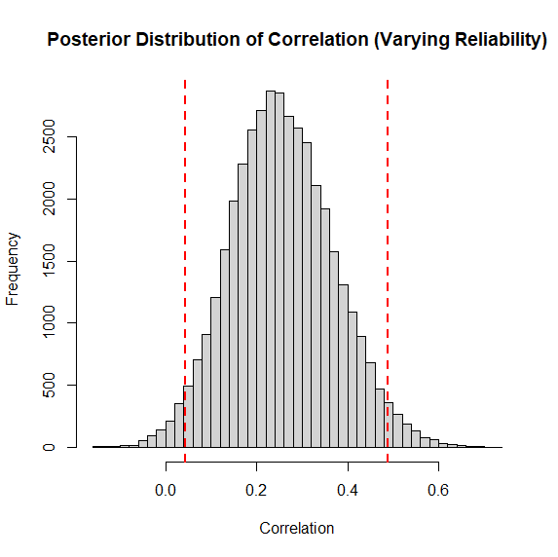
2.5% 97.5%
0.04397761 0.48918878
.002 to .239 R2
Just Basian CI empirical example
# Load necessary libraries
library(MASS)
library(brms)

# Parameters
n <- 141
r <- 0.318
reps <- 10 # Number of simulations

# Generate correlated data
Sigma <- matrix(c(1, r, r, 1), 2, 2)
data <- mvrnorm(n, mu = c(0, 0), Sigma = Sigma)
data <- data.frame(A = data[, 1], B = data[, 2])

# Define the Bayesian model
model <- bf(B ~ A)

# Fit the Bayesian model
fit <- brm(model, data = data, chains = 4, iter = 2000, warmup = 1000, seed = 123)

# Summarize the results
summary(fit)

# Extract the posterior samples for the correlation
posterior_samples <- as_draws_df(fit)
correlation_samples <- posterior_samples$b_A

# Calculate the 95% credible interval
credible_interval <- quantile(correlation_samples, probs = c(0.025, 0.975))

# Print the credible interval
print(credible_interval)

# Plot the posterior distribution of the correlation
hist(correlation_samples, main = "Posterior Distribution of Correlation", xlab = "Correlation", breaks = 50)
abline(v = credible_interval, col = "red", lwd = 2, lty = 2) # Add credible interval lines
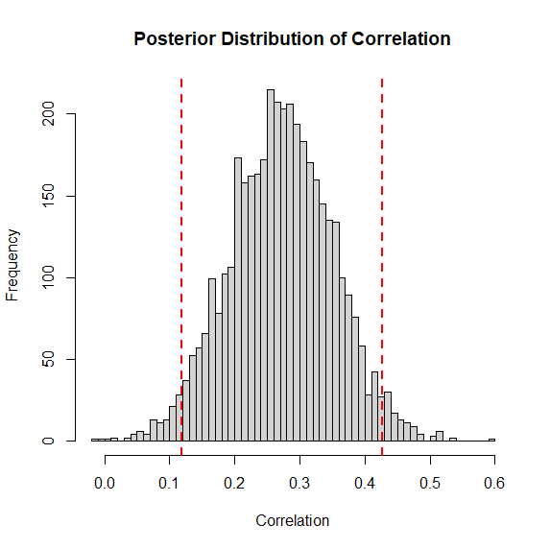
2.5% 97.5%
0.1179504 0.4272126
.014 to .182 R2

Code for 95% CI Bootstrap empirical example
# Load necessary libraries
library(MASS)
library(boot)

# Function to calculate correlation
correlation_function <- function(data, indices) {
d <- data[indices, ]
return(cor(d$A, d$B))
}

# Parameters
n <- 141
r <- 0.318
reps <- 10000

# Generate correlated data
Sigma <- matrix(c(1, r, r, 1), 2, 2)
data <- mvrnorm(n, mu = c(0, 0), Sigma = Sigma)
data <- data.frame(A = data[, 1], B = data[, 2])

# Bootstrapping
set.seed(123)
bootstrap_results <- boot(data, statistic = correlation_function, R = reps)

# Calculate confidence intervals
ci <- boot.ci(bootstrap_results, type = "perc")

# Print confidence intervals
print(ci)

# Plot histogram of bootstrap correlations
bootstrap_correlations <- bootstrap_results$t
hist(bootstrap_correlations, main = "Bootstrap Distribution of Correlations", xlab = "Correlation", breaks = 50)
abline(v = ci$percent[4:5], col = "red", lwd = 2, lty = 2) # Add confidence interval lines

Intervals :
Level Percentile
95% ( 0.2421, 0.5099 )
.059 to .260
- 3 Replication predictions from OPEN SCIENCE replicability project
Code for replicability data reliability informed Bayesian CI
# Load necessary libraries
library(MASS)
library(brms)

# Define the data directly in the code
data <- data.frame(
Study = c(1, 2, 3, 4, 5, 6, 7, 8, 10, 11, 12, 13, 15, 17, 19, 20, 22, 24, 25, 26, 27, 28, 29, 32, 33, 36, 37, 39, 43, 44, 46, 48, 49, 50, 52, 53, 55, 56, 58, 61, 63, 64, 65, 68, 71, 72, 73, 80, 81, 82, 84, 86, 87, 89, 93, 94, 97, 104, 106, 107, 110, 111, 112, 113, 114, 115, 116, 117, 118, 120, 121, 122, 124, 127, 129, 132, 133, 134, 135, 136, 139, 140, 142, 143, 145, 146, 148, 149, 150, 151, 153, 154, 155, 158, 161, 165, 167),
n = c(24, 24, 25, 240, 32, 24, 100, 48, 32, 22, 48, 36, 95, 39, 32, 96, 18, 154, 24, 16, 32, 32, 8, 37, 40, 24, 12, 68, 67, 70, 230047, 100, 36, 98, 133, 48, 57, 103, 186, 110, 71, 82, 45, 122, 375, 261, 37, 46, 94, 50, 52, 85, 55, 163, 91, 28, 90, 236, 36, 86, 280, 59, 141, 126, 32, 32, 173, 12, 115, 31, 12, 8, 36, 32, 28, 25, 24, 119, 684, 30, 4, 84, 82, 57, 80, 30, 208, 208, 14, 43, 8, 70, 53, 40, 48, 56, 18),
r = c(0.594605285, 0.611120054, 0.424979665, 0.228739615, 0.461300742, 0.594960462, 0.715143728, 0.561422534, 0.698586719, 0.672084167, 0.178477629, 0.52450217, 0.195136354, 0.304772411, 0.560499145, 0.224092029, 0.219359299, 0.363732358, 0.348120689, 0.160955695, 0.378068955, 0.341773488, 0.73782079, 0.623367433, 0.516812354, 0.713921386, 0.551178255, 0.366615713, 0.347251138, 0.352175067, 0.022542373, 0.225490086, 0.378345294, 0.208058463, 0.20573686, 0.377126878, 0.229852265, 0.379139495, 0.167288593, 0.219666896, 0.274010238, 0.425496777, 0.431865646, 0.185849827, 0.222131584, 0.207643072, 0.322574106, 0.259958534, 0.268278965, 0.3, 0.503449638, 0.212014281, 0.395559206, 0.139816632, 0.317462994, 0.344312999, 0.378274916, 0.127392361, 0.381744212, 0.222330235, 0.554427187, 0.333441051, 0.701088742, 0.681152182, 0.570693584, 0.501799075, 0.28771881, 0.130782132, 0.21368683, 0.38, 0.851679354, 0.721890032, 0.384260399, 0.685347348, 0.371775163, 0.246947019, 0.445652636, 0.20996855, 0.00464002, 0.498149178, 0.496363588, 0.233776428, 0.593405778, 0.172960188, 0.768651993, 0.649955571, 0.188662549, 0.188662549, 0.722536382, 0.400010244, 0.859552403, 0.43, 0.31, 0.374787884, 0.483442318, 0.28378815, 0.595271914)
)

# Parameters
reps <- 15 # Number of simulations
reliabilities <- runif(reps, 0.0, 1)

# Initialize lists to store results
credible_intervals <- list()
correlation_samples_list <- list()

# Function to simulate data with varying reliability
simulate_data <- function(n, r, reliability) {
Sigma <- matrix(c(1, r, r, 1), 2, 2)
data <- mvrnorm(n, mu = c(0, 0), Sigma = Sigma)
A <- data[, 1]
B <- data[, 2] * sqrt(reliability) + rnorm(n) * sqrt(1 - reliability)
return(data.frame(A = A, B = B))
}

# Initialize a data frame to store the results
results <- data.frame(Study = integer(), n = integer(), r = numeric(), Simulation = integer(), Lower_CI = numeric(), Upper_CI = numeric())

# Loop over each study and fit the Bayesian model
for (i in 1:nrow(data)) {
study_number <- data[i, 1]
n <- data[i, 2]
r <- data[i, 3]

for (j in 1:reps) {
sim_data <- simulate_data(n, r, reliabilities[j])

model <- bf(B ~ A)
fit <- brm(model, data = sim_data, chains = 4, iter = 2000, warmup = 1000, seed = 123)

# Extract the posterior samples for the correlation
posterior_samples <- as_draws_df(fit)

# Ensure posterior_samples$b_A is numeric
if (is.list(posterior_samples$b_A)) {
correlation_samples <- unlist(posterior_samples$b_A)
} else {
correlation_samples <- as.numeric(posterior_samples$b_A)
}

correlation_samples <- pmin(pmax(correlation_samples, -1), 1)

# Calculate the 95% credible interval
credible_interval <- quantile(correlation_samples, probs = c(0.025, 0.975))

# Store the results
credible_intervals[[paste(i, j, sep = "_")]] <- credible_interval
correlation_samples_list[[paste(i, j, sep = "_")]] <- correlation_samples

# Save the results to the data frame
results <- rbind(results, data.frame(Study = study_number, n = n, r = r, Simulation = j, Lower_CI = credible_interval[1], Upper_CI = credible_interval[2]))
}
}

# Write the results to a CSV file
write.csv(results, "credible_intervals.csv", row.names = FALSE)

Study number is the original study number from the master file in the RPP

Just Bayesian
# Load necessary libraries
library(MASS)
library(brms)
library(ggplot2)

# Define the data directly in the code
data <- data.frame(
Study = c(1, 2, 3, 4, 5, 6, 7, 8, 10, 11, 12, 13, 15, 17, 19, 20, 22, 24, 25, 26, 27, 28, 29, 32, 33, 36, 37, 39, 43, 44, 46, 48, 49, 50, 52, 53, 55, 56, 58, 61, 63, 64, 65, 68, 71, 72, 73, 80, 81, 82, 84, 86, 87, 89, 93, 94, 97, 104, 106, 107, 110, 111, 112, 113, 114, 115, 116, 117, 118, 120, 121, 122, 124, 127, 129, 132, 133, 134, 135, 136, 139, 140, 142, 143, 145, 146, 148, 149, 150, 151, 153, 154, 155, 158, 161, 165, 167),
n = c(24, 24, 25, 240, 32, 24, 100, 48, 32, 22, 48, 36, 95, 39, 32, 96, 18, 154, 24, 16, 32, 32, 8, 37, 40, 24, 12, 68, 67, 70, 230047, 100, 36, 98, 133, 48, 57, 103, 186, 110, 71, 82, 45, 122, 375, 261, 37, 46, 94, 50, 52, 85, 55, 163, 91, 28, 90, 236, 36, 86, 280, 59, 141, 126, 32, 32, 173, 12, 115, 31, 12, 8, 36, 32, 28, 25, 24, 119, 684, 30, 4, 84, 82, 57, 80, 30, 208, 208, 14, 43, 8, 70, 53, 40, 48, 56, 18),
r = c(0.594605285, 0.611120054, 0.424979665, 0.228739615, 0.461300742, 0.594960462, 0.715143728, 0.561422534, 0.698586719, 0.672084167, 0.178477629, 0.52450217, 0.195136354, 0.304772411, 0.560499145, 0.224092029, 0.219359299, 0.363732358, 0.348120689, 0.160955695, 0.378068955, 0.341773488, 0.73782079, 0.623367433, 0.516812354, 0.713921386, 0.551178255, 0.366615713, 0.347251138, 0.352175067, 0.022542373, 0.225490086, 0.378345294, 0.208058463, 0.20573686, 0.377126878, 0.229852265, 0.379139495, 0.167288593, 0.219666896, 0.274010238, 0.425496777, 0.431865646, 0.185849827, 0.222131584, 0.207643072, 0.322574106, 0.259958534, 0.268278965, 0.3, 0.503449638, 0.212014281, 0.395559206, 0.139816632, 0.317462994, 0.344312999, 0.378274916, 0.127392361, 0.381744212, 0.222330235, 0.554427187, 0.333441051, 0.701088742, 0.681152182, 0.570693584, 0.501799075, 0.28771881, 0.130782132, 0.21368683, 0.38, 0.851679354, 0.721890032, 0.384260399, 0.685347348, 0.371775163, 0.246947019, 0.445652636, 0.20996855, 0.00464002, 0.498149178, 0.496363588, 0.233776428, 0.593405778, 0.172960188, 0.768651993, 0.649955571, 0.188662549, 0.188662549, 0.722536382, 0.400010244, 0.859552403, 0.43, 0.31, 0.374787884, 0.483442318, 0.28378815, 0.595271914)
)

# Initialize a data frame to store the results
results <- data.frame(Study = integer(), n = integer(), r = numeric(), Lower_CI = numeric(), Upper_CI = numeric())

# Loop over each study and fit the Bayesian model
for (i in 1:nrow(data)) {
study_number <- data[i, "Study"]
n <- data[i, "n"]
r <- data[i, "r"]

# Simulate data
Sigma <- matrix(c(1, r, r, 1), nrow = 2)
sim_data <- mvrnorm(n = n, mu = c(0, 0), Sigma = Sigma)
sim_data <- data.frame(A = sim_data[, 1], B = sim_data[, 2])

# Fit Bayesian model
model <- bf(B ~ A)
fit <- brm(model, data = sim_data, chains = 4, iter = 2000, warmup = 1000, seed = 123)

# Extract the posterior samples for the correlation
posterior_samples <- as_draws_df(fit)

# Ensure posterior_samples$b_A is numeric
if (is.list(posterior_samples$b_A)) {
correlation_samples <- unlist(posterior_samples$b_A)
} else {
correlation_samples <- as.numeric(posterior_samples$b_A)
}

correlation_samples <- pmin(pmax(correlation_samples, -1), 1)

# Calculate the 95% credible interval
credible_interval <- quantile(correlation_samples, probs = c(0.025, 0.975))

# Save the results to the data frame
results <- rbind(results, data.frame(Study = study_number, n = n, r = r, Lower_CI = credible_interval[1], Upper_CI = credible_interval[2]))
}

# Write the results to a CSV file
write.csv(results, "credible_intervalsjustbayes.csv", row.names = FALSE)

For the three studies with test-retest estimates

What Do Cross_National Comparisons of Personality Traits Tell Us? The Case of Conscientiousness

# Load necessary libraries
library(MASS)
library(brms)

# Parameters
n <- 70
r <- 0.43
reps <- 5 # Number of simulations

# Function to simulate data with varying reliability
simulate_data <- function(n, r, reliability) {
Sigma <- matrix(c(1, r, r, 1), 2, 2)
data <- mvrnorm(n, mu = c(0, 0), Sigma = Sigma)
A <- data[, 1]
B <- data[, 2] * sqrt(reliability) + rnorm(n) * sqrt(1 - reliability)
return(data.frame(A = A, B = B))
}

# no reliability
reliabilities <- runif(reps, 0.6, .8)

# Initialize lists to store results
credible_intervals <- list()
correlation_samples_list <- list()

# Loop over each reliability value and fit the Bayesian model
for (i in 1:reps) {
data <- simulate_data(n, r, reliabilities[i])

# Define the Bayesian model
model <- bf(B ~ A)

# Fit the Bayesian model
fit <- brm(model, data = data, chains = 4, iter = 2000, warmup = 1000, seed = 123)

# Extract the posterior samples for the correlation
posterior_samples <- as_draws_df(fit)
correlation_samples <- posterior_samples$b_A

# Constrain correlation samples to valid range
correlation_samples <- pmin(pmax(correlation_samples, -1), 1)

# Calculate the 95% credible interval
credible_interval <- quantile(correlation_samples, probs = c(0.025, 0.975))

# Store the results
credible_intervals[[i]] <- credible_interval
correlation_samples_list[[i]] <- correlation_samples
}

# Combine all correlation samples into one vector for plotting
all_correlation_samples <- unlist(correlation_samples_list)

# Plot the posterior distribution of the correlation for all simulations
hist(all_correlation_samples, main = "Posterior Distribution of Correlation (Varying Reliability)", xlab = "Correlation", breaks = 50)

# Calculate overall credible interval for all simulations
overall_credible_interval <- quantile(all_correlation_samples, probs = c(0.025, 0.975))

# Add overall credible interval lines to the plot
abline(v = overall_credible_interval, col = "red", lwd = 2, lty = 2)

# Print overall credible interval
print(overall_credible_interval)

2.5% 97.5%
0.09023572 0.75896902

Why do implicit and explicit attitude tests diverge? The role of structural fit.

# Load necessary libraries
library(MASS)
library(brms)

# Parameters
n <- 70
r <- 0.352175067
reps <- 5 # Number of simulations
# Function to simulate data with varying reliability
simulate_data <- function(n, r, reliability) {
Sigma <- matrix(c(1, r, r, 1), 2, 2)
data <- mvrnorm(n, mu = c(0, 0), Sigma = Sigma)
A <- data[, 1]
B <- data[, 2] * sqrt(reliability) + rnorm(n) * sqrt(1 - reliability)
return(data.frame(A = A, B = B))
}

# reliability
reliabilities <- runif(reps, 0.64, .79)

# Initialize lists to store results
credible_intervals <- list()
correlation_samples_list <- list()

# Loop over each reliability value and fit the Bayesian model
for (i in 1:reps) {
data <- simulate_data(n, r, reliabilities[i])

# Define the Bayesian model
model <- bf(B ~ A)

# Fit the Bayesian model
fit <- brm(model, data = data, chains = 4, iter = 2000, warmup = 1000, seed = 123)

# Extract the posterior samples for the correlation
posterior_samples <- as_draws_df(fit)
correlation_samples <- posterior_samples$b_A

# Constrain correlation samples to valid range
correlation_samples <- pmin(pmax(correlation_samples, -1), 1)

# Calculate the 95% credible interval
credible_interval <- quantile(correlation_samples, probs = c(0.025, 0.975))

# Store the results
credible_intervals[[i]] <- credible_interval
correlation_samples_list[[i]] <- correlation_samples
}

# Combine all correlation samples into one vector for plotting
all_correlation_samples <- unlist(correlation_samples_list)

# Plot the posterior distribution of the correlation for all simulations
hist(all_correlation_samples, main = "Posterior Distribution of Correlation (Varying Reliability)", xlab = "Correlation", breaks = 50)

# Calculate overall credible interval for all simulations
overall_credible_interval <- quantile(all_correlation_samples, probs = c(0.025, 0.975))

# Add overall credible interval lines to the plot
abline(v = overall_credible_interval, col = "red", lwd = 2, lty = 2)

# Print overall credible interval
print(overall_credible_interval)
2.5% 97.5%
0.1054865 0.6938230

Decision making and learning while taking sequential risks.
# Load necessary libraries
library(MASS)
library(brms)

# Parameters
n <- 68
r <- .3666157130000000
reps <- 5 # Number of simulations

# Function to simulate data with varying reliability
simulate_data <- function(n, r, reliability) {
Sigma <- matrix(c(1, r, r, 1), 2, 2)
data <- mvrnorm(n, mu = c(0, 0), Sigma = Sigma)
A <- data[, 1]
B <- data[, 2] * sqrt(reliability) + rnorm(n) * sqrt(1 - reliability)
return(data.frame(A = A, B = B))
}

# reliability
reliabilities <- runif(reps, 0.82, .87)

# Initialize lists to store results
credible_intervals <- list()
correlation_samples_list <- list()

# Loop over each reliability value and fit the Bayesian model
for (i in 1:reps) {
data <- simulate_data(n, r, reliabilities[i])

# Define the Bayesian model
model <- bf(B ~ A)

# Fit the Bayesian model
fit <- brm(model, data = data, chains = 4, iter = 2000, warmup = 1000, seed = 123)

# Extract the posterior samples for the correlation
posterior_samples <- as_draws_df(fit)
correlation_samples <- posterior_samples$b_A

# Constrain correlation samples to valid range
correlation_samples <- pmin(pmax(correlation_samples, -1), 1)

# Calculate the 95% credible interval
credible_interval <- quantile(correlation_samples, probs = c(0.025, 0.975))

# Store the results
credible_intervals[[i]] <- credible_interval
correlation_samples_list[[i]] <- correlation_samples
}

# Combine all correlation samples into one vector for plotting
all_correlation_samples <- unlist(correlation_samples_list)

# Plot the posterior distribution of the correlation for all simulations
hist(all_correlation_samples, main = "Posterior Distribution of Correlation (Varying Reliability)", xlab = "Correlation", breaks = 50)

# Calculate overall credible interval for all simulations
overall_credible_interval <- quantile(all_correlation_samples, probs = c(0.025, 0.975))

# Add overall credible interval lines to the plot
abline(v = overall_credible_interval, col = "red", lwd = 2, lty = 2)

# Print overall credible interval
print(overall_credible_interval)

2.5% 97.5%
0.03482497 0.76410483

Supplement B Additional Analyses and Tables
Supplement B.1 Simulated Illustration additional analyses
The distributions of the replicated correlations are compared to the same replications of the study where again A is correlated with B at r =.20 but the test retest reliability of B is .80 and also where the test retest reliability of B varies from .4 to .8 (See Figure 4 Panel A). The mean, standard deviation and min and max estimates of the three distributions of correlations are in the below Table B1 and illustrated in Figure B2.
Next was simulated 10,000 replications of the study again where n = 1000 and where variable A is correlated with B at r =.20 and where the test retest reliability of B was again .40, ,80 and also varying from .4 to .8. but now the estimates are adjusted using the dis-attenuation formula (See Figure Panel B) and in a third set of simulations using the attenuation formula (Panel C). The mean, standard deviation and min and max estimates of the three sets of three distributions of correlations are also in Table 1.
Supplemental Table B1
Summary of additional Runs of the Simulation Studies – Detailed data from the

 |  |  | Mean |  | SD | min | Max
 |  | Replication
 |  | Reliability .4 | .127 |  | .031 | -.001 | .252
 |  | Reliability .8 | .179 |  | .031 | .063 | .296
 | Varying .4 to .8 |  | .154 |  | .035 | .019 | .276
Dis-Attenuated
Reliability .4 |  |  | .200 |  | .049 | .023 | .382
Reliability .8 |  |  | .200 |  | .034 | .075 | .327
Varying .4 to .8 |  |  | .200 |  | .050 | .020 | .411
Attenuated
Reliability .4 |  |  | .127 |  | .024 | .042 | .210
Reliability .8 |  |  | .179 |  | .014 | .119 | .229
Varying .4 to .8 |  |  | .154 |  | .025 | .058 | .231
Supplemental Figure B1. Illustration of additional simulation studies distribution of replicated correlations (Panel 1) dis-attenuated (Panel 2) and attenuated simulations where r = .02, reliability at .4 and .8 as well as varying from .4 to .8 (Panel 3).
Panel 1
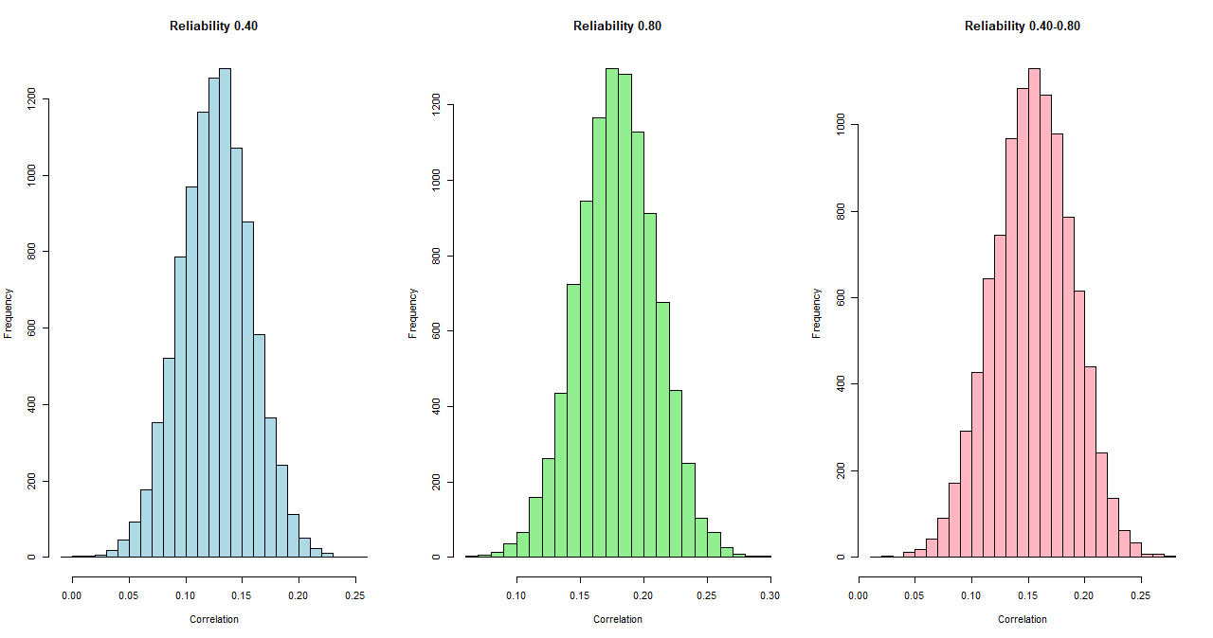
Panel 2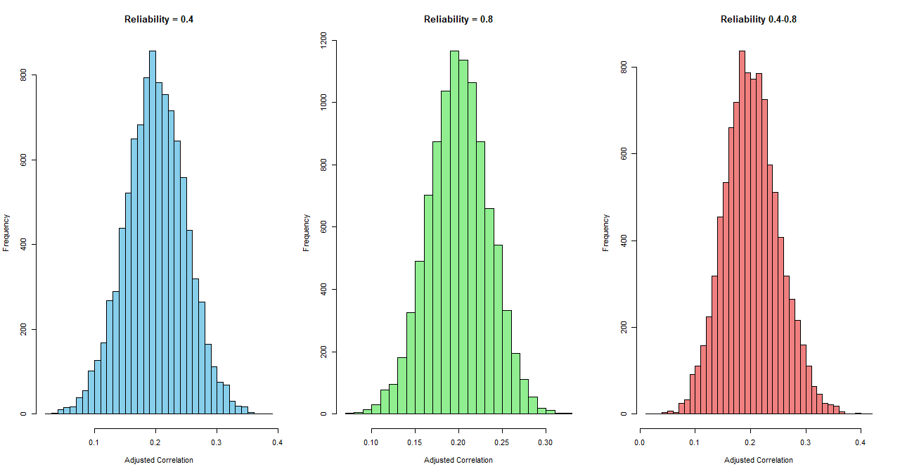
Panel 3
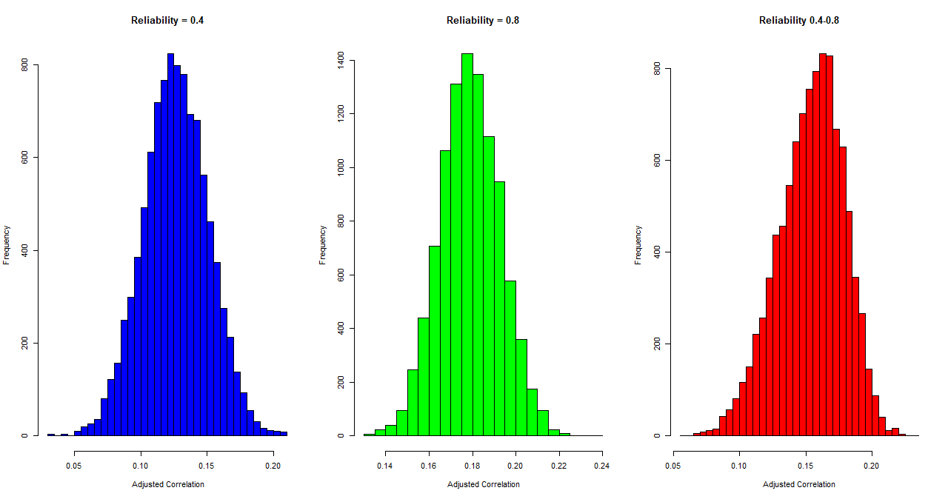

Supplement B.2 Analysis Table for replicability project analysis.

One-Sample Proportions Tests
 | Test Type | Observed |  |  | Observed - Test Valueª | Asymptotic Standard Error | Z | Significance
 | Test Type | Successes | Trials | Proportion | Observed - Test Valueª | Asymptotic Standard Error | Z | One-Sided p | Two-Sided p
Adjusted Baeyes CI | Mid-p Adjusted Binomial | 65 | 97 | .670 | .170 | .048 |  | <.001 | <.001
Adjusted Baeyes CI | Score | 65 | 97 | .670 | .170 | .048 | 3.351 | <.001 | <.001
Adjusted Bayes CI Updated with reliability | Mid-p Adjusted Binomial | 66 | 97 | .680 | .180 | .047 |  | <.001 | <.001
Adjusted Bayes CI Updated with reliability | Score | 66 | 97 | .680 | .180 | .047 | 3.554 | <.001 | <.001
Unadjusted Bayes CI | Mid-p Adjusted Binomial | 58 | 97 | .598 | .098 | .050 |  | .027 | .054
Unadjusted Bayes CI | Score | 58 | 97 | .598 | .098 | .050 | 1.929 | .027 | .054
a. Test Value = .5

