Table 2: Gas chromatography mass spectrometry (GC-MS) analysis of n-hexane fraction
No. | Name of Compound | Molecular Formula | Molecular Weight (g/mol) | R. Time (minutes) | Peak Area (%) | Structure of Compounds
1 | Mesitylene | C₆H₁₂ | 120.2 | 3.730 | 0.29 | 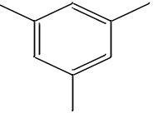
2 | Naphthalene, 1-methyl | C₁₁H₁₀ | 142.2 | 10.146 | 0.75 | 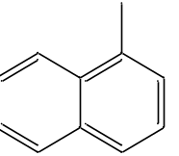
3 | Dibutyl phthalate | C₁₆H₂₄0₄ | 278.3 | 19.054 | 0.11 | 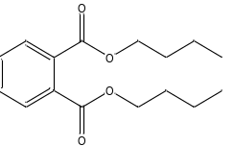
4 | Linoleic acid ethyl ester | C₂₀H₃₆0₂ | 308.5 | 21.651 | 1.66 | 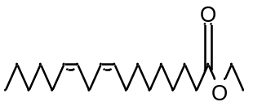
5 | Bis(2-ethylhexyl) phthalate | C₂₄H₃₈0₄ | 390.6 | 25.249 | 1.16 | 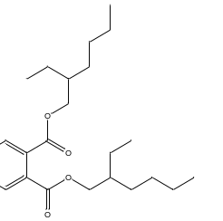
6 | 4-(4-Methoxyphenyl)-1-butanol | C₁₁H₁₆0₂ | 180.2 | 26.527 | 1.7 | 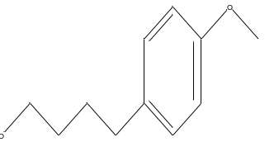
7 | 1,3-Benzenedicarboxylic acid | C₈H₆0₄ | 166.1 | 26.933 | 0.25 | 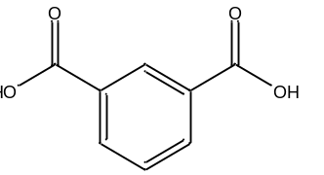
8 | 2-(4-Methoxyphenyl) ethanol | C9H1202 | 152.2 | 27.167 | 0.58 | 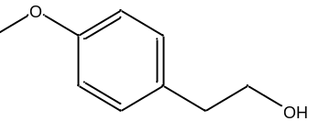
9 | Squalene | C₃₀H₅₀ | 410.7 | 27.447 | 1.7 | 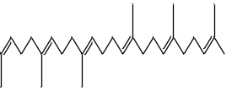
10 | Cyclononasiloxane, octadecamethyl | C₁₈H₅₄O₉Si₉ | 667.4 | 27.650 | 0.17 | 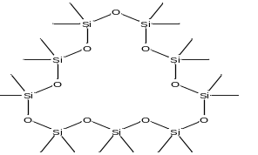

Table 3: Gas chromatography mass spectrometry GC-MS) analysis of ethyl acetate fraction
No. | Name of Compound | Molecular Formula | Molecular Weight (g/mol) | R. Time (minutes) | Peak Area (%) |  | Structure of Compounds
1 | Alpha. -Terpineol | C₁₀H₁₈O | 154.2 | 8.256 | 2.13 | 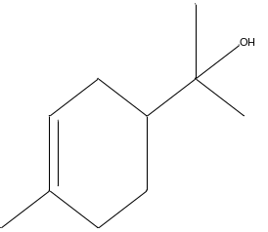
2 | Piracetam | C₆H₁₀N₂O₂ | 142,2 | 11.160 | 0.24 | 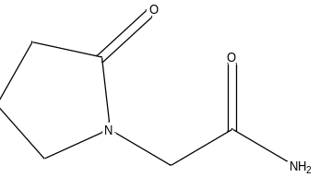
3 | Dichloroxylenol | C₈H₈Cl₂0 | 156.6 | 11.725 | 1.53 | 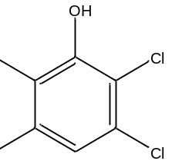
4 | 2,4-Di-tert-butylphenol | C₁₄H₂₂0 | 206.3 | 13.263 | 1.74 | 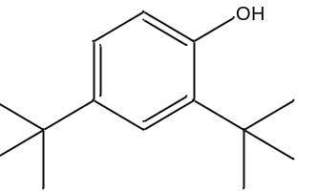
5 | 1,1'-Biphenyl, 3,3',4,4'-tetramethyl | C₁₆H₁₈ | 210.3 | 15.410 | 0.60 | 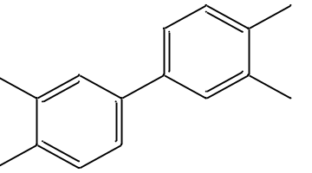
6 | Cholest-5-ene, 3-methoxy-, (3. beta.) | C₂₈H₄₈0 | 400.7 | 24.726 | 11.29 | 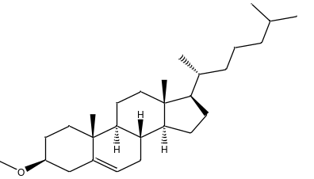
7 | Bis(2-ethylhexyl) phthalate | C₂₄H₃₈0₄ | 390.6 | 25.240 | 2.83 | 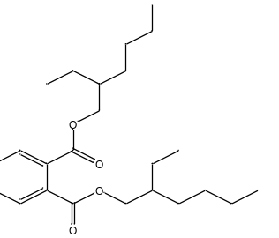
8 | Stigmasterol | C₂₉H₄₈0 | 412.7 | 25.569 | 28.00 | 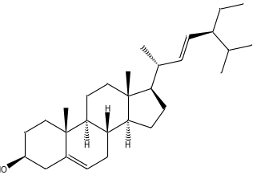
9 | Gamma. -Sitosterol | C₂₉H₅₀O | 414.7 | 26.861 | 2.49 | 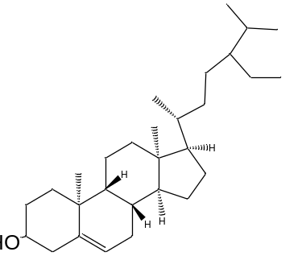
10 | Ergosta-4,22-dien-3-one | C₂₈H₄₄O |  | 28.026 | 0.60 | 